**Web Engineering Project**

**Final Report**

**Getupstartup.com**

**ASM - Agile Start up Management**

*An Agile Start-Up Collaboration Platform*

**Group Members:**

Muhammad Gul Zain Ali Khan - 32099

14besegkhan@seecs.edu.pk

Rohma Shakeel - 32398

14besershakeel@seecs.edu.pk

**Class:** BESE – 5A

**Table of Contents**

|  |  |  |
| --- | --- | --- |
| **S. No.** | **Title** | **Page No** |
| 1 | **Overview**  Project Description  Features & Functionality  Tools  Work Distribution (website, report, ppt) | 3 |
| 2 | **Website SiteMap** | 4 |
| 3 | **Website Screens**  Sign In  Sign Up  Projects Board  Project Dashboard/User Home Page | 5, 6, 7 |
| 4 | **Testing**  Test Cases | 7 |
| 5 | **Source Code**  Sign In  Projects Board  Project Dashboard/User Home Page | 7-32 |

**Overview**

**Project Description**

The website will act as a pipeline for start-ups to walk them through processes of team building, customer evaluation, product building through lean and creating an agile environment through collaboration.

**Features & Functionality**

1. User Registration
2. Startup Registration

(registration is combined and generic for now for both)

1. Startup Task Management -
   1. Project Dashboard
   2. CRUD Tasks (View only for now)
   3. Backlog Maintenance (in future)
2. Profile Setup (in future)
3. Projects Board/Newsfeed (in future)
4. Complete DBMS for the Portal’s Backend (in future)

**Tools**

***Front End -***

HTML, CSS, Javascript

***Backend*** ***-***

PHP, MySQL in phpMyAdmin, Wamp Server

**Work Distribution**

***Front End Design -***

Rohma + Gul Zain

***Front End Implementation -***

Gul Zain

***Back End Functionality Prototype -***

Rohma

***Report + Presentation -***

Rohma

**Website Site Map**

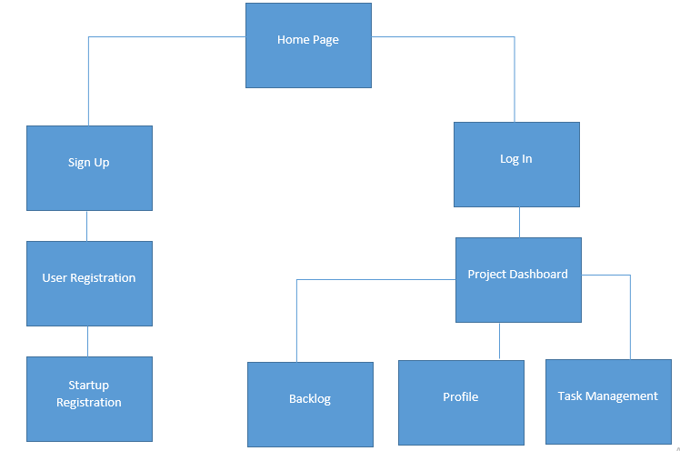

**Website Screens**

**Sign In -**User will enter email and password to log into portal

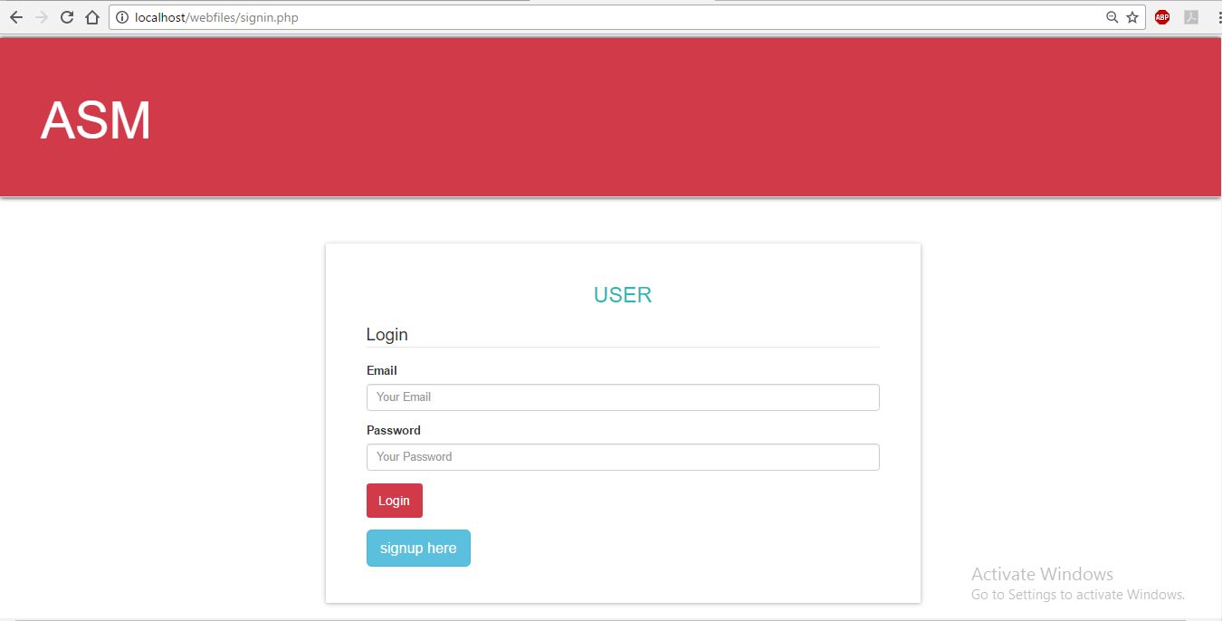

**Sign Up -** User will enter details regarding their startup to register

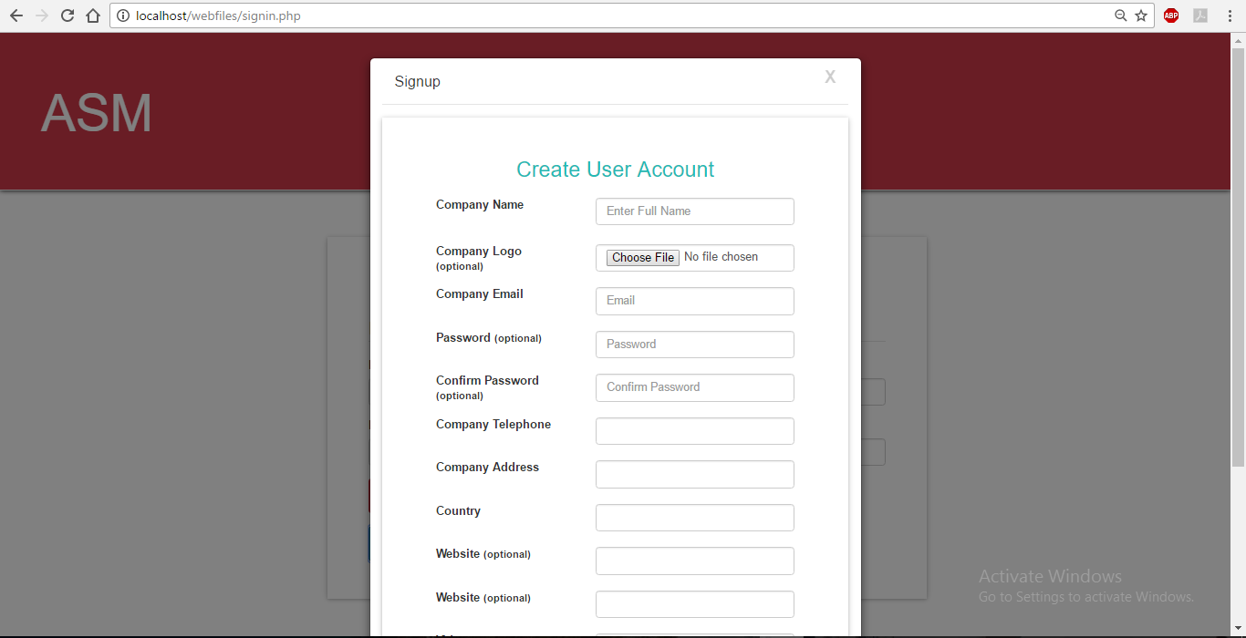

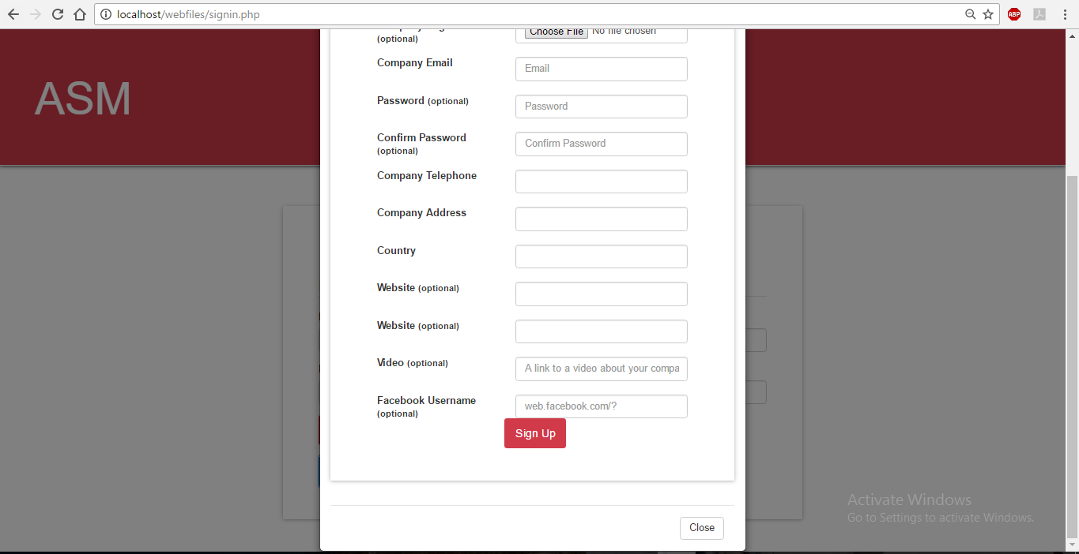

**Projects Board** - Logging in takes the user to a list of projects currently on the portal which can be viewed upon clicking on them

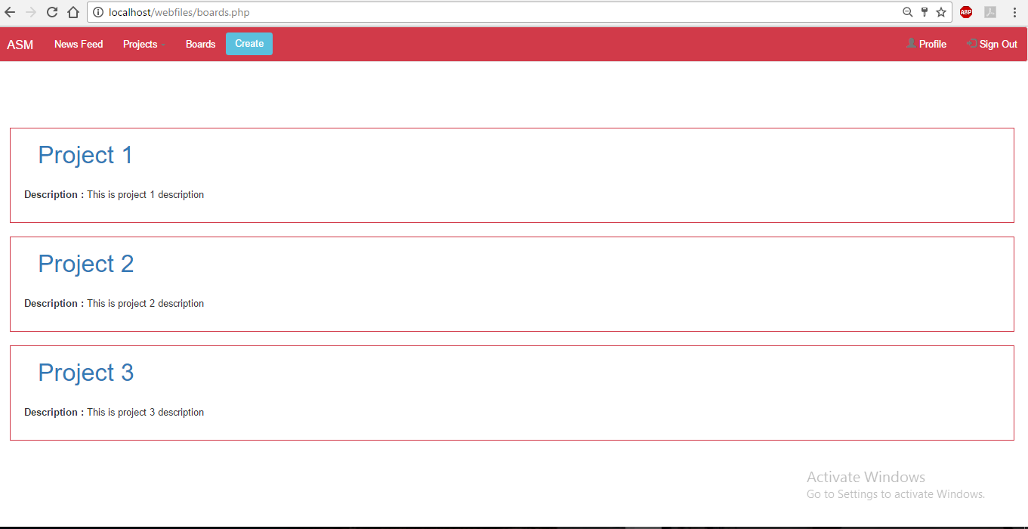

**Project Dashboard/User Home Page -** User’s task management page

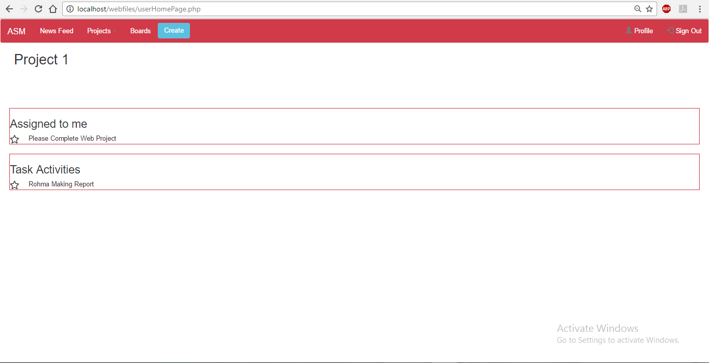

**Testing**

***Test Cases***

(shown in demo)

**Sign In -**

* Email and Password can’t be empty
* Clicking on Sign Up opens the registration modal
* Clicking on Sign In takes user to Projects Board

**Other Pages -**

* Clicking on Create in Navigation Bar opens the registration modal
* Sign Up - Email must have ‘@’
* Navigation between pages
* Clicking on Sign Out takes user to Sign In screen
* New registration name and email stored in database

**Source Code**

**Sign In**

***.php***

<?php

if (isset($_POST['signup']))

{

$suemail=$_POST['suemail'];

$suname=$_POST['suname'];

$con=mysqli_connect('localhost','root','','getupstartup')

or die('Error connecting to MySQL server.');

if(!$con)

{

echo "error";

}

mysqli_query($con, "INSERT into getupstartup.user(suname,suemail) VALUES('$suname','$suemail')");

if(mysqli_affected_rows($con) > 0){

echo "<p>Record Added</p>";

} else {

echo "Record NOT Added<br />";

echo mysqli_error ($con);

}

//print '<script type = "text/javascript">';

//print 'alert("Startup Created!")';

mysqli_close($con);

}

else

{

echo "not set";

}

?>

<!DOCTYPE html>

<html lang="en">

<head>

<title>ASM</title>

<meta charset="utf-8">

<meta name="viewport" content="width=device-width, initial-scale=1">

<link rel="stylesheet" href="http://maxcdn.bootstrapcdn.com/bootstrap/3.3.6/css/bootstrap.min.css">

<script src="https://ajax.googleapis.com/ajax/libs/jquery/1.12.2/jquery.min.js"></script>

<script src="http://maxcdn.bootstrapcdn.com/bootstrap/3.3.6/js/bootstrap.min.js"></script>

<script src= "script.js"></script>

<link rel="stylesheet" type="text/css" href="style.css"></link>

</head>

<body>

<div class="jumbotron page-header">

<h1>ASM</h1>

</div>

<div class="container">

<div class="container">

<div class="col-md-12 col-lg-offset-2">

<div class="login-signup">

<div class="row">

<div class="col-md-8 nav-tab-holder">

</div>

</div>

<div class="tab-content">

<div role="tabpanel" class="tab-pane active" id="home">

<div class="row">

<div class="col-md-8 mobile-pull">

<article role="login">

<h3 class="text-center"><i class="fa fa-lock"></i>USER</h3>

<form role="form" action="boards.php" method="post" name="loginform" class="login-form">

<fieldset>

<legend>Login</legend>

<div class="form-group">

<label for="name">Email</label>

<input type="text" name="email" placeholder="Your Email" required class="form-control" />

</div>

<div class="form-group">

<label for="name">Password</label>

<input type="password" name="password" placeholder="Your Password" required class="form-control" />

</div>

<div class="form-group">

<input type="submit" name="login" value="Login" class="btn btn-primary" />

</div>

<button type="button" class="btn btn-info btn-lg" id="myBtn">signup here</button>

</fieldset>

</form>

</article>

</div>

</div>

<!-- end of row -->

</div>

<!-- end of home -->

<!-- Trigger the modal with a button -->

<!-- Modal -->

<div class="modal fade" id="myModal" role="dialog">

<div class="modal-dialog">

<!-- Modal content-->

<div class="modal-content col-md-12">

<div class="modal-header">

<button type="button" class="close" data-dismiss="modal">X</button>

<h4 class="modal-title">Signup</h4>

</div>

<div class="modal-body">

<div class="row">

<article role="login">

<h3 class="text-center"><i class="fa fa-lock"></i> Create User Account</h3>

<form role="form" action="" method="post" name="signupform">

<!-- Text input-->

<div class="form-group">

<label class="col-md-5 control-label">Company Name</label>

<div class="col-md-7">

<input type="text" name="suname" placeholder="Enter Full Name" value="" class="form-control" />

</div>

</div>

<br>

<br>

<br>

<!-- Text input-->

<div class="form-group">

<label class="col-md-5 control-label">Company Logo <small>(optional)</small></label>

<div class="col-md-7">

<input type="file" name="inputFile" id="inputFile" class="form-control" placeholder="" >

</div>

</div>

<br>

<br>

<!-- Text input-->

<div class="form-group">

<label class="col-md-5 control-label">Company Email</label>

<div class="col-md-7">

<input type="email" name="suemail" placeholder="Email" value="" class="form-control" />

</div>

</div>

<br>

<br>

<!-- Text input-->

<div class="form-group">

<label class="col-md-5 control-label">Password <small>(optional)</small></label>

<div class="col-md-7">

<input type="password" name="password" placeholder="Password" class="form-control" />

</div>

</div>

<br><br> <!-- Text input-->

<div class="form-group">

<label class="col-md-5 control-label">Confirm Password <small>(optional)</small></label>

<div class="col-md-7">

<input type="password" name="cpassword" placeholder="Confirm Password" class="form-control" />

</div>

</div>

<br><br>

<div class="form-group">

<label class="col-md-5 control-label">Company Telephone</label>

<div class="col-md-7">

<input type="text" class="form-control" id="telephone" name ="telephone"placeholder="" />

</div>

</div>

<br> <br>

<div class="form-group">

<label class="col-md-5 control-label">Company Address</label>

<div class="col-md-7">

<input type="text" class="form-control" id="com_add" name ="com_add"placeholder="" />

</div>

</div>

<br>

<br>

<div class="form-group">

<label class="col-md-5 control-label">Country</label>

<div class="col-md-7">

<input type="text" class="form-control" id="contry" name ="country"placeholder="" />

</div>

</div>

<br> <br>

<div class="form-group">

<label class="col-md-5 control-label">Website <small>(optional)</small></label>

<div class="col-md-7">

<input type="url" class="form-control" id="inputwebsite" name ="web"placeholder="">

</div>

</div> <br>

<br>

<div class="form-group">

<label class="col-md-5 control-label">Website <small>(optional)</small></label>

<div class="col-md-7">

<input type="url" class="form-control" id="inputwebsite" name ="web"placeholder="">

</div>

</div>

<br><br>

<div class="form-group">

<label class="col-md-5 control-label">Video <small>(optional)</small></label>

<div class="col-md-7">

<input type="url" class="form-control" id="inputvideo" name="video" placeholder="A link to a video about your company" />

</div>

</div>

<br><br>

<div class="form-group">

<label class="col-md-5 control-label">Facebook Username <small>(optional)</small></label>

<div class="col-md-7">

<input type="url" class="form-control" id="inputfbUser" name="fbuser" placeholder="web.facebook.com/?" />

</div>

</div>

<!--

<div class="form-group">

<input type="submit" class="btn btn-success btn-block" value="SUBMIT">

</div>

-->

<div class="form-group">

<input type="submit" name="signup" value="Sign Up" class="btn btn-primary" />

</div>

</form>

</article>

</div>

</div>

<div class="modal-footer">

<button type="button" class="btn btn-default" data-dismiss="modal">Close</button>

</div>

</div>

</div>

</div>

</div>

</body>

</html>

***.css***

.login-signup {

padding: 25 0 25px;

margin-top:25px;

}

.login-signup {

padding: 0 0 25px;

}

.btn-success {

background: #23bab5;

border-radius:0;

border: 2px solid #23bab5;

webkit-transition: all 400ms cubic-bezier(.4,0,.2,1);

transition: all 400ms cubic-bezier(.4,0,.2,1);

}

a {

color: #23bab5;

}

ul {

list-style-type: none;

}

.page-header h1{

padding-left:50px;

color: #ffffff;

}

article[role="login"] {

background: #fff;

box-shadow: 0 1px 3px rgba(0, 0, 0, 0.12), 0 1px 2px rgba(0, 0, 0, 0.24);

-webkit-box-shadow: 0 1px 3px rgba(0, 0, 0, 0.12), 0 1px 10px rgba(0, 0, 0, 0.24);

webkit-transition: all 400ms cubic-bezier(0.4, 0, 0.2, 1);

transition: all 400ms cubic-bezier(0.4, 0, 0.2, 1);

padding: 30px 50px;

margin-bottom: 20px;

}

article[role="login"] input[type="submit"] {

padding: 10px 15px;

background-color: #d13a49;

font-size: 16px;

border: none;

}

input[type="submit"]:hover {

background-color:#d30c20;

}

article[role="login"]:hover {

box-shadow: 0 10px 20px rgba(0, 0, 0, 0.19), 0 6px 6px rgba(0, 0, 0, 0.23);

-webkit-box-shadow: 0 10px 20px rgba(0, 0, 0, 0.19), 0 1px 15px rgba(0, 0, 0, 0.23);

webkit-transition: all 400ms cubic-bezier(0.4, 0, 0.2, 1);

transition: all 400ms cubic-bezier(0.4, 0, 0.2, 1);

}

article[role="login"] h3 {

font-size: 26px;

font-weight: 300;

color: #23bab5;

margin-bottom: 20px;

}

article[role="login"] p {

font-size: 16px;

padding: 5px 15px;

}

.page-header{

background-color: #d13a49;

box-shadow: 0px 0px 8px #000000;

}

.nav-tab-holder {

padding: 0 0 0 30px;

float: right;

}

.nav-tab-holder {

float: none;

overflow: hidden;

}

.nav-tabs > li > a {

font-size: 13px;

font-weight: 600;

padding: 10px 5px;

overflow: hidden;

text-overflow: ellipsis;

}

.nav-tabs > li {

width: 50%;

}

.nav-tab-holder .nav-tabs {

border: 0;

float: none;

display: table;

table-layout: fixed;

width: 100%;

}

.nav-tab-holder

.nav-tabs > li > a {

background: #d9d9d9;

color: #6c6c6c;

margin: 0;

font-size: 18px;

font-weight: 300;

}

.nav-tab-holder .nav-tabs > li {

margin-bottom: -3px;

text-align: center;

padding: 0;

display: table-cell;

float: none;

padding: 0;

}

.nav-tab-holder .nav-tabs > li.active > a,

.nav-tabs > li.active > a:hover,

.nav-tabs > li.active > a:focus {

color: #FFF;

background-color: #23bab5;

border: 0;

border-radius: 0;

}

***.js***

$(document).ready(function(){

$("#myBtn").click(function(){

$("#myModal").modal();

});

$(".login-form").onsubmit=doAction();

});

function doAction(){

location.href('boards.php’);

}

**Boards**

***.php***

<?php

if (isset($_POST['signup']))

{

$suemail=$_POST['suemail'];

$suname=$_POST['suname'];

$con=mysqli_connect('localhost','root','','getupstartup')

or die('Error connecting to MySQL server.');

if(!$con)

{

echo "error";

}

mysqli_query($con, "INSERT into getupstartup.user(suname,suemail) VALUES('$suname','$suemail')");

if(mysqli_affected_rows($con) > 0){

echo "<p>Record Added</p>";

} else {

echo "Record NOT Added<br />";

echo mysqli_error ($con);

}

//print '<script type = "text/javascript">';

//print 'alert("Startup Created!")';

mysqli_close($con);

}

//else

//{

//echo "not set";

//}

?>

<!DOCTYPE html>

<head>

<title> Home </title>

<meta charset="utf-8">

<meta name="viewport" content="width=device-width, initial-scale=1">

<link rel="stylesheet" href="http://maxcdn.bootstrapcdn.com/bootstrap/3.3.6/css/bootstrap.min.css">

<script src="https://ajax.googleapis.com/ajax/libs/jquery/1.12.2/jquery.min.js"></script>

<script src="http://maxcdn.bootstrapcdn.com/bootstrap/3.3.6/js/bootstrap.min.js"></script>

<script src="boards.js"></script>

<link rel="stylesheet" href="boards.css"></link>

<body>

<nav class="navbar navbar-default my-nav">

<div class="container-fluid">

<div class="navbar-header">

<a class="navbar-brand" href="#"><span class="nav-el"><span class="nav-el">ASM</span></span></a>

</div>

<ul class="nav navbar-nav">

<li><a class="nav-el" href="#"><span class="nav-el">News Feed</span></a></li>

<li class="dropdown">

<a class="dropdown-toggle nav-el" data-toggle="dropdown" href="#"><span class="nav-el">Projects</span>

<span class="caret"></span></a>

<ul class="dropdown-menu">

<li><a href="userHomePage.php">Project 1</a></li>

<li><a href="#">Project 2</a></li>

<li><a href="#">Project 3</a></li>

</ul>

</li>

<li><a href="boards.php"><span class="nav-el">Boards</span></a></li>

</ul>

<ul class="nav navbar-nav navbar-right">

<li><a href="#"><span class="glyphicon glyphicon-user"></span> <span class="nav-el">Profile</span></a></li>

<li><a href="signin.php"><span class="glyphicon glyphicon-log-in"></span> <span class="nav-el">Sign Out</span></a></li>

</ul>

<button class="btn navbar-btn create-project" href="#">Create</button>

</div>

</nav>

<br>

<br>

<br>

<div class="my-container">

<a href="userHomePage.php"><h1> Project 1</h1></a>

<p> <b> Description : </b> This is project 1 description</p>

</div>

<div class="my-container">

<a href="#"><h1> Project 2</h1></a>

<p> <b> Description : </b> This is project 2 description</p>

</div>

<div class="my-container">

<a href="#"><h1> Project 3</h1></a>

<p> <b> Description : </b> This is project 3 description</p>

</div>

</body>

<!-- MODAL -->

<div class="modal fade" id="myModal" role="dialog">

<div class="modal-dialog">

<!-- Modal content-->

<div class="modal-content col-md-12">

<div class="modal-header">

<button type="button" class="close" data-dismiss="modal">X</button>

<h4 class="modal-title">Signup</h4>

</div>

<div class="modal-body">

<div class="row">

<article role="login">

<h3 class="text-center"><i class="fa fa-lock"></i> Create Your Startup</h3>

<form role="form" action="" method="post" name="signupform">

<!-- Text input-->

<div class="form-group">

<label class="col-md-5 control-label">Company Name</label>

<div class="col-md-7">

<input type="text" name="suname" placeholder="Enter Full Name" value="" class="form-control" />

</div>

</div>

<br>

<br>

<br>

<!-- Text input-->

<div class="form-group">

<label class="col-md-5 control-label">Company Logo <small>(optional)</small></label>

<div class="col-md-7">

<input type="file" name="inputFile" id="inputFile" class="form-control" placeholder="" >

</div>

</div>

<br>

<br>

<!-- Text input-->

<div class="form-group">

<label class="col-md-5 control-label">Company Email</label>

<div class="col-md-7">

<input type="email" name="suemail" placeholder="Email" value="" class="form-control" />

</div>

</div>

<br>

<br>

<br><br>

<div class="form-group">

<label class="col-md-5 control-label">Company Telephone</label>

<div class="col-md-7">

<input type="text" class="form-control" id="telephone" name ="telephone"placeholder="" />

</div>

</div>

<br> <br>

<div class="form-group">

<label class="col-md-5 control-label">Company Address</label>

<div class="col-md-7">

<input type="text" class="form-control" id="com_add" name ="com_add"placeholder="" />

</div>

</div>

<br>

<br>

<div class="form-group">

<label class="col-md-5 control-label">Country</label>

<div class="col-md-7">

<input type="text" class="form-control" id="contry" name ="country"placeholder="" />

</div>

</div>

<br> <br>

<div class="form-group">

<label class="col-md-5 control-label">Website <small>(optional)</small></label>

<div class="col-md-7">

<input type="url" class="form-control" id="inputwebsite" name ="web"placeholder="">

</div>

</div> <br>

<br>

<div class="form-group">

<label class="col-md-5 control-label">Website <small>(optional)</small></label>

<div class="col-md-7">

<input type="url" class="form-control" id="inputwebsite" name ="web"placeholder="">

</div>

</div>

<br><br>

<div class="form-group">

<label class="col-md-5 control-label">Video <small>(optional)</small></label>

<div class="col-md-7">

<input type="url" class="form-control" id="inputvideo" name="video" placeholder="A link to a video about your company" />

</div>

</div>

<br><br>

<div class="form-group">

<label class="col-md-5 control-label">Facebook Page <small>(optional)</small></label>

<div class="col-md-7">

<input type="url" class="form-control" id="inputfbUser" name="fbuser" placeholder="web.facebook.com/?" />

</div>

</div>

<!--

<div class="form-group">

<input type="submit" class="btn btn-success btn-block" value="SUBMIT">

</div>

-->

<div class="form-group">

<input type="submit" name="signup" value="Create" class="btn btn-primary" />

</div>

</form>

</article>

</div>

</div>

<div class="modal-footer">

<button type="button" class="btn btn-default" data-dismiss="modal">Close</button>

</div>

</div>

</div>

</div>

</div>

***.css***

.create-project{

background-color: #5bc0de;

color: white;

}

.my-nav{

background-color: #d13a49;

text-color:white;

}

.nav-el{

color:white;

}

.my-container{

border: 1px solid #d13a49;

margin: 20px 20px 20px;

}

.my-container:hover{

background-color: #d6d8db;

}

.my-container p{

padding: 20px 20px 20px;

}

.task-item{

margin-left:10px;

padding: 10px 10px 10px;

}

article[role="login"] {

background: #fff;

box-shadow: 0 1px 3px rgba(0, 0, 0, 0.12), 0 1px 2px rgba(0, 0, 0, 0.24);

-webkit-box-shadow: 0 1px 3px rgba(0, 0, 0, 0.12), 0 1px 10px rgba(0, 0, 0, 0.24);

webkit-transition: all 400ms cubic-bezier(0.4, 0, 0.2, 1);

transition: all 400ms cubic-bezier(0.4, 0, 0.2, 1);

padding: 30px 50px;

margin-bottom: 20px;

}

article[role="login"] input[type="submit"] {

padding: 10px 15px;

background-color: #d13a49;

font-size: 16px;

border: none;

}

article[role="login"]:hover {

box-shadow: 0 10px 20px rgba(0, 0, 0, 0.19), 0 6px 6px rgba(0, 0, 0, 0.23);

-webkit-box-shadow: 0 10px 20px rgba(0, 0, 0, 0.19), 0 1px 15px rgba(0, 0, 0, 0.23);

webkit-transition: all 400ms cubic-bezier(0.4, 0, 0.2, 1);

transition: all 400ms cubic-bezier(0.4, 0, 0.2, 1);

}

article[role="login"] h3 {

font-size: 26px;

font-weight: 300;

color: #23bab5;

margin-bottom: 20px;

}

article[role="login"] p {

font-size: 16px;

padding: 5px 15px;

}

h2{

padding-left: 30px;

margin-top: 40px:

}

h1{

padding-left: 40px;

}

h1:hover{

color: blue;

}

***.js***

$(document).ready(function(){

$(".create-project").click(function(){

$("#myModal").modal();

});

});

**User Home Page**

***.php***

<?php

if (isset($_POST['signup']))

{

$suemail=$_POST['suemail'];

$suname=$_POST['suname'];

$con=mysqli_connect('localhost','root','','getupstartup')

or die('Error connecting to MySQL server.');

if(!$con)

{

echo "error";

}

mysqli_query($con, "INSERT into getupstartup.user(suname,suemail) VALUES('$suname','$suemail')");

if(mysqli_affected_rows($con) > 0){

echo "<p>Record Added</p>";

} else {

echo "Record NOT Added<br />";

echo mysqli_error ($con);

}

//print '<script type = "text/javascript">';

//print 'alert("Startup Created!")';

mysqli_close($con);

}

//else

//{

// echo "not set";

//}

?><!DOCTYPE html>

<head>

<title> Home </title>

<meta charset="utf-8">

<meta name="viewport" content="width=device-width, initial-scale=1">

<link rel="stylesheet" href="http://maxcdn.bootstrapcdn.com/bootstrap/3.3.6/css/bootstrap.min.css">

<script src="https://ajax.googleapis.com/ajax/libs/jquery/1.12.2/jquery.min.js"></script>

<script src="http://maxcdn.bootstrapcdn.com/bootstrap/3.3.6/js/bootstrap.min.js"></script>

<script src="userHomePageStyle.js"></script>

<link rel="stylesheet" href="userHomePageStyle.css"></link>

<body>

<nav class="navbar navbar-default my-nav">

<div class="container-fluid">

<div class="navbar-header">

<a class="navbar-brand" href="#"><span class="nav-el"><span class="nav-el">ASM</span></span></a>

</div>

<ul class="nav navbar-nav">

<li><a class="nav-el" href="#"><span class="nav-el">News Feed</span></a></li>

<li class="dropdown">

<a class="dropdown-toggle nav-el" data-toggle="dropdown" href="#"><span class="nav-el">Projects</span>

<span class="caret"></span></a>

<ul class="dropdown-menu">

<li><a href="#">Project 1</a></li>

<li><a href="#">Project 2</a></li>

<li><a href="#">Project 3</a></li>

</ul>

</li>

<li><a href="boards.php"><span class="nav-el">Boards</span></a></li>

</ul>

<ul class="nav navbar-nav navbar-right">

<li><a href="#"><span class="glyphicon glyphicon-user"></span> <span class="nav-el">Profile</span></a></li>

<li><a href="signin.php"><span class="glyphicon glyphicon-log-in"></span> <span class="nav-el">Sign Out</span></a></li>

</ul>

<button class="btn navbar-btn create-project" href="#">Create</button>

</div>

</nav>

<h2> Project 1</h2>

<br>

<br>

<br>

<div class="my-container">

<h3> Assigned to me</h3>

<img class="task-progress" src="Buzz Outline star.ico" alt="Mountain View" style="width:20px;height:20px;"><span class="task-item">Please Complete Web Project</span></img>

</div>

<div class="my-container">

<h3> Task Activities</h3>

<img class="task-progress" src="Buzz Outline star.ico" alt="Mountain View" style="width:20px;height:20px;"><span class="task-item">Rohma Making Report</span></img>

</div>

</body>

<!-- MODAL -->

<div class="modal fade" id="myModal" role="dialog">

<div class="modal-dialog">

<!-- Modal content-->

<div class="modal-content col-md-12">

<div class="modal-header">

<button type="button" class="close" data-dismiss="modal">X</button>

<h4 class="modal-title">Signup</h4>

</div>

<div class="modal-body">

<div class="row">

<article role="login">

<h3 class="text-center"><i class="fa fa-lock"></i> Create Your Startup</h3>

<form role="form" action="" method="post" name="signupform">

<!-- Text input-->

<div class="form-group">

<label class="col-md-5 control-label">Company Name</label>

<div class="col-md-7">

<input type="text" name="suname" placeholder="Enter Full Name" value="" class="form-control" />

</div>

</div>

<br>

<br>

<br>

<!-- Text input-->

<div class="form-group">

<label class="col-md-5 control-label">Company Logo <small>(optional)</small></label>

<div class="col-md-7">

<input type="file" name="inputFile" id="inputFile" class="form-control" placeholder="" >

</div>

</div>

<br>

<br>

<!-- Text input-->

<div class="form-group">

<label class="col-md-5 control-label">Company Email</label>

<div class="col-md-7">

<input type="email" name="suemail" placeholder="Email" value="" class="form-control" />

</div>

</div>

<br>

<br>

<br><br>

<div class="form-group">

<label class="col-md-5 control-label">Company Telephone</label>

<div class="col-md-7">

<input type="text" class="form-control" id="telephone" name ="telephone"placeholder="" />

</div>

</div>

<br> <br>

<div class="form-group">

<label class="col-md-5 control-label">Company Address</label>

<div class="col-md-7">

<input type="text" class="form-control" id="com_add" name ="com_add"placeholder="" />

</div>

</div>

<br>

<br>

<div class="form-group">

<label class="col-md-5 control-label">Country</label>

<div class="col-md-7">

<input type="text" class="form-control" id="contry" name ="country"placeholder="" />

</div>

</div>

<br> <br>

<div class="form-group">

<label class="col-md-5 control-label">Website <small>(optional)</small></label>

<div class="col-md-7">

<input type="url" class="form-control" id="inputwebsite" name ="web"placeholder="">

</div>

</div> <br>

<br>

<div class="form-group">

<label class="col-md-5 control-label">Website <small>(optional)</small></label>

<div class="col-md-7">

<input type="url" class="form-control" id="inputwebsite" name ="web"placeholder="">

</div>

</div>

<br><br>

<div class="form-group">

<label class="col-md-5 control-label">Video <small>(optional)</small></label>

<div class="col-md-7">

<input type="url" class="form-control" id="inputvideo" name="video" placeholder="A link to a video about your company" />

</div>

</div>

<br><br>

<div class="form-group">

<label class="col-md-5 control-label">Facebook Page <small>(optional)</small></label>

<div class="col-md-7">

<input type="url" class="form-control" id="inputfbUser" name="fbuser" placeholder="web.facebook.com/?" />

</div>

</div>

<!--

<div class="form-group">

<input type="submit" class="btn btn-success btn-block" value="SUBMIT">

</div>

-->

<div class="form-group">

<input type="submit" name="signup" value="Create" class="btn btn-primary" />

</div>

</form>

</article>

</div>

</div>

<div class="modal-footer">

<button type="button" class="btn btn-default" data-dismiss="modal">Close</button>

</div>

</div>

</div>

</div>

</div>

***.css***

.create-project{

background-color: #5bc0de;

color: white;

}

.my-nav{

background-color: #d13a49;

text-color:white;

}

.nav-el{

color:white;

}

.my-container{

border: 1px solid #d13a49;

margin: 20px 20px 20px;

}

.task-item{

margin-left:10px;

padding: 10px 10px 10px;

}

article[role="login"] {

background: #fff;

box-shadow: 0 1px 3px rgba(0, 0, 0, 0.12), 0 1px 2px rgba(0, 0, 0, 0.24);

-webkit-box-shadow: 0 1px 3px rgba(0, 0, 0, 0.12), 0 1px 10px rgba(0, 0, 0, 0.24);

webkit-transition: all 400ms cubic-bezier(0.4, 0, 0.2, 1);

transition: all 400ms cubic-bezier(0.4, 0, 0.2, 1);

padding: 30px 50px;

margin-bottom: 20px;

}

article[role="login"] input[type="submit"] {

padding: 10px 15px;

background-color: #d13a49;

font-size: 16px;

border: none;

}

article[role="login"]:hover {

box-shadow: 0 10px 20px rgba(0, 0, 0, 0.19), 0 6px 6px rgba(0, 0, 0, 0.23);

-webkit-box-shadow: 0 10px 20px rgba(0, 0, 0, 0.19), 0 1px 15px rgba(0, 0, 0, 0.23);

webkit-transition: all 400ms cubic-bezier(0.4, 0, 0.2, 1);

transition: all 400ms cubic-bezier(0.4, 0, 0.2, 1);

}

article[role="login"] h3 {

font-size: 26px;

font-weight: 300;

color: #23bab5;

margin-bottom: 20px;

}

article[role="login"] p {

font-size: 16px;

padding: 5px 15px;

}

h2{

padding-left: 30px;

margin-top: 40px:

}

***.js***

$(document).ready(function(){

$(".create-project").click(function(){

$("#myModal").modal();

});

});