**Q. What is GITHUB?**

**_______________________________________**

GITHUB is a developer platform that allows developers to store and manage their code.

GITHUB is version control tool

**Q. Why use GITHUB ?**

1. **Centralised the code**
2. **GIT is version control tool**

**How to works with GIT**

_________________________________

1. Install the GIT in your system

<https://git-scm.com/downloads>

   Note: when we install GITHUB in your system we get git bash for work with GIT

**Q. What is GITBash?**

_____________________________________

GITBash is like a power shell of a window or terminal in linux which provides an interface to us to provide different commands to git.

**How to create repository on local machine**

_____________________________________

**Q. What is a repository?**

**____________________________________**

Repository means location where we can store your projects on a local machine called a repository.

**Steps to work with repository on local machine**

**_______________________________________**

1. **Create folder on specified path**

**D:\\july2024\\GITWorkshop**

1. **Open the folder on location**

**Right click  – select show more option  – select git bash**

1. **Setup the user information**

**Q.Why user information is needed?**

Because a single repository can be accessible by more than one developer/users and if we want to track user activity then we need to recognize users so we require setup user information.

1. **How to configure user with repository**

**____________________________________**

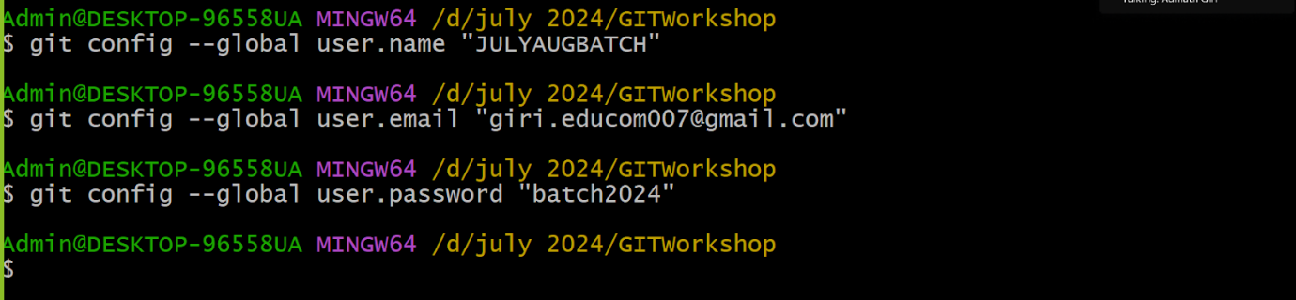

**If we want to check the user details and some more details about repository we have following command**

**Once we setup user details and if we want to check your repository is git repository or not**

**Then we can check following command**

**git status**

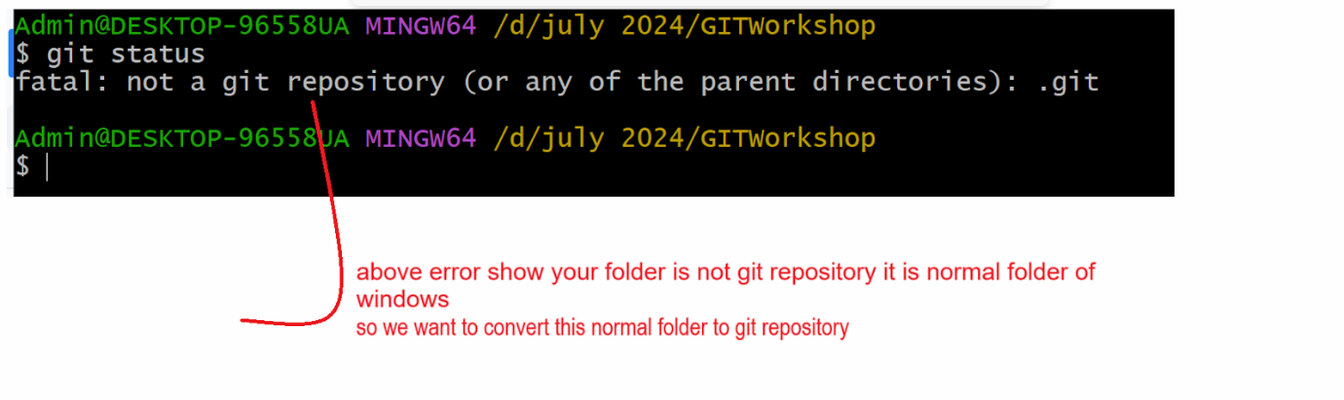

**If we want to mark your folder as git repository we have command**

**git init**

**Note:** if we want to work with git repository we need to know the architecture of git repository

**Architecture of GIT Repository**

__________________________________

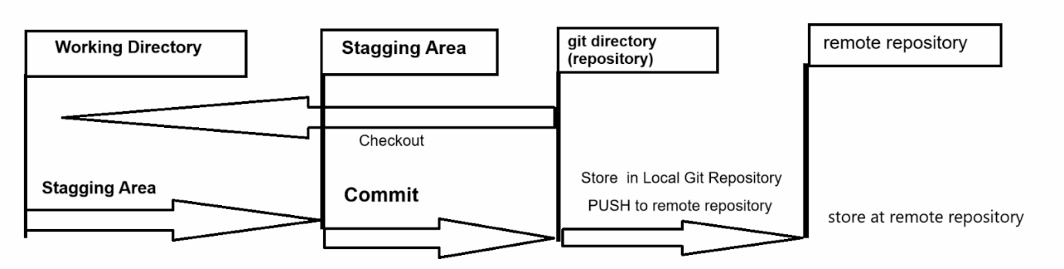

**Working Directory:** working directory means if you have repository and you are working on it means modify some files or add new files in directory called as working directory

**Example: D:\\july2024\\GITworkshop  - it is our working directory**

**Staging Area: staging means process we mark the file or modified file to save in current version of repository and by default every file in working directory is unstage so we need to convert unstage file to stage process**

**Means if we save change in repository we need to perform staging operation first**

**Commit: commit operation means we want to save a file in a local repository called a commit operation.**

**How to convert unstage file to stage file**

**_____________________________________**

**If we want to convert unstage file to stage we have command**

**git add filename**

Example: git add TableApp.java

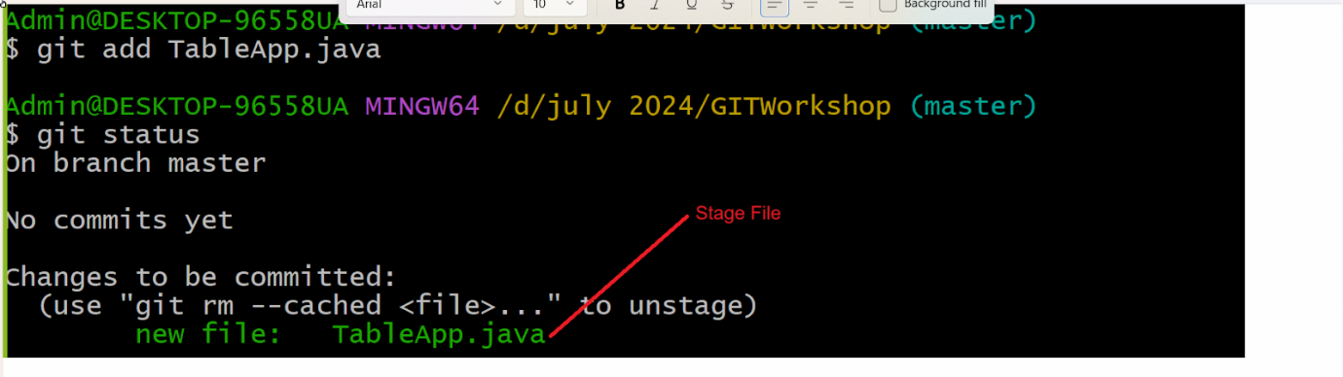

Once we stage file we can commit the file means save in local repository

**Revise screen shot of  git architecture**

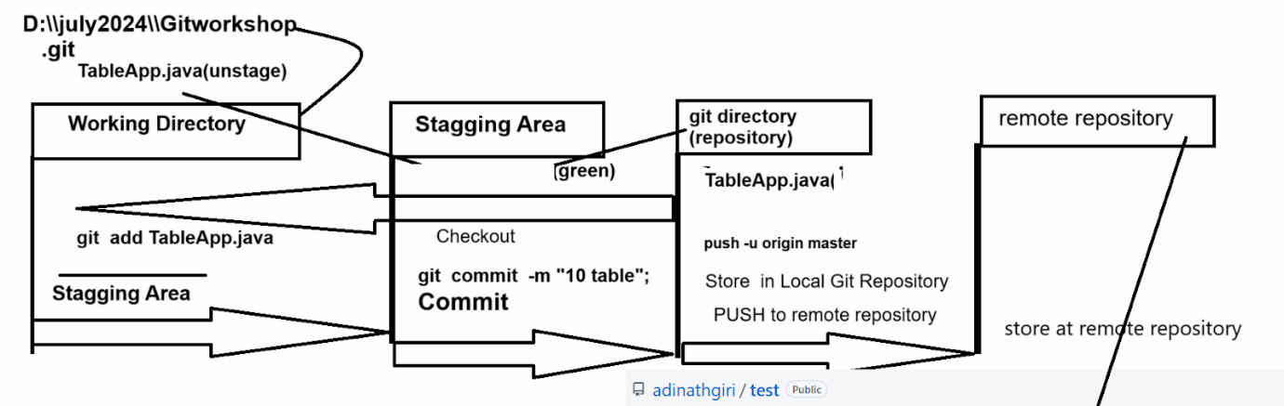

**How to work with remote repository**

________________________________________

Means now we want to create repository on git web site and push our local repository code on

github website

**Steps**

______________________________________

1. Open account on github website

https://github.com/

1. Login to github website
2. Create repository on github website

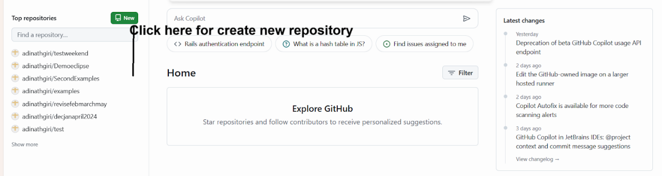

1. Set the SSH key for repository
2. Copy https link from code of repository
3. Connect remote repository with local repository on our system

If we want to connect your remote repository with

Local repository we have to use following command

git remote add origin URL remote repository

**Branching concept in GIT**

______________________________________

A branch represents an independent line of development.

Branches serve as an abstraction for the edit /stage/commit process. Branch is new separate version for new repository

How to create the branch in github

______________________________________

If we want to create branch in github we have command

**Syntax**: git branch branchname

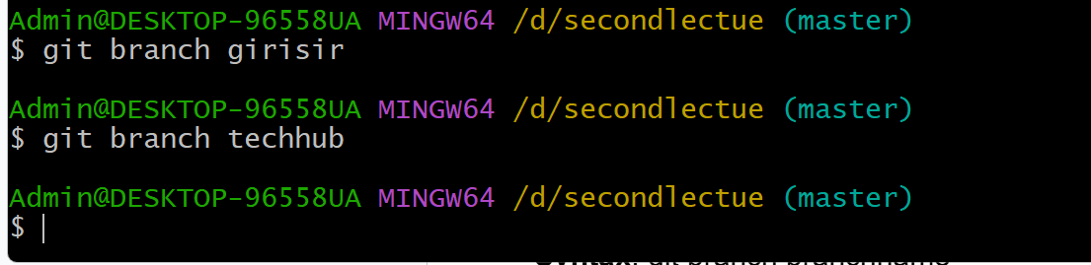

How to switch from one branch to another

________________________________________

git checkout branchname

Or

git switch branchname

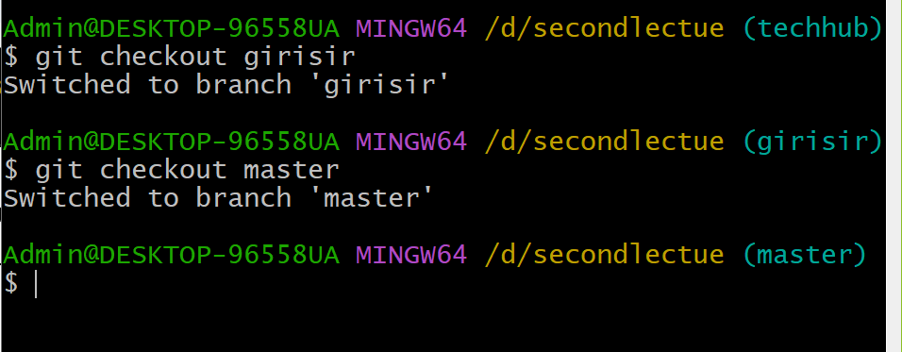

How to merge branches with each other

______________________________________

If we want to merge other branches in master we have following command

**Syntax:**  git merge branchname



**How to create branch and how to switch branch at the time of creation**

________________________________________

If we want to create branch and switch it at the time of branch creation

**Syntax:** git checkout  -b branchname

Here git checkout indicate we want to switch branch  -b indicate create new branch and switch  it branch name is name of your branch

**How to create eclipse project and push on github website**

_______________________________________

**Steps**

1. **Create repository on GITHUB website**
2. **Create SSH Key**
3. **Create Project in eclipse**
4. **Convert your project as repository using eclipse**

**Right click on project  — select team option  — share project option**

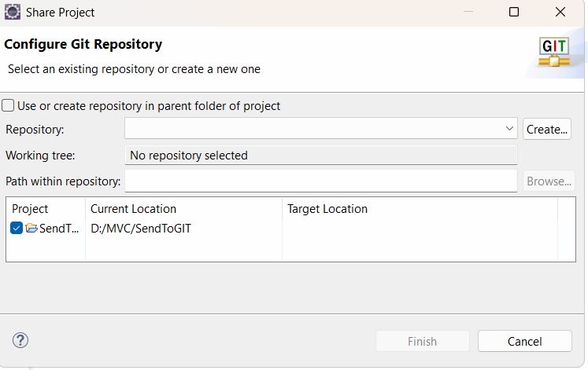

**How to clone remote repository on local machine**

________________________________________

Git clone  repository path