The Deliberative Process Design Tool (DPDT): A Decision-Support System for AI-Enabled Deliberation at Scale
Francesco Veri¹, Gustavo Kreia Umbelino¹, Maurice Flechtner¹,
¹ Centre for Democracy Studies (ZDA), University of Zurich, Switzerland
Correspondent author: francesco.veri@zda.uzh.ch

Abstract
Scaling deliberation beyond small-group settings remains one of the central challenges of deliberative democracy. Scaling participation to hundreds or thousands of participants introduces difficult trade-offs between inclusion, equality, and reflection but would be highly beneficial as deliberative processes can increase participants’ knowledge on policy issues, reduce polarisation, and lead to more legitimate decisions. These tensions require deliberative process design capable of balancing normative priorities against real-world institutional constraints. To address this challenge, we present the Deliberative Process Design Tool (DPDT), a decision support system designed to help practitioners and public authorities design large-scale deliberative processes by translating deliberative principles into concrete process recommendations. DPDT applies multi-criteria decision analysis (MCDA) to score and rank deliberative design templates and recommend appropriate process configurations based on practitioner’s constraints (institutional mandate, interaction format, available resources) and priorities across five deliberative principles (equality, inclusion, plurality, authenticity, reflection). The platform also integrates AI-supported functionalities, engagement features, and socio-technical risk diagnostics to support transparent and context-sensitive process design. Two illustrative cases demonstrate how similar normative priorities can produce substantially different deliberative architectures when institutional constraints differ.
Keywords: deliberative democracy, decision-support system, AI-enabled participation, process design, scaling deliberation

Introduction
Deliberation—the collective exchange of arguments and perspectives through which participants reflect and form more informed judgments [2], is widely recognised as a mechanism for improving democratic decision-making [8,12,29]. Research demonstrates that structured deliberation increases participants’ knowledge about policy issues [12], fosters reflective reasoning [36,37], reduces polarisation [19], and strengthens civic dispositions [20]. Yet these benefits have been established predominantly in small-group settings (typically 15–25 participants), and scaling deliberation to the hundreds or thousands that institutional participation demands remains a central challenge in democratic innovation [24,28].
Scaling deliberation introduces important design tensions such as tensions between quality of the interaction and size [24], consequentiality, or the extent to which deliberation influences real decisions, and engagement [6,14,30]. Yet, while AI-supported tools can help manage some of these challenges by structuring contributions, monitoring participation balance, or synthesising large volumes of input, achieving high-quality deliberative outcomes ultimately depends on how deliberative processes themselves are reimagined, designed, and organised. Empirical studies on mini-publics show that procedural configurations such as group-building activities, deliberation duration, voting procedures, and participant composition can significantly affect the quality of deliberative reasoning and collective sense-making [37].
Practitioners designing large-scale deliberative processes generally lack support to translate principles into operational decisions under real-world constraints, despite a growing body of normative theory and empirical evidence on deliberative processes [5]. Available guidance risks being too abstract, with deliberation discussed mainly at the theoretical level and with limited connection to practice, but can also be too context-specific, as in individual case reports that are difficult to generalise, or too technology-driven, e.g. when focusing on platform functionalities without clear normative foundations.
We address this gap with the Deliberative Process Design Tool (DPDT), an interactive, constraint-driven recommendation engine that connects normative principles to operational design through a traceable multi-criteria decision pipeline. Rather than treating deliberative principles as abstract ideals or technologies as isolated features, the DPDT links real-world constraints and design tensions to concrete deliberative process configurations. Through the DPDT, practitioners specify contextual constraints, and the tool generates ranked deliberative designs with full traceability from normative priorities to scaling strategies and stage-specific process features.

The DPDT makes three main contributions. First, it formalises the operationalisation gap between deliberative theory and practitioner action through a traceable constraint–strategy pipeline linking normative trade-offs to concrete design features. This moves beyond existing approaches that either remain at the level of principle catalogues or focus narrowly on technological functionalities without integrating procedural design logic. Second, the DPDT integrates process design with socio-technical risk assessment through a risk framework that helps practitioners anticipate and mitigate challenges associated with specific AI tools and deliberative configurations. Third, the DPDT is implemented as a deployable open-source decision-support application rather than a purely conceptual framework, enabling practitioners to generate exportable and institutionally documented deliberative process recommendations. In doing so, the tool makes the deliberative design space more legible, transparent, auditable, and improvable for non-specialist practitioners and public authorities.

2. Deliberative Principles and Processes
Deliberative democracy is a political theory centred on public discussion and grounded in Habermasian principles of communicative discourse [7,21]. Deliberative theory assumes that democratic legitimacy emerges from processes in which citizens exchange arguments, consider alternative perspectives, and justify collective decisions through reason-giving [2]. Several principles are consistently identified as central to high-quality deliberation: equality, understood as equal standing and voice among participants, helps to prevent domination and ensure balanced participation [15]; inclusion, referring to the presence of diverse and marginalised perspectives, thereby broadening representativeness and epistemic diversity [15]; plurality, namely the diversity of arguments, experiences, and discourses represented within the process, supporting exposure to competing viewpoints and reducing consensus bias [10,11]; authenticity involving sincerity, mutual respect, and non-coercive communication, fostering trust and non-coercive exchange [9]; and reflection referring to the capacity of participants to weigh arguments, reconsider preferences, and integrate competing reasons into more informed collective judgments, thereby enabling learning and preference transformation [29]. These principles should not be understood as isolated dimensions, but as configurational and mutually dependent components of deliberation, as the strengthening or weakening of one principle frequently shapes the conditions under which others can be sustained, for example when authenticity and plurality create the communicative conditions necessary for deeper reflection [14].
Deliberation is also a practical endeavour in which theory-based principles are translated into standardised and operational deliberative processes [27]. This often takes the form of mini-publics and other democratic innovations in which deliberative principles of communicative discourse are institutionalised through concrete procedural designs [35]. A mapping study of deliberative cases from Participedia [38] further suggests that these processes tend to converge around four recurrent process stages (i.e., selection, pre-deliberation, deliberation, and post-deliberation) and nine recurring functional modules related to:
- recruitment, concerning how participants are selected and invited;
- orientation, referring to the introduction of participants to the process, objectives, rules, and deliberative expectations;
- group-building, aimed at fostering trust, cohesion, and communicative readiness among participants;
- information & learning, involving the provision and exchange of relevant knowledge and evidence;
- problem definition, definition, concerning the framing and clarification of the issue under discussion;
- discussion, referring to the exchange and evaluation of arguments and perspectives;
- solution, involving the development and refinement of proposals or recommendations;
- output generation, concerning the synthesis and formalization of collective outputs; and
- review & communication , involving feedback, evaluation, and dissemination of the process outcomes.
The recurrence of these stages and modules across diverse deliberative settings suggests that deliberative processes rely on relatively stable procedural components. Identifying these recurring elements therefore provides an empirically grounded and analytically coherent basis for structuring deliberative processes in a more systematic and modular way.
After more than two decades of empirical research, there is substantial evidence that deliberation can generate important benefits for participants at both the individual and collective levels [26], but scaling deliberation is limited by unsolved challenges of legitimacy and other practical constraints.

3. The Challenge of Scaling Deliberation
At least two distinct sources drive the problem of upscaling deliberation. The first, largely discussed by Flechtner and Veri [14], can be described as a normative challenge intrinsic to deliberative democracy itself: if deliberation is meant to promote inclusion, equality, plurality, learning, and reflective opinion formation, then these benefits should extend beyond small groups and reach a larger number of participants. The second is a practical or real-world challenge stemming from extrinsic contextual conditions under which deliberative processes must operate in practice. These include constraints linked to institutional mandates, the communicative architecture, and the infrastructure capacities of the organisers.
Normative Challenges: The challenge of scaling deliberation lies in guaranteeing that the core normative aims of deliberation, such as inclusion, equality, reciprocity, and reason-giving, can be preserved under conditions of mass participation [14]. Deliberation is expected not only to improve collective outcomes by incorporating a broader range of perspectives and experiences [11,29], but also to distribute the individual benefits of participation, as learning, reflection, and civic engagement, across larger segments of the population [13]. Scaling deliberation therefore becomes both a democratic and an epistemic objective: democratic because it seeks to extend participation and inclusion to society as a whole, thereby strengthening the democratic legitimacy and social grounding of collective decisions, and epistemic because it aims to improve the quality of collective judgement through exposure to diverse perspectives, reason-giving, and the development of participants’ reflective capacities. Yet these deliberative principles do not scale automatically: some may be strengthened through scale, such as plurality and inclusion through broader participation, while others become increasingly vulnerable [14]. Equality may erode through power-law participation dynamics in large online spaces [18], authenticity may be weakened by AI-mediated distortions, as biases may privilege dominant narratives, suppress minority viewpoints, or incentivize strategically conformist forms of communication rather than sincere and reflective exchange, [22], and sustained reflection may decline as interaction becomes fragmented or weaken by strategic behaviour [37].
Scaling deliberation generates recurring design tensions that challenge core deliberative principles. These tensions are configurational and mutually reinforcing, since deliberative principles themselves are interdependent and operationalised through interconnected processes [14]. Following Flechtner and Veri [14], the four tensions identified below should therefore be understood not as isolated categories, but as recurrent analytical patterns through which broader trade-offs of large-scale deliberation become visible.
- Interaction vs size: As deliberative processes expand, the conditions that sustain reciprocity, reflection, reason-giving, and sustained interaction become increasingly difficult to maintain, often leading to fragmented discussions and lower deliberative quality [24].
- Identity vs. Anonymity: Scaling deliberation can erode authenticity (mutual recognition, interpersonal trust), and equality of voice, as participants become increasingly anonymous and socially disconnected within large-scale environments [34].
- Diversity vs. Depth: While scaling deliberation formally expands plurality, inclusiveness, and representativeness, these forms of diversity often remain only weakly operationalised in practice, as large-scale environments can limit sustained interaction, reflective exchange, and the integration of diverse perspectives into meaningful collective understanding [25].
- Consequentiality vs. Engagement: As deliberative processes scale, participants frequently perceive their individual contributions as less consequential, which can reduce motivation, attentiveness, and reflective engagement [30].
Real-world constraints can be analytically grouped into three broad categories corresponding to: 1) what the broader institutional and governance context allows the process to do, 2) how deliberation can unfold within the communicative architecture of the process itself, and 3) what resources and infrastructures (e.g., funds, staff, timeline) are available for implementation. These constraints shape how deliberation unfolds and which deliberative principles can realistically be sustained at scale. They can be grouped into three categories:
- Operational constraints (what the process is allowed to do) map onto the institutional limits placed on deliberation itself, such as consultative-only mandates that restrict decision authority, top-down agenda-setting that limits collective reframing of issues, or single-cycle and time-bounded processes that compress opportunities for reflection and iterative learning [4,39].
- Format constraints (how participation can occur) map onto the communicative architecture of the process, such as asynchronous-only interaction that weakens social presence, flat discussion structures (e.g., chronological streams) that inhibit dialogical exchange, or open self-selected participation formats that tend to produce unequal and highly concentrated participation dynamics [3,4,39].
- Resource and infrastructure constraints (what is available) map onto the socio-technical capacities underpinning deliberative processes, such as platforms lacking grouping or facilitation functionalities, limited moderation and facilitation capacity, or weak mechanisms for feedback loops and visibility of institutional uptake. [3,4].
Each constraint interacts with specific design tensions in predictable ways, for example, flat comment streams intensify the tension between quality and size, while consultative mandates weaken consequentiality. Other constraints may also shape deliberative processes; we focus here on those that are procedural and more directly controllable through deliberative design.

4. Upscaling deliberation: two solution dimensions
These challenges to large-scale deliberation also provide a deductive basis for identifying corresponding design strategies. These can be conceptualised along two complementary dimensions and deeply engage with principles, tension and constraints as detailed by figure 1. The first directly draw from Flechtner and Veri [14], consists of process-level scaling strategies, namely structural responses to the normative tensions generated by scale, which emerge when existing deliberative processes are no longer able to adequately sustain core deliberative principles, such as trade-offs between quality and size or diversity and depth. These strategies shape the deliberative architecture itself by reconfiguring interaction, participation, coordination, and information flows across the process in ways intended to better sustain deliberative principles under large-scale conditions. The second consists of operational enhancement mechanisms, including AI-supported functionalities, gamification, and multimodal communication tools, which function as transversal deliberative treatments that support and reinforce deliberative processes under operational, communicative, and infrastructural constraints. Rather than defining the process structure directly, these mechanisms enhance reflection, accessibility, engagement, coordination, and comprehensibility across different stages and modules of deliberation.
Process-level Strategies: Each strategy can be understood as the process-design responses to one or more tensions that emerge when deliberation expands beyond small-group settings [14].

Complexity reduction responds to the tension between diversity and depth by reducing cognitive overload through layered information, structured prompts, and AI-assisted clustering [24].

Quality by division responds to the tension between interaction quality and size by preserving deliberative quality through small-group interaction combined with cross-group synthesis mechanisms [14].

Community by connection responds to the tension between identity and anonymity by fostering trust, reciprocity, and shared identity through stable groups, facilitation, and feedback loops [23].

Inclusion by comprehensibility responds to the tension between diversity and depth by enabling participation across literacy and ability levels through accessible communication formats [1].

Inclusion by design diversity responds to the tension between diversity and depth by expanding access through hybrid participation channels, stratified recruitment, and diversity monitoring [16].

Engagement by motivation responds to the tension between consequentiality and engagement by sustaining participation through recognition, visible progress, and meaningful milestones [31].

These strategies can be applied selectively depending on institutional constraints and often work best in combination. While these strategies provide a normatively anchored framework for addressing the tensions of large-scale deliberation, their implementation must be contextualised within specific institutional, technological, and social conditions. Their effectiveness depends on available resources, governance structures, technological infrastructures, and participant capacities.

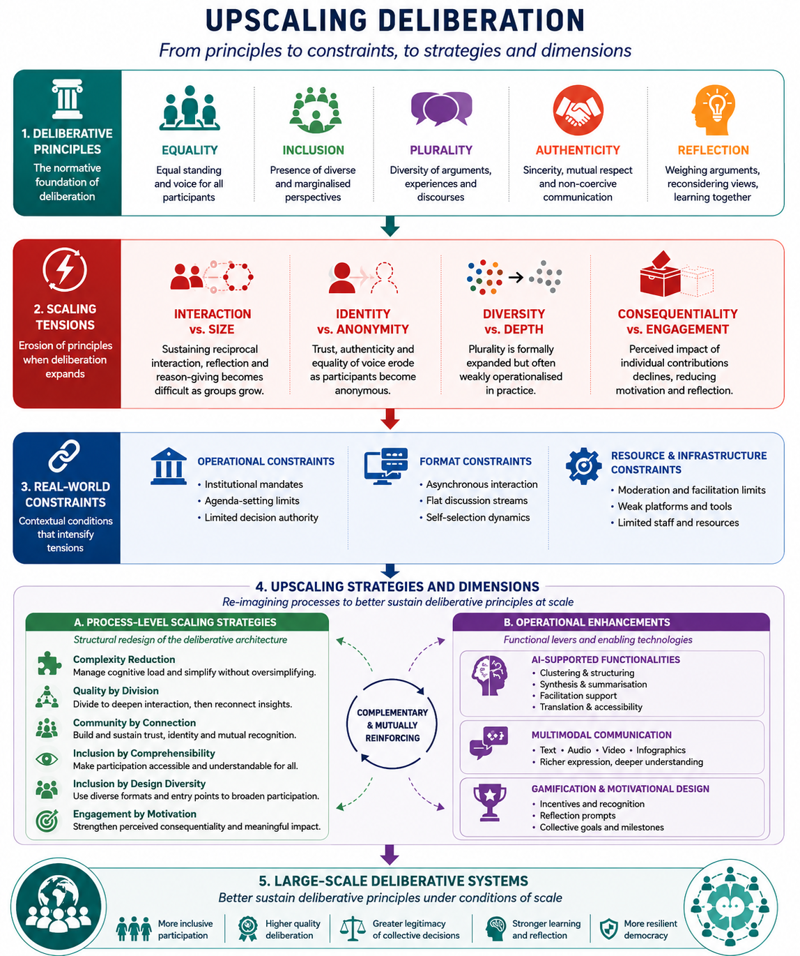

Figure 1: Upscaling deliberation from principles to treatments
Operational Enhancement Mechanisms: Beyond process-level strategies, the second dimension consists of transversal mechanisms that support deliberative quality across stages and modules. These mechanisms, AI-supported functionalities, gamification, and multimodal communication, do not define the deliberative architecture but enhance its implementation under real-world constraints. Here are mapped into three different propositions, namely the AI-supported functionality, multimodal communication, and gamification:
- AI-supported functionalities serve as enabling infrastructure throughout the deliberative process. They support coordination, accessibility, and sense-making at scale by performing tasks such as plain-language rewriting and multilingual translation during pre-deliberation, participation-balance monitoring and argument clustering during deliberation, and traceable synthesis with source-linked provenance in post-deliberation. AI tools can also power adaptive learning paths, detect under-represented groups in recruitment, and generate reflective prompts that compare participants' evolving positions with group-level reasoning. Crucially, these functionalities are designed as epistemic supporter and not authorities [40]: in principle, every AI-generated output should be subject to human review, and the role of AI must remain transparent and contestable throughout the process.
- Multimodal communication enhances inclusion and comprehensibility by offering information and participation pathways through multiple formats (as text, audio, video, infographics, or interactive elements) so that participants can engage in ways aligned with their cognitive preferences, literacy levels, and accessibility needs [17]. Multimodality reduces cognitive overload and lowers barriers linked to education, language, or digital fluency by combining formats such as videos, visuals, and text summaries. In this way, it operationalises inclusion by comprehensibility while supporting plural participation at scale.
- Gamification sustains motivation, engagement, and learning by introducing elements of play, such as rewards, progress indicators, cooperative challenges, and reflective prompts, into the deliberative process [38]. Rather than trivialising political participation, well-designed gamification makes reflection and cooperation intrinsically motivating. This includes motivational gamification (digital badges, progress bars, collective milestones) to sustain participation across stages, cooperative gamification (group achievements, shared goals) to build collective identity, learning gamification (quizzes, role-plays, simulations) to make complex topics accessible, and reflective gamification (perspective-taking prompts, justification checkpoints) to deepen reasoning. Gamification goals need to be tailored to the normative priorities of deliberation, and should avoid privileging activity over quality or competition over authentic deliberative exchange.

3. The DPDT: Architecture and Design

3.1. Theoretical Foundations
The DPDT is built on a generative logic that connects deliberative problems to design solutions through a structured decision procedure. Its theoretical backbone consists of three interlocking elements: 1) a process scaffold that defines where and how an intervention should be placed within the process design, 2) a constraining taxonomy that maps into the upscaling challenges and specifies what problems must be addressed, and 3) two solution dimensions that determine how those problems are resolved. Together, these elements produce a decision-tree architecture in which each node corresponds to a design choice anchored in deliberative theory (figure 2). Rather than a deterministic optimisation model, the DPDT functions as a decision-support architecture that systematically links contextual conditions, deliberative vulnerabilities, and appropriate design responses.
The theoretical backbone of the DPDT comprises three interconnected layers:
- The process scaffold provides the structural substrate into which all design interventions are embedded. It consists of a process design discussed above (i.e., four-stage deliberative pipeline and nine modules procedural functions). The scaffold is not itself a design prescription, but a map of the functional positions at which scaling tensions and operational constraints are most likely to manifest, and at which design responses can therefore be most effectively targeted.
- The constraining taxonomy defines the problem space from the challenges framework discussed above. As such, it integrates four normative structural tensions and real-world constraints, grouped into three dimensions: operational constraints (consultative-only mandates, top-down framing, single-cycle time-bounded processes), format constraints (asynchronous-only interaction, flat discussion structures, open self-selected participation), and resource constraints (absence of grouping functionalities, limited facilitation capacity, and weak feedback and uptake mechanisms) [3,4,39]. Crucially, tensions and constraints are not independent: each constraint maps onto specific tensions it is likely to intensify, and both map onto the process stages and modules where they exert the greatest pressure. This cross-mapping is what gives the taxonomy its diagnostic function, it allows designers to identify, for a given institutional context, which deliberative functions are most at risk and why.
- Two solution dimensions define the response space. The first consists of six process-level scaling strategies discussed above, each designed to address one or more structural tensions by restructuring the deliberative architecture itself. These strategies operate at the level of process design: they determine how interaction is organised, how participation is distributed, and how information flows across stages. The second dimension consists of operational enhancement mechanisms considering a gamification catalogue of 22 mechanisms across motivational, cooperative, learning, and reflective types, and a multimodality catalogue of 32 tools, which function as transversal treatments that can be applied across stages and modules to reinforce deliberative quality under constraint [32,38].Where strategies reshape the architecture, operational mechanisms support its implementation by strengthening motivation, accessibility, comprehension, and coordination.

3.2. Decision tree
The DPDT’s generative logic emerges from the interaction between contextual conditions, deliberative vulnerabilities, and design responses (Figure 2).

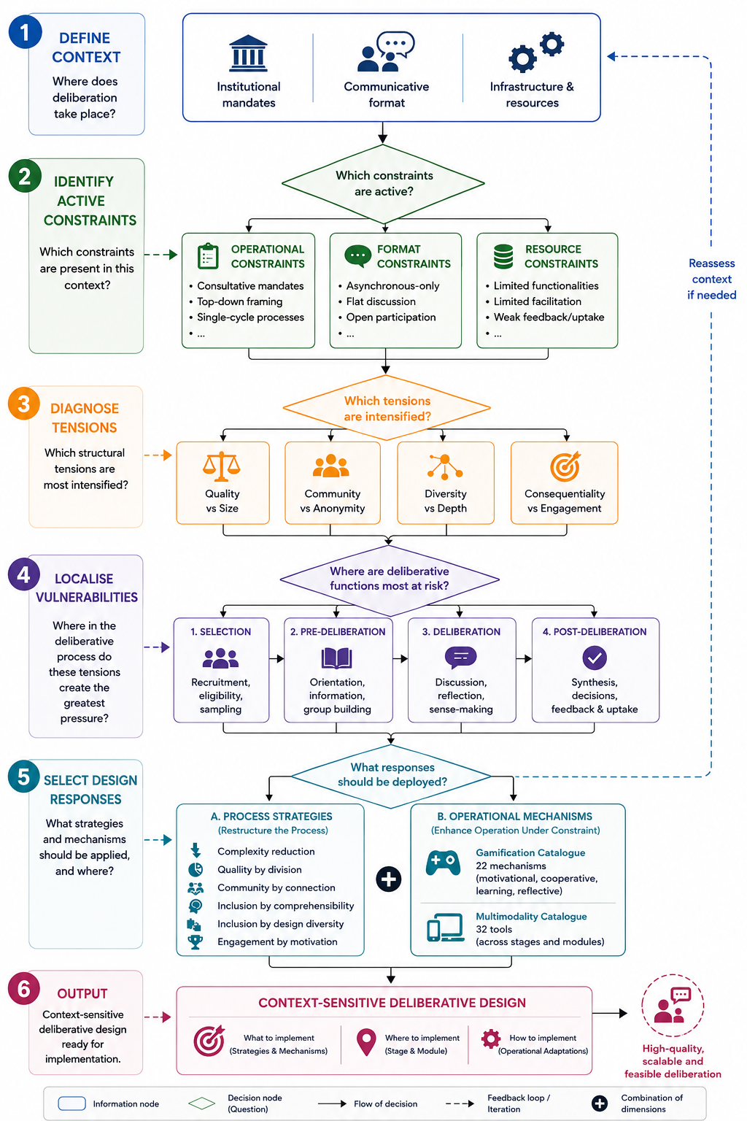
Figure 2: DPDT decision tree
The framework operates as a structured decision-tree architecture.
First, the deliberative context, defined by institutional mandates, communicative formats, and available infrastructures, establishes the conditions under which deliberation unfolds. Second, the real-world constraining taxonomy diagnoses which real-world constraints become most acute within that context. Third, the structural tensions challenges are diagnosed and related to the existing (if any) process. Fourth, the process scaffold localises these vulnerabilities within existing stages and modules of the deliberative process, Selection, Pre-deliberation, Deliberation, and Post-deliberation, identifying where deliberative functions are most exposed to pressure. Fifth, the framework selects appropriate design responses through two complementary intervention dimensions: process-level scaling strategies that restructure the deliberative architecture itself, and operational enhancement mechanisms, including AI-supported functionalities, gamification, and multimodality, that reinforce deliberative processes under constrained conditions.
Finally, these elements are combined into context-sensitive deliberative designs specifying what should be implemented, where within the process it should be deployed, and how it should be operationally adapted.

3.3. Design Templates
So far, the tool encodes 40 design templates, each specifying: applicable scaling strategies, base principle scores (0–10 on each of the five principles), AI tool features, gamification bundles, multimodality features, and hard-constraint prerequisites. The following five templates illustrate some of the main deliberative architectures currently implemented in the system:
- Variant 1 – Asynchronous Structured Deliberation: A large-scale online deliberation process where participants contribute asynchronously through structured discussion spaces rather than live meetings. AI tools support argument clustering, thematic summarisation, discourse visualisation, and synthesis tracking to maintain coherence and traceability across large volumes of contributions.
- Variant 2 – Distributed Small-Group Deliberation: A deliberative process organised into multiple smaller discussion groups to preserve interaction quality and reflective exchange at scale. AI supports participant grouping, moderation assistance, cross-group synthesis, and comparison of emerging viewpoints between groups.
- Variant 3 – Layered Meta-Deliberation: A multi-stage deliberative architecture in which later groups deliberate on the outputs generated by earlier deliberation rounds. Initial participants generate arguments, proposals, or priorities, while subsequent panels review, compare, validate, and synthesise these outputs. AI supports clustering, summarisation, traceability, and identification of disagreements across deliberative layers.
- Variant 4 – Multimodal Inclusive Deliberation: An accessibility-oriented deliberative process designed to maximise inclusion across different linguistic, educational, and cognitive backgrounds. The process integrates multimodal communication tools such as translation systems, text-to-speech, speech-to-text, videos, visual summaries, infographics, and simplified content explanations.
- Variant 5 – Gamified Engagement: A deliberative process integrating learning and motivational mechanisms to sustain engagement over time. Participants progress through structured learning journeys supported by quizzes, badges, milestones, progress indicators, and adaptive prompts. AI personalises learning materials and monitors engagement patterns.
Thirty-five additional templates address specific constraint configurations. These for example include: traceable consultation for consultative mandates (Variant 7), reframing support under top-down agenda-setting (Variant 8), flat-stream structuring for platforms without threading (Variant 9), equality-first voice-balance correction for open self-selected contexts (Variant 10), staged reflection checkpoints for time-bounded cycles (Variant 11), procedural scaffolding for limited facilitation (Variant 12), micro-deliberation pods (Variant 19), multi-round rotating delegates (Variant 20), multilingual inclusive modes (Variant 22), and polarisation counter-frame modes (Variant 25), among others. Beyond the fixed catalogue, the system also includes a generative variant engine capable of recombining compatible process features, AI interventions, gamification mechanisms, and multimodal components to produce new but fully auditable deliberative configurations adapted to emerging constraint environments

3.4. Deliberation Translation Matrices
A central component of the DPDT is a set of interconnected deliberation translation matrices (Figures 3–5) that map deliberative functions, constraints, and compensatory design mechanisms across stages and modules of the deliberative process. Rather than functioning as simple technology catalogues, these matrices operate as diagnostic translation frameworks showing how deliberative functions can be protected, relocated, or reinforced when ideal deliberative conditions are unavailable. Each entry specifies: the stage and module where the tool, the process or the media operates and the deliberative function under pressure.
- AI-feature matrix (figure 3): maps more than 70 AI-supported functionalities to deliberative stages, process modules, constraints, and translation mechanisms. Each entry specifies where a tool operates, which deliberative function is under pressure, and how AI-supported mechanisms may compensate for specific constraints.
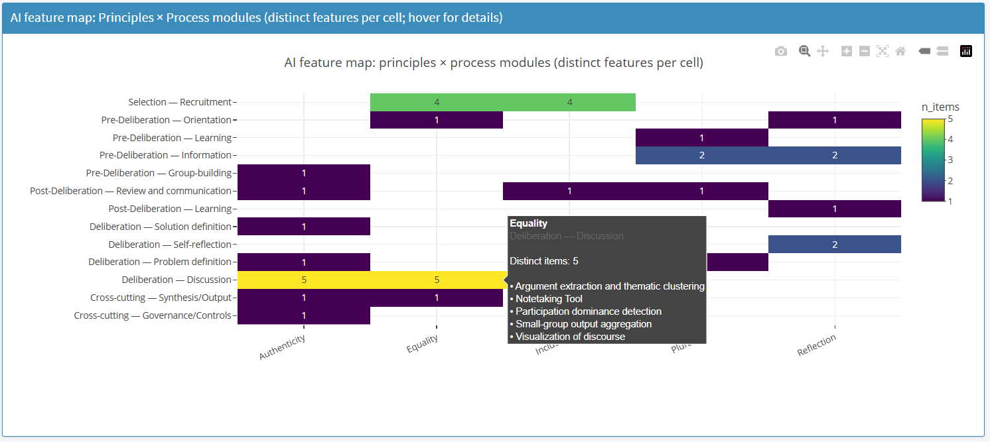
Figure 3: AI-feature matrix example
- Gamification matrix (Figure 4): maps gamification mechanisms onto deliberative principles and process modules, showing how motivational, cooperative, learning, and reflective features can support equality, inclusion, plurality, engagement, and participation continuity across different stages of the process.
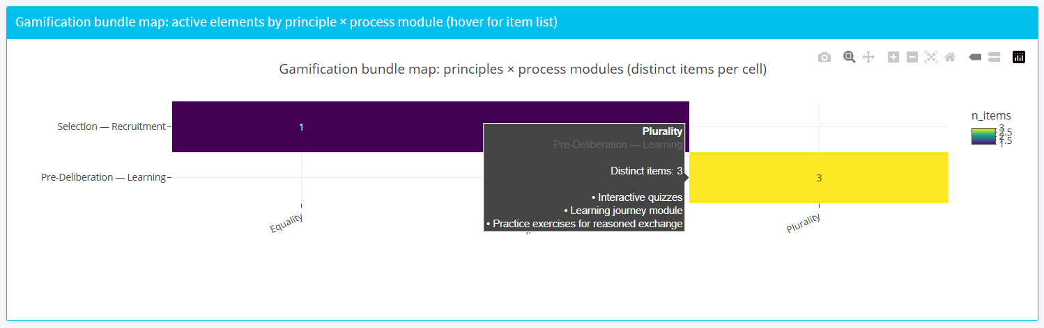
Figure 4: Gamification translation matrix example
Multimodality matrix (Figure 5): It maps multimodal participation and communication features onto deliberative principles and process modules, highlighting how accessibility, translation, visualisation, audio interaction, and alternative communication formats can strengthen inclusion, comprehension, plurality, and reflective learning.
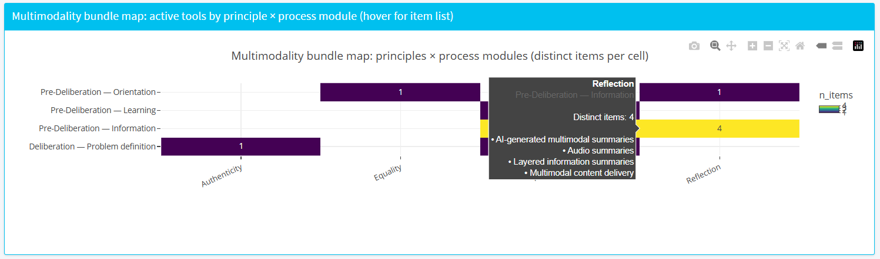
Figure 3: Multimodality translation matrix example
When the DPDT selects a design template, these matrices are dynamically populated according to the active constraints and selected scaling strategies, producing tailored stage-specific combinations of AI-supported functionalities, gamification bundles, and multimodal features for each recommended deliberative architecture.

4. Audience, Deployment, and Practical Use

The DPDT is designed for practitioners involved in the design of large-scale deliberative processes. Rather than evaluating deliberation retrospectively, the tool supports the ex-ante design of deliberative processes by helping practitioners navigate the trade-offs generated by scale, institutional constraints, and technological choices.

The platform is publicly available as a browser-based Shiny web application and requires no installation. Users interact with the system through a sequence of tabs that progressively move from diagnosis to design recommendation and implementation support. Practitioners begin by specifying the main characteristics and constraints of their process, including participation format, interaction structure, decision authority, duration, and available resources. They can then define the relative importance of different deliberative principles and target objectives such as scale, diversity, or engagement. Based on these inputs, the system generates ranked design recommendations together with visual and operational outputs, including principle radar plots, stage-based timelines, AI feature matrices, multimodality and gamification bundles, decision traces, and socio-technical risk assessments. Exportable reports can also be generated for institutional documentation and planning purposes.

Importantly, the tool does not automate deliberative design or replace political judgement. Its recommendations function as structured starting points rather than optimal solutions. The purpose of the DPDT is to make the design space more transparent, auditable, and adaptable by helping practitioners understand which deliberative tensions are likely to emerge under specific constraints, what compensatory mechanisms are available, and which trade-offs are being made.

5. Limitations and Future Work

The platform should be understood as proof-of-concept rather than a fully validated decision-support system. While elements of the framework have been refined through pilot activities within the AI4Deliberation project [33], the current deliberative design templates and Translation Matrices remain primarily theory-driven and expert-derived. Their outputs reflect normative assumptions and analytical judgments grounded in deliberative democracy research and socio-technical design theory, but they have not yet been systematically calibrated against large-scale comparative evidence from deployed deliberative processes, nor validated through extensive practitioner-based evaluation across diverse institutional contexts.

The platform should therefore be interpreted primarily as a structured design, comparison, and diagnostic aid that helps practitioners navigate trade-offs, constraints, and procedural alternatives in the design of large-scale deliberative processes. It is intended to support deliberative planning, transparency, and institutional reflection rather than to function as a predictive system or a fully validated optimisation engine capable of determining objectively optimal deliberative configurations.

6. Conclusion

Scaling deliberation requires practitioners to make difficult trade-offs between deliberative principles such as inclusion, equality, authenticity, reflection. While digital and AI-supported tools can help address some of these tensions, deliberative quality ultimately depends on how technologies, process architectures, and institutional constraints are combined through coherent design choices.

The Deliberative Process Design Tool (DPDT) contributes to this challenge by translating deliberative theory into an operational and transparent decision-support framework. By linking constraints, tensions, scaling strategies, AI-supported functionalities, multimodality, gamification, and socio-technical risks within a single computational pipeline, the platform helps practitioners navigate complex deliberative design spaces in a more systematic and auditable way.

More broadly, the DPDT illustrates how deliberative democracy can move from abstract normative principles toward adaptive and context-sensitive design infrastructures capable of supporting large-scale democratic participation under real-world conditions.

Acknowledgements
This work is funded by the European Union under Horizon Europe grant agreement No. 101178806 (AI4Deliberation).

References
1. Arlene Archer. 2014. Multimodal designs for learning in contexts of diversity. Designs for Learning 7, 2: 8. https://doi.org/10.2478/dfl-2014-0061
2. Andre Bächtiger, John S. Dryzek, Jane Mansbridge, and Mark D. Warren (eds.). 2018. The Oxford Handbook of Deliberative Democracy. Oxford University Press. https://doi.org/10.1093/oxfordhb/9780198747369.001.0001
3. Laura W Black. 2011. The promise and problems of online deliberation. Retrieved from https://localgovernment.extension.wisc.edu/files/2016/04/Black-Online-Delib-KFWP-2011-2.pdf
4. Stephen Coleman and Giles Moss. 2012. Under Construction: The Field of Online Deliberation Research. Journal of Information Technology & Politics 9, 1: 1–15. https://doi.org/10.1080/19331681.2011.635957
5. Nicole Curato, John S. Dryzek, Selen A. Ercan, Carolyn M. Hendriks, and Simon Niemeyer. 2017. Twelve Key Findings in Deliberative Democracy Research. Daedalus 146, 3: 28–38. Retrieved January 11, 2025 from https://www.jstor.org/stable/48563094
6. Anthony Downs. 1957. An Economic Theory of Political Action in a Democracy. Journal of Political Economy 65, 2: 135–150. Retrieved from https://www.jstor.org/stable/1827369
7. John Dryzek. 2007. Theory, evidence, and the tasks of deliberation. In Deliberation, participation and democracy: Can the people govern? Palgrave Macmillian.
8. John S. Dryzek. 2002. Deliberative Democracy and Beyond: Liberals, Critics, Contestations. Oxford University PressOxford. https://doi.org/10.1093/019925043X.001.0001
9. John S. Dryzek. 2009. Democratization as Deliberative Capacity Building. Comparative Political Studies 42, 11: 1379–1402. https://doi.org/10.1177/0010414009332129
10. John S. Dryzek and Simon Niemeyer. 2006. Reconciling Pluralism and Consensus as Political Ideals. American Journal of Political Science 50, 3: 634–649. https://doi.org/10.1111/j.1540-5907.2006.00206.x
11. David Estlund and Hélène Landemore. 2018. The Epistemic Value of Democratic Deliberation. In The Oxford Handbook of Deliberative Democracy (1st ed.), Andre Bächtiger, John S. Dryzek, Jane Mansbridge and Mark D. Warren (eds.). Oxford University Press, 113–131. https://doi.org/10.1093/oxfordhb/9780198747369.013.26
12. James Fishkin. 2009. When the People Speak: Deliberative Democracy and Public Consultation. Oxford University Press.
13. James S. Fishkin. 2018. Democracy When the People Are Thinking. Oxford University Press. https://doi.org/10.1093/oso/9780198820291.001.0001
14. Maurice Flechtner and Francesco Veri. 2026. Upscaling Deliberation Under Constraint: From Normative Principles to Socio-Technical Design.
15. Archon Fung. 2005. Deliberation before the Revolution: Toward an Ethics of Deliberative Democracy in an Unjust World. Political Theory 33, 3: 397–419. https://doi.org/10.1177/0090591704271990
16. J. E. Gonçalves, I. Ioannou, and T. Verma. 2024. No one-size-fits-all: Multi-actor perspectives on public participation and digital participatory platforms. Philosophical Transactions of the Royal Society A: Mathematical, Physical and Engineering Sciences 382, 2285: 20240111. https://doi.org/10.1098/rsta.2024.0111
17. J. E. Gonçalves, I. Ioannou, and T. Verma. 2024. No one-size-fits-all: Multi-actor perspectives on public participation and digital participatory platforms. Philosophical Transactions of the Royal Society A: Mathematical, Physical and Engineering Sciences 382, 2285: 20240111. https://doi.org/10.1098/rsta.2024.0111
18. Todd Graham and Scott Wright. 2014. Analysing ‘Super-Participation’ in Online Third Spaces. In Analyzing Social Media Data and Web Networks, Marta Cantijoch, Rachel Gibson and Stephen Ward (eds.). Palgrave Macmillan UK, London, 197–215. https://doi.org/10.1057/9781137276773_8
19. Kimmo Grönlund, Kaisa Herne, and Maija Setälä. 2015. Does Enclave Deliberation Polarize Opinions? Political Behavior 37, 4: 995–1020. https://doi.org/10.1007/s11109-015-9304-x
20. Kimmo Grönlund, Maija Setälä, and Kaisa Herne. 2010. Deliberation and civic virtue: lessons from a citizen deliberation experiment. European Political Science Review 2, 1: 95–117. https://doi.org/10.1017/S1755773909990245
21. Jürgen Habermas. 1996. Between Facts and Norms: Contributions to a Discourse Theory of Law and Democracy. The MIT Press. https://doi.org/10.7551/mitpress/1564.001.0001
22. Michael Townsen Hicks, James Humphries, and Joe Slater. 2024. ChatGPT is bullshit. Ethics and Information Technology 26, 2. https://doi.org/10.1007/s10676-024-09775-5
23. Markus Holdo. 2020. Meta-deliberation: everyday acts of critical reflection in deliberative systems. Politics 40, 1: 106–119. https://doi.org/10.1177/0263395719837914
24. Mark Klein. 2012. Enabling Large-Scale Deliberation Using Attention-Mediation Metrics. Computer Supported Cooperative Work (CSCW) 21, 4–5: 449–473. https://doi.org/10.1007/s10606-012-9156-4
25. Robert E. Kraut, Paul Resnick, Sara Kiesler, Moira Burke, Yan Chen, Niki Kittur, Joseph Konstan, Yuqing Ren, and John Riedl. 2012. Building Successful Online Communities: Evidence-Based Social Design. The MIT Press. https://doi.org/10.7551/mitpress/8472.001.0001
26. Jonathan W. Kuyper. 2018. The Instrumental Value of Deliberative Democracy – Or, do we have Good Reasons to be Deliberative Democrats? Journal of Deliberative Democracy 14, 1. https://doi.org/10.16997/jdd.291
27. Marina Lindell. 2023. 19 Internal dynamics at work. In De Gruyter Handbook of Citizens’ Assemblies, Min Reuchamps, Julien Vrydagh and Yanina Welp (eds.). De Gruyter, 257–270. https://doi.org/10.1515/9783110758269-021
28. Carolyn Lukensmeyer and Steve Bregham. 2002. Taking democracy to scale: Creating a town hall meeting for the twenty-first century. National Civic Review 91, 4: 351–366. Retrieved from https://heinonline.org/HOL/LandingPage?handle=hein.journals/natmnr91&div=36&id=&page=
29. Simon Niemeyer, Francesco Veri, John S. Dryzek, and André Bächtiger. 2024. How Deliberation Happens: Enabling Deliberative Reason. American Political Science Review 118, 1: 345–362. https://doi.org/10.1017/S0003055423000023
30. Anthony T. Pescosolido. 2003. Group Efficacy And Group Effectiveness: The Effects of Group Efficacy Over Time on Group Performance and Development. Small Group Research 34, 1: 20–42. https://doi.org/10.1177/1046496402239576
31. Michael Sailer and Lisa Homner. 2020. The Gamification of Learning: a Meta-analysis. Educational Psychology Review 32, 1: 77–112. https://doi.org/10.1007/s10648-019-09498-w
32. Michael Sailer and Lisa Homner. 2020. The Gamification of Learning: a Meta-analysis. Educational Psychology Review 32, 1: 77–112. https://doi.org/10.1007/s10648-019-09498-w
33. Efthimios Tambouris. 2025. Artificial Intelligence for Mass Democratic Deliberations: The AI4Deliberation Project Objectives and Methodology. In Intelligent Computing, Kohei Arai (ed.). Springer Nature Switzerland, Cham, 562–574. https://doi.org/10.1007/978-3-031-92602-0_36
34. W. Ben Towne and James D. Herbsleb. 2012. Design Considerations for Online Deliberation Systems. Journal of Information Technology & Politics 9, 1: 97–115. https://doi.org/10.1080/19331681.2011.637711
35. Francesco Veri. 2023. Mapping Democratic Innovations: A Bottom-up Empirical Perspective. Representation 59, 2: 171–188. https://doi.org/10.1080/00344893.2022.2075032
36. Francesco Veri. 2025. Fostering Reasoning in the Politically Disengaged: The Role of Deliberative Minipublics. Political Studies Review 23, 1: 254–275. https://doi.org/10.1177/14789299241239909
37. Francesco Veri and Simon Niemeyer. 2025. Deliberative reason and the effect of minipublic configurations. European Political Science Review 17, 3: 530–540. https://doi.org/10.1017/s1755773925000050
38. Yannick Von Ostheim, Maurice Flechtner, and Francesco Veri. 2026. Gamifying Deliberation: Towards a Process-Sensitive Framework. In 25th IFIP WG 8.5 International Conference, EGOV 2026 Proceedings.
39. Scott Wright and John Street. 2007. Democracy, deliberation and design: the case of online discussion forums. New Media & Society 9, 5: 849–869. https://doi.org/10.1177/1461444807081230
40. Andrea Ferrario, Alessandro Facchini, and Alberto Termine. 2024. Experts or Authorities? The Strange Case of the Presumed Epistemic Superiority of Artificial Intelligence Systems. Minds & Machines 34. https://doi.org/10.1007/s11023-024-09681-1

