COMP 350 Assignment 3

|  |  |
| --- | --- |
| Guillaume Labranche 260585371 | October 13, 2015 |

1. 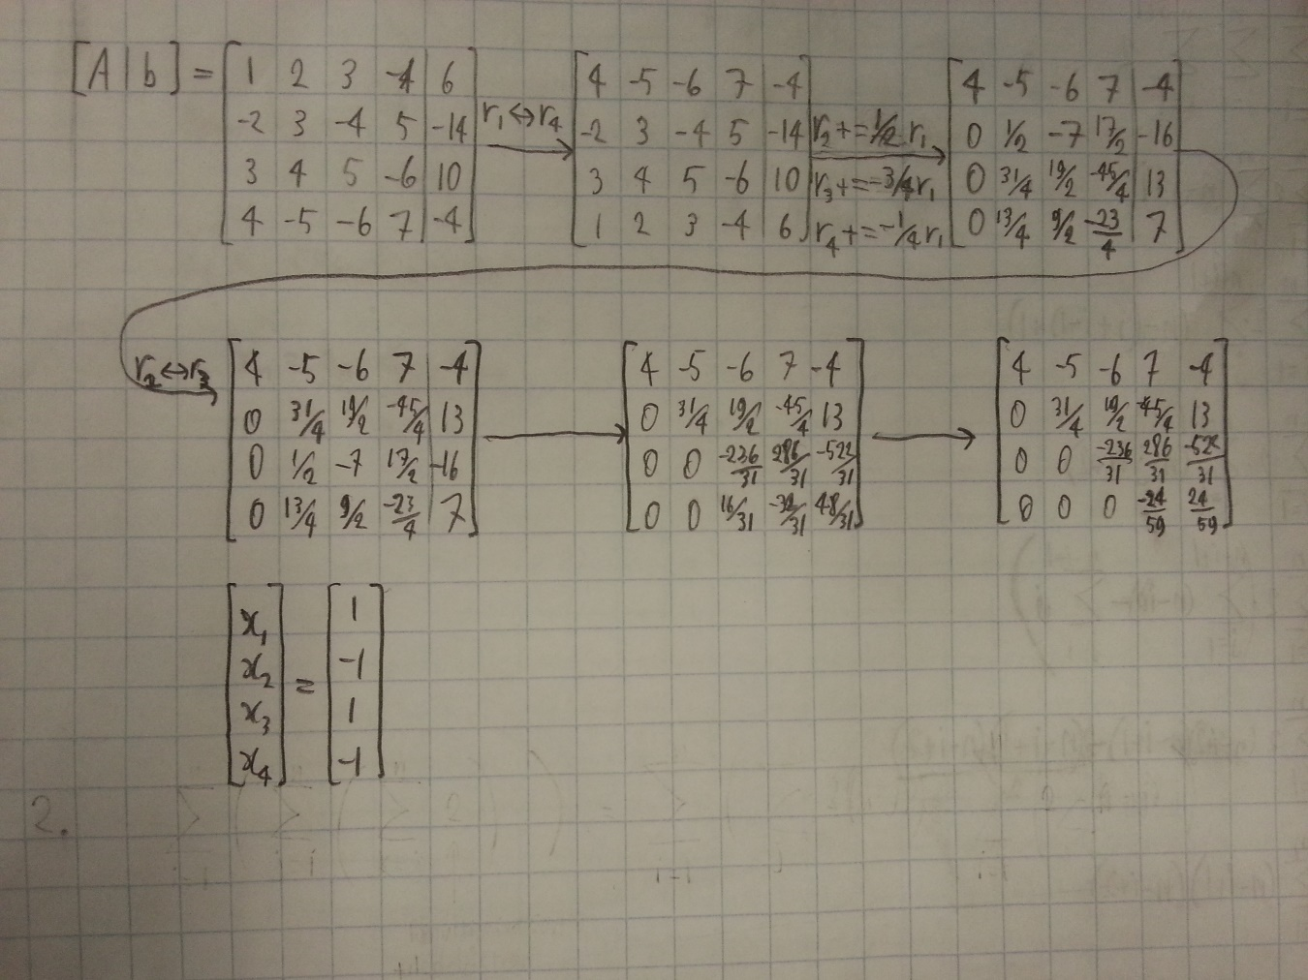
2. The number of flops is  
   .

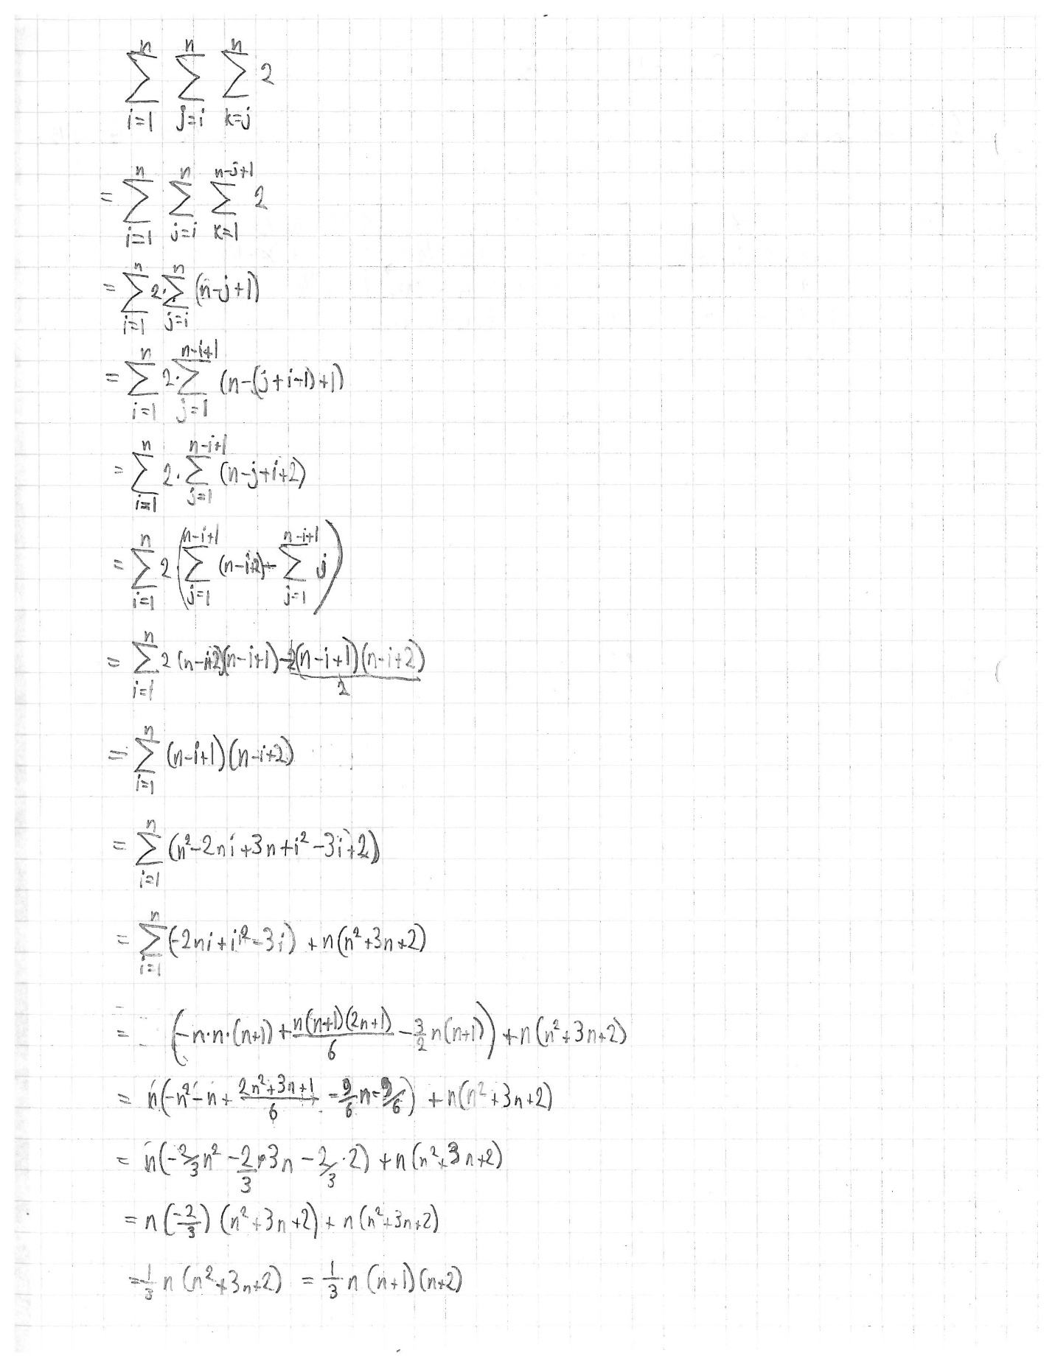

* 1. See q3a_genp.m and q3a_gepp.m for the source code.
     + GENP: $5n+1n+3n=9n$**flops** and $4*(2n+1)$ **memory locations**
     + GEPP: $9n$ **flops** and $4*(2n+1)$ **memory locations**
  2. See q3b.m for the source code.
  3. See q3c.m for the source code.

>> q3b

avg_imp = 3.7894

>> q3b

avg_imp = 2.9249

>> q3b

avg_imp = 4.7632

>> q3c

avg_imp = 6.6232e+11

>> q3c

avg_imp = 6.6881e+11

>> q3c

avg_imp = 6.7002e+11