Installation and Configuration of Nginx, Apache Tomcat, and Docker Using AWS

Task 1: AWS EC2 Instance Setup and Jenkins Installation

Outcome:

Jenkins was successfully installed on an existing Amazon Linux 2023 EC2 instance using Java 21 (Amazon Corretto). The Jenkins service was started, and the web dashboard was accessed successfully through a browser using port 8080.

Objective:

The objective of this practical is to install and configure Jenkins on an AWS EC2 instance and gain hands-on experience with Java 21 installation, SSH key-based authentication, package repository configuration, Linux service management, AWS security group settings, and accessing the Jenkins web dashboard through a browser.
.
Prerequisites:

- An active AWS account with access to the Amazon EC2 service.

- Appropriate IAM permissions to manage EC2 instances, key pairs, and security groups.

- An existing EC2 instance running Amazon Linux 2023.

- Git Bash installed on the local Windows computer to establish an SSH connection to the EC2 instance.

- A valid SSH private key (.pem or the appropriate key file) associated with the EC2 instance.

- A stable internet connection on both the local computer and the EC2 instance.

- A Java 21 (Amazon Corretto) compatible environment for running Jenkins.

- Sufficient EC2 instance memory, CPU resources, and disk space to support Jenkins.

- A security group configured to allow SSH access through port 22 from the authorized IP address.

- An inbound security group rule allowing access to Jenkins through port 8080 from the authorized IP address.

- Required permissions to execute administrative commands using sudo on the EC2 instance.

- A web browser, such as Google Chrome or Microsoft Edge, to access the Jenkins dashboard.

Step-by-Step Implementation:

Step 1: Create an SSH Key Pair in the AWS Console
Objective:
Create an SSH key pair in AWS to securely connect to the Amazon Linux 2023 EC2 instance using Git Bash.

Procedure:
- Sign in to the AWS Management Console.
- Navigate to EC2 → Network & Security → Key Pairs.
- Click Create key pair.
- Enter a key pair name, such as linuxkey.
- Select RSA as the key pair type and .pem as the private key file format.
- Click Create key pair. AWS automatically downloads the private key file to your local computer.
- Store the downloaded linuxkey.pem file in a secure location. When launching the EC2 instance, select this key pair so that you can authenticate through SSH.
Important: AWS provides the private key file for download only when the key pair is created. Keep it secure, never share it, and do not include its contents in screenshots.

Step 2: Import the Public Key into AWS

Objective:

Import the public SSH key into AWS so that it can be associated with an EC2 instance for secure, key-based authentication.
Procedure:
- Sign in to the AWS Management Console and navigate to EC2 → Network & Security → Key Pairs.
- Click Import key pair.
- Enter linuxkey as the key pair name.
- Upload the linuxkey.pub file generated in the previous step, or copy and paste its public-key contents into the designated field.
- Click Import key pair to complete the process.
- Verify that linuxkey appears in the EC2 Key Pairs list.
Expected result: The public key is successfully imported into AWS and is available for use when launching a new EC2 instance.
Important: Keep the private key (linuxkey) secure. Only the public key (linuxkey.pub) should be uploaded to AWS.
Note: If you created the key pair directly through the AWS Console in Step 1, you do not need to import it again. AWS has already registered that key pair, so you can proceed to the next step.
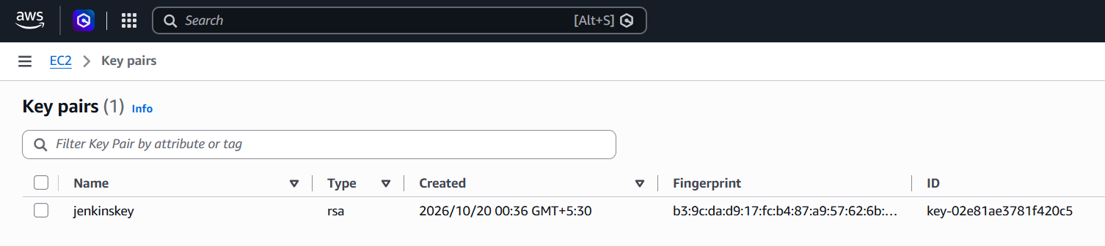

Step 3: Launch or Select an Amazon EC2 Instance
Objective:
Select an Amazon Linux 2023 EC2 instance and configure the appropriate SSH key pair for secure access through Git Bash.
Procedure:
- Sign in to the AWS Management Console and navigate to EC2 → Instances.
- If launching a new instance, choose Launch instance and select Amazon Linux 2023 as the operating system.
- Under Key pair (login), select the AWS key pair named linuxkey that was created in Step 1.
- Configure the instance's security group to allow SSH access on port 22 from your trusted IP address.
- Launch the instance and wait until it is running. If using an existing instance, verify its configuration and public IPv4 address.
Instance Configuration:
Parameter | Value
Cloud provider | Amazon Web Services (AWS)
Service | Amazon EC2
Operating system | Amazon Linux 2023
Default login username | ec2-user
SSH key pair | linuxkey
SSH port | 22
Note: For this practical, Jenkins was installed on an existing Amazon Linux 2023 EC2 instance. If documenting a newly launched instance, include a screenshot showing the selected key pair in the Key pair (login) section during instance configuration.
Expected result: An Amazon Linux 2023 EC2 instance is available, and the correct SSH key pair is configured for secure connection through Git Bash.
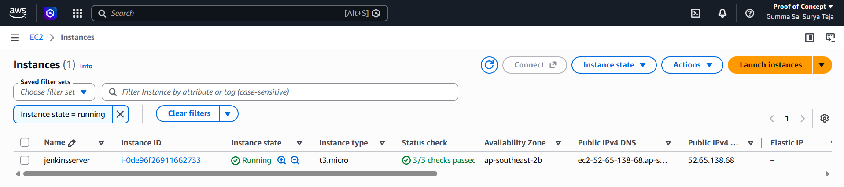

Step 4: Connect to the EC2 Instance Using Git Bash
Objective:
Establish a secure SSH connection to the Amazon Linux 2023 EC2 instance using Git Bash and verify the instance's login user and operating system.
Procedure:
- Open Git Bash on your Windows computer.
- Navigate to the directory containing the downloaded private key file linuxkey.pem.
- Set the appropriate permissions for the private key:
chmod 400 linuxkey.pem
- Connect to the EC2 instance using SSH:
ssh -i "linuxkey.pem" ec2-user@YOUR_EC2_PUBLIC_IP
- Replace YOUR_EC2_PUBLIC_IP with the public IPv4 address of your EC2 instance.
- After connecting successfully, verify the current login user:
Whoami

Expected result: A secure SSH connection is established through Git Bash, and the login user and operating system are verified successfully.

Note: Ensure that the EC2 instance's security group allows SSH traffic on port 22 from your trusted IP address. Use the .pem filename exactly as it appears on your computer.

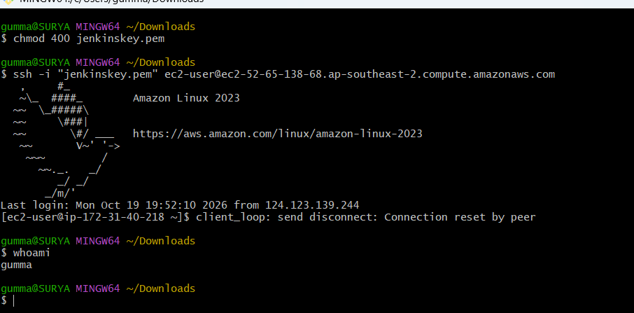

Step 5: Check System Resources

Objective:

Evaluate the EC2 instance's memory and disk capacity to determine whether its resources are sufficient for a basic Jenkins installation.
Procedure:
After connecting to the EC2 instance through Git Bash using SSH, execute the following commands in the remote Linux terminal.
1. Check memory usage
free -h
This command displays the system's total, used, free, and available memory in a human-readable format.
2. Check disk space
df -h
This command displays filesystem capacity, used space, available space, and usage percentage for mounted filesystems. Locate the entry mounted at / to identify the root filesystem.

Observed System Resources
Resource | Observed Value
Total memory | 913 MiB
Available memory | 626 MiB
Root filesystem (/) size | 8 GB
Available space on the root filesystem (/) | 6.4 GB
Root filesystem (/) usage | 20%
Result and Observation:
The EC2 instance had approximately 913 MiB of total memory, with 617 MiB available. The root filesystem (/) had a total capacity of 8 GB, of which 6.4 GB was available and approximately 20% was in use. These resources were sufficient for a basic Jenkins installation exercise; however, the limited memory and disk capacity could affect performance during larger builds or multiple concurrent jobs.
Expected Result: The memory and disk usage information is displayed successfully, including the capacity and utilization of the root filesystem (/), providing a baseline for evaluating the instance before installing Jenkins.
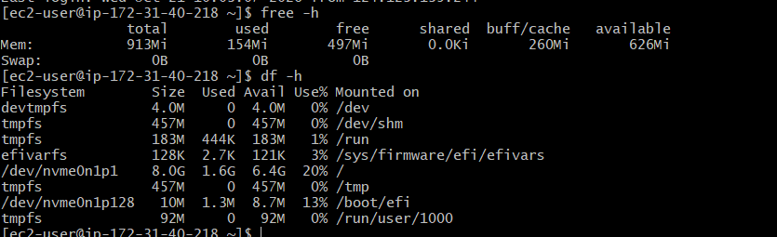

Step 6: Install Java 21 (Amazon Corretto)
Objective: Install Java 21, a compatible Java runtime required to run Jenkins on the Amazon Linux 2023 EC2 instance.
Procedure:
- Ensure that you are connected to the EC2 instance through Git Bash using SSH.
- Execute the following command to install Java 21 (Amazon Corretto) and fontconfig:
sudo dnf install java-21-amazon-corretto fontconfig -y
The dnf package manager downloads and installs the required packages and their dependencies. The -y option automatically confirms the installation prompts.

Verify the Java installation
After the installation completes, run:
java --version
Observed Output:
The command output confirmed that OpenJDK 21, provided by Amazon Corretto, was installed successfully. The reported version was Amazon Corretto 21.0.12.1 LTS.
Result:
Java 21 was installed and verified successfully on the Amazon Linux 2023 EC2 instance, preparing the environment for the Jenkins installation.
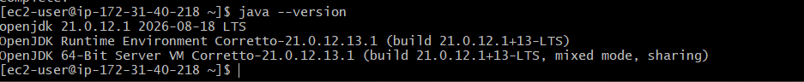

Step 7: Configure the Jenkins Repository
Objective: Configure the official Jenkins stable RPM repository and import its signing key so that Jenkins packages can be downloaded and verified during installation.
Procedure:
Ensure that you are connected to the Amazon Linux 2023 EC2 instance through Git Bash using SSH. Then perform the following steps.
1. Download the Jenkins repository configuration
Execute the following command to download the repository configuration file and save it to the system's repository directory:
sudo wget -O /etc/yum.repos.d/jenkins.repo \
https://pkg.jenkins.io/rpm-stable/jenkins.repo
This command creates or updates jenkins.repo in /etc/yum.repos.d/, allowing the package manager to locate Jenkins stable releases.
2. Import the Jenkins signing key
Run the following command to import the Jenkins package-signing key:
sudo rpm --import https://pkg.jenkins.io/rpm-stable/jenkins.io-2026.key
The signing key allows the package manager to verify the authenticity of signed Jenkins packages before installation.
Result:
The Jenkins stable repository configuration is downloaded, and the signing key is imported. The system is now configured to obtain Jenkins packages from the configured repository.
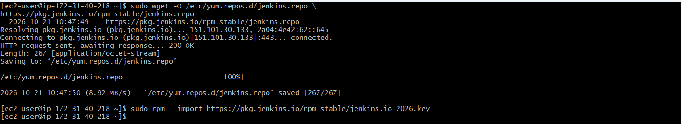

Step 8: Install Jenkins
Objective: Install Jenkins on the Amazon Linux 2023 EC2 instance using the configured Jenkins stable repository.
Procedure:
- Ensure that you are connected to the EC2 instance through Git Bash using SSH.
- Execute the following command to install Jenkins and its required dependencies:
sudo dnf install jenkins -y
The dnf package manager retrieves the Jenkins package from the configured repository and installs it along with any required dependencies. The -y option automatically confirms installation prompts.
Wait for the installation process to complete.
Review the terminal output for any errors or package installation failures.
Result:
Jenkins is installed on the Amazon Linux 2023 EC2 instance. The next step is to start the Jenkins service, enable it to launch automatically at system startup, and verify its status.
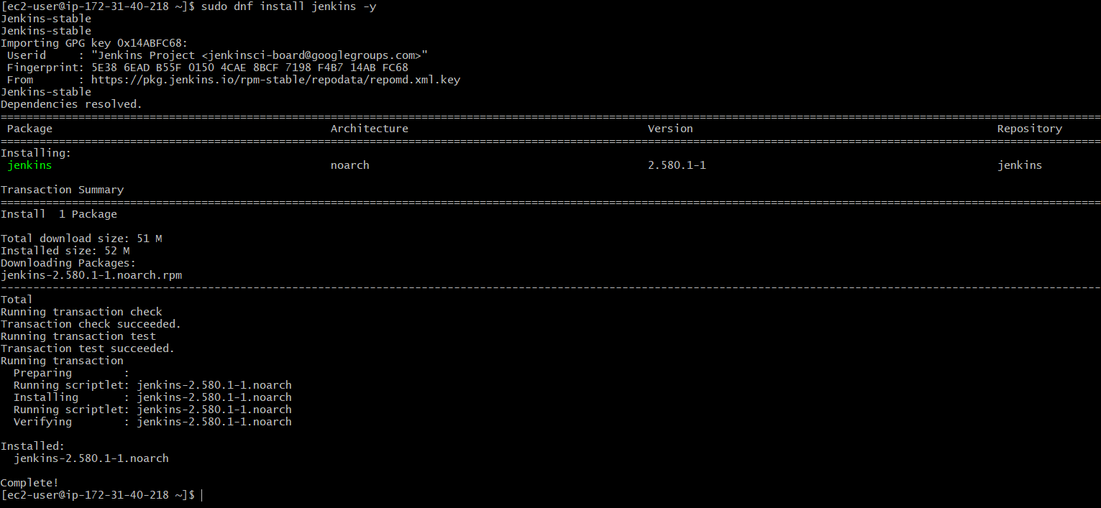

Step 9: Start and Enable the Jenkins Service
Objective: Start the Jenkins service, configure it to launch automatically when the EC2 instance boots, and verify that it is running and listening on port 8080.
Procedure:
1. Reload the systemd configuration
Execute the following command to reload the systemd manager configuration:
sudo systemctl daemon-reload
2. Enable and start Jenkins
Run the following command to enable Jenkins at system startup and start the service immediately:
sudo systemctl enable --now jenkins
3. Verify the Jenkins service status
Check whether Jenkins is running successfully:
sudo systemctl status jenkins --no-pager
A successful service check should display:
Active: active (running)
This indicates that the Jenkins service is running.

4. Verify that Jenkins is listening on port 8080
Execute the following command to check whether a process is listening on port 8080:
sudo ss -lntp | grep 8080
Observed Output:
LISTEN 0 50 *:8080 *:* users:(("java",pid=27101,fd=9))
The output confirms that a Java process is listening on port 8080, which is Jenkins' default web interface port.
Result:
The Jenkins service was enabled to start automatically at boot and started successfully. The service status and listening-port checks confirmed that Jenkins was running and that a Java process was listening on port 8080.
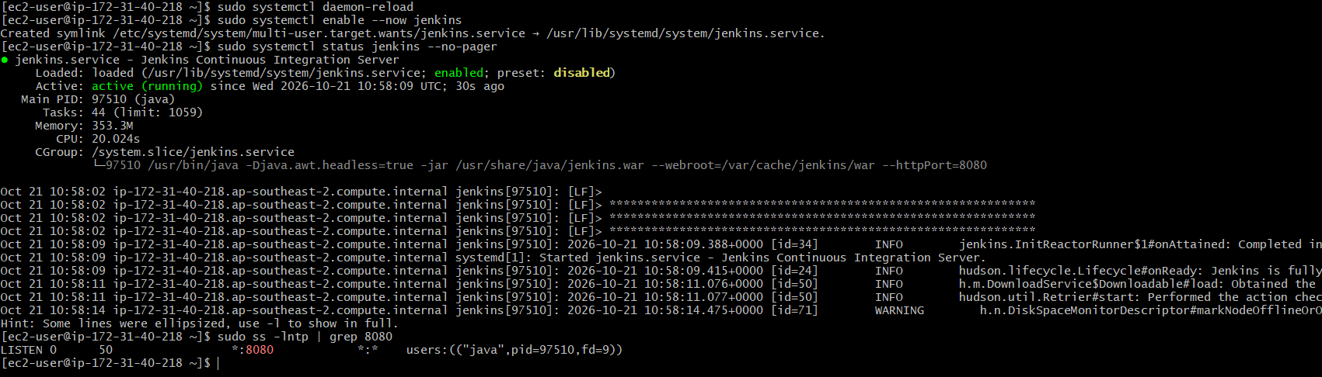

Step 10: Troubleshoot Jenkins Browser Connectivity
Objective: Configure network access to the Jenkins web interface and verify that it can be accessed through the EC2 instance's public IPv4 address using port 8080.
Procedure:
Initially, Jenkins could not be accessed through the browser using the EC2 instance's public IPv4 address and port 8080. The EC2 security group's inbound rules were reviewed and updated to allow Jenkins web traffic.
1. Open the EC2 security group settings
In the AWS Management Console, navigate to:
EC2 → Instances → Select the Jenkins instance → Security → Security groups → Edit inbound rules

2. Add or verify the Jenkins inbound rule
Configure the following rule to allow access to the Jenkins web interface:
Parameter | Value
Type | Custom TCP
Protocol | TCP
Port range | 8080
Source | Your trusted public IP address with /32
Save the changes after verifying the rule.
3. Access Jenkins through a web browser
Open a browser and enter the following URL, replacing the placeholder with the public IPv4 address of your EC2 instance:
http://YOUR_EC2_PUBLIC_IP:8080
After the inbound rule was updated, the browser connection succeeded and the Jenkins web interface became accessible.
Security Note:
During troubleshooting, the task notes indicate that all traffic was temporarily allowed. This configuration is overly permissive and should not be retained. Replace it with narrowly scoped inbound rules:
- Port 8080: Allow TCP traffic only from trusted IP addresses that require access to Jenkins.
- Port 22: Allow SSH access only from your own trusted public IP address wherever possible.
Avoid leaving inbound rules open to all sources (0.0.0.0/0) unless there is a specific, justified requirement.
Result:
The EC2 security group's inbound rules were updated to permit access to Jenkins on port 8080. The Jenkins web interface was then accessed successfully through the instance's public IPv4 address.

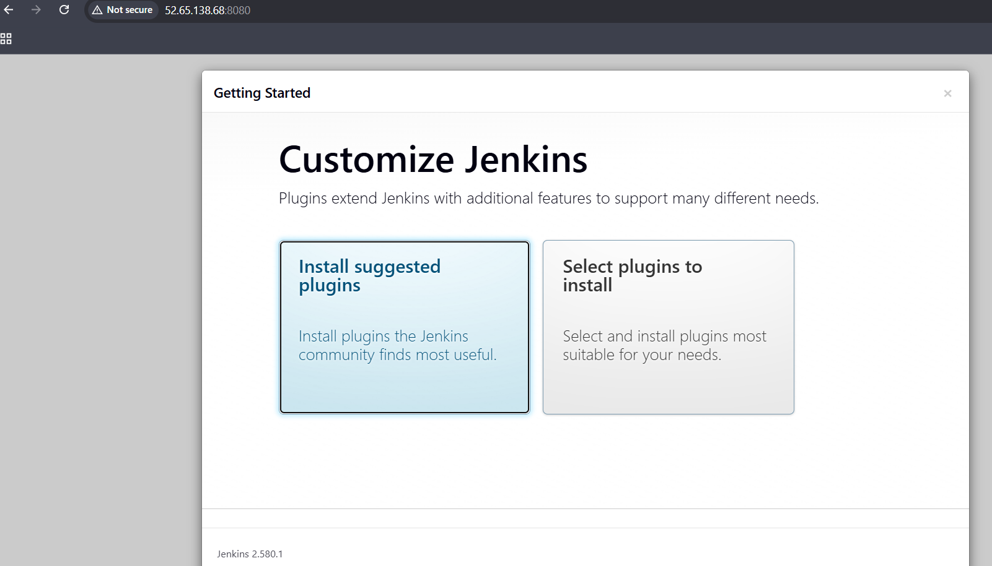

Validation Steps:

Validation Checklist
Validation Item | Command or Check | Expected Result
Operating system | cat /etc/os-release | Amazon Linux 2023 is confirmed.
Java runtime | java --version | Java 21 (Amazon Corretto) is installed.
Jenkins service status | sudo systemctl is-active jenkins | Output displays active.
Jenkins listening port | sudo ss -lntp | grep 8080 | A Java process is listening on port 8080.
Browser accessibility | Open http://YOUR_EC2_PUBLIC_IP:8080 in a browser. | The Jenkins web interface is accessible.
Security group configuration | Review the EC2 security group's inbound rules in the AWS Console. | TCP port 8080 is restricted to trusted source IP addresses, and SSH port 22 is similarly restricted.

Explanation
Jenkins automates software development tasks such as building, testing, and deploying applications through CI/CD pipelines. It runs on Java, while the Jenkins repository enables package installation and systemd manages the service. Port 8080 provides access to the Jenkins web interface. SSH key pairs secure EC2 access, and security group rules control network traffic.
Verification: Check the inbound rules to confirm that port 8080 and SSH port 22 are restricted to trusted IP addresses. Capture a screenshot as evidence,while security group rules control inbound network access.
Real-Time Use Case:
In a software development organization, developers push code to a Git repository, triggering a Jenkins pipeline to check out the code, build the application, run tests, and generate deployment artifacts. The pipeline can then deploy the application to a test environment, reducing manual effort and improving delivery consistency.
Common Errors and Troubleshooting:
Error or Issue | Possible Cause | Recommended Resolution
SSH connection failed | Incorrect username, private key, or security group rule | Verify the username, private key, public IP address and inbound SSH rule on port 22
Java command not found | Java is not installed or missing from path | Install a compatible java runtime and verify using java --version
Jenkins package not found | Missing or incorrect repository configuration | Verify the Jenkins repository file ane refresh package metadata
Jenkins service fails to start | Memory limitations, Java incompatibility, or configuration errors | Check logs using sudo journal -u jenkins -n 50 -- no pager
Browser cannot connect | Security group, routing, public IP or service issue | Check Jenkins status, port listener, public IP, and inbound security group rules
Disk space becomes low | Logs or build atrifacts consume storage | Run df -h and du -sh to check disk usage before removing unnecessary files
Built-In node shows offline | Node configuration or resource related issue | Check the node status and Jenkins logs, the web interface may still be available

Task 2: Deploying Apache Tomcat on an Ubuntu EC2 Instance
Outcome:
Successfully launched an Ubuntu EC2 instance on AWS, installed and configured Java 21 and Apache Tomcat, verified that the Tomcat service was listening on port 8080, and accessed the Tomcat welcome page through a web browser using the instance’s public IPv4 address. This confirmed that Apache Tomcat was running and accessible over the network.
Objective:
The objective of this task was to install and configure Apache Tomcat on an Ubuntu Linux server hosted on AWS EC2 using Git Bash for remote access via SSH. The task involved installing Java 21, configuring the Tomcat application server, managing Linux services, verifying port 8080, configuring AWS security group rules, and validating access to the Tomcat web interface through a browser using the instance’s public IPv4 address.

Prerequisites
- The following requirements must be met before installing and configuring Apache Tomcat:
- An AWS account with the necessary permissions to create and manage EC2 instances.
- An Ubuntu Server EC2 instance launched and running on AWS.
- Git Bash installed on the local Windows system to establish a remote SSH connection to the EC2 instance.
- An SSH key pair (.pem file) for secure authentication.
- An active internet connection to download and install the required packages.
- An EC2 security group with inbound SSH access (TCP port 22) restricted to a trusted IP address.
- An inbound security group rule allowing TCP port 8080 from a trusted IP address to access the Apache Tomcat web interface.

Step-by-Step Implementation

Step 1: Launch an Ubuntu EC2 Instance
Procedure:
Signed in to the AWS Management Console using valid credentials.
Navigated to EC2 → Instances → Launch instances.
Configured the EC2 instance with the following settings:
Parameter | Configuration
Instance Name | tomcat-ubuntu-lab
Operating System | Ubuntu Server
Ubuntu Version | Ubuntu 26.04, as identified in the installed system
Instance Type | As selected during instance creation
Key Pair | jenkinskey
Storage | As configured during launch
Network | AWS VPC and associated subnet
SSH Access | TCP port 22, restricted to a trusted source IP address
Reviewed the instance configuration and launched the EC2 instance.
Waited until the instance state changed to Running.
Verified that the EC2 instance passed the required AWS status checks.
Recorded the instance’s public IPv4 address for establishing an SSH connection through Git Bash.
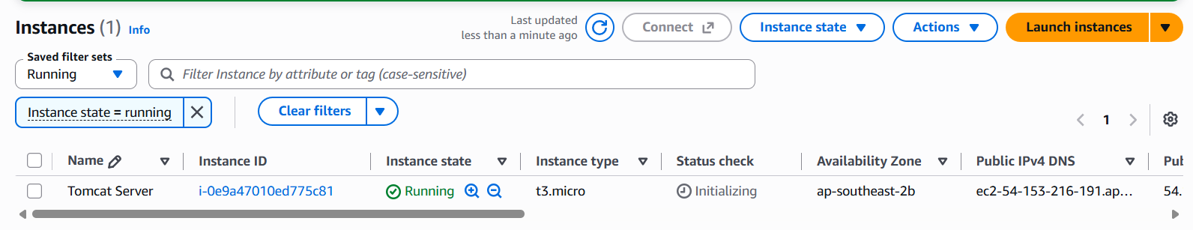

Step 2: Connect to the EC2 Instance Using Git Bash
Procedure:
- Opened Git Bash on the local Windows system.
- Navigated to the directory containing jenkinskey.pem.
- Connected to the Amazon Linux 2023 EC2 instance using SSH:
ssh -i "jenkinskey.pem" ec2-user@your_ip
- Accepted the host authenticity prompt if displayed and verified the connection.
- After successful authentication, the terminal should display a prompt similar to:
[ec2-user@ip-172-31-42-164 ~]$
This confirms that the remote Amazon Linux server is ready for configuration.
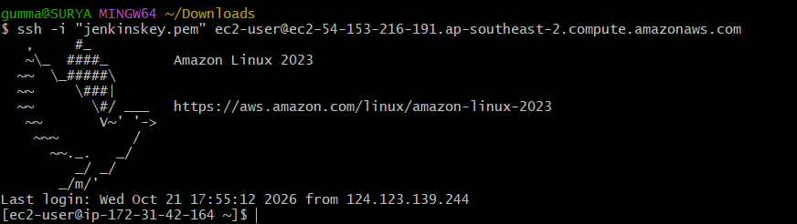

Step 3: Update Package Information
Procedure:
Executed the following command in the remote Amazon Linux terminal:
sudo dnf update -y
The command checked for available package updates and installed them.
Purpose: Updating the system ensures that available software packages and security updates are applied before installing Java and Apache Tomcat.
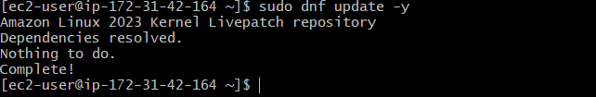

Step 4: Install Java 21
Apache Tomcat is a Java-based application server and requires a compatible Java runtime environment to operate. Java 21 was installed on the Amazon Linux 2023 EC2 instance using the DNF package manager.
Procedure:
Executed the following command in the remote EC2 terminal:
sudo dnf install java-21-amazon-corretto -y

Waited for the package manager to download and complete the Java installation.
Verified the installed Java version using:
java --version
Explanation:
sudo executes the command with administrative privileges.
dnf install installs software packages from the configured repositories.
java-21-amazon-corretto installs Amazon Corretto 21, a Java Development Kit distribution.
-y automatically confirms installation prompts.
Verification:
The java -version command displays the installed Java version and runtime details. An output identifying Java 21 confirms that the required Java version is available.

Step 5: Install Apache Tomcat 10
Apache Tomcat is an open-source Java-based application server used to deploy and run Java web applications. Before installation, the availability of the Tomcat 10 package was checked in the configured Amazon Linux repositories.
Procedure:
Checked whether the Tomcat 10 package was available:
sudo dnf info tomcat

If the package was available, installed it using:

sudo dnf install tomcat -y
Waited for the package manager to complete the installation and install the required dependencies.
Explanation:
sudo executes the command with administrative privileges.
dnf install installs packages from configured repositories.
tomcat specifies the Apache Tomcat package.
-y automatically confirms installation prompts.

Verification:
After installation, checked the package and service availability before proceeding with service configuration.
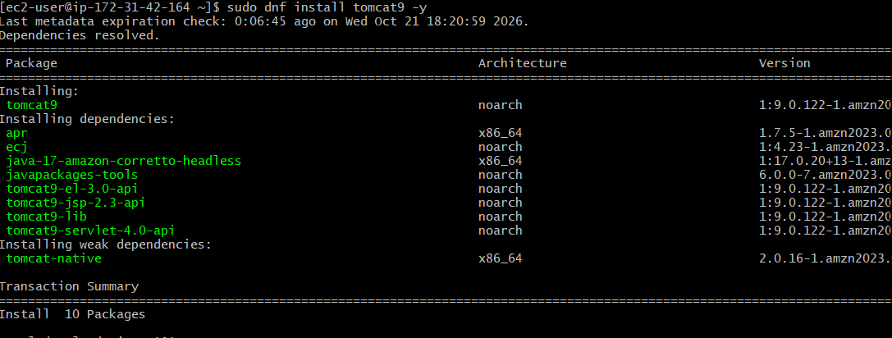

Step 6: Start and Enable the Apache Tomcat Service
After installing Apache Tomcat, the service was configured to start immediately and launch automatically whenever the EC2 instance boots.
Procedure:
Enabled and started the Tomcat service using the following command:
sudo systemctl enable --now tomcat
Checked the service status to verify that Tomcat was running:
sudo systemctl status tomcat
Confirmed that the service status displayed:
Active: active (running)
Explanation:
systemctl manages system services on Linux.
enable configures the service to start automatically during system boot.
--now starts the service immediately.
status displays the current state of the service.
Result: A service status of active (running) confirms that the Tomcat service is running successfully.
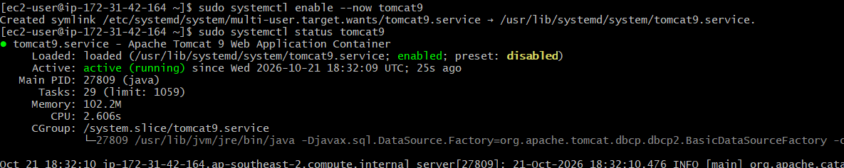

Step 7: Verify That Apache Tomcat Is Listening on Port 8080
After starting the Tomcat service, the network port was checked to verify that the Java process was listening on TCP port 8080.
Procedure:
Executed the following command in the EC2 terminal:
sudo ss -lntp | grep 8080
Observed the following output:
LISTEN 0 100 *:8080 *:* users:(("java",pid=31232,fd=40))
Explanation:
ss displays network socket information.
-l shows listening sockets.
-n displays numeric addresses and port numbers.
-t filters for TCP sockets.
-p displays process information.
grep 8080 filters the output to show entries containing port 8080.
Result: The output confirmed that a Java process was listening on TCP port 8080, the configured port for the Tomcat server in this setup. This verified that the application server was listening for incoming connections.
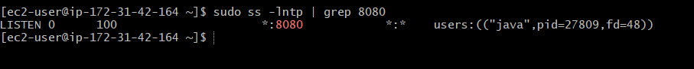

Step 8: Test Apache Tomcat Locally
After verifying that Tomcat was listening on port 8080, a local HTTP request was sent to confirm that the server was responding correctly.
Procedure:
Executed the following command on the EC2 instance:
curl -I http://localhost:8080

Observed the following response headers:

HTTP/1.1 200
Accept-Ranges: bytes
ETag: W/"1905-1792160335176"
Last-Modified: Fri, 16 Oct 2026 14:18:55 GMT
Content-Type: text/html
Content-Length: 1905
Date: Fri, 16 Oct 2026 14:21:50 GMT
Explanation:
curl sends HTTP requests to a specified server.
-I requests the response headers without downloading the response body.
localhost:8080 refers to port 8080 on the EC2 instance itself.
HTTP/1.1 200 indicates that the server successfully processed the request.
Result: The HTTP 200 response confirmed that the Tomcat server was responding successfully to local HTTP requests on port 8080.
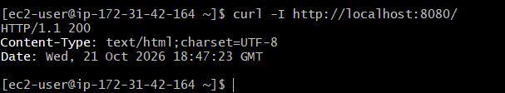

Step 9: Configure the AWS Security Group
To allow external access to the Apache Tomcat server, the inbound rules of the security group attached to the EC2 instance were configured to permit HTTP traffic on port 8080.
Procedure:
Logged in to the AWS Management Console.
Navigated to EC2 → Instances.
Selected the running Amazon Linux 2023 EC2 instance.
Opened the Security tab.
Selected the security group attached to the instance.
Clicked Edit inbound rules.
Added the following inbound rule:
Setting | Value
Type | Custom TCP
Protocol | TCP
Port range | 8080
Source | My IP (recommended for testing)
Description | Allow access to Apache Tomcat
Saved the inbound rule.
Explanation:
The security group controls incoming network traffic to the EC2 instance. Allowing TCP traffic on port 8080 enables a browser to connect to the Tomcat server from the specified source IP address. SSH access on port 22 should also be allowed from a trusted IP address to manage the instance.
Result: The security group was configured to permit Tomcat traffic on port 8080. External access can then be tested by opening http://54.153.216.191:8080/ in a web browser.
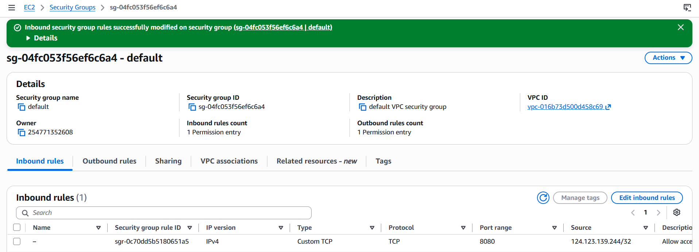

Step 10: Access Apache Tomcat Through a Web Browser
The Apache Tomcat server was accessed through a web browser using the public IPv4 address of the EC2 instance and port 8080.
URL:
http://your_IP:8080/
The URL was entered into the browser after verifying that Tomcat was responding successfully to local HTTP requests. The Tomcat welcome page was expected to appear.
This step verifies external access to the Tomcat server through the EC2 public IP address, provided that the security group allows inbound TCP traffic on port 8080.
Result: Browser access should be confirmed by successfully loading the Tomcat page.
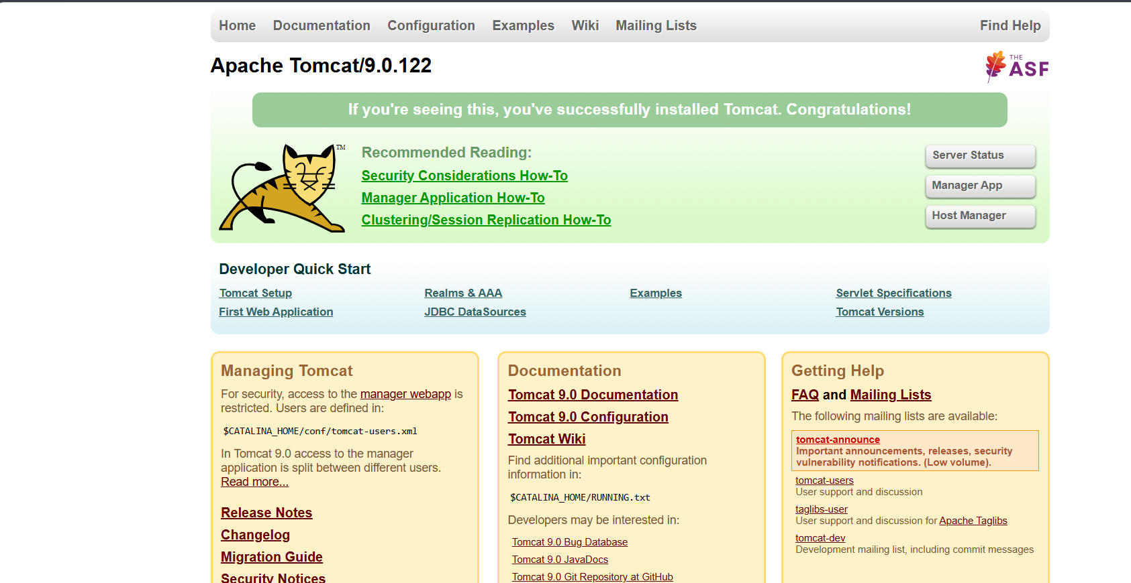

Validation Steps
The installation and configuration of Apache Tomcat were validated using the following commands and methods.
Validation | Command or Method | Expected Result | Status
EC2 SSH access | Connect using Git Bash and the EC2 key pair | Successful SSH connection and EC2 shell prompt | Passed
Java installation | java -version | Java 21 version information | Passed, if verified
Tomcat service status | sudo systemctl status tomcat9 | Service status shows active (running) | Passed
Tomcat port verification | sudo ss -lntp | grep 8080 | Java process listening on port 8080 | Passed
Local HTTP request | curl -I http://localhost:8080/ | HTTP 200 response | Passed
External browser access | Open the EC2 public IP with port 8080 | Tomcat welcome page loads successfully | Verify in browser
Validation summary: The Tomcat service was confirmed to be running, listening on port 8080, and returning HTTP 200 to a local request. External browser access must be confirmed separately.

Explanation
Apache Tomcat is an open-source Java servlet container and web server used to host Java-based web applications. In this task, Tomcat 9 was configured on an Amazon Linux 2023 EC2 instance, with Java 21 providing the Java runtime environment.
The systemctl command was used to check the Tomcat service status. The ss command verified that a Java process was listening on TCP port 8080, while curl tested the server's local HTTP response. After the missing ROOT web application was addressed, the local request returned HTTP 200, confirming that the requested resource was being served successfully.
The AWS security group was configured to allow inbound traffic on port 8080 from the intended source IP address. This configuration enables external browser access when the instance's public IP address, network configuration, and service are all correct.

Real-Time Use Case
Apache Tomcat is commonly used to host Java web applications in development, testing, and production environments. For example, an organization may deploy a Java-based web application to Tomcat running on an EC2 instance, allowing authorized users to access the application over HTTP.
In a DevOps environment, Tomcat can be integrated into a Continuous Integration and Continuous Delivery (CI/CD) pipeline using tools such as Jenkins. A typical pipeline builds the application, runs automated tests, packages the application as a WAR file, and deploys it to Tomcat.
Operational practices such as service monitoring, restricted network access, backups, automated deployment, and controlled release procedures help improve application reliability, security, and maintainability.

Common Errors and Troubleshooting
Error or Issue | Possible Cause | Troubleshooting or Solution
Permission denied (publickey) | Incorrect SSH username or private key | Verify the key pair and use the appropriate Amazon Linux username, ec2-user.
java: command not found | Java is not installed or is not available in the PATH | Install the required Java runtime and verify it with java -version.
Tomcat service fails to start | Java, package, permissions, or configuration issue | Run sudo systemctl status tomcat9 and sudo journalctl -u tomcat9 -n 50 --no-pager.
Port 8080 is not listening | Tomcat is stopped or failed to initialize the connector | Check the service status and logs, then verify with sudo ss -lntp | grep 8080.
Local HTTP request returns an error | Application is missing, undeployed, or incorrectly configured | Test with curl -I http://localhost:8080/ and inspect the deployed web applications and logs.
Browser cannot access Tomcat | Incorrect public IP, security group rule, or network configuration | Verify the EC2 public IPv4 address and allow inbound TCP port 8080 from the intended client IP.
Browser displays an unexpected page | Incorrect URL or application deployment issue | Check the URL, Tomcat deployment directory, and application configuration.

Security and Cost Considerations
The following security and cost-management practices should be followed when hosting Tomcat on AWS EC2:
Restrict SSH access: Allow inbound TCP port 22 only from trusted IP addresses.
Limit application access: Restrict TCP port 8080 to the intended client IP addresses instead of allowing unrestricted access from the internet.
Avoid unnecessary inbound rules: Remove temporary rules when they are no longer required.
Protect credentials: Keep the EC2 private key secure and never share it publicly.
Manage instance costs: Stop or terminate the EC2 instance when the practical is complete and the environment is no longer required.
Review storage resources: Check attached EBS volumes and their deletion settings before terminating the instance.
Monitor AWS charges: Stopping or terminating an instance does not necessarily remove all billable resources. EBS volumes, snapshots, Elastic IP addresses, and other retained resources may continue to incur charges.

Task 3: Install and Configure Docker Desktop on Windows 11

Outcome
Docker Desktop was installed and started on Windows 11, and Windows Subsystem for Linux (WSL 2) was configured as the Linux integration environment. Docker CLI commands were used to verify the client and Docker Engine. The hello-world image was executed successfully, and the resulting container exited with status code 0, confirming that the container completed its task successfully.

Objective
The objective of this practical was to install and configure Docker Desktop on Windows 11 and verify the working Docker environment. The task covered WSL 2 setup, Docker Desktop installation, Docker CLI verification, image execution, container lifecycle management, and basic container validation.

Prerequisites

A computer running Windows 11.
Administrator privileges for installing Windows components.
Hardware virtualization enabled in the system firmware.
WSL 2 support and the required Windows components.
Internet connectivity to download Docker Desktop and container images.
Sufficient system memory and disk space.
PowerShell for executing Windows and Docker commands.

Step-by-Step Implementation

Step 1: Verify Windows Version and Hardware Virtualization
The Windows version was checked by executing:
winver
The system reported the following version information:
10.0.26200.9711
Hardware virtualization was checked by opening Task Manager → Performance → CPU and reviewing the virtualization status.
Result: The Windows version was recorded, and hardware virtualization was checked before configuring Docker Desktop.

Step 2: Install Windows Subsystem for Linux
PowerShell was opened with administrator privileges, and the following command was executed:
wsl --install
When WSL was not installed, the required components were enabled using:
wsl --install --no-distribution
The command returned the following message:
The requested operation is successful. Changes will not be effective until the system is rebooted.
Windows was restarted to apply the changes.
Result: The WSL installation command completed successfully, and a restart was performed to apply the required Windows changes.

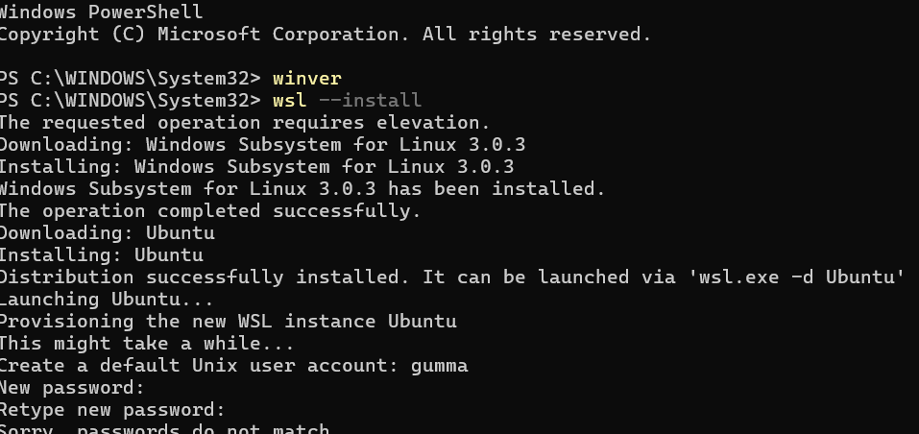

Step 3: Install and Configure Ubuntu on WSL
Ubuntu was installed through PowerShell using:
wsl --install Ubuntu
During the initial setup, a default Unix user account named ubuntu was created, and its password was configured.
The terminal displayed:
Create a default Unix user account: ubuntu
passwd: password updated successfully
The WSL configuration was verified using:
wsl --status
The reported default version was:
Default Version: 2
The installed Linux distributions were also checked using:
wsl --list --verbose
Result: Ubuntu was configured as a WSL distribution, and the WSL default version was confirmed as 2.

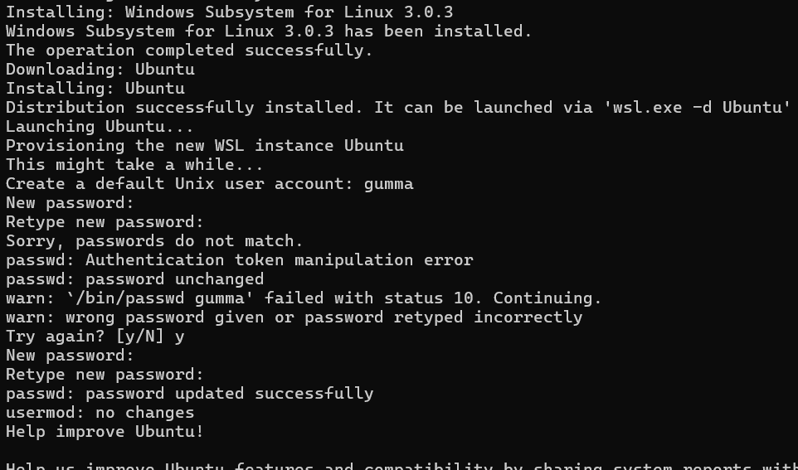

Step 4: Install and Configure Docker Desktop
Docker Desktop was downloaded from the official Docker installation documentation:
https://docs.docker.com/desktop/setup/install/windows-install/
The installer was executed, and the installation was completed. Docker Desktop was then launched, and the Docker Engine was allowed to initialize. Account sign-in was skipped during the initial welcome screen.
The Docker Desktop dashboard displayed the engine status as:
Engine running
Result: Docker Desktop started, and the dashboard indicated that the Docker Engine was running.
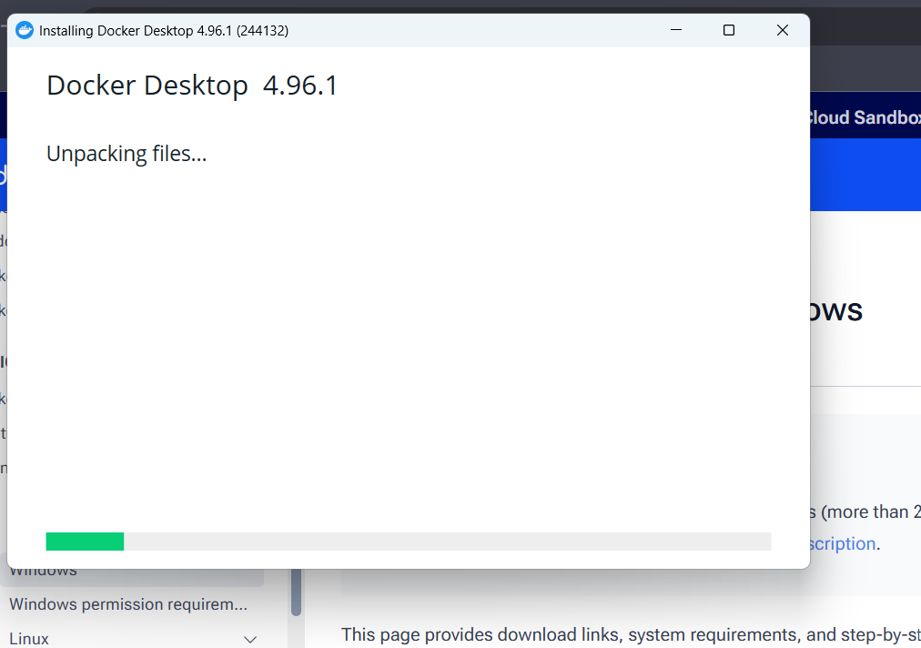

Step 5: Verify Docker CLI Availability
A new PowerShell window was opened, and the following command was executed:
docker --version

This command verifies that the Docker command-line interface (CLI) is available and reports its version

Step 6: Verify Docker Client and Server
The following command was executed:
docker version
This command displays version information for the Docker client and server.
Docker client: Accepts commands entered through the command line.
Docker server (Docker Engine): Manages container images, containers, networks, and other Docker resources.
Expected result: Both client and server details are displayed without a connection error.

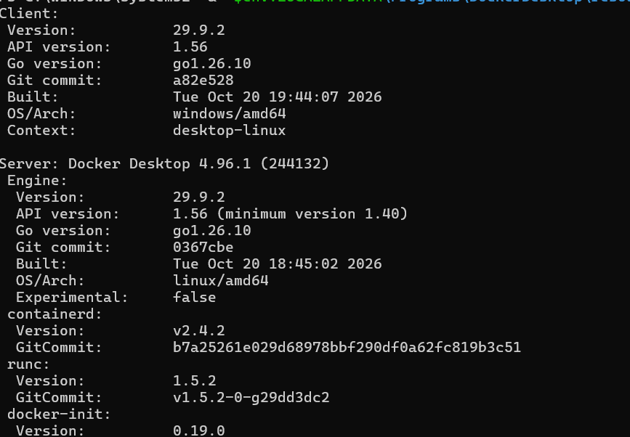

Step 7: Run the Hello World Container
The following command was executed:
docker run hello-world
Docker checked for the hello-world image locally and downloaded it if it was not available. It then created and executed a container from the image.
The expected success message begins with:
Hello from Docker!
Result: The successful message confirms that Docker can retrieve an image and execute a container.

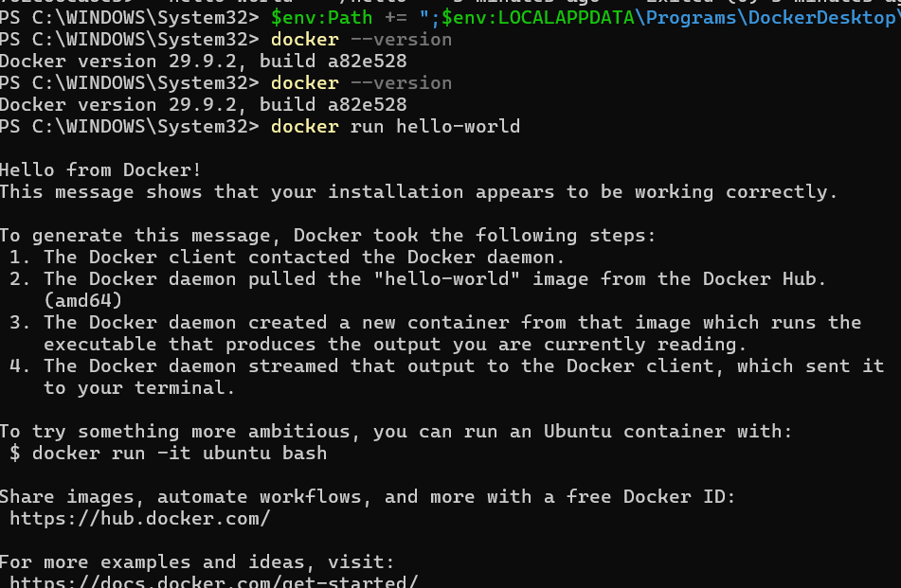

Step 8: Verify the Container
The following command was executed:
docker ps -a
The recorded output was:
CONTAINER ID IMAGE COMMAND CREATED STATUS NAMES
59fb5aa8e133 hello-world "/hello" 45 seconds ago Exited (0) 44 seconds ago vibrant_tu
Explanation:
docker ps -a lists all containers, including stopped containers.
CONTAINER ID identifies the container.
IMAGE identifies the image used to create the container.
COMMAND displays the command executed inside the container.
STATUS indicates the container's current state.
NAMES displays the automatically assigned container name.
Exited (0) indicates that the container finished successfully.
Result: The container was listed, and its exit status of 0 confirmed successful completion. The stopped state is expected for the hello-world test because the program exits after displaying its message.

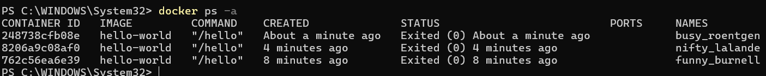

Validation Steps
The following checks were used to validate the Windows, WSL, Docker Desktop, and container environment.
Validation | Command or Method | Expected Result | Status
Windows version | winver | Windows version information displayed | Verified
WSL installation | wsl --status | WSL status and default version information displayed | Verified
Ubuntu configuration | wsl --list --verbose | Ubuntu distribution listed with WSL version 2 | Verify saved output
Docker Desktop | Docker Desktop dashboard | Engine running | Passed
Docker CLI | docker --version | Docker version information | Verify saved output
Docker client and server | docker version | Client and server details displayed | Verify saved output
Container execution | docker run hello-world | Successful Hello from Docker! message | Passed
Container listing | docker ps -a | hello-world container listed with Exited (0) | Passed
Validation summary: The successful hello-world execution and the recorded Exited (0) status demonstrate that the test container ran successfully. Any validation status marked for verification should be updated after checking the corresponding command output.

Explanation
Docker Desktop provides a local environment for building, running, and managing containers on Windows. WSL 2 supplies the Linux environment and kernel integration used by Docker Desktop's WSL 2 backend.
The Docker CLI enables users to interact with Docker Engine through terminal commands. In this practical, docker --version was used to check CLI availability, while docker version was used to inspect client and server information.
The hello-world image served as a basic functional test. Docker retrieved the image, created a container, executed its program, and displayed a success message. The docker ps -a command then confirmed that the container existed and had exited with status code 0.
Together, these steps demonstrate the basic workflow of downloading an image, creating a container, executing its program, and inspecting its final state.

Real-Time Use Case
Docker is widely used in DevOps to package applications and their dependencies into portable containers. For example, a developer can build a web application image, test it locally, and deploy the same image to a testing or production environment.
Docker can also be integrated with CI/CD tools such as Jenkins to automate image building, application testing, image tagging, and publishing to a container registry. This helps maintain consistency across development, testing, and production environments.
Containers can improve deployment repeatability and simplify application packaging, although production deployments still require appropriate security controls, monitoring, networking, and resource management.

Common Errors and Troubleshooting
Error or Issue | Possible Cause | Solution
docker is not recognized | Docker CLI is unavailable or the terminal has not refreshed its environment | Confirm Docker Desktop is installed and open a new PowerShell window.
WSL is not installed | Required Windows components are missing | Run wsl --install in administrator PowerShell and restart if prompted.
WSL 2 cannot start | Virtualization is disabled or a required Windows feature is unavailable | Enable hardware virtualization and verify the required Windows components.
Docker Engine fails to start | WSL or Docker Desktop startup issue | Check WSL status, review Docker Desktop diagnostics, and restart Docker Desktop.
Cannot connect to Docker Engine | Engine is not running or the Docker context is incorrect | Wait for Docker Desktop to finish starting and run docker version.
Image download fails | Network, proxy, DNS, or registry connectivity issue | Verify internet access and retry after resolving the connectivity issue.
Container shows Exited (0) | The container's process finished normally | This is expected for hello-world. Use a long-running application container to test a running state.
docker version shows only client details | Docker Engine is unavailable | Check the Docker Desktop dashboard and confirm that the engine is running.

Security and Resource Considerations
The following practices help maintain a secure and efficient Docker environment:
Use trusted images: Download images from trusted publishers and review their documentation.
Keep software updated: Install supported updates for Docker Desktop, WSL, and Windows.
Limit privileges: Avoid running unknown containers with elevated privileges or unnecessary host access.
Review port mappings: Publish only the ports required by the application, and restrict external access when appropriate.
Protect sensitive information: Avoid storing passwords, access tokens, or other secrets directly in container images.
Monitor resource usage: Review Docker Desktop's memory, CPU, and disk consumption.
Clean up unused resources: Remove unneeded containers and images when they are no longer required.
Understand container states: Use docker ps to list running containers and docker ps -a to list all containers, including stopped ones.
These practices help improve security, reduce unnecessary resource consumption, and support reliable local container development.

