Git Tasks

1. Create the project folder: MyProject
Open Git Bash and create a folder. Run the commands from the parent directory where you want the project.
cd ~/Desktop
mkdir MyProject
cd MyProject
pwd
If your Desktop is inside OneDrive, use the corresponding OneDrive path. Your screenshot may show a different path from this example.

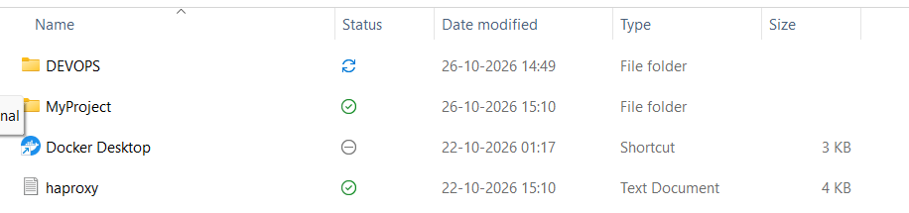

Create a file

The original notes use `vi dockerfile`. This opens the vi editor; it does not simply create and display file contents. If you are learning the basics, use `touch` to create the file, or use `echo` to create it with sample content.
touch Dockerfile
echo "Hello, Git" > Dockerfile
cat Dockerfile

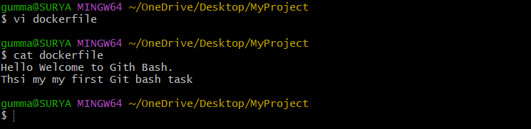
.

3. Create multiple files
In the original notes, `touch file1,file2,file3,file4` would normally create one file whose name contains commas. Use spaces between filenames to create four separate files.
touch file1 file2 file3 file4
ls


4. Run git status before initializing Git
git status
In a normal folder that is not inside a Git repository, Git may show a fatal message saying that this is not a Git repository. This is expected before you initialize one.
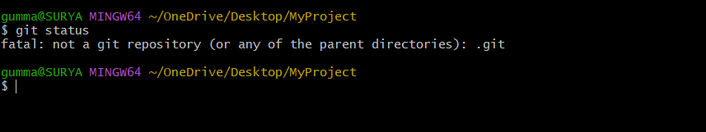

5. Initialize the repository with git init
git init
git status
ls -a
`git init` creates Git repository metadata in the hidden `.git` directory. `ls -a` displays hidden entries so you can see `.git`. New files are not automatically tracked just because you ran `git init`.
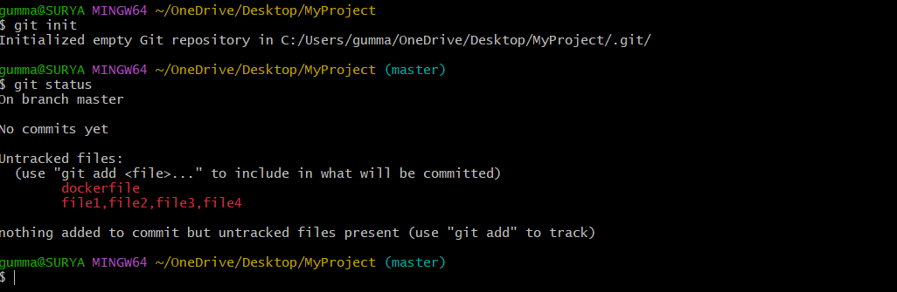
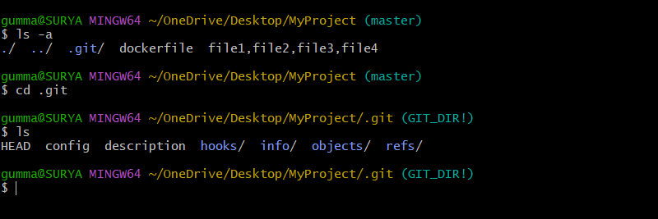

6. Configure your Git name and email
git config --global user.name "Your Name"
git config --global user.email "your-email@example.com"
git config --global user.name
git config --global user.email
git config --list
Replace the example name and email with your preferred commit identity. `--global` applies these values across repositories for your Windows user. The name and email are recorded in commits; they are not the same thing as signing in to GitHub.
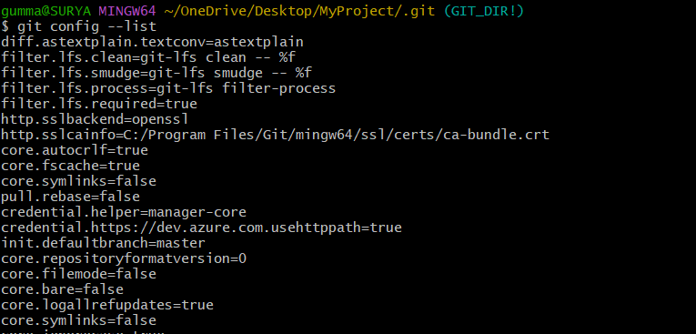
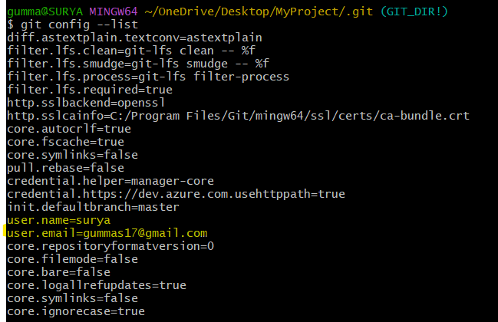

7. Stage files with git add
git add .
git status
`git add .` stages changes under the current directory, subject to ignore rules. Check `git status`; files should appear under “Changes to be committed” if staging succeeded.
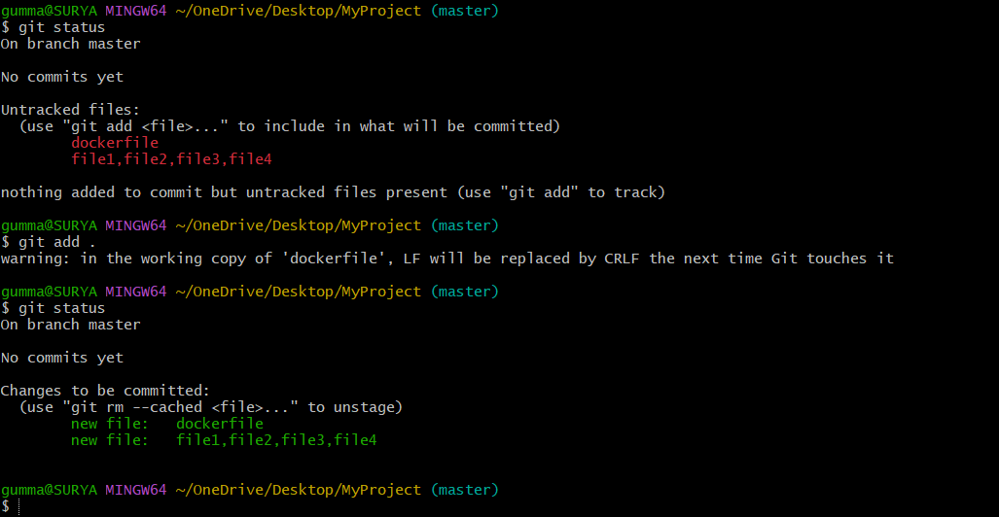

8. Commit the staged changes
git commit -m "Initial commit"
git status
A commit records a snapshot of staged changes in the local repository. If Git asks you to configure your name and email, complete Step 6 first.

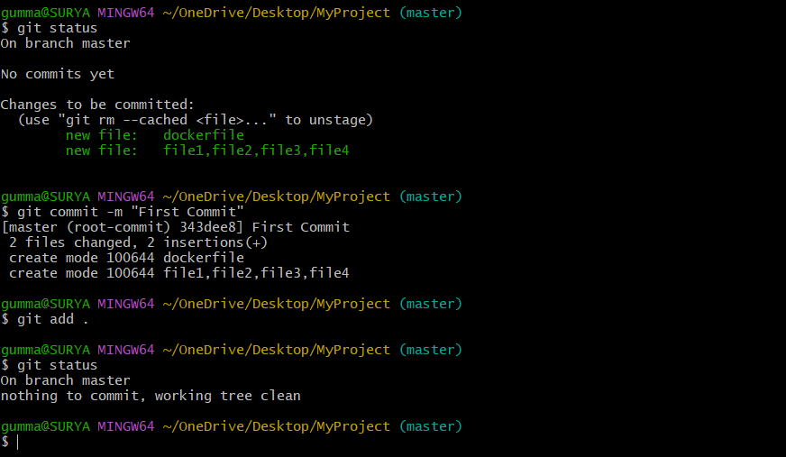

9. View commit history with git log
git log
The log displays existing commits, including commit IDs, author details, dates, and messages. After a second commit, the history will show that commit as well.

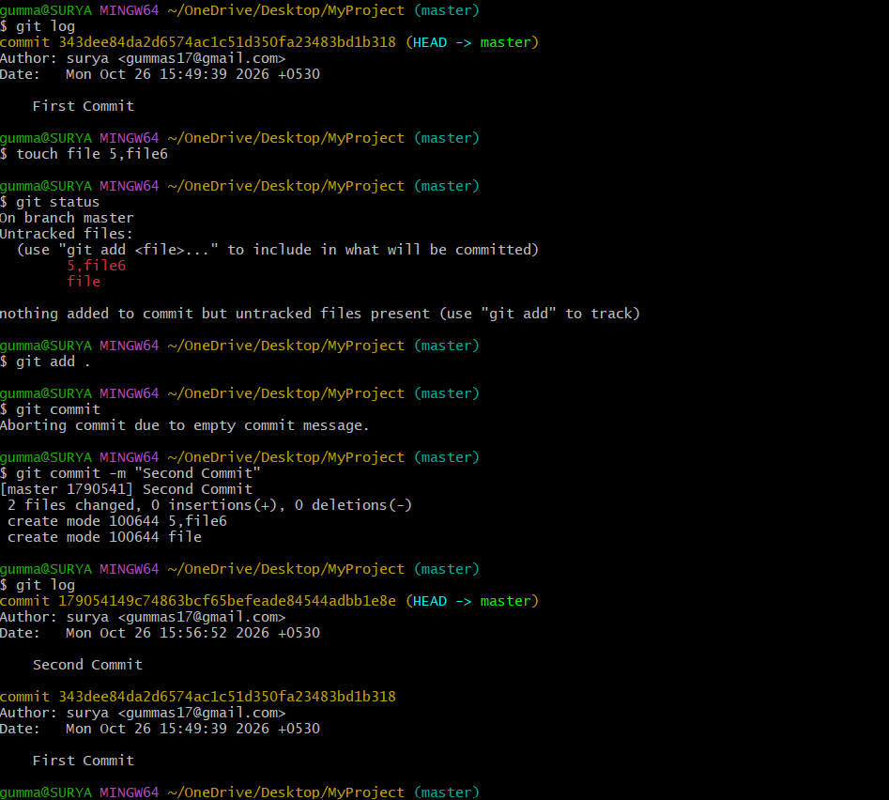

Create a central repository on GitHub

- Sign in to GitHub and choose New repository.
- Enter a repository name, for example Testing.
- Choose Public
- If you already have local commits to push, the simplest setup is to create an empty remote repository (do not pre-create a README, license, or .gitignore).
- Create the repository and copy its SSH URL.
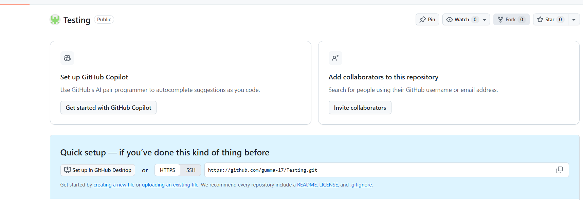

11. Check and add the remote
git remote -v
git remote add origin git@github.com:YOUR-USERNAME/Testing.git
git remote -v

Replace `YOUR-USERNAME` with your actual GitHub username. `origin` is the conventional nickname for the remote. If `origin` already exists, use `git remote set-url origin <URL>` rather than adding it a second time.
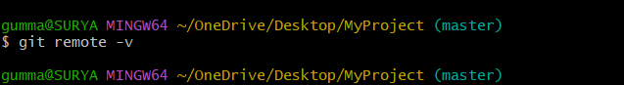
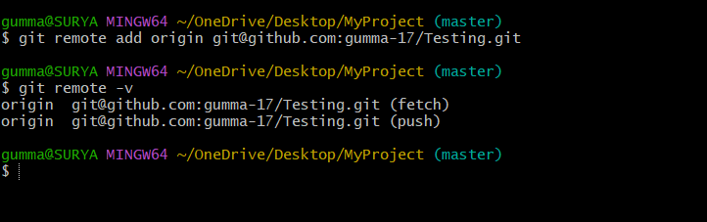

12. Generate an SSH key and add the public key to GitHub
ssh-keygen
Follow the prompts. If the default key already exists, do not overwrite it without checking; reuse it or select a different filename. The private key is usually `~/.ssh/id_ed25519`; the public key is `~/.ssh/id_ed25519.pub`.
cat ~/.ssh/id_ed25519.pub
- Copy the complete public-key output.
- On GitHub, open Settings → SSH and GPG keys → New SSH key.
- Give the key a recognizable title, select Authentication Key, paste the public key, and save it.
- Never paste or upload the private key (the file without .pub).
- Test the connection with `ssh -T git@github.com`.
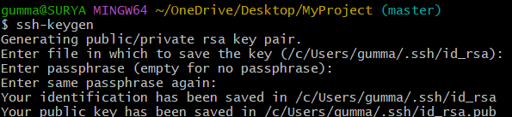

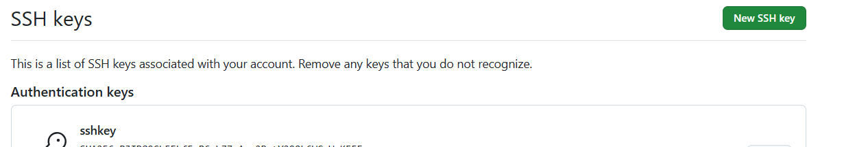

13. Push your local commits to GitHub
git push -u origin main
Use the actual branch name printed by the first command. If it prints `master`, run `git push -u origin master` instead. The `-u` option sets upstream tracking for later pushes and pulls.

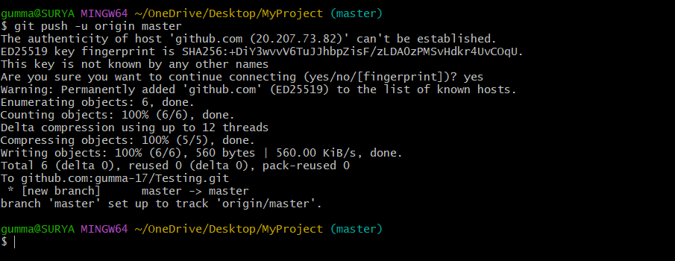

Delete local files and update GitHub

Separate filenames with spaces, not commas. You can delete files and then stage the deletions:
rm file1 file2 file3 file4
git status
git add -A
git commit -m "Remove unused files"
git push
Alternatively, `git rm file1 file2` removes the named files and stages their deletions in one step. The files disappear from the latest GitHub version only after the deletion is committed and pushed.
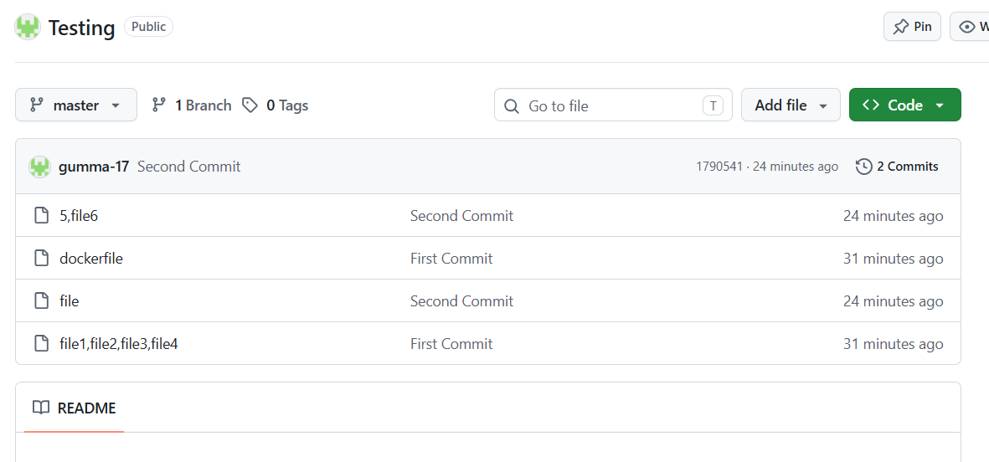
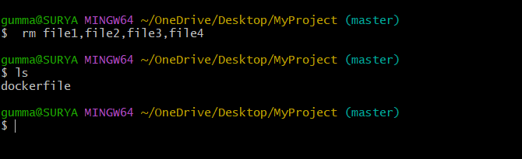

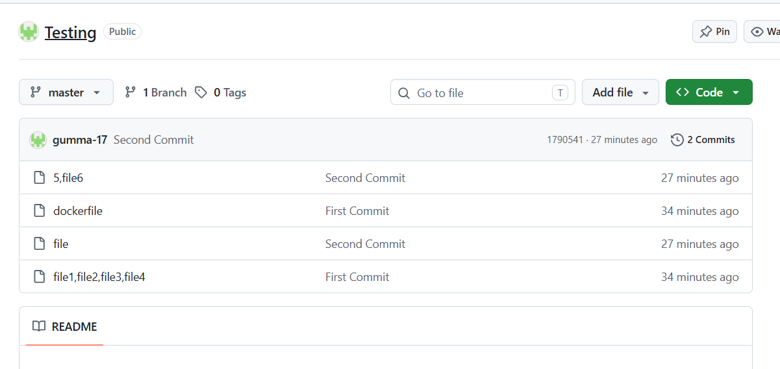

Handle a rejected push when GitHub has newer changes
If someone adds a file or makes a commit directly on GitHub, your next push may be rejected because the remote branch has commits your local branch does not have.
git status
git pull
git push
Before pulling, commit or safely stash any local changes you need to keep. `git pull` fetches and integrates remote changes. Depending on configuration, Git may merge or rebase. If conflicts occur, inspect `git status`, resolve the conflict markers in the affected files, stage the resolved files, and complete the merge or rebase before pushing.
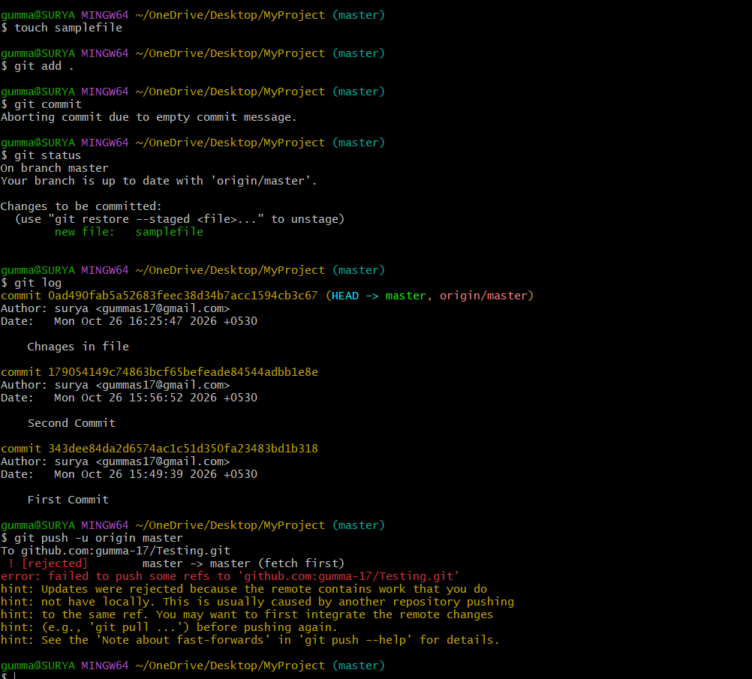

Pull remote changes
git pull
git status
git push
After a successful pull and any conflict resolution, push your local commits. If Git reports unrelated histories or asks you to choose a merge/rebase strategy, stop and read the specific error before trying extra commands.
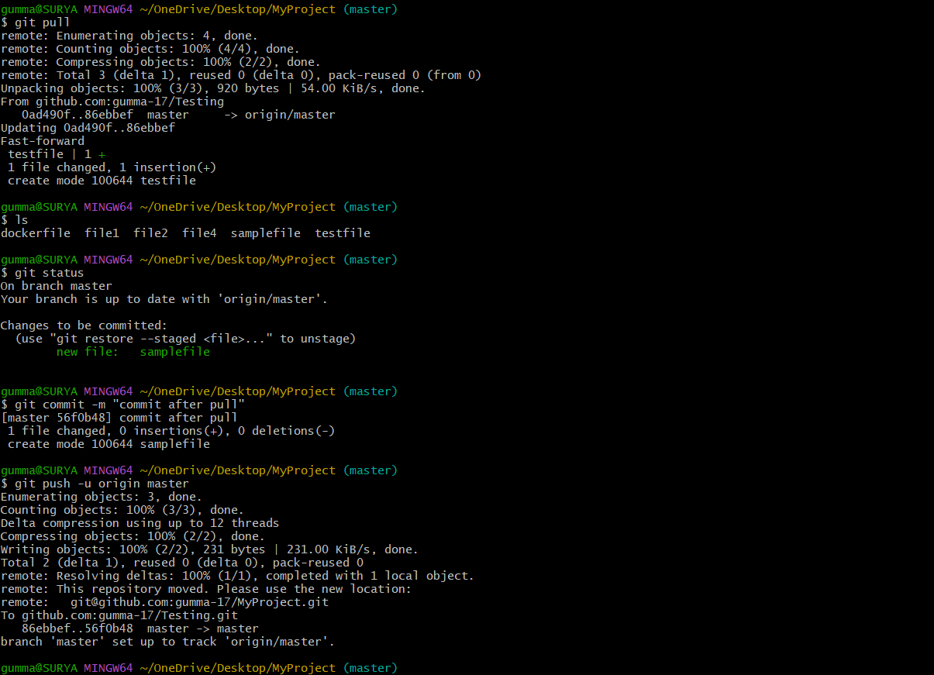
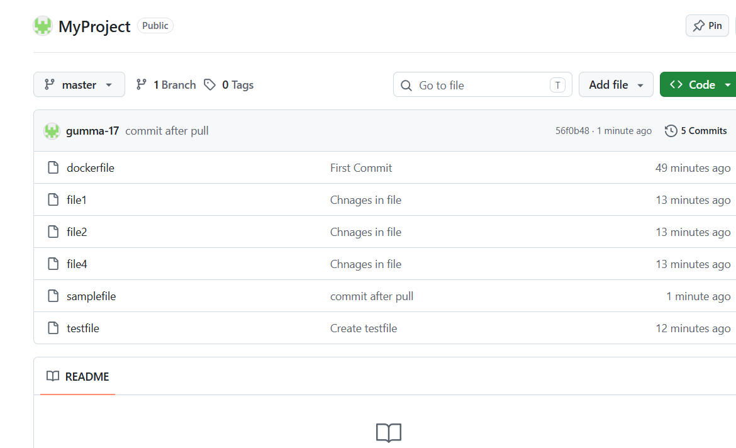

17. Clone an existing repository
git clone git@github.com:YOUR-USERNAME/Testing.git
cd Testing
git status
git remote -v
Run `git clone` from the parent directory where you want the new folder created. Cloning downloads repository files and history and normally configures a remote named `origin`. You usually do not need to run `git init` first.

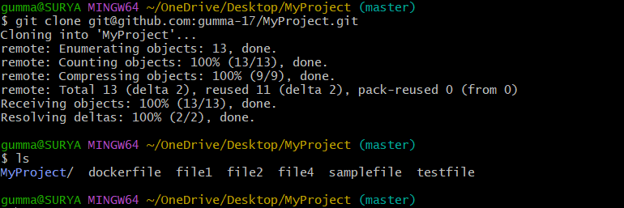

Unstage a file with git reset / git restore

touch file10
git add file10
git status
git restore --staged file10
git status
Because `file10` is a new file that has never been committed, it will usually appear as untracked after being unstaged. `git reset` with no commit argument also commonly unstages changes, but other forms of reset can change branch history.

