Task 1: Install Git

Outcome
Git is installed and verified on a Windows system using the Git Bash terminal.

Objective
To verify Git availability and install Git for Windows if it is not already installed, enabling version control and source code management.

Prerequisites
- Windows operating system.
- Git Bash terminal.
- Internet connection.
- Permission to install software on Windows.

Step-by-Step Implementation

Step 1: Open Git Bash
Open the Start menu, search for Git Bash, and launch the terminal.
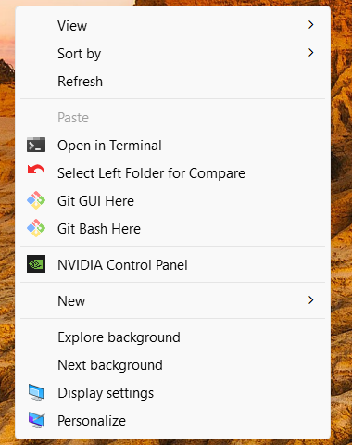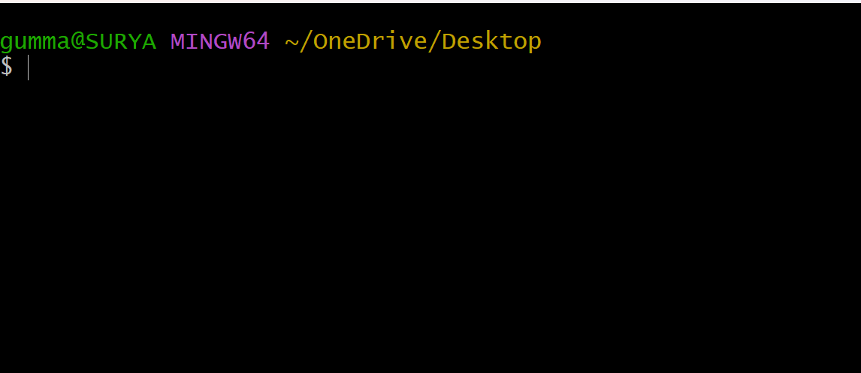

Step 2: Check Whether Git Is Installed
Run the following command:
git --version
Example output:
git version 2.x.x.windows.x
If the version appears, Git is already installed. You do not need to install it again.
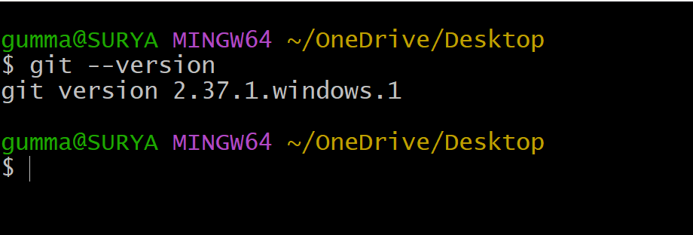

Step 3: Install Git
- Run the downloaded installer.
- Follow the installation wizard.
- Keep the recommended settings unless you have specific requirements.
- Complete the installation.
- Close and reopen Git Bash.
Note: Git Bash normally comes bundled with Git for Windows. If Git Bash is already working, Git is usually installed.

Step 5: Verify the Git Installation
Run:
git --version
To check the executable location, run:
which git
Example output:
/usr/bin/git
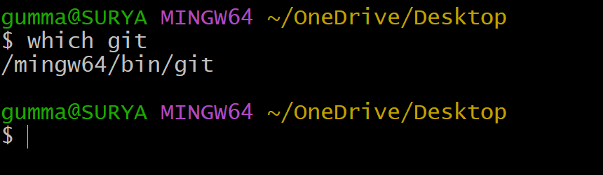

Step 6: Configure Git
Set your name and email address for Git commits:
git config --global user.name "Your Name"
git config --global user.email "your-email@example.com"
Replace the example values with your own details.
Verify the configuration:
git config --global --list

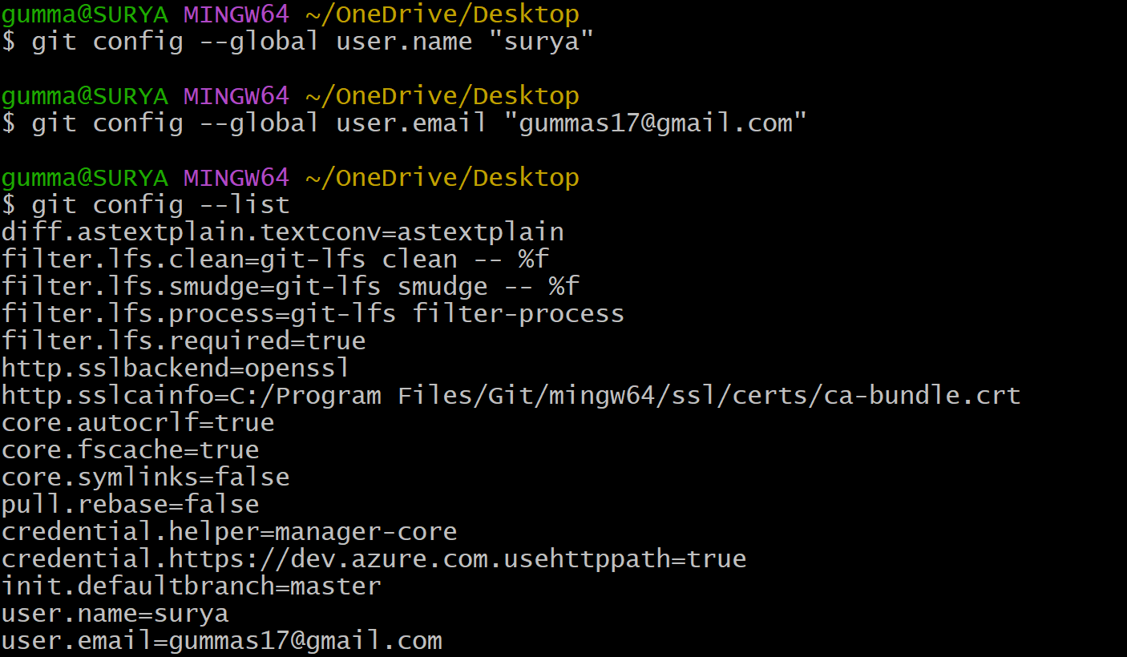

Step 7: Test Git with a Repository
Create a test directory and initialize a Git repository:
mkdir git-test
cd git-test
git init
Expected output will indicate that an empty Git repository has been initialized.
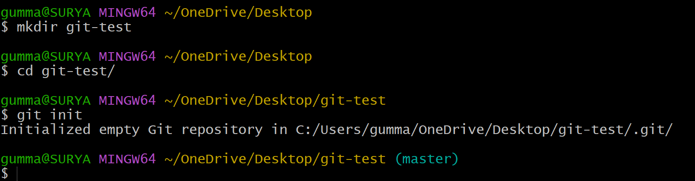

Validation Steps
No. | Test | Expected Result
1 | Run git --version | Installed Git version is displayed
2 | Run which git | Git executable path is displayed
3 | Run git config --global --list | Configured name and email are displayed
4 | Run git init | A Git repository is initialized successfully

Explanation
git --version displays the installed Git version.
which git identifies the Git executable available in the terminal.
git config --global user.name sets the default author name.
git config --global user.email sets the default author email.
git init initializes a new local Git repository.

Real-Time Use Case
Git is widely used in DevOps to manage application source code, track changes, collaborate with development teams, and integrate code with CI/CD pipelines.

Common Errors and Troubleshooting
Error | Possible Cause | Solution
git: command not found | Git is not installed or is unavailable in the terminal | Install Git for Windows and reopen Git Bash
Git Bash does not open | Installation problem | Reinstall Git for Windows
git init fails | Directory permission issue | Navigate to a directory where you have write permission
Git author identity is missing | Name and email are not configured | Run the git config --global commands
Repository clone fails | Incorrect URL or network access issue | Verify the repository URL and internet connection

Conclusion
Git was checked and installed on Windows using Git for Windows, with verification performed through the Git Bash terminal. Git configuration and repository initialization were also demonstrated, providing the basic setup required for source code management and DevOps workflows.

Task 2: Create a repo in github with README.md and .ignore file.

Outcome
A GitHub repository is created with a README file and a .gitignore file.

Objective
To create a central repository for storing and managing project files.

Prerequisites
- GitHub account.
- Web browser.

Step-by-Step Implementation
Log in to https://github.com.
Click New repository.
Enter the repository name git-practice.
Add a description if required.
Select Public or Private.
Check Add a README file.
Select a suitable .gitignore template, such as Python, or choose None and create it manually.
Click Create repository.

If you need to create .gitignore manually, open the repository and select Add file → Create new file. Name it .gitignore and add:
*.log
*.tmp
.env
node_modules/
Commit the file to the repository.
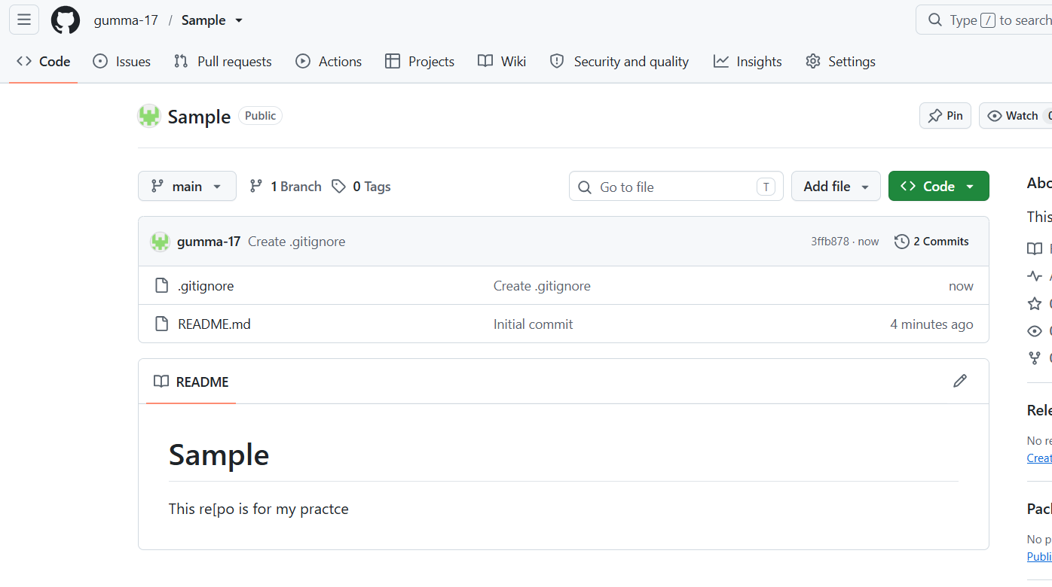

Validation Steps
Confirm that README.md appears in the repository.
Confirm that .gitignore appears in the file list.

Explanation
README.md describes the project. .gitignore tells Git which untracked files or directories to ignore.

Real-Time Use Case
Developers use README files to document projects and .gitignore to exclude temporary files and local configuration.

Common Errors and Troubleshooting
Error | Solution
Repository name unavailable | Choose another name
.gitignore does not appear | Check the filename and commit the file
Sensitive file is already tracked | Remove it from tracking and rotate any exposed secrets

Conclusion
A GitHub repository was created with project documentation and ignore rules.

Task 3: Clone the GitHub Repository to Local

Outcome
The GitHub repository is downloaded to the local computer.

Objective
To obtain a local copy of the central repository for development.

Prerequisites
- Repository created on GitHub.
- Git Bash installed.
- Repository access permissions.

Step-by-Step Implementation
Open the GitHub repository.
Click Code and copy its SSH URL.
Open Git Bash.
Navigate to the desired directory:
cd ~/Desktop
Clone the repository:
git clone https://github.com/YOUR_USERNAME/git-practice.git

Enter the repository:
cd git-practice
Check the files:
ls -la

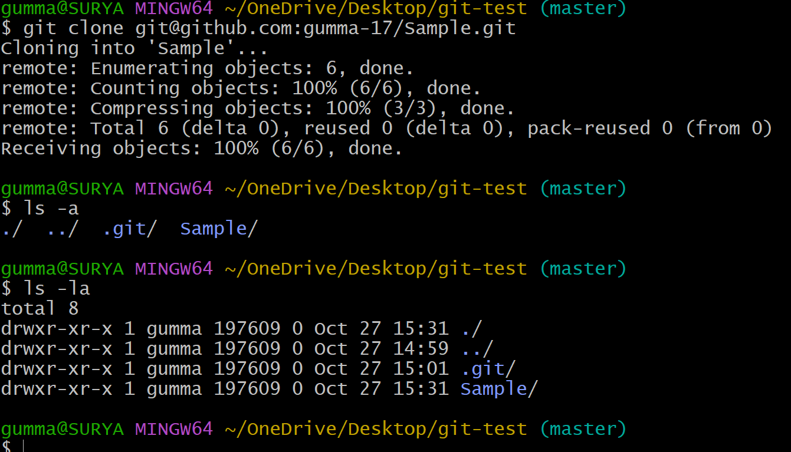

Validation Steps
git status
git remote -v
Expected result: Git displays the working tree status and the GitHub remote URL.

Explanation
git clone downloads repository files and commit history and configures the remote named origin.

Real-Time Use Case
A developer clones a project before modifying source code locally.

Common Errors and Troubleshooting
Error | Solution
Repository not found | Check the URL and repository permissions
Authentication failed | Use an authorized GitHub authentication method
Directory already exists | Choose another destination or inspect the existing directory

Conclusion
The remote repository was cloned successfully to the local computer.

Task 4: Create Two Files in the Local Repository

Outcome
Two files are created inside the local repository.

Objective
To create project files that can be tracked by Git.

Prerequisites
- Repository cloned locally.
- Git Bash opened in the repository directory.

Step-by-Step Implementation
Navigate to the repository:
Create two files:
touch file1.txt file2.txt
Add sample content:
echo "This is file one." > file1.txt
echo "This is file two." > file2.txt
Check the files:
ls
Check Git status:
git status

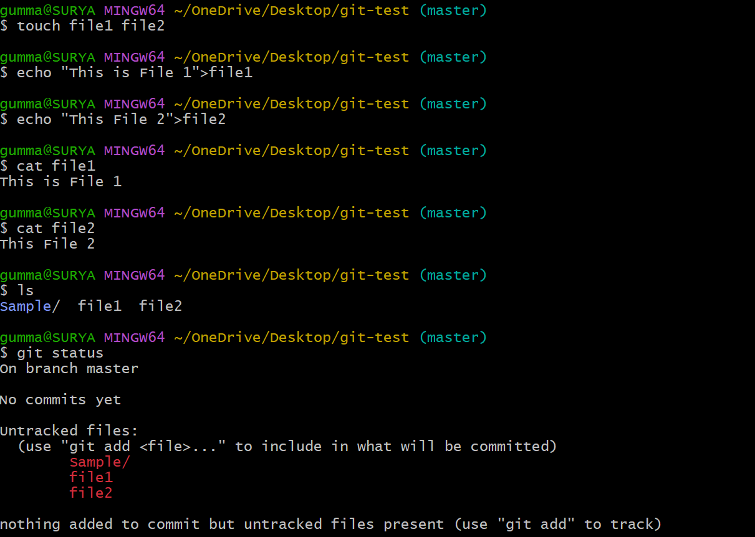

Validation Steps
cat file1.txt
cat file2.txt
git status
Both files should appear as untracked files.

Explanation
touch creates empty files when they do not exist. echo writes content to them. Git identifies new files as untracked until they are staged.

Real-Time Use Case
Developers create configuration files, scripts, documentation, and source code locally before committing them.

Common Errors and Troubleshooting
Error | Solution
File created in the wrong directory | Run pwd and navigate to the repository
File does not appear in Git status | Check whether .gitignore excludes it
Permission denied | Use a directory where you have write permission

Conclusion
Two local files were created and identified by Git as untracked files.

Task 5: Commit Two Files and Push Them to GitHub

Outcome
Two files are committed locally and uploaded to GitHub.

Objective
To understand staging, committing, and pushing changes.

Prerequisites
Local repository connected to GitHub.
Two files created.
GitHub authentication configured.

Step-by-Step Implementation
Stage both files:
git add .
Check the staged changes:
git status
Commit the files:
git commit -m "Add two sample files"
Push the current branch:
git push -u origin master

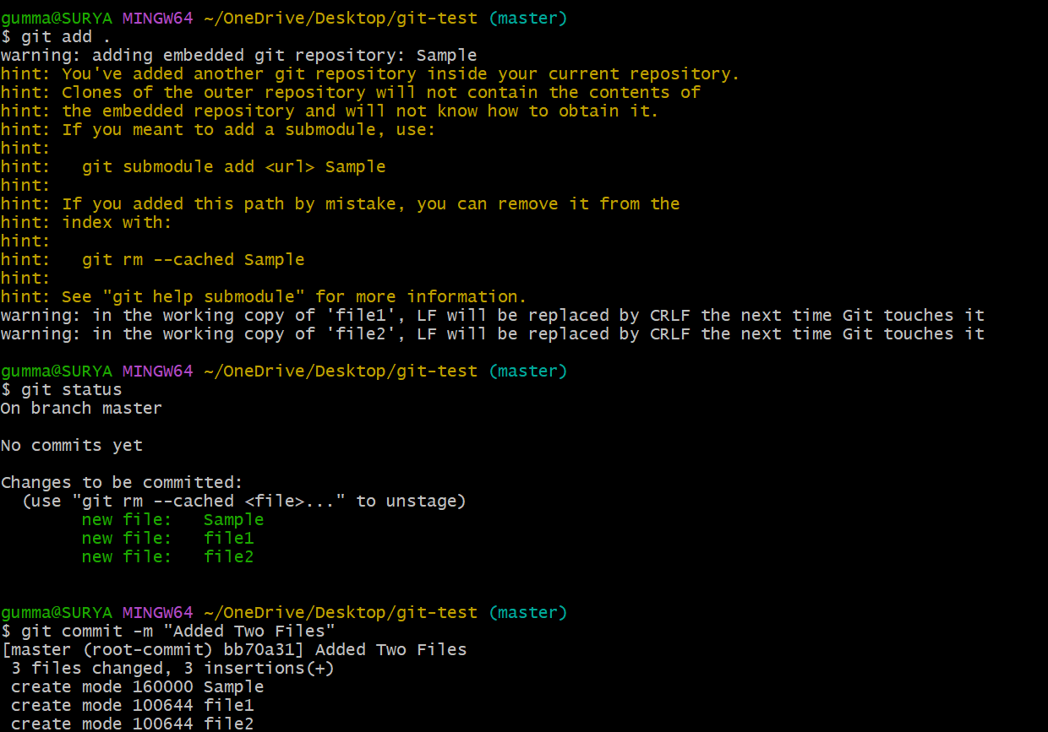
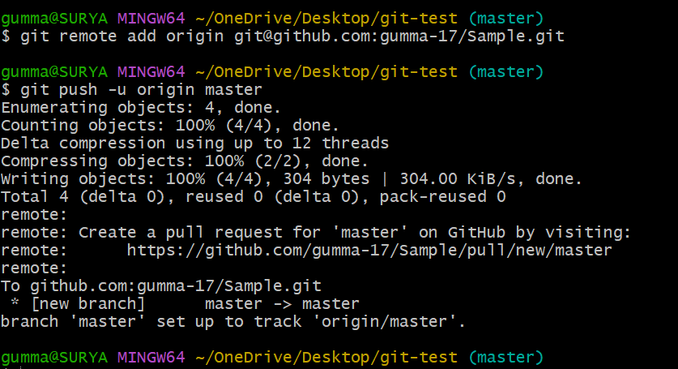

Validation Steps
git log
git status

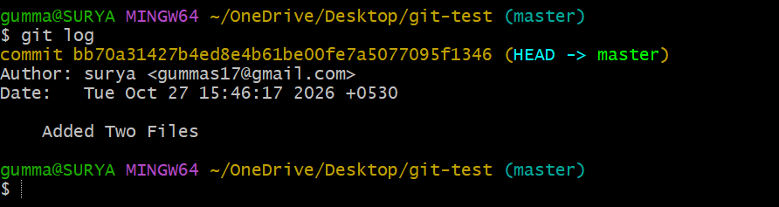
Open GitHub and confirm that file1.txt and file2.txt appear in the repository.
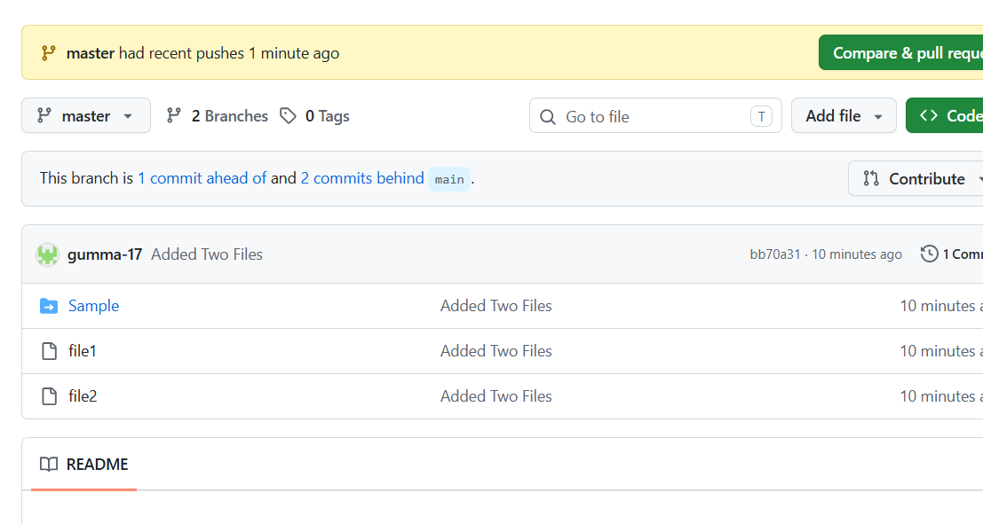

Explanation
git add stages changes.
git commit saves a snapshot in local Git history.
git push uploads commits to the remote repository.

Real-Time Use Case
Developers push completed changes to GitHub so team members can review and access them.

Common Errors and Troubleshooting
Error | Solution
Nothing to commit | Check that files contain changes and are staged
Authentication failed | Configure GitHub authentication
No upstream branch | Use git push -u origin HEAD
Push rejected | Fetch remote changes and integrate them before retrying

Conclusion
Two files were staged, committed, and pushed to the central repository.

Task 6: Create a Local Branch, Add a File, and Push the Branch

Outcome
A new branch is created locally, and its sample file is pushed to GitHub.

Objective
To practice branch creation and publishing a branch to a remote repository.

Prerequisites
Local repository connected to GitHub.
Clean working tree.

Step-by-Step Implementation
Create and switch to a branch:
git switch -c feature-local
Create a sample file:
echo "This file belongs to the feature branch." > feature.txt
Stage and commit:
git add feature.txt
git commit -m "Add feature sample file"
Push the new branch:
git push -u origin feature-local

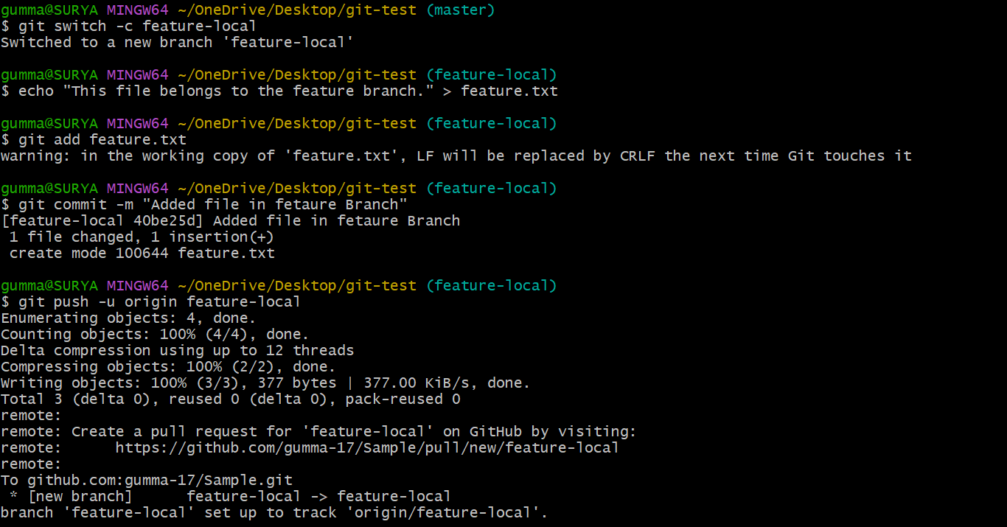

Validation Steps
git branch
git branch -r
git status
Open GitHub and select the feature-local branch.

Explanation
A branch allows development to proceed independently from the main branch.

Real-Time Use Case
Feature branches allow developers to implement changes without directly modifying production code.

Common Errors and Troubleshooting
Error | Solution
Branch already exists | Choose another name or switch to the existing branch
Push rejected | Fetch remote updates and resolve the conflict
File missing on GitHub | Confirm that the file was committed and the correct branch was pushed

Conclusion
A local feature branch was created and published to GitHub.

Task 7: Create a Branch on GitHub and Bring It to Local

Outcome
A branch created on GitHub is checked out locally.

Objective
To retrieve and work with a branch created in the remote repository.

Prerequisites
- Existing GitHub repository.
- Local clone of the repository.

Step-by-Step Implementation
Open the GitHub repository.
Open the branch selector and enter feature-remote.
Select the option to create the branch from the current branch.
Return to Git Bash and run:
git fetch origin
Check available remote branches:
git branch -r
Create a local tracking branch:
git switch --track origin/feature-remote

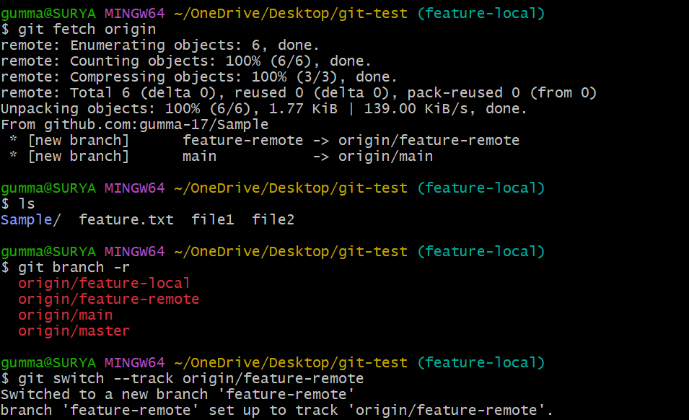

Validation Steps
git branch
git status
The current branch should be feature-remote.

Explanation
git fetch downloads remote branch information without merging it into the current branch. git switch --track creates a local branch that tracks the remote branch.

Real-Time Use Case
A developer checks out a branch created by a teammate through GitHub.

Common Errors and Troubleshooting
Error | Solution
Remote branch not found | Check the branch name and run git fetch origin
Branch already exists locally | Run git switch feature-remote
Local changes prevent switching | Commit or stash the changes first

Conclusion
A branch created on GitHub was fetched and checked out locally.

Task 8: Merge a Created Branch into Main Locally

Outcome
Changes from a feature branch are merged into the local main branch.

Objective
To combine changes from one branch into another using Git.

Prerequisites
- Local main branch.
- Feature branch containing committed changes.
- Working tree clean.

Step-by-Step Implementation
Switch to the main branch:
git switch master
Update it from GitHub:
git pull origin main
Merge the feature branch:
git merge feature-local
If there are no conflicts, Git completes the merge.
Push the merged main branch:
git push origin main

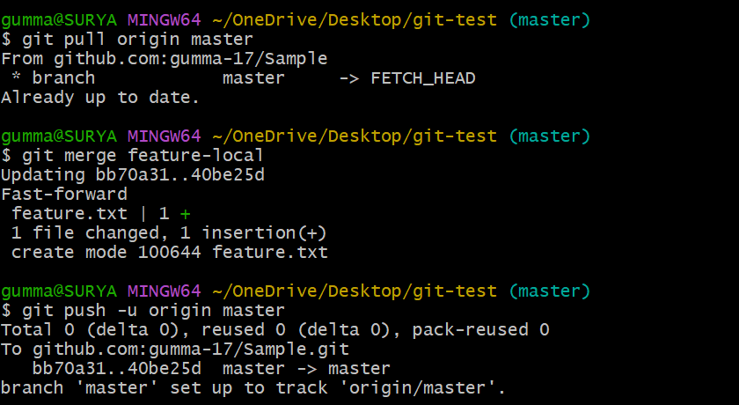

Validation Steps
git log --oneline --graph --all
git status
Confirm that the feature branch's changes are included in main.

Explanation
git merge combines the history of the specified branch into the current branch. The destination branch is the branch currently checked out.

Real-Time Use Case
After feature development is completed, its changes are merged into the main development branch.

Common Errors and Troubleshooting
Error | Solution
Merge conflict | Resolve conflict markers, stage files, and complete the merge
Main branch has remote changes | Pull or fetch and integrate the changes
Uncommitted changes prevent merge | Commit or stash them first

Conclusion
The feature branch was merged into the local main branch and pushed to GitHub.

Task 9: Merge a Branch into Main on GitHub Using a Pull Request

Outcome
A feature branch is merged into main through a GitHub pull request.

Objective
To practice code review and branch merging through GitHub.

Prerequisites
- GitHub repository.
- Feature branch pushed to GitHub.
- Permission to create and merge pull requests.

Step-by-Step Implementation
Push the feature branch:
git push -u origin feature-local
Open the repository on GitHub.
Select Pull requests → New pull request.
Set the base branch to main.
Set the compare branch to feature-local.
Click Create pull request.
Enter a title and description.
Review the changes and resolve any required checks or conflicts.
Click Merge pull request, then confirm the merge if permitted.
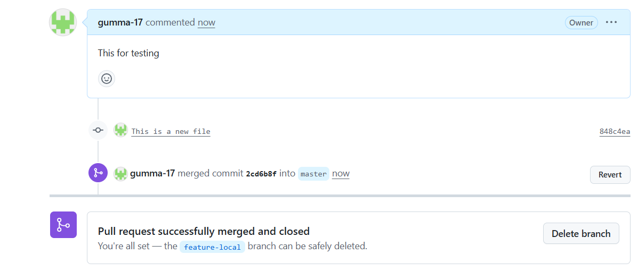

Validation Steps
Open the repository's main branch.
Confirm the merged file is present.
Check the pull request's status.
Optionally synchronize the local main branch:
git switch main
git pull origin main

Explanation
A pull request proposes changes for review before merging them into the target branch. GitHub may require approvals or automated checks before allowing the merge.

Real-Time Use Case
Teams use pull requests for code reviews, automated testing, and controlled integration of changes.

Common Errors and Troubleshooting
Error | Solution
No changes to compare | Ensure the feature branch has commits not already in main
Conflicts detected | Update the feature branch and resolve conflicts
Merge button unavailable | Check permissions, required reviews, and status checks

Conclusion
A feature branch was reviewed and merged into main using a GitHub pull request.

Task 10: Create a File Locally and Push It to a GitHub Branch

Outcome
A newly created local file is pushed to a selected remote branch.

Objective
To practice committing and pushing a change to a specific branch.

Prerequisites
- Local repository.
- Target branch exists locally or remotely.
- GitHub access configured.

Step-by-Step Implementation
Switch to the target branch:
git switch feature-local
Create a file:
echo "Changes pushed from the local computer." > local-update.txt
Stage the file:
git add local-update.txt
Commit it:
git commit -m "Add local update file"
Push the branch:
git push origin feature-local

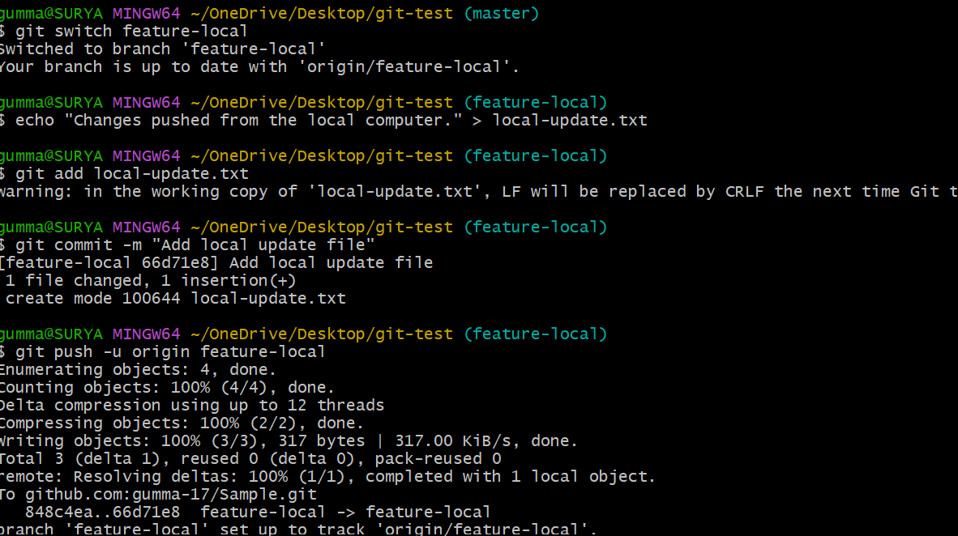

Validation Steps
git status
git log
Open GitHub and select feature-local to confirm the file is present.
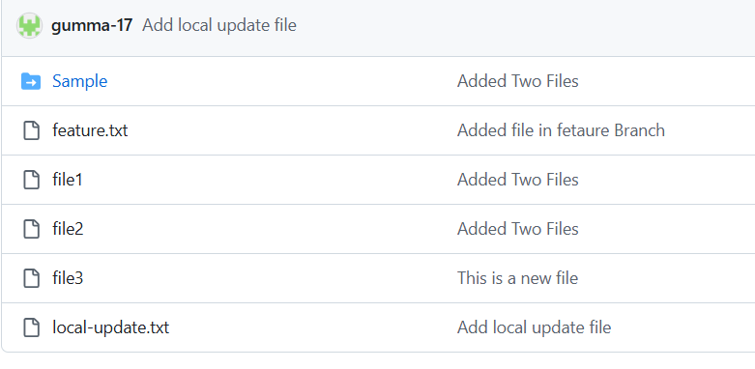

Explanation
Git pushes commits from the current local branch to the corresponding remote branch when the branch is specified.

Real-Time Use Case
A developer sends a completed script or configuration file to a feature branch for review.

Common Errors and Troubleshooting
Error | Solution
File is not staged | Run git add local-update.txt
Push rejected | Fetch remote changes and integrate them
Wrong branch selected | Check git branch --show-current before committing

Conclusion
A new local file was committed and pushed to the selected GitHub branch.

Task 11: Clone Only One Branch from GitHub

Outcome
Only the specified branch is cloned into the local working copy, rather than fetching the full branch history for all remote branches.

Objective
To reduce unnecessary branch downloads when only one branch is needed.

Prerequisites
- Existing GitHub repository.
- Branch name known.
- Repository access.

Step-by-Step Implementation
Open Git Bash.
Navigate to the destination directory:
cd ~/Desktop
Clone only the required branch:
git clone --single-branch --branch feature-local git@github.com:gumma-17/Sample.git
Enter the cloned directory:
cd git-practice

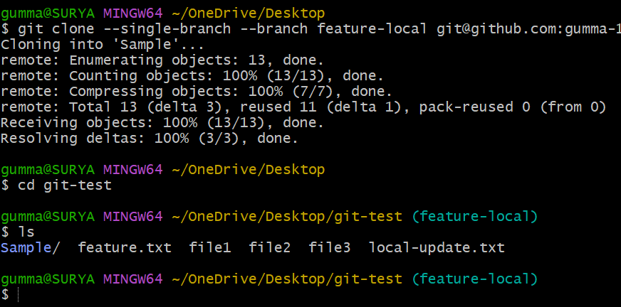

Validation Steps
git branch
git branch -r
git status
The working copy should be on feature-local. Only that branch is configured for fetching by default.

Explanation
--branch specifies the branch to check out. --single-branch limits fetching to that branch. This is not the same as --depth 1, which limits the commit history.

Real-Time Use Case
A deployment job may need only the release branch instead of all development branches.

Common Errors and Troubleshooting
Error | Solution
Branch not found | Verify the exact branch name
Repository access denied | Check URL and authentication
Clone directory already exists | Choose another directory or rename the existing one

Conclusion
A specific GitHub branch was cloned using the single-branch option.

Task 12: Create a Password File and Prevent Git from Tracking It

Outcome
A local password file is excluded from Git tracking using .gitignore.

Objective
To prevent local files containing sensitive information from being accidentally committed.

Prerequisites
- Local Git repository.
- .gitignore file or permission to create one.

Step-by-Step Implementation
Important: Do not put real passwords, API keys, or production secrets into a repository. Use dummy data for this practical.
Create a local password file:
touch passwords.txt
Add the filename to .gitignore:
echo "passwords.txt" >> .gitignore
Check Git status:
git status
The untracked passwords.txt file should not appear.
Commit the ignore rule if appropriate:
git add .gitignore
git commit -m "Ignore local password file"
If the file was already tracked, remove it from the index without deleting the local file:
git rm --cached passwords.txt
git add .gitignore
git commit -m "Stop tracking local password file"

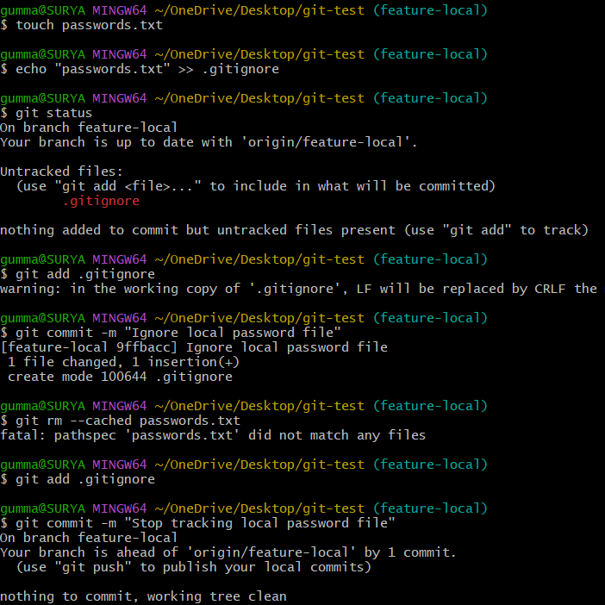

Validation Steps
git check-ignore -v passwords.txt
git status

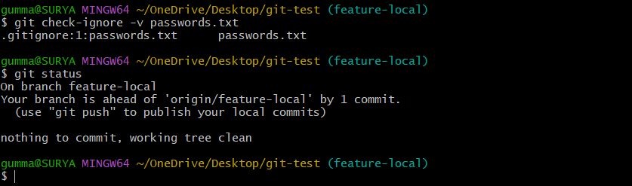

Explanation
.gitignore excludes matching untracked files. It does not automatically stop tracking files that have already been committed.

Real-Time Use Case
Developers exclude local environment files, credentials, logs, and machine-specific configuration from source control.

Common Errors and Troubleshooting
Error | Solution
Password file still appears in Git status | Check .gitignore path and pattern
File is still tracked | Use git rm --cached
Secret was committed previously | Rotate the secret; removing the file from the latest commit is not sufficient

Conclusion
A password file was excluded from Git tracking. Real secrets should be stored in a secure secrets manager, not in source control.

Task 13: Reset a Commit and Discard Its Changes

Outcome
The most recent commit is removed from the current branch, and its changes are discarded from the working tree.

Objective
To understand how git reset --hard changes local commit history.

Prerequisites
- Local Git repository.
- At least two commits in the current branch.
- Understanding that this operation discards work.

Step-by-Step Implementation
Inspect the recent commits:
git log
Confirm the current status:
git status
Reset to the parent of the latest commit:
git reset --hard HEAD~1
Check the updated history:
git log
git status

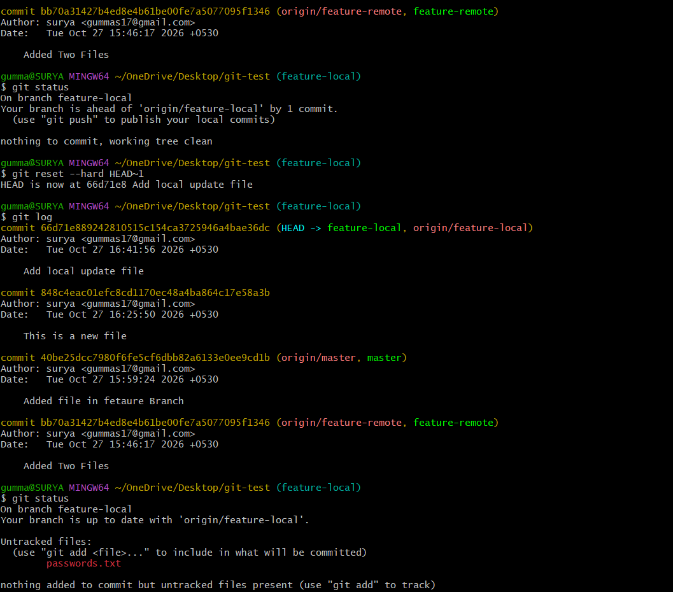

Validation Steps
The previous tip commit should no longer be at the top of the current branch, and changes introduced by that commit should be absent from the working tree.

Explanation
git reset --hard HEAD~1 moves the current branch back by one commit and resets the index and working tree. It can permanently discard uncommitted changes and is destructive. Back up any work you may need before running it.
If the commit has already been pushed and others use the branch, prefer git revert rather than rewriting shared history.

Real-Time Use Case
A developer may discard a mistaken local commit before it is shared with the team.

Common Errors and Troubleshooting
Error | Solution
Changes disappear | Check backups or Git recovery options promptly; recovery is not guaranteed
No parent commit exists | Inspect the history before resetting
Remote history differs | Coordinate with the team before changing shared history

Conclusion
The latest local commit was reset using git reset --hard. This command should be used carefully because it discards changes.

Task 14: Revert a Commit to an Older Version

Outcome
A new commit is created that reverses the changes introduced by an earlier commit.

Objective
To undo a commit without rewriting the existing branch history.

Prerequisites
Git repository with existing commits.
Commit ID to revert.

Step-by-Step Implementation
Display commit history:
git log
Copy the commit ID that introduced the unwanted change.
Revert the commit:
git revert COMMIT_ID
Replace COMMIT_ID with the actual commit hash.
If Git opens an editor, save and close it to accept the default revert message.
If a conflict occurs, resolve the files, stage them, and continue:
git add .
git revert --continue
Push the resulting commit if needed:
git push origin master

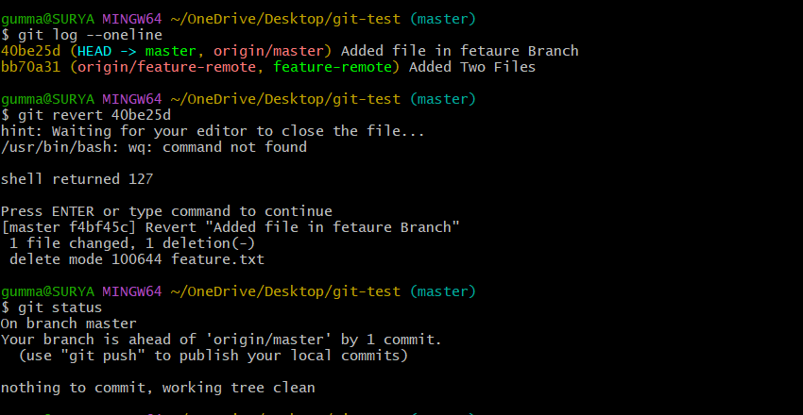

Validation Steps
git log --oneline
git status
Confirm that a new revert commit appears in the history.

Explanation
Unlike git reset, git revert preserves previous commits and adds a new commit that reverses the selected change.

Real-Time Use Case
A team uses revert to undo a faulty production change while preserving the shared commit history.

Common Errors and Troubleshooting
Error | Solution
Invalid commit ID | Copy the correct hash from git log
Revert conflict | Resolve conflicts, stage files, and continue
Nothing to revert | Check whether the change was already reversed

Conclusion
A previous commit was undone by creating a new revert commit.

Task 15: Stash Changes and Work on Another File

Outcome
Changes to one file are saved temporarily in the Git stash, allowing work to continue elsewhere.

Objective
To temporarily set aside unfinished changes without committing them.

Prerequisites
Local Git repository.
A tracked file with modifications.
A clean or understood working state.

Step-by-Step Implementation
Modify a tracked file, for example:
echo "Temporary changes" >> file1.txt
Save the change in the stash:
git stash push -m "Work on file1"
Confirm the working tree is clean:
git status
Work on another file:
echo "Work on a second file" > file2.txt
git add file2.txt
git commit -m "Update second file"

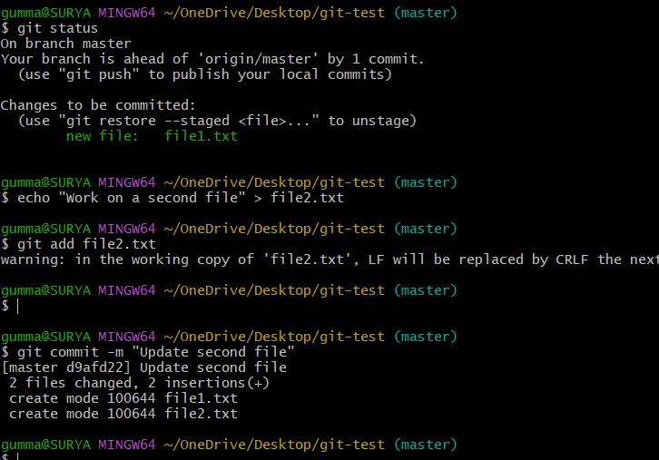

Validation Steps
git stash list
git status
The stash should contain the saved changes, and the second file should be committed independently.

Explanation
git stash push saves tracked working-tree and staged changes in a stash entry. Untracked files are not included by default; use git stash push -u when you also need to stash untracked files.

Real-Time Use Case
A developer temporarily saves unfinished work to switch branches and fix an urgent issue.

Common Errors and Troubleshooting
Error | Solution
Changes are not stashed | Check whether the changes are tracked
Untracked file remains | Use git stash push -u if appropriate
Wrong stash entry selected | Inspect git stash list before applying

Conclusion
Unfinished changes were saved in the stash while work continued on another file.

Task 16: Restore a Stashed File and Continue Working

Outcome
Previously stashed changes are restored to the working tree.

Objective
To retrieve unfinished work from the Git stash.

Prerequisites
- A stash entry created previously.
- Same repository used to create the stash.

Step-by-Step Implementation
View saved stashes:
git stash list
Preview the latest stash:
git stash show -p stash@{0}
Restore the latest stash and remove it from the stash list:
git stash pop
Alternatively, apply the changes without removing the stash:
git stash apply stash@{0}
Continue editing the restored file.
When ready, stage and commit the changes:
git add password.txt.txt
git commit -m "Continue work on file1"

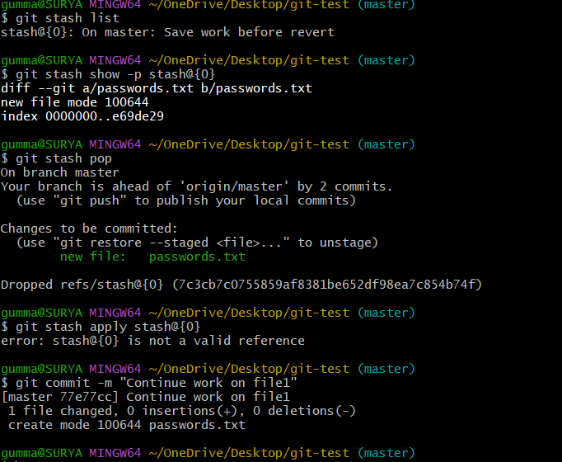

Validation Steps
git status
git stash list
After a successful pop, the applied stash is normally removed. If conflicts occur, Git may retain the stash.

Explanation
git stash pop applies a stash and normally removes it. git stash apply restores the changes while keeping the stash entry.

Real-Time Use Case
A developer restores unfinished feature work after completing an urgent bug fix.

Common Errors and Troubleshooting
Error | Solution
No stash entries found | Check whether the changes were saved in the correct repository
Merge conflicts occur | Resolve the conflicts and inspect the working tree
Changes are not restored | Check the selected stash entry and git status

Conclusion
The saved changes were restored and made available for further development.

Task 17: Generate an SSH Key and Configure It in GitHub

Outcome
An SSH key pair is generated and the public key is added to GitHub.

Objective
To configure SSH authentication for Git operations without repeatedly entering HTTPS credentials.

Prerequisites
- Git Bash installed.
- GitHub account.
- Secure storage for the private key.

Step-by-Step Implementation
Generate an Ed25519 SSH key:
ssh-keygen -t ed25519 -C "your-email@example.com"
Press Enter to accept the default key path, and optionally set a passphrase.
Start the SSH agent:
eval "$(ssh-agent -s)"
Add the private key to the agent:
ssh-add ~/.ssh/id_ed25519
Display the public key:
cat ~/.ssh/id_ed25519.pub
Copy the entire public key output.
On GitHub, open Settings → SSH and GPG keys → New SSH key.
Enter a title, paste the public key, and save it.
Test the connection:
ssh -T git@github.com
If your repository currently uses HTTPS, switch its remote to SSH:
git remote set-url origin git@github.com:YOUR_USERNAME/git-practice.git

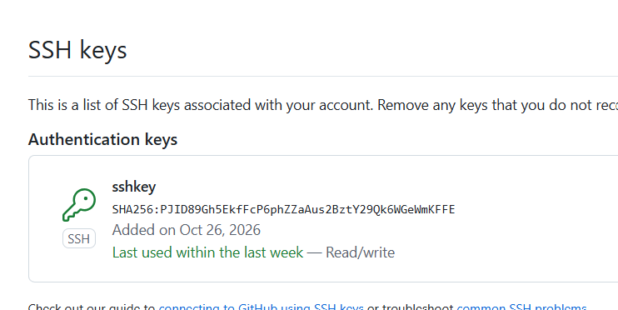

Validation Steps
ssh -T git@github.com
git remote -v
GitHub should authenticate the key and identify your account. The SSH test may report that shell access is unavailable; that is expected.

Explanation
The private key stays on your computer. The public key is uploaded to GitHub to verify your identity.

Real-Time Use Case
SSH authentication is used by developers and deployment systems to access Git repositories securely.

Common Errors and Troubleshooting
Error | Solution
Permission denied (publickey) | Verify that the correct public key is registered
SSH agent has no identities | Run ssh-add ~/.ssh/id_ed25519
Host authenticity prompt appears | Verify the host fingerprint using GitHub's official documentation
Private key exposed | Revoke or replace the key immediately

Conclusion
An SSH key was generated, registered with GitHub, and tested for repository authentication.

Task 18: Configure a Webhook in GitHub

Outcome
A GitHub webhook is configured to send event notifications to an external endpoint.

Objective
To understand how GitHub notifies external systems about repository events.

Prerequisites
- GitHub repository with administrative access.
- A publicly reachable webhook receiver.
- HTTPS endpoint recommended for production.
- Secret configured for signature verification.

Step-by-Step Implementation
Open the GitHub repository.
Navigate to Settings → Webhooks.
Click Add webhook.
Enter the receiver's public payload URL, for example:
https://your-domain.example/webhook
This is an example URL; it must be replaced with a real endpoint that accepts GitHub webhook requests.
Select the content type, usually application/json.
Set a webhook secret known to both GitHub and the receiver.
Choose the events to send, such as Just the push event.
Enable the webhook and click Add webhook.
Push a test commit to the repository.
Open the webhook's Recent Deliveries section and inspect the response.


Validation Steps
Confirm the webhook appears in repository settings.
Trigger the selected event.
Check delivery status and receiver logs.
Verify the receiver validates GitHub's webhook signature.

Explanation
A webhook sends an HTTP request to a configured endpoint when a selected GitHub event occurs. A receiver can use these events to start CI/CD pipelines, notify teams, or trigger automation.

Real-Time Use Case
A push to GitHub can trigger a build and deployment pipeline in a CI/CD platform.

Common Errors and Troubleshooting
Error | Solution
Connection refused | Ensure the endpoint is running and reachable
HTTP 404 | Verify the payload URL and route
HTTP 401 or 403 | Check receiver authentication and configuration
Webhook delivery fails | Inspect GitHub delivery details and receiver logs

Conclusion
A webhook was configured to notify an external endpoint about repository events. Reliable operation requires a reachable receiver and appropriate security checks.

Task 19: Understand the .git Directory

Outcome
The main contents of the local .git directory are inspected.

Objective
To understand how Git stores repository metadata, commits, references, and configuration.

Prerequisites
- Existing local Git repository.
- Git Bash opened in the repository directory.

Step-by-Step Implementation
Navigate to the repository:
cd ~/Desktop/git-test
List hidden files:
ls -la
Inspect the .git directory:
ls .git

Check the Git directory location:

git rev-parse --git-dir
Check the current branch:
git branch --show-current

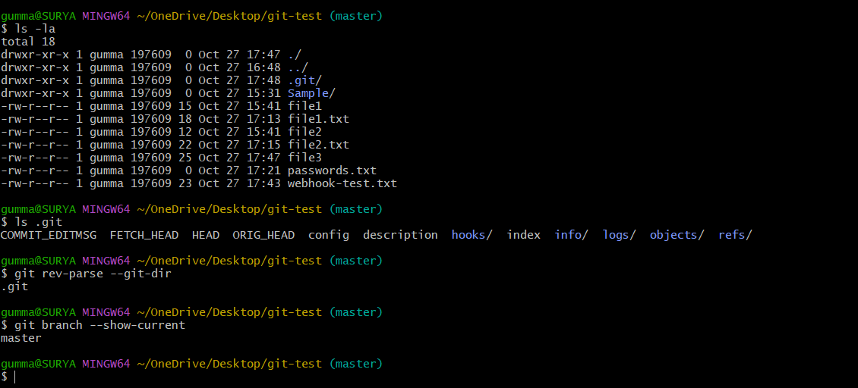

Validation Steps
Run:
git status
git log --oneline
Git should identify the repository and display its commit history.

Explanation
Common entries inside .git include:
Item | Purpose
HEAD | Identifies the current branch or commit
config | Stores local repository configuration
objects/ | Stores Git objects, including content and commit data
refs/ | Stores references to commits, such as branch references
index | Stores the staging area's information
logs/ | Stores reference movement history when available
The exact structure can vary. Some repositories use packed references, worktrees, or other Git storage formats.

Real-Time Use Case
Understanding .git helps troubleshoot repository state, branches, and commit history.

Common Errors and Troubleshooting
Error | Solution
.git not visible | Run ls -la or check whether the directory is a repository
Not a Git repository | Navigate into the cloned repository
.git directory deleted | Restore from a backup or re-clone the repository

Conclusion
The .git directory was inspected to understand Git's local metadata and version history storage.

Task 20: Check Git Commit Logs

Outcome
The commit history is displayed using Git log commands.

Objective
To inspect previous commits, authors, timestamps, and changes.

Prerequisites
Git repository containing commits.

Step-by-Step Implementation
Display the full commit log:
git log
Display a concise log:
git log --oneline
Display a graph of branches:
git log --oneline --graph --decorate --all
Display the latest five commits:
git log -5 --oneline
Inspect the changes in the latest commit:
git show HEAD
Inspect commits that changed a specific file:
git log --oneline -- file1.txt

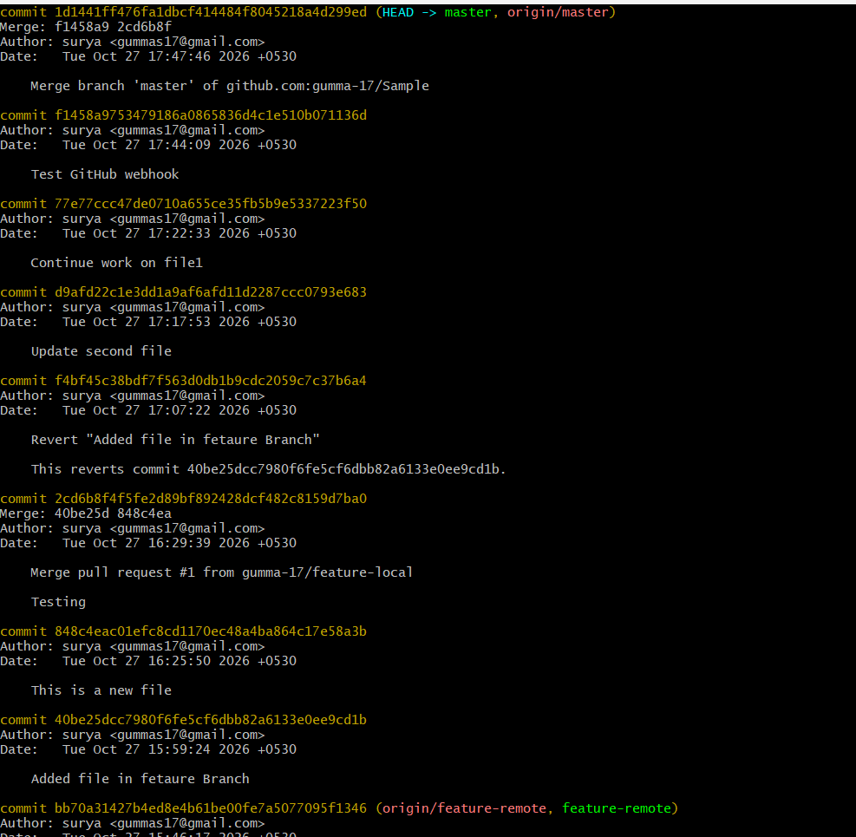
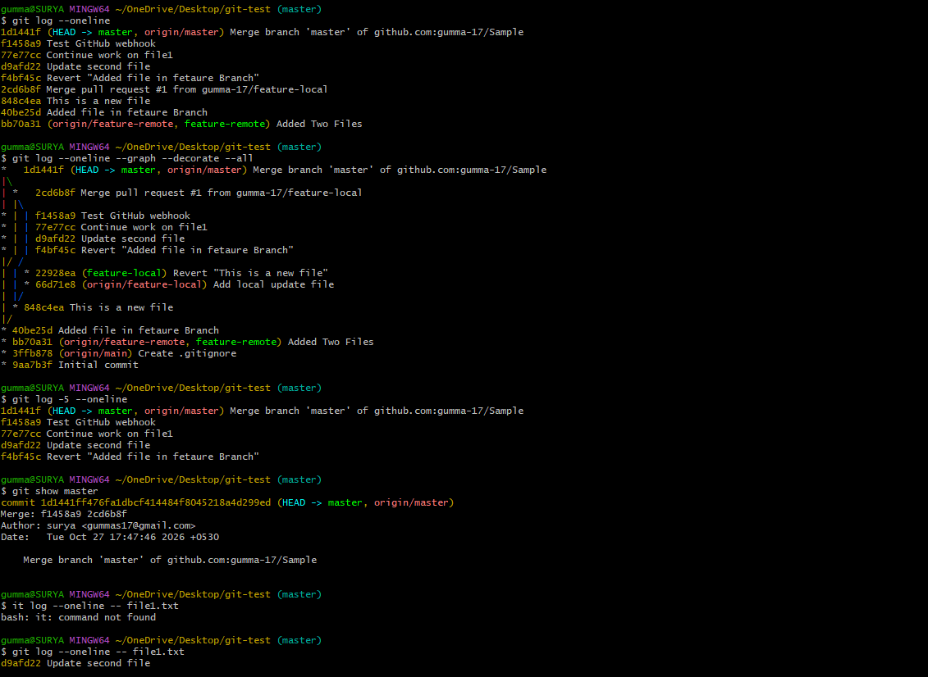

Validation Steps
Confirm that the log displays commit IDs, commit messages, and the expected history.

Explanation
git log provides a record of commit history. Options allow the user to filter or format the output.

Real-Time Use Case
Developers inspect history to identify when a change was introduced or which commit needs review.

Common Errors and Troubleshooting
Error | Solution
No commits displayed | Create a commit first
Wrong repository history | Check the current directory
Commit not shown | Check branch selection and use --all

Conclusion
Git history was inspected using multiple log commands.

Task 21: Rename the Latest Commit Message

Outcome
The latest commit message is changed using git commit --amend.

Objective
To correct or improve a commit message.

Prerequisites
- Git repository with at least one commit.
- Awareness that amending changes the commit ID.

Step-by-Step Implementation
View the latest commit:
git log -1 --oneline
Change the latest commit message:
git commit --amend -m "Corrected commit message"
Verify the updated message:
git log -1 --oneline

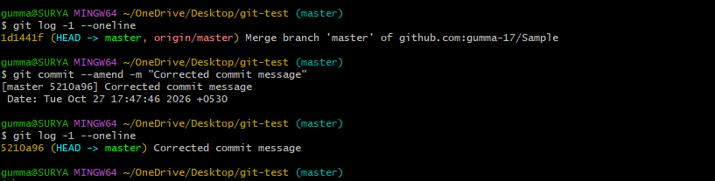

Validation Steps
Confirm that the latest commit displays the corrected message.

Explanation
git commit --amend replaces the latest commit with an amended commit. The commit hash changes.
If the original commit has already been pushed to a shared branch, coordinate with collaborators before rewriting history. A new push may require a carefully coordinated force push; avoid force-pushing shared branches casually.

Real-Time Use Case
A developer corrects a typo or clarifies a commit message before submitting a pull request.

Common Errors and Troubleshooting
Error | Solution
No changes to amend | Confirm that a commit exists
Wrong commit amended | Inspect the history before continuing
Remote rejects the push | Check whether the commit was already published and coordinate before rewriting remote history

Conclusion
The latest commit message was changed and verified.

Task 22: Merge Multiple Commits into a Single Commit

Outcome
Multiple commits are combined into one commit using interactive rebase.

Objective
To clean up local commit history before sharing changes.

Prerequisites
- Git repository with multiple commits.
- Clean working tree.
- Understanding of interactive rebase.

Step-by-Step Implementation
Inspect the latest commits:
git log --oneline -5
Start an interactive rebase for the last three commits:
git rebase -i HEAD~3
An editor opens with the commits listed from oldest to newest, similar to:
pick abc1234 First change
pick def5678 Second change
pick ghi9012 Third change
Keep pick for the first commit and change the next two lines to squash:
pick abc1234 First change
squash def5678 Second change
squash ghi9012 Third change
Save and close the editor.
If prompted, edit the combined commit message, then save and close the editor.
Verify the result:
git log --oneline -5

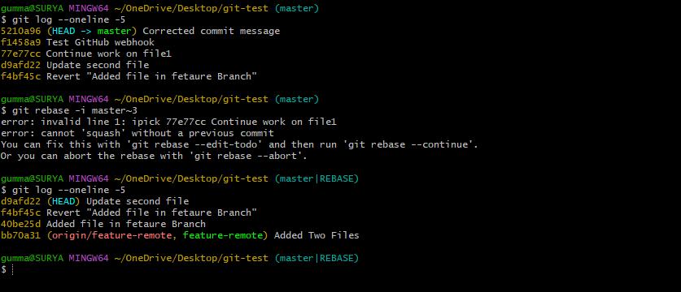

Validation Steps
Confirm that the three selected commits have been combined into a single commit.

Explanation
Interactive rebase allows commits to be reordered, edited, dropped, or squashed. Squashing combines changes and commit messages into a new commit.
Important: Rewriting commits changes history. Use this technique primarily on local or private branches. If the original commits were already pushed, coordinate with collaborators before updating the remote branch.

Real-Time Use Case
Developers squash several small development commits into one logical commit before merging a feature branch.

Common Errors and Troubleshooting
Error | Solution
Rebase conflicts | Resolve conflicts, stage files, and run git rebase --continue
Rebase started by mistake | Use git rebase --abort if the rebase is still in progress
Incorrect commits selected | Inspect git log before starting the rebase
Remote push rejected after rewriting history | Coordinate with collaborators and review the appropriate recovery procedure

Conclusion
Multiple commits were combined into one using interactive rebase, producing a cleaner commit history.

