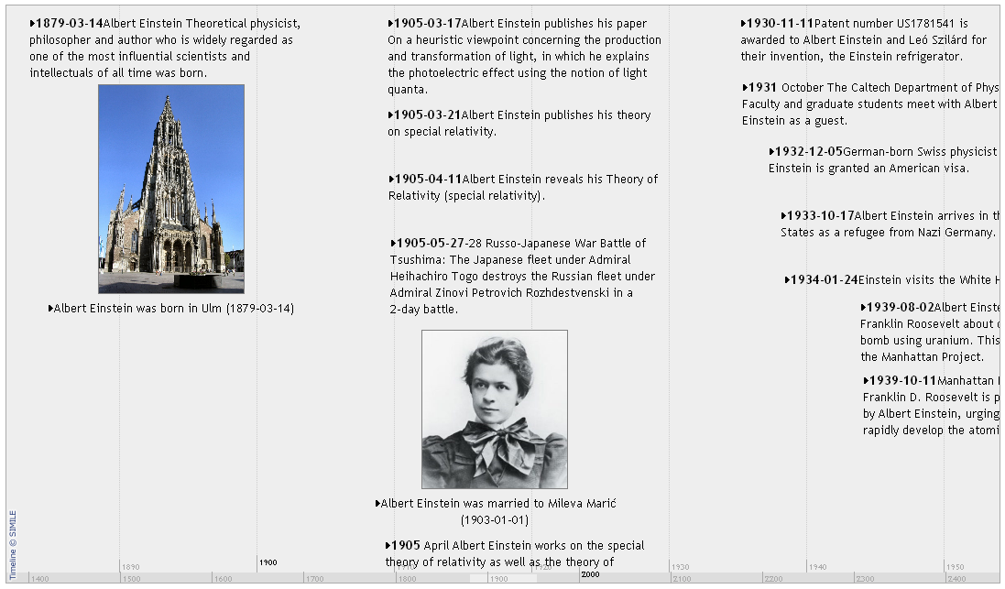

**Entity image**

**Time point**

**Upper band**

**Lower band**