# Autonomy delegation to foreign subsidiaries: An enabling mechanism for emerging-market multinationals

(赋予外国子公司自治权：新兴市场跨国公司的授权机制)

## INTRODUCTION

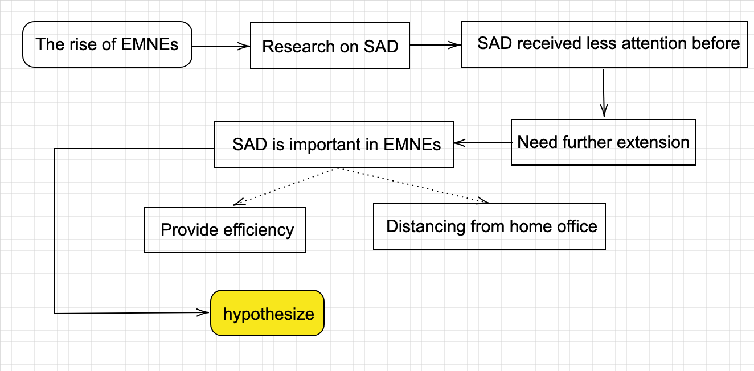

INTRODUCTION

The rise of emerging-market multinational enterprises (EMNEs) provides an ideal opportunity to complement a long line of research on the antecedents of **subsidiary autonomy delegation** in the area of international business.

Subsidiary autonomy received less attention in early MNE-centered perspectives and greater attention in later subsidiary-based perspectives.

* **early MNE-centered perspectives**: focus on the benefits of control and efficiency in exploiting home-based advantages.
* **later subsidiary-based perspectives**: emphasize the increased importance of subsidiaries in the widespread and complex MNE network.

Complex institutions in emerging economies are conducive to **disadvantages**, rather than advantages, in global competition for internationalizing domestic firms.

Traditional views on the design of foreign subsidiary autonomy need further extension. Building on theoretical developments proposing that internationalization can be a way for EMNEs to overcome home-country-based disadvantages at both the firm and country levels (Bartlett & Ghoshal, 2000; Boisot & Meyer, 2008; Luo & Tung, 2007; Mathews, 2006), we argue that **EMNEs use subsidiary autonomy delegation as a key strategic mechanism and an organizational platform to lessen their home-originated weaknesses after foreign entry**.

Subsidiary autonomy plays a twofold role for EMNEs:

1. Providing efficiency in EMNEs’ approaches to overcome latecomer disadvantages.
   1. **Metanational advantage**(firms benefit from tapping globally dispersed knowledge, rather than from exploiting advantages learned in the home country).
      1. Strategic asset-seeking behaviors to compensate for EMNEs’ deficiencies in brand recognition, technological knowledge, and managerial expertise (Child & Rodriguez, 2005)
      2. Opportunity-seeking behaviors to exploit existing resources, and access and leverage locally embedded knowledge from around the world (Gubbi, Aulakh, Ray, Sarkar, & Chittoor, 2010)
   2. **However**, these approaches require abilities which can be challenging to accomplish without prior international experience and organizational expertise to organize complex activities globally, as well as in a realm of domestic institutional constraints.
      1. Organizational learning (Mathews, 2006)
      2. Development of strong learning capabilities (Bartlett & Ghoshal, 2000)
2. Distancing the foreign subsidiary from home office impediments instilled by the domestic institutional environment.
   1. Domestic institutions in emerging economies can impose constraints for the post-entry foreign operation of EMNEs.
      1. EMNEs may suffer from weak corporate governance and accountability (Luo & Tung, 2007)
      2. Have generally poor credibility and image in the host country (Bartlett & Ghoshal, 2000)
   2. In addition, as a consequence of the institutional voids in emerging economies (Khanna & Palepu, 1997), it is particularly relevant during the post-entry stage in host countries, and hence requires remedies different from the ones that focus on circumventing institutional voids in the home country (Khanna & Palepu, 2010)

hypothesize that subsidiary autonomy delegation is particularly salient among those EMNEs that rely on foreign markets as a springboard to acquire strategic assets.

## THEORY DEVELOPMENT

### Antecedents of Subsidiary Autonomy

Emphasis on **subsidiary autonomy** has increased as research moved from **MNE-centered** to **subsidiary-centered** perspectives (Paterson & Brock, 2002)

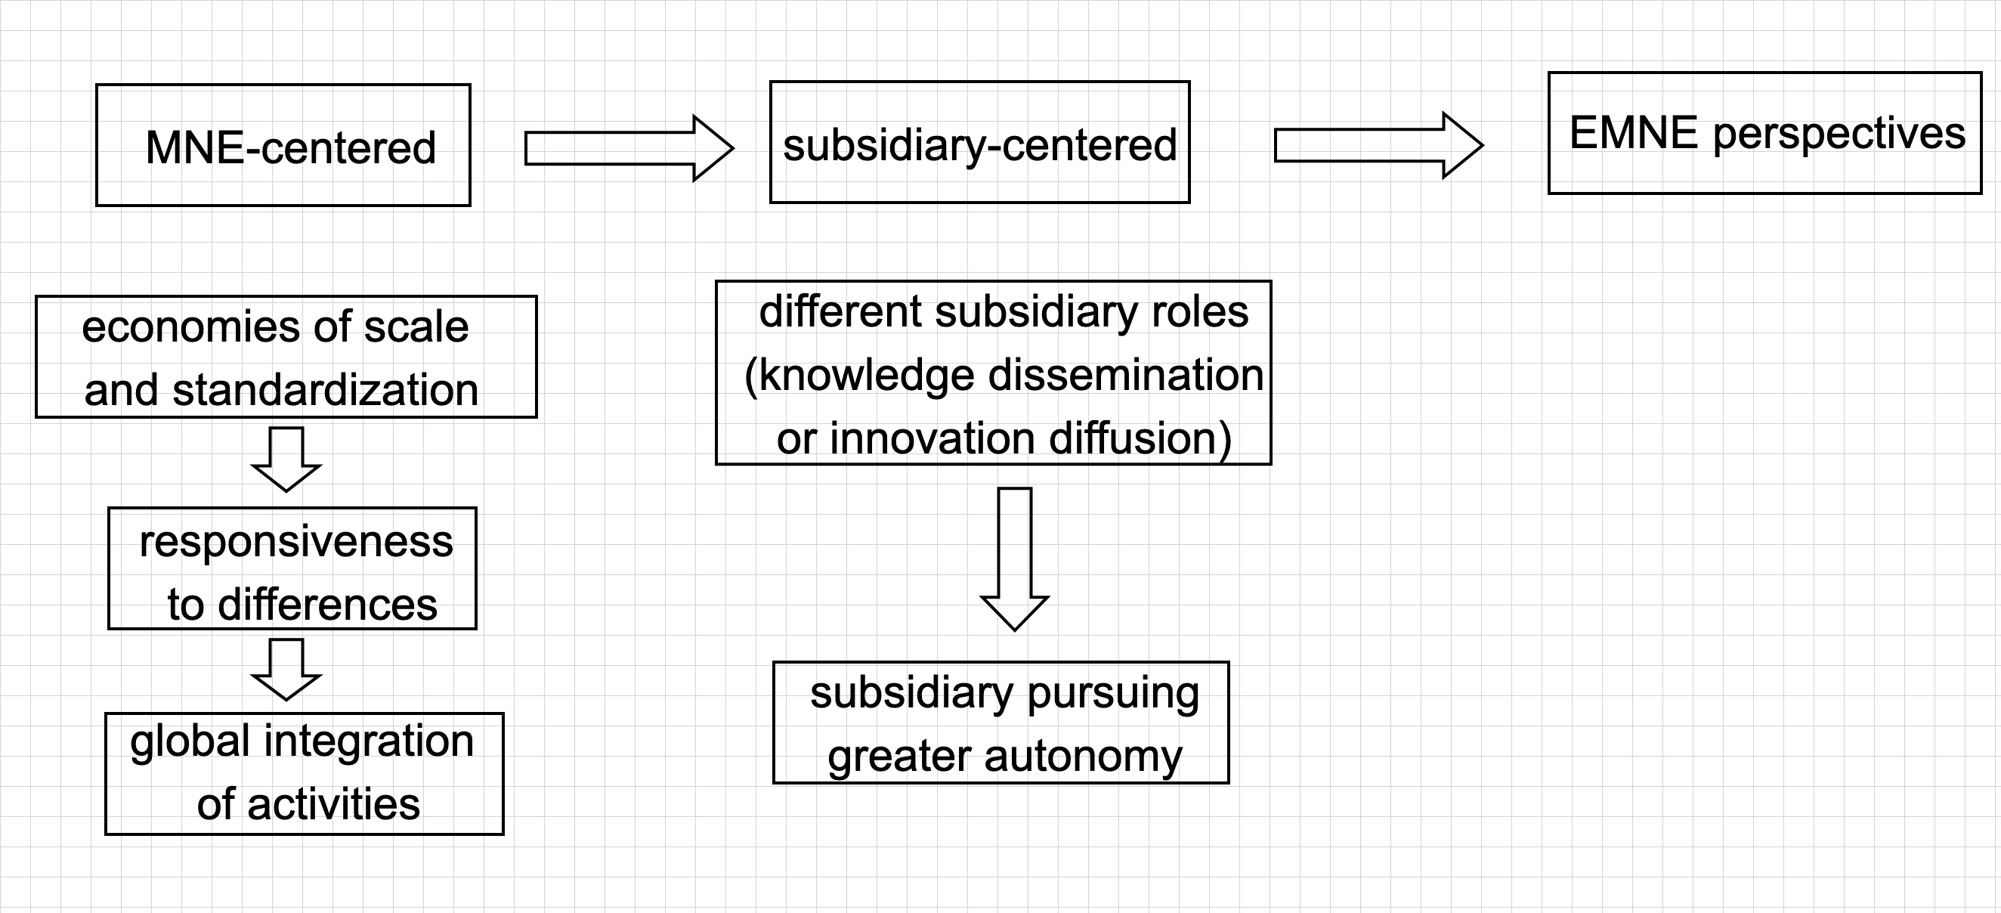

Antecedents of Subsidiary Autonomy

On the basis of the experiences of MNEs from **advanced economies**, the evolution of these views is fundamentally based on the idea of exploiting ownership advantages built in the home country (Dunning, 1988, 1993) and incrementally expanding global operations (Johanson & Vahlne, 1977, 1990).

Traditional views on the antecedents of subsidiary autonomy are difficult to apply – neither can the MNE-centered perspectives be applied to the resource-disadvantageous position of EMNEs, nor can the subsidiary-centered perspectives be easily applied to the fledgling network of most EMNEs.

### EMNE Perspectives

The pioneering scholarly works on EMNEs, includ- ing the work of Kumar and McLeod (1981) and Wells (1983), have provided unique features of EMNEs, such as:

* the lack of proprietary advantages
* weaker home institutions
* the latecomer status.

Recent theoretical developments have particularly highlighted **how EMNEs use internationalization to overcome their existing disadvantages** on the global stage (Bartlett & Ghoshal, 2000; Luo & Tung, 2007; Mathews, 2002, 2006).

Nevertheless, according to a recent study by *McKinsey Quarterly*,in the last decade EMNEs grew approximately **twice as fast** as those domiciled in advanced economies (Atsmon, Kloss, & Smit, 2012).

The insufficiency of mainstream internationalization theories, such as the eclectic paradigm (Dunning, 1988, 1993) and the internationalization process model (Johanson & Vahlne, 1977, 1990), to explain this phenomenon has spurred the development of other theoretical perspectives:

1. **springboard perspective** (Luo & Tung, 2007)
2. **linkage-leverage-learning (LLL) framework** (Mathews, 2002, 2006)

### EMNEs’ Post-Entry Disadvantages