TRADING EXCHANGE
Backend
A concurrent spot exchange in Java 26 + Spring Boot 4
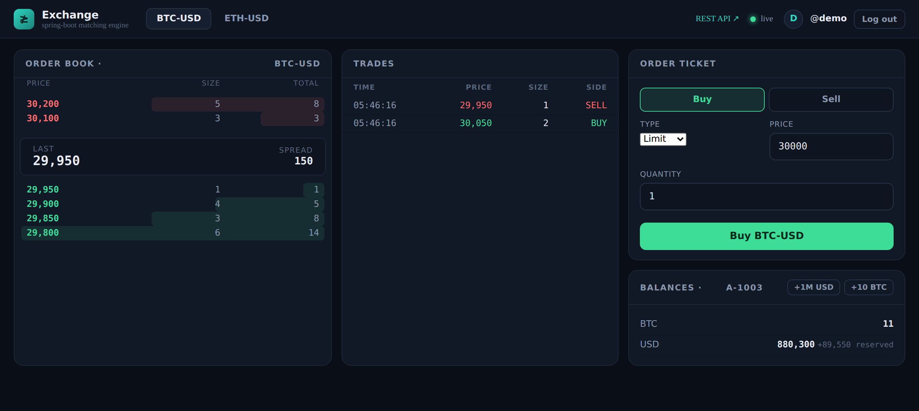
Live trading dashboard — order book, trade tape, order ticket and balances over REST + WebSocket.
Matching | Money model | Concurrency | API
Price-time priority | Exact integer units | Per-symbol locks | REST + WebSocket

Contents
1 Overview
2 Architecture
3 The Matching Engine
4 Accounts, Reservation & Atomic Settlement
5 Concurrency & the Conservation Invariant
6 Authentication & Authorization
7 REST + WebSocket API
8 Testing
9 Running It
10 Honesty Notes & Production Extensions

1 Overview
This is a self-contained spot trading exchange built with Java 26 and Spring Boot 4 (on Spring Framework 7). It provides a thread-safe, price-time-priority matching engine, full account and balance management with fund reservation and atomic settlement, stateless JWT authentication (username/password and Google sign-in), and a REST + WebSocket API with OpenAPI documentation and a live dashboard.
The defining engineering property is conservation of value: matching only ever transfers assets between accounts — it never creates or destroys them. This invariant is enforced by the settlement logic and verified by a concurrency test that fires 8,000 orders across 8 threads and asserts the total quantity of every asset is exactly unchanged.

What it demonstrates
- Correct concurrent state management under a clear, deadlock-free locking model.
- Careful money handling — exact integer arithmetic, no floating-point currency.
- Clean layered architecture with a framework-independent domain and engine.
- REST and WebSocket API design with validation and structured error handling.
- Stateless security with Spring Security + JWT, and authorization derived from the token rather than the request.
- A test suite that proves the hard invariants, not just the happy path.

2 Architecture
A standard layered Spring Boot application. The domain and engine are plain Java with no framework coupling, which keeps them fast to unit-test in isolation.
web/ REST controllers, WebSocket handler, exception handler
|
service/ ExchangeService (locking, settlement), AccountService
|
engine/ MatchingEngine - pure price-time matching -> Fills
|
domain/ Order, Trade, OrderBook, Account, Instrument, enums
|
repository/ in-memory stores behind simple interfaces
A request enters through a controller, is validated, and reaches ExchangeService, which reserves funds, calls the MatchingEngine, settles each resulting fill atomically against the two accounts, records the trade, and publishes a live update to WebSocket subscribers.

3 The Matching Engine
Each instrument has one order book. Each side is a price-sorted map of FIFO queues: bids sorted descending (best = highest), asks ascending (best = lowest), and within a price level orders form a FIFO queue so earlier arrivals match first.
This yields price-time priority — better prices first, ties broken by arrival — with O(log L) access to the best level in the number of price levels L.

Rules
- Trades print at the resting maker's price.
- A LIMIT order not fully filled rests in the book.
- A MARKET order never rests; any remainder is cancelled.
- A MARKET BUY is capped by a quote budget, since its cost is unknown until it executes — guaranteeing every fill is affordable.

4 Accounts, Reservation & Atomic Settlement
Every account holds, per asset, an available balance (spendable) and a reserved balance (held against open orders). Placing an order reserves the funds it might spend, so they cannot be double-spent:
Order | Reserves
Limit buy | quantity x price of the quote asset
Limit sell | quantity of the base asset
Market sell | quantity of the base asset
Market buy | nothing up front; capped by available quote as a budget

Each fill then settles atomically. The seller spends reserved base and receives quote; the buyer spends quote (from reserved for a limit order, from available for a budgeted market buy) and receives base. A limit buy that executes below its limit has the difference refunded from reserved back to available — bid 100, trade at 90, keep the 10.

Money is always integer
All prices and quantities are long integers in the asset's smallest tradable unit, so notional = price x quantity is exact. There is no double anywhere in the money path — floating-point currency bugs are an unacceptable class of error in an exchange.

5 Concurrency & the Conservation Invariant
- All activity on an instrument is serialised under a per-symbol ReentrantLock, so one book behaves as if single-threaded while different symbols run in parallel.
- Account balance mutations are atomic per account, so there are no lost updates when an account trades on several symbols at once.
- The service never holds two account locks at once, so there is no lock-ordering deadlock.
The ConcurrencyTest exercises this directly: 8 threads each place 1,000 random orders against a shared book, after which it asserts total USD and total BTC are unchanged to the unit, no balance is negative, and the run did not deadlock.

6 Authentication & Authorization
Access is gated by a login/register screen and secured with Spring Security and stateless JWT bearer tokens. Users authenticate in one of two ways:
- Username / password. Registration hashes the password with BCrypt, provisions a fresh trading account, and returns a signed token; login verifies the hash.
- Google sign-in. The browser obtains a Google ID token via Google Identity Services; the server verifies its signature against Google's public JWKS and checks issuer and audience before issuing its own token, provisioning an account on first sign-in.
Tokens are HMAC-SHA256 JWTs carrying the username and linked accountId, minted with Spring Security's JwtEncoder and validated by the OAuth2 resource server on every protected request. Two authorization choices are worth highlighting:
- The trading account is taken from the token, never the request body — a user can only ever act on their own funds.
- Reading a resource you don't own returns 404, so the API never confirms the existence of other users' accounts or orders.
Market-data reads, the WebSocket feed, the docs and the login page are public; everything else requires a token. Google sign-in is enabled by setting GOOGLE_CLIENT_ID and registering http://localhost:8080 as an authorized origin; unset, the app runs with username/password only.
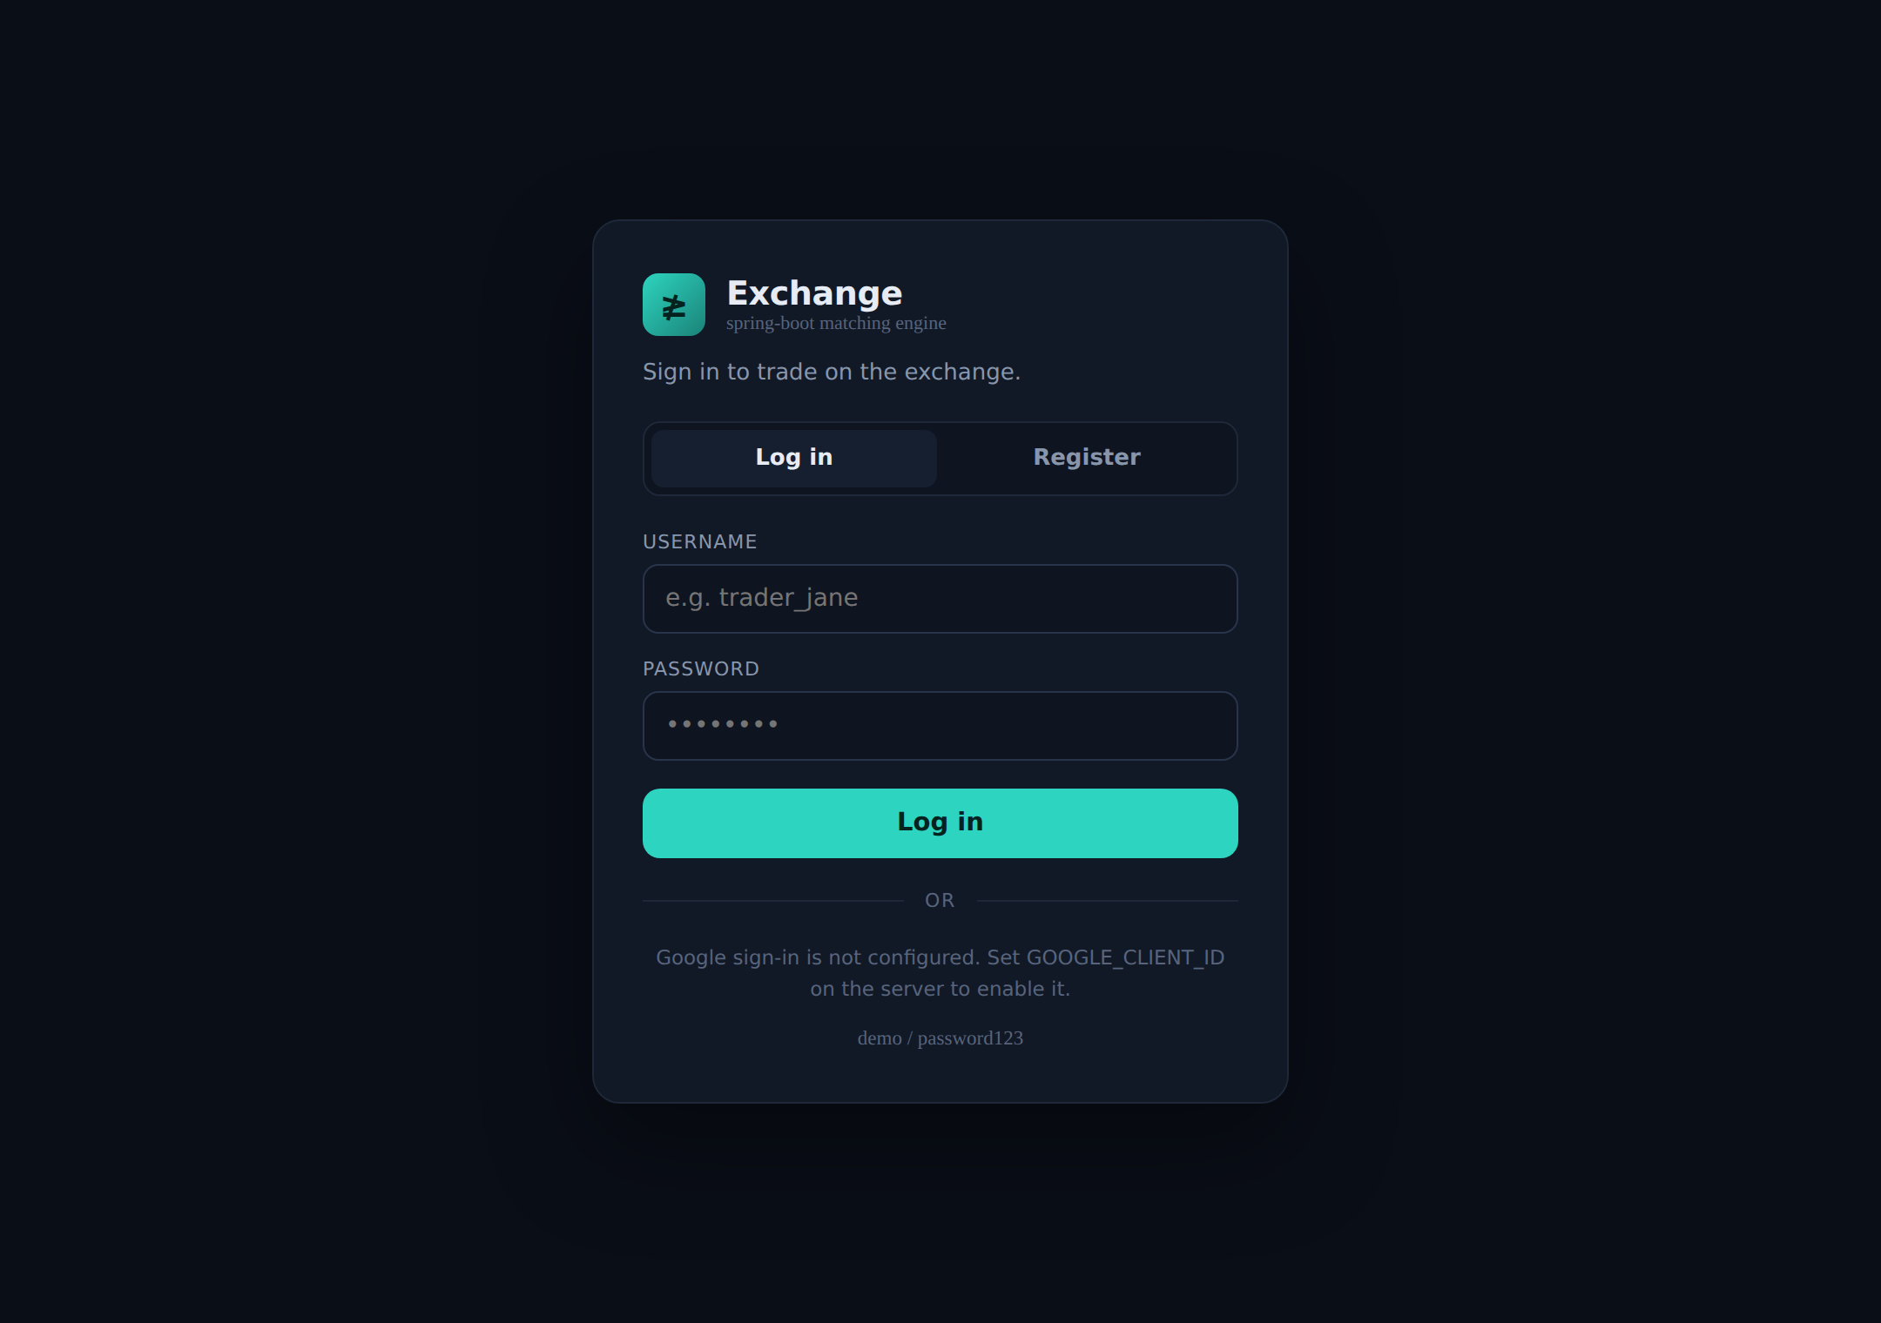
The login screen — username/password with an optional Google sign-in button.

7 REST + WebSocket API
Base path /api. Interactive OpenAPI docs at /swagger-ui.html. A lock icon marks endpoints that require a bearer token.
Method | Path | Description
POST | /api/auth/register | Create a user (returns token + accountId)
POST | /api/auth/login | Log in with username/password
POST | /api/auth/google | Log in with a Google ID token
GET | /api/auth/me 🔒 | Current user + balances
POST | /api/orders 🔒 | Place an order on your account
GET | /api/orders/{id} 🔒 | Order status (owner only)
DELETE | /api/orders/{id} 🔒 | Cancel (owner only)
GET | /api/accounts/{id} 🔒 | Account with balances (owner only)
GET | /api/market/{symbol}/book | L2 order-book depth
GET | /api/market/{symbol}/trades | Recent trades
WS | /ws/market | Live book & trade events

Errors return clean JSON with the correct status: 401 (missing/invalid token), 404 (unknown or unowned account/order), 422 (rejected — bad market, insufficient funds, invalid credentials), 400 (validation).

8 Testing
17 tests across four suites, all passing:
Suite | Tests | Covers
MatchingEngineTest | 6 | priority, multi-level sweeps, market budget, resting
ExchangeServiceTest | 6 | reservation, settlement, refunds, rejects, cancel
ConcurrencyTest | 1 | conservation of value under 8x1,000 orders
ApiIntegrationTest | 4 | authenticated trade flow, 401, 400, bad login (MockMvc)

$ mvn test
Tests run: 17, Failures: 0, Errors: 0, Skipped: 0
BUILD SUCCESS

9 Running It
Requires JDK 26.
mvn spring-boot:run # http://localhost:8080
# login : http://localhost:8080/ (demo / password123)
# swagger : http://localhost:8080/swagger-ui.html

docker compose up --build # containerised, port 8080
A starting BTC-USD book and a ready demo login (demo / password123) are seeded on launch; or register your own auto-funded user. Set GOOGLE_CLIENT_ID to enable Google sign-in.

10 Honesty Notes & Production Extensions
This is a faithful model of an exchange's core, not a production venue. The simplifications, and how each would be hardened:
- In-memory state. Accounts, orders and trades are lost on restart; repositories sit behind interfaces so a JPA/PostgreSQL store with a persisted trade log can drop in.
- Integer money. Production would use a typed money abstraction and per-instrument tick/lot rules.
- Authentication is implemented; authorization is coarse. Password + Google login and per-account ownership are in place, but there are no roles, no token refresh/revocation, and users are held in memory. Production would persist users and add refresh tokens and finer scopes.
- Self-trades allowed. Real venues add self-trade prevention.
- Single node. One process with in-memory locks; a real engine is often a single-writer event loop per symbol with a replicated log for HA.
- Order types. Only LIMIT and MARKET — no stop, IOC/FOK, or post-only.
None of these affect the correctness of what is implemented — matching, reservation, settlement and the conservation invariant all hold as tested.

