AIR QUALITY ANALYSIS IN TAMILNADU

**PHASE 2:Innovative approach**:

INTRODUCTION:

Predicting the quality of air is a complex task as there is a dynamic nature, high variability of pollutants and particulates. Air quality modelling and analysis is also becoming more relevant in metropolitan areas owing to the rise in human population and human-made activities and environmental change. Therefore the innovations in this analysis could provide us the better examples of how the air quality index can be analysed. Also we have enclosed the steps involved in determining the air quality analysis in Tamilnadu.

1. Empathize and User-Centric Data Collection:

- Develop a mobile application that allows residents to report real-time air quality observations using their smartphones.

- Integrate data from air quality sensors, wearables, and satellite imagery to create a comprehensive picture of air quality in different locations.

- Utilize AI and machine learning algorithms to analyze user-generated data and identify air quality hotspots and trends.

2. Define and AI-Driven Problem Identification:

- Implement an AI-powered system that processes and interprets the collected data, automatically identifying pollution sources and patterns.

- Develop personalized air quality profiles for residents, alerting them to health risks and suggesting preventive measures.

- Collaborate with data scientists and environmental experts to refine algorithms and continuously improve the system.

3. Ideate and Innovative Solutions:

- Explore novel approaches like urban greenery initiatives, where AI is used to plan and optimize the placement of green spaces in urban areas.

- Develop virtual reality (VR) simulations to educate the public about the impact of their daily choices on air quality, promoting behaviour change.

- Create a blockchain-based platform for incentivizing emission reduction actions by individuals, industries, and transportation providers.

4. Prototype and Advanced Monitoring:

- Deploy state-of-the-art, low-cost air quality sensors throughout the state, connected to a cloud-based network.

- Create 3D air quality models using real-time data for more accurate predictions and visualizations.

- Experiment with autonomous drones equipped with air quality sensors to monitor remote and inaccessible areas.

5. Test and Smart City Initiatives:

- Implement smart city projects in collaboration with local governments, incorporating AI-driven air quality management.

- Launch autonomous electric bus fleets, reducing emissions and congestion, while monitoring air quality along their routes.

- Partner with local tech startups to develop innovative air purification technologies and test them in urban settings.

6. Implement and Policy Advocacy:

- Establish partnerships with government agencies to advocate for and enforce stricter environmental regulations.

- Develop a "Clean Air Certification" program for industries and businesses, promoting environmentally responsible practices.

- Collaborate with policymakers to create incentives and subsidies for electric vehicles and green technologies.

7. Evaluate and Data-Driven Decision-Making:

- Continuously monitor air quality improvements using AI analytics and geospatial data.

- Engage citizens in data interpretation, involving them in decision-making processes.

- Regularly update and refine the AI algorithms and solutions based on real-time data and community feedback.

**FLOWCHART FOR THE STEPS INVLOVED IN AIR QUALITY ANALYSIS IN TAMILNADU IS GIVEN BELOW:**

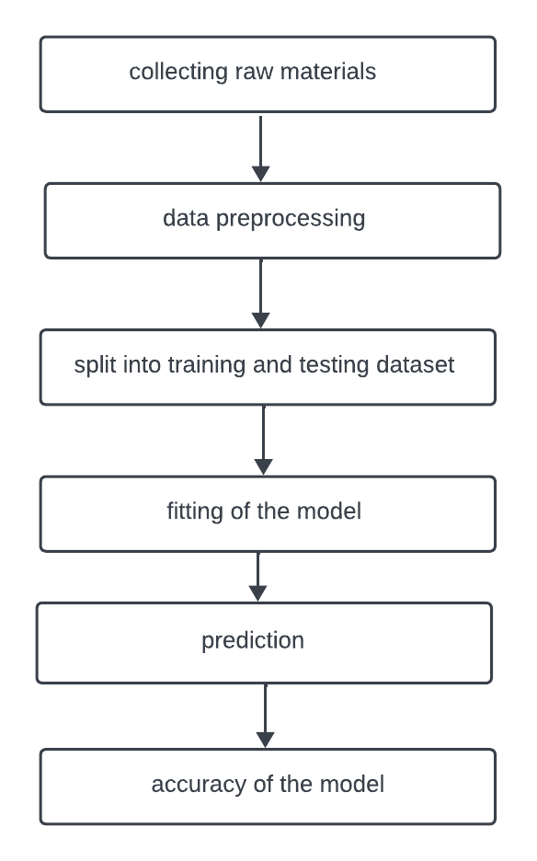

**Collecting the Raw Data:**

Data collecting is the technique of aggregating and analysing data from various sources. Keeping track of previous events allows one to use data analysis to identify recurring patterns. Air Quality is a collection of statistics collected from the internet. The dataset included four independent variables (HC, NOX, SO, and HUMID) and one target variable (Pollution), all of which were measured as shown in Figure 3. Each attribute is represented with a value these are used as raw data.

**Pre-processing:**

To transform raw data into a form that machine learning algorithms can utilize to gain insights or predict outcomes, the process of data pre-processing is termed. The data processing approach used in this project is the search for missing values. It's difficult to get all the data points for every record in a dataset. If there are any empty cells, fill the values for it. There were no missing values in the dataset utilized for the research.

**Train and test split :**

The dataset is divided into a training dataset and a testing dataset using the train test split () technique in the scikit learn module. A training dataset (80% of the dataset) and a testing dataset (20% of the dataset).

**Fitting the model:**

The process of fine-tuning a model's parameters in order to improve its accuracy is called fitting. To construct a machine learning model, an algorithm is performed on data for which the target variable is already known. In order to assess the correctness of a model, it must be compared against real, observed values of the target variable. When a machine learning model is able to generalize data that it was trained on, it is called model fitting. A good model fit is one that reliably predicts the result when given unknown inputs

**Accuracy of Model :**

Machine learning models may be used to predict the values of fresh input data, which is known as scoring. The degree to which a model has improved over time may be determined by calculating its accuracy score () using a training dataset.

**Predicting the Model:**

"Prediction" is the term used to describe the outcome of an algorithm after it has been trained on a prior dataset and applied to fresh data. Using the test feature dataset to forecast the model with predict () method. It produced an array of expected values as the output.

**CONCLUSION**:

By combining user-centric data collection, cutting-edge technology, and policy advocacy, this innovative approach aims to create a sustainable and holistic solution for addressing air quality in Tamil Nadu. It leverages the power of AI, IoT, and blockchain to engage the community, businesses, and policymakers in a collective effort to combat air pollution and improve the quality of life in the region.