Statistics

Descriptive statistics:

Statistics involving describing data. Involves summarizing and organizing data so they can be easily understood.

Inference statistics:

Complex set of procedures to draw conclusions over large populations with sample data.

Data

Numeric: wind speed, time duration, discrete etc.

Categorical: Car types, Binary, ordinal (ordered).

*------------------- 5/7/2024 Up to Page 5*

Exploratory Data Analysis

Data Structure:

* Rectangular (rows are records & columns are variable or features) and
* Non-Rectangular (spatial or graph)

In statistics we use mostly rectangular data:

**Estimates of Location**

An estimate of where most of the data is located (i.e., its central tendency)

|  |  |  |  |
| --- | --- | --- | --- |
| Key Term | Definition | Formula | Usage |
| Mean | Sum of all values/ number of values |  | average |
| Weighted Mean | Sum of all values times a weight / sum of weights |  | Some variables are intrinsically more variable than other and high variable observations are given lower weight. Ex: when taking average from multiple sensors giving lower weight for sensors that giving less accurate readings. |
| Median | The value such that one-half of data lies above and below |  | While calculating average household income in a city where bill gate lives the mean gives diff value where median gives right value no matter who is rich or not. |
| Percentile | The value such that P percentage of data lies below |  |  |
| Weighted Median | The value such that one half of the weighted sum lies above and below the sorted data. |  |  |
| Trimmed Mean | The average of all values after removing fixed number of extreme values | P smallest and largest values omitted | A trimmed means eliminate the influence of extreme values, EX: International diving the top score & bottom score from five judges are dropped and the final score is the average of scores from 3 remaining judges. This makes it difficult for a single judge to manipulate the scores. |

Note: Trimmed mean, Median and weighted median are robust to outliers.

Outlier: is a any value which is very distant from other values in data set and cause skewness.

*------------------- 5/8/2024 Up to Page 11*

[Refer Estimates of Location in Python Notebooks]

*------------------- 5/9/2024 Up to Page 12*

**Estimates of Variability**

Measures whether the data values are tightly clustered or spread out.

At the heart of the statistics lies variability:

* Measuring it
* Reducing it
* Distinguishing random from real variability
* Identifying the various sources of real variability
* Make decision out of it in presence.

|  |  |  |  |
| --- | --- | --- | --- |
| Key Terms | Why | Formula | Formula Explanation |
| Deviation | To calculate how individual item deviate from mean, useful to calculate Standard deviation | Mean – Individual Value | Simple distance calculation formula |
| Variance | How each data is varied from the mean |  | Its not express in square root as it already quantifies the spread of data in squared units. |
| Standard Deviation  (Population) means whole dataset | Square root of variance |  | Just calculating the mean of deviations (distance form mean), squaring to avoid negatives to cancel with positive. Square root to get back squares to their original unit. |
| Standard Deviation (sample) | Same as population but n-1  Dividing by 𝑛−1 instead of n results in a slightly larger value for the standard deviation, which better reflects the variability in the population from which the sample was drawn |  | This adjustment is known as Bessel's correction. The rationale behind this correction is to provide an unbiased estimate of the population standard deviation. |
| Mean Absolute Deviation (Manhattan Norm, l1 – norm) | Mean of absolute values of the deviation from the mean |  | SD emphasize the large deviation, but MAD won’t because its taking absolute values |
| Median Absolute Deviation from Median | Robustness to outliers |  | Median of absolute values of the deviation from the median |
| Percentile | A percentile tells you where a certain value falls within a dataset when arranged in ascending order. |  | Simple percentage calculation  For instance, if your score is at the 70th percentile, it means you've scored as well as or better than 70% of the other people in the dataset. |
| Interquartile range | The difference between 75th percentile and 25th percentile |  | This range represents where the bulk of the data lies, excluding the extremes. |

*------------------- 5/10/2024 Up to Page 14 (Additional notes pending)*

*------------------- 5/11/2024 Up to Page 14 (Additional notes updated with why and formula explanation)*

**Degrees of freedom and n or n – 1?**

whether you divide by n or n – 1. It is based on the premise that you want to make estimates about a population, based on a sample. If you use the intuitive denominator of n in the variance formula, you will underestimate the true value of the variance and the standard deviation in the population. This is referred to as a biased estimate. However, if you divide by n – 1 instead of n, the variance becomes an unbiased estimate.

To fully explain why using n leads to a biased estimate involves the notion of degrees of freedom, which considers the number of constraints in computing an estimate. In this case, there are n – 1 degrees of freedom since there is one constraint: the standard deviation depends on calculating the sample mean. For most problems, data scientists do not need to worry about degrees of freedom.

Notes:

* Even for normal distribution the calculation of SD, MAD, Median AD are different.
* The percentile is essentially the same as a quantile, with quantiles indexed by fractions (so the .8 quantile is the same as the 80th percentile).

*------------------- 5/12/2024 Up to Page 17*

[Refer Estimates of Variability in Python Notebooks]

*------------------- 5/13/2024 Up to Page 18*

**Explore Data Distribution**

|  |  |  |
| --- | --- | --- |
| Key Term | Usage | visual |
| Box Plot | * Helps to identify the quartiles, Interquartile, median, find outliers | Box Plot - Simply explained - DATAtab |
| Frequency Table | * Able to find how frequent or the count of category or intervals in a dataset. * Helps to summarize data. * Further helps to plot Bar and pie charts. | Frequency Table: How to Make & Examples - Statistics By Jim |
| Histogram | Visual representation of data distribution, the bar height says how frequence of the data occur.  Uses bins to represent frequency of observations. | Histograms Unveiled: Analyzing Numeric Distributions |
| Density Plot | A smoothed version of the histogram, often based on a kernel density estimate.  estimate the probability density function (PDF) of the underlying distribution, providing a smoothed representation of the data distribution.  When dataset is large and continuous data. | Density – from Data to Viz |

*------------------- 5/14/2024 Up to Page 19*

[Refer Estimates of Distribution in Python Notebooks]

*------------------- 5/15/2024 Up to Page 26*

**Exploring Binary and Categorical data**

|  |  |  |
| --- | --- | --- |
| Key Term | Definition | Example |
| Mode | The most commonly occurring category or value in a data set. | In most part of US, the mode of religious preference would be Christian |
| Expected value | When categories can be associated with numerical values, this gives an average value based on category’s probability of occurrence. |  |
| Bar chart | The proportion of each category plotted as bars |  |
| Pie chart | The proportion of each category plotted as wedges in a pie. |  |

*------------------- 5/16/2024 Up to Page 27*

[Refer Exploration of Binary and Categorical Data in Python Notebooks]

*------------------- 5/17/2024 Up to Page 28*

Expected Value

A marketer for a new cloud technology, for example, offers two levels of service, one priced at $300/month and another at $50/month. The marketer offers free webinars to generate leads, and the firm figures that 5% of the attendees will sign up for the $300 service, 15% will sign up for the $50 service, and 80% will not sign up for anything. This data can be summed up, for financial purposes, in a single “expected value,”

The expected value is calculated as follows:

1. Multiply each outcome by its probability of occurrence.

2. Sum these values

In the cloud service example, the expected value of a webinar attendee is thus $22.50 per month, calculated as follows:

EV = (0 .05) (300) + (0 .15) (50) + (0 .80) (0) = 22.5

*------------------- 5/18/2024 Up to Page 29*

**Probability**

For our purposes the probability of an event will happen is the proportion of the event will occur if the situation could be repeated over and over again, infinitely.

**Correlation**

In Exploratory Data Analysis the correlation will be performed among features or between feature and target variables.

If the highest value of X goes with highest value of Y then correlation of X and Y is positively correlated and also for vice versa.

If the highest value of X goes with lowest value of X then correlation of X and Y is negatively correlated and also for vice versa

*------------------- 5/19/2024 Up to Page 30*

**Correlation key terms**

*Correlation coefficient:* a metric to which extend the numerical variables are associated ranges from -1 to +1.

*Correlation matrix*: a matrix in which variables are both in rows and columns and correlation between them as values.

*Scatter plot:* a plot which x-axis is one plot and y axis is one plot.

**Vector Sum of Products**

First, let's clarify what the "vector sum of products" means:

Given two vectors:

Vector 𝐴

A = [1, 2, 3]

Vector 𝐵

B = [4, 5, 6]

The sum of products (or dot product) of these vectors is calculated as:

1⋅4 + 2⋅5 + 3⋅6

Breaking it down:

1⋅4=4

2⋅5=10=10

3⋅6=18

Adding these up:

4+10+18=32

Shuffling and Recalculation

The next part talks about shuffling one of the vectors and recalculating the sum of products. Let's shuffle vector 𝐵

Assume we shuffle vector 𝐵

B to [6, 4, 5]. Now, we recalculate the sum of products:

1⋅6+2⋅4+3⋅5

Breaking it down:

1⋅6=6

2⋅4=8

3⋅5=15

Adding these up:

6+8+15=29

In this case, the new sum of products is 29, which is less than 32.

Why the Original Sum is the Highest

The text states that "the vector sum of products will never be higher than 32" when you shuffle the elements. This is because the original ordering of the vectors (1, 2, 3 with 4, 5, 6) maximizes the sum of products due to the way the values are paired. This property is a result of the vectors being sorted in the same order. When both vectors are sorted in increasing order, the sum of their products is maximized.

Using the Sum as a Metric

The sum of products (32 in the original case) can be used as a metric to compare against random shufflings. By shuffling one of the vectors multiple times and calculating the sum of products each time, you can generate a distribution of sums. This relates to a resampling-based estimate.

Resampling-Based Estimate

In statistics, resampling methods involve repeatedly drawing samples from a data set and calculating a statistic (in this case, the sum of products) for each sample. By comparing the observed statistic (32) to the distribution of statistics from the resampled data, you can determine how likely or unusual the observed value is.

In summary, the vector sum of products is maximized when both vectors are in the same order. Shuffling and recalculating this sum multiple times allows for a comparison of the observed value against a distribution of potential values, which can be used in various statistical analyses, such as hypothesis testing or confidence interval estimation.

To compute **Pearson’s correlation coefficient**, we multiply deviations from the mean for variable 1 times those for variable 2, and divide by the product of the standard deviations

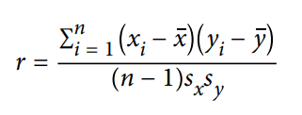

*------------------- 5/20/2024 Up to Page 31*

Variables can have an association that is not linear, in which case the correlation coefficient may not be a useful metric. The relationship between tax rates and revenue raised is an example: as tax rates increase from zero, the revenue raised also increases. However, once tax rates reach a high level and approach 100%, tax avoidance increa‐ ses and tax revenue actually declines.

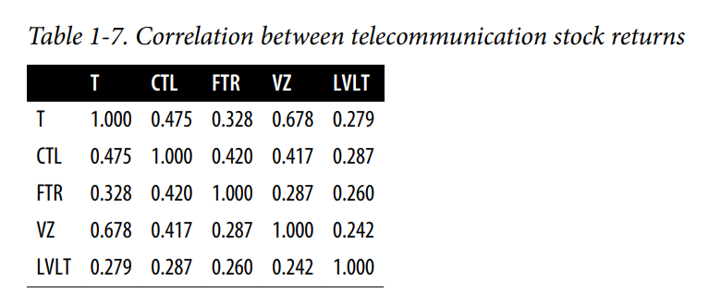

*------------------- 5/21/2024 Up to Page 32*

NumPy

To work with N Dimensional array

Create arrays -> np.array([List]) | np.zeros() |np.linspace(), np.logspace()

Examining -> .dtype, .ndim, .shape, .size

*------------------- 5/22/2024 [External]*

[Refer Correlation in Python Notebooks]

*------------------- 5/23/2024 Up to Page 32*

[Refer Correlation in Python Notebooks]

*------------------- 5/24/2024 Up to Page 33*

[Refer Scatter plot in Python Notebooks]

*------------------- 5/25/2024 Up to Page 34*

Scatterplot

The standard way to visualize the relationship between two measured data variables is with a scatterplot.

The correlation coefficient measures the extent to which two paired variables (e.g., height and weight for individuals) are associated with one another.

When high values of v1 go with high values of v2, v1 and v2 are positively associated.

• When high values of v1 go with low values of v2, v1 and v2 are negatively associated.

• The correlation coefficient is a standardized metric, so that it always ranges from –1 (perfect negative correlation) to +1 (perfect positive correlation).

• A correlation coefficient of zero indicates no correlation, but be aware that ran‐ dom arrangements of data will produce both positive and negative values for the correlation coefficient just by chance

*------------------- 5/26/2024 Up to Page 35*

**Explore two or more variables.**

**Contingency table**

A tally of counts between two or more categorical variables.

**Hexagonal binning**

A plot of two numeric variables with the records binned into hexagons.

**Contour plot.**

A plot showing the density of two numeric variables like a topographical map.

**Violin plot**

Like a boxplot but showing the density estimate.

*------------------- 5/27/2024 Up to Page 36*

**Hexagonal Binning and Contours (Plotting Numeric Versus Numeric Data)**

Scatter Plot is good for less amount of dataset. But what if the dataset size is 100s of 1000s of Millions?  
Plotting scatter plot will be too dense.

The records will be plotted by grouped bins with two variables and the color coded will be gradient color indicating the number of records in that bin.

*------------------- 5/28/2024 Up to Page 37*

In Contours chart

It is contours overlaid on scatterplot to show relationships between two variables. It is a topographical map to two variables. Each contour band represents a density of points.

Heat map, hexagonal binning and contours chart are similar story telling plots for two-dimensional density.

*------------------- 5/29/2024 Up to Page 38*

**Two Categorical Variables**

A useful way to summarize two categorical variables is a contingency table or Pivot table.

Contingency tables can look only at counts, or they can also include column and total percentages. Pivot tables in Excel are perhaps the most common tool used to create contingency tables

*------------------- 5/30/2024 Up to Page 40*

**Categorical and Numeric Data**

Boxplots are a simple way to visually compare the distributions of a numeric variable grouped according to a categorical variable.

*------------------- 5/31/2024 Up to Page 41*

Violin Plot

Violin plot is an enhancement of box plot, where its show the density and y – axis. The density is mirrored and flipped over and resulting shape is filled in creating an image resembling a VIOLIN.

It shows the nuances in the distribution that aren’t perceptible in box plot. On the other hand the boxplot clearly shows the outliers.

*------------------- 6/1/2024 Up to Page 42*

Visualizing Multiple Variables

The type of chart used to compare two variables can readily extended to more variables through the notion of conditioning.

**EDA Summary:**

Exploratory data analysis (EDA), pioneered by John Tukey

The key idea of EDA is that the first and most important step in any project based on data is to look at the data. By summarizing and visualizing the data, you can gain valuable intuition and understanding of the project.

*------------------- 6/3/2024 Up to Page 46*

Data and Sampling Distributions

Sampling is necessary even though we have big data!

In traditional statistics, there assumptions made on population but in current statistics there is no need and sample is used to train models and use it against the big data.

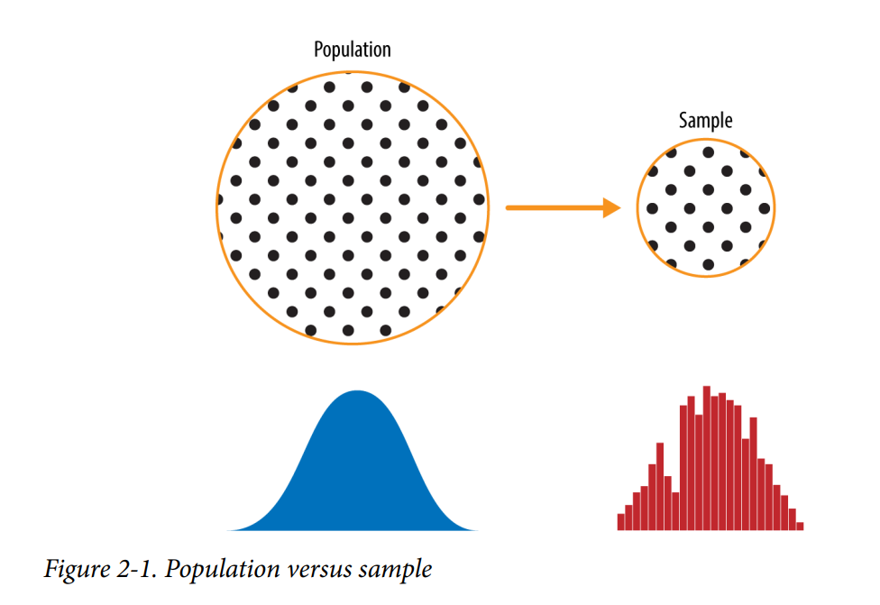

*------------------- 6/4/2024 Up to Page 47*

**Random Sampling and Sample Bias**

Random sampling is a process in which each available member of the population being sampled has an equal chance of being chosen for the sample at each draw. The sample that results is called a *simple random sample*. Sampling can be done with replacement, in which observations are put back in the population after each draw for possible future reselection. Or it can be done without replacement, in which case observations, once selected, are unavailable for future draws.

Data quality often matters more than data quantity when making an estimate or a model based on a sample. Data quality in data science involves completeness, consistency of format, cleanliness, and accuracy of individual data points. Statistics adds the notion of representativeness.

*------------------- 6/5/2024 Up to Page 48*

**Key Terms for Random Sampling**

*Sample:*

A subset from a larger dataset.

*Population:*

The larger data set or idea of a data set.

*N (n):*

The size of the population (sample).

*Random sampling:*

Drawing elements into a sample at random.

*Stratified sampling:*

Dividing the population into strata and randomly sampling from each strata.

*Stratum (pl., strata):*

A homogeneous subgroup of a population with common characteristics.

*Simple random sample:*

The sample that results from random sampling without stratifying the population.

*Bias:*

Systematic error.

*Sample Bias:*

A sample that misrepresents the population.

*------------------- 6/6/2024 Up to Page 49*

Self-Selection Sampling Bias

The reviews of restaurants, hotels, cafés, and so on that you read on social media sites like Yelp are prone to bias because the people submitting them are not randomly selected. rather, they themselves have taken the initiative to write. This leads to self-selection bias— the people motivated to write reviews may have had poor experiences, may have an association with the establishment, or may simply be a different type of person from those who do not write reviews. Note that while self-selection samples can be unreliable indicators of the true state of affairs, they may be more reliable in simply com‐ paring one establishment to a similar one; the same self-selection bias might apply to each.

**Bias**

Statistical bias refers to measurement or sampling errors that are systematic and pro‐ duced by the measurement or sampling process.

An important distinction should be made between errors due to random chance and errors due to bias. Consider the physical process of a gun shooting at a target. It will not hit the absolute center of the target every time, or even much at all. An unbiased process will produce error, but it is random and does not tend strongly in any direction (see Figure 2-2). The results shown in Figure 2-3 show a biased process—there is still random error in both the x and y direction, but there is also a bias. Shots tend to fall in the upper-right quadrant.

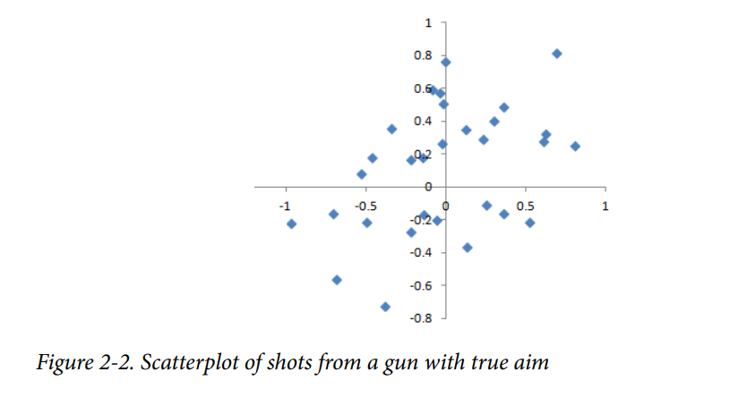

Bias comes in different forms, and may be observable or invisible. When a result does suggest bias (e.g., by reference to a benchmark or actual values), it is often an indica‐ tor that a statistical or machine learning model has been mis specified, or an important variable left out.

*------------------- 6/7/2024 Up to Page 50*

**Random Selection**

To avoid the problem of sample bias that led the Literary Digest to predict Landon over Roosevelt, George Gallup (shown in Figure 2-4) opted for more scientifically chosen methods to achieve a sample that was representative of the US voting elector‐ ate. There are now a variety of methods to achieve representativeness, but at the heart of all of them lies random sampling.

*------------------- 6/8/2024 Up to Page 51*

**How to do Random sampling using strata**

First, we need to define who a customer is. We might select all customer records where purchase amount > 0. Do we include all past customers? Do we include refunds? Internal test purchases? Resellers? Both billing agent and customer? Next, we need to specify a sampling procedure. It might be “select 100 customers at random.” Where a sampling from a flow is involved (e.g., real-time customer transactions or web visitors), timing considerations may be important (e.g., a web visitor at 10 a.m. on a weekday may be different from a web visitor at 10 p.m. on a weekend). In stratified sampling, the population is divided up into strata, and random samples are taken from each stratum. Political pollsters might seek to learn the electoral preferences of whites, blacks, and Hispanics. A simple random sample taken from the population would yield too few blacks and Hispanics, so those strata could be over‐ weighted in stratified sampling to yield equivalent sample sizes.

*------------------- 6/9/2024 Up to Page 52*

**Size Versus Quality: When Does Size Matter?**

In the era of big data, it is sometimes surprising that smaller is better. Time and effort spent on random sampling not only reduces bias but also allows greater attention to data exploration and data quality. For example, missing data and outliers may contain useful information. It might be prohibitively expensive to track down missing values or evaluate outliers in millions of records, but doing so in a sample of several thou‐ sand records may be feasible. Data plotting and manual inspection bog down if there is too much data.

*------------------- 6/10/2024 Up to Page 52*

**So when are massive amounts of data needed?**

Consider the search queries received by Google, where columns are terms, rows are individual search queries, and cell values are either 0 or 1, depending on whether a query contains a term. The goal is to determine the best predicted search destination for a given query. There are over 150,000 words in the English language, and Google processes over one trillion queries per year. This yields a huge matrix, the vast majority of whose entries are “0.” This is a true big data problem—only when such enormous quantities of data are accumulated can effective search results be returned for most queries. And the more data accumulates, the better the results.

Consider the search phrase “Ricky Ricardo and Little Red Riding Hood.” In the early days of the internet, this query would probably have returned results on the band‐ leader Ricky Ricardo, the television show I Love Lucy in which that character appeared, and the children’s story Little Red Riding Hood. Both of those individual items would have had many searches to refer to, but the combination would have had very few. Later, now that trillions of search queries have been accumulated, this search query returns the exact I Love Lucy episode in which Ricky narrates, in dramatic fashion, the Little Red Riding Hood story to his infant son in a comic mix of English and Spanish.

Keep in mind that the number of actual pertinent records—ones in which this exact search query, or something very similar, appears (together with information on what link people ultimately clicked on)—might need only be in the thousands to be effective. However, many trillions of data points are needed to obtain these pertinent records (and random sampling, of course, will not help)

*------------------- 6/11/2024 Up to Page 53*

Sample Mean Versus Population Mean

The symbol x (pronounced “x-bar”) is used to represent the mean of a sample from a population, whereas μ is used to represent the mean of a population. Why make the distinction?

*------------------- 6/12/2024 Up to Page 53*

Information about samples is observed, and information about large populations is often inferred from smaller samples. Statisticians like to keep the two things separate in the symbology

**Key Ideas**

• Even in the era of big data, random sampling remains an important arrow in the data scientist’s quiver.

• Bias occurs when measurements or observations are systematically in error because they are not representative of the full population.

• Data quality is often more important than data quantity, and random sampling can reduce bias and facilitate quality improvement that would otherwise be prohibitively expensive.

*------------------- 6/13/2024 Up to Page 53*

**Selection Bias**

Selection bias refers to the practice of selectively choosing data—consciously or unconsciously—in a way that leads to a conclusion that is misleading or ephemeral.

Data snooping:

Extensive hunting through data in search of something interesting.

Vast search effect:

Bias or non-reproducibility resulting from repeated data modeling, or modeling data with large numbers of predictor variables

The difference between a phenomenon that you verify when you test a hypothesis using an experiment and a phenomenon that you discover by perusing available data can be illuminated with the following thought experiment

Since repeated review of large data sets is a key value proposition in data science, selection bias is something to worry about. A form of selection bias of particular con‐ cern to data scientists is what John Elder (founder of Elder Research, a respected data mining consultancy) calls the vast search effect. If you repeatedly run different models and ask different questions with a large data set, you are bound to find something interesting. But is the result you found truly something interesting, or is it the chance outlier? We can guard against this by using a holdout set, and sometimes more than one hold‐ out set, against which to validate performance. Elder also advocates the use of what he calls target shuffling (a permutation test, in essence) to test the validity of predic‐ tive associations that a data mining model suggests

*------------------- 6/14/2024 Up to Page 54*

Regression to the Mean

Regression to the mean refers to a phenomenon involving successive measurements on a given variable.

Sports fans are familiar with the “rookie of the year, sophomore slump” phenomenon. Among the athletes who begin their career in a given season (the rookie class), there is always one who performs better than all the rest. Generally, this “rookie of the year” does not do as well in his second year. Why not? In nearly all major sports, at least those played with a ball or puck, there are two elements that play a role in overall performance:

• Skill

• Luck

Regression to the mean is a consequence of a particular form of selection bias. When we select the rookie with the best performance, skill and good luck are probably con‐ tributing. In his next season, the skill will still be there, but very often the luck will not be, so his performance will decline—it will regress.

*------------------- 6/15/2024 Up to Page 55*

**Galton’s study that identified the phenomenon of regression to the mean**

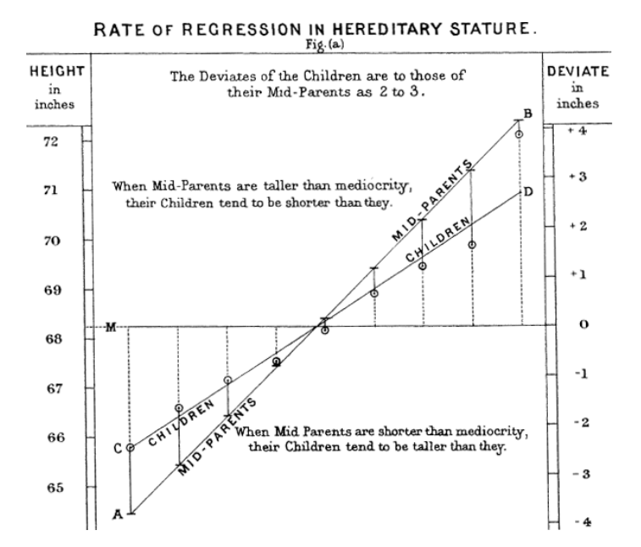

*------------------- 6/16/2024 Up to Page 56*

Regression to the mean, meaning to “go back,” is distinct from the statistical modeling method of linear regression, in which a linear relationship is estimated between predictor variables and an out‐ come variable.

**Sampling Distribution of a Statistic**

The term sampling distribution of a statistic refers to the distribution of some sample statistic over many samples drawn from the same population. Much of classical statis‐ tics is concerned with making inferences from (small) samples to (very large) populations.

*------------------- 6/17/2024 Up to Page 56*

Key Terms for Sampling Distribution

*Sample statistic* A metric calculated for a sample of data drawn from a larger population.

*Data distribution* The frequency distribution of individual values in a data set.

*Sampling distribution* The frequency distribution of a sample statistic over many samples or resamples.

*Central limit theorem* The tendency of the sampling distribution to take on a normal shape as sample size rises.

*Standard error* The variability (standard deviation) of a sample statistic over many samples (not to be confused with standard deviation, which by itself, refers to variability of individual data values).

*------------------- 6/18/2024 Up to Page 57*

The distribution of a sample statistic such as the mean is likely to be more regular and bell-shaped than the distribution of the data itself. The larger the sample the statistic is based on, the more this is true. Also, the larger the sample, the narrower the distribution of the sample statistic.

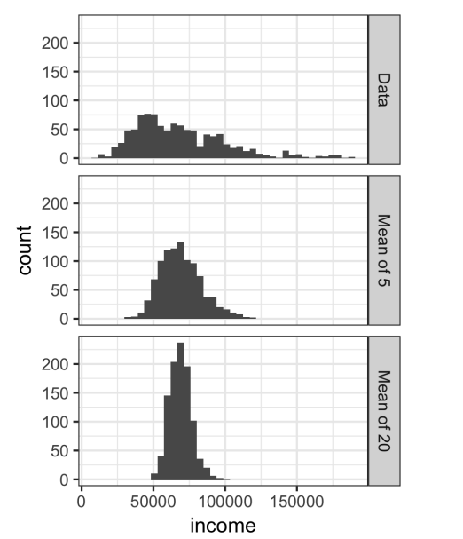

*------------------- 6/19/2024 Up to Page 58*

Python implementation of sample distribution of statistics

*------------------- 6/20/2024 Up to Page 59*

**Central Limit Theorem**

It says that the means drawn from multiple samples will resemble the familiar bell-shaped nor‐ mal curve (see “Normal Distribution” on page 69), even if the source population is not normally distributed, provided that the sample size is large enough and the departure of the data from normality is not too great.

the central limit theorem is not so central in the practice of data science.

*------------------- 6/21/2024 Up to Page 60*

**Standard Error**

The standard error is a single metric that sums up the variability in the sampling distribution for a statistic. The standard error can be estimated using a statistic based on the standard deviation s of the sample values, and the sample size n

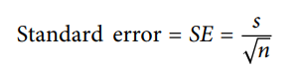

*------------------- 6/22/2024 Up to Page 60*

As the sample size increases, the standard error decreases, corresponding to what was observed in. The relationship between standard error and sample size is sometimes referred to as the square root of n rule: to reduce the standard error by a factor of 2, the sample size must be increased by a factor of 4. The validity of the standard error formula arises from the central limit theorem. In fact, you don’t need to rely on the central limit theorem to understand standard error. Consider the following approach to measuring standard error:

1. Collect a number of brand-new samples from the population.

2. For each new sample, calculate the statistic (e.g., mean)

3. Calculate the standard deviation of the statistics computed in step 2; use this as your estimate of standard error

*------------------- 6/23/2024 Up to Page 60*

**The Bootstrap**

One easy and effective way to estimate the sampling distribution of a statistic, or of model parameters, is to draw additional samples, with replacement, from the sample itself and recalculate the statistic or model for each resample. This procedure is called the bootstrap, and it does not necessarily involve any assumptions about the data or the sample statistic being normally distributed.

*------------------- 6/24/2024 Up to Page 61*

Conceptually, you can imagine the bootstrap as replicating the original sample thou‐ sands or millions of times so that you have a hypothetical population that embodies all the knowledge from your original sample (it’s just larger). You can then draw samples from this hypothetical population for the purpose of estimating a sampling distribution.

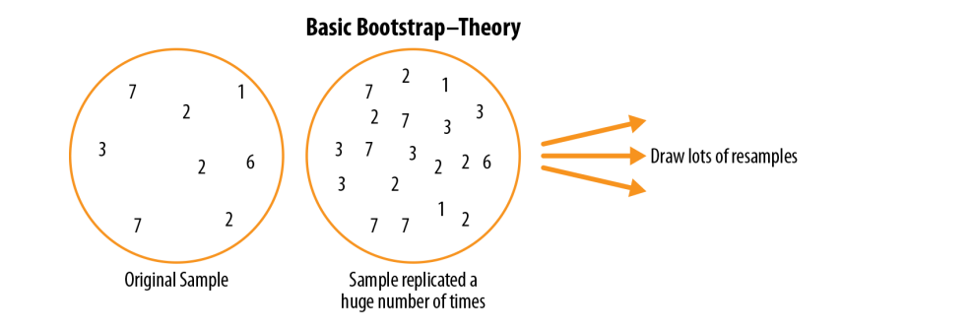

*------------------- 6/25/2024 Up to Page 62*

In practice, it is not necessary to actually replicate the sample a huge number of times. We simply replace each observation after each draw; that is, we sample with replacement. In this way we effectively create an infinite population in which the probability of an element being drawn remains unchanged from draw to draw. The algorithm for a bootstrap resampling of the mean, for a sample of size n, is as follows:

1. Draw a sample value, record it, and then replace it.   
2. Repeat n times.   
3. Record the mean of the n resampled values.   
4. Repeat steps 1–3 R times.   
5. Use the R results to:

a. Calculate their standard deviation (this estimates sample mean standard error).

b. Produce a histogram or boxplot.

c. Find a confidence interval.

*------------------- 6/26/2024 Up to Page 63*

*Python code implementation*

*------------------- 6/27/2024 Up to Page 64*

The bootstrap can be used with multivariate data, where the rows are sampled as units (see Figure 2-8). A model might then be run on the bootstrapped data, for example, to estimate the stability (variability) of model parameters, or to improve predictive power. With classification and regression trees (also called decision trees), running multiple trees on bootstrap samples and then averaging their predictions (or, with classification, taking a majority vote) generally performs better than using a single tree. This process is called bagging (short for “bootstrap aggregating”;

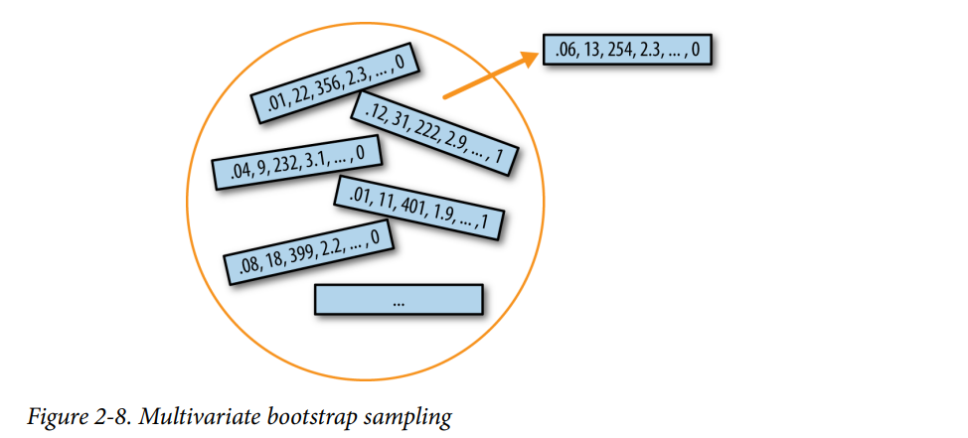

*------------------- 6/28/2024 Up to Page 64*

The repeated resampling of the bootstrap is conceptually simple. However, it is also computationally intensive and was not a feasible option before the widespread availability of computing power. It was particularly popular among researchers who use statistics but are not statisticians, and for use with metrics or models where mathematical approximations are not readily available.

The bootstrap does not compensate for a small sample size; it does not create new data, nor does it fill in holes in an existing data set. It merely informs us about how lots of additional samples would behave when drawn from a population like our original sample.

*------------------- 6/29/2024 Up to Page 64*

Resampling Versus Bootstrapping

Sometimes the term resampling is used synonymously with the term bootstrapping, as just outlined. More often, the term resampling also includes permutation procedures (see “Permutation Test” on page 97), where multiple samples are combined and the sampling may be done without replacement. In any case, the term bootstrap always implies sampling with replacement from an observed data set

*------------------- 6/30/2024 Up to Page 65*

• The bootstrap (sampling with replacement from a data set) is a powerful tool for assessing the variability of a sample statistic.

• The bootstrap can be applied in similar fashion in a wide variety of circumstances, without extensive study of mathematical approximations to sampling distributions.

• It also allows us to estimate sampling distributions for statistics where no mathematical approximation has been developed.

• When applied to predictive models, aggregating multiple bootstrap sample pre‐ dictions (bagging) outperforms the use of a single model.

*------------------- 7/1/2024 Up to Page 65*

Confidence Intervals

Frequency tables, histograms, boxplots, and standard errors are all ways to under‐ stand the potential error in a sample estimate. Confidence intervals are another.

*------------------- 7/2/2024 Up to Page 65*

Presenting an estimate not as a single number but as a range is one way to counteract this tendency. Confidence intervals do this in a manner grounded in statistical sampling principles.

Confidence intervals always come with a coverage level, expressed as a (high) per‐ centage, say 90% or 95%

*------------------- 7/3/2024 Up to Page 66*

Calculation of boot‐ strap confidence interval:

1. Draw a random sample of size n with replacement from the data (a resample).   
2. Record the statistic of interest for the resample.   
3. Repeat steps 1–2 many (R) times.   
4. For an x% confidence interval, trim [(100-x) / 2]% of the R resample results from either end of the distribution.   
5. The trim points are the endpoints of an x% bootstrap confidence interval.

*------------------- 7/4/2024 Up to Page 67*

The probability question associated with a confidence interval starts out with the phrase “Given a sampling procedure and a population, what is the probability that…” To go in the opposite direction, “Given a sample result, what is the probability that (something is true about the population)?” involves more complex calculations and deeper imponderables.

• Confidence intervals are the typical way to present estimates as an interval range.

• The more data you have, the less variable a sample estimate will be.

• The lower the level of confidence you can tolerate, the narrower the confidence interval will be.

• The bootstrap is an effective way to construct confidence intervals.

*------------------- 7/5/2024 Up to Page 68*

**Normal Distribution**

The bell-shaped normal distribution is iconic in traditional statistics.1 The fact that distributions of sample statistics are often normally shaped has made it a powerful tool in the development of mathematical formulas that approximate those distributions.

*------------------- 7/6/2024 Up to Page 69*

Error   
The difference between a data point and a predicted or average value.

Standardize   
Subtract the mean and divide by the standard deviation.

z-score   
The result of standardizing an individual data point.

Standard normal   
A normal distribution with mean = 0 and standard deviation = 1.

QQ-Plot   
A plot to visualize how close a sample distribution is to a specified distribution, e.g., the normal distribution.

*------------------- 7/7/2024 Up to Page 69*

It is a common misconception that the normal distribution is called that because most data follows a normal distribution—that is, it is the normal thing. Most of the variables used in a typical data science project—in fact, most raw data as a whole—are not normally distributed.

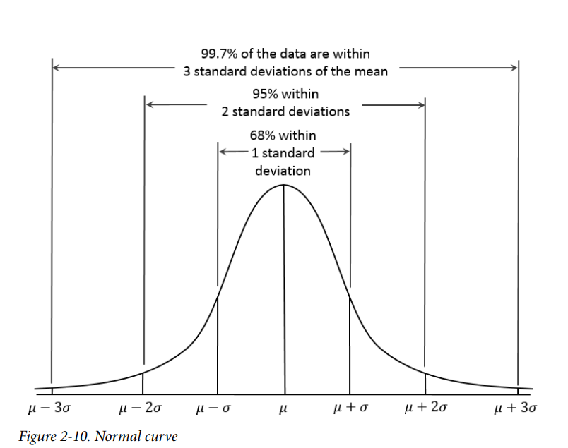

*------------------- 7/8/2024 Up to Page 70*

**Standard Normal and QQ-Plots**

A standard normal distribution is one in which the units on the x-axis are expressed in terms of standard deviations away from the mean. To compare data to a standard normal distribution, you subtract the mean and then divide by the standard deviation; this is also called normalization or standardization

*------------------- 7/9/2024 Up to Page 71*

A QQ-Plot is used to visually determine how close a sample is to a specified distribution—in this case, the normal distribution. The QQ-Plot orders the z-scores from low to high and plots each value’s z-score on the y-axis; the x-axis is the corresponding quantile of a normal distribution for that value’s rank. Since the data is normalized, the units correspond to the number of standard deviations away from the mean. If the points roughly fall on the diagonal line, then the sample distribution can be considered close to normal.

*------------------- 7/10/2024 Up to Page 71*

*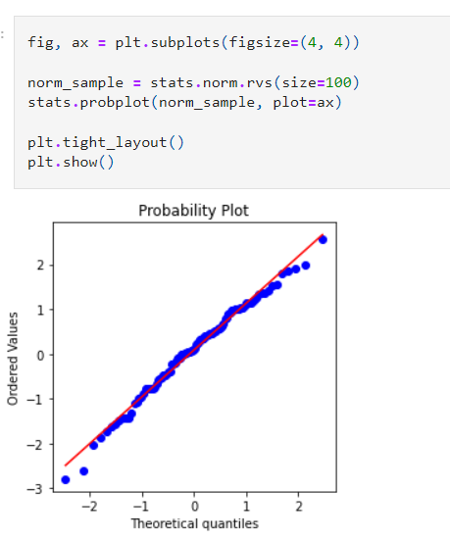-------------------- 7/11/2024 up to page 71*

The normal distribution was essential to the historical development of statistics, as it permitted mathematical approximation of uncertainty and variability.

• While raw data is typically not normally distributed, errors often are, as are aver‐ ages and totals in large samples.

• To convert data to z-scores, you subtract the mean of the data and divide by the standard deviation; you can then compare the data to a normal distribution.

*--------------------- 7/12/2024 up to page 72*

**Long-Tailed Distributions**

Tail

The long narrow portion of a frequency distribution, where relatively extreme values occur at low frequency.

Skew

Where one tail of a distribution is longer than the other.

*--------------------- 7/13/2024 up to page 73*

Sometimes, the distribution is highly skewed (asymmetric), such as with income data; or the distribution can be discrete, as with binomial data. Both symmetric and asymmetric distributions may have long tails. The tails of a distribution correspond to the extreme values (small and large).

*--------------------- 7/14/2024 up to page 74*

**Student’s t-Distribution**

The t-distribution is a normally shaped distribution, except that it is a bit thicker and longer on the tails. It is used extensively in depicting distributions of sample statistics. Distributions of sample means are typically shaped like a t-distribution, and there is a family of t-distributions that differ depending on how large the sample is. The larger the sample, the more normally shaped the t-distribution becomes.

*--------------------- 7/15/2024 up to page 75*

Degrees of freedom

A parameter that allows the t-distribution to adjust to different sample sizes, statistics, and numbers of groups

*--------------------- 7/16/2024 up to page 76*

A number of different statistics can be compared, after standardization, to the tdistribution, to estimate confidence intervals in light of sampling variation. Consider a sample of size n for which the sample mean x has been calculated. If s is the sample standard deviation, a 90% confidence interval around the sample mean is given by *A number with numbers and numbers
--------------------- 7/17/2024 up to page 77*

• The t-distribution is actually a family of distributions resembling the normal distribution but with thicker tails.

• The t-distribution is widely used as a reference basis for the distribution of sample means, differences between two sample means, regression parameters, and more

*--------------------- 7/18/2024 up to page 78*

Binomial Distribution

Yes/no (binomial) outcomes lie at the heart of analytics since they are often the culmination of a decision or other process; buy/don’t buy, click/don’t click, survive/die, and so on. Central to understanding the binomial distribution is the idea of a set of trials, each trial having two possible outcomes with definite probabilities.

*--------------------- 7/19/2024 up to page 78*

Trial   
An event with a discrete outcome (e.g., a coin flip).   
Success   
The outcome of interest for a trial. Synonym “1” (as opposed to “0”)   
Binomial   
Having two outcomes. Synonyms yes/no, 0/1, binary   
Binomial trial   
A trial with two outcomes. Synonym Bernoulli trial   
Binomial distribution   
Distribution of number of successes in x trials. Synonym Bernoulli distribution

*--------------------- 7/20/2024 up to page 79*

The binomial distribution is the frequency distribution of the number of successes (x) in a given number of trials (n) with specified probability (p) of success in each trial. There is a family of binomial distributions, depending on the values of n and p. The binomial distribution would answer a question like:

If the probability of a click converting to a sale is 0.02, what is the probability of observing 0 sales in 200 clicks?

*--------------------- 7/21/2024 up to page 79*

The scipy.stats module implements a large variety of statistical distributions. For the binomial distribution, use the functions stats.binom.pmf and stats.binom.cdf:

stats.binom.pmf(2, n=5, p=0.1) stats.binom.cdf(2, n=5, p=0.1)

*--------------------- 7/22/2024 up to page 80*

Binomial outcomes are important to model, since they represent, among other things, fundamental decisions (buy or don’t buy, click or don’t click, survive or die, etc.).

• A binomial trial is an experiment with two possible outcomes: one with probability p and the other with probability 1 – p.

• With large n, and provided p is not too close to 0 or 1, the binomial distribution can be approximated by the normal distribution.

*--------------------- 7/23/2024 up to page 80*

Chi-Square Distribution

***The chi-square distribution is a way to understand how much variation exists in a set of data compared to what we'd expect by chance. It's often used in statistics to test hypotheses, particularly in situations where we want to see if there's a significant difference between observed and expected frequencies in categorical data.***

***Here's a simple breakdown:***

***Chi-Square Test: This is a statistical test that uses the chi-square distribution. It's commonly used to compare observed data with data we would expect to obtain according to a specific hypothesis.***

***Observed and Expected Frequencies: In the chi-square test, you start with observed frequencies (the actual data you have) and expected frequencies (what you would expect if there was no significant effect or difference).***

***Calculating the Chi-Square Statistic: The chi-square statistic is calculated by taking the difference between observed and expected frequencies, squaring it, dividing by the expected frequency, and then summing these values for all categories.***

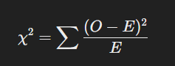***​***

***Here, 𝑂 O is the observed frequency, and***

***𝐸 E is the expected frequency.***

***Degrees of Freedom: The chi-square distribution is defined by degrees of freedom, which typically relate to the number of categories minus one. The degrees of freedom affect the shape of the chi-square distribution.***

***Interpreting the Result: Once you have the chi-square statistic, you compare it to a critical value from the chi-square distribution table (which is based on the degrees of freedom and your chosen significance level, like 0.05). If your statistic is larger than the critical value, you reject the null hypothesis, suggesting that there is a significant difference between the observed and expected frequencies.***

***Example***

***Imagine you have a dice that you suspect is not fair. You roll it 60 times and record how often each number (1 through 6) appears.***

***Observed frequencies: 1: 5, 2: 8, 3: 12, 4: 10, 5: 15, 6: 10.***

***Expected frequencies: Since a fair dice should show each number equally often, you expect each number to appear 10 times (since 60 rolls / 6 sides = 10).***

***You would use the chi-square formula to see if the differences between observed and expected frequencies are due to chance or indicate that the dice is not fair.***

***In summary, the chi-square distribution helps you determine if the differences between your observed data and what you expected by chance are statistically significant.***

*--------------------- 7/24/2024 up to page 81*

F-Distribution

A common procedure in scientific experimentation is to test multiple treatments across groups—say, different fertilizers on different blocks of a field. This is similar to the A/B/C test referred to in the chi-square distribution

*--------------------- 7/25/2024 up to page 82*

except we are dealing with measured continuous values rather than counts. In this case we are interested in the extent to which differences among group means are greater than we might expect under normal random variation

*--------------------- 7/26/2024 up to page 82*

• The F-distribution is used with experiments and linear models involving measured data.

• The F-statistic compares variation due to factors of interest to overall variation.

*--------------------- 7/27/2024 up to page 82*

Poisson Distributions

The Poisson distribution tells us the distribu‐ tion of events per unit of time or space when we sample many such units. It is useful when addressing queuing questions such as “How much capacity do we need to be 95% sure of fully processing the internet traffic that arrives on a server in any fivesecond period?”

The key parameter in a Poisson distribution is λ, or lambda. This is the mean number of events that occurs in a specified interval of time or space. The variance for a Pois‐ son distribution is also λ

*--------------------- 7/28/2024 up to page 83*

Exponential Distribution

Using the same parameter λ that we used in the Poisson distribution, we can also model the distribution of the time between events: time between visits to a website or between cars arriving at a toll plaza

*--------------------- 7/29/2024 up to page 84*

***Example***

*Suppose we have a system where events occur at an average rate of 2 per hour. The time between events follows an exponential distribution with λ=2\lambda = 2λ=2. The mean time between events is 12\frac{1}{2} 21​ hours (or 30 minutes), and the variance is 14\frac{1}{4}41​ hours squared.*

*The probability that the time between events is less than or equal to 15 minutes (0.25 hours) can be calculated using the CDF:*

**

*--------------------- 7/30/2024 up to page 84*

Estimating the Failure Rate

In many applications, the event rate, λ, is known or can be estimated from prior data. However, for rare events, this is not necessarily so. Aircraft engine failure, for exam‐ ple, is sufficiently rare (thankfully) that, for a given engine type, there may be little data on which to base an estimate of time between failures. With no data at all, there is little basis on which to estimate an event rate

*--------------------- 7/31/2024 up to page 84*

Weibull Distribution In many cases, the event rate does not remain constant over time. If the period over which it changes is much longer than the typical interval between events, there is no problem; you just subdivide the analysis into the segments where rates are relatively constant, as mentioned before. If, however, the event rate changes over the time of the interval, the exponential (or Poisson) distributions are no longer useful. This is likely to be the case in mechanical failure—the risk of failure increases as time goes by. The Weibull distribution is an extension of the exponential distribution in which the event rate is allowed to change, as specified by a shape parameter, β

*--------------------- 8/1/2024 up to page 85*

The symbol used is η, the Greek letter eta. It is also called the scale parameter

*--------------------- 8/2/2024 up to page 85*

• For events that occur at a constant rate, the number of events per unit of time or space can be modeled as a Poisson distribution.

• You can also model the time or distance between one event and the next as an exponential distribution.

• A changing event rate over time (e.g., an increasing probability of device failure) can be modeled with the Weibull distribution.

*--------------------- 8/3/2024 up to page 86*

Statistical Experiments and Significance Testing

*--------------------- 8/4/2024 up to page 87*

An experiment (it might be an A/B test) is designed to test the hypothesis—designed in such a way that it hopefully will deliver conclusive results. The data is collected and analyzed, and then a conclusion is drawn. The term inference reflects the intention to apply the experiment results, which involve a limited set of data, to a larger process or population

*--------------------- 8/5/2024 up to page 87*

A/B Testing An A/B test is an experiment with two groups to establish which of two treatments, products, procedures, or the like is superior. Often one of the two treatments is the standard existing treatment, or no treatment. If a standard (or no) treatment is used, it is called the control. A typical hypothesis is that a new treatment is better than the control

*--------------------- 8/6/2024 up to page 88*

Treatment   
Something (drug, price, web headline) to which a subject is exposed.   
Treatment group   
A group of subjects exposed to a specific treatment.   
Control group   
A group of subjects exposed to no (or standard) treatment.   
Randomization   
The process of randomly assigning subjects to treatments.   
Subjects   
The items (web visitors, patients, etc.) that are exposed to treatments.   
Test statistic   
The metric used to measure the effect of the treatment

*--------------------- 8/7/2024 up to page 88*

A/B tests are common in web design and marketing, since results are so readily meas‐ ured. Some examples of A/B testing include:

• Testing two soil treatments to determine which produces better seed germination

• Testing two therapies to determine which suppresses cancer more effectively

• Testing two prices to determine which yields more net profit

• Testing two web headlines to determine which produces more clicks (Figure 3-2)

• Testing two web ads to determine which generates more conversions

*--------------------- 8/8/2024 up to page 88*

Any difference between the treatment groups is due to one of two things:

• The effect of the different treatments

• Luck of the draw in which subjects are assigned to which treatments (i.e., the ran‐ dom assignment may have resulted in the naturally better-performing subjects being concentrated in A or B)

*--------------------- 8/9/2024 up to page 89*

*--------------------- 8/10/2024 up to page 90*

Why Have a Control Group?

When you have a control group, it is subject to the same conditions (except for the treatment of interest) as the treatment group. If you simply make a comparison to “baseline” or prior experience, other factors, besides the treatment, might differ.

**Blinding in studies**

A blind study is one in which the subjects are unaware of whether they are getting treatment A or treatment B. Awareness of receiving a particular treatment can affect response

A double-blind study is one in which the investigators and facilitators (e.g., doctors and nurses in a medical study) also are unaware which subjects are get‐ ting which treatment.

**Why Just A/B? Why Not C, D,…?**

A/B tests are popular in the marketing and ecommerce worlds.  
Additional treatments can be included. Pharmaceutical trials where subjects are scarce, expensive, and acquired over time are sometimes designed with multiple opportunities to stop the experiment and reach a conclusion.

Which, out of multiple possible prices, is best? For this, a relatively new type of experimental design is used: the ***multi-arm bandit***

Hypothesis Tests

Hypothesis tests, also called significance tests, are ubiquitous in the traditional statistical analysis of published research.

Their purpose is to help you learn whether random chance might be responsible for an observed effect.

***Null hypothesis***   
The hypothesis that chance is to blame.   
This is like saying, "Nothing unusual is happening." It's the idea that any observed effect is just due to chance. Ex: flipping a coin

***Alternative hypothesis***   
Counterpoint to the null (what you hope to prove).   
It’s what you want to prove.   
*Example*: If you suspect the coin is biased, your alternative hypothesis would be that the coin is not fair, meaning it doesn't have a 50/50 chance.

***One-way test***   
Hypothesis test that counts chance results only in one direction.   
*Example*: If you're only interested in proving that the coin lands more on heads than tails, you'd use a one-way test.

***Two-way test***   
Hypothesis test that counts chance results in two directions.  
*Example*: If you're interested in proving that the coin is either more likely to land on heads or tails (but you're not sure which), you'd use a two-way test

*--------------------- 8/11/2024 up to page 93*

Statistical hypothesis testing was invented as a way to protect researchers from being fooled by random chance.

the tendency of the human mind to underestimate the scope of natural random behavior. One manifestation of this is the failure to anticipate extreme events, or so-called “black swans” .Another manifestation is the tendency to misinterpret random events as having patterns of some significance

*--------------------- 8/12/2024 up to page 93*

Ask several friends to invent a series of 50 coin flips: have them write down a series of random Hs and Ts. Then ask them to actually flip a coin 50 times and write down the results. Have them put the real coin flip results in one pile, and the madeup results in another. It is easy to tell which results are real: the real ones will have longer runs of Hs or Ts. In a set of 50 real coin flips, it is not at all unusual to see five Hypothesis Tests | 93 or six Hs or Ts in a row. However, when most of us are inventing random coin flips and we have gotten three or four Hs in a row, we tell ourselves that, for the series to look random, we had better switch to T

*--------------------- 8/13/2024 up to page 94*

In a properly designed A/B test, you collect data on treatments A and B in such a way that any observed difference between A and B must be due to either: • Random chance in assignment of subjects • A true difference between A and B A statistical hypothesis test is further analysis of an A/B test, or any randomized experiment, to assess whether random chance is a reasonable explanation for the observed difference between groups A and B.

*--------------------- 8/14/2024 up to page 94*

The Null Hypothesis Hypothesis tests use the following logic: “Given the human tendency to react to unusual but random behavior and interpret it as something meaningful and real, in our experiments we will require proof that the difference between groups is more extreme than what chance might reasonably produce.”

*--------------------- 8/15/2024 up to page 94*

Alternative Hypothesis

Hypothesis tests by their nature involve not just a null hypothesis but also an offset‐ ting alternative hypothesis. Here are some examples:   
• Null = “no difference between the means of group A and group B”; alternative = “A is different from B” (could be bigger or smaller)   
• Null = “A ≤ B”; alternative = “A > B”   
• Null = “B is not X% greater than A”; alternative = “B is X% greater than A” Taken together, the null and alternative hypotheses must account for all possibilities. The nature of the null hypothesis determines the structure of the hypothesis test.

*--------------------- 8/16/2024 up to page 95*

**One-Way Versus Two-Way Hypothesis Tests**

you want a hypothesis test to protect you from being fooled by chance in the direction favoring B. You don’t care about being fooled by chance in the other direction, because you would be sticking with A unless B proves definitively better. So you want a directional alternative hypothesis (B is better than A). In such a case, you use a one-way (or onetail) hypothesis test. This means that extreme chance results in only one direction count toward the p-value.

*--------------------- 8/17/2024 up to page 95*

• A null hypothesis is a logical construct embodying the notion that nothing spe‐ cial has happened, and any effect you observe is due to random chance.

• The hypothesis test assumes that the null hypothesis is true, creates a “null model” (a probability model), and tests whether the effect you observe is a rea‐ sonable outcome of that model.

*--------------------- 8/18/2024 up to page 96*

Resampling

Resampling in statistics means to repeatedly sample values from observed data, with a general goal of assessing random variability in a statistic. It can also be used to assess and improve the accuracy of some machine-learning models (e.g., the predictions from decision tree models built on multiple bootstrapped data sets can be averaged in a process known as bagging

*--------------------- 8/19/2024 up to page 96*

There are two main types of resampling procedures: the bootstrap and permutation tests. The bootstrap is used to assess the reliability of an estimate

Permutation tests are used to test hypotheses, typically involving two or more groups

*--------------------- 8/20/2024 up to page 96*

Permutation test   
The procedure of combining two or more samples together and randomly (or exhaustively) reallocating the observations to resamples. Synonyms Randomization test, random permutation test, exact test

Resampling Drawing additional samples (“resamples”) from an observed data set.

With or without replacement In sampling, whether or not an item is returned to the sample before the next draw.

*--------------------- 8/21/2024 up to page 97*

1. Combine the results from the different groups into a single data set.

2. Shuffle the combined data and then randomly draw (without replacement) a resample of the same size as group A (clearly it will contain some data from the other groups).

*--------------------- 8/22/2024 up to page 97*

3. From the remaining data, randomly draw (without replacement) a resample of the same size as group B. 4. Do the same for groups C, D, and so on. You have now collected one set of resamples that mirror the sizes of the original samples

*--------------------- 8/23/2024 up to page 97*

5. Whatever statistic or estimate was calculated for the original samples (e.g., differ‐ ence in group proportions), calculate it now for the resamples, and record; this constitutes one permutation iteration. 6. Repeat the previous steps R times to yield a permutation distribution of the test statistic

*--------------------- 8/24/2024 up to page 97*

Now go back to the observed difference between groups and compare it to the set of permuted differences. If the observed difference lies well within the set of permuted differences, then we have not proven anything—the observed difference is within the range of what chance might produce. However, if the observed difference lies outside most of the permutation distribution, then we conclude that chance is not responsible. In technical terms, the difference is statistically significant

*--------------------- 8/25/2024 up to page 98*

A proxy variable is one that stands in for the true variable of interest, which may be unavailable, too costly, or too time-consuming to measure. In climate research, for example, the oxygen content of ancient ice cores is used as a proxy for temperature. It is useful to have at least some data on the true variable of interest, so the strength of its association with the proxy can be assessed

*--------------------- 8/26/2024 up to page 98*

One potential proxy variable for our company is the number of clicks on the detailed landing page. A better one is how long people spend on the page. It is reasonable to think that a web presentation (page) that holds people’s attention longer will lead to more sales. Hence, our metric is average session time, comparing page A to page B.

*--------------------- 8/27/2024 up to page 98*

Exhaustive and Bootstrap Permutation Tests In addition to the preceding random shuffling procedure, also called a random per‐ mutation test or a randomization test, there are two variants of the permutation test: • An exhaustive permutation test • A bootstrap permutation test

*--------------------- 8/28/2024 up to page 102*

In an exhaustive permutation test, instead of just randomly shuffling and dividing the data, we actually figure out all the possible ways it could be divided. This is practical only for relatively small sample sizes

*--------------------- 8/29/2024 up to page 102*

With a large number of repeated shufflings, the random permutation test results approximate those of the exhaustive permutation test, and approach them in the limit. Exhaustive permutation tests are also sometimes called exact tests, due to their statistical property of guaranteeing that the null model will not test as “significant” more than the alpha level of the test

*--------------------- 8/30/2024 up to page 102*

In a bootstrap permutation test, the draws outlined in steps 2 and 3 of the random permutation test are made with replacement instead of without replacement. In this way the resampling procedure models not just the random element in the assignment of treatment to subject but also the random element in the selection of subjects from a population

*--------------------- 8/31/2024 up to page 103*

Permutation Tests: The Bottom Line for Data Science

Permutation tests are useful heuristic procedures for exploring the role of random variation.

• In a permutation test, multiple samples are combined and then shuffled.   
• The shuffled values are then divided into resamples, and the statistic of interest is calculated.   
• This process is then repeated, and the resampled statistic is tabulated.   
• Comparing the observed value of the statistic to the resampled distribution allows you to judge whether an observed difference between samples might occur by chance

*--------------------- 9/1/2024 up to page 103*

Statistical Significance and p-Values Statistical significance is how statisticians measure whether an experiment (or even a study of existing data) yields a result more extreme than what chance might produce. If the result is beyond the realm of chance variation, it is said to be statistically significant.

*--------------------- 9/2/2024 up to page 103*

Key Terms for Statistical Significance and p-Values

p-value Given a chance model that embodies the null hypothesis, the p-value is the prob‐ ability of obtaining results as unusual or extreme as the observed results.

*--------------------- 9/3/2024 up to page 103*

Alpha The probability threshold of “unusualness” that chance results must surpass for actual outcomes to be deemed statistically significant. Type 1 error Mistakenly concluding an effect is real (when it is due to chance). Type 2 error Mistakenly concluding an effect is due to chance (when it is real)

*--------------------- 9/4/2024 up to page 103*

“If the two prices share the same conversion rate, could chance variation produce a difference as big as 5%?

*--------------------- 9/5/2024 up to page 104*