**Assignment-1**

**Data Analysis of Student Performance Dataset Results**

**Guna Charan Polavarapu**

**16351716**

1. We’ve added new columns called passedMath, passedReading and passedWriting based on the condition whether a student have marks greater than 50 or not. This graph shows how females and males are distributed among each subject when taken the passing score as more than 50, the graph uses blue to indicate the number of females and red to indicate the number of males.

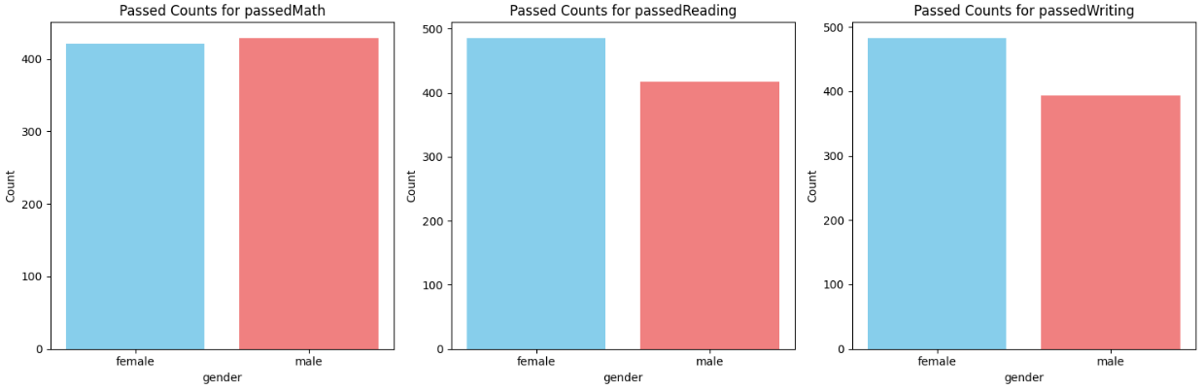

Evidently, except in math more females have passing scores of greater than 50 when compared with males. Only in math males have a slightly higher count than females.

1. Histograms have been employed as visual representations to illustrate the distribution patterns of Reading, Writing, and Math Scores. The X-axis delineates the score intervals for each subject, while the Y-axis denotes the frequency of occurrence. Upon analysis, it is evident that a significant proportion of students exhibit Reading, Math, and Writing Scores ranging from 60 to 80.

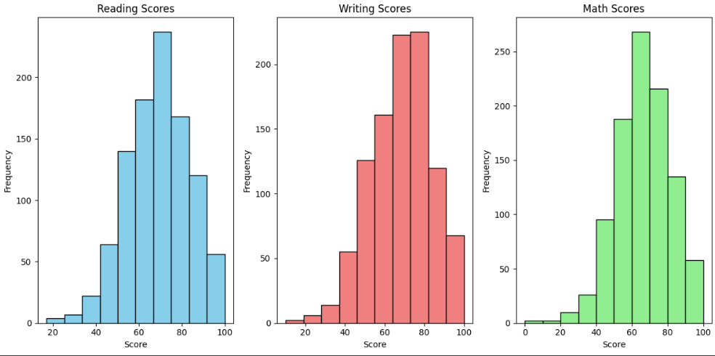

To summarize, a notable proportion of students demonstrate Reading, Math, and Writing Scores within the range of 60 to 80.

1. The pie chart offers a comparative analysis between the total number of students who completed the test preparation and those who did not, both overall and across each subject. It is evident from the chart that a larger proportion of students did not complete the preparation course, as opposed to those who did.

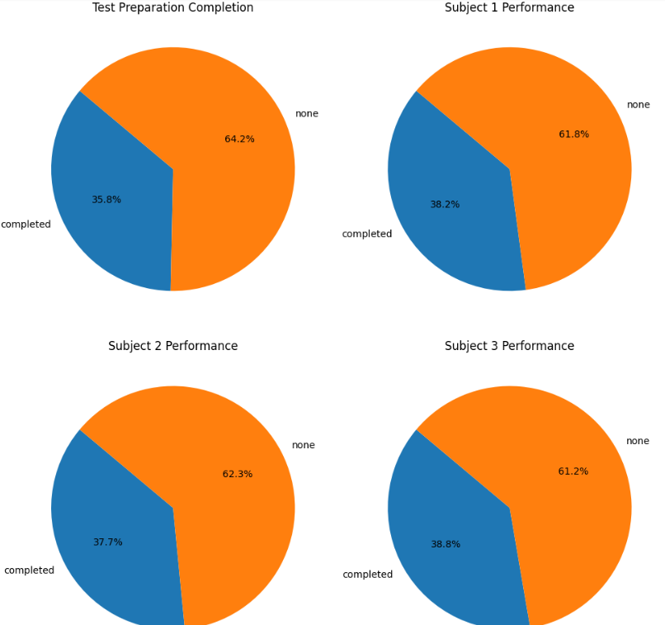

1. The grouped graph below illustrates the comparison between students who completed the test preparation course and achieved passing marks versus those who did not, alongside those who did not complete the course yet achieved passing marks. It is evident that a greater number of students who completed the course have successfully passed, as compared to those who did not. This pattern remains consistent in the scenario where students did not pass as well.

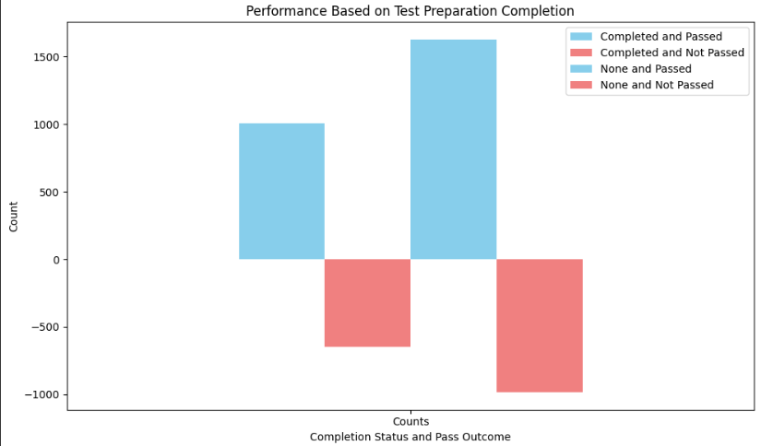

1. The graph below provides a comparison of students who achieved passing marks in each subject based on their parents' level of education. It is notable that students whose parents hold an associate degree have attained pass marks across all three subjects, surpassing students from other educational backgrounds. Following closely are students whose parents have attained a level of education at some college.

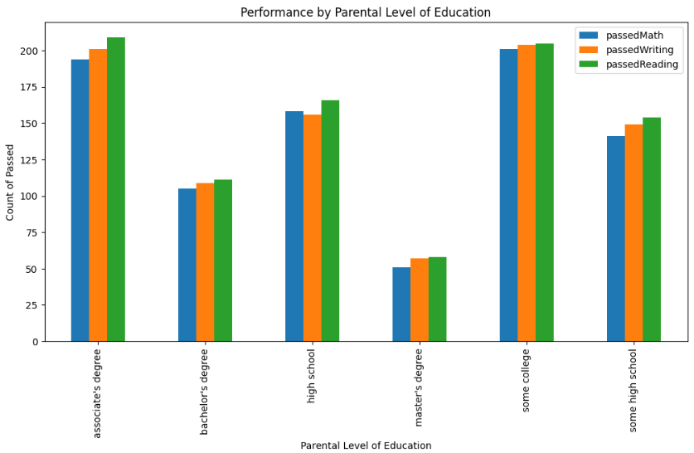

1. The graph presented illustrates the comparison of students' average scores across all subjects with respect to their lunch type. Clearly, students with a standard meal plan have exhibited superior performance compared to their counterparts.

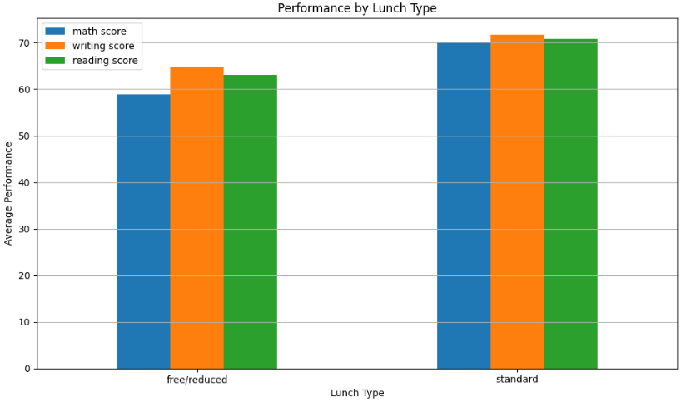

1. The visualization juxtaposes the scores of male and female students based on their participation in a test preparation course. The Y-axis depicts different score types, while the X-axis distinguishes between students who completed the course and those who did not. Ultimately, it is apparent that the impact of test preparation courses on student performance varies, contingent upon both the score type and the gender of the students.

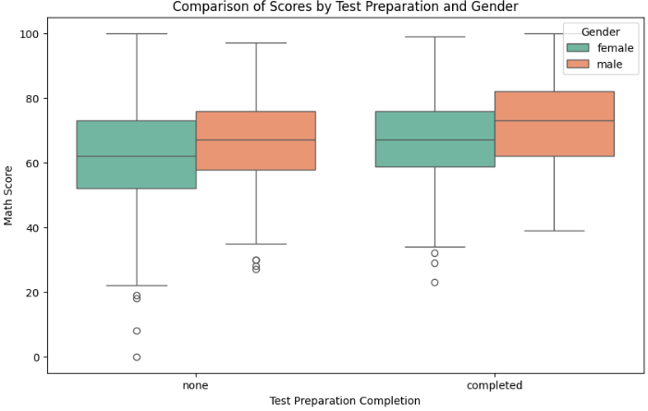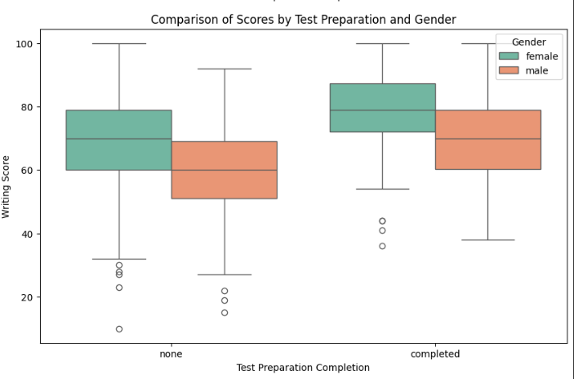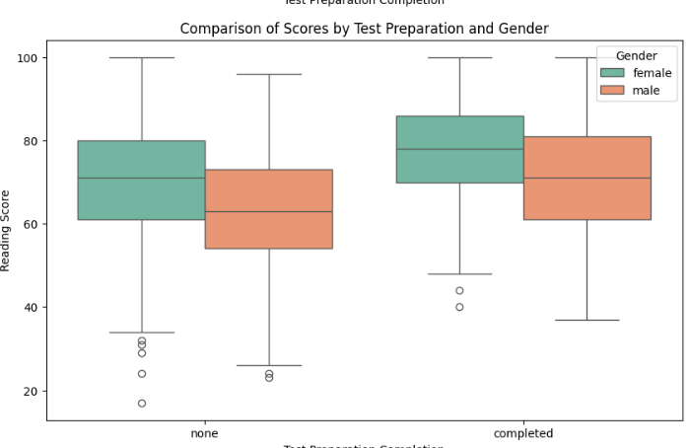

1. The graph illustrates the distribution of students by gender (male and female) across different race/ethnicity groups. It is notable that a larger number of students are categorized under group C, followed by group D.

