**COMPATIBILITY TESTING (ANDROID)**

This document explains all compatibility tests that has been conducted on several Android devices. The devices used are Sony Xperia M, Redmi Note 3G, Redmi 3, and Infinix Note 2. The devices selected are based on the difference in screen sizes, screen resolution and OS platform. The range from lowest to highest specification is as follows:

* Screen size     : From 4 inches to 6 inches
* Screen resolution : From 480 x 854 pixels to 720 x 1280 pixels
* Platform     : From Android OS 4.3 (Jelly Bean) to Android OS 6.0 (Marshmallow)

Based on our SRS document, the test results is expected to succeed from Android OS 4.3 (Jelly Bean) to Android OS 6.0 (Marshmallow). And the result from each device is described below.

* **Sony Xperia M**

|  |  |  |  |
| --- | --- | --- | --- |
| **Tested By:** | | Alvin | |
| **Test Type** | | Compatibility Testing | |
| **Test Case Number** | | C-1 | |
| **Test Case Name** | | Sony Xperia M test | |
| **Test Case Description** | | * Display size : 4.0 inches * Display resolution : 480 x 854 pixels * OS platform : Android OS, v4.3 (Jelly Bean) | |
| **Item(s) to be tested** | | | |
| Test all app’s function on the Android device with Android OS. 4.3 | | | |
| **Specifications** | | | |
| **Input** | | | **Expected**  **Output/Result** |
| All that is associated with app’s navigation structure | | | All function running successfully |
| **Procedural Steps** | | | |
| 1 | Run the PALS Android application | | |
| 2 | Test all PALS Android application functions to ensure that can be run normally on Android OS | | |
| **Result** | | | |
| Success | | | |

**Attachment:**

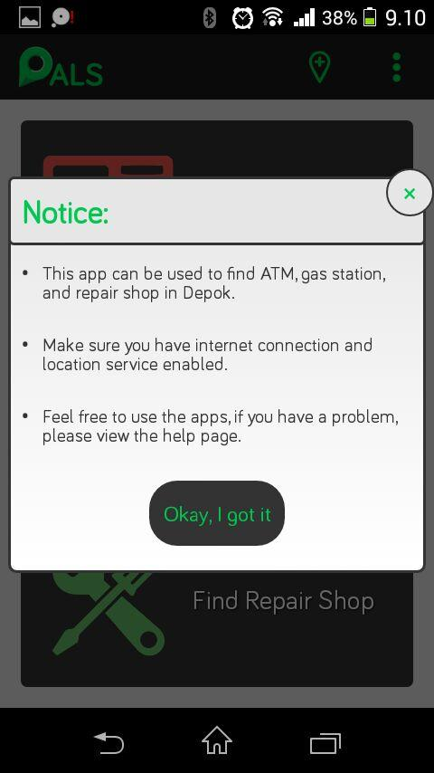 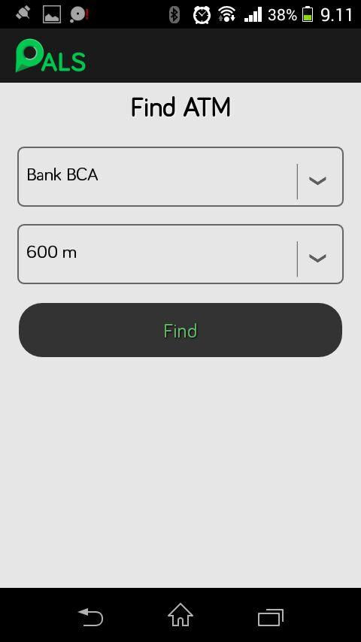 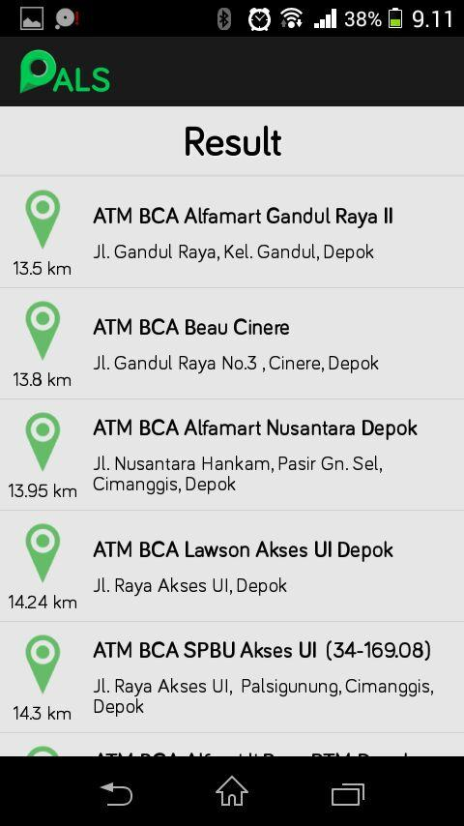

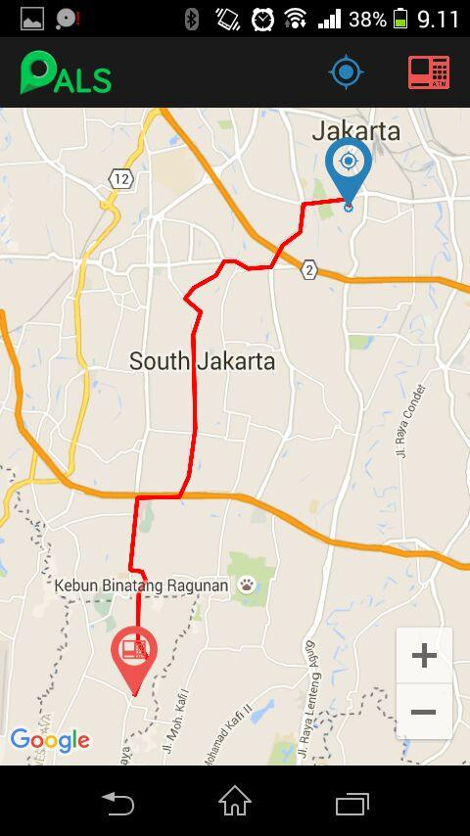 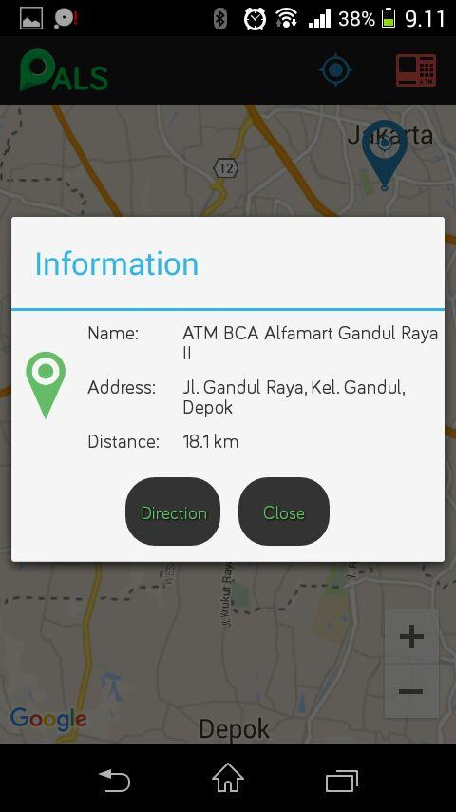 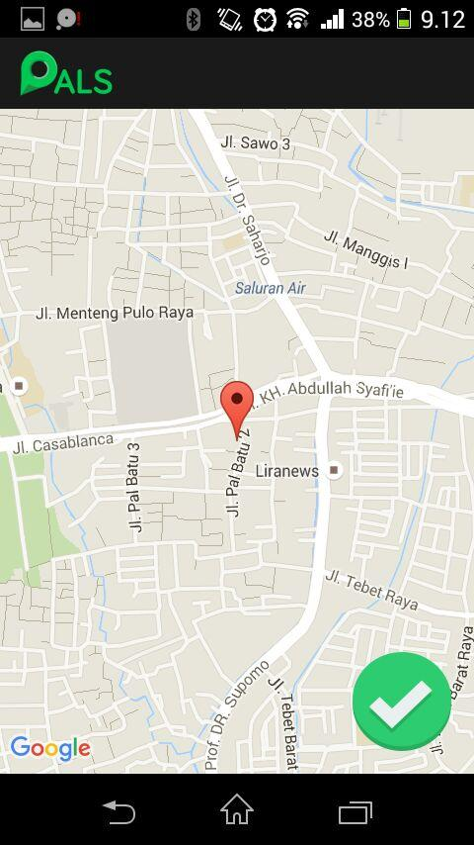

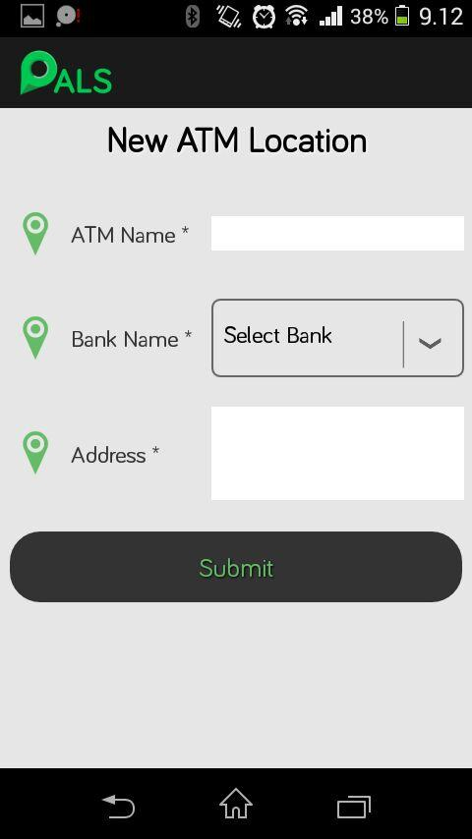 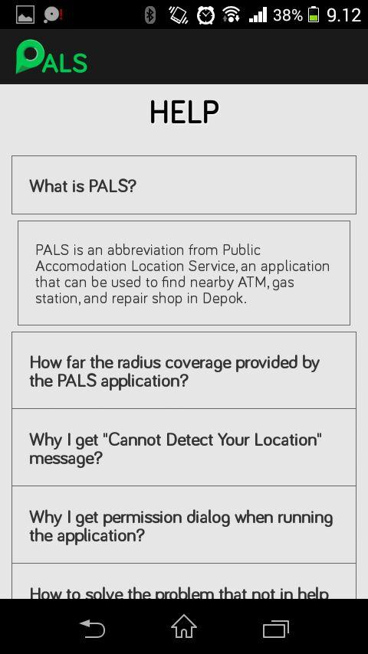 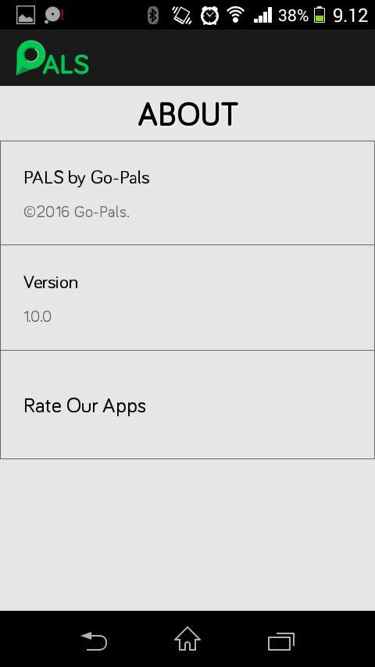

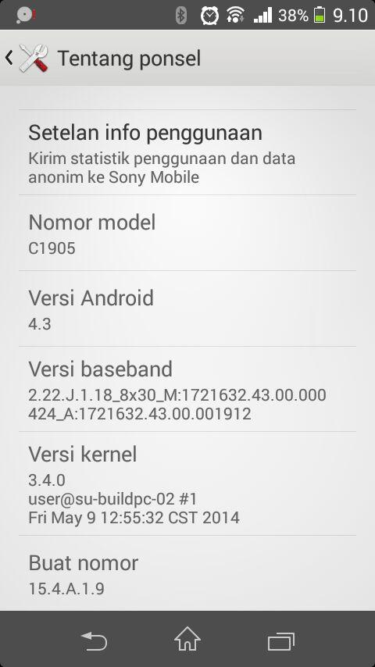

* **Redmi Note 3G**

|  |  |  |  |
| --- | --- | --- | --- |
| **Tested By:** | | Alvin | |
| **Test Type** | | Compatibility Testing | |
| **Test Case Number** | | C-2 | |
| **Test Case Name** | | Redmi Note 3G test | |
| **Test Case Description** | | * Display size : 5.5 inches * Display resolution : 720 x 1280 pixels * OS platform : Android OS, v4.4.2 (Kitkat) | |
| **Item(s) to be tested** | | | |
| Test all app’s function on the Android device with Android OS. 4.4.2 | | | |
| **Specifications** | | | |
| **Input** | | | **Expected**  **Output/Result** |
| All that is associated with app’s navigation structure | | | All function running successfully |
| **Procedural Steps** | | | |
| 1 | Run the PALS Android application | | |
| 2 | Test all PALS Android application functions to ensure that can be run normally on Android OS | | |
| **Result** | | | |
| Success | | | |

**Attachment:**

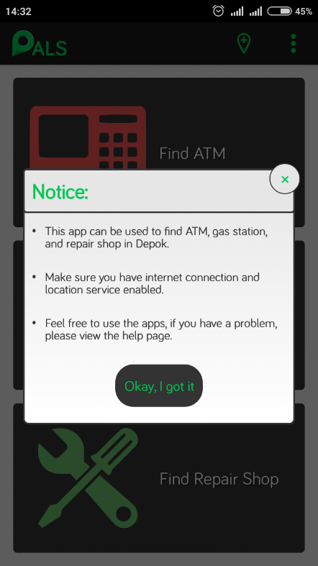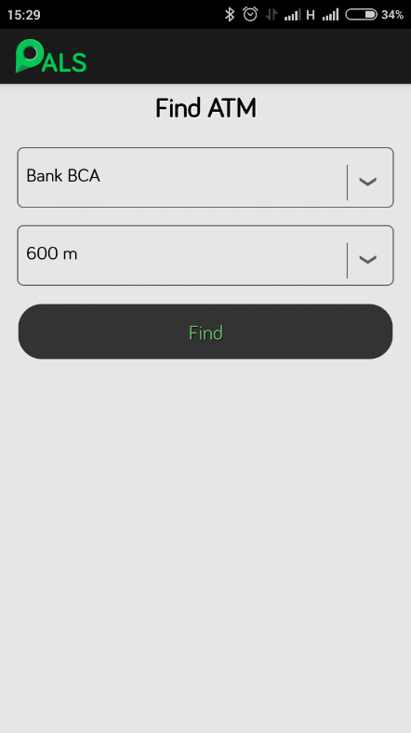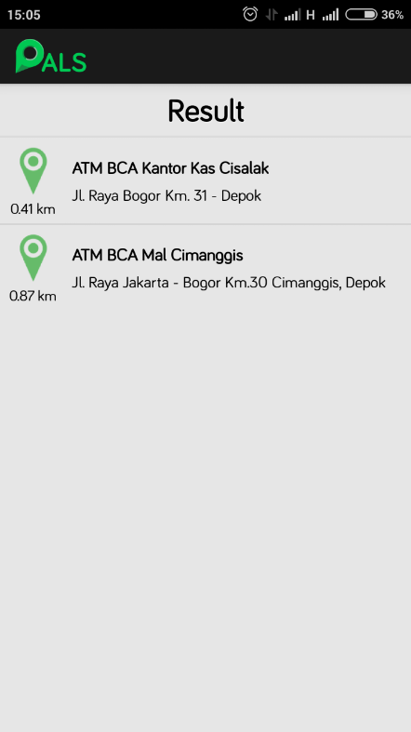

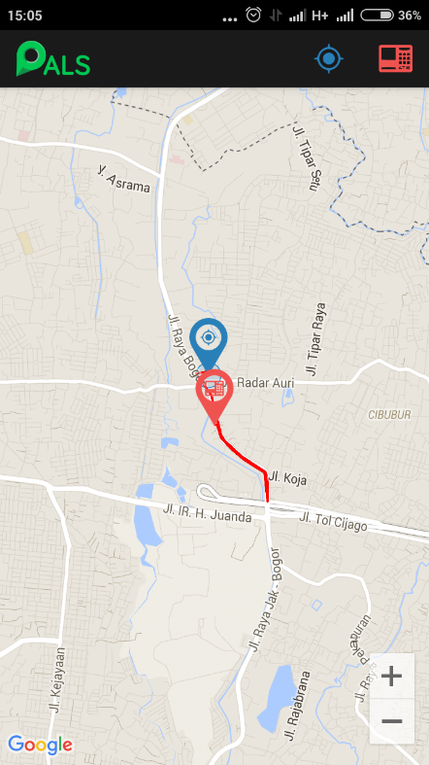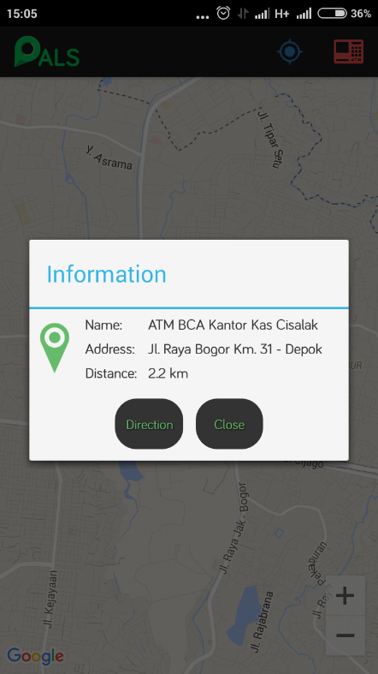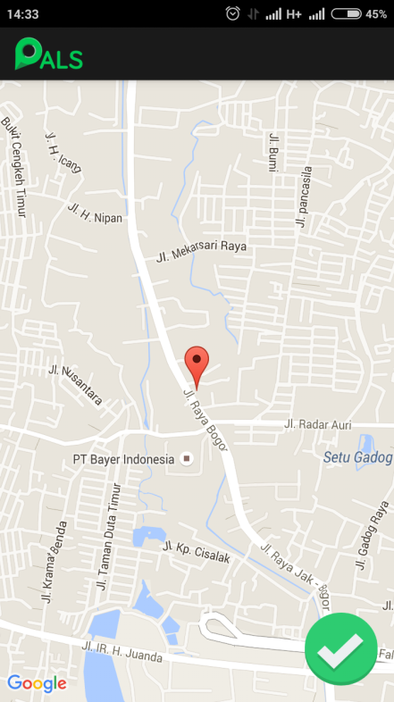

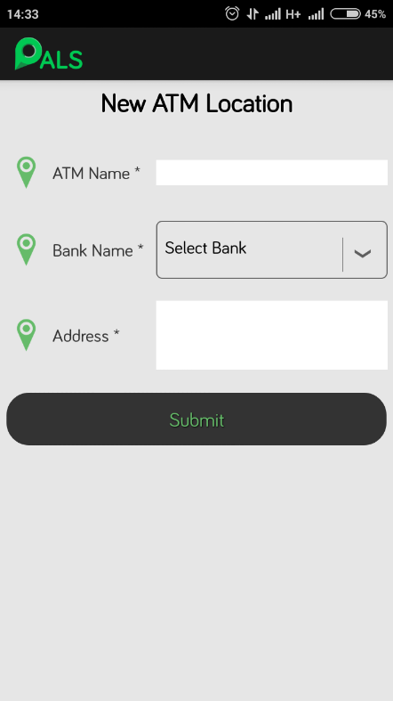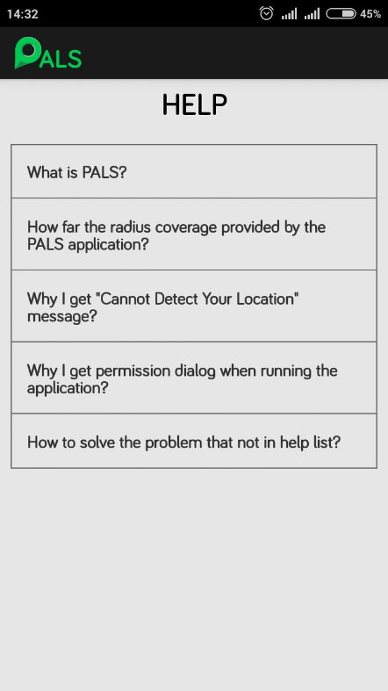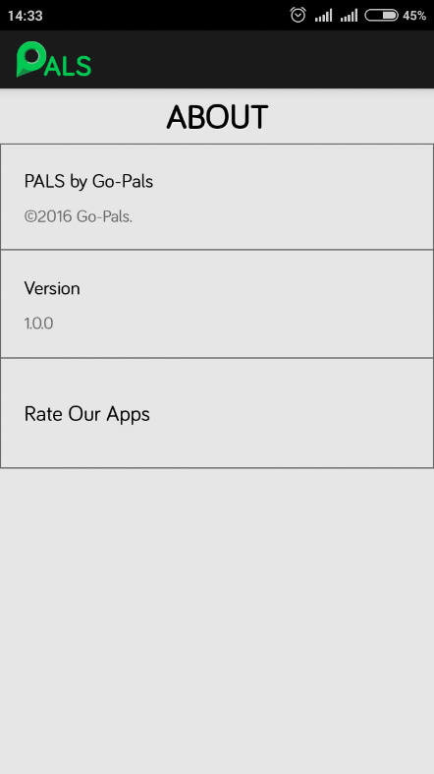

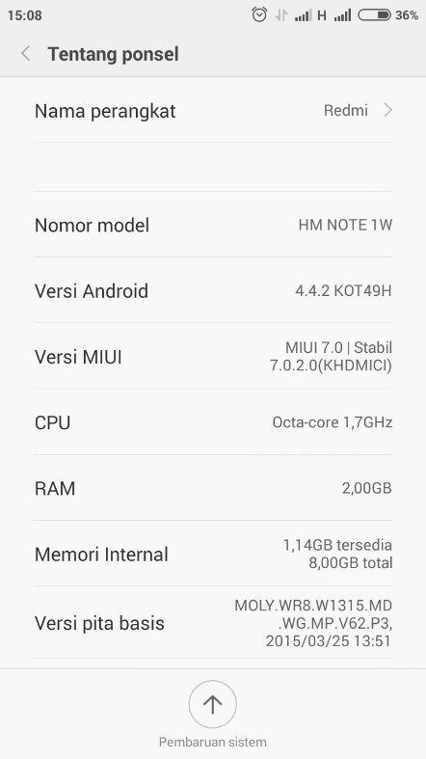

* **Redmi 3**

|  |  |  |  |
| --- | --- | --- | --- |
| **Tested By:** | | Alvin | |
| **Test Type** | | Compatibility Testing | |
| **Test Case Number** | | C-3 | |
| **Test Case Name** | | Redmi 3 test | |
| **Test Case Description** | | * Display size : 5.0 inches * Display resolution : 720 x 1280 pixels * OS platform : Android OS, v5.1.1 (Lollipop) | |
| **Item(s) to be tested** | | | |
| Test all app’s function on the Android device with Android OS. 5.1.1 | | | |
| **Specifications** | | | |
| **Input** | | | **Expected**  **Output/Result** |
| All that is associated with app’s navigation structure | | | All function running successfully |
| **Procedural Steps** | | | |
| 1 | Run the PALS Android application | | |
| 2 | Test all PALS Android application functions to ensure that can be run normally on Android OS | | |
| **Result** | | | |
| Success | | | |

**Attachment:**

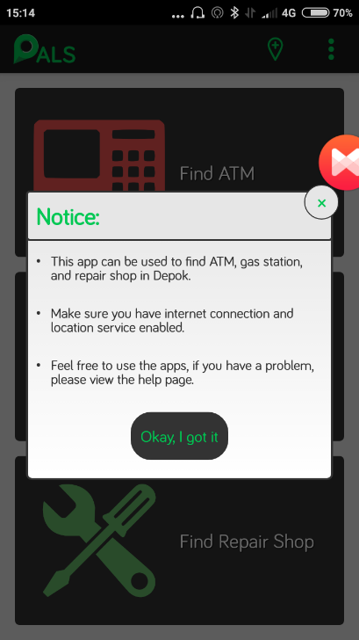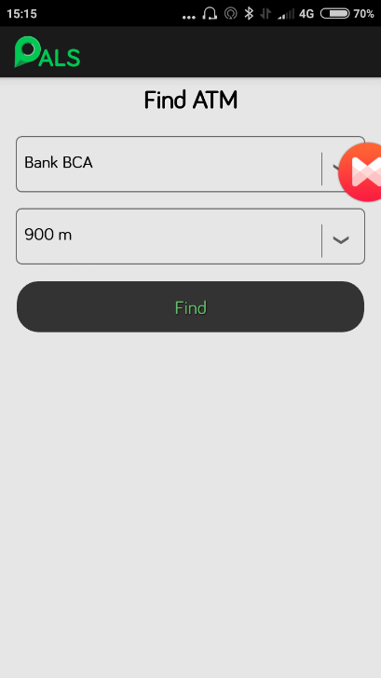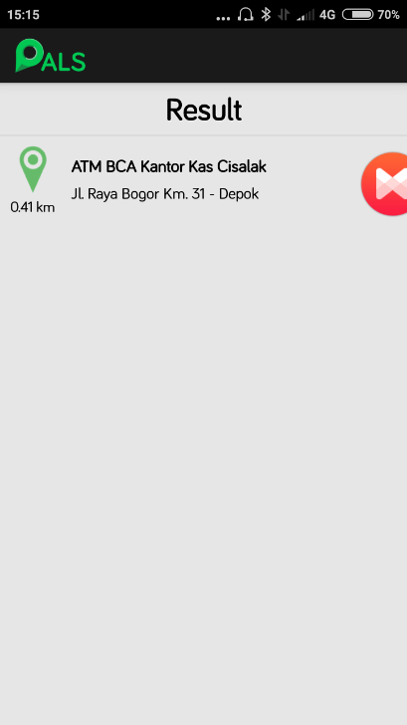

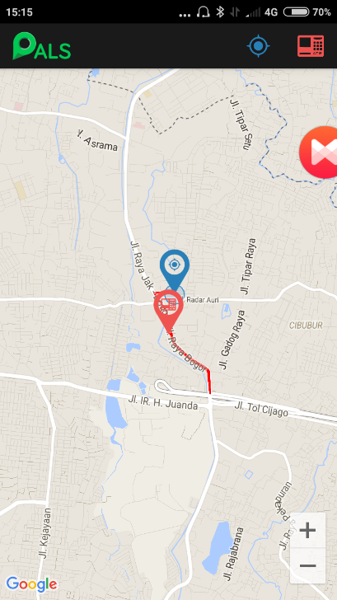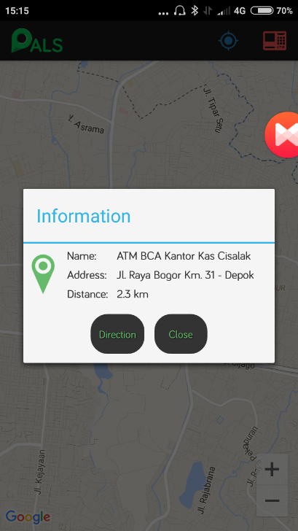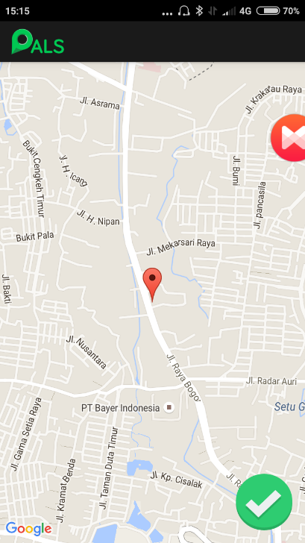

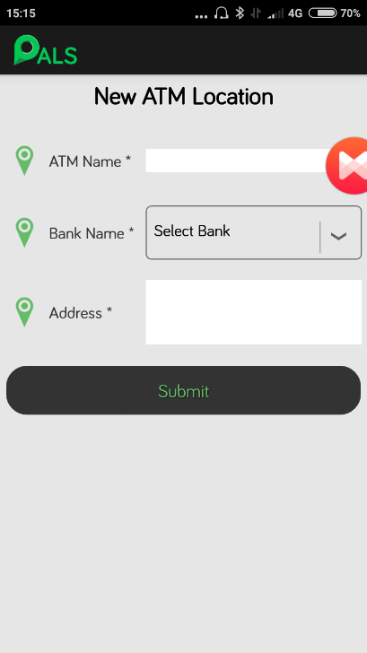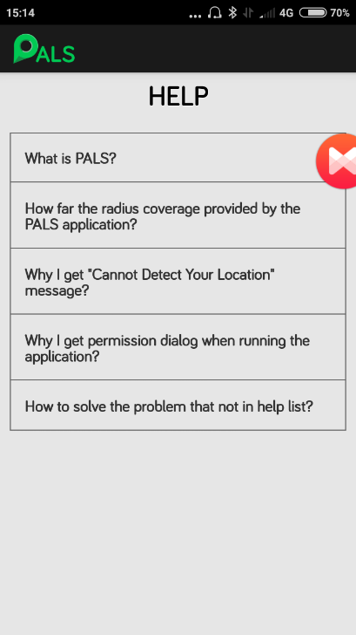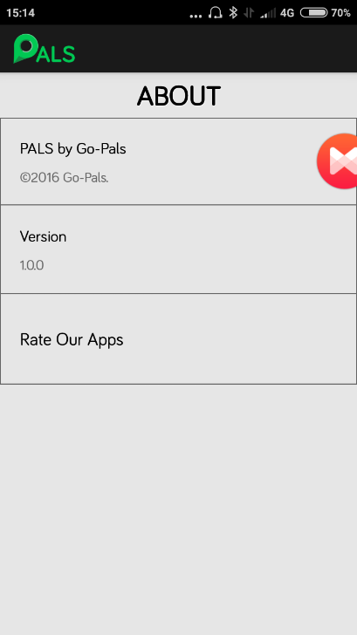

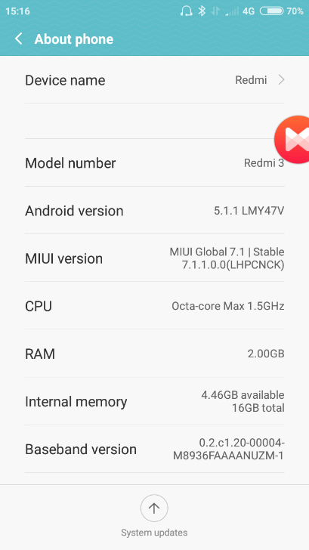

* **Infinix Note 2**

|  |  |  |  |
| --- | --- | --- | --- |
| **Tested By:** | | Alvin | |
| **Test Type** | | Compatibility Testing | |
| **Test Case Number** | | C-4 | |
| **Test Case Name** | | Infinix Note 2 test | |
| **Test Case Description** | | * Display size : 6.0 inches * Display resolution : 720 x 1280 pixels * OS platform : Android OS. 6.0 (Marshmallow) | |
| **Item(s) to be tested** | | | |
| Test all app’s function on the Android device with Android OS. 6.0 | | | |
| **Specifications** | | | |
| **Input** | | | **Expected**  **Output/Result** |
| All that is associated with app’s navigation structure | | | All function running successfully |
| **Procedural Steps** | | | |
| 1 | Run the PALS Android application | | |
| 2 | Give any permission requested by the application | | |
| 3 | Test all PALS Android application functions to ensure that can be run normally on Android OS | | |
| **Result** | | | |
| Success | | | |

**Attachment:**

