Nama : Muhamad Rizaludin

Nim : 1219016

Tugas : Riset Operasi

**Latihan NO 2**

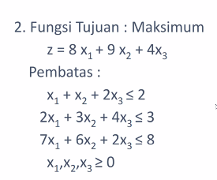

**Jawaban :**

|  |  |  |
| --- | --- | --- |
| **Model Simplexs** | |  |
|  |  |  |
| fugsi tujuan : maksimumkan | | |
| **z-8x1-9x2-4x3 = 0** | |  |
| **x1 + x2 + 2x3 + s1 = 2** | |  |
| **2x1 + 3x2 + 4x3 + s2 = 3** | | |
| **7x1 + 6x2 + 2x3 + s3 = 8** | | |
| **x1 + x2 + x3 >= 0** | |  |

