Patrick Garrettson, Chris Gunadi
May 7, 2010
CSCI-3366
Final Report Write-Up

Project Description: The Traveling Salesman problem is an optimization problem regarding the route planning given certain number of points located on a plane. Each route must navigate through every point on the plane, but can only pass through each point. The distances between points are calculated “as the crow flies”, meaning points are connected with straight lines regardless of physical characteristics and intersections.
The solutions for the problem are simple to find and verify as the problem is NP-complete. Human subjects are often able to produce good, if not optimal solutions relatively quickly based upon perceptual (visual) processing alone (Rooij, 2006). That being said, as of yet computers lack the ability to estimate and generalize as they are not sentient. Of course given a computer's speed it would surely be easy to use a brute-force approach to finding an optimal route between a number of points. Unfortunately, this approach can take up to factorial time as the number of solutions can be denoted as follows:
(Number of Points)! or (Number of Points)!/2 if direction is not taken into consideration.
Our goal was to implement a greedy-algorithm solution to the Traveling Salesman Problem (TSP). Our implementation of the TSP is implemented both in Java with Strings and C with OpenMP. For testing purposes, the 'world' is read in from a file and the distances between all points are computed and stored in a two-dimensional array.
When a route is planned, it receives its starting point and refers to the two-dimensonal array in order to determine where its next destination is. As our algorithm is a greedy algorithm, the salesman chooses the closest node so long as it has not already been visited. In the case that the closest node is unavailable, the salesman will select the second closest node, so on and so forth. In order to save computation time, when a route is being computed, if it is longer than the current shortest complete route, computation will end.
Results:
Java Implementation
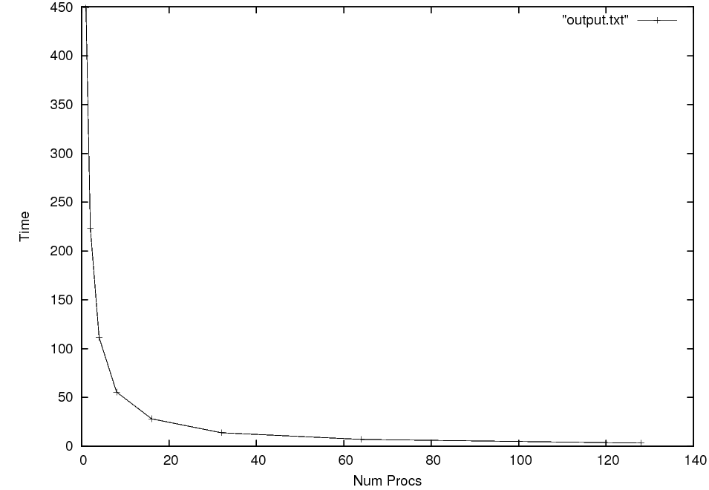
Figure 1. - Time in Seconds vs. the number of Processes. All tests were run on dione00
1 | 448.79
2 | 223.22
4 | 111.46
8 | 55.55
16 | 28.14
32 | 13.83
64 | 7.01
128 | 3.3
256 | 1.66
512 | 0.85
1024 | 0.49
2048 * | 0.31
4096 ^ | 0.49
* - Linear speedup ends ^ - Benefits of adding more threads becomes marginal

C + Open MP
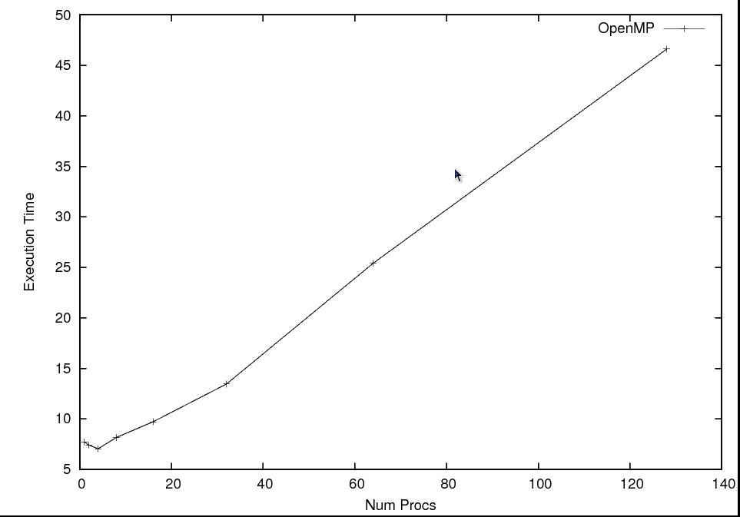
Figure 2 – Time in Seconds vs. Num Procs for the C/Open MP implementation
1 | 7.74
2 | 7.42
4 | 7.04
8 | 8.16
16 | 9.7
32 | 13.45
64 | 25.41
128 | 46.61
256 | 60.44
512 | 59.55
1024 | 57.75
2048 | 59.46
4096 | 59.77

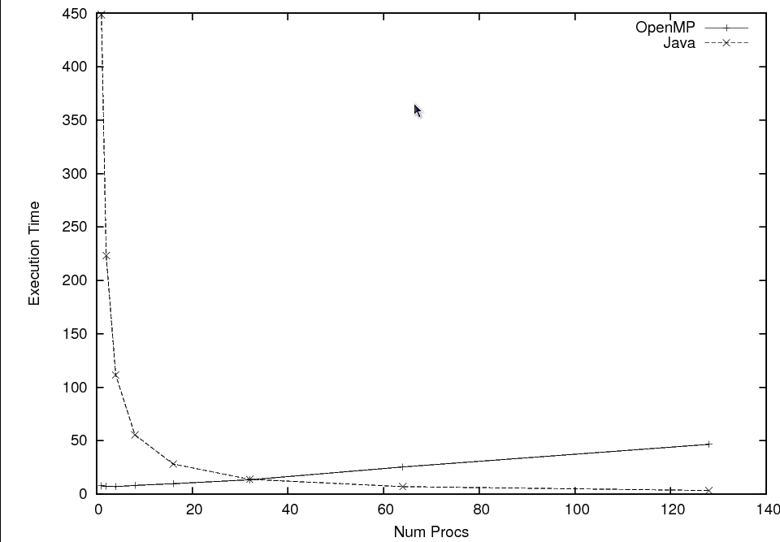
Figure 3 – Comparison of results between Open MP and Java implementations. 4096 points
Discussion – As you can see, the results for the two implementations were... interesting. The Java implementation's results where characterized by a linear increase in performance for number of processors until we reached parity between number of processes and points. The Open MP implementation, when looking at the lower number of processes, was much faster than the Java implementation taking only around 7 seconds as compared to 448. However, rather than showing marked performance improvements for each increase in the number of processes, the opposite proved true. At this point we are unsure if this is due to implementation or overhead specific to the language.

Conclusion – Given our approach to parallelizing the Traveling Salesman Problem, the benefits of using an object oriented languages seem to be apparent in the performance results. That being said, the Java implementation was the original implementation, we faced some challenges in trying to port the code over to the C/OpenMP environment. Also, J is evil.

