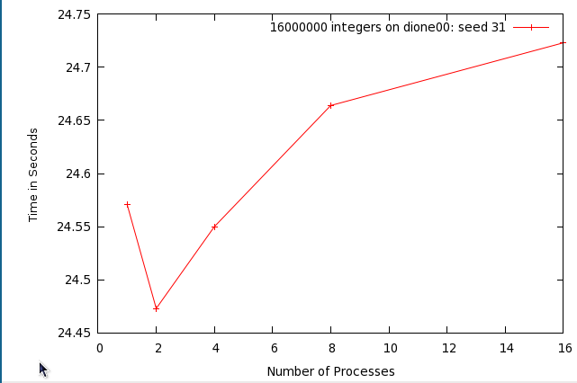
Figure 1: Results for seed 31.

Raw Data:
1 24.571
2 24.473
4 24.55
8 24.664
16 24.723
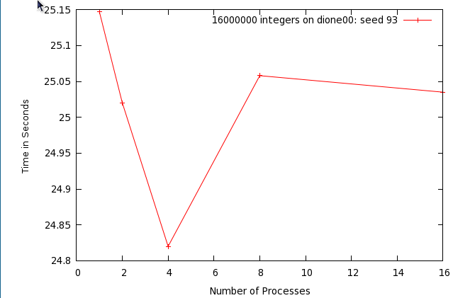
Figure 2: Results for seed 93

Raw data:

1 25.147
2 25.02
4 24.82
8 25.058
16 25.035

