1.INTRODUCTION
The rapid growth of digital documents requires intelligent systems that can retrieve information accurately. Traditional keyword-based search methods often fail to understand the actual meaning of user queries. Retrieval-Augmented Generation (RAG) solves this problem by combining information retrieval with Large Language Models (LLMs) to generate context-aware answers.
In this project, we built a Document Question Answering System using RAG on a Paracetamol PDF. The system splits the document into chunks, converts them into embeddings using a Hugging Face model, stores them in FAISS, and retrieves the most relevant content to generate answers. The application is implemented using LangChain and deployed with Streamlit, allowing users to upload documents and receive accurate answers along with source text.
2.ARCHITECTURE
The architecture of the Document Question Answering System follows the Retrieval-Augmented Generation (RAG) pipeline. The system consists of five main components: Document Processing, Embedding Generation, Vector Database, Retrieval Mechanism, and Answer Generation. The entire pipeline is integrated using LangChain and deployed through a Streamlit user interface.
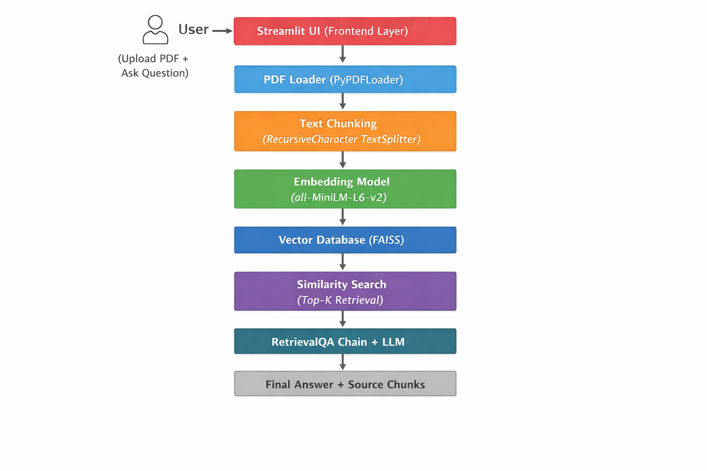
3. CHUNKING STRATEGY
In this project, RecursiveCharacterTextSplitter was used to divide the PDF into smaller chunks with:
- chunk_size = 400
- chunk_overlap = 50
Chunking is necessary because large documents cannot be processed directly due to token limitations and reduced retrieval accuracy. Splitting the document improves semantic search and ensures efficient similarity matching.
A chunk size of 400 provides sufficient context while maintaining retrieval precision. The overlap of 50 characters preserves continuity between chunks, preventing loss of important boundary information.
RecursiveCharacterTextSplitter maintains natural language structure by splitting text hierarchically (paragraph → sentence → word), making the retrieval process more effective.
4. EMBEDDING CONCEPT
Embeddings are numerical vector representations of text that capture its semantic meaning. Instead of storing text as plain words, embeddings convert each chunk into a list of numbers that represent its context and meaning in a high-dimensional vector space.
In this project, we used the all-MiniLM-L6-v2 model from Hugging Face to generate embeddings. This model transforms both document chunks and user queries into fixed-size dense vectors. These vectors are designed in such a way that texts with similar meanings are placed closer together in the vector space.
Embeddings are essential in a RAG system because they enable semantic similarity search rather than simple keyword matching. Even if the user’s question uses different words from the document, the system can still retrieve relevant information based on meaning. This improves accuracy and relevance of retrieved chunks.
Furthermore, embeddings reduce unstructured text into structured numerical format, making it possible to efficiently store and search data using vector databases like FAISS. By comparing vector distances (such as cosine similarity), the system identifies the most relevant chunks to generate accurate answers.
5. RETRIEVAL PROCESS
The retrieval process is a core component of the RAG system that identifies the most relevant information from the document based on the user’s query. When a user asks a question, the system first converts the query into an embedding vector using the same embedding model (all-MiniLM-L6-v2) that was used for the document chunks. This ensures both the query and document chunks exist in the same vector space. The query vector is then compared with the stored document vectors in the FAISS vector database. Using similarity search FAISS retrieves the Top-K most relevant chunks that are semantically closest to the query.
These retrieved chunks are passed to the RetrievalQA chain along with the user’s question. The language model then generates a final answer using only the retrieved context. Additionally, the system returns the source chunks to maintain transparency and reliability. This retrieval process ensures that the generated answer is based on relevant document content, improving accuracy and reducing hallucinations.
6.CONCLUSION
This project successfully implements a Document Question Answering System using the Retrieval-Augmented Generation (RAG) approach. The system processes PDF documents, performs chunking, generates embeddings, and stores them in a FAISS vector database for semantic retrieval. By combining retrieval with a language model, it generates accurate, context-based answers through an interactive Streamlit interface.

