“A NEURAL NETWORK ARCHITECTURE FOR CLASSIFICATION AND DIAGNOSIS OF DIGITAL CHEST RADIOGRAPHS”

A Synopsis of thesis submitted in partial fulfilment of the requirements
for the award of the degree of

DOCTOR OF PHILOSOPHY

IN
COMPUTER SCIENCE & ENGINEERING
By

N.SARADA

[173030045]

Under the esteemed guidance of

Dr. K.THIRUPATHI RAO

Professor, Department of CSE



DEPARTMENT OF COMPUTER SCIENCE & ENGINEERING
KONERU LAKSHMAIAH EDUCATION FOUNDATION
K L Deemed to be University
(Deemed to be University u/s 3 of UGC-Act 1956)
VADDESWARAM - 522502
ANDHRA PRADESH
INDIA
FEBRUARY - 2022
TABLE OF CONTENTS

Abstract 1
CHAPTER-1
  - Introduction 2
CHAPTER-2
2.1 Literature Survey 3
CHAPTER-3
3.1 Research Approach 7
3.2 Research Gaps 7
3.3 Research Objectives 8
3.4 Problem Statement 8
CHAPTER-4 Architecture for Image Segmentation 9 4.1 Introduction 9
4.2 Convolutional Neural Networks for Medical Image Processing 10
4.3 Image Segmentation using CNN on Lung Segmentation 11
4.4 U-NET Architecture for Image Segmentation 13
4.5 Proposed U-Net Model for Segmentation 14
CHAPTER-5 Neural Network Architecture for Image Classification 18 5.1 Introduction 18
5.2 Proposed Approach 19
5.3 Dataset Overview 20
5.4 Proposed Architecture for Classification 21
5.5 Network Training 22 5.6 Conclusion 23

CHAPTER-6
6.1 Tweaking the Architecture 24
CHAPTER-7
7.1 Results Analysis 28
7.2 Results Comparison 33
CONCLUSION 34
FUTURE SCOPE 34
REFERENCES 35

ABSTRACT

The medical imaging procedures performed are increasing several times faster than the number of Radiologists who can interpret them. Each scan is now much more involved and information-rich than is used to be in the past. Various machine learning models have been deployed on the deep learning algorithms to accurately detect and highlight abnormalities, reducing the chances of missing diagnosis.
Existing classification techniques such as Support Vector Machine (SVM) and Random Forest (RF), Multilayer Perceptron (MLP) and logistic regression (LR) models haven't been very much significant on classification when compared with Deep learning.
Deep learning algorithms, in particular, convolutional networks, have rapidly become an of choice go-to for classification of imaging data. Deep Convolutional Neural Networks could be more efficient to attain the higher level of classification accuracy on Medical Imaging data.
Deploying Deep Convolutional Neural Networks (CNN) while using suitable layers for medical imaging expands the view for better insights and thereby increasing accuracy in the process of diagnosis.
In this system, we structure, analyse and train Deep Convolutional Neural Networks with layer-wise tuning on Medical Images which increases the effectiveness of the classification and diagnosis of Digital Chest Radiographs. Adding the right layers to the network would create a more significant change in computation and production of an analysis that corresponds to the data.
The design architecture of convolutional neural network would be validated with a robust data set of medical imaging of various patients while tuning layers to offer a practical way to reach maximum and efficient performance for classification of DICOM data.
We conclude with a summary of bringing state-of-the-art classification and design of Convolutional Neural Networks for analysis of Medical Images.
CHAPTER-1

  - Introduction
Chest abnormalities and lung cancer are the most commonly observed problems in the current era due to the increase in pollution. Lung Cancer is one of the small non-cell types of cancer that is being diagnosed in the recent years. Few abnormalities like Tuberculosis, Pneumonia are also becoming difficult to be identified with the naked eye by radiologists. Additionally, due to the increase in the treatment costs and lack of required medical equipment, it is difficult to locate where the diagnosis needs to be done. Also, high cost and very less availability of these, results in loss of crucial information needed for the diagnosis. There have been several advancements in computer vision to identify these problems in the recent years. However, it is difficult to determine and tackle these problems without the involvement of radiologists as it will be a challenging task for a machine to predict accurate results. There are several Artificial Intelligence and Machine Learning techniques that have been applied to solving the same but which couldn't achieve a high accuracy. Instead, deep learning can produce better diagnosis and results than a radiologist. Few architectures like MobileNet, ResNet and DeepMind Net can also be used for image segmentation.

One of the drawbacks of using Neural Networks is that, it consumes ample of time for the training process. If the data is not consistent or processed, it results in false predictions. Therefore, Neural Networks need a lot of computational power which CPUs alone cannot afford; on the flip side, these are powered by GPUs to quicken the training process. Approximately, CPU consumes 15 mins to run a simple Convolutional Neural Network, whereas a GPU can do the same in 60 seconds. GPUs, therefore, make great disruptive progress in computing, especially in the fields of deep learning. The primary goal of this research is to demonstrate the efficient way of two-dimensional Medical Image Segmentation and classification and to identify the abnormalities, which is being done on Chest X-Rays (CXR) in this work.

CHAPTER-2

  - Literature Survey
Medical Image Analysis generally comprises Image Acquisition; Image Pre-Processing; Image Enhancement/De-Noising and Restoration; Image Segmentation; Feature Extraction and Classification-Post Processing. Tremendous research works reported in literature on analysis of the medical images used for diagnosis of various diseases such as lung cancer, pancreas cancer, brain tumour etc. Major difficulties are huge data; poor quality of images; processing time; no robust method that can deal with all modalities. Robustness is all time research problem particularly in the area of image de-noising and segmentation of the images. Machine learning methods using Neural Networks are used in feature extraction or training methods employed in analysis and post-processing of medical images.

Conventional training uses traditional neural network based and Support Vector Machine (SVM), approaches which do not help in getting features appropriately and therefore an emerging method of learning “deep learning” has potential that can address challenges of medical image processing [Sinha, G.R., Patil S., 2014]. Non-conventional method of machine learning can provide improved result both qualitatively and quantitatively [Sinha, G.R., Patil S., 2014].
We recommend Deep Learning methods in feature extraction process of Medical Image Analysis and the Study focussed on Neural Network based and deep learning-based research works.

In [Criminisi, A., 2016], study of machine learning methods and their applications for analysis of medical images is presented. Large dataset and complexity of algorithms were discussed.

In [Marleen, B., 2016], the importance of using machine learning methods was emphasised for image analysis and feature extraction for diagnosis of medical images. The main challenges of machine learning methods, variations in images, and evaluation of results were discussed.

In [Gyeongju, 2016], CAD is used for reducing false positive cases and improving the performance of CAD system. CNN as deep learning resulted more than 93 percent of true positive cases (TP) but 128 percent of false positive cases (FP) was major concern in this research work.
Deep learning is used in the classification of cardiac MR images. The method has no computational complexity as such but its adoption in routine clinical practice is the major challenge as concluded as prospect of the implementation of CNN [Archontis G., 2016].

In [Jafari, 2016], the existing research papers on skin lesion detection were studied and artefact was observed the factor for noise in the images. Pre-processed images were subjected to deep CNN that includes local and global contextual information, and segmentation mask helps in getting the lesions. However, the mask for segmentation needs to be further refined.

In [Suyu, D., 2016], segmentation method was implemented for left ventricular (LV) endocardium and analysis of anatomic structures was made. CNN training was performed that generated binary cuboids which further assisted in exact location of regions of interest. The results are more accurate in comparison with that of expert’s measurements.
Contextual Neural network was suggested for medical image segmentation for analysis of biomedical images. The study suggests that CNN can be trained for obtaining automated segmentation results for medical images in their analysis [Hao C., 2016].

In [Anshuman, V., 2015], content-based image retrieval (CBIR) system exploits visual features of images at low level for obtaining good retrieval results over query images. Feature representation plays an important role in CBIR and therefore, CNN was used in feature representation stage of implementation.

In [Zhipeng, C., 2016], CNN in effective segmentation of brain MRI images was suggested. In [Florin, C., 2016], CNN is tested for around 6000 CT images for their anatomical classification. General methodology was suggested for learning and classification accuracy was calculated.

In [Kalinovskya, A., 2017], deep learning is claimed to have detected tuberculosis lesions, tested over 3D images of 338 scans. The segmentation was seen as semantic segmentation in this work and the method outperformed the existing conventional methods.

The role of deep learning in feature representation of pathological dataset was studied, especially affected with poor contrast and pathological areas of MRI sequences. Localization uses deep learning followed by normalisation process. However, the implementation was done for limited number of images [Awais, M., 2016].

In [Diplom, I., 2015], state of the art methods such as k-means method, support vector machine (SVM) and random tree method are compared with deep learning-based methods.

In [Korsuk, S., 2016], spatially constrained CNN (SC-CNN) is used for detection and classification of cell nuclei of images that are affected with stained tissues and eosin stain. It was claimed as the potential highlighted in particular.

Texture descriptor worked successfully on the results of CNN based features, and future developments of this method for further analysis were also highlighted [Carlos, A., 2017].

In [Mark, J., 2016], deep learning is suggested for medical image analysis especially regarding training and processing time. Training time reduction was achieved in comparison with traditional approaches of machine learning.

In [Pim, M., 2016], segmentation of MRI images was simulated and quantitative analysis was made. Segmentation of tissues was not robust and therefore need arises for suitable learning method for improved classification of tissues.

In [Sergio, P., 2016], segmentation of medical images was presented that uses CNN based deep learning. In brain tumours, gliomas are difficult to analyse and MRI images are acquired for analysis of such aggressive elements. CNN based method provided better segmentation results in comparison with existing methods. Large amount of structural variation as well as spatial variability are common problems in this work.

In [Qinpei, S., 2017], deep learning is suggested for content-based medical image retrieval (CBMIR) in comparison with shallow architectures of traditional learning methods. Deep learning is a kind of human mimic-based learning that makes feature extraction easy. However, the metrics for assessment of CBMIR accuracy are not found robust.

In [Nima, T., 2016], CNN based training is employed in large dataset case for effective medical image analysis. Several questions were discussed critically, related to whether pre-trained data requires deep learning in medical image analysis.

CHAPTER-3
3.1 Research Approach
Deep Learning for Feature Extraction: Convolutional Neural Network gives better results of accuracy of medical image analysis. Convolutional Neural Network (CNN) is a model of deep learning taken as a classic example of deep learning.

Convolutional Neural Networks (CNN) are fully and locally connected to hidden layers unlike traditional neural network because for all fully connected networks, the operation becomes computationally intensive. CNNs use parameter sharing, pooling and dropout also which reduce the number of common features to large extent and hence addressing the computational issues.
First convolution layer extracted features which are usually low-level features such as edges and lines and subsequent layers extracted high-level features. Size of input is N x N x D and this has to be convolved with kernels whose size is k x k x D separately. Convolution of an input with one kernel produces one output feature, and with H kernels independently produces H features. Each feature in the output consists of (N-k+1) x (N-k+1) elements. For each position of the kernel in a sliding window process, k x k x D elements of input and k x k x D elements of kernel are multiplied and added. The k x k x D multiply-accumulate operations are required for producing one output feature.
Classification and Analysis : We will analyse the medical images based on features extracted in previous stage using suitable classifiers. The results will be finally compared with few results of conventional method of machine learning that may be ordinary neural network based learning technique.

3.2 Research Gaps

Automated medical image analysis and diagnosis has become common in all modern diagnostic centres. Research contributions are reported on computer-aided diagnosis system-based methods for detection of abnormalities in different modalities of medical images. The current literature suggests limited research in the medical image processing using deep learning.
Thus, critical review suggests that there is great scope of deep learning-based research in the area of medical image analysis. Current literature suggests Deep Learning as an emerging method for machine learning for medical image analysis but with the following concluding remarks as challenges:
Lack of robust approach: Methods are not tested against large number of images particularly medical images.
Assessment Metrics are not robust: Set of metrics evaluating accuracy were not found robust.

3.3 Research Objectives

The objectives of this research work is to analyse digital chest radiographs to automatically detect and diagnose images of lungs using neural network architectures for image segmentation and classification.

Objective 1: To design and implement a neural network architecture “MU-Net” for efficient image segmentation.
Objective 2: To propose and implement a neural network architecture “PtecX” that classifies segmented medical images to identify abnormalities on the segmented images.
Objective 3: To tweak the proposed neural network architecture to address medical problems reliably and accurately and to localize the presence of abnormality.

3.4 Problem Statement
In this system, we structure, analyse and train Deep Convolutional Neural Networks with layer-wise tuning on Medical Images which increases the effectiveness of the classification and diagnosis of Digital Chest Radiographs.

CHAPTER-4
Architecture for Image Segmentation
4.1 Introduction

In the fields of computer vision, Image Semantic Segmentation is widely used for medical image processing. This helps in the prediction of abnormalities and describing the accurate analysis on CT-Scans and X-Rays. With the rise of deep learning, Neural Networks are performing and are achieving the highest possible metrics in the fields of image classification and segmentation. In this work, we use the Con-volutional Neural Network on Chest-X-Rays for segmenting the lungs. The proposed architecture used for image segmentation is modified U-Net which was applied for evaluation on the train and test of NIH dataset. The outputs of the model describe the pre-processed image, accuracies on the test, train dataset, loss and prediction with intersection over union values (how dynamic the images are segmented) of Chest X Rays over two thousand examples.
Chest Abnormalities and lung cancer are one of the most commonly observed problems due to the increase in the pollution. Lung cancer is one of the small non-cell types of cancer that is being diagnosed by most of the doctors in recent years. Few abnormalities like tuberculosis, pneumonia is also being very difficult to identify with the naked eye by radiologists. Due to the increase in the treatment costs and lack of medical equipment requirement, it is difficult to locate where exactly the diagnosis is to be made. Also, it is relatively known that high cost and very less availability of this results in lots of loss. There have been several advancements in computer vision to identify these problems day by day. However, it is difficult to determine these problems without the involvement of radiologists as it will be a very challenging task for a machine to make the algorithm more accurate.
There are several Artificial Intelligence and Machine Learning and trans-forms techniques that have been applied to solving the same but couldn’t achieve higher accuracy but with deep learning this could produce better diagnosis and results than a radiologist. Few architectures like MobileNet, ResNet and DeepMind Net can also be used for image segmentation. One of the drawbacks of using Neural networks is that, they take more time for the training process. If the data is not consistent or processed, they result in false predictions.
Neural Networks need a lot of computational power which CPUs couldn’t generate; these are powered by GPUs for the faster training process. Approximately in an average CPU, a simple Convolutional Neural Network takes 15 minutes of time, whereas with a GPU (Graphics Processing Unit) it can be done in 60 seconds. These GPUs also made great disruptive progress in computing especially in the fields of deep learning. The primary goal of this research is to demonstrate the efficient way of two-dimensional Medical Image Segmentation and to identify abnormalities, which is done on Chest X-Rays (CXR) in this work. We use a CheXnet model for prediction of pathologies. This is the initial step that is to be processed.

4.2 Convolutional Neural Networks for Medical Image Processing

Convolutional Neural Networks performed exceptionally well for image classification and image segmentation with maximum accuracy and less error. In this work, we’ll be dis- cussing briefly how Convolutional Neural Networks perform on medical images for identifying abnormalities, pathologies etc. These are a particular type of Neural Networks that use an architecture which uses three different layers. The primary layer in this architecture is known as the convolutional layer, it can also be called as convolutional kernel which is a filter with a particular value when multi-plied with the image (Image Pixel Values) identifies the features in it.
Next to convolution kernel is a pooling layer which defines the most effective elements once the convolution layer is filtered. There are two types of pooling techniques one is max pooling the other is average pooling. In max pooling, the feature with the highest value is elevated, while in average pooling the average of the highlights is taken and selected between elements. The next layers are fully connected layers, there are usually used after series of convolution and pooling layers for high-level reasoning in the neural network. The figure shown below is the initial Convolution Architecture used for Image Classification that was proposed by Alex Krizhevsky et al.
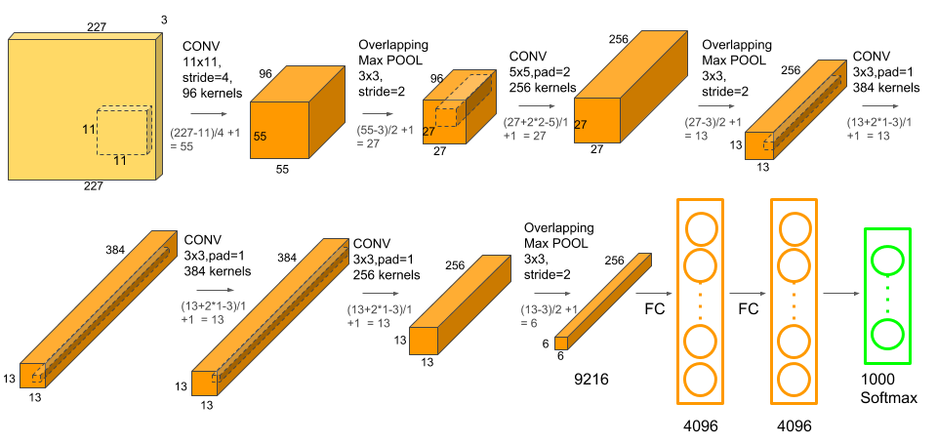

Figure 4.1 : Convolution Architecture Proposed and Used for Image Classification by Alex Krizhevsky et al.[3]

4.3 Image Segmentation using Convolutional Neural Networks on Lung Segmentation

4.3.1 Dataset
The below mentioned segmentation Convolutional Neural Networks are applied on NIH dataset, an open dataset where research can be carried out. This dataset contains over one lakh images of the X-Rays and CT Scans of the chest. All the photos are not classified based on abnormalities or any cancer identification. The total number of unique patients can be recognised in the data are around 30,000. Few radiology reports which are diagnosed are available, but almost many other models on the same dataset gave about 90% of accuracies using Neural Networks with weakly supervised learning [10]. CheXnet[8] was a model developed in the same dataset which almost identified several abnormalities and pathologies in the lungs. The architecture used on this dataset is a 121-layer Convolutional Network. In this work, we use the same data for lung segmentation. Below are the few sample images where the image segmentation using our model is carried out.

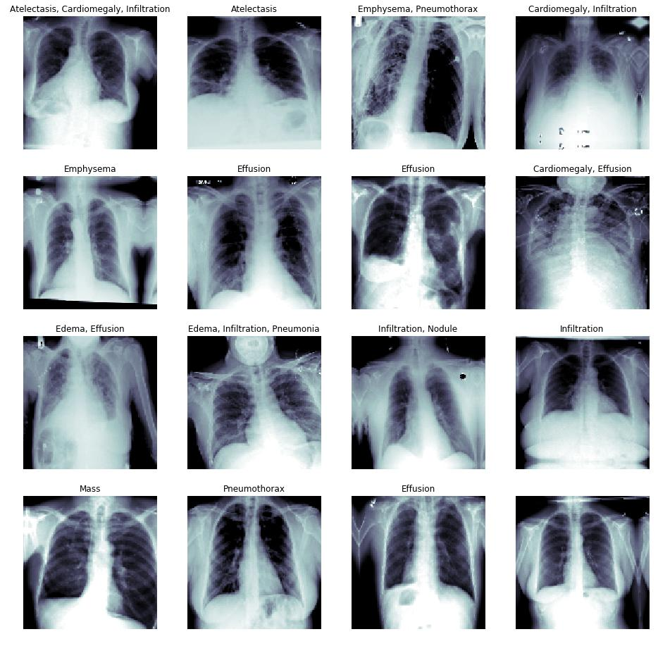

Figure 4.2 : NIH dataset Peek Over, Images and their abnormalities described on the labels that are provided.

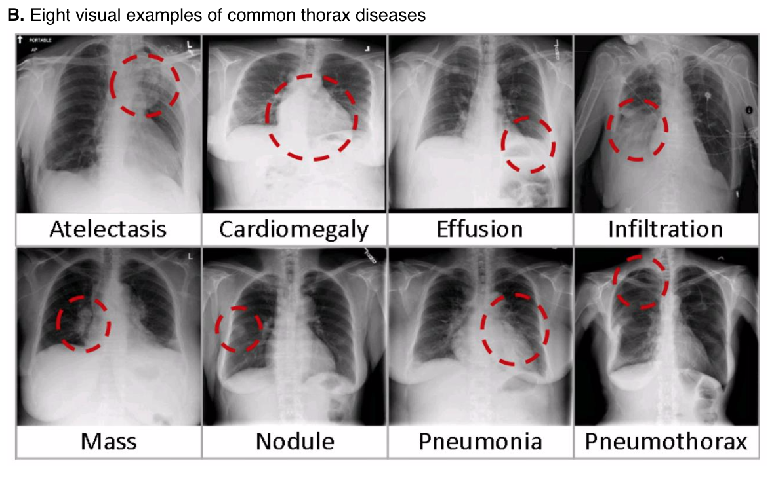

Figure 4.3 : Eight visual examples of common thorax diseases
4.4 U-NET Architecture for Image Segmentation

U-Net is a convolutional architecture that is applied to medical images to segment nerve channels or organs present. In this work, we separate the left and right lung from the given CT-Scan or the X-Ray using U-Nets. The architecture of U-Net is de-scribed below. The U-Net architecture is comprised of two parts one on its left, and one on it’s right namely, contracting portion and expansive path respectively. Two 3x3 convolutions are repeated followed by ReLU activation function with two max pooling and two down sampling kernels with stride s = 2. In the right side which is expansive path the sampling was done to the feature map are served by 2x2 convolutions which reduce the number of feature channels to the half these are added with the cropped feature map from the left part i.e., contracting path wherein again two convolution operation of kernel size 3x3 are done followed by ReLU activation layers. In the last segment, a 1x1 sized convolution operation is done to harmonise every feature vector of 64-component.
As we see the figure which is proposed as the official architecture of U-Net[13], it consists of 23 convolution operations. We also require to determine a proper input size so that max operations are implemented with even x and y values.

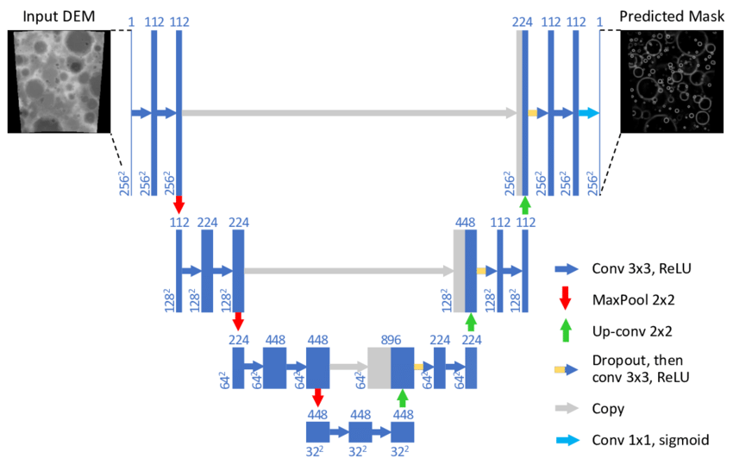

Figure 4.4 : U-Net: Convolutional Networks for Biomedical Image Segmentation proposed by Olaf Ronneberger et al.[9]

  - Proposed U-Net Model for Segmentation

The proposed U-Net model for segmentation is a 22-layer Convolutional Neural Network with 11 convolutional kernels, 11 upsampling layers, each layer starts with upsampling followed by convolutional layer and ReLU (Linear rectified unit) activation function.
The last layer is followed by Sigmoid activation function which is a binary classifier returning the segmented lungs from the medical image that is passed in. The total number of parameters passed inside the convolutional layer is more than six thousand.
There are five crucial steps for feature identification that are carried out by the model. Initially, the original image is converted into a tensor – a multidimensional array representation, and the dimensions are passed in as the input to the network.
The work is carried out on the pre-processed images if variable size 256*256 and 126*126 which are original images.
A ground truth binary mask is generated over the lung parts using computer vision techniques by finding the mean and median of the pixel array of the input image. Below are the tabulated values of mean of the sample chest x-ray images.
Using these mean and median values, the model next generates a new binary mask which is acquired from the training dataset. Ground Truth Mask overlay on Original Image is applied to the original image where most of the segmentation process is.
These are adjusted with the trained weights based on the accuracy that is generated by the model. Final steps of the model are it then creates a mask overlay on the original image where deconvolutional layers help in scaling up the image resolution

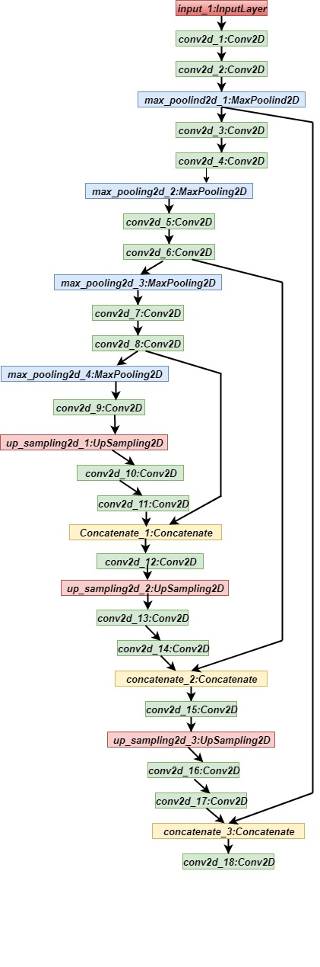

Figure 4.5 : Modified U-Net Architecture

Image | Mean
Processed Image 0 | 0.956614709
Processed Image 1 | 0.960528436
Processed Image 2 | 0.960258242
Processed Image 3 | 0.964508957
Processed Image 4 | 0.956614703
Processed Image 5 | 0.960528436
Processed Image 6 | 0.960258243
Processed Image 7 | 0.964508957
Processed Image 8 | 0.960258242
Processed Image 9 | 0.967389534
Processed Image 10 | 0.934661563
Processed Image 11 | 0.934561560
Processed Image 12 | 0.934634616
Processed Image 13 | 0.944661564
Processed Image 14 | 0.923615600

Table 4.1 : Mean Values of Mask Overlays of Segmented images
    - Training the Model and Analysis

The U-Net proposed U-Net architecture have 5,469,473 parameters in all the layers with 23 layers in total including fully connected layers. The kernel size for all the convolutional layers is almost 3. The training model takes the input image dimensions as 256*256, else if the image is given in other formats or shapes it automatically reshapes the image into 256*256 size or 128*128 size based on the input parameters. The batch size considered for the training process is 16, which means the number of training examples that are processed at a time.

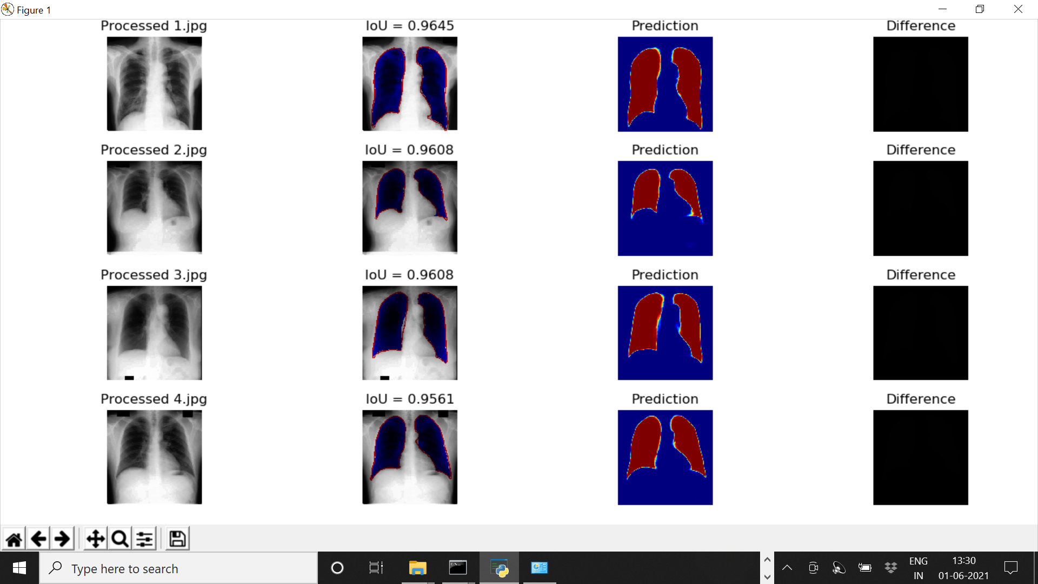

Figure 4.5 : Figure depicting Processed and Segmented X-Ray images along with IOU values and Difference

CHAPTER-5
Neural Network Architecture for Image Classification
5.1 Introduction

Neural Networks are widely used for the automation of analysis and classification tasks in the fields of medical image processing. They have successfully achieved state of the art performance in medical image segmentation and feature extraction techniques. This automatic classification in the medical field is very helpful in developing tools for early detection of dreadful pathologies like Tuberculosis and Pneumonia in areas where access to doctors or radiologists in scarce. In this work, we propose a novel approach for the classification of lung pathologies like Tuberculosis and Pneumonia by masking them in boundary boxes using Convolutional Neural Networks. Our solution provides a flexible way by using saved trained models that could be directly employed by the Radiologists. In this paper, we describe the architecture required to achieve such a scalable model which could be used by doctors and radiologists without too much training in technology. The proposed convolutional architecture consists of connected components which are parallel residual blocks and sampling layers. The images do not lose their original quality, giving the best error free predictions. We envision this model to be deployed in labs, providing access to medical imaging expertise in some of the most remote places in the world.
Identifying the pathologies is one of the challenging tasks in medical fields, it’s still an epidemiological study. More than one million people get hospitalized and more than 50,000 people die with Tuberculosis. Diseases like these are reported to increase at a very unusual rate due to human immunodeficiency virus, bacterial immunity to medication, a rising number of the homeless/drug users, and so on [1, 2]. Tuberculosis is an infectious disease that affects the lungs caused by Mycobacterium; doctors term these infected, affected regions to be bacillus. If a patient is diagnosed with bacillus in lung x-ray, it will be termed as Tuberculosis positive/positive spectrum smear. According to the World Health Organization, if one bacillus is present in 100 images, a minimum of 100 fields are examined to declare the positive sputum smear [3]. To identify this bacillus or the affected areas in the lungs, we need to be precise in color, shape, and edges.
This can be extracted using image processing or pattern recognition techniques. Previously, research scientists used traditional machine learning and computer vision techniques like support vector machines, multi-layer neural networks that dealt with many expenses to detect the spectrum spear. The CAD (Computer- aided diagnosis) is used before machine learning algorithms [4] which follows four steps in finding the anomaly of the given CXR images. These include pre-processing, segmentation, feature extraction, and classification. However, CAD systems only use computer vision techniques in finding the affected regions, they couldn’t meet the human level accuracies. Later in the year 2012, when deep learning has been popular due to its end to end architectures, it could extract features of how pathologies could be identified in the given CXR images.
In this work, we will be using Convolutional Neural Networks to classify the given lung pathologies based on their classes whether they fall into normal or abnormal. The architecture can be generic to Tuberculosis and Pneumonia pathologies. It mainly relies on the hospital dataset which we will be trained using ConvNets to extract the features and identify the masks (the affected regions of the lungs either bacillus or the positive pneumonia region) via segmentation. The Neural Network is given, masks of pneumonia affected areas and the CXR images. The model is trained over a set of images; once the training process is complete, the weights will be able to predict if the pathology is positive or negative in a given model by masking the affected region.

Proposed Approach
5.2.1 Segmenting the masked regions
Segmentation is the partitioning of an image into various segments which are a set of pixels. It is based on the similarity of pixel components, the pixels which are similar are grouped into one cluster. It can be implemented using clustering, thresholding, edge-detection, etc. These conventional techniques give out lesser accuracy in comparison to Artificial Neural Networks which have given scope for many novel approaches such as - using Convolutional Neural Networks to perform image segmentation[13]. CNN produces heat maps or masks as outputs when an input image is given to it. Regions of high similarity among the adjacent pixels are formed.
The network should be initially trained with a set of input images and their masks, and later heat maps or masks would be generated for the test images.
In our proposed approach, we are using a Convolutional Neural Network to segment the given chest radiographs (CXR) to detect pneumonia.

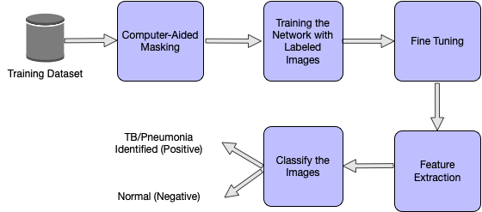

Figure 5.1 : Phases of the proposed approach

  - Dataset Overview
We use RSNA Pneumonia dataset, which is divided into both, train and test image samples. The training labels are also provided which tells the coordinates of the mask in the images. All the train images are in DICOM format. The train labels are provided with a set of patients and bounding boxes. The bounding boxes are defined as, x-min y-min width height. There is a binary target column Target, indicating Pneumonia or Non-Pneumonia and there may be multiple rows per Patient ID. There are 26,684 input CXRs and 3000 test CXRs. The train labels file comprises the filename, and the pneumonia locations which are transformed into a dictionary wherein the filename acts as the key and the pneumonia locations are the values. This dictionary only has file names where Pneumonia is detected, and if there is no Pneumonia in that file, it is not included in the dictionary. Out of 26,684 images, 6012 files have shown a positive sign regarding the presence of Pneumonia.
5.3.1 Dataset generator:
The dataset is broken down into random chunks to feed these set of images and masks into the model. Along with this, a few parameters, say, the batch size, image size, if the images are to be shuffled, etc are also given to the model. The images are resized to 256 x 256 from the original 1024 x 1024 and the default batch size used is 32. These images or CXRs are then sent to the Convolutional Neural Network to train the model.

  - Proposed Architecture for Classification

The Convolutional Neural Network is trained such that different parameter values are optimized to extract useful features from the given input CXRs. The bounding boxes are drawn around the predicted areas of pneumonia. The network is initially given the training images and labels. CNNs then extract low-level features followed by high-level features.

The proposed CNN has residual blocks with down sampling and convolutions. An up-sampling layer is used at last to resize the image to the original shape.

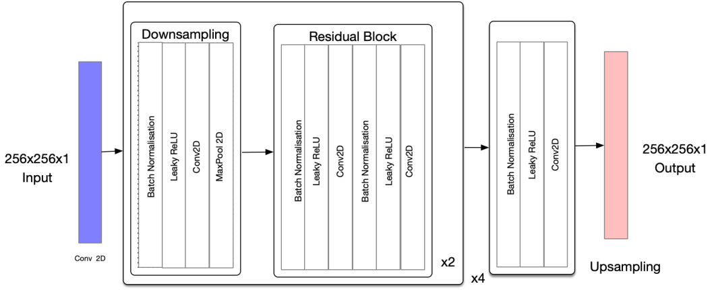

Figure 5.2 : Architecture of the Proposed CNN

Network Training

A Neural Network model entirely relies on the metrics that we con-sider for the training. In the literature, we have seen many training models which are used for the segmentation process. Few architectures like LeNet[18], ResNet[15], AlexNet[19], and ChexNet[20] have many layers which take much time for training on a standard CPU. However, training a Neural Network with thousands of images takes more than days over a CPU, hence we trained our network on a cloud-based GPU. The hardware specifications include 12GB of NVIDIA TESLA RAM and 8 Cores of CPU. To speed up the training process, the input will be given in batches from the training set.
Training the network includes three main steps. Initially, the images are loaded from the training dataset and preprocessed based on the input dimensions of the network. Here the images are resized to the aspects of 256x256x1, and the networks first layer has the same number of neurons. Second, we need to segment the pathologies affected regions of the lungs where we will be using convolutions and pooling layers. This feature extraction is achieved by training the network with input images and the masked areas from the CSV files. Lastly, the network is qualified to be a classifier. To this, labels are provided to the CXR images as vectors which contain value 1 for the pneumonia (positive class) and 0 for the non-pneumonia case. The proposed network is 69 layers convolutional architecture, taken as inspiration from u-net architecture.

A sequence of layers, namely convolutions, batch normalization, and upsampling layers are arranged in the intended network for feature extraction. Leaky ReLU incorporates the removal of linearity between the layers by adjusting the weights of the net-work. This architecture is trained over 25 epochs, and an epoch is defined as one complete forward pass and backward pass. The weights get updated in the forward pass and updated in the backward pass based on the given loss function. 69 layers are used to get accurate result, it gets out-fitted if more than 69 layers are used, it gets under-fitted if less than 69 layers are used. We use IOU BCE loss and Adam optimizer as the parameters and both, train and validation sets are obtained using the dataset generator described in the dataset section.

5.6 Conclusion
In our paper, we have proposed a CNN architecture for the detection of Pneumonia, this can be generalized to Tuberculosis. Now, instead of resorting to manual techniques for finding out the presence of lung abnormalities, we put forth an easier and reliable way to automatically detect Pneumonia. This is the need of the hour which could be used in areas where people are more prone to Pneumonia/Tuberculosis. The complexity of the proposed technique is high when dealing with bigger datasets.

CHAPTER-6
Tweaking the architecture
Introduction
As we already knew that, to apply a deep learning model, we need a large amount of data that may or might not be labelled. Some of the researchers have generated few synthetic chest scan images to increase the data for training and identification of the virus. These images are used in the training model where the generator of images is placed over the discriminator model and the information gets updated accordingly. This model of CNN is trained on both normal and infected scans of patients which are called as CXR’s meaning chest x-rays. They have a testing sample of 30,000 images. It is specified to have an increase of accuracy from 85 to 95 percentage by increasing the original test data with the usage of proposed architecture.
Every image is not perfect to extract features and train the model for detection. Few images have noisy data that is unclear, and the model might take that data in a different manner and even few important features might be lost because the data is in-appropriate and noisy. So, while training the data it is most important to keep track that the data is perfect and there might have no loss in features.
The proposed neural network architectures i.e., Segmentation architecture (modified U net) and Classification architecture are tweaked against NIH and RSNA datasets (Training, Validation and Testing).
- Radiological Society of North America (RSNA®)
- National Institute of Health (NIH)
- More than 100 images from Third i Imaging & Diagnostics are tested against the model.

Table 6.1: Depicting Loss, Accuracy, DICE, IOU, Val LOSS, Val DICE, Val IOU of the first 20 epochs of RSNA dataset
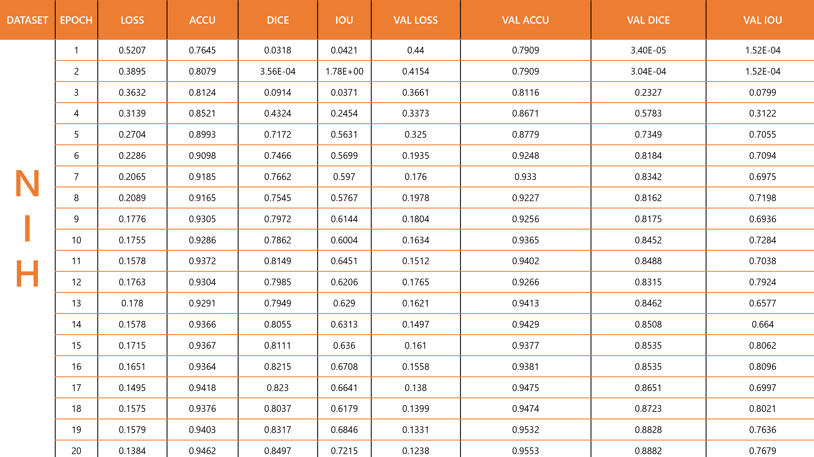
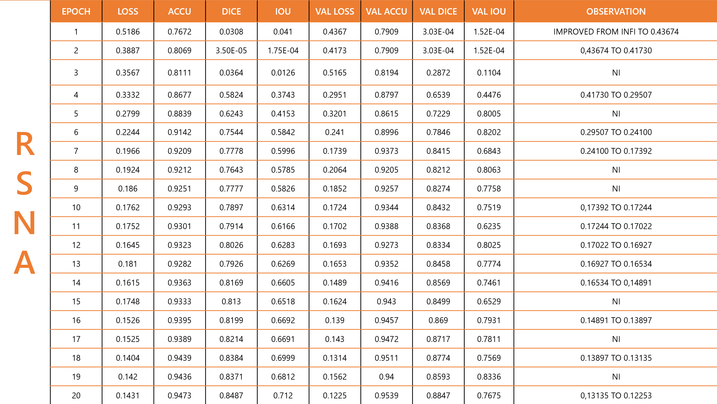

Table 6.2: Depicting Loss, Accuracy, DICE, IOU, Val LOSS, Val DICE, Val IOU of the first 20 epochs of NIH dataset
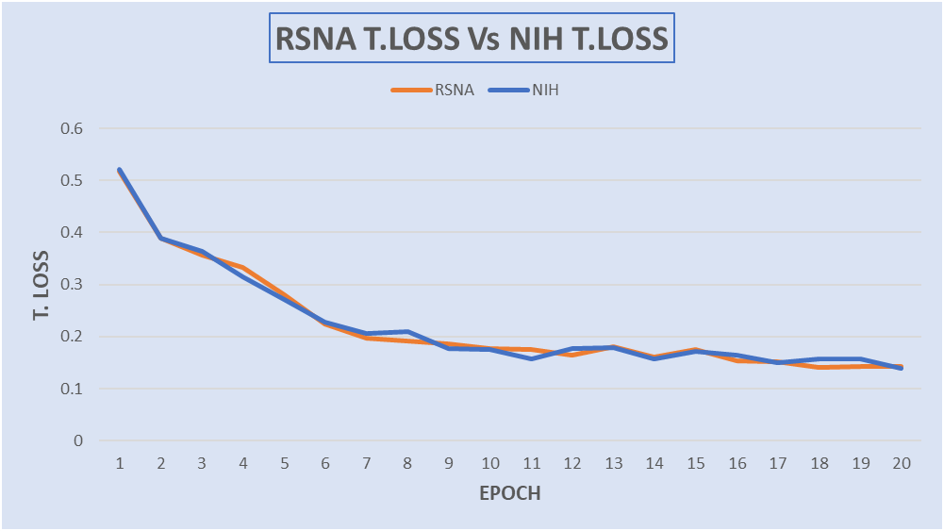
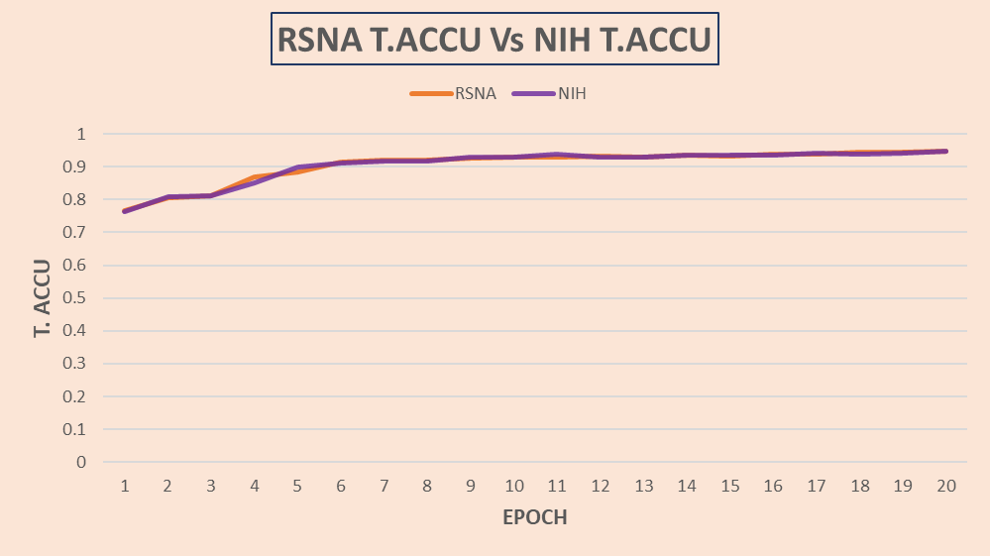
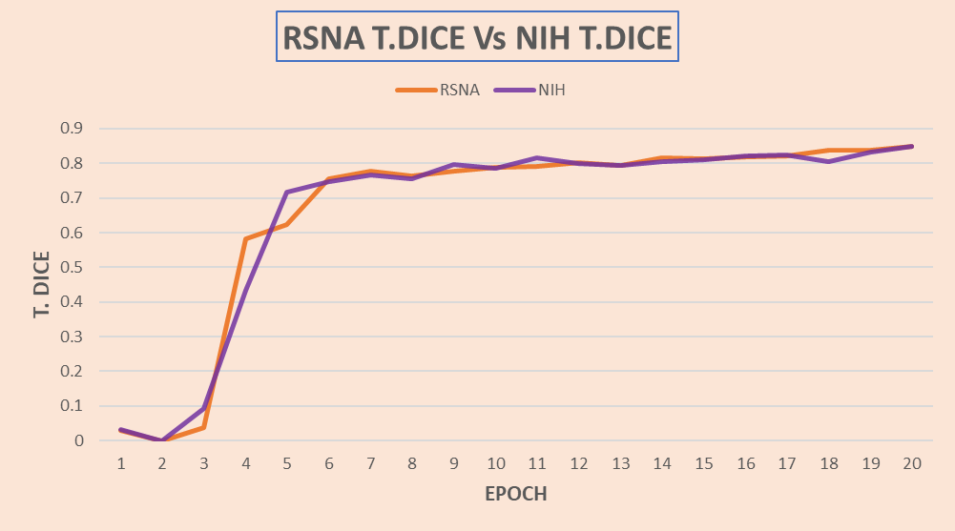
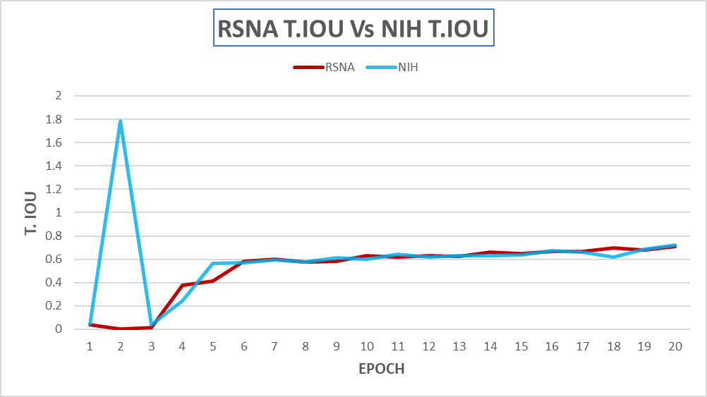
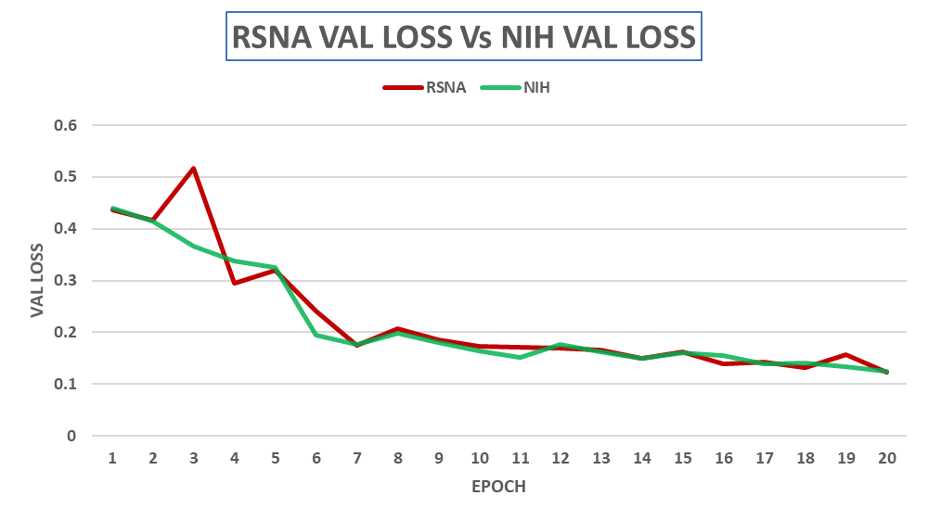
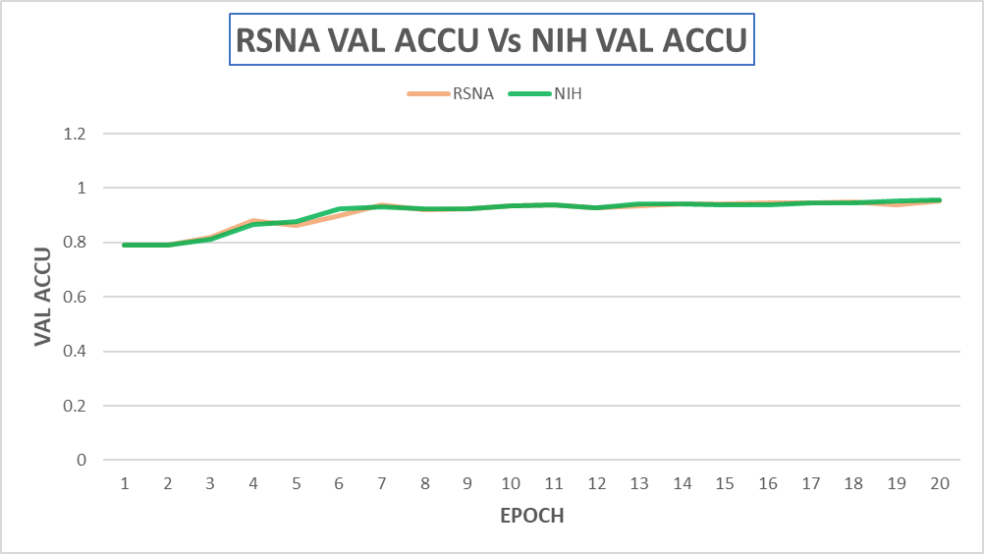
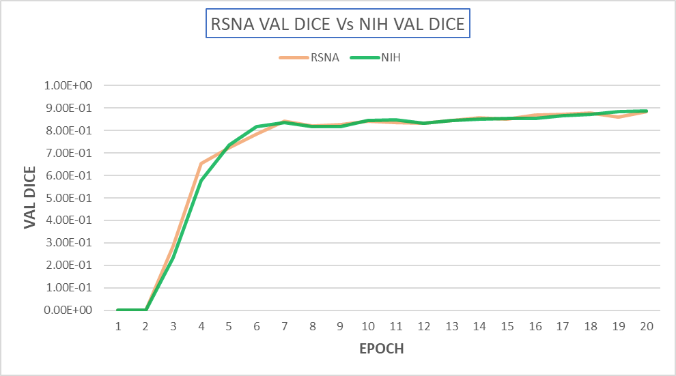
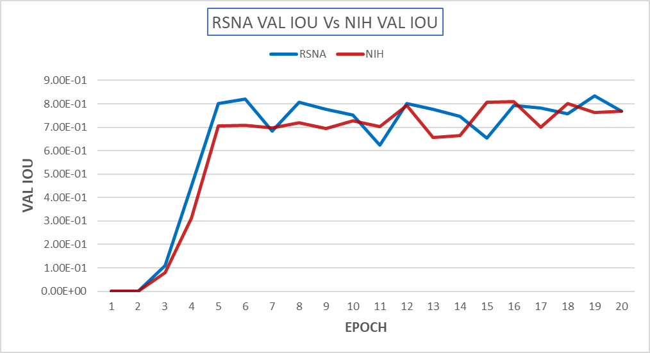
Figure 6.1 : Comparison of Training-Loss, Accuracy, Dice and IOU graphs of RSNA Vs NIH

Figure 6.2 : Comparison of Validation-Loss, Accuracy, Dice and IOU graphs of RSNA Vs NIH
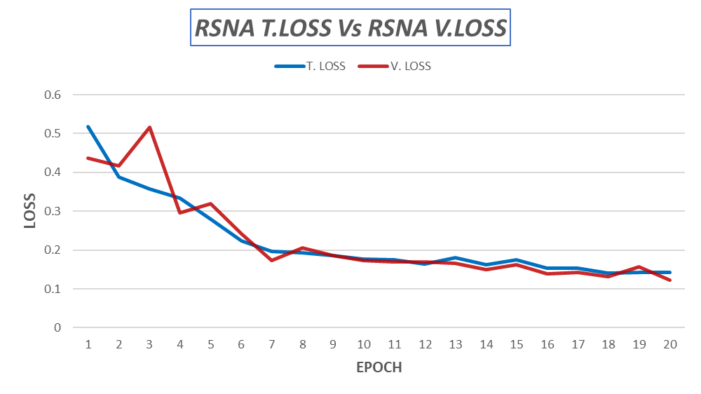
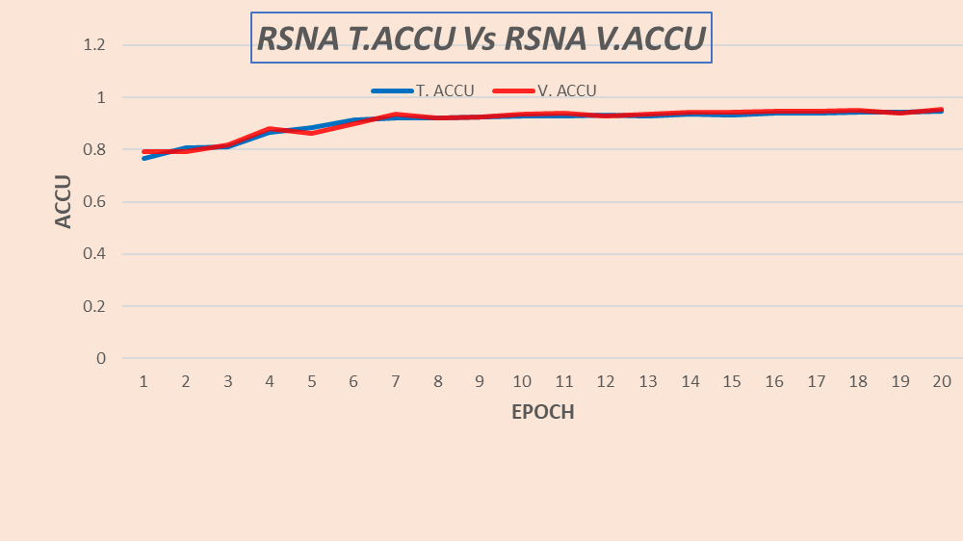
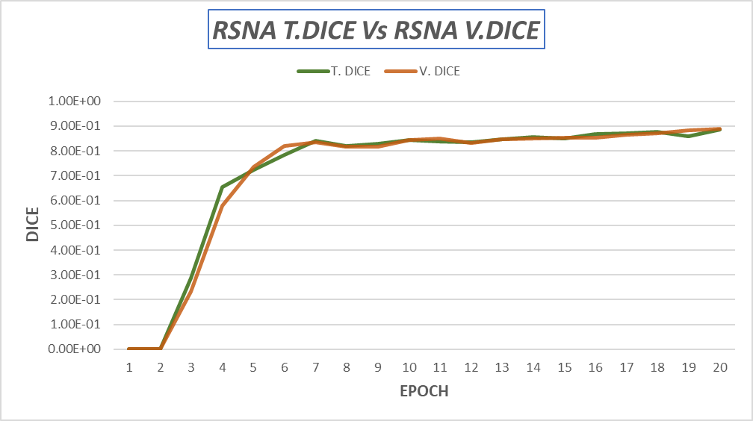
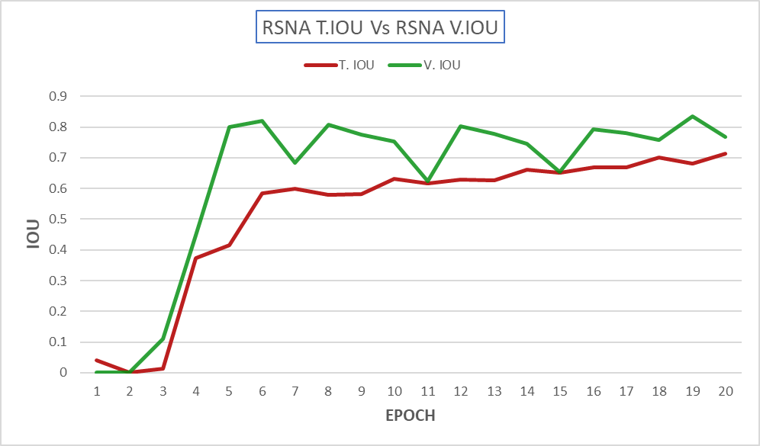
Figure 6.3 : Comparison of Training(RSNA)-Loss, Accuracy, Dice and IOU graphs against 20 epochs
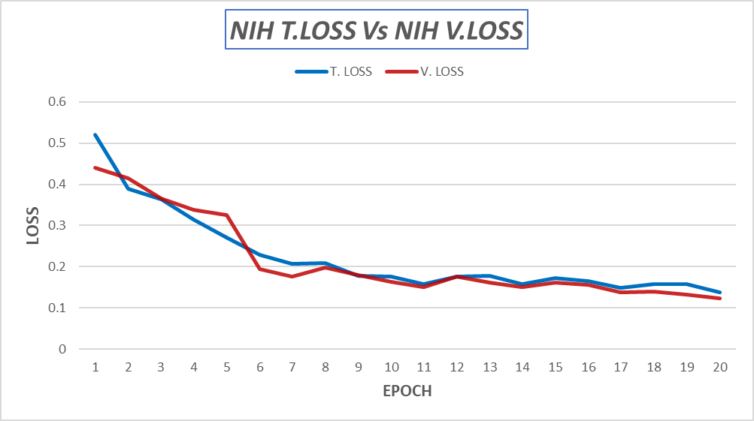
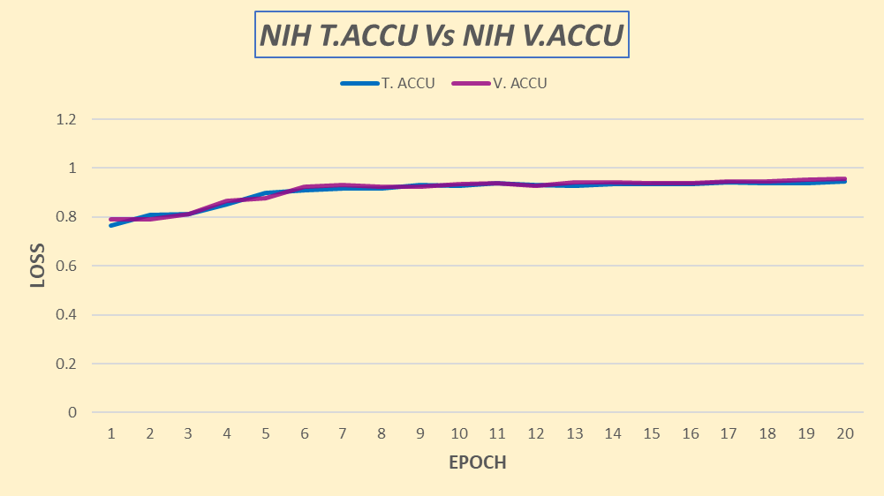
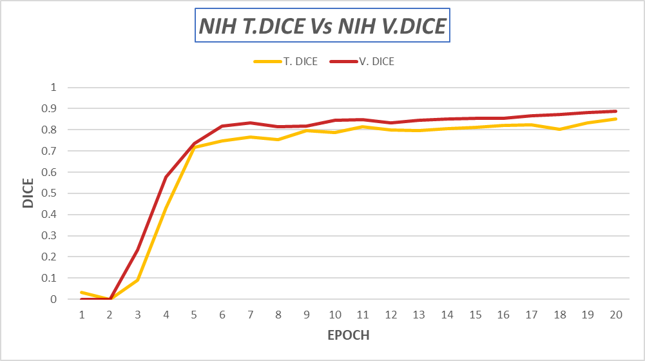
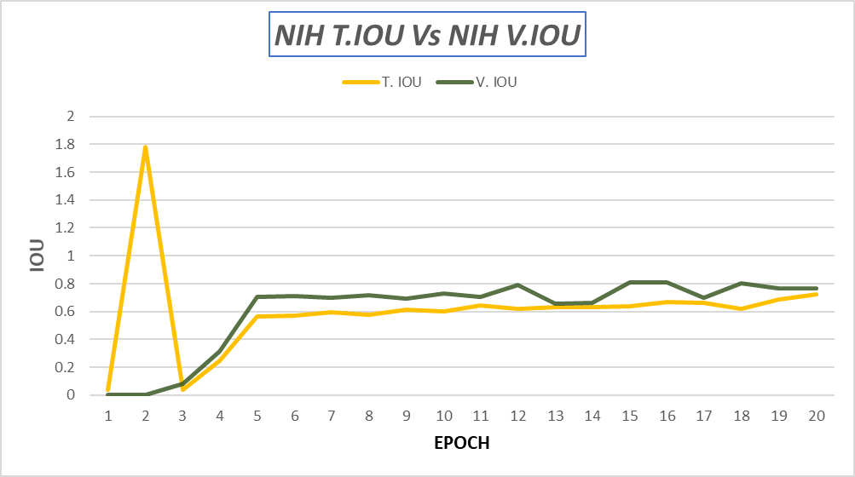

Figure 6.4 : Comparison of Training(NIH)-Loss, Accuracy, Dice and IOU graphs against 20 epochs
CHAPTER 7

7.1 Result Analysis
Before taking up CNN for image segmentation, a fair amount of analysis is being done on the traditional models along with the various CNN architectures, which gave various perspectives while dealing with medical images. Having that knowledge as base we have made a comparison among different algorithms. In this work initially, we have restricted our comparison with few most prominent models like SVM, Decision Tree, CNN, and later with Convolutional Neural Network models like efficient net, VGG16, Inception V3 and ResNet 50.

Models | Accuracy | F-score | Error- rate
Decision tree | 0.76 | 0.62 | 0.23
Random Forest | 0.82 | 0.71 | 0.18
SVM | 0.75 | 0.56 | 0.23
CNN | 0.84 | 0.77 | 0.16

Table 7.1: Showing Values of Models against Scores(Accuracy, F-Score, Error Rate)
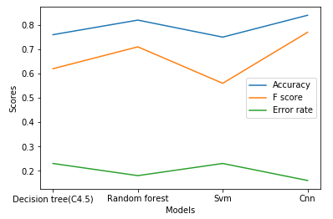
Figure 7.1 : Graph showing models Vs Scores (Accuracy, F score, Error Rate)

The accuracy for CNN is 84% which is high compared to other classification models with 82% and less. By seeing the visualization, the error rate for CNN is very much low comparing with the other models on this CXR data.
Secondly, let us consider the accuracy of the three different image classifier models VGG 16, Inception V3 and ResNet 50. After training these models with the x-ray image data the accuracy scores and validation information for 10 and 20 epochs is given in the below table.

Models | Accuracy score | Loss | Val Acc | Val Loss
VGG 16 | 0.66 | 0.59 | 0.68 | 0.53
Inception V3 | 0.65 | 0.66 | 0.55 | 0.85
ResNet 50 | 0.67 | 1.23 | 0.45 | 2.56

Table7.2: Depicting values of models vs scores
These are the scores of the 3 different models for 10 epochs on 1850 images. As interpreted in the table, the model’s accuracies at these epochs are 66% for VGG 16, 65% for inception V3 and 67% for ResNet 50. The scores of loss, validation loss and accuracies are also achieved as above.

Models | Accuracy Score | Loss | Val Acc | Val Loss
VGG 16 | 0.62 | 0.64 | 0.54 | 0.87
Inception V3 | 0.66 | 0.63 | 0.54 | 1.88
ResNet 50 | 0.75 | 0.76 | 0.45 | 2.77

Table 7.3: Depicting values of models vs scores
The images count has increased to 3265 and on these images the training continued with 20 epochs for all the 3 models. As we can see from the table, we find that the VGG 16 model has an average accuracy of 62% with just 20 epochs but the loss is equivalently high than the accuracy with 64%.

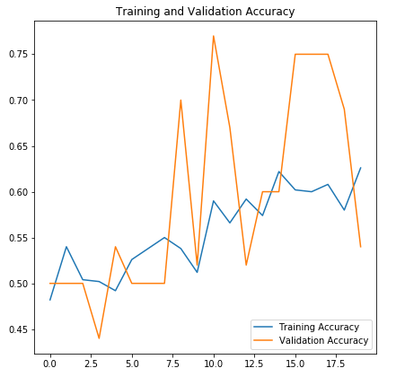
Figure 7.2 : Training vs Validation (VGG16)Accuracy for 20 epochs
When we consider the other models like Inception V3 which has a decent accuracy of 66% the loss is equivalent with the accuracy but unlike VGG 16 it is less than the accuracy that the model gained.
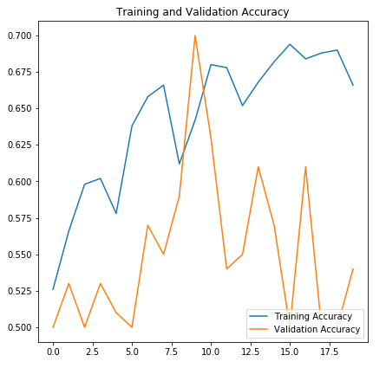
Figure 7.3 : Training vs Validation(Inception V3) Accuracy for 20 epochs
While ResNet 50 got 75% which is highest compared with all the other models. Since the loss and accuracy is good the model is a good fit.

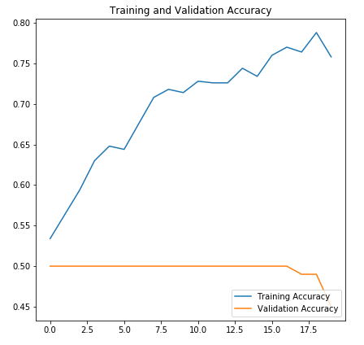
Figure 7.4 : Training vs Validation(ResNet50) Accuracy for 20 epochs

When we also consider the comparison between the models from 10 epoch to 20 epochs. There are few drastic differences. As we can see from the tables, there is a drastic difference in the accuracy of the models. Let us look at the numbers considering each model starting with VGG16 which has an accuracy of 66% when considering 10 epoch and reduced to 62% with 20 epochs. It is evident that the accuracy and epochs are inversely proportional. In this case that this model is not suitable for this data, we move on to Inception V3 which has a very slight difference in its accuracy when trained with 10 and 20 epochs on the image data.
The percentage difference is just one percent between the different epochs but on a long run the accuracy might increase with the epochs. Finally, ResNet 50 has scored the highest and has very drastic change in the accuracy with the epochs where we could find an accuracy difference of about 8% from 10 epochs to 20 epochs. We can also consider the data increase as input to the models between 10 and 20 epochs which also contributed to the difference in the models accuracy. So, this seems like accuracy and epochs are directly proportional and model is quite a good fit for the image data.

7.2 Result Comparison

We assess the performance of the proposed architecture on the test set for the pneumonia detection task. Table below summarizes the performance of each architecture against our proposed modified U-Net architecture. The calculated accuracy is 97.5 % which shows an improvement of 20 %.
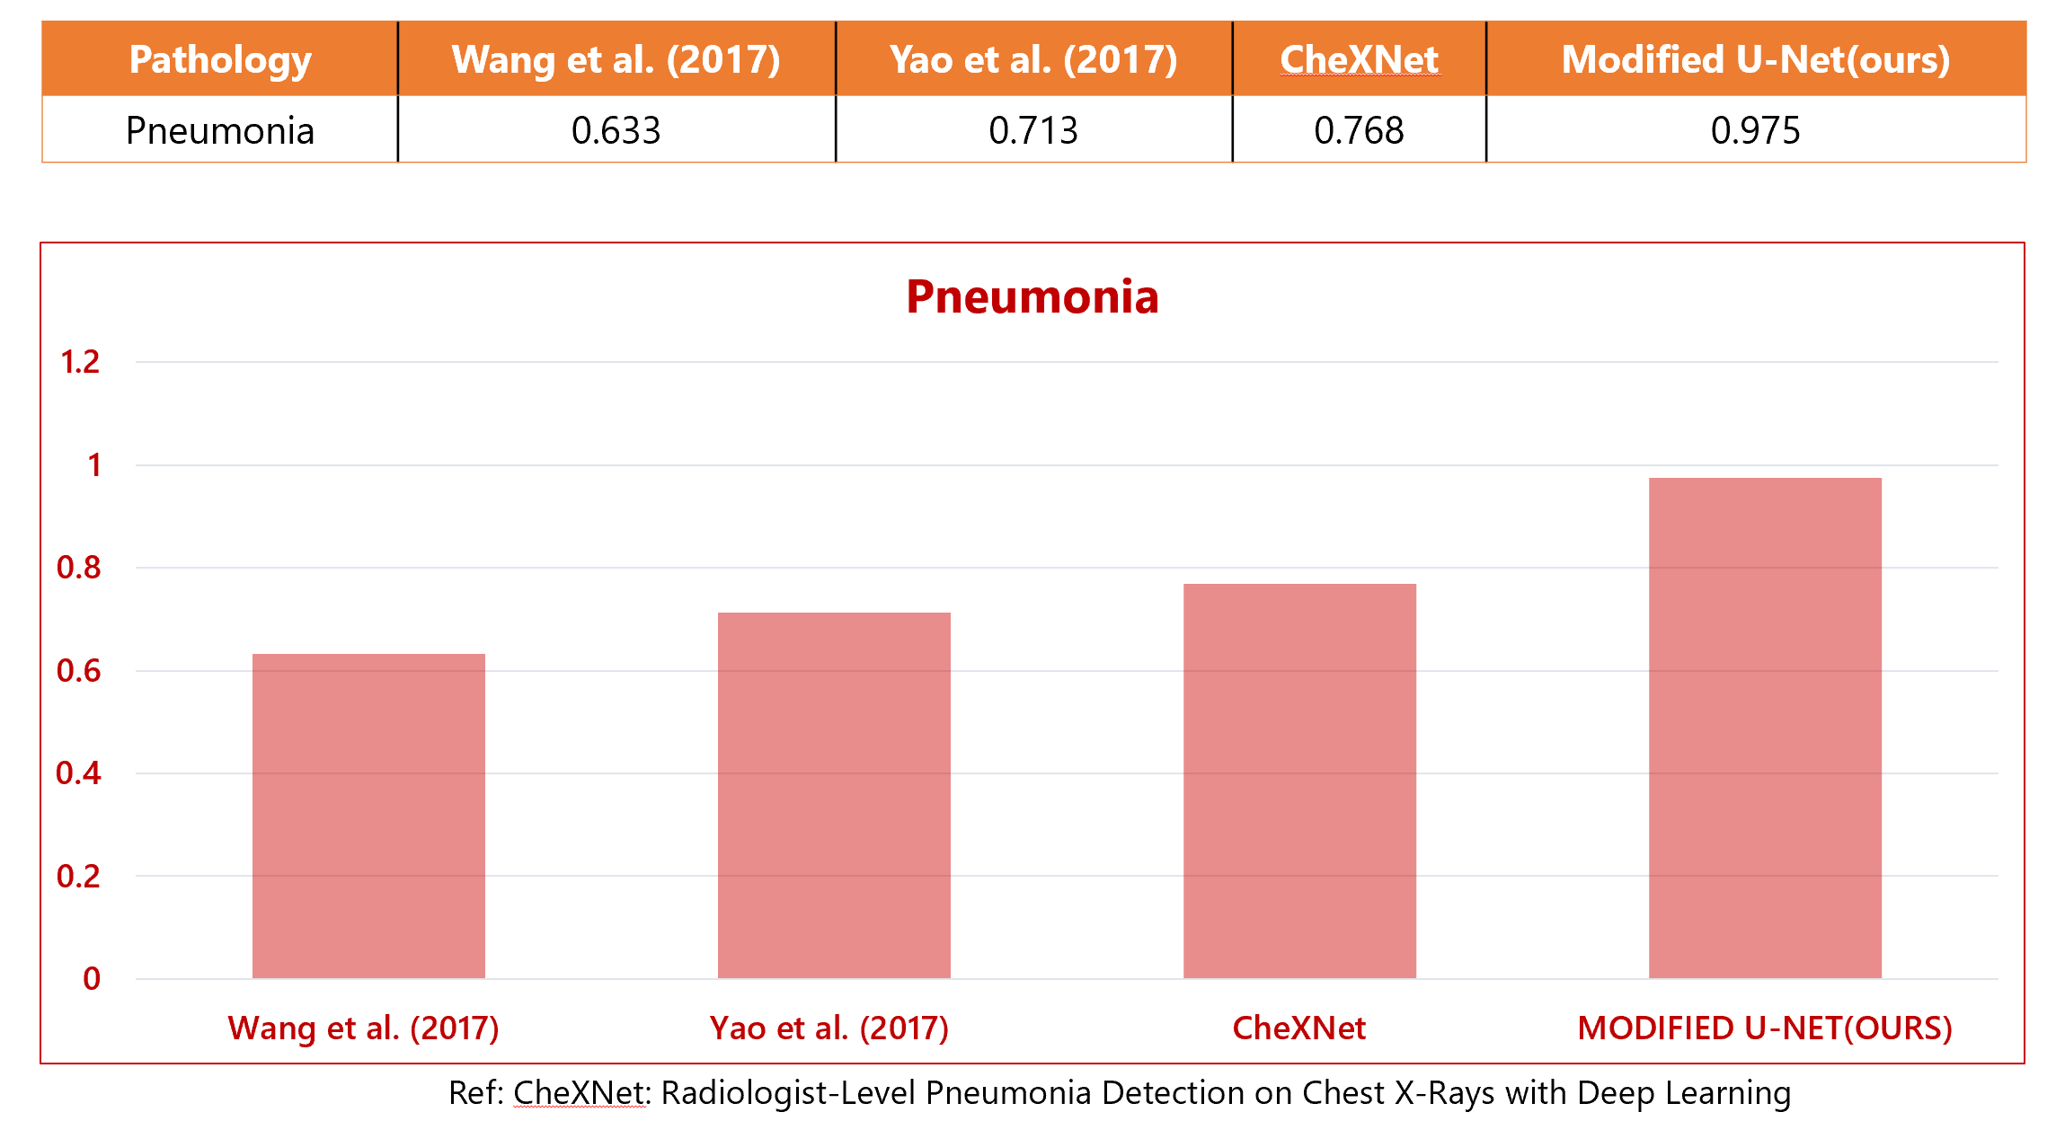
Table 7.4 : Summarizes the performance of each architecture against proposed model

Table 7.5 : Graph summarizes the performance (calculated accuracy) of each architecture against our proposed modified U-Net architecture.

CHAPTER-8

8.1 Conclusion and Future Scope
Pneumonia accounts for a significant proportion of patient morbidity and mortality (Gon¸calves-Pereira et al., 2013). Early diagnosis and treatment of Pneumonia is critical to preventing complications including death (Aydogdu et al., 2010). With approximately 2 billion procedures per year, chest X-rays are the most common imaging examination tool used in practice, critical for screening, diagnosis, and management of a variety of diseases including Pneumonia (Raoof et al., 2012). However, two thirds of the global population lacks access to radiology diagnostics, according to an estimate by the World Health Organization (Mollura et al., 2010). There is a shortage of experts who can interpret X-rays, even when imaging equipment is available, leading to increased mortality from treatable diseases (Kesselman et al., 2016). We developed an algorithm which detects Pneumonia from frontal-view chest X-ray images at a level exceeding practicing radiologists. We also suggest that a simple extension of our algorithm is useful to detect COVID-19 in a reliable manner. With automation at the level of experts, we hope that this technology can improve healthcare delivery and increase access to medical imaging expertise in parts of the world where access to skilled radiologists is limited .Deep Learning remains in central focus of the research that would help in improving the results of conventional learning methods. Implementation of the proposed work would achieve an efficient medical image analysis for CT, MRI and X-ray Images. Research work on medical image processing using deep learning is limited in current research and therefore the recommended method of research would give prospects of Deep Learning based implementations in the field of medical image processing, analysis and diagnosis of diseases. A set of metrics of performance measures such as accuracy of automated medical image analysis is recommended so that the same can be used for wide range of applications of medical image analysis. The comparison is suggested regarding quantitative as well as qualitative statistical parameters such as accuracy of medical image diagnosis, PSNR and computation time.We also recommend for the attempt to be made studying more number of medical image modalities such as CT and MRI images. Research work using Deep Learning for medical image analysis and subsequent diagnosis needs to be more vibrantly done in Indian context.
REFERENCES

- Szegedy, C., Liu, W., Jia, Y., Sermanet, P., Reed, S., Anguelov, D., Erhan, D., Vanhoucke, V. and Rabinovich, A., 2015. Going deeper with convolutions. In Proceedings of the IEEE conference on computer vision and pattern recognition(pp. 1-9).
- Toshev, A. and Szegedy, C., 2014. Deeppose: Human pose estimation via deep neural networks. In Proceedings of the IEEE conference on computer vision and pattern recognition(pp. 1653-1660).
- Serre, T., Wolf, L., Bileschi, S., Riesenhuber, M. and Poggio, T., 2007. Robust object recognition with cortex-like mechanisms. IEEE transactions on pattern analysis and machine intelligence, 29(3), pp.411-426.
- Krähenbühl, P. and Koltun, V., 2012. Efficient inference in fully connected crfs with gaussian edge potentials. arXiv preprint arXiv:1210.5644.
- Kayalibay, B., Jensen, G. and van der Smagt, P., 2017. CNN-based segmentation of medical imaging data. arXiv preprint arXiv:1701.03056.
- Rajpurkar, P., Irvin, J., Zhu, K., Yang, B., Mehta, H., Duan, T., Ding, D., Bagul, A., Langlotz, C., Shpanskaya, K. and Lungren, M.P., 2017. Chexnet: Radiologist-level pneumonia detection on chest x-rays with deep learning. arXiv preprint arXiv:1711.05225.
- Ronneberger, O., Fischer, P. and Brox, T., 2015, October. U-net: Convolutional networks for biomedical image segmentation. In International Conference on Medical image computing and computer-assisted intervention (pp. 234-241). Springer, Cham.
- Bhutia, R., Narain, K., Devi, K.R., Singh, T.S.K. and Mahanta, J., 2013. Direct and early detection of Mycobacterium tuberculosis complex and rifampicin resistance from sputum smears. The International journal of tuberculosis and lung disease, 17(2), pp.258-261.
- Priya, E. and Srinivasan, S., 2016. Automated object and image level classification of TB images using support vector neural network classifier. Biocybernetics and Biomedical Engineering, 36(4), pp.670-678.
- Van Ginneken, B., Katsuragawa, S., ter Haar Romeny, B.M., Doi, K. and Viergever, M.A., 2002. Automatic detection of abnormalities in chest radiographs using local texture analysis. IEEE transactions on medical imaging, 21(2), pp.139-149.
- Guo, G., Wang, H., Bell, D., Bi, Y. and Greer, K., 2003, November. KNN model-based approach in classification. In OTM Confederated International Conferences" On the Move to Meaningful Internet Systems" (pp. 986-996). Springer, Berlin, Heidelberg.
- Hogeweg, L., Mol, C., de Jong, P.A., Dawson, R., Ayles, H. and van Ginneken, B., 2010, September. Fusion of local and global detection systems to detect tuberculosis in chest radiographs. In International conference on medical image computing and computer-assisted intervention (pp. 650-657). Springer, Berlin, Heidelberg.
- Jaeger, S., Karargyris, A., Antani, S. and Thoma, G., 2012, August. Detecting tuberculosis in radiographs using combined lung masks. In 2012 Annual international conference of the IEEE engineering in medicine and biology society (pp. 4978-4981). IEEE.
- Karargyris, A., Siegelman, J., Tzortzis, D., Jaeger, S., Candemir, S., Xue, Z., Santosh, K.C., Vajda, S., Antani, S., Folio, L. and Thoma, G.R., 2016. Combination of texture and shape features to detect pulmonary abnormalities in digital chest X-rays. International journal of computer assisted radiology and surgery, 11(1), pp.99-106.
- Maduskar, P., Philipsen, R.H., Melendez, J., Scholten, E., Chanda, D., Ayles, H., Sánchez, C.I. and van Ginneken, B., 2016. Automatic detection of pleural effusion in chest radiographs. Medical image analysis, 28, pp.22-32.
- O'Shea, K. and Nash, R., 2015. An introduction to convolutional neural networks. arXiv preprint arXiv:1511.08458.
- Srivastava, N., Hinton, G., Krizhevsky, A., Sutskever, I. and Salakhutdinov, R., 2014. Dropout: a simple way to prevent neural networks from overfitting. The journal of machine learning research, 15(1), pp.1929-1958.
- Kurama, V., Alla, S. and Rohith, V.K., 2018. Image semantic segmentation using deep learning. International Journal of Image, Graphics and Signal Processing, 10(12), p.1.
- Ioffe, S. and Szegedy, C., 2015, June. Batch normalization: Accelerating deep network training by reducing internal covariate shift. In International conference on machine learning (pp. 448-456). PMLR.
- He, K., Zhang, X., Ren, S. and Sun, J., 2016. Deep residual learning for image recognition. In Proceedings of the IEEE conference on computer vision and pattern recognition (pp. 770-778).
- Bingham, G. and Miikkulainen, R., 2020. Discovering Parametric Activation Functions. arXiv preprint arXiv:2006.03179.
- Loshchilov, I. and Hutter, F., 2016. Sgdr: Stochastic gradient descent with warm restarts. arXiv preprint arXiv:1608.03983.
- Krizhevsky, A. and Hinton, G., 2009. Learning multiple layers of features from tiny images.
- Krizhevsky, A., Sutskever, I. and Hinton, G.E., 2012. Imagenet classification with deep convolutional neural networks. Advances in neural information processing systems, 25, pp.1097-1105.
- Agweyu, A., Lilford, R.J., English, M., Irimu, G., Ayieko, P., Akech, S., Githanga, D., Were, F., Kigen, B., Aduro, N. and Inginia, R., 2018. Appropriateness of clinical severity classification of new WHO childhood pneumonia guidance: a multi-hospital, retrospective, cohort study. The Lancet Global health, 6(1), pp.e74-e83.
- LeCun, Y., Bottou, L., Bengio, Y. and Haffner, P., 1998. Gradient-based learning applied to document recognition. Proceedings of the IEEE, 86(11), pp.2278-2324.
- Anifowose, F., Labadin, J. and Abdulraheem, A., 2013, April. Ensemble learning model for petroleum reservoir characterization: a case of feed-forward back-propagation neural networks. In Pacific-Asia Conference on Knowledge Discovery and Data Mining (pp. 71-82). Springer, Berlin, Heidelberg.
- Deng, J., Dong, W., Socher, R., Li, L.J., Li, K. and Fei-Fei, L., 2009, June. Imagenet: A large-scale hierarchical image database. In 2009 IEEE conference on computer vision and pattern recognition (pp. 248-255). Ieee.
- Khobragade, S., Tiwari, A., Patil, C.Y. and Narke, V., 2016, July. Automatic detection of major lung diseases using Chest Radiographs and classification by feed-forward artificial neural network. In 2016 IEEE 1st International Conference on Power Electronics, Intelligent Control and Energy Systems (ICPEICES) (pp. 1-5). IEEE.
- Fernandes, S.L., Gurupur, V.P., Lin, H. and Martis, R.J., 2017. A novel fusion approach for early lung cancer detection using computer aided diagnosis techniques. Journal of Medical Imaging and Health Informatics, 7(8),pp.1841-1850.

