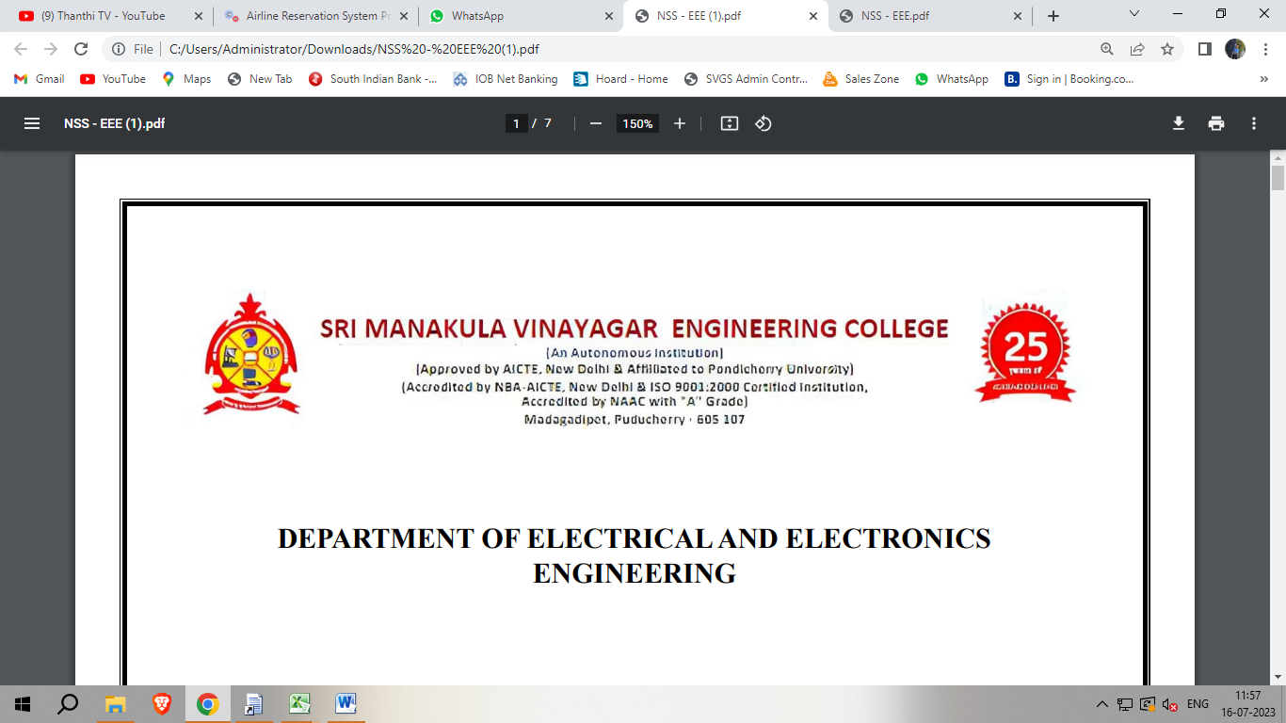

**Department of electrical and electronic engineering**

**Programming in java**

**Mini project**

**TEAM MEMBERS:**

SOWMIYA.J [21EEL007]

GUNAPRIYA.S [21UEE011]

KAVEEYA.K [21UEE021]

DHIVYASHREE.M [21UEE005]

**YEAR/SEM:** 2ND YEAR/4TH SEM

**TOPIC:** ONLINE TEST MANAGEMENT SYSTEM USING JAVA

**ONLINE TEST MANAGEMENT SYSTEM USING JAVA**

**INTRODUCTION:**

1. The purpose of on-line test simulator is to take online test in an efficient manner and no time wasting for checking the paper.
2. The main objective of on-line test  is to efficiently evaluate the candidate thoroughly through a fully automated system that not only saves lot of time but also gives fast results.
3. For students they give papers according to their convenience and time and there is no need of using extra thing like paper, pen etc.

**ABSTRACT:**

MCQ based Online Examination System using java is a Test Management Software, which offers a complete solution for Computer Based Test (CBT) .They are used to set up multiple choice tests for set time periods that when submitted are automatically corrected and the results are displayed immediately after submitting the test.

**MAIN PROGRAM:**

**import java.awt.*;**

**import java.awt.event.*;**

**import javax.swing.*;**

**class OnlineTest extends JFrame implements ActionListener**

**{**

**JLabel l;**

**JRadioButton jb[]=new JRadioButton[5];**

**JButton b1,b2;**

**ButtonGroup bg;**

**int count=0,current=0,x=1,y=1,now=0;**

**int m[]=new int[10];**

**OnlineTest(String s)**

**{**

**super(s);**

**l=new JLabel();**

**add(l);**

**bg=new ButtonGroup();**

**for(int i=0;i<5;i++)**

**{**

**jb[i]=new JRadioButton();**

**add(jb[i]);**

**bg.add(jb[i]);**

**}**

**b1=new JButton("Next");**

**b2=new JButton("Bookmark");**

**b1.addActionListener(this);**

**b2.addActionListener(this);**

**add(b1);add(b2);**

**set();**

**l.setBounds(30,40,450,20);**

**jb[0].setBounds(50,80,100,20);**

**jb[1].setBounds(50,110,100,20);**

**jb[2].setBounds(50,140,100,20);**

**jb[3].setBounds(50,170,100,20);**

**b1.setBounds(100,240,100,30);**

**b2.setBounds(270,240,100,30);**

**setDefaultCloseOperation(JFrame.EXIT_ON_CLOSE);**

**setLayout(null);**

**setLocation(250,100);**

**setVisible(true);**

**setSize(600,350);**

**}**

**public void actionPerformed(ActionEvent e)**

**{**

**if(e.getSource()==b1)**

**{**

**if(check())**

**count=count+1;**

**current++;**

**set();**

**if(current==9)**

**{**

**b1.setEnabled(false);**

**b2.setText("Result");**

**}**

**}**

**if(e.getActionCommand().equals("Bookmark"))**

**{**

**JButton bk=new JButton("Bookmark"+x);**

**bk.setBounds(480,20+30*x,100,30);**

**add(bk);**

**bk.addActionListener(this);**

**m[x]=current;**

**x++;**

**current++;**

**set();**

**if(current==9)**

**b2.setText("Result");**

**setVisible(false);**

**setVisible(true);**

**}**

**for(int i=0,y=1;i<x;i++,y++)**

**{**

**if(e.getActionCommand().equals("Bookmark"+y))**

**{**

**if(check())**

**count=count+1;**

**now=current;**

**current=m[y];**

**set();**

**((JButton)e.getSource()).setEnabled(false);**

**current=now;**

**}**

**}**

**if(e.getActionCommand().equals("Result"))**

**{**

**if(check())**

**count=count+1;**

**current++;**

**//System.out.println("correct ans="+count);**

**JOptionPane.showMessageDialog(this,"correct ans="+count);**

**System.exit(0);**

**}**

**}**

**void set()**

**{**

**jb[4].setSelected(true);**

**if(current==0)**

**{**

**l.setText("Que1: Which one among these is not a datatype");**

**jb[0].setText("int");jb[1].setText("Float");jb[2].setText("boolean");jb[3].setText("char");**

**}**

**if(current==1)**

**{**

**l.setText("Que2: Which class is available to all the class automatically");**

**jb[0].setText("Swing");jb[1].setText("Applet");jb[2].setText("Object");jb[3].setText("ActionEvent");**

**}**

**if(current==2)**

**{**

**l.setText("Que3: Which package is directly available to our class without importing it");**

**jb[0].setText("swing");jb[1].setText("applet");jb[2].setText("net");jb[3].setText("lang");**

**}**

**if(current==3)**

**{**

**l.setText("Que4: String class is defined in which package");**

**jb[0].setText("lang");jb[1].setText("Swing");jb[2].setText("Applet");jb[3].setText("awt");**

**}**

**if(current==4)**

**{**

**l.setText("Que5: Which institute is best for java coaching");**

**jb[0].setText("Utek");jb[1].setText("Aptech");jb[2].setText("SSS IT");jb[3].setText("jtek");**

**}**

**if(current==5)**

**{**

**l.setText("Que6: Which one among these is not a keyword");**

**jb[0].setText("class");jb[1].setText("int");jb[2].setText("get");jb[3].setText("if");**

**}**

**if(current==6)**

**{**

**l.setText("Que7: Which one among these is not a class ");**

**jb[0].setText("Swing");jb[1].setText("Actionperformed");jb[2].setText("ActionEvent");jb[3].setText("Button");**

**}**

**if(current==7)**

**{**

**l.setText("Que8: which one among these is not a function of Object class");**

**jb[0].setText("toString");jb[1].setText("finalize");jb[2].setText("equals");jb[3].setText("getDocumentBase");**

**}**

**if(current==8)**

**{**

**l.setText("Que9: which function is not present in Applet class");**

**jb[0].setText("init");jb[1].setText("main");jb[2].setText("start");jb[3].setText("destroy");**

**}**

**if(current==9)**

**{**

**l.setText("Que10: Which one among these is not a valid component");**

**jb[0].setText("JButton");jb[1].setText("JList");jb[2].setText("JButtonGroup");jb[3].setText("JTextArea");**

**}**

**l.setBounds(30,40,450,20);**

**for(int i=0,j=0;i<=90;i+=30,j++)**

**jb[j].setBounds(50,80+i,200,20);**

**}**

**boolean check()**

**{**

**if(current==0)**

**return(jb[1].isSelected());**

**if(current==1)**

**return(jb[2].isSelected());**

**if(current==2)**

**return(jb[3].isSelected());**

**if(current==3)**

**return(jb[0].isSelected());**

**if(current==4)**

**return(jb[2].isSelected());**

**if(current==5)**

**return(jb[2].isSelected());**

**if(current==6)**

**return(jb[1].isSelected());**

**if(current==7)**

**return(jb[3].isSelected());**

**if(current==8)**

**return(jb[1].isSelected());**

**if(current==9)**

**return(jb[2].isSelected());**

**return false;**

**}**

**public static void main(String s[])**

**{**

**new OnlineTest("Online Test Of Java");**

**}**

**}**

**sample output:**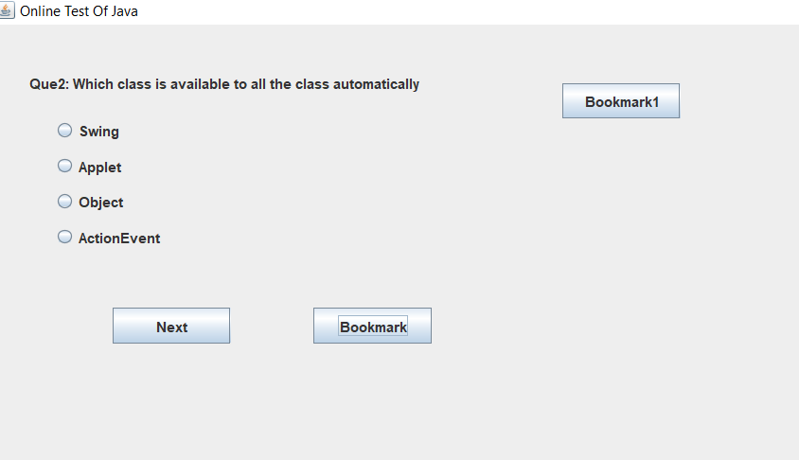

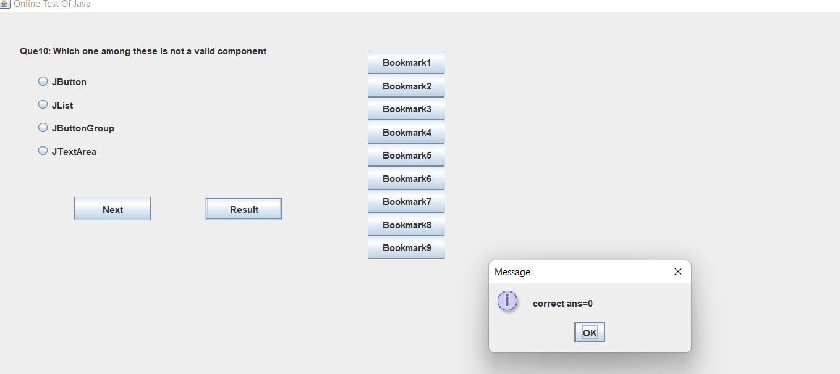

**conclusion:**

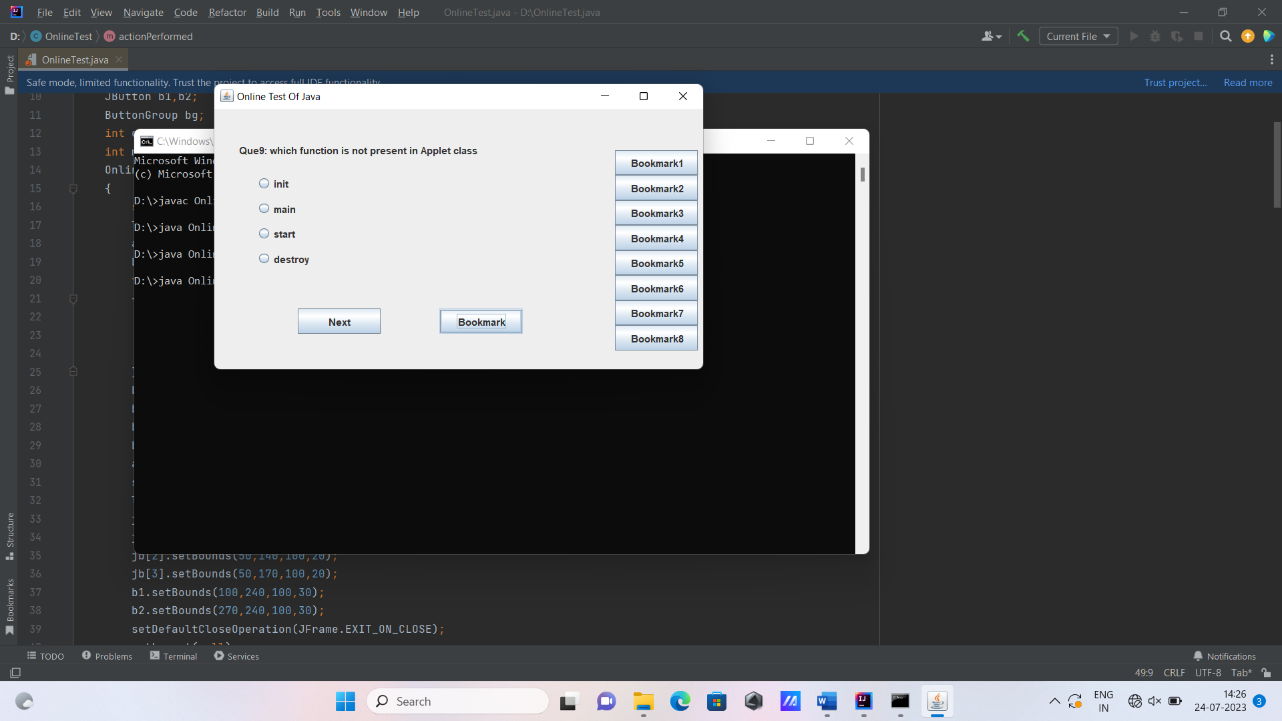

MCQ based Online Examination System is being toughest job.but by using

this it can be easily accesssable by everyone.we can make our own style of pattern

through this.