**PRODUCT PLAN**

**Project: AI Customer Analyzer**

**Group: 19**

|  |  |  |  |  |
| --- | --- | --- | --- | --- |
| Release: February 2023 | |  | | |
| Date: 13, February 2023 |  | | | |
|  | | | |  |
| **PRINCE2** | | | |  |
|  | | | |  |
| Author: Gunarakulan Gunaretnam (Project Manager) | | |
| Owner: Dr. Yasas Jayaweera (Project Executive) | | | | |
| Client: DreamSpace (Private) Limited  Project Manager: Gunarakulan Gunaretnam (2208408)  Startup Manager: Sangeetha Thangavadivel (2135801)  Risk Manager: Haritha Thavarajah (2211320)  Schedule Manager: Mathumitha Arasakulasoorian (2211336)  Quality Manager: Delaxsan Raj Sathiyanesan (2211294) | | | | |
| Document Ref: Project Plan Report Group 19 | | | | |

|  |  |
| --- | --- |
|  |  |
|  |  |
|  |  |
|  |  |
|  |  |
|  |  |

# 1 Project Plan History

## 1.1 Document Location

This document is only valid on the day it was printed.

The source of the document will be found on the project's PC in location

## 1.2 Revision History

**Date of this revision:**

**Date of Next revision:**

|  |  |  |  |
| --- | --- | --- | --- |
| **Revision date** | **Previous revision date** | **Summary of Changes** | **Changes marked** |
| 06-02-2023 |  | First issue |  |

## 1.3 Approvals

This document requires the following approvals.

Signed approval forms are filed in the Management section of the project files.

|  |  |  |  |  |
| --- | --- | --- | --- | --- |
| **Name** | **Signature** | **Title** | **Date of Issue** | **Version** |
| Dr.Yasas Jayaweera |  | Project Executive |  |  |
| Gunarakulan Gunaretnam |  | Project Manager | 13-02-2023 | 1.0.0 |
| Kishoth Navaretnarajah |  | Client | 13-02-2023 | 1.0.0 |

## 1.4 Distribution

This document has been distributed to:

|  |  |  |  |
| --- | --- | --- | --- |
| **Name** | **Title** | **Date of Issue** | **Version** |
| Gunarakulan Gunaretnam (2208408) | Project Manager | 13-02-2023 | 1.0.0 |
| Sangeetha Thangavadivel (2135801) | Startup Manager | 13-02-2023 | 1.0.0 |
| Haritha Thavarajah (2211320) | Risk Manager | 13-02-2023 | 1.0.0 |
| Mathumitha Arasakulasoorian (2211336) | Schedule Manager | 13-02-2023 | 1.0.0 |
| Delaxsan Raj Sathiyanesan (2211294) | Quality Manager | 13-02-2023 | 1.0.0 |

# 2 Table of Contents

1 Project Plan History 2

1.1 Document Location 2

1.2 Revision History 2

1.3 Approvals 2

1.4 Distribution 2

2 Table of Contents 3

3 Purpose 4

4 Plan Description 5

5 Prerequisites 6

6 Dependencies 7

7 Assumptions 8

8 Project Plan 10

8.2 Product Breakdown Structure 10

8.3 Product Flow Diagrams 11

8.4 Product Descriptions 11

8.5 Activity Network 11

8.6 Financial Budget 12

8.7 Change Budget 12

8.8 Resource Requirements 12

8.9 Specific Resources 13

8.10 Tolerance 14

8.11 Contingency Plans 14

# 3 Purpose

## The document referred to here is a project plan, a detailed and comprehensive outline of a project's objectives, scope, approach, and resources. The primary purpose of the project plan is to provide a clear and concise guide for all those involved in the project, from the project team to the management and the client.

## The project plan outlines the steps that will be taken to achieve the project's objectives and sets out a timeline for when these steps will be taken. This timeline is critical for project managers to ensure that the project stays on track and is completed within the agreed-upon timeframe. The project plan also includes information about the risks and issues that may arise during the project's execution and how these will be managed.

## One of the critical advantages of having a project plan is that it provides a clear roadmap for the project team. This roadmap ensures that everyone on the team knows exactly what is expected of them and what they need to do to achieve the project's objectives. It also helps identify potential bottlenecks or roadblocks that could impact the project's progress and allows the team to devise contingency plans to address these issues.

## Furthermore, the project plan provides a way for the project team to track progress and monitor the project's status. It enables the team to identify areas where they are ahead of schedule or behind schedule and to make adjustments accordingly. Additionally, it provides a way for the team to report progress to the client and other stakeholders, which helps to build trust and confidence in the project.

## In summary, a project plan is a crucial document that provides a clear and concise roadmap for the project team, management, and clients. It sets out the project's objectives, scope, approach, resources, risks, and timelines and helps to ensure that the project stays on track, is completed on time, and achieves its goals.

# 4 Plan Description

The project plan document is a comprehensive reference for the DreamSpace project team and the client, detailing the objectives, timeline, budget, risks, resources, and quality control measures of the proposed AI-powered computer vision-based customer analysis system.

The project plan covers the objectives of the project, which include accurately counting the number of customers entering DreamSpace's premises, detecting the age range, gender, emotions, and race of customers, monitoring sales employees' vocals, and providing a backend panel for DreamSpace to view and analyze the gathered data.

The project plan also includes the timeline, which states that the project should be delivered within ten weeks from the start date, with regular updates and progress reports provided to the client. This timeline guides the project team to ensure the project is completed within the specified timeframe.

The budget is another crucial element of the project plan. It outlines the project’s estimated costs, including developing the AI security bot using computer vision and machine learning libraries such as OpenCV, TensorFlow, and the MERN Stack for web panel development. The budget is carefully designed to ensure the project is completed within the allocated funds.

The plan also considers the project’s potential risks and outlines the contingency plans to mitigate them. Threats such as technical issues, delays, and budget overruns are addressed in the project plan to ensure that the project team is well-prepared to handle them if they arise.

Resources are another critical element of the project plan. The plan describes the person, group, or skill type needed to create this product. It specifies the required technical expertise, including Python, computer vision, and machine learning knowledge, and the ability to use deep learning algorithms such as convolutional neural networks (CNNs) for age, gender, and mood prediction. The plan also specifies the need for a user-friendly interface and a backend panel to visualize and analyze the gathered data.

The project plan includes quality control measures to meet the client's requirements and standards. The quality criteria for the project are outlined, and the quality method and quality check skills required to ensure that the project is of the highest quality are also included in the plan.

# 5 Prerequisites

* Clear understanding of the project objectives: All stakeholders involved in the project should have a clear understanding of the project objectives, including the client, project team, and other relevant parties. All parties should document and agree upon this understanding to ensure everyone is working towards the same goal.
* Available project resources: The project team should have the necessary resources to execute the project plan successfully. This includes human resources, hardware and software resources, and any resources required to complete the project. The resources should be allocated and scheduled appropriately to ensure they are available.
* Well-defined roles and responsibilities: All project team members should have well-defined roles and responsibilities. This includes clear reporting lines, communication channels, and decision-making authority. Each team member should know their role in the project and their expected contribution.
* Stakeholder involvement: The involvement of key stakeholders in the project is crucial to its success. These stakeholders include the client, end-users, and other parties vested in the project's outcome. They should be informed about project progress and consulted as required throughout the project lifecycle.
* Clear project scope and boundaries: The scope limitations should be clearly defined and documented. This includes the project's objectives, deliverables, timelines, and budget. Any changes to the scope or boundaries should be documented and approved through the appropriate change control procedures.
* Appropriate project management methodology: The appropriate project management methodology should be selected and implemented. In this case, Prince2 has been chosen to manage the project. To implement it correctly, all project team members should be trained and familiar with the methodology.

## 6 Dependencies

First, the availability of necessary hardware and software components is crucial. This includes computer systems, cameras, and other devices required for the computer vision-based analysis system. In addition, the proper functioning and compatibility of the software libraries and tools used in the development process, such as OpenCV and TensorFlow, must be ensured. Any failure or delay in the availability of these components or compatibility issues could result in project delays or losses.

Second, the project’s success depends on the timely completion of the data labelling and annotation process, which is essential for training deep learning algorithms. The process involves manually labelling each customer's age range, gender, and emotion, which is time-consuming and requires high accuracy. Any delay or error in the labelling process could negatively impact the project's success.

Then, the project's success also depends on the availability and cooperation of the sales employees whom the system will monitor. The employees must be willing to participate in the audio monitoring process and use the feedback provided to improve their communication skills. Any employee resistance or lack of cooperation could negatively impact the project's success.

The project's success also depends on the timely delivery of the necessary resources and support from external suppliers or vendors. Any delay or issues with the supply chain could result in project delays or failures.

# 7 Assumptions

* Availability of resources: Assuming that the necessary resources such as manpower, equipment, and materials will be available when needed can affect project progress and cause delays if they are not.
* Stable requirements: If the project requirements remain stable throughout the project can lead to issues continents change, leading to scope creep and delays.
* Adequate funding: If the project has adequate funding throughout the project lifecycle can affect project progress and cause delays or cancellations if funds are unavailable label.
* Effective communication: Assuming that communication between stakeholders will be effective can lead to misunderstandings, conflicts, and delays.
* Dependence on external factors: If external factors such as weather, government regulations, or market conditions will not change can lead to delays and project failure.
* All the stakeholders, including the client, project team, and vendors, will actively participate in the project and complete their tasks per the agreed timelines.
* The project team possesses the required skills and expertise to complete the project deliverables, and any gaps in the required skillset can be addressed through training or hiring additional resources.
* The project budget and timeline are sufficient to meet the project requirements and any changes or scope creep can be accommodated within the existing project constraints.
* The infrastructure, hardware, and software required for the project are available and can be procured per the project schedule.
* The legal and regulatory requirements related to the project, including intellectual property rights, data privacy, and security compliance, will be addressed and adhered to throughout the project lifecycle.
* Any dependencies on external vendors or third-party services will be addressed, and the availability and reliability of these services will not impact the project's progress or success.
* Any risks and issues identified during the project lifecycle will be addressed promptly, and appropriate contingency plans will be in place to mitigate any adverse impact on the project's progress and success.

# 8 Project Plan

8.1 Gantt or Bar Chart

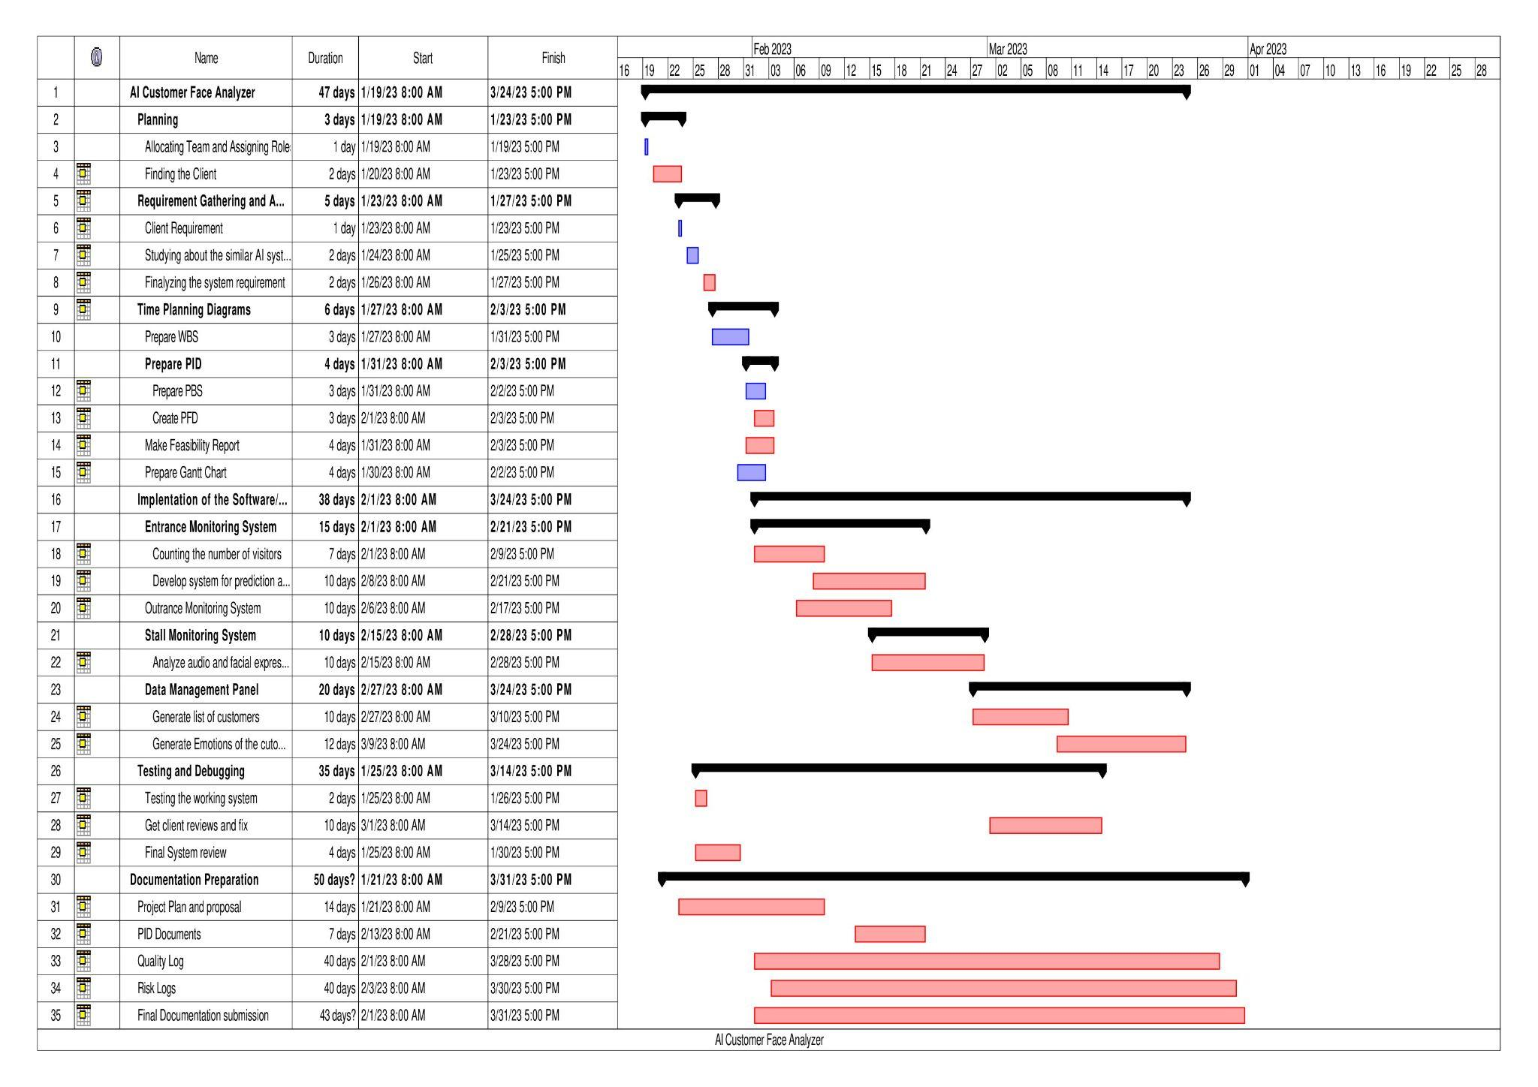

### 8.2 Product Breakdown Structure

*Figure SEQ Figure \* ARABIC 1 The high-quality image is given as a separate file*

### 8.3 Product Flow Diagrams

*Figure 2 The high-quality image is given as a separate file*

### 8.4 Product Descriptions

- Attached as a separate file called (Product Description)

### 8.5 Activity Network

### 8.6 Financial Budget

|  |  |  |  |
| --- | --- | --- | --- |
| **Role / Things** | **No of Hours / Quantity** | **Hourly Rate (LKR)** | **Total Cost (LKR)** |
| Project Manager | 260 | 2000/- | 520000/- |
| Startup Manager | 220 | 1500/- | 330000/- |
| Schedule Manager | 160 | 1000 | 160000/- |
| Risk Manager | 190 | 1200/- | 228000/- |
| Quality Manager | 180 | 1200/- | 216000/- |
| Infrastructure | - | - | 100000/- |
| Software Licenses | 3 | - | 100000/- |
| Hardware Equipment | 4 | - | 120000/- |
| Developer Cost | 250 | 2000/- | 500000 |
| Marketing | - | - | 10000/- |
| **Total** | **-** | **-** | **2284000/-** |
|  |  |  |  |
|  |  |  |  |
|  |  |  |  |

### 8.7 Change Budget

-

### 8.8 Resource Requirements

* Project Manager: A skilled and experienced project manager responsible for planning, executing, and controlling the project activities. The project manager will ensure that the project stays within scope, time, and budget constraints.
* AI and Machine Learning Experts: The project requires a team of AI and machine learning experts who can develop and implement the project's computer vision and machine learning algorithms. They should have experience in using libraries such as OpenCV and TensorFlow and have a good understanding of convolutional neural networks (CNNs).
* Web Developers: The project also requires a team of web developers who can develop the user interface and backend panel. They should have experience in using the MERN stack for web development.
* Testing Team: The testing test tests the system for accuracy, reliability, and security. They will ensure the system is error-free and that all features work as expected.
* Language Translators: The project requires translators who translate the system's welcoming message into Tamil, Sinhala, and English.
* Hardware Engineers: The project also requires hardware engineers who can design and implement the hardware system needed for the project, such as cameras, microphones, and displays.
* Project Sponsor: A project sponsor who will provide funding and support to ensure that the project meets the organization's goals and objectives.
* Administrative Staff: Administrative support video support for the project, including scheduling meetings, documenting progress, and handling project-related paperwork.
* Communication Tools: The project requires communication tools such as video conferencing software, project management tools, and collaboration tools to ensure effective communication and collaboration between the team members.
* Training Resources: The project will require training resources for the sales employees to improve their communication skills.
* Infrastructure: The project will require appropriate infrastructure, including hardware, software, and network systems, to support the project's development and deployment.

### 8.9 Specific Resources

* Project Manager
  + Responsible for planning, executing, and controlling the project activities.
  + Ensure the project stays within scope, time, and budget constraints.
  + Liaise with all stakeholders to ensure that the project objectives are met.
* AI and Machine Learning Experts
  + Develop and implement the computer vision and machine learning algorithms for the project
  + Have experience in using libraries such as OpenCV and TensorFlow
  + Have a good understanding of convolutional neural networks (CNNs)
* Web Developers
  + Develop the user interface and backend panel using the MERN stack
  + Have experience in web development and implementing web services.
* Testing Team
  + Test the system for accuracy, reliability, and security.
  + Ensure that the system is error-free, and all features are working as expected
  + Have experience in software testing and quality assurance.
* Language Translators - Part-time
  + Translate the system's welcoming message into Tamil, Sinhala, and English
  + Have experience in translating technical content.
* Communication Tools - As required.
* Video conferencing software, project management tools, and collaboration tools
* Ensure effective communication and collaboration between the team members.
* Training Resources - As required.
  + Develop training resources for the sales employees to improve their communication skills.
  + Have experience in developing training programs and materials.
  + Infrastructure - As required.

### 8.10 Tolerance

-

### 8.11 Contingency Plans

* Risk: The computer vision algorithm is not accurate enough.
* Contingency Plan: Initially, test the system with a few visitors to detect and correct any errors. Increase the number of visitors over time as the algorithm is confirmed.
* Risk: The hardware system malfunctions.
* Contingency Plan: A backup hardware system can be quickly installed if the primary system fails. The team should test the backup system regularly to ensure it functions correctly.
* Risk: The project still needs to be is not met.
* Contingency Plan: Review the project plan and adjust the timelines, resources, or tasks as required ensure that the project is completed within the expected timeframe.
* Risk: The team members do not have the required skills.
* Contingency Plan: Assess the team's skillset at the outset and determine if additional training or resources are needed. Consider hiring additional team members with the required skills.
* Risk: The project's costs exceed the budget.
* Contingency Plan: Monitor the project's expenses regularly and adjust the project sources to stay within the budget.
* Risk: The system is insecure, and data is lost or compromised.
* Contingency Plan: Ensure the system is adequately secured by following best data privacy and security practices. Test the system regularly to identify and address any vulnerabilities.
* Risk: The client is not satisfied with the project's outcome.
* Contingency Plan: Communicate with the client regularly to ensure their expectations are met. Have a detailed plan for addressing any concerns or issues that may arise, including changes to the project's scope or additional training for the client.