

**SOFTWARE REQUIREMENT SPECIFICATION (SRS)**

**AI Customer Analyzer**

**Group: 19**

**February 12, 2023**

|  |  |  |
| --- | --- | --- |
| Author: Sangeetha Thangavadivel (Startup Manager) | |  |
| Owner: Dr. Yasas Jayaweera (Project Executive) |  | |
| Client: DreamSpace (Private) Limited  Project Manager: Gunarakulan Gunaretnam (2208408)  Startup Manager: Sangeetha Thangavadivel (2135801)  Risk Manager: Haritha Thavarajah (2211320)  Schedule Manager: Mathumitha Arasakulasoorian (2211336)  Quality Manager: Delaxsan Raj Sathiyanesan (2211294) |  | |
| Document Ref: Project Brief Group 19 |  | |
| Version No: 1.0. |  | |

**Contents**

1. Introduction 5

○ 1.1 Purpose 5

1.2 Document Conventions 7

1.3 Intended Audience and Reading Suggestions 7

1.4 Product Scope 8

2. Overall Description 9

2.1 Product Perspective 9

2.2 Product Functions 10

2.3 Operating Environment 11

2.4 Design and Implementation Constraints 11

2.5 User Documentation 11

3. External Interface Requirements 12

3.1 User Interfaces 12

3.2 Hardware Interfaces 16

3.3 Communications Interfaces 18

4. System Functional Features 19

4.1 Use Case Diagram 19

○ 19

4.2 Assumptions and Dependencies 20

4.3 CRC CARDS 20

○ Use Case Name: Analyze Customer Informations 20

○ 20

○ Actors 20

○ System Admin 20

○ Pre – Conditions 20

○ A person belonging to top management 20

○ Goal/Overview 20

○ Produce reports, analyze customer information, 20

○ Actor Actions 20

○ System Response 20

○ Click the “Register employee” tab. 20

○ Fill the Form and Click the “submit” Button 20

○ Display the “Register” form. 20

○ Registered successfully 20

○ Post – Condition 20

○ Message 20

○ Alternative Flow 20

○ 20

○ 1a Display Error Message 20

○ 1b. unsuccessful registration 20

○ Use Case Name: Login as a super admin 21

○ 21

○ Actors 21

○ System Admin 21

○ Pre – Conditions 21

○ A person belonging to top management 21

○ Goal/Overview 21

○ Monitoring 21

○ Actor Actions 21

○ System Response 21

○ Click the “login” tab. 21

○ Fill the credentials and submit the form 21

○ Display the “Login” form. 21

○ Login Successful 21

○ Post – Condition 21

○ Message 21

○ Alternative Flow 21

○ 21

○ Display Error Message 21

○ Please try again unsuccessful login 21

○ Use Case Name: Login as a employee to the audio anayzler system 22

○ 22

○ Actors 22

○ Employees 22

○ Pre – Conditions 22

○ A person belonging to top sales 22

○ Goal/Overview 22

○ System will listen employee’s speech 22

○ Actor Actions 22

○ System Response 22

○ Click the “login” tab. 22

○ Fill the credentials and submit the form 22

○ Display the “Login” form. 22

○ Login Successful 22

○ Post – Condition 22

○ Message 22

○ Alternative Flow 22

○ 22

○ Display Error Message 22

○ Please try again unsuccessful login 22

5. Non-functional features 22

5.1Performance Requirements 22

5.2 Safety Requirements 23

5.3 Security Requirements 24

○ 5.4 Accuracy Requirements 25

● The system should be able to accurately identify and classify at least 90% of the emotions expressed in the user's input. 25

● The system should be able to provide an appropriate response or recommendation at least 95% of the time based on the identified emotion. 25

● The system should be able to accurately identify the user's intent at least 90% of the time. 25

● The system should be able to accurately identify and recognize the user's speech or text input at least 75% of the time. 25

● The system should be able to accurately translate the user's speech or text input, if necessary, with an error rate of no more than 5%. 25

○ 5.5 Usability Requirements 25

5.5 Software Quality Attributes 26

5.4 Business Rules 27

6. Other Requirements 28

6.1 Work Breakdown Structure 28

6.2 Product Break Down Structure 29

6.3 Product Flow Diagram 30

7. Conclusion 31

# Introduction

## 1.1 Purpose

This System Requirement Specification document has been prepared with the primary purpose of software requirements for the development of the AI-powered computer vision-based customer analysis system for DreamSpace Academy orgnization. All the sections of the document illustrate the main idea for the software engineers maintaining the software, project manager, technical writers, quality assurance and developers of the system and also the information that is given in each section will help Dream space to better understand the requirements of the system.

The system will be placed at the entrance of the company's premises to detect customers as they enter and collect information such as the number of customers, their age range, gender, and emotions. It will also analyze real-time audio to calculate the negative and positive words used by sales employees when talking with customers to improve their communication skills in the future. The content of this document will be useful for the project team to analyze the overall project and its requirements. The whole document gives an idea of the look and feel of the system for Dream Space, to the customers as per the specified finalized set of requirements.

In today's world, companies must understand their customers to serve them better and provide a personalized experience. Customer analysis helps businesses identify the demographics of their target audience, preferences, and behavior. Traditional methods of customer analysis, such as surveys and interviews, can be time-consuming and may not accurately represent the customer base. As a result, many companies are turning to AI-powered solutions to collect customer data in real time and provide valuable insights.

DreamSpace, based in Sri Lanka, recognizes the need for a more efficient and accurate customer analysis system. To address this, they have initiated a project to develop an AI-powered computer vision-based customer analysis system that can monitor and gather data about its customers in real time. This system will use computer vision and machine learning algorithms to detect the number of customers, age range, gender, emotions, and even race. Additionally, it will monitor the interactions between sales employees and customers to improve their communication skills in the future.

The system will be placed at the entrance of the company's premises. It will perform the essential duties of a security guard, welcoming visitors, counting them, and predicting their age range, gender, and mood. The system will also remind visitors to wear a face mask if necessary, contributing to the customers and staff's health and safety. DreamSpace aims to develop a user-friendly interface for visitors, making interacting with the system easy.

This project will leverage deep learning algorithms, such as convolutional neural networks (CNNs), and machine learning libraries, such as OpenCV and TensorFlow, to develop an accurate and efficient AI security bot for visitor analysis and mask reminder. The project will be delivered within ten weeks from the start date, with regular updates and progress reports provided to the client. The system will provide valuable insights and data that can be used to understand better and serve DreamSpace's customers, ultimately leading to improved customer satisfaction and business growth.

## 1.2 Document Conventions

The report is generated in Microsoft Word application, the font being used is Times New Roman within the whole document, and it uses a line spacing of 1.5 and a left margin of 1.5 inches.

**Main Titles**

∙ Font -Times New Roman, Face-Bold, Size-18

**Level Two Titles**

∙ Font-Times New Roman, Face-Bold, Size-16

**Level Three Titles**

∙ Font-Times New Roman, Face- Bold, Size-14

## 1.3 Intended Audience and Reading Suggestions

This document covers six main sections starting from the introduction section which describes how the document is built, the scope of the project and the main references. Secondly, it shows an overall description which includes product functions and their perspective, operating environment, and design of the system including the architecture constraints and user documents the next following section will describe external Interface requirements which consist of user interfaces, hardware interfaces, software interfaces and communication interfaces. then next section comes the system features with use case diagram, use case scenarios and the activity diagram then follows the nonfunctional requirements including performance requirements, safety requirements, security requirements, software quality attributes and business rules and lastly about other requirements

## 1.4 Product Scope

The scope of this project includes the development of an AI Security Bot that uses computer vision and machine learning to perform the following tasks:

* **Welcome Visitors**-the system should welcome visitors in Tamil, Sinhala, and English as they enter the premises.
* **Counting Visitors**-the system should accurately count the number of visitors entering Dream Space’s premises.
* **Predicting Visitor Characteristics**-system should use computer vision and machine learning algorithms to predict the following characteristics of visitors such as:
* Age Range-predict the age range of visitors using deep learning algorithms such as convolutional neural networks (CNNs).
* Gender-systems should predict the gender of visitors using deep learning algorithms such as CNNs.
* Mood-systems should predict the mood of visitors using deep learning algorithms such as CNNs.
* Race-system should predict the race of visitors using deep learning algorithms such as CNNs
* **Mask Reminder**-system should remind visitors to wear a face mask if necessary.
* **User-Friendly Interface**- the system should have a user-friendly interface that allows easy interaction with visitors.
* **Backend Panel**-system should provide a backend panel for Dream Space to view and analyze the gathered data.

# Overall Description

## 2.1 Product Perspective

The following system is only designed to be used at Dream Space, in addition, to the users of the above-mentioned company. The following Architecture Diagram shows the major components of the overall system, subsystem interconnections, and external interfaces and how the business analyst team is interacting.

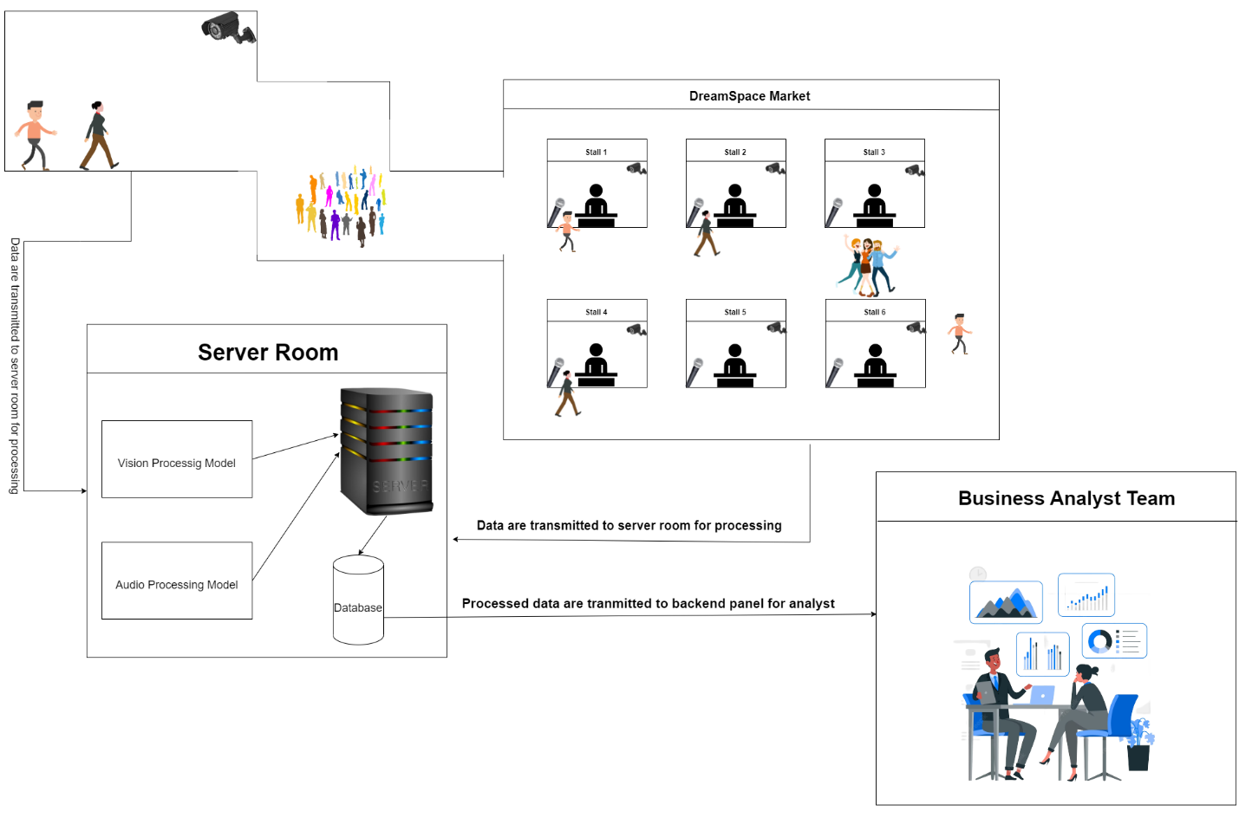

*Figure SEQ Figure \* ARABIC 1 Architecture Diagram of the System*

## 2.2 Product Functions

The main product functions which are the system’s main functions are as follows:

* The user should be able to find the customer’s mood
* Should be able to greet the customers
* The admin should manage projects.
* Should be able to view the predictions according to the customer

## Operating Environment

The system is designed to be a cross-platform application, which means it can function seamlessly on various operating systems, including but not limited to Windows, Linux, and MacOS. This ensures that the software can be used on multiple platforms without any compatibility issues or limitations, providing users with flexibility and convenience in accessing the system.

## Design and Implementation Constraints

System frontend designing almost started according to the client’s needs and currently, all the meetings are being held timely and client meetings are held through zoom according to their priority.

## User Documentation

There will be user manual documentation given to the client when handing over the system so that the client will have a clear understanding of how to use the system and how the future works can be maintained. The user manual could be used following the simple steps and the guidelines the user will be able to understand how the system will be working and how to operate them accordingly.

# External Interface Requirements

## User Interfaces

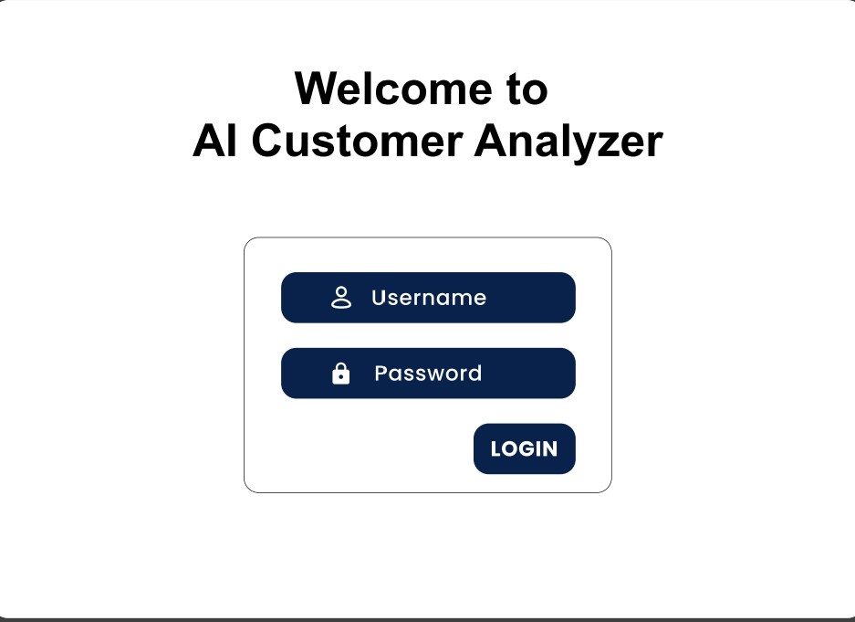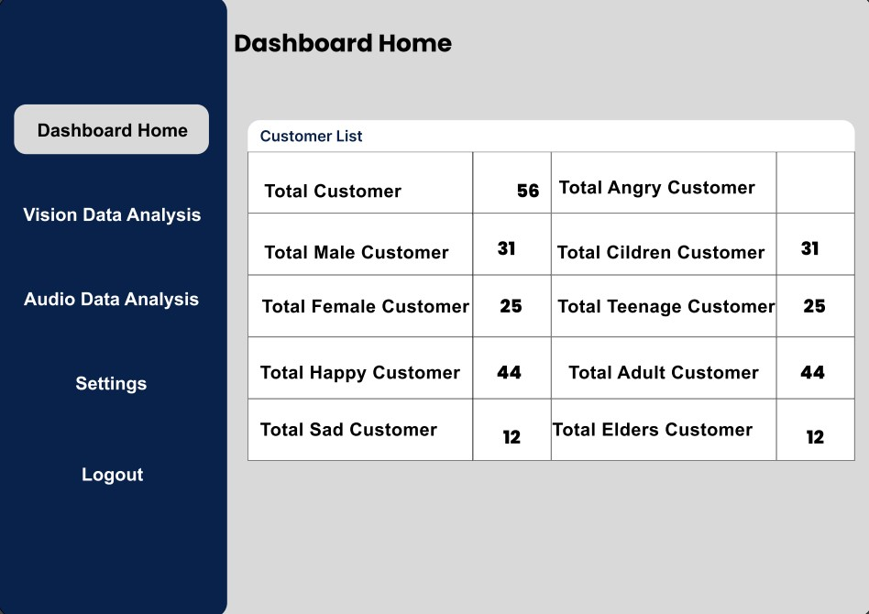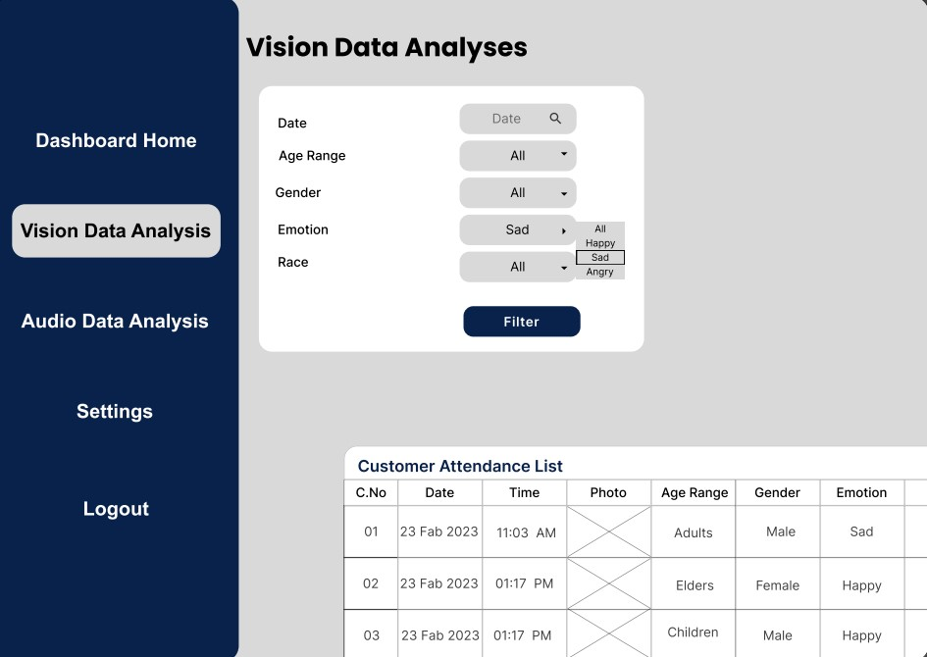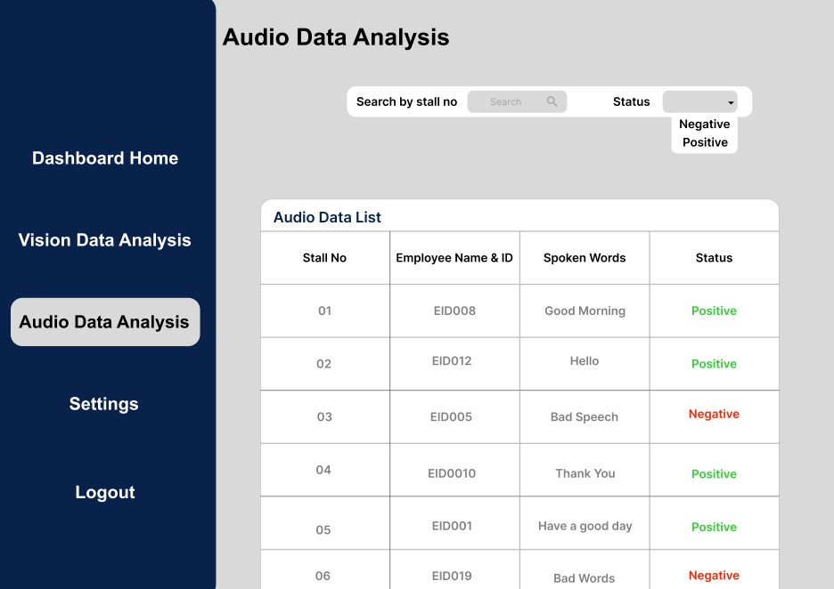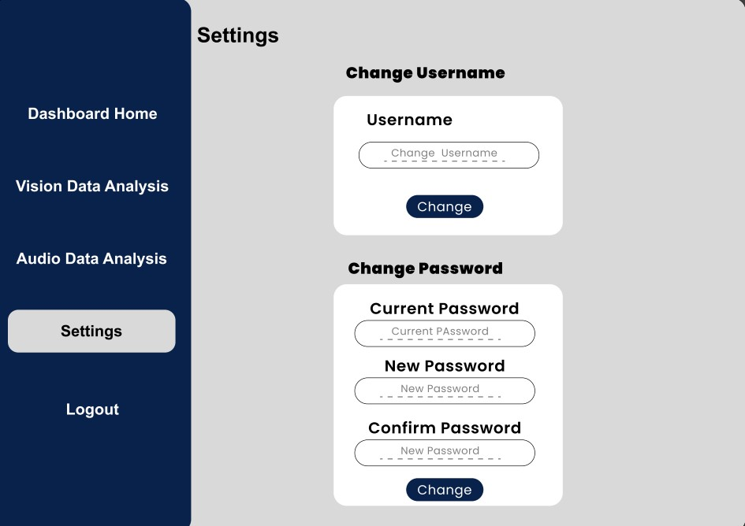

## 3.2 Hardware Interfaces

* Ram: 8GB
* CPU: i7
* GPU: GTX 1650
* Hard Drive: 2 GB
* Vision: Hight Quality Camera
* Audio: Speaker

**3.3.3 Project Management Tools**

* Time Management Tool:
  + Clockify:
* Task/Ticket Management Tool:
  + Azure Boards:
* Version Control Tool:
  + GitHub
* Communication Tools:
  + Slack
  + Email
* Meeting Tools:
  + Google Meet
* Scheduling Tool:
  + Google Calander
* Documentation Tools
  + Google Workspace
  + Google Docs
  + Google Slide
  + Google Sheet
* Could Storage
  + Google Drive
* Development Tools
  + VS Code
  + Live Share
  + Coding Extensions / Boilerplate

**3.3.4 Project Management Methods**

* Agile Project Management: We are going to use agile project management method for the project, because it is a flexible and iterative approach to project management that focuses on delivering high-quality products or services while responding to changing requirements and feedback from stakeholders. It emphasizes collaboration, continuous improvement, and adaptive planning throughout the project lifecycle. In other words, instead of following a rigid plan, the project team will work in short iterations, called sprints, and regularly review and adjust the project plan based on feedback from stakeholders and the team's progress. This approach allows for greater flexibility, faster delivery, and better alignment with stakeholder needs.

**3.3.5 Project Management Guidelines**

* Name Conventions Guideline:
  + [kebab-case](https://www.theserverside.com/definition/Kebab-case)
* Consistent Code Style Guideline:
  + [snake-case](https://www.theserverside.com/definition/Snake-case)
* GitHub Commit Message Guideline:
  + [Conventional Commits](https://www.conventionalcommits.org/en/v1.0.0/)
* Documentation Guideline:
  + Single Sentence Theory
* Task Priority Guideline:
  + [Eisenhower Priority Matrix](https://www.productplan.com/glossary/eisenhower-matrix/)
* Daily Update Guidelines
  + What are you going to do today?
  + What did you do yesterday?
  + Blockers?
* Daily Update Reminder Bot
  + Slack Bot

## Communications Interfaces

The communication mechanism used in our project is the client-server architecture in which HTTPS is used for secured communication between the client and the server and uses its store’s information about the person. There should be a proper internet connection and a proper network to have a proper record of the customers entering the location.

# System Functional Features

## Use Case Diagram

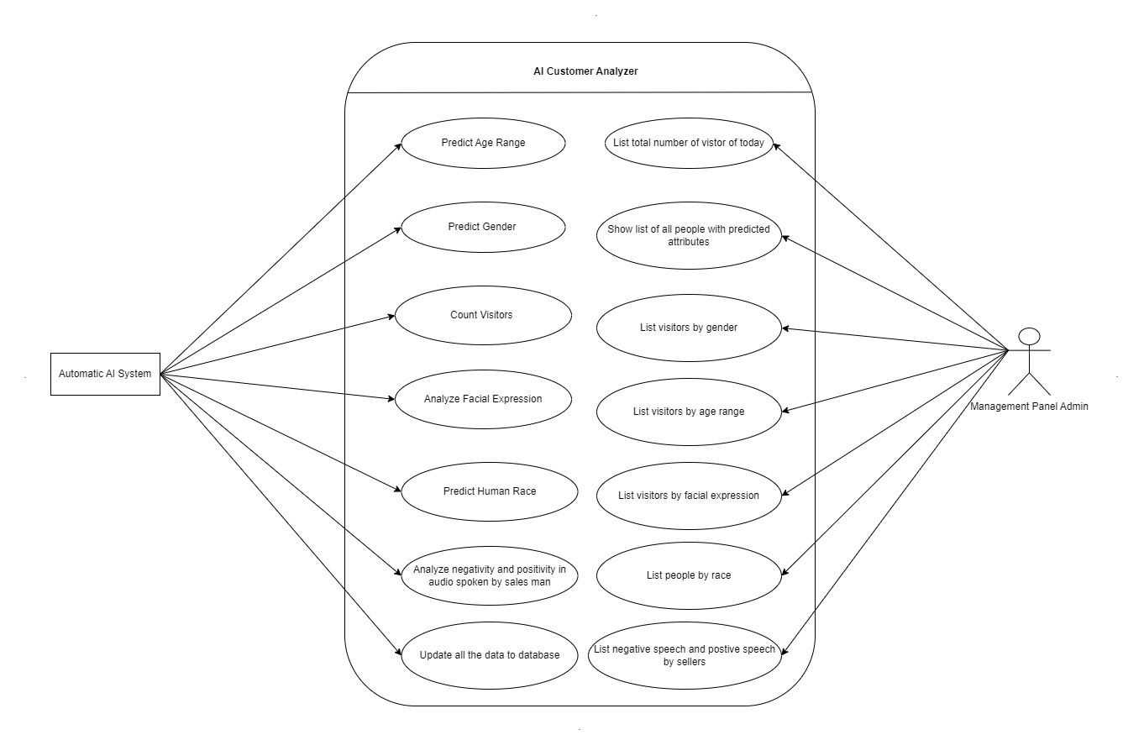

*Figure SEQ Figure \* ARABIC 2Use Case Diagram*

## 

## Assumptions and Dependencies

The development of the AI Security Bot for Visitor Analysis and Mask Reminder is dependent on the following assumptions and dependencies:

* The system will require access to a reliable power source and internet connectivity.
* The system will require access to an appropriate physical location for installation.
* The accuracy of the system is dependent on the quality of the input data.

## 4.3 CRC CARDS

**Use Case ID: AD001**

|  |  |
| --- | --- |
| Use Case Name: Analyze Customer Informations |  |
| Actors | System Admin |
| Pre – Conditions | A person belonging to top management |
| Goal/Overview | Produce reports, analyze customer information, |
| Actor Actions | System Response |
| Click the “Register employee” tab.Fill the Form and Click the “submit” Button | Display the “Register” form.Registered successfully |
| Post – Condition | Message |
| Alternative Flow |  |
| 1a Display Error Message | 1b. unsuccessful registration |

**Use Case ID: AD002**

|  |  |
| --- | --- |
| Use Case Name: Login as a super admin |  |
| Actors | System Admin |
| Pre – Conditions | A person belonging to top management |
| Goal/Overview | Monitoring |
| Actor Actions | System Response |
| Click the “login” tab.Fill the credentials and submit the form | Display the “Login” form.Login Successful |
| Post – Condition | Message |
| Alternative Flow |  |
| Display Error Message | Please try again unsuccessful login |

**Use Case ID: AD003**

|  |  |
| --- | --- |
| Use Case Name: Login as a employee to the audio anayzler system |  |
| Actors | Employees |
| Pre – Conditions | A person belonging to top sales |
| Goal/Overview | System will listen employee’s speech |
| Actor Actions | System Response |
| Click the “login” tab.Fill the credentials and submit the form | Display the “Login” form.Login Successful |
| Post – Condition | Message |
| Alternative Flow |  |
| Display Error Message | Please try again unsuccessful login |

# Non-functional features

## 5.1Performance Requirements

* Accuracy: The system should accurately detect and analyze the number of customers, their age range, gender, emotions, and race, as well as monitor sales employees' vocal interactions with customers.
* Speed: The system should operate in real-time, with the ability to process and analyze customer data quickly.
* Scalability: The system should be able to handle an increasing number of customers without sacrificing accuracy or speed.
* Reliability: The system should operate consistently and reliably, with minimal downtime or errors.
* User-Friendly Interface: The system should have a simple and intuitive user interface that visitors can easily interact with.
* Compatibility: The system should be compatible with the existing hardware and software systems used by DreamSpace.
* Security: The system should be secure, with proper data encryption and user authentication to prevent unauthorized access.
* Maintenance: The system should be easy to maintain, with regular updates and bug fixes provided as needed.
* Integration: The system should be easy to integrate with other data analysis tools and platforms used by DreamSpace.
* Accessibility: The system should be accessible to all visitors, regardless of their physical abilities, and provide support for multiple languages if necessary.

## Safety Requirements

* All electrical equipment and wiring must comply with relevant safety standards and be installed by a licensed electrician.
* The use of hazardous materials should be minimized and handled in accordance with relevant safety regulations.
* Safety training must be provided to all workers and visitors to the site, including instruction on the safe operation of equipment and procedures for responding to emergencies.
* The construction site must be secured with appropriate fencing, signage, and barriers to prevent unauthorized access and ensure the safety of workers and visitors.
* All tools and equipment must be regularly maintained and inspected to ensure they are in safe working condition.
* First aid facilities must be provided at the site, and all workers must be trained in basic first aid procedures.

## Security Requirements

* User Authentication: The system should require user authentication to access the backend panel, ensuring that only authorized personnel can access and view customer data.
* Data Encryption: Customer data should be encrypted both in transit and at rest to prevent unauthorized access or data breaches.
* Access Control: The system should provide role-based access control to ensure that only authorized personnel can perform specific actions and view certain data.
* Secure Communication: The system should use secure communication protocols, such as HTTPS, to ensure that all data transmitted between the system and the backend is secure and encrypted.
* Protection against Malicious Activities: The system should be protected against malicious activities such as DDoS attacks, SQL injection attacks, and other common types of attacks.
* Regular Security Audits: Regular security audits should be conducted to identify any potential security vulnerabilities in the system and ensure that security measures are up to date.
* Data Retention: The system should comply with relevant data protection laws and regulations and ensure that customer data is retained only for the necessary period and securely deleted after that.
* Monitoring and Logging: The system should provide robust monitoring and logging capabilities to detect any unauthorized access or activities and provide an audit trail for investigation if required.
* Incident Response: The system should have an incident response plan in place in case of any security breaches or incidents, outlining the steps to be taken to contain the breach and mitigate any damage.

## 5.4 Accuracy Requirements

## The system should be able to accurately identify and classify at least 90% of the emotions expressed in the user's input.

## The system should be able to provide an appropriate response or recommendation at least 95% of the time based on the identified emotion.

## The system should be able to accurately identify the user's intent at least 90% of the time.

## The system should be able to accurately identify and recognize the user's speech or text input at least 75% of the time.

## The system should be able to accurately translate the user's speech or text input, if necessary, with an error rate of no more than 5%.

## 5.5 Usability Requirements

* User-friendly interface: The system should have an easy-to-use interface that allows users to navigate the system quickly and perform tasks with minimal effort.
* Intuitive design: The system should be designed in a way that it is intuitive for users, with familiar features and standard design patterns.
* Clear and concise labeling: All labels, instructions, and error messages should be clear and concise, with no ambiguity in their meaning.
* Easy-to-understand documentation: The system should come with clear and concise documentation that explains how to use it, its features, and its limitations.
* Minimal user input required: The system should require minimal user input to perform tasks, with default values used where possible.
* Consistent design: The system should have a consistent design throughout, with similar features grouped together and a consistent color scheme.
* Error handling: The system should have clear error messages that help users identify the problem and how to fix it.
* Help and support: The system should provide easy access to help and support, including FAQs, knowledge bases, and customer support.

## 5.5 Software Quality Attributes

* Maintainability: The software should be designed and developed in a way that makes it easy to maintain and modify over time. This includes clear and well-documented code, consistent coding practices, and well-structured architecture.
* Reliability: The software should be reliable and perform consistently under varying conditions. This includes avoiding crashes, errors, and other unexpected behavior, as well as handling edge cases and input validation.
* Scalability: The software should be scalable to accommodate an increasing number of users and data over time. This includes designing a modular architecture, efficient algorithms, and proper use of resources such as memory and processing power.
* Performance: The software should be designed and optimized for optimal performance, with a focus on minimizing response time, maximizing throughput, and reducing latency.
* Security: The software should be secure and protect against unauthorized access, data breaches, and other security threats. This includes proper authentication and authorization, data encryption, and other security measures.
* Usability: The software should be user-friendly and easy to use, with a focus on intuitive user interfaces, clear instructions, and efficient workflows.
* Testability: The software should be designed and developed with testing in mind, with a focus on easy test automation, clear and thorough test cases, and effective debugging tools.

## Business Rules

* The AI Customer Analyzer system must be used solely for analyzing and gathering data about customers at DreamSpace's premises and cannot be used for any other purpose.
* The system must be installed at the entrance of DreamSpace's premises and cannot be relocated without prior approval from the project manager.
* The system must accurately detect and count the number of customers entering DreamSpace's premises.
* The system must accurately detect and analyze the age range, gender, and emotions of customers entering DreamSpace's premises.
* The system must not store any personal information or images of customers, and all data collected must be kept confidential and used solely for business analysis purposes.
* The system must provide a mask reminder to visitors if necessary and cannot force visitors to wear masks.
* The system must have a user-friendly interface for visitors to interact with, and any necessary instructions or information must be displayed clearly.
* The system must provide real-time data analysis and display information in a clear and organized manner.
* The system must be regularly maintained and updated to ensure accuracy and efficiency.
* The system must not interfere with the normal operations of DreamSpace's premises, and any issues or malfunctions must be promptly addressed by the project team.

# Other Requirements

## Work Breakdown Structure

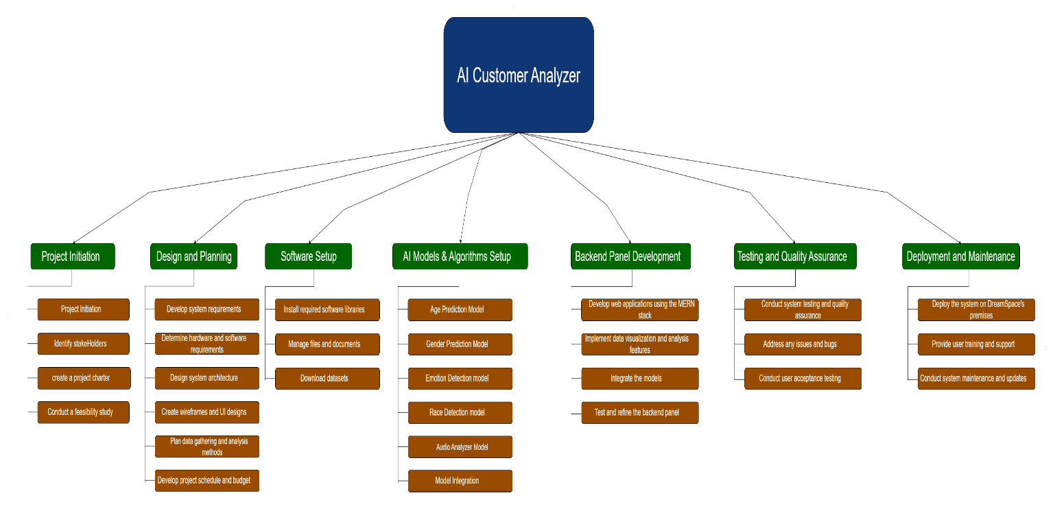

*Figure SEQ Figure \* ARABIC 3Work Breakdown Structure*

## Product Break Down Structure

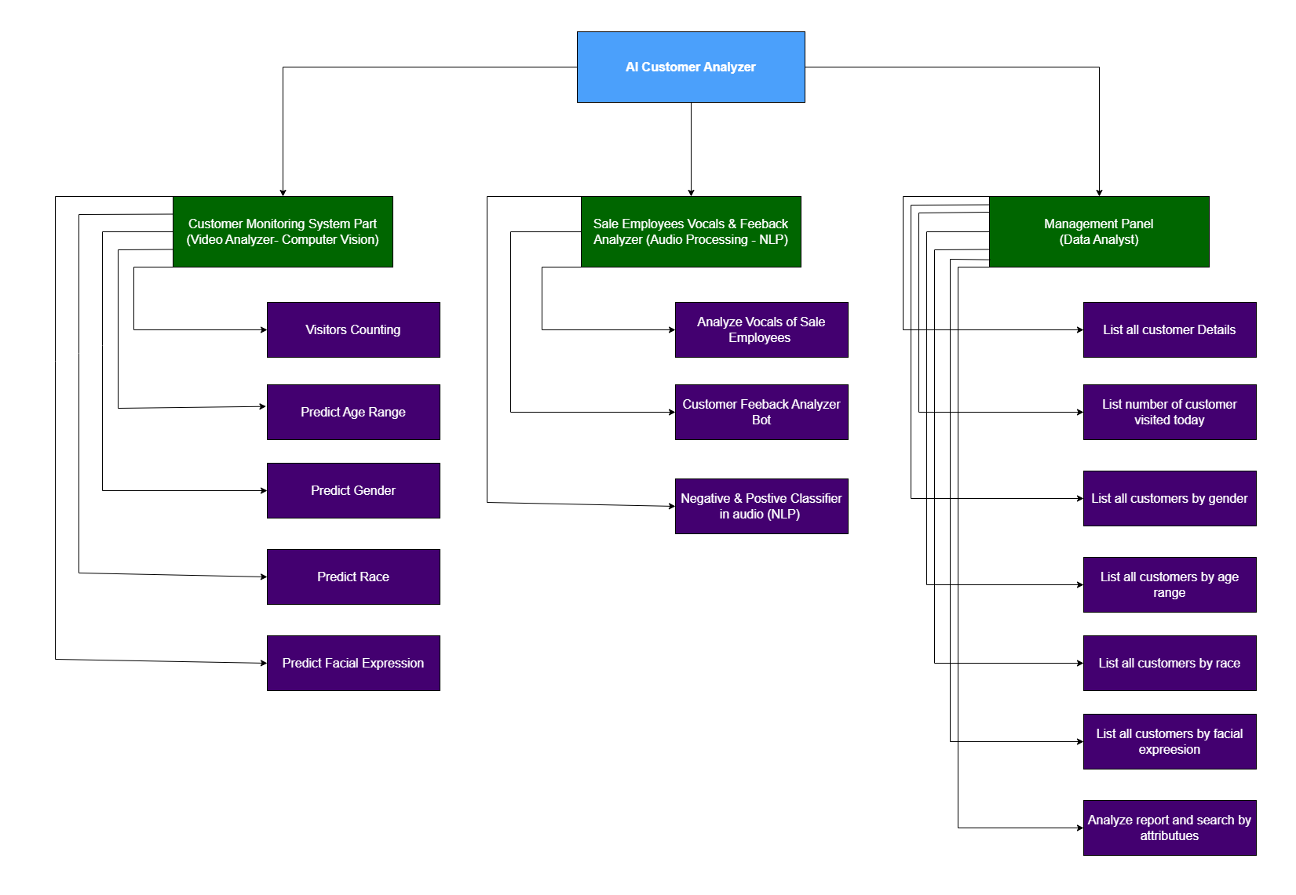

*Figure SEQ Figure \* ARABIC 4-Product Breakdown Structure*

## Product Flow Diagram

*Figure SEQ Figure \* ARABIC 5Product Flow Diagram*

# Conclusion

In conclusion, the AI-powered computer vision-based customer analysis system proposed for DreamSpace Academy is a cutting-edge solution that will revolutionize the way businesses understand and serve their customers. With the ability to detect and collect real-time customer data, including age range, gender, emotions, and even race, the system will provide valuable insights and analytics that can be used to improve customer satisfaction and business growth.

The project will leverage deep learning algorithms such as CNNs and machine learning libraries like OpenCV and TensorFlow to develop an accurate and efficient AI security bot for visitor analysis and mask reminder. The system's user-friendly interface will make it easy for visitors to interact with the system, and the backend panel will enable DreamSpace to view and analyze the gathered data.

The document outlines the system's scope, product functions, operating environment, design and implementation constraints, and user documentation. It provides a detailed description of the project's requirements and features, including use case diagrams, scenarios, and activity diagrams. It also covers non-functional requirements such as performance, safety, security, software quality attributes, and business rules.

Overall, the document provides a comprehensive guide for the project team, including software engineers, project managers, technical writers, quality assurance, and developers, to ensure the successful development and implementation of the AI-powered computer vision-based customer analysis system for DreamSpace Academy. The system will provide valuable insights and data that can be used to improve customer satisfaction and business growth, making it a valuable investment for the organization.