**STAGE PLAN**

**Project: AI Customer Analyzer**

**Group: 19**

|  |  |  |  |  |
| --- | --- | --- | --- | --- |
| Release: February 2023 | |  | | |
| Date: 25 February 2023 |  | | | |
|  | | | |  |
| **PRINCE2** | | | |  |
|  | | | |  |
| Author: Gunarakulan Gunaretnam (Project Manager) | | |  | |
| Owner: Dr. Yasas Jayaweera (Project Executive) | | | |  |
| Client: DreamSpace (Private) Limited  Project Manager: Gunarakulan Gunaretnam (2208408)  Startup Manager: Sangeetha Thangavadivel (2135801)  Risk Manager: Haritha Thavarajah (2211320)  Schedule Manager: Mathumitha Arasakulasoorian (2211336)  Quality Manager: Delaxsan Raj Sathiyanesan (2211294) | | | |  |
| Document Ref: Stage Plan Group 19 | | | |  |
| Version No: 1.0.0 | | | |  |

# 1 Stage Plan Report History

## 1.1 Document Location

This document is only valid on the day it was printed.

The source of the document will be found on the project's PC in location

## 1.2 Revision History

**Date of this revision:**

**Date of Next revision:**

|  |  |  |  |
| --- | --- | --- | --- |
| **Revision date** | **Previous revision date** | **Summary of Changes** | **Changes marked** |
| 06-02-2023 |  | First issue |  |

## 1.3 Approvals

This document requires the following approvals.

Signed approval forms are filed in the Management section of the project files.

|  |  |  |  |  |
| --- | --- | --- | --- | --- |
| **Name** | **Signature** | **Title** | **Date of Issue** | **Version** |
| Dr.Yasas Jayaweera |  | Project Executive |  | 1.0.0 |
| Gunarakulan Gunaretnam |  | Project Manager | 25-03-2023 | 1.0.0 |
| Kishoth Navaretnarajah |  | Client | 25-03-2023 | 1.0.0 |

## 1.4 Distribution

This document has been distributed to:

|  |  |  |  |
| --- | --- | --- | --- |
| **Name** | **Title** | **Date of Issue** | **Version** |
| Gunarakulan Gunaretnam (2208408) | Project Manager | 25-03-2023 | 1.0.0 |
| Sangeetha Thangavadivel (2135801) | Startup Manager | 25-03-2023 | 1.0.0 |
| Haritha Thavarajah (2211320) | Risk Manager | 25-03-2023 | 1.0.0 |
| Mathumitha Arasakulasoorian (2211336) | Schedule Manager | 25-03-2023 | 1.0.0 |
| Delaxsan Raj Sathiyanesan (2211294) | Quality Manager | 25-03-2023 | 1.0.0 |

# Table of Contents

1 Stage Plan Report History 2

1.1 Document Location 2

1.2 Revision History 2

1.3 Approvals 2

1.4 Distribution 2

Table of Contents 3

3 Purpose 3

4 Plan Description 4

5 Quality Plan 4

6 Plan Prerequisites 5

7 External Dependencies 6

9 Monitoring and Control 7

11 Planning Assumptions 8

12 Graphical Plan 9

12.1 Gantt or Bar Chart 9

12.2 Product Breakdown Structure 9

12.3 Product Flow Diagram 10

12.4 Activity Network 10

12.5 Financial Budget 10

12.7 Risk Assessment 11

13 Product Descriptions 11

## 3 Purpose

The purpose of this document is to provide a detailed plan for the current stage of the project. It is the basis for project management control throughout the stage and guides the project team to execute their tasks efficiently. The Stage Plan identifies all the products the stage must produce and provides a statement of how and when the stage's objectives will be achieved. This is accomplished by showing the deliverables, activities, and resources required for the stage.

## 4 Plan Description

This plan should include a summary of the stage's objectives and the products that must be produced to achieve those objectives. It covers the activities and tasks that must be completed, along with their dependencies and timelines.

It covers quality plans, plan prerequisites, external dependencies, tolerances, monitoring control, reporting, planning, and other graphical diagrams.

## 5 Quality Plan

Quality Objectives: This section should outline the overall quality objectives for the Stage Plan document. It should define what quality means for this document and the quality criteria.

Quality Control: This section should describe the quality control measures that will be used to ensure that the Stage Plan document meets the defined quality criteria. It should include details about the quality review process, including the roles and responsibilities of those involved.

Quality Assurance: This section should describe the quality assurance measures that will be used to ensure that the quality control measures are working effectively. It should include details about the quality audit process, including the roles and responsibilities of those involved.

Quality Management Tools: This section should describe the tools and techniques used to manage quality throughout the Stage Plan document. It should include details about any quality management software, checklists, or templates that will be used.

Roles and Responsibilities: This section should outline the roles and responsibilities of the individuals involved in ensuring the quality of the Stage Plan document. It should include details about who will be responsible for quality control and assurance and who will be responsible for managing the quality management tools.

Training and Competence: This section should describe the training and competence requirements for the individuals involved in ensuring the quality of the Stage Plan document. It should include details about any training that will be provided and any qualifications or certifications required.

Documentation and Records: This section should describe the documentation and record-keeping requirements for quality management in the Stage Plan document. It should include details about the required documentation and how records will be maintained.

## 6 Plan Prerequisites

* Clear project objectives: All stakeholders must define and agree upon the project objectives before the stage plan is created.
* Adequate resources: Sufficient resources, including personnel, budget, and equipment, must be allocated for the project to achieve its objectives.
* Stakeholder engagement: Key stakeholders must be identified and engaged in the planning process to ensure their needs and expectations are considered.
* Clear roles and responsibilities: All project team members and stakeholders must be clearly defined and communicated to ensure effective collaboration and accountability.
* Risk management plan: A risk management plan must be developed to identify potential risks and their impact on the project and mitigation strategies to minimize or avoid them.
* Change management process: A change management process must be established to manage any changes to the project scope, objectives, or deliverables that may arise during the stage.

## 7 External Dependencies

* Availability of required external resources such as hardware, software, and human resources.
* Availability of necessary permits, licenses, or certifications required to carry out the project activities.
* Dependence on external suppliers to deliver critical products or services required for the project.
* Dependence on external stakeholders for their inputs or approvals at various project stages.
* Dependence on external regulations or legal requirements that may impact the project's progress or success.
* Dependence on external weather conditions or natural events that may impact project delivery timelines.
* Dependence on external funding or financial support to continue the project activities.

## 9 Monitoring and Control

* Progress tracking: The project team will use project management software, such as Microsoft Project or Primavera P6, to track progress against the stage plan. This will enable the team to monitor progress against the baseline plan and identify any deviations that need to be addressed.
* Regular reporting: Regular progress reports will be produced to monitor progress against the stage plan. These reports will summarize the work completed to date, highlight any issues or risks that have arisen, and provide an overview of the work planned for the next reporting period.
* Change control: A formal change control process will be in place to manage any changes to the stage plan. This process will ensure that any changes are assessed for their impact on the project and that the necessary approvals are obtained before any changes are implemented.
* Quality control: Quality control will be implemented to ensure that the project is delivered to the required standard. This will involve regular inspections and testing to verify that the deliverables meet the specified quality criteria.
* Risk management: A plan will be developed to identify, assess, and manage project risks. This will include regular risk assessments and implementing risk mitigation strategies to minimize the impact of any risks that materialize.
* Stakeholder management: Stakeholder management will be critical to the project's success. A stakeholder management plan will be developed to identify and engage with stakeholders, ensure their needs are understood, and manage any issues or concerns they may have.

## 11 Planning Assumptions

The first expectation is that everyone in the project will execute their tasks efficiently on time. It will lead to the whole project being completed on time. Customer expectations are another key factor. When doing the project, the developers should presume that the client would not alter the specifications.

## 12 Graphical Plan

### 12.1 Gantt or Bar Chart

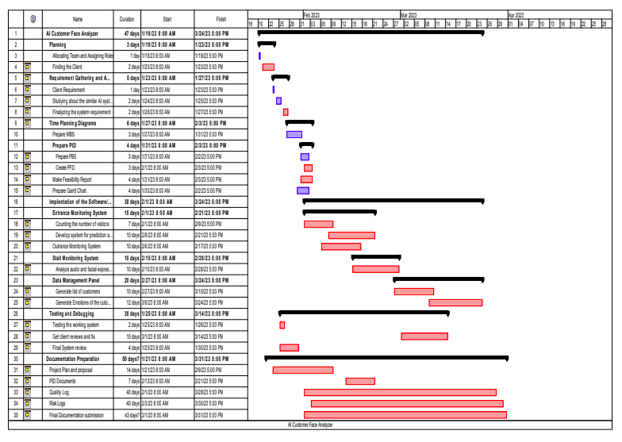

### 12.2 Product Breakdown Structure

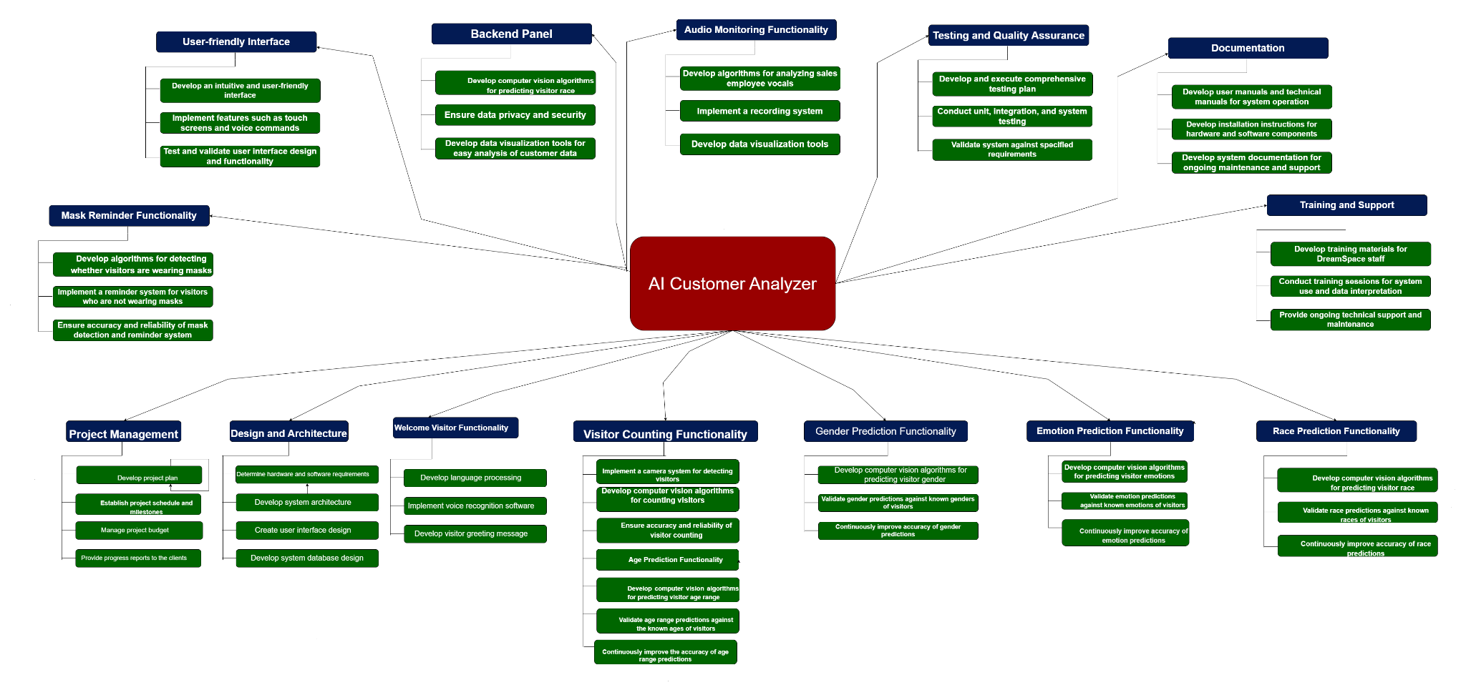

### 12.3 Product Flow Diagram

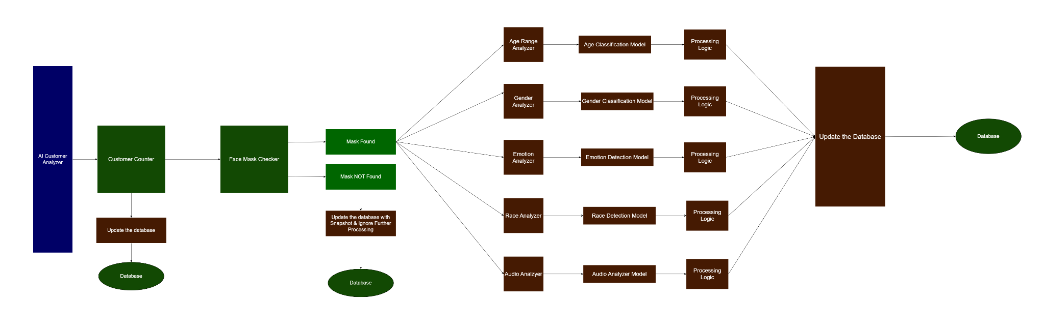

### 12.4 Activity Network

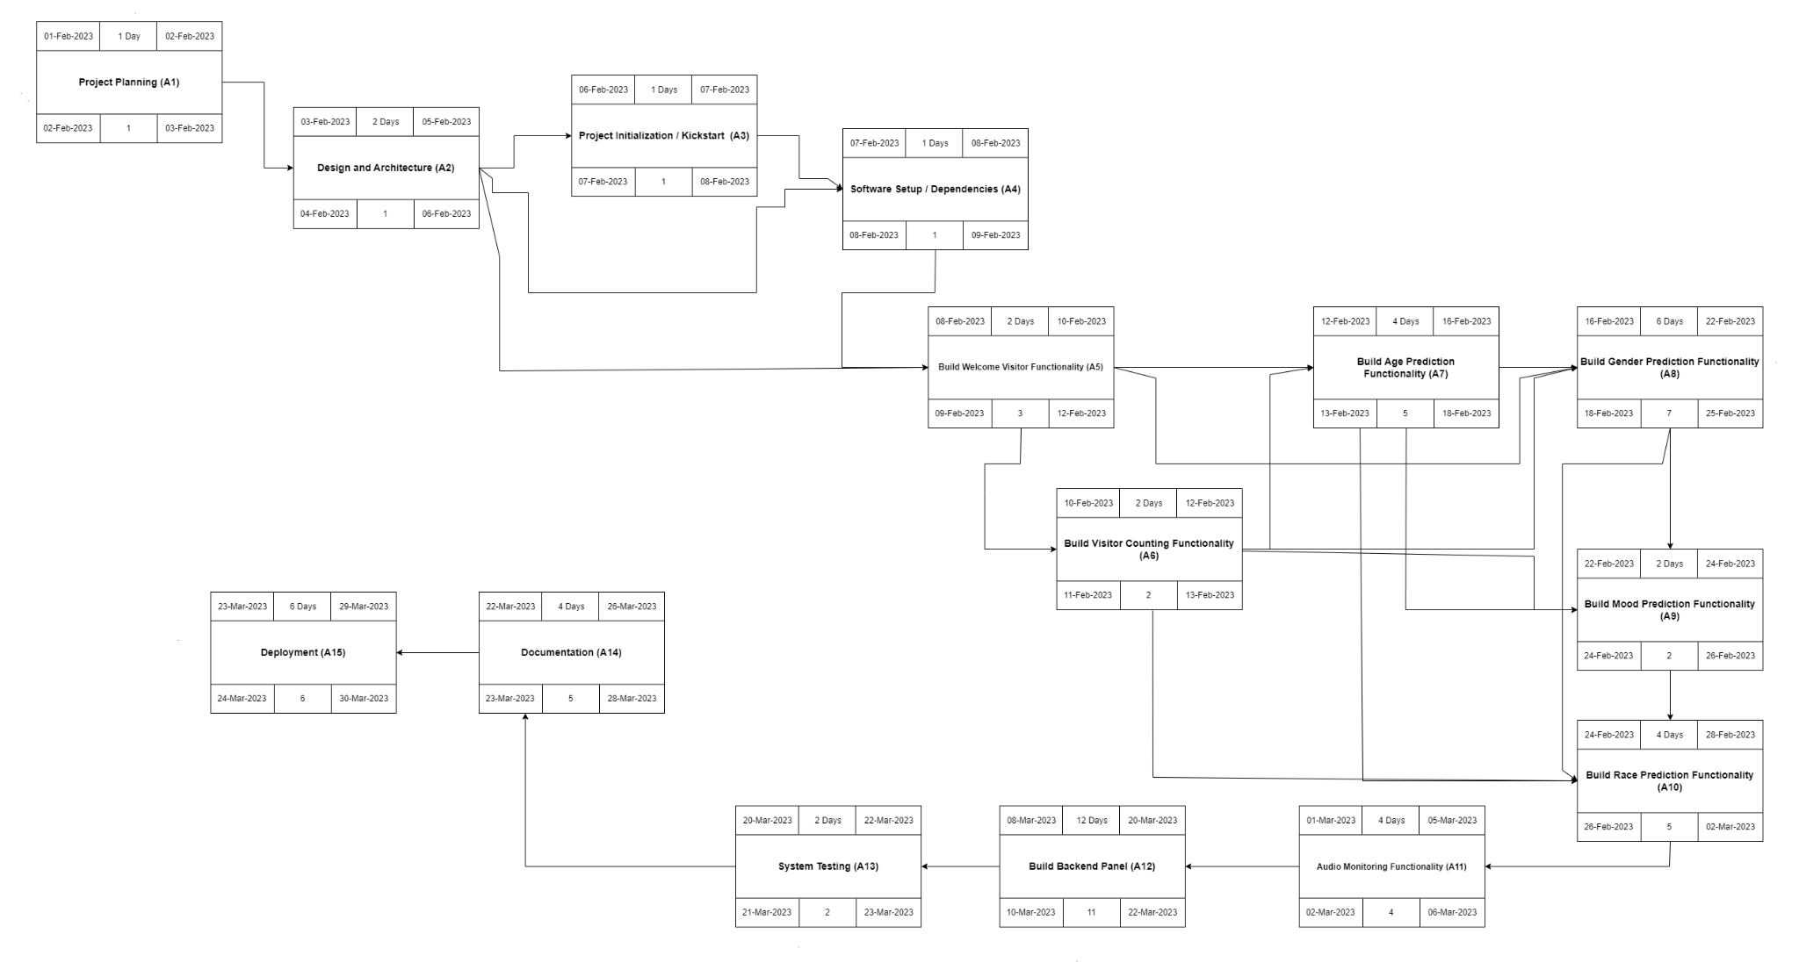

### 12.5 Financial Budget

|  |  |  |  |
| --- | --- | --- | --- |
| **Role / Things** | **No of Hours / Quantity** | **Hourly Rate (LKR)** | **Total Cost (LKR)** |
| Project Manager | 260 | 2000/- | 520000/- |
| Startup Manager | 220 | 1500/- | 330000/- |
| Schedule Manager | 160 | 1000 | 160000/- |
| Risk Manager | 190 | 1200/- | 228000/- |
| Quality Manager | 180 | 1200/- | 216000/- |
| Infrastructure | - | - | 100000/- |
| Software Licenses | 3 | - | 100000/- |
| Hardware Equipment | 4 | - | 120000/- |
| Developer Cost | 250 | 2000/- | 500000 |
| Marketing | - | - | 10000/- |
| **Total** | **-** | **-** | **2284000/-** |
|  |  |  |  |
|  |  |  |  |
|  |  |  |  |

### 12.7 Risk Assessment

Attached with it

## 13 Product Descriptions

**Note:** Attached with it