**HIGHLIGHT REPORT 1**

**Project: AI Customer Analyzer**

**Group: 19**

|  |  |  |  |  |
| --- | --- | --- | --- | --- |
| Release: MARCH 2023 | |  | | |
| Date: 04 MARCH 2023 |  | | | |
|  | | | |  |
| **PRINCE2** | | | |  |
|  | | | |  |
| Author: Gunarakulan Gunaretnam (Project Manager) | | |  | |
| Owner: Dr. Yasas Jayaweera (Project Executive) | | | |  |
| Client: DreamSpace (Private) Limited  Project Manager: Gunarakulan Gunaretnam (2208408)  Startup Manager: Sangeetha Thangavadivel (2135801)  Risk Manager: Haritha Thavarajah (2211320)  Schedule Manager: Mathumitha Arasakulasoorian (2211336)  Quality Manager: Delaxsan Raj Sathiyanesan (2211294) | | | |  |
| Document Ref: Highlight Report Group 19 | | | |  |
| Version No: 1.0.0 | | | |  |

# 1 Highlight Report History

## 1.1 Document Location

This document is only valid on the day it was printed.

The source of the document will be found on the project's PC in location

## 1.2 Revision History

**Date of this revision:**

**Date of Next revision:**

|  |  |  |  |
| --- | --- | --- | --- |
| **Revision date** | **Previous revision date** | **Summary of Changes** | **Changes marked** |
| 06-02-2023 |  | First issue |  |

## 1.3 Approvals

This document requires the following approvals.

Signed approval forms are filed in the Management section of the project files.

|  |  |  |  |  |
| --- | --- | --- | --- | --- |
| **Name** | **Signature** | **Title** | **Date of Issue** | **Version** |
| Dr.Yasas Jayaweera |  | Project Executive |  |  |
| Gunarakulan Gunaretnam |  | Project Manager | 02-03-2023 |  |
| Kishoth Navaretnarajah |  | Client | 02-03-2023 |  |

## 1.4 Distribution

This document has been distributed to:

|  |  |  |  |
| --- | --- | --- | --- |
| **Name** | **Title** | **Date of Issue** | **Version** |
| Gunarakulan Gunaretnam (2208408) | Project Manager | 02-03-2023 |  |
| Sangeetha Thangavadivel (2135801) | Startup Manager | 02-03-2023 |  |
| Haritha Thavarajah (2211320) | Risk Manager | 02-03-2023 |  |
| Mathumitha Arasakulasoorian (2211336) | Schedule Manager | 02-03-2023 |  |
| Delaxsan Raj Sathiyanesan (2211294) | Quality Manager | 02-03-2023 |  |

# 2 Table of Contents

1 Highlight Report History 2

1.1 Document Location 2

1.2 Revision History 2

1.3 Approvals 2

1.4 Distribution 2

2 Table of Contents 3

Highlight Report 4

3 Purpose 4

4 Budget Status 4

5 Schedule Status 7

6 Products Completed 7

7 Problems and Risk Update 14

8 Products to be Completed 14

9 Project Issue Status 17

10 Budget/Schedule Impact 19

# Highlight Report

## 3 Purpose

The purpose of submitting the highlight report is to provide the Project Board with a concise summary of the stage status at intervals defined by them. The report enables the Project Board to monitor the stage and project progress effectively. The Project Manager also uses the report to advise the Project Board of any potential problems or areas where the Project Board could help. This information helps the Project Board to make informed decisions and take appropriate actions to ensure that the project remains on track and delivers the expected outcomes within the defined constraints. The highlight report serves as a communication tool that facilitates collaboration and alignment among stakeholders involved in the project.

## 4 Budget Status

|  |  |  |  |  |  |  |  |  |
| --- | --- | --- | --- | --- | --- | --- | --- | --- |
|  | | | Predicted Budget Amount | | | Current Status | | |
| **Expense** | **Description** | **Basis** | **Unit** | **Rate** | **Total** | **Unit** | **Rate** | **Total** |
| **Planning** | | | | | | | | |
| Requirement Gathering | To visit the company and get requirements | Hourly | 20 | 30000/- | 30000/- | 29 | 43500/- | 43500/- |
| Business study | Analysis the requirements | Hourly | 24 | 36000/- | 36000 | 20 | 30000/- | 30000/- |
| **Development** | | | | | | | | |
| Initialize the development work. | To setup development environment and install dependencies | Hourly | 20 | 40000/- | 40000/- | 27 | 54000/- | 54000/- |
| Setup DevOps | To setup devops | Hourly | 18 | 36000/- | 36000/- | 15 | 30000/- | 30000/- |
| Develop Vision processing module | To access video frames, preprocessing | Hourly | 10 | 20000/- | 20000/- | 8 | 18000/ | 18000/ |
| Develop Face detection module | To detect face and configure face detection model | Hourly | 10 | 20000/- | 20000/- | 6 | 16000/- | 16000/- |
| Develop face mask detection module | To check weather the visitor wearing a facemask to avoid further processing | Hourly | 15 | 30000/- | 30000/- | 22 | 44000/- | 44000/- |
| **Testing** | | | | | | | | |
| Functionalities testing | Do the testing with test cases | Hourly | 10 | 12000/- | 12000/- | 12 | 14400/- | 14400/- |
| **Documentation** | | | | | | | | |
| Document hard copies | Copies of all the documents and guides of the system | Hourly | 25 | 50000/- | 50000/- | 25 | 50000/- | 50000/- |
| **Set up of the system** | | | | | | | | |

|  |  |  |  |
| --- | --- | --- | --- |
| **Role / Things** | **No of Hours / Quantity** | **Hourly Rate (LKR)** | **Total Cost (LKR)** |
| Project Manager | 260 | 2000/- | 520000/- |
| Startup Manager | 220 | 1500/- | 330000/- |
| Schedule Manager | 160 | 1000 | 160000/- |
| Risk Manager | 190 | 1200/- | 228000/- |
| Quality Manager | 180 | 1200/- | 216000/- |
| Infrastructure | - | - | 100000/- |
| Software Licenses | 3 | - | 100000/- |
| Hardware Equipment | 4 | - | 120000/- |
| Developer Cost | 250 | 2000/- | 500000 |
| Marketing | - | - | 10000/- |
| **Total** | **-** | **-** | **2284000/-** |
|  |  |  |  |
|  |  |  |  |
|  |  |  |  |

## 5 Schedule Status

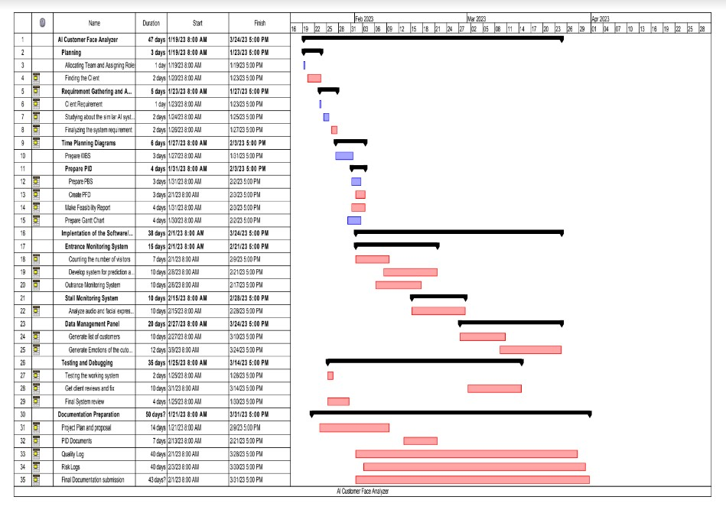

## 6 Products Completed

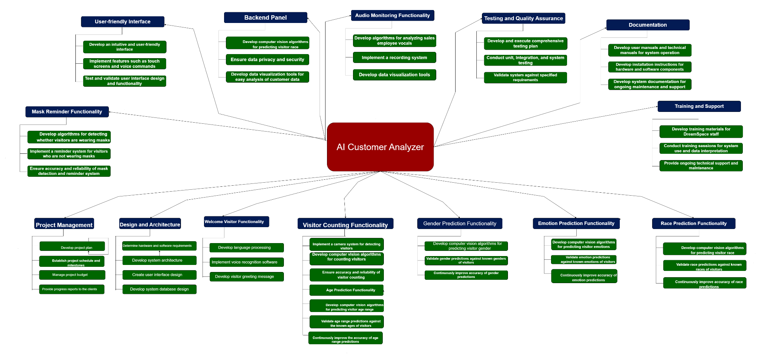

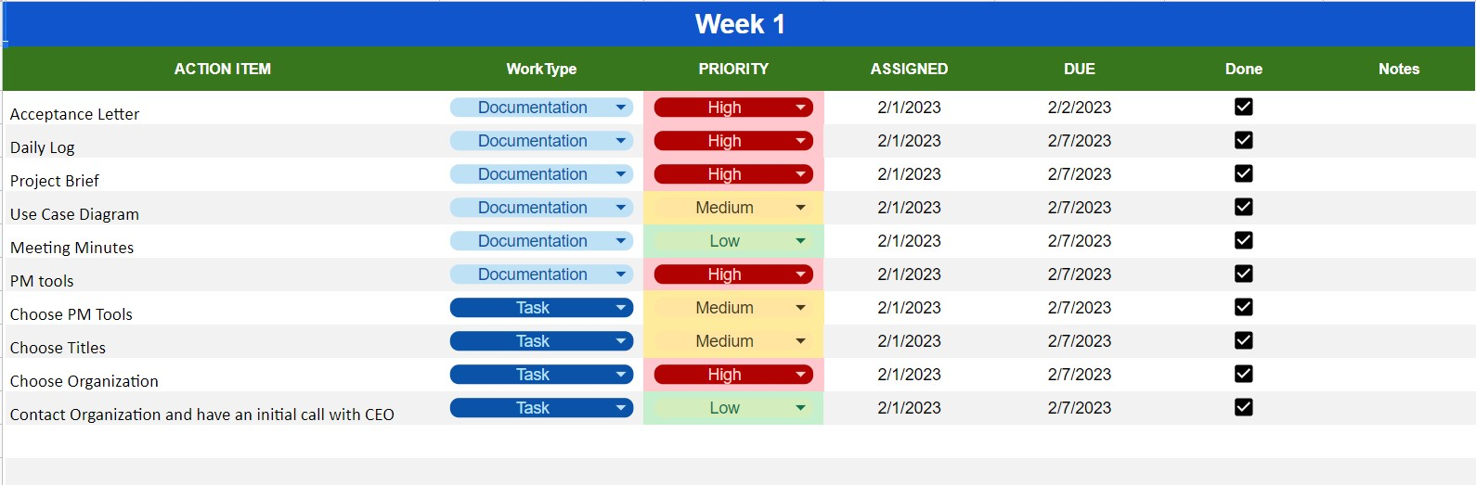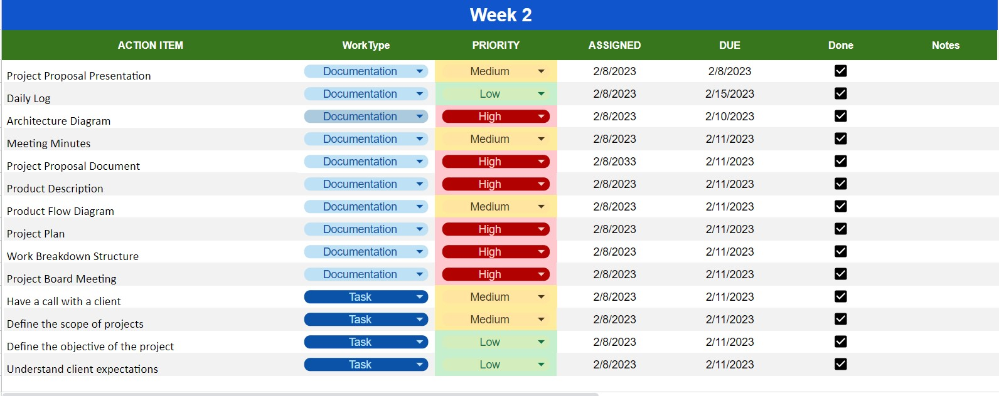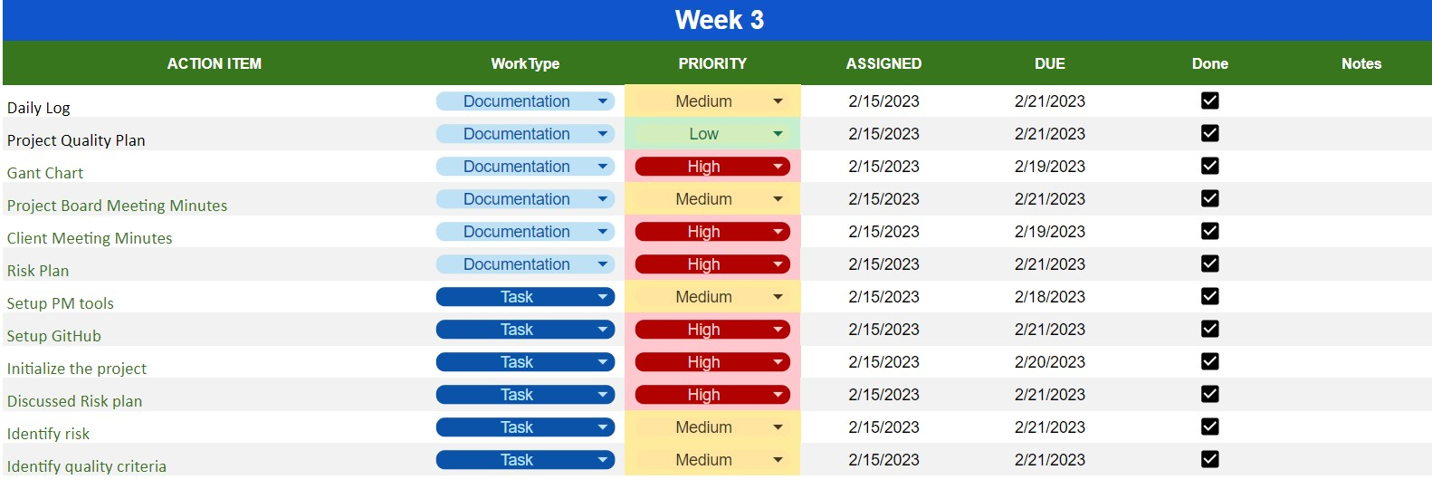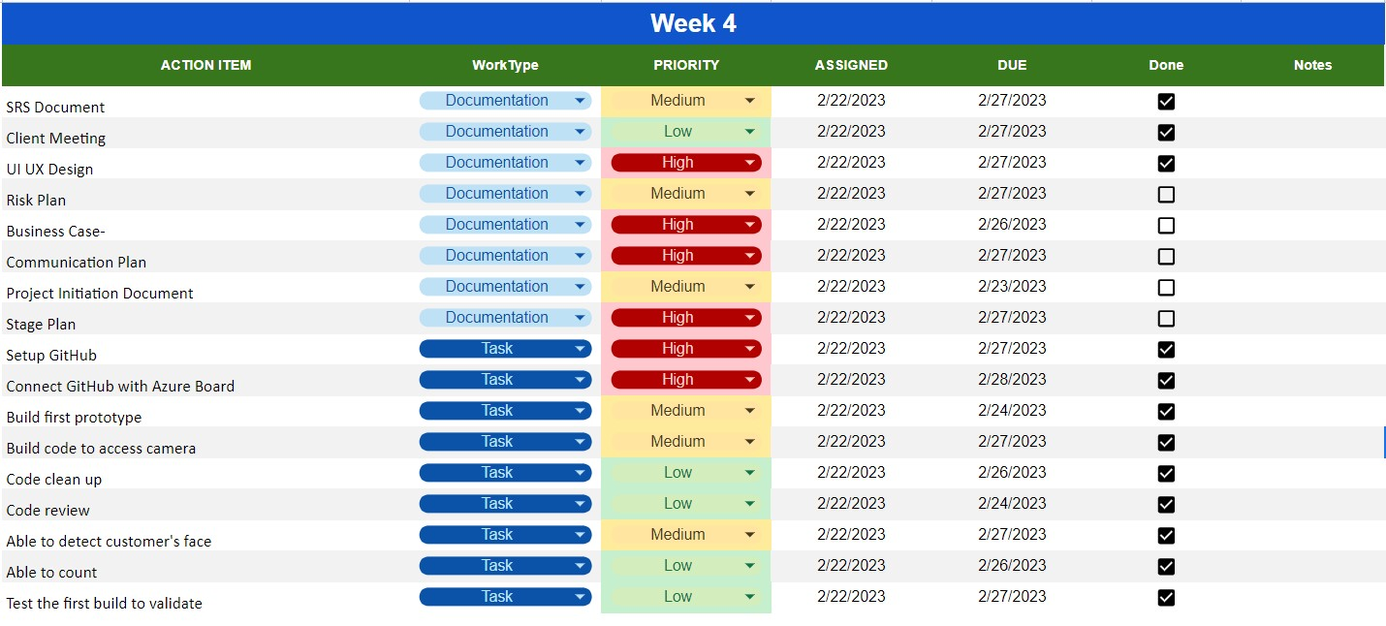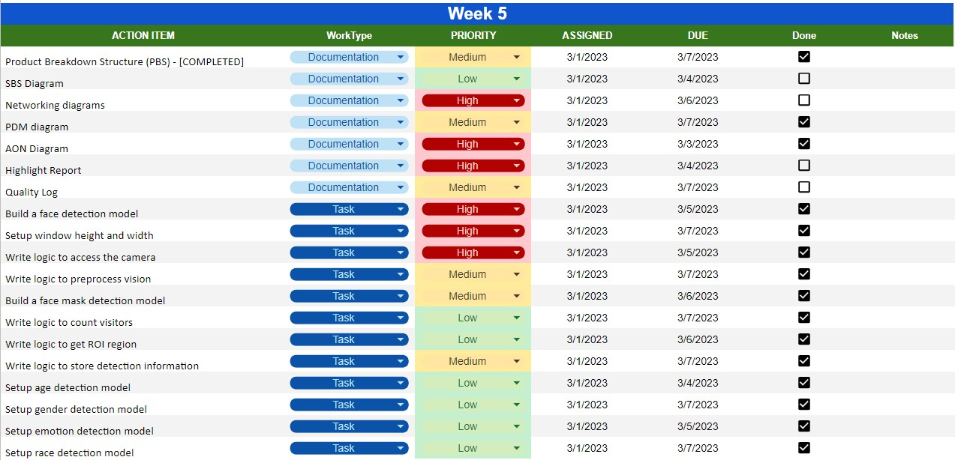

***IMPORTANT NOTE:*** The Product Progress Matrix Excel Sheet is attached to this weekly documentation with the name of “progress-mattrix.xlsx” under the week-5 folder: <https://docs.google.com/spreadsheets/d/17M8OnrUFK8a-K4bDvf9Wsvnhj7htiiEv/>

### 6.1 System State (Development)

* Build functionality to access the camera.
* Build functionality to extract frames.
* Build functionality to preprocess the frames.
* Build functionality to detect faces
* Build functionality to count people.
* Build functionality to detect face masks.

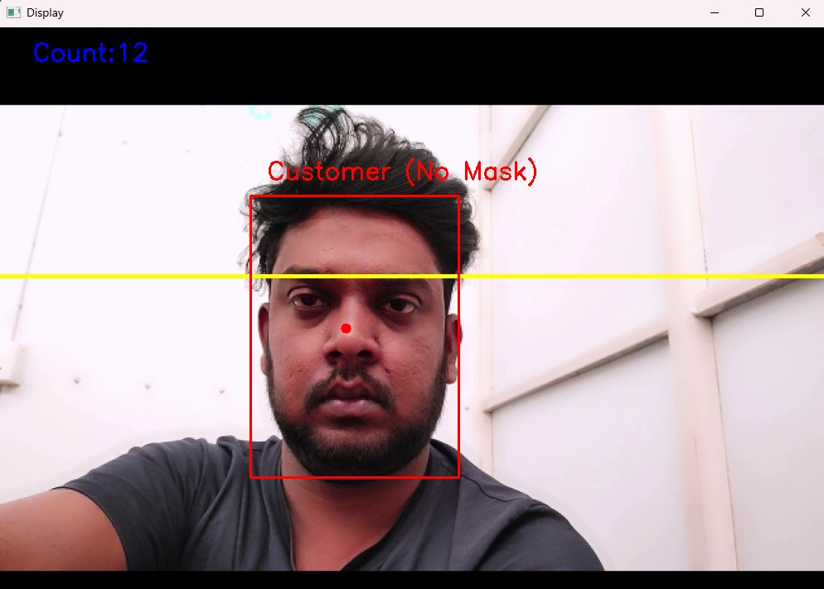

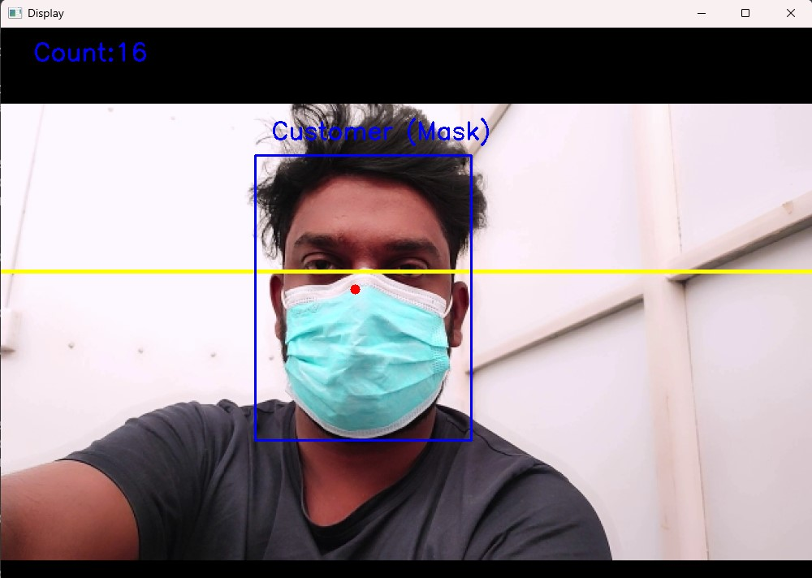

**IMPORTANT NOTE:** The project source is given with this weekly update; the project source can be found here: <https://github.com/gunarakulangunaretnam/ai-customer-analyzer>

## 6.2 Management State

#### 6.2.1 Team Management

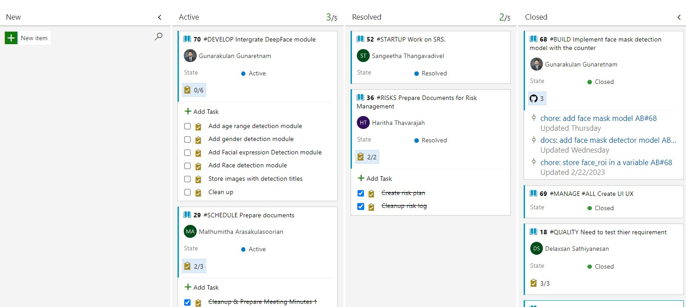

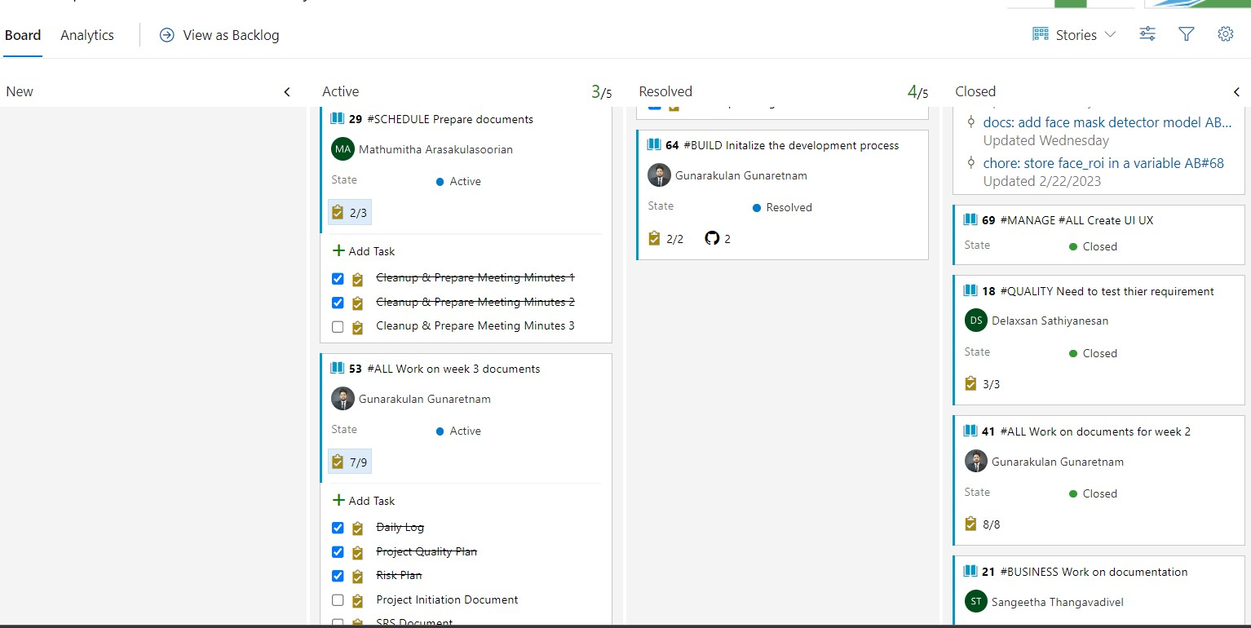

#### 6.2.2 Source Management State

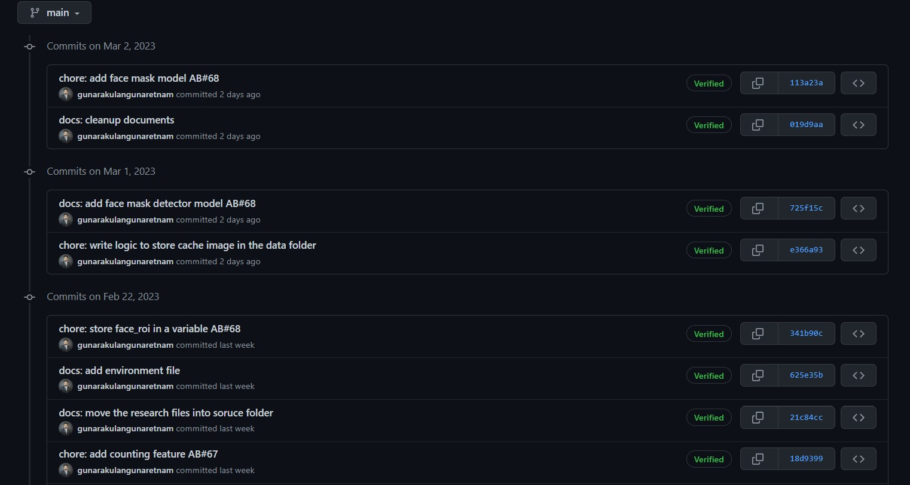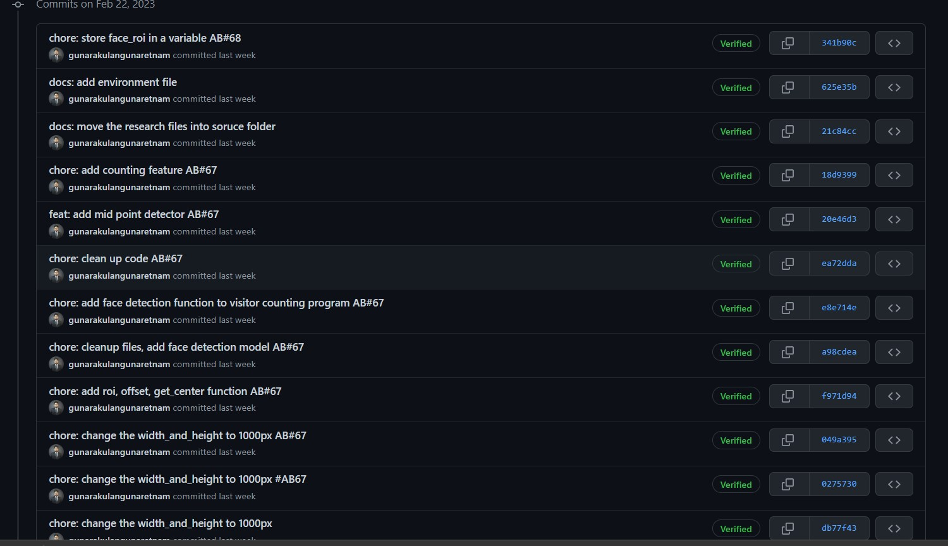

## 7 Problems and Risk Update

* Technical Risks - Technical issues may arise during development, which could delay the project schedule or increase costs. For example, integrating different software components may require more time and resources than anticipated.
* Resource Risks - The project team may face constraints such as lack of access to necessary equipment or tools, lack of skilled resources, or team members leaving the project unexpectedly.
* Scope Creep - Stakeholders may request changes to the project scope or requirements, which could impact the project schedule, budget, and quality.
* Budget Risk - Budget estimates may need more accurate, or unexpected costs may arise during the project lifecycle. For example, a new hardware or software component may be required, not included in the original budget.
* Communication Risks - Inadequate communication or unclear expectations between project team members, stakeholders, and customers could lead to misunderstandings, delays, and rework.
* Data Security Risks - As the project involves sensitive data, there is a risk of data breaches or unauthorized access to the system, which could impact the project's reputation and customer confidence.
* Integration Risks - Integration of various components may present challenges that could cause delays, rework, and additional costs. For example, integration of a new payment gateway or logistics module.

## 8 Products to be Completed.

* Build age range detection module
* Build gender detection module
* Build emotion detection module
* Build race detection module
* Build audio analyser module
* Build backend panel
  + Dashboard
  + Vision data analysis panel
  + Audio data analysis panel
  + Settings.

### 8.1 Pending UI Components to be completed.

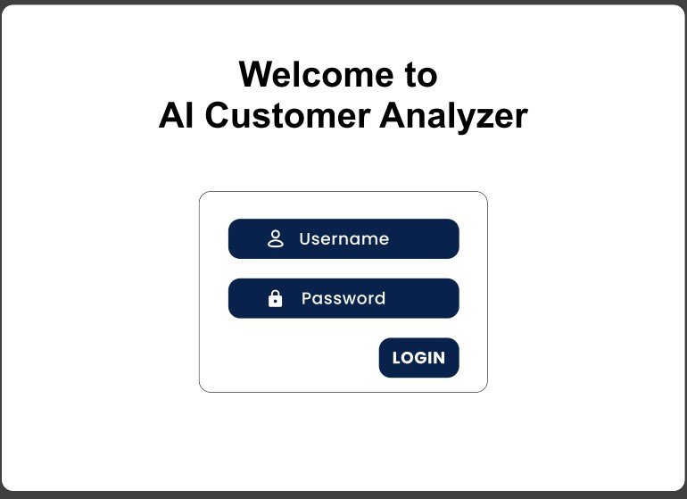

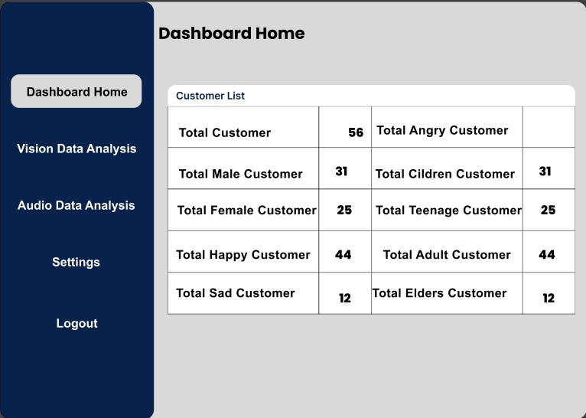

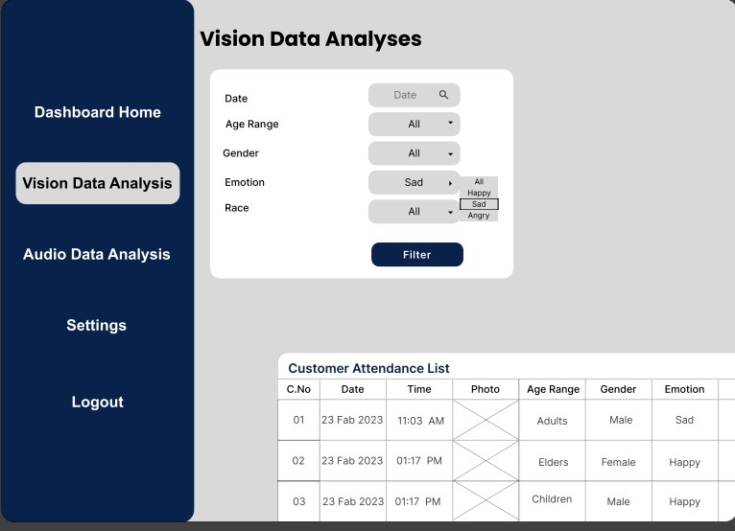

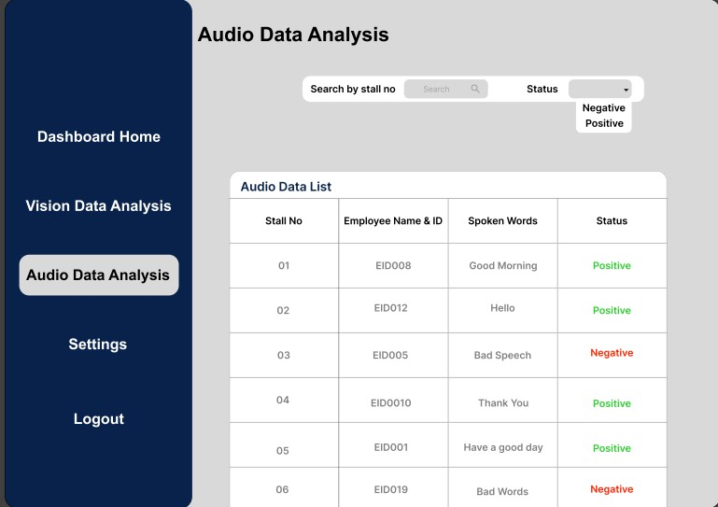

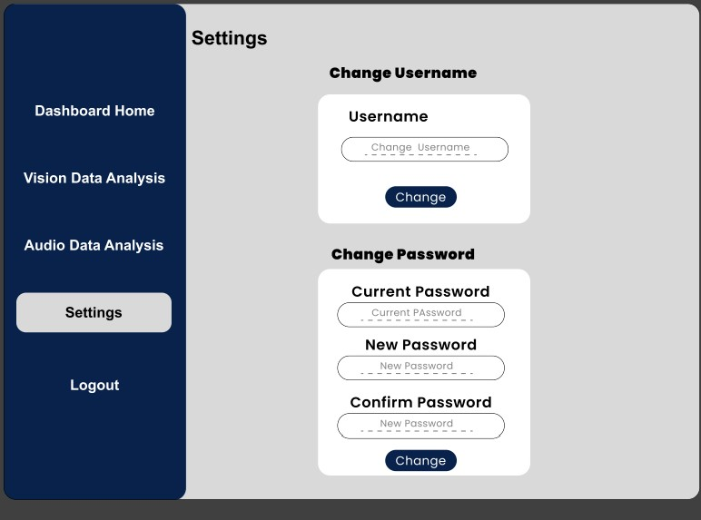

## 9 Project Issue Status

|  |  |  |  |
| --- | --- | --- | --- |
| **Action ID** | **Action** | **Responsible Individual** | **Status** |
| 1 | Organise a team meeting to discuss finding a client. | Startup Manager | Resolved |
| 2 | Organise a client meeting to initiate the project. | Schedule manager | Resolved |
| 3 | Organise a client meeting to gather requirements. | Startup Manager | Resolved |
| 4 | Organise a board meeting to discuss the project scope. | Startup Manager | Resolved |
| 5 | Identify the system architecture according to client requirements. | Project manager | Resolved |
| 6 | Identify issues in the use case diagram. | Risk manager | Resolved |
| 7 | Organise a team meeting to identify issues in PID. | Project manager | Resolved |
| 8 | Organise a team meeting to confirm the designs. | Schedule Manager | Resolved |
| 9 | Identify the issues in the designs. | Quality manager | Resolved |
| 10 | Organise a client meeting to take client approval for designs. | Startup manager | Resolved |
| 11 | Organise a team meeting to discuss issues in SRS. | Startup manager | Resolved |
| 12 | Updating the risk log by identifying upcoming risks. | Risk manager | Resolved |

## 10 Budget/Schedule Impact

* PV (Planned Value) = 500,000 LKR (Total planned budget for the project)
* EV (Earned Value) = 400,000 LKR (Value of the work completed so far, as per project plan)
* AC (Actual Cost) = 450,000 LKR (Total actual cost incurred to date)
* BAC (Budget at Completion) = 500,000 LKR (Total budget allocated for the project)
* CV (Cost Variance) = EV - AC = 400,000 - 450,000 = -50,000 LKR (Negative value means cost overrun)
* CPI (Cost Performance Index) = EV / AC = 400,000 / 450,000 = 0.89 (Less than 1.0 means cost overruns)
* SPI (Schedule Performance Index) = EV / PV = 400,000 / 500,000 = 0.8 (Less than 1.0 means behind schedule)