Task 1:

* **Use Sqoop tool to export data present in SQOOPOUT folder made while demo of Import table**

Export data from hdfs to mysql:

-- 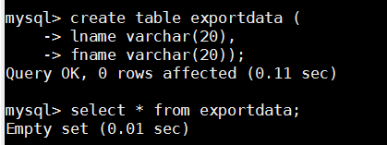



sqoop export --connect jdbc:mysql://localhost/simplidb --username root -password Root@123 --table exportdata --export-dir /sqoopout1/part-m-00000



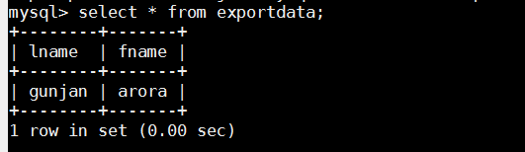

Task 2:

**Use Sqoop tool to export data present in SQOOPOUT folder made while demo of Import table**

**with parameter person_id =3.**

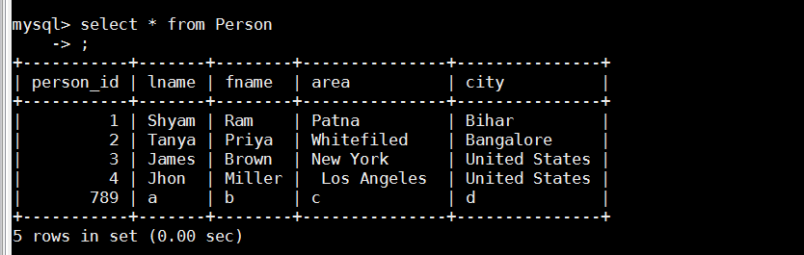

sqoop import --connect jdbc:mysql://localhost/simplidb --table Person --username root -P --target-dir /sqoopoutbyidbyrows -m 1 --where "Person_id = '3'"



