Cricket Match Winner in IPL

A PROJECT REPORT

Submitted by

Gunasekhar Ravilla
16MIS1175

in partial fulfillment for the award of the degree of

Master of Technology

in

Software Engineering (5 Year Integrated Programme)



School of Computer Science and Engineering

Vellore Institute of Technology

Vandalur - Kelambakkam Road, Chennai - 600 127

November - 2020



School of Computer Science and Engineering

DECLARATION

I hereby declare that the project entitled Cricket Match Winner in IPL submitted by me to the School of Computer Science and Engineering, Vellore Institute of Technology, Chennai, 600 127, in partial fulfillment of the requirements of the award of the degree of Master of Technology in Software Engineering (5 year Integrated Programme) and as part of SWE3004 – Software Design and Development Project is a bona-fide record of the work carried out by me under the supervision of Prof. Dr S Maheswari. I further declare that the work reported in this project, has not been submitted and will not be submitted, either in part or in full, for the award of any other degree or diploma of this institute or of any other institute or University.

Place: Chennai

Date:23-10-2020

Gunasekhar Ravilla
Signature of Candidate

School of Computer Science and Engineering

CERTIFICATE

This is to certify that the report entitled Cricket Match Winner in IPL is prepared and submitted by Gunasekhar Ravilla (Reg. No. 16MIS1175) to Vellore Institute of Technology, Chennai, in partial fulfillment of the requirement for the award of the degree of Master of Technology in Software Engineering (5-year Integrated Program) and as part of SWE3004 – Software Design and Development Project is a bona-fide record carried out under my guidance. The project fulfills the requirements as per the regulations of this University and in my opinion meets the necessary standards for submission.

Guide/Supervisor HoD

Name: Dr. S Maheswari Name: Dr. Asnath Victy Phamila Y

Date:23-10-2020 Date:

Examiner Examiner

Name: Name:

Date: Date:

(Seal of SCOPE)

iii

Acknowledgement

I obliged to give my appreciation to a number of people without whom I could not have completed this thesis successfully.

I would like to place on record my deep sense of gratitude and thanks to my internal guide Prof. Dr S Maheswari, School of Computer Science and Engineering (SCOPE), Vellore Institute of Technology, Chennai, whose esteemed support and immense guidance encour-aged me to complete the project successfully.

I would like to thank our HoD Dr. Asnath Victy Phamila Y, School of Computer Science and Engineering (SCOPE) and Project Coordinator Dr. C. Sweetlin Hemalatha, Vellore Institute of Technology, Chennai, for their valuable support and encouragement to take up and complete this thesis.

Special mention to our Dean Dr. Jagadeesh Kannan R, Associate Dean Dr. S. Geetha, School of Computer Science and Engineering (SCOPE), Vellore Institute of Technology, Chennai, for motivating us in every aspect of software engineering.

I thank our management of Vellore Institute of Technology, Chennai, for permitting me to use the library and laboratory resources. I also thank all the faculty members for giving me the courage and the strength that I needed to complete my goal. This acknowledgment would be incomplete without expressing the whole hearted thanks to my family and friends who motivated me during the course of my work.

Gunasekhar Ravilla

16MIS1175

School of Computer Science and Engineering, Vellore Institute of Technology, Chennai

Cricket Match Winner in IPL iv

Abstract

Cricket, particularly in the T20 formats, has most extreme vulnerability, where a single over can totally change the force of the game. With a large number of individuals following the Indian Premier League (IPL) building up a model for foreseeing the result of its matches is a genuine issue. A cricket coordinate relies on different elements, and in this work, the components which altogether impact the result of a T20 cricket matches are recognized. Every players execution in the the field is considered to discover the total weight (relative quality) of the playing11. A multivariate regression-based arrangement is proposed to compute points for every player in the IPL and a total load of playing 11 is processed dependent on the previous performance of the players who have shown up most for the group. At long last, a dataset is displayed depending on the distinguished seven variables that impact the result of an IPL match. A match's fate is decided by the teams that are participating, the venue, the city, number of wickets, runs etc. It also depends on the toss, the team who wins the toss and the decision to bat or field, is also crucial. These insights can be drawn by applying machine learning to our data. Machine Learning is affecting our day to day lives, in a rapid and unimaginable way. Thanks to the field of artificial intelligence, that made it possible for the common man to predict things, which were always left on God or destiny.

School of Computer Science and Engineering, Vellore Institute of Technology, Chennai

Cricket Match Winner in IPL v

Contents

 | Declaration |  |  |  | i
 | Certificate |  |  |  | ii
 | Acknowledgement |  |  |  | iii
 | Abstract |  |  |  | iv
1 | Introduction |  |  |  | 1
 | 1.1 | Background . . . . . . . . . . . . . . . . . . . . . . . . . . .. . |  |  | 1
 | 1.2 | Statement . . . . . . . . . . . . . . . . . . . . . . . . . . . . . . |  |  | 2
 | 1.3 | Motivation . . . . . . . . . . . . . . . . . . . . . . . . . . . . . . |  |  | 2
 | 1.4 | Challenges . . . . . . . . . . . . . . . . . . . . . . . . . . . . . . |  |  | 2
2 Planning & Requirements Specification |  |  |  |  | 2
 | 2.1 | System Planning . . . . . . . . . . . . . . . . . . . . . . . .. . |  |  | 3
 | 2.2 | Requirements . . . . . . . . . . . . . . . . . . . . . . . . . . .. |  |  | 3
 |  | 2.2.1 |  | User requirements . . . . . . . . . . . . . . . . . . . . . | 3
 |  | 2.2.2 |  | Non-Functional requirements . . . . . . . . . . . . . . . | 3
 | 2.3 | System Requirements . . . . . . . . . . . . . . . . . . . . . . . . |  |  | 4
 |  | 2.3.1 |  | Hardware Requirements . . . . . . . . . . . . . . . . . . | 4
 |  | 2.3.2 |  | Software Requirements . . . . . . . . . . . . . . . . . .. | 4
3 | System Design |  |  |  | 5
4 | Implementation of System |  |  |  | 7
5 | Results & Discussion |  |  |  | 9
 |  |  |  |  | 15
6 | Conclusion and Future Work
 |  |  |  |  | 16
 | References
 | Appendix <Sample code, snapshot etc.>

School of Computer Science and Engineering, Vellore Institute of Technology, Chennai

Cricket Match Winner in IPL viii

List of Tables
1.1 HARDWARE REQUIREMENTS | 4
1.2 SOFTWARE REQUIREMENTS | 4

School of Computer Science and Engineering, Vellore Institute of Technology, Chennai

Cricket Match Winner in IPL ix

List of Figures

3.1 Architecture Diagram
3.2 Sequence Diagram
3.3 Class Diagram
3.4 Use case Diagram

- Introduction
After football, cricket is generally cherished and viewed by numerous people in the world however in India cricket is the most cherished game. In previous years, loads of research papers are distributed and bunches of work is done which predicts the winner of a cricket match by utilizing the variables that influence the match result what's more, they are utilizing supervised machine learning algorithms to anticipate the result of the match like Linear regression, uphold vector machines, decision tree, logistic regression, Random forest, Bayes network. Cricket is one of the most popular games in the world. Particularly the T20 format is mainstream as it is a relentless type of the game that pulls in the audience at the ground and the viewer at home. The Indian Premier League (IPL) is an expert T20 cricket league that is administered by the Board of Control for Cricket in India (BCCI). The Indian Premier League is conducted each year and each team in it represents a certain city in India. Different regular variables influence the game, the promotion has given by the media, and an enormous market like dream 11. The guidelines of the game, the aptitude of the players, their structure, and different other regular elements are significant in the expectation exactness of the aftereffect of a cricket coordinate. As innovation is developing and the applications like dream11 and betting sites are getting well known the people going to utilize the forecasts given by the AI model. The utilization of AI makes life simpler in numerous aspects.

  - Background
Endeavors towards result forecast. Kampakis and Thomas proposed an AI model that predicts the 20 over province cricket cup. Main purpose behind his work was to support the betting business by utilizing multi step approach. Creators took the dataset from chronicle accessible at cricinfo.com for the season 2009 to 2014 and determined extra highlights like strike rate for foreseeing results. They applied four classifiers to be specific Naïve Bayes, Strategic Regression, Gradient Boosted Decision Trees and Irregular Forests and assessed the advantages of host group and away group characterized a forecast model by means of subsection of match factors with grouping and relapse calculations that assesses notable Cricket match-up data and the on-the-spot states of a match to figure movement of game and the last result of One Day International game. To follow the movement, Edge strategy and discretionary property choice are utilized to anticipate the runs scored inside the innings and zeroed in on Achievement Reaching Ability (MRA) which is the total of the apparent multitude of characteristics of batsmen that comprises of opening batsmen, middle order, wicket-guardian, all-rounders, what's more, tail-enders.
  - Statement
Our report has a sole goal to observe the radiating impact of the Internet Sports betting on worldwide premise, and how the variables (age limitation, inappropriate bookmakers, secluded exchanges among individuals) are being inspected and affected by particular clients. Bookmakers with terrible client service influences the entire structure of the framework and contribution of cash at first is an awful methodology. These teamed up issues which emerge in wagering measure usually makes danger in the public eye and are against a portion of the laws furthermore, other legitimate norms. Utilizing some safe methodology in exchange measures, without losing our minds on execution accuracy models utilizing some animal power assessment of all certain and negative perspectives, we can present a protected, secure and viable internet betting framework with varieties of expansions.

  - Motivation
the primary motivation behind this project will be helpful to people in making a safe bet. This project will be interesting for the biggest IPL fans and people who always wish to guess the results of matches.

  - Challenges
Based on the players performance also match results will depend but analyze the players performance want more data from the previous match like no of balls faced, no of boundaries, strike rate, which type of bowling they are hitting more, which type of balls they are hitting (yorker, length, shot balls etc.,)

- Planning & Requirements Specification

  - Planning
Requirements Specifications are the first step in system planning. Here by using the previous research papers based on the smart irrigation systems, we should collect the requirements needed for this system. Information gathering Techniques such as Questionaries are used to gather information required for the system.
- What is IPL?
- How to secure data from Manipulators
- What are Required Components for project?
- What is the cost Estimation?
- Which age group is going to use our system?
- How to extract data from storage?
- How to send data from one place to another?
- How to visualize the data?
- How to publish the system?
- Which software is required for coding the system?
These are some questions which helped in gathering the requirements for the system. The next step is a feasibility study of the system. To check if the system is economically feasible to spend money on the system. Here we are using opensource technologies to build the system, so it economically feasible to build the system. To check if the system is technically feasible to run the system on present technologies. Using Machine learning helps the system to run on various languages and frameworks, so it is very much feasible technically. To check the Operational feasibility, whether the system works as per given conditions. We can see live operations in the field area and check the system architecture is working properly. Identify the risk of the system.

  - Requirements
    - User Requirements
- Predict The match Result.
- Update The latest match data.
- Release the system in online.

    - Non-Functional Requirements
- Availability: The system should be available to the user 24/7
- Security: Data should be private and only visible to the user.
- Reliability: User should be able to handle the system
- Accuracy & Performance
- Transparency.
- Security & Privacy
  - System Requirements
2.3.1 Hardware Requirements

Processor | I3/Intel Processor
RAM | 4GB (min)
Hard Disk | 160GB
Key Board | Standard Windows Keyboard
Mouse | Two or Three Button Mouse

2.3.2 Software Requirements

Operating System | Windows 10
Server-side Script | Python
IDE | Google colab or Jupyter Notebook

3.System Design
3.1ARCHITECTURE DIAGRAM

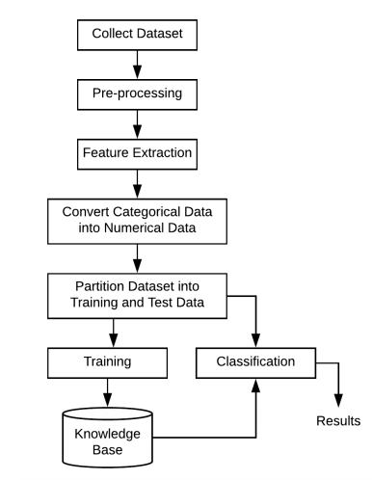
UML Diagrams
3.2 Sequence Diagram
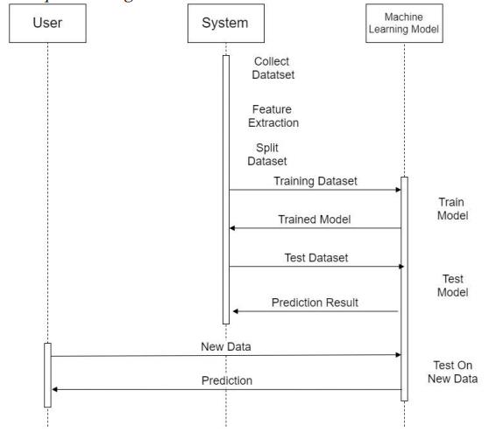
3.3 Class Diagram
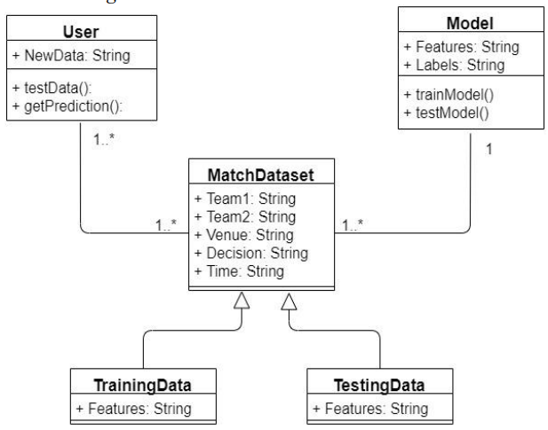
  - Use case Diagram
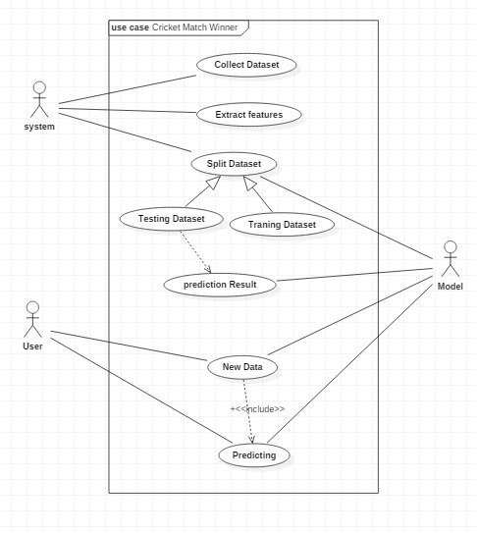

- Implementation of System
The model comprises 4 fundamental stages-Data Preprocessing, Data Cleansing, Data Preparation, Encoding the information. At first, the 10 IPL seasons' continuous dataset is taken in CSV format. In the information preprocessing stage, the information is fragmented, uproarious, and conflicting. Information is to be loaded up with missing qualities and right the irregularities. In the information purifying stage, information approval is finished by keeping up consistency over the dataset, and an information upgrade is finished by adding related data to the dataset. The information arrangement is huge for accomplishing ideal outcomes. This includes picking a result measure to assess diverse indicator factors. In the information Encoding stage, mark each term with short names and encode them as mathematical qualities for prescient displaying as actualized beneath.

matches. replace (['MumbaiIndians','KolkataKnightRiders','RoyalChallengersBangalore','DeccanChargers','Chennai
SuperKings','RajasthanRoyals','DelhiDaredevils','GujaratLions','KingsXIPunjab','SunrisersHyderabad','RisingPuneSup
ergiant','KochiTuskersKerala','PuneWarriors'], ['MI','KKR','RCB','DC','CSK','RR','DD','GL','KXIP','SRH','RPS','KTK',
PW’], inplace=True)
encode= {
'team1’: {'MI':1,'KKR':2,'RCB':3,'DC':4,'CSK':5,'RR':6,'DD':7,'GL':8,'KXIP':9,'SRH':10,'RPS':11,'KTK':12,'PW': 13},
'team2’: {'MI':1,'KKR':2,'RCB':3,'DC':4,'CSK':5,'RR':6,'DD':7,'GL':8,'KXIP':9,'SRH':10,'RPS':11,'KTK':12,'PW':13}
,
'toss_winner’: {'MI':1,'KKR':2,'RCB':3,'DC':4,'CSK':5,'RR':6,'DD':7,'GL':8,'KXIP':9,'SRH':10,'RPS':11,'KTK':12,'P
W':13},
'winner’: {'MI':1,'KKR':2,'RCB':3,'DC':4,'CSK':5,'RR':6,'DD':7,'GL':8,'KXIP':9,'SRH':10,'RPS':11,'KTK':12,'PW':13,
'Draw': 14}}
The test dataset is taken as input to the learning algorithm, evaluates different scenarios like toss winner, toss
decision and team winner. Thus, new data is obtained with final prediction

The scikit-learn LabelEncoder is a python library that converts categorical variables to numeric variables and a
prescient model is made utilizing a nonexclusive capacity called class model that takes boundaries model (calculation), information, indicators information, and result in the unsurprising element. Distinctive multi-arrangement calculations, for example, Logistic
Regression, Decision Tree, and Random Forest are implemented to predict the accuracy and cross-validation score. Out of these classification algorithms, the Random Forest algorithm is proved to be the best accurate
classifier.
Import models from scikit learn module:
from sklearn. linear model import LogisticRegression
from sklearn. cross validation import KFold #For K-fold cross-validation from sklearn.ensemble import
RandomForestClassifier
from sklearn.tree import DecisionTreeClassifier

def classification_model (model, data, predictors, outcome): model.fit(data[predictors], data[outcome])
predictions = model.predict(data[predictors])
accuracy = metrics.accuracy_score(predictions,data[outcome])
print('Accuracy : %s' % '{0:.3%}'.format(accuracy))
kf = KFold(data.shape[0], n_folds=5)
error = []
for train, test in kf:
train_predictors = (data[predictors].iloc[train,:])
train_target = data[outcome].iloc[train]
model.fit(train_predictors, train_target)
error.append(model.score(data[predictors].iloc[test,:], data[outcome].iloc[test]))
print('Cross-Validation Score : %s' % '{0:.3%}'.format(np.mean(error)))
model.fit(data[predictors],data[outcome])

Result and Discussion

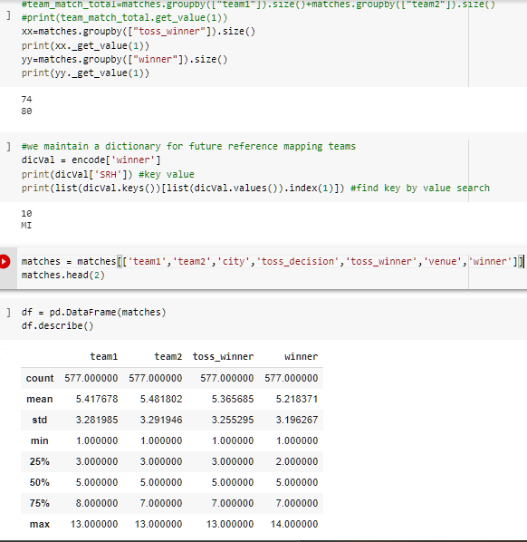
Fig.1.Probability of toss winning- ‘head’

Discussion: This screenshot takes the different fields i.e., team1, team2, city, toss_decision, toss_winner, venue, winner and predicts the winner based on the toss_winner.

Random Forest Accuracy
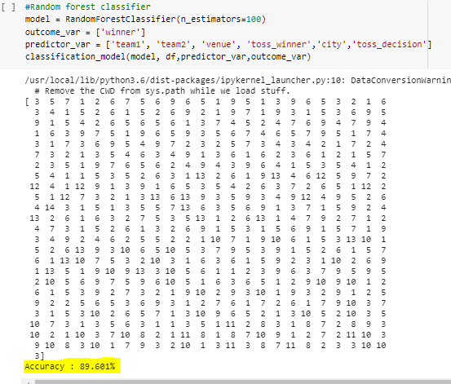
Fig. 2 Random Forest Accuracy

Discussion: This screenshot shows the 89.06% accuracy of Random Forest Classifier algorithm by using a generic function classification model.

KNN Algorithm
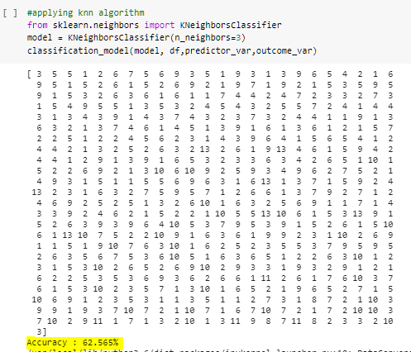
Fig. 3 KNN Algorithm Accuracy

Discussion: This screenshot shows the 89.06% accuracy of KNN algorithm with N = 3.

Gradient boost Algorithm

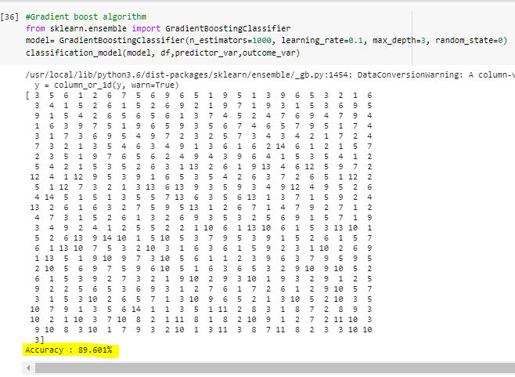

Fig. 4 Gradient Boost Algorithm Accuracy

Discussion: This screenshot shows the 89.601% Gradient boost Algorithm accuracy with n_estimators=1000, learning_rate=0.1, max_depth=3, random_state=0

Testing Data Accuracy

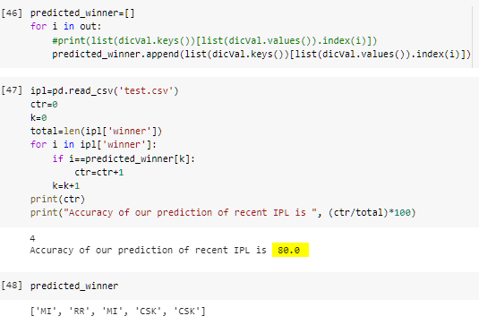

Fig. 5 Prediction result of Test Data

Discussion: This screenshot shows the 80% Accuracy when tested with new set of data of 5 matches

Feature Importance

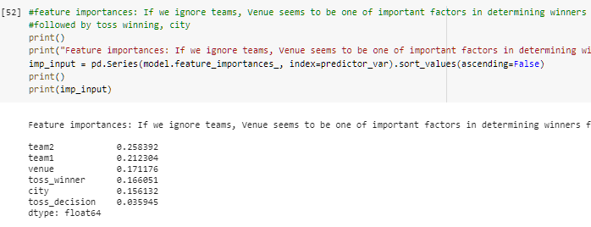

Fig. 6 importance of different features in Matches

Discussion: If we ignore teams, Venue seems to be one of important factors in determining winners followed by toss winning and venue

Visualizations
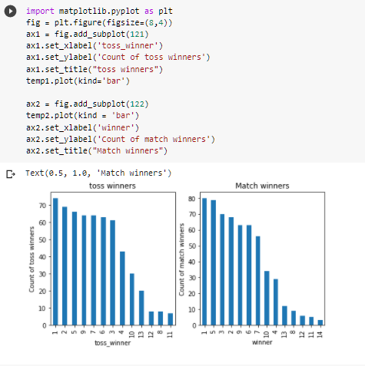

Fig. 7 Visualizations

Discussion: This screenshot is a histogram that shows two different visualizations. First is toss winners and count of toss winners. Second is probability of match winning by winning toss.
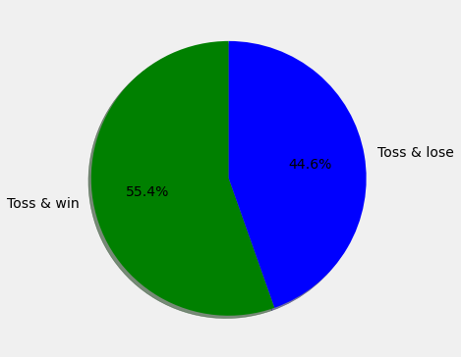

Fig. 8 probability of match winning by winning toss for MI
Discussion: Toss winning does not guarantee a match win from analysis of current stats and thus prediction feature gives less weightage to that
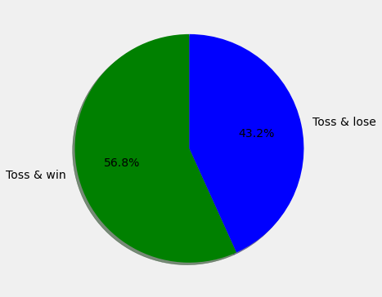

Fig. 9 probability of match winning by winning toss for csk

Discussion: Toss winning does not guarantee a match win from analysis of current stats and thus prediction feature gives less weightage to that
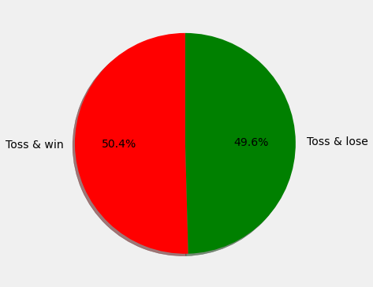

Fig. 10 generalized probability for winning match by winning toss

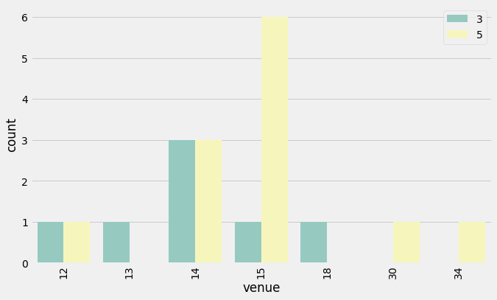
Fig. 11 Proves venue is important feature in predictability

Discussion: Top 2 team analysis based on number of matches won against each other and how venue affects them. Previously we noticed that CSK won 79, RCB won 70 matches. now let us compare venue against a match between CSK and RCB.we find that CSK has won most matches against RCB in MA Chidambaram Stadium, Chepauk, Chennai. RCB has not won any match with CSK in stadiums St George's Park and Wankhede Stadium, but won matches with CSK in Kingsmead, New Wanderers Stadium. It does prove that chances of CSK winning are more in Chepauk stadium when played against RCB.Proves venue is important feature in predictability

Conclusion and future work

Determination of the best playing for a cricket match assumes a noteworthy part for the team victory. The fundamental objective of this paper is to Analyze the IPL cricket information and foresee the players' performance. Here, three characterization calculations are utilized and contrasted with locating the best precise calculation. The usage devices utilized are Anaconda pilot and Jupyter. Arbitrary Forest is seen to be the best precise classifier with 89.15% to foresee the best player execution. This information will be utilized in the future to anticipate the triumphant teams for the following arrangement IPL matches. Consequently, utilizing this forecast, as well as can be expected to be shaped.

References:

[1] Sankaranarayanan, Vignesh Veppur, Junaed Sattar, and LaksVS Lakshmanan.” Auto-play: A Data Mining Approach to ODI Cricket Simulation and Prediction.” SDM. 2014

[2] Rabindra Lamsal and Ayesha Choudhary, “Predicting Outcome of Indian Premier League (IPL) Matches Using Machine Learning”, arXiv:1809.09813 [stat.AP] (September 2018)
[3] Muhammad Yasir, LI CHEN, Sabir Ali Shah, Khalid Akbar, M. Umer Sarwar, “Ongoing Match Prediction in T20 International”, International Journal of Computer Science and Network Security, Volume: 17 Number: 11 (November
2017
[4] R. P. Schumaker, O. K. Solieman and H. Chen, "Predictive Modeling for Sports and Gaming” in Sports Data Mining, vol. 26, Boston, Massachusetts: Springer, 2010.
[5] Rameshwari Lokhande and P.M. Chawan, “Live Cricket Score and Winning Prediction”, International Journal of Trend in Research and Development, Volume 5(1), ISSN: 2394-9333.
[6] T. Chen, T. He, M. Benesty, V. Khotilovich, and Y. Tang, “Xgboost: extreme gradient boosting,” R package version 0.4-2, pp. 1–4, 2015.
[7] D. Parker, P. Burns, Natarajan, H. Player,” valuations in the Indian Premier League”, Frontier Economics, October, 2008, 1-17.

[8] S. Singh,” Measuring the Performance of Teams in the Indian Premier League”, American Journal of Operations Research, 2011, vol 1, No 3, pp 180-184.

