As when the application starts, the following folders will be automatically created (if not already exist) under the root directory.

Refer root directory information \resources\appenv.properties

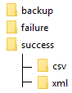

* **backup**: Will have a copy of the original file after the process is completed.
* **failure**: Will have duplicate transaction id details along with the customer info.
* **success**: Will have sub folders (csv and xml) which will have the successful transacted customer records
  + **CSV** : successfully processed transaction ID(s) will have its entries in its corresponding .csv file(s).
  + **XML**: successfully processed transaction ID(s) will have its entries in its corresponding .xml file(s).

Once the relevant folders are created, place the **records.csv** in the root directory.

Hence the root directory will have files like this

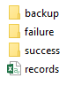

Access the following url to process the statement and generate the reports.

**http://localhost:8484/statement/process**

**UC1: Expected file (reports.csv) not found** (If you forgot to place the records.csv file under root, you can expect the following output)

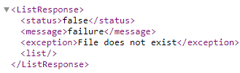

**UC2: Expected (reports.csv) file found and has no issues with reports.csv**

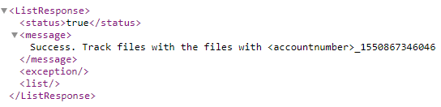

**Note**: Time Stamp is appended to track the files that are created during that request.

* Backup folder will have a file



* Failure Folder will have file, but since the use case is successful flow, this file will have empty content.



* CSV Folder will have following files

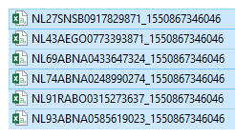

Sample `csv would look like the following screenshot

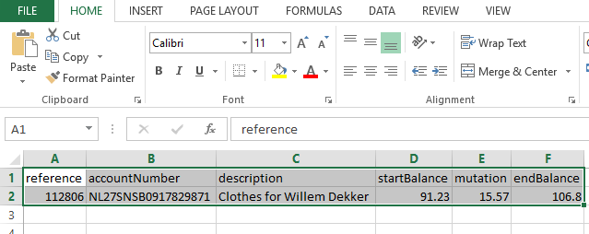

* XML Folder will have following files

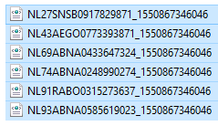

Sample XML would look like the following screenshot

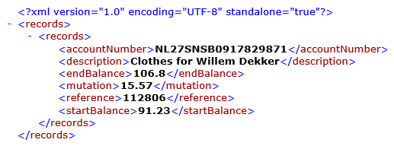

**UC3: Duplicate entry found** (you can expect the following output)

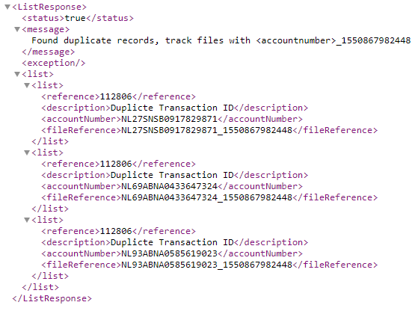

Here, the Failure folder will have csv file created and the content will have the details of the duplicate entries

