Project Report
PADS — Parkinson's Disease Smartwatch
Introduction
This project analyzes the PADS (Parkinson's Disease Smartwatch) dataset, which contains smartwatch sensor data used to study tremor patterns in patients with Parkinson's disease. Parkinson's disease is a neurological disorder that affects movement, causing tremors, stiffness, and coordination difficulties. Wearable sensors such as accelerometers and gyroscopes enable continuous monitoring of these movement patterns.
The dataset includes patient demographics, non-motor symptom questionnaire responses, and motion sensor signals. The objective of this project was to transform the raw dataset into a clean analytical dataset for visualization and analysis. Python was used to extract raw JSON files, and PostgreSQL was used to clean and structure the data. The final dataset integrates demographic information, symptom scores, and sensor features such as RMS, frequency, and amplitude to support tremor analysis.
1.Dataset Description
The PADS dataset contains three primary components:
- Demographics Data – patient characteristics such as age, gender, height, weight, handedness, and family history.
- Questionnaire Responses – patient responses to Non-Motor Symptoms (NMS) questionnaires capturing sleep, fatigue, cognitive, emotional, and lifestyle indicators.
- Movement Sensor Data – smartwatch motion sensor recordings measuring tremor activity.
Important variables derived from the movement dataset include:
- RMS – Root Mean Square of sensor signals representing tremor intensity
- Standard Deviation – signal variability
- Frequency – dominant tremor frequency
- Amplitude – average magnitude of movement signal
- Tremor Rating – categorical classification of tremor severity
Together, these variables enable integrated analysis of motor and non-motor Parkinson's disease symptoms.

Preprocessing
Preprocessing was necessary to convert the raw PADS dataset into a structured and reliable format for analysis. The raw data contained multiple JSON files, inconsistent formats, and missing values that required cleaning and standardization. Data preprocessing also helped restructure the sensor data into an analytical format and create derived features such as tremor ratings.
2.Data Extraction
The original smartwatch sensor dataset was stored in JSON format inside patient folders. Python scripts were used to automatically extract and consolidate the sensor information.
The extraction process involved:
- Reading all patient folders from the dataset directory
- Loading JSON files containing sensor recordings
- Extracting accelerometer and gyroscope features
- Converting the JSON data into structured tabular format
- Exporting the combined dataset as CSV files
Three CSV files were generated from the extraction stage:
- patients.csv
- questionnaire_responses.csv
- movement_timeseries_summary.csv
These files were then imported into PostgreSQL using COPY commands for further processing and cleaning.
3.Data Transformation
After loading the extracted CSV files into PostgreSQL, transformation steps were applied to standardize and restructure the dataset.
The raw tables created were:
- Demographics_raw
- questionnaire_responses_raw
- movement_sensor_raw
These raw tables stored the extracted data exactly as generated during extraction. Transformation operations were applied to create cleaned analytical tables.
Transformation process involved:
- Text fields were standardized using TRIM() and NULLIF() functions.
- Sensor measurements were rounded to improve consistency.
- Device location values were normalized into "Left" and "Right" categories.
- Wide sensor features were converted into a long format where each row represents a single sensor axis measurement.
This transformation stage ensures that the dataset follows a structured relational format that supports efficient querying and analysis.
4.Data Cleaning
Data cleaning was performed using PostgreSQL to improve data quality and ensure reliable analysis.
Demographics Cleaning
Age, height, and weight values were validated using logical ranges. Records outside realistic medical limits were converted to NULL values. Gender values were standardized into "Male" and "Female". A Body Mass Index (BMI) variable was calculated using height and weight values.
Questionnaire Cleaning
Questionnaire text fields were standardized by removing unnecessary spaces and converting blank values into NULL values. Responses were converted into numeric values where True/Yes were mapped to 1 and False/No were mapped to 0.
Questions were grouped into clinical categories including:
- Sleep
- Fatigue
- Mobility
- Cognitive
- Anxiety
- Depression
- Pain
- Daily Activity
- Social
- Lifestyle
Category-level symptom scores were calculated for each patient.
Movement Sensor Cleaning
Sensor features from accelerometer and gyroscope signals were standardized and converted into a long format table containing: Patient_id, movement type, sensor type, axis, RMS, standard deviation, frequency, amplitude, and tremor rating.
Tremor severity was calculated using RMS thresholds to classify tremor intensity into four categories:
Rating | Category | RMS Threshold
0 | Normal | RMS < 1
1 | Mild Tremor | RMS between 1 and 3
2 | Moderate Tremor | RMS between 3 and 6
3 | Severe Tremor | RMS > 6
This classification helps categorize tremor intensity levels for further analysis of Parkinson's disease movement patterns.
5.Data Pipeline
The end-to-end data pipeline followed these sequential stages:

Raw JSON Sensor Files
Python Extraction (JSON Parsing)
CSV Files Generated
• patients.csv
• questionnaire_responses.csv
• movement_timeseries_summary.csv
PostgreSQL Database Load
SQL Transformation
• Standardize text values
• Convert numeric fields
• Normalize device location
• Restructure wide → long sensor format
SQL Data Cleaning
• Remove null / invalid values
• Calculate BMI
• Categorize NMS responses
• Compute tremor rating
Clean Analytical Tables
Demographics
nms_category
nms_response
nms_questions
movement_sensor
Schema Table
6.Database Schema
The cleaned dataset follows a relational schema that connects patient demographic information with questionnaire responses and movement sensor data.
Database Architecture (ERD)
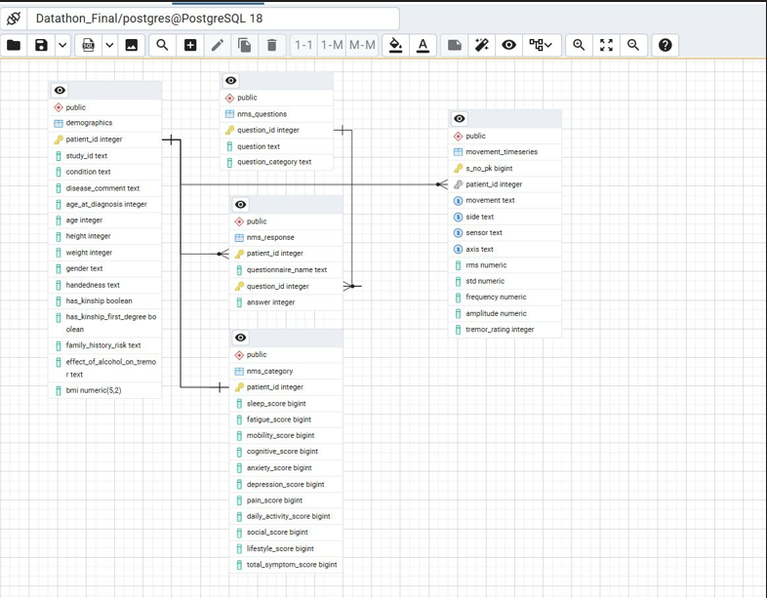
The relational schema connects patient demographic information with questionnaire responses and movement sensor data through the patient identifier, enabling integrated cross-domain analysis.
Conclusion
This project successfully transformed the raw PADS smartwatch dataset into a structured analytical dataset through systematic extraction, transformation, and cleaning processes.
Key outcomes include:
- Automated extraction of smartwatch sensor data
- Standardized relational tables in PostgreSQL
- Feature engineering of tremor metrics
- Categorization of non-motor symptoms
- Integration of demographic and time sensor data
The final dataset enables effective visualization and analysis of tremor behavior in Parkinson's disease patients and provides a foundation for advanced analytical models and monitoring systems.

