HACKUP TECHNOLOGY PVT. LTD.

AI-Powered SOC & Digital Forensics

SECURITY LOG ANALYSIS REPORT

Mini Project – Authentication Log Investigation

NAME: GUNAVATHI.J

Student Information
Field | Details
Report Type | Security Log Investigation
Project Name | Authentication Failure Analysis
Environment | Kali Linux Virtual Machine
Monitoring Area | SSH Authentication Logs

1. Project Objective
The purpose of this project is to investigate authentication logs to identify suspicious login behavior, failed SSH login attempts, attacker activity, and possible unauthorized access within the system.

2. Investigation Environment
Component | Description
Operating System | Kali Linux
Virtualization Tool | VirtualBox
Log Source | /var/log/auth.log
Service Monitored | OpenSSH
Investigation Method | Command-line log analysis

3. Log Analysis Commands


Failed Login Detection

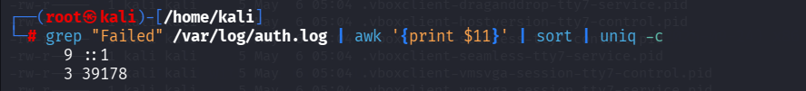
Count Total Failed Attempts

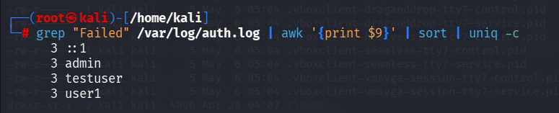
Extract Suspicious IP Address

Detect Targeted Accounts


Verify Successful SSH Access

4. Security Investigation Findings
Investigation Area | Result
Failed Login Attempts | Multiple attempts detected
Attack Pattern | Repeated SSH authentication failures
Targeted Accounts | admin, user1, testuser
Suspicious Source | localhost (::1)
Successful Login Detected | Yes
Session Created | SSH session opened successfully

5. Incident Analysis

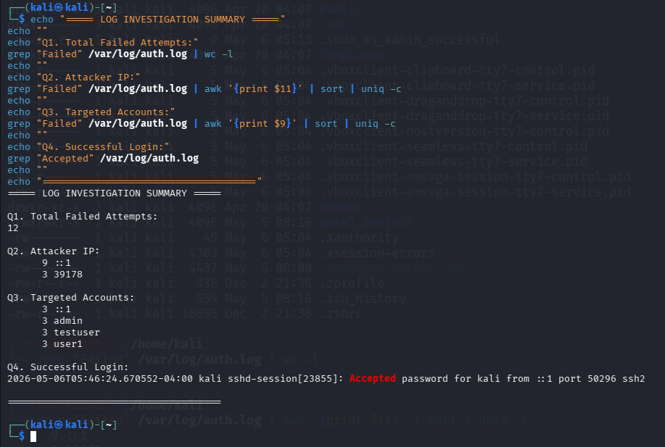

During the investigation, several failed SSH login attempts were observed within a short duration. The login attempts targeted multiple user accounts repeatedly, indicating possible brute-force behavior.
The logs later confirmed a successful authentication for the kali account, followed by an active SSH session creation.
This activity demonstrates how attackers may continuously test passwords until valid credentials are obtained.

6. Attack Timeline
Time | Activity | Risk Level
05:40 AM | Initial failed login attempt | Medium
05:41 AM | Multiple account targeting started | High
05:42 AM | Repeated SSH failures continued | High
05:46 AM | Successful login detected | Critical
05:46 AM | SSH session established | Critical

7. Security Recommendations
- Enable strong password policies.
- Configure account lockout after repeated failures.
- Install Fail2Ban for automatic IP blocking.
- Disable password-based SSH authentication.
- Use SSH key authentication for secure access.
- Monitor authentication logs regularly.
- Enable real-time SOC alerts for suspicious login activity.

8. Conclusion
The investigation successfully identified suspicious SSH authentication activity through log analysis. Multiple failed login attempts and a successful SSH login were detected using the system authentication logs.
This project demonstrates the importance of continuous monitoring, log analysis, and proactive security controls in detecting unauthorized access attempts within a network environment.

