“Smart Disk Scheduler”
A Project Report Submitted in the partial fulfillment of the requirements for the award of the degree of

BACHELOR OF TECHNOLOGY
In

DEPARTMENT OF COMPUTER SCIENCE & INFORMATION TECHNOLOGY

By

R. SAI CHARAN REDDI 2520090184

G. MANIDEEP PATEL 2520090100

P. AKHIL YADAV 2520090155

Under the Esteemed Guidance of

Raghupathi M
Assistant Professor
Department of Computer Science and Information Technology




K L (Deemed to be) University
DEPARTMENT OF COMPUTER SCIENCE & INFORMATION TECHNOLOGY
&

DEPARTMENT OF COMPUTER SCIENCE AND INFORMATION TECHNOLOGY

Declaration

The Project Report entitled “Smart Disk Scheduler” is a record of Bonafide work of R. SAI CHARAN REDDI - 2520090184, G. MANIDEEP PATEL - 2520090100, P. AKHIL YADAV - 2520090155, submitted in partial fulfillment for the award of B. Tech in Computer Science and Engineering (or) Computer Science and Information Technology to the K L University. The results embodied in this report have not been copied from any other departments/University/Institute.

R. SAI CHARAN REDDI-2520090184

G. MANIDEEP PATEL-2520090100

P. AKHIL YADAV-2520090155

K L (Deemed to be) University

DEPARTMENT OF COMPUTER SCIENCE ENGINEERING

CERTIFICATE

This is certify that the mini project based report entitled “Smart Disk Scheduler” is a bonafide work done and submitted by R. SAI CHARAN REDDI - 2520090184, G. MANIDEEP PATEL - 2520090100, P. AKHIL YADAV - 2520090155, in partial fulfillment of the requirements for the award of the degree of BACHELOR OF TECHNOLOGY in Department of Computer Science Engineering, K L (Deemed to be University), during the academic year 2025-2026.

Signature of the Guide

Signature of the Course Coordinator Signature of the HOD

ACKNOWLEDGEMENT
The success in this project would not have been possible but for the timely help and guidance rendered by many people. Our wish to express my sincere thanks to all those who has assisted us in one way or the other for the completion of my project.

Our greatest appreciation to my Course Coordinator Dr. K. Anusha, and my guide Raghupathi M , Department of Computer Science which cannot be expressed in words for his/her tremendous support, encouragement and guidance for this project.

We express our gratitude to Dr. Khaja Shareef (CSIT), Head of the Department for Computer Science & Information Technology for providing us with adequate facilities, ways and means by which we are able to complete this project-based Lab.

We thank all the members of teaching and non-teaching staff members, and also who have assisted me directly or indirectly for successful completion of this project. Finally, I sincerely thank my parents, friends and classmates for their kind help and cooperation during my work.

R. SAI CHARAN REDDI-2520090184

G. MANIDEEP PATEL-2520090100

P. AKHIL YADAV-2520090155

Abstract

The Smart Disk Scheduler is an operating systems project designed to reduce the time a disk spends moving its read/write head while serving input/output requests. In every operating system, many processes issue requests for data stored on different tracks of the disk at the same time. Serving these requests in the order in which they arrive can cause the head to travel long distances, which increases seek time and lowers disk throughput. To address this problem, our project implements the major disk-scheduling algorithms and adds a smart selection mechanism that chooses the most suitable one for the given requests.
The system is developed using Python and the Tkinter graphical user interface (GUI), with Matplotlib for drawing head-movement graphs. The scheduling engine implements FCFS, SSTF, SCAN, C-SCAN, LOOK and C-LOOK. For a given request queue, initial head position and disk size, it calculates the order of service and the total head movement of each algorithm. The smart selector then compares the results, recommends the algorithm with the least head movement, and also suggests the best starvation-free alternative so that fairness is not ignored.
The project also provides a graphical dashboard through which users can enter the request queue, choose an algorithm or use the smart mode, and observe the results. The dashboard displays the service order, total head movement, a comparison table and a head-movement graph for each algorithm. Invalid inputs, such as non-numeric values or cylinders outside the disk range, are detected and reported to the user.
This project demonstrates important operating system concepts, including disk structure, seek time, request queues, disk-scheduling policies, starvation and the trade-off between throughput and fairness. It also highlights how a simple selection strategy can be built on top of classical algorithms to give better results for different workloads. The proposed system is intended for educational and demonstration purposes and provides a foundation for developing more advanced disk-scheduling tools. Overall, the Smart Disk Scheduler aims to reduce head movement, improve disk performance and provide a simple way to understand and compare disk-scheduling algorithms.

Index

S. No. | Chapter | Topics / Subtopics | Page No.
 | Acknowledgement |  | i
 | Abstract |  | ii
1 | Introduction |  | 7
 |  | 1.1 Background of the Project
 |  | 1.2 Problem Statement
 |  | 1.3 Objectives of the Project
2 | OS Concepts and Background Study |  | 8
 |  | 2.1 Operating System Concepts Related to the Project
3 | Technologies Used |  | 9
4 | System Architecture and Design |  | 10–11
 |  | 4.1 GUI Dashboard
 |  | 4.2 Scheduling Engine
 |  | 4.3 Smart Selector
 |  | 4.4 Working Methodology
 |  | 4.5 Implementation Modules
5 | Testing and Validation |  | 12–13
 |  | 5.1 Screenshots of Test Execution
6 | Results |  | 14
7 | Limitations |  | 15
8 | Future Enhancements |  | 16
9 | Team Contributions |  | 17
10 | Conclusion |  | 18

CHAPTER -1 INTRODUCTION
1.1 Background of the Project
Disk requests from many processes arrive in a queue, and the order in which they are served decides how far the read/write head must travel. Seek time is the largest part of disk access time, so a poor service order slows down every process that waits for the disk. This project aims to reduce that cost by choosing a good scheduling order automatically.
The Smart Disk Scheduler takes a queue of cylinder requests, the current head position and the disk size as input. It runs the classical algorithms, compares their total head movement, and recommends the best one. The GUI provides a convenient way to enter requests, view the results and understand how each algorithm behaves.
1.2 Problem Statement
To develop a system that implements the common disk-scheduling algorithms, compares their head movement for a given request queue, and automatically selects the most suitable algorithm, reducing seek time and improving disk performance.
1.3 Objectives of the Project
- Accept a queue of disk requests and the initial head position.
- Implement FCFS, SSTF, SCAN, C-SCAN, LOOK and C-LOOK scheduling.
- Calculate the service order and total head movement.
- Select the best algorithm automatically (smart mode).
- Provide a graphical interface for input and results.
- Display head-movement graphs and a comparison table.
- Demonstrate operating-system disk-management concepts.

CHAPTER -2 OS CONCEPTS AND BACKGROUND STUDY
2.1 Operating System Concepts Related to the Project
- Disk structure: A disk is divided into tracks (cylinders) and sectors, and requests are addressed by cylinder number.
- Seek time: The time taken by the head to move to the requested cylinder, which is the main cost of disk access.
- Disk scheduling: The operating system decides the order in which pending I/O requests are served to reduce head movement.
- Scheduling algorithms: FCFS, SSTF, SCAN, C-SCAN, LOOK and C-LOOK follow different rules for choosing the next request.
- Starvation: SSTF can delay far-away requests indefinitely, whereas sweep-based algorithms give every request a turn.
- Request queue: The pending cylinders and the current head position together decide the total head movement.

CHAPTER -3 TECHNOLOGIES USED
- Programming language: Python
- Scheduling algorithms: FCFS, SSTF, SCAN, C-SCAN, LOOK, C-LOOK
- GUI framework: Tkinter
- Graph plotting: Matplotlib
- Operating system: Windows / Ubuntu Linux
- Development environment: Visual Studio Code
- Version control: Git and GitHub

CHAPTER -4 SYSTEM ARCHITECTURE AND DESIGN
The system consists of three main components.
4.1 GUI Dashboard
The Python Tkinter dashboard lets the user enter the request queue, initial head position and disk size, and choose an algorithm or the smart mode. It displays the service order, total head movement, a comparison table and the head-movement graph.
[ Insert screenshot here ]
Show the input fields, algorithm selection, comparison table, recommended algorithm and head-movement graph
Figure 4.1: GUI Dashboard
4.2 Scheduling Engine
The Python scheduling engine contains one function for each algorithm: FCFS, SSTF, SCAN, C-SCAN, LOOK and C-LOOK. Each function takes the request queue, head position and disk size, and returns the order in which cylinders are served together with the total head movement.
4.3 Smart Selector
The smart selector runs every algorithm on the same input and compares the total head movement. It recommends the algorithm with the least movement and also reports the best starvation-free algorithm, so that the user can balance speed against fairness.
4.4 Working Methodology
- The user opens the GUI dashboard.
- The user enters the request queue, head position and disk size.
- The GUI validates the input values.
- The scheduling engine runs all six algorithms.
- The service order and total head movement are calculated for each.
- The smart selector compares the results.
- The recommended algorithm and the best starvation-free alternative are displayed.
- The GUI draws the head-movement graph and the comparison table.
- The user can change the input and run the scheduler again.
4.5 Implementation Modules
- Scheduling engine (six algorithms)
- Smart selector
- Python GUI dashboard
- Input validation
- Head-movement graph and comparison table

CHAPTER -5 TESTING AND VALIDATION
The following tests are planned or performed to evaluate the system.
Test | Expected result
Enter requests | Queue, head position and disk size are accepted
Run all algorithms | Each algorithm gives its service order and total head movement
Check with standard example | FCFS gives 640 for queue 98, 183, 37, 122, 14, 124, 65, 67 with head at 53
Smart selection | The algorithm with the least head movement is recommended
Invalid input | Non-numeric or out-of-range requests are rejected with a message
Graph display | The head-movement graph follows the service order

5.1 Screenshots of Test Execution
[ Insert screenshot here 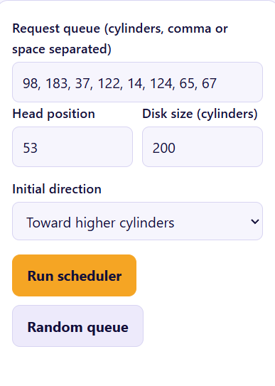
Figure 5.1: Input: request queue and head position are entered
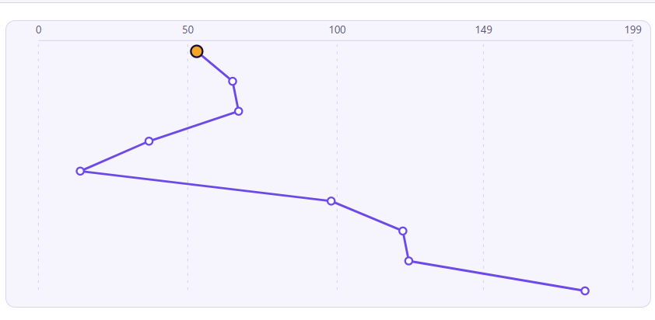f each algorithm
Figure 5.2: Execution: the service order of each algorithm is computed
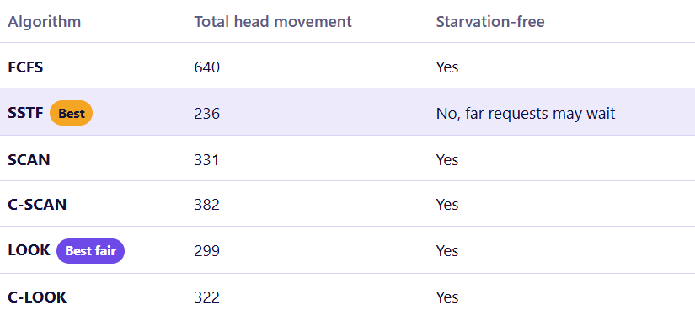
Figure 5.3: Comparison: total head movement of each algorithm
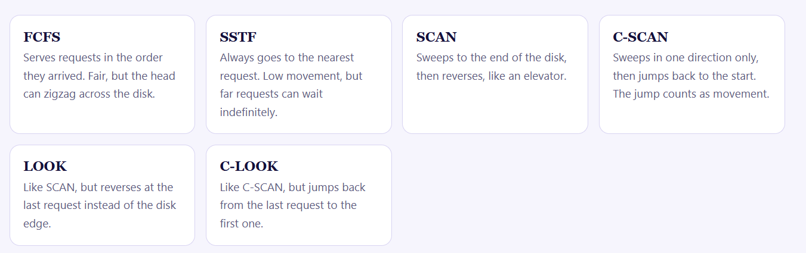
Figure 5.4: Smart selection: the best algorithm is recommended
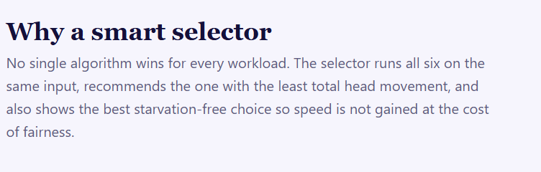
Figure 5.5: Invalid input: the error is reported to the user

CHAPTER -6 RESULTS
For the standard example (requests 98, 183, 37, 122, 14, 124, 65, 67; head at cylinder 53; disk of 200 cylinders), the total head movement is 640 for FCFS, 236 for SSTF, 331 for SCAN, 382 for C-SCAN (including the return sweep), 299 for LOOK and 322 for C-LOOK. The smart selector therefore recommends SSTF as the least-movement algorithm and LOOK as the best starvation-free alternative. The same input is used to verify the implementation during testing.
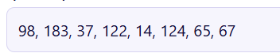
Figure 6.1: Head-movement graph of the recommended algorithm
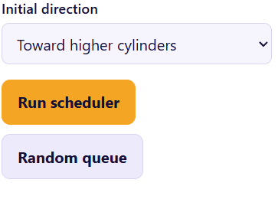
Figure 6.2: Comparison of total head movement

CHAPTER -7 LIMITATIONS
- The current version works on a static queue of requests entered by the user.
- The prototype simulates disk movement and does not control a real disk.
- Rotational latency and transfer time are not included in the calculation.
- Smart selection is based only on total head movement and a simple fairness check.

CHAPTER -8 FUTURE ENHANCEMENTS
- Accept requests dynamically while the scheduler is running.
- Include rotational latency and transfer time in the cost model.
- Add more algorithms such as N-Step SCAN and FSCAN.
- Predict the best algorithm from the workload pattern.
- Export results and graphs to files.
- Add configuration files and additional automated tests.

CHAPTER -9 TEAM CONTRIBUTIONS
- R. Sai Charan Reddi (2520090184): Scheduling engine, FCFS, SSTF, SCAN and C-SCAN algorithms, and smart selector logic.
- G. ManiDeep Patel (2520090100): LOOK and C-LOOK algorithms, GUI dashboard, input validation, and graph display.
- P. Akhil Yadav (2520090155): Test cases, result comparison, documentation, and presentation.

CHAPTER -10 CONCLUSION
The Smart Disk Scheduler demonstrates how operating-system disk-management techniques can be used to reduce seek time. By combining six classical scheduling algorithms with a smart selector and a Python GUI, the project provides a practical demonstration of request queues, head movement, starvation and the trade-off between performance and fairness.

