create or replace package pkg_department is

procedure add_department(dep_id departments.department_id%type,

dep_name departments.department_name%type,

man_id departments.manager_id%type,

loc_id departments.location_id%type);

procedure upd_department(dep_id departments.department_id%type,

dep_name departments.department_name%type);

procedure del_department(dep_id departments.department_id%type);

procedure get_department(dep_id departments.department_id%type,

dep_name out departments.department_name%type);

end pkg_department;

/

create or replace package body pkg_department is

procedure add_department

(dep_id departments.department_id%type,

dep_name departments.department_name%type,

man_id departments.manager_id%type,

loc_id departments.location_id%type)

is begin

insert into departments values (dep_id, dep_name,man_id,loc_id);

dbms_output.put_line(dep_name||' '||dep_id||' '||man_id||' '||loc_id);

end add_department;

procedure upd_department

(dep_id departments.department_id%type,

dep_name departments.department_name%type)

is begin

update departments

set department_name=dep_name

where department_id=dep_id;

dbms_output.put_line(dep_name||' '||dep_id);

end upd_department;

procedure del_department

(dep_id departments.department_id%type)

is begin

delete from departments where department_id=dep_id;

end del_department;

procedure get_department

(dep_id departments.department_id%type,

dep_name out departments.department_name%type)

is begin

select department_name into dep_name

from departments

where department_id=dep_id;

dbms_output.put_line(dep_name||' '||dep_id);

end get_department;

end pkg_department;

/

set serveroutput on

declare

dep_name departments.department_name%type;

begin

pkg_department.get_department(10,dep_name);

end;

/

begin

pkg_department.add_department(280,'Cleaning Service',200,1700);

end;

/

begin

pkg_department.upd_department(280,'Back Office');

end;

/begin

pkg_department.del_department(270);

end;

/

1. tidak terjadi error
2. akan error
3. Error
4. 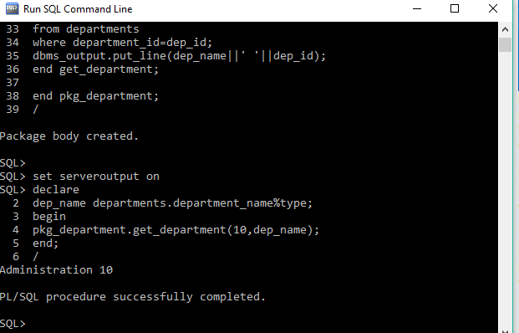error

pengamatan 3

CREATE OR REPLACE PACKAGE PKG_VOLUME IS

tinggi NUMBER := 9;

FUNCTION volume_balok(panjang NUMBER, lebar NUMBER) RETURN NUMBER;

FUNCTION volume_tabung(jari_jari NUMBER) RETURN NUMBER;

END pkg_volume;

/

CREATE OR REPLACE PACKAGE BODY PKG_VOLUME IS

FUNCTION volume_balok(panjang NUMBER, lebar NUMBER) RETURN NUMBER is volume number;

tinggi NUMBER := 9;

begin

volume:=panjang*lebar*tinggi;

return volume;

end volume_balok;

FUNCTION volume_tabung(jari_jari NUMBER) RETURN NUMBER is volume number;

tinggi NUMBER := 9;

phi number:=3.14;

begin

volume:=phi*jari_jari*jari_jari*tinggi;

return volume;

end volume_tabung;

END pkg_volume;

set serveroutput on

begin dbms_output.put_line(pkg_volume.volume_balok(5,6)); dbms_output.put_line(pkg_volume.volume_tabung(10));

end;

/

BEGIN

DBMS_OUTPUT.PUT_LINE(pkg_volume.volume_tabung.tinggi); END;

/

3. tidak bisa

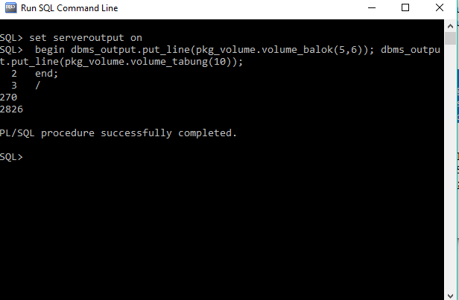

11.4 TEST AKHIR

1. Buatlah package bernama PKG_LUAS_BANGUN. Package ini berisi empat buah function

sebagai berikut:

a. Function LUAS_PERSEGI, mengembalikan luas dari persegi

b. Function LUAS_SEGITIGA, mengembalikan luas dari segitiga.

c. Function LUAS_LINGKARAN, mengembalikan luas lingkaran.

d. Function LUAS_BELAHKETUPAT, mengembalikan luas belah ketupat.

CREATE OR REPLACE PACKAGE PKG_LUAS_BANGUN IS

FUNCTION LUAS_PERSEGI (s NUMBER) RETURN NUMBER;

FUNCTION LUAS_SEGITIGA (a NUMBER, t NUMBER) RETURN NUMBER;

FUNCTION LUAS_LINGKARAN (r NUMBER) RETURN NUMBER;

FUNCTION LUAS_BELAHKETUPAT (d1 NUMBER, d2 NUMBER) RETURN NUMBER;

END PKG_LUAS_BANGUN;

/

CREATE OR REPLACE PACKAGE BODY PKG_LUAS_BANGUN IS

FUNCTION LUAS_PERSEGI (s NUMBER) RETURN NUMBER IS

BEGIN

RETURN (s*s);

END LUAS_PERSEGI;

FUNCTION LUAS_SEGITIGA (a NUMBER, t NUMBER) RETURN NUMBER IS

BEGIN

RETURN (0.5*a*t);

END LUAS_SEGITIGA;

FUNCTION LUAS_LINGKARAN (r NUMBER) RETURN NUMBER IS

phi CONSTANT NUMBER := 3.14;

BEGIN

RETURN (phi*r*r);

END LUAS_LINGKARAN;

FUNCTION LUAS_BELAHKETUPAT (d1 NUMBER, d2 NUMBER) RETURN NUMBER IS

BEGIN

RETURN ((d1*d2)/2);

END LUAS_BELAHKETUPAT;

END PKG_LUAS_BANGUN;

/

BEGIN

DBMS_OUTPUT.PUT_LINE(pkg_luas_bangun.LUAS_PERSEGI(6));

DBMS_OUTPUT.PUT_LINE(pkg_luas_bangun.LUAS_SEGITIGA(6,10));

DBMS_OUTPUT.PUT_LINE(pkg_luas_bangun.LUAS_LINGKARAN(7));

DBMS_OUTPUT.PUT_LINE(pkg_luas_bangun.LUAS_BELAHKETUPAT(8,8));

END;

/

2. Buatlah package bernama PKG_EMPJOB yang berisi procedure dan function sebagai berikut:

a. Procedure NEW_JOB, berfungsi untuk menambahkan data baru di tabel JOBS

b. Procedure UPD_JOBSAL, berfungsi untuk merubah gaji minimum dan maksimum di tabel

jobs.

c. Function GET_YEARS_SERVICE, berfungsi untuk mengembalikan lama bekerja dari seorang

pegawai.

d. Function GET_JOB_COUNT, berfungsi untuk mengembalikan jumlah job yang pernah

dijalani oleh seorang pegawai dari awal hingga saat ini (data diambil dari tabel employees

dan job_history).

CREATE OR REPLACE PACKAGE PKG_EMPJOB IS

PROCEDURE NEW_JOB (j_id jobs.job_id%type, j_title jobs.job_title%type, min_s jobs.min_salary%type, max_s jobs.max_salary%type);

PROCEDURE UPD_JOBSAL (j_id jobs.job_id%type, min_s jobs.min_salary%type, max_s jobs.max_salary%type);

FUNCTION GET_YEARS_SERVICE RETURN NUMBER;

FUNCTION GET_JOB_COUNT RETURN NUMBER;

END PKG_LUAS_BANGUN;

/

CREATE OR REPLACE PACKAGE BODY PKG_EMPJOB IS

PROCEDURE NEW_JOB (j_id jobs.job_id%type, j_title jobs.job_title%type, min_s jobs.min_salary%type, max_s jobs.max_salary%type);

BEGIN

END;

PROCEDURE UPD_JOBSAL (j_id jobs.job_id%type, min_s jobs.min_salary%type, max_s jobs.max_salary%type);

BEGIN

END;

FUNCTION GET_YEARS_SERVICE (e_id employees.employee_id%type) RETURN NUMBER IS

jml NUMBER;

BEGIN

SELECT end_date - start_date as htg INTO jml FROM job_history join employees using (employee_id);

RETURN jml;

END;

FUNCTION GET_JOB_COUNT RETURN NUMBER;

BEGIN

END;

END PKG_EMPJOB;

/