**JURNAL**

CREATE OR REPLACE PACKAGE PKG_DEPARTMENT IS

FUNCTION get_department(dep_id departments.department_id%type) RETURN departments%ROWTYPE;

FUNCTION get_department(dep_name departments.department_name%type) RETURN departments%ROWTYPE;

FUNCTION get_department(man_id departments.manager_id%type, loc_id departments.location_id%type)

RETURN departments%ROWTYPE;

FUNCTION get_department(loc_id departments.location_id%type) RETURN departments%ROWTYPE;

FUNCTION get_department(dep_id CHAR) RETURN departments%ROWTYPE;

FUNCTION get_department(dep_id departments.department_id%type) RETURN VARCHAR2;

PROCEDURE del_department(dep_id departments.department_id%type);

PROCEDURE del_department(dep_name departments.department_name%type);

PROCEDURE del_department(loc_id departments.location_id%type);

END pkg_department;

/

CREATE OR REPLACE PACKAGE BODY PKG_DEPARTMENT IS

FUNCTION get_department(dep_id departments.department_id%type) RETURN departments%ROWTYPE IS

CURSOR cur IS SELECT * FROM departments WHERE department_id = dep_id;

dep departments%ROWTYPE;

BEGIN

OPEN cur;

FETCH cur INTO dep;

CLOSE cur;

RETURN dep;

END get_department;

FUNCTION get_department(dep_name departments.department_name%type) RETURN departments%ROWTYPE IS

CURSOR cur IS SELECT * FROM departments WHERE department_name = dep_name;

dep departments%ROWTYPE;

BEGIN

OPEN cur;

FETCH cur INTO dep;

CLOSE cur;

RETURN dep;

END get_department;

FUNCTION get_department(man_id departments.manager_id%type, loc_id departments.location_id%type)

RETURN departments%ROWTYPE IS

CURSOR cur IS SELECT * FROM departments WHERE manager_id = man_id AND location_id = loc_id;

dep departments%ROWTYPE;

BEGIN

OPEN cur;

FETCH cur INTO dep;

CLOSE cur;

RETURN dep;

END get_department;

FUNCTION get_department(loc_id departments.location_id%type) RETURN departments%ROWTYPE IS

CURSOR cur IS SELECT * FROM departments WHERE location_id = loc_id;

dep departments%ROWTYPE;

BEGIN

OPEN cur;

FETCH cur INTO dep;

CLOSE cur;

RETURN dep;

END get_department;

FUNCTION get_department(dep_id CHAR) RETURN departments%ROWTYPE IS

CURSOR cur IS SELECT * FROM departments WHERE department_id = dep_id;

dep departments%ROWTYPE;

BEGIN

OPEN cur;

FETCH cur INTO dep;

CLOSE cur;

RETURN dep;

END get_department;

FUNCTION get_department(dep_id departments.department_id%type) RETURN VARCHAR2 IS

CURSOR cur IS SELECT * FROM departments WHERE department_id = dep_id;

dep departments%ROWTYPE;

x VARCHAR(50);

BEGIN

OPEN cur;

FETCH cur INTO dep;

CLOSE cur;

x := 'Query berhasil';

RETURN x;

END get_department;

PROCEDURE del_department(dep_id departments.department_id%type) IS

BEGIN

DELETE FROM Departments where department_id = dep_id;

DBMS_OUTPUT.PUT_LINE('Berhasil dihapus');

END del_department;

PROCEDURE del_department(dep_name departments.department_name%type) IS

BEGIN

DELETE FROM Departments where department_id = dep_name;

DBMS_OUTPUT.PUT_LINE('Berhasil dihapus');

END del_department;

PROCEDURE del_department(loc_id departments.location_id%type) IS

BEGIN

DELETE FROM Departments where department_id = loc_id;

DBMS_OUTPUT.PUT_LINE('Berhasil dihapus');

END del_department;

END pkg_department;

/

set serveroutput on

begin

DBMS_OUTPUT.PUT_LINE(pkg_department.get_department(205,1700).department_name);

END;

/

Pengamatan

1. Bisa, karena tidak ada yang menyimpan parameter dengan loc_id .

2. Bisa, karena tidak ada parameter yang menyimpan dep_id dengan tipe datachar.

3. Bisa, karena return yang di kembalikan berbeda.

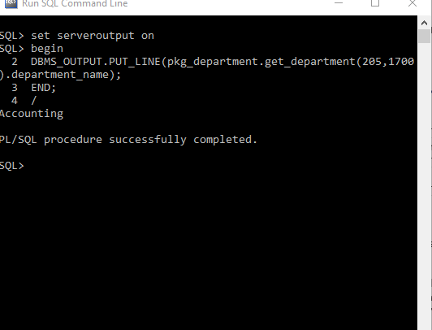

CREATE TABLE RATES

( CURRENCY VARCHAR2(10),

PERIOD DATE, RATE NUMBER,

CONSTRAINT PK_RATES PRIMARY KEY (CURRENCY, PERIOD) ENABLE

);

INSERT INTO RATES VALUES('IDR', '21-JAN-14', '12860');

CREATE OR REPLACE PACKAGE PKG_SALARY IS

kurs NUMBER:=1;

FUNCTION CONVERT(val_currency NUMBER) RETURN NUMBER;

PROCEDURE PRINT_SALARY;

END PKG_SALARY;

/

CREATE OR REPLACE PACKAGE BODY PKG_SALARY IS

FUNCTION CONVERT(val_currency NUMBER) RETURN NUMBER IS

BEGIN

RETURN(kurs*val_currency);

END CONVERT;

PROCEDURE PRINT_SALARY IS

CURSOR cur IS SELECT employee_id, first_name||' '||last_name nama, salary FROM employees;

BEGIN

DBMS_OUTPUT.PUT_LINE('DAFTAR GAJI PEGAWAI DALAM RUPIAH');

DBMS_OUTPUT.PUT_LINE('ID NAMA GAJI');

FOR i IN cur LOOP

DBMS_OUTPUT.PUT_LINE(i.employee_id||' '||i.nama||' '||CONVERT(i.salary));

END LOOP;

END PRINT_SALARY;

BEGIN

SELECT rate INTO kurs FROM rates;

END PKG_SALARY;

/

pengamatan

1. Error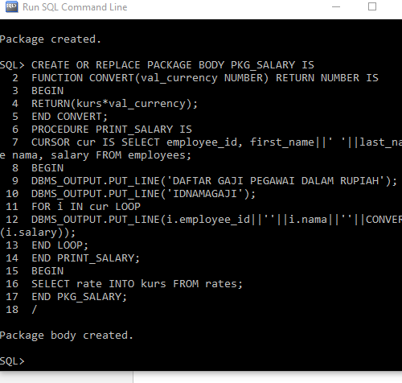

.

CREATE OR REPLACE PACKAGE PKG_SALARY IS

FUNCTION CONVERT(val_currency NUMBER) RETURN NUMBER;

PROCEDURE PRINT_SALARY;

END PKG_SALARY;

/

CREATE OR REPLACE PACKAGE BODY PKG_SALARY IS

FUNCTION CONVERT(val_currency NUMBER) RETURN NUMBER IS

kurs NUMBER:=1;

BEGIN

RETURN(kurs*val_currency);

END CONVERT;

PROCEDURE PRINT_SALARY IS

CURSOR cur IS SELECT employee_id, first_name||' '||last_name nama, salary FROM employees;

BEGIN

DBMS_OUTPUT.PUT_LINE('DAFTAR GAJI PEGAWAI DALAM RUPIAH');

DBMS_OUTPUT.PUT_LINE('ID NAMA GAJI');

FOR i IN cur LOOP

DBMS_OUTPUT.PUT_LINE(i.employee_id||' '||i.nama||' '||CONVERT(i.salary));

END LOOP;

END PRINT_SALARY;

BEGIN

SELECT rate INTO kurs FROM rates;

END PKG_SALARY;

/

Pengamatan

Langkahnya, update setelah itu commit pada sesi 1.

Terus di sesi dua menyelek, dan berubah semua.

1. Akan Terupdate semua.

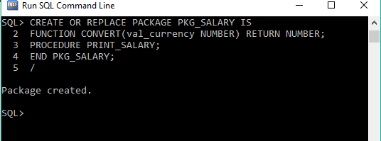

**TUGAS AKHIR**

CREATE OR REPLACE PACKAGE PKG_VOLUME IS

tinggi NUMBER := 9;

FUNCTION volume_balok(panjang NUMBER, lebar NUMBER) RETURN

NUMBER;

FUNCTION volume_balok(panjang NUMBER, lebar NUMBER, tinggi NUMBER) RETURN

NUMBER;

FUNCTION volume_tabung(jari_jari NUMBER) RETURN NUMBER;

FUNCTION volume_tabung(jari_jari NUMBER, tinggi NUMBER) RETURN NUMBER;

END pkg_volume;

/

CREATE OR REPLACE PACKAGE BODY PKG_VOLUME IS

FUNCTION volume_balok(panjang NUMBER, lebar NUMBER) RETURN

NUMBER

IS

BEGIN

RETURN panjang*lebar*tinggi;

END volume_balok;

FUNCTION volume_balok(panjang NUMBER, lebar NUMBER, tinggi NUMBER) RETURN

NUMBER

IS

BEGIN

RETURN panjang*lebar*tinggi;

END volume_balok;

FUNCTION volume_tabung(jari_jari NUMBER) RETURN

NUMBER

IS

BEGIN

RETURN 3.14*jari_jari*tinggi;

END volume_tabung;

FUNCTION volume_tabung(jari_jari NUMBER, tinggi NUMBER) RETURN

NUMBER

IS

BEGIN

RETURN 3.14*jari_jari*tinggi;

END volume_tabung;

END pkg_volume;

/

set serveroutpun on

begin

dbms_output.put_line(pkg_volume.volume_balok(5,6));

dbms_output.put_line(pkg_volume.volume_balok(5,6,3));

dbms_output.put_line(pkg_volume.volume_tabung(10));

dbms_output.put_line(pkg_volume.volume_tabung(10,2));

end;

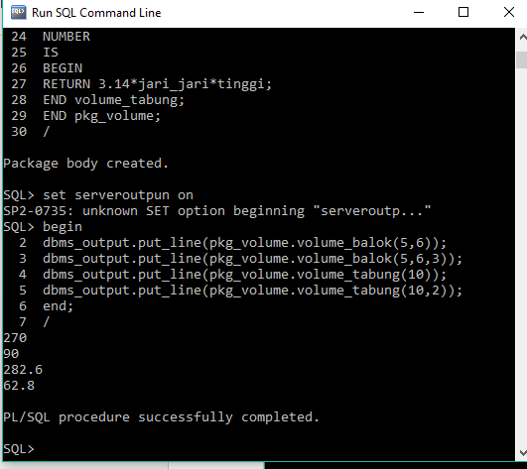/

2. CREATE TABLE RATES

( CURRENCY VARCHAR2(10),

PERIOD DATE, RATE NUMBER,

CONSTRAINT PK_RATES PRIMARY KEY (CURRENCY, PERIOD) ENABLE

);

INSERT INTO RATES VALUES('IDR', sysdate, '12860');

CREATE OR REPLACE PACKAGE PKG_SALARY IS

kurs NUMBER:=1;

cur_Date DATE := sysdate;

cur_currency VARCHAR2(10) := 'IDR';

FUNCTION CONVERT(val_currency NUMBER) RETURN NUMBER;

PROCEDURE PRINT_SALARY;

END PKG_SALARY;

/

CREATE OR REPLACE PACKAGE BODY PKG_SALARY IS

FUNCTION CONVERT(val_currency NUMBER) RETURN NUMBER IS

BEGIN

RETURN(kurs*val_currency);

END CONVERT;

PROCEDURE PRINT_SALARY IS

CURSOR cur IS SELECT employee_id, first_name||' '||last_name nama, salary FROM employees;

BEGIN

DBMS_OUTPUT.PUT_LINE('DAFTAR GAJI PEGAWAI DALAM RUPIAH');

DBMS_OUTPUT.PUT_LINE('ID NAMA GAJI');

FOR i IN cur LOOP

DBMS_OUTPUT.PUT_LINE(i.employee_id||' '||i.nama||' '||CONVERT(i.salary));

END LOOP;

END PRINT_SALARY;

BEGIN

SELECT rate INTO kurs FROM rates WHERE period=cur_Date;

END PKG_SALARY;

/

SET SERVEROUTPUT ON

BEGIN

PKG_SALARY.PRINT_SALARY;

END;

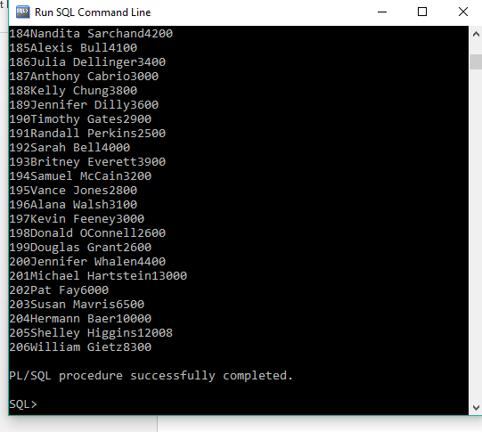/

3. CREATE OR REPLACE PACKAGE PKG_SALARY IS

cur_Date DATE := sysdate;

cur_currency VARCHAR2(10) := 'IDR';

FUNCTION CONVERT(val_currency NUMBER) RETURN NUMBER;

PROCEDURE PRINT_SALARY;

END PKG_SALARY;

/

CREATE OR REPLACE PACKAGE BODY PKG_SALARY IS

kurs NUMBER;

FUNCTION CONVERT(val_currency NUMBER) RETURN NUMBER IS

BEGIN

RETURN(kurs*val_currency);

END CONVERT;

PROCEDURE PRINT_SALARY IS

CURSOR cur IS SELECT employee_id, first_name||' '||last_name nama, salary FROM employees;

BEGIN

DBMS_OUTPUT.PUT_LINE('DAFTAR GAJI PEGAWAI DALAM RUPIAH');

DBMS_OUTPUT.PUT_LINE('ID NAMA GAJI');

FOR i IN cur LOOP

DBMS_OUTPUT.PUT_LINE(i.employee_id||' '||i.nama||' '||CONVERT(i.salary));

END LOOP;

END PRINT_SALARY;

BEGIN

kurs := 0;

SELECT rate INTO kurs FROM rates WHERE period=cur_Date;

END PKG_SALARY;

/

SET SERVEROUTPUT ON

BEGIN

pkg_salary.print_salary;

END;

/ 