DEEP LEARNING PROJECT G SAI YESHWANTH

ROLL NO: 192CS006

**PROJECT: PRINTED CIRCUIT BOARDS**

**BEST MODEL**: Inceptionv3

This is Start of Art model developed by Google, it is an Improvement of Inception1 which is also called as GoogleNet.This Convolution Neural network is 48 layers deep.

* Uses RMSProp as optimizer.
* To avoid overfitting instead of going very deep it uses different size filters in same level.
* It uses many 1*1 convolution filters to decrease number of parameters.
* Larger kernel size is implemented using more less kernel sizes.
* Uses Batch Normalization.
* shown to attain greater than 78.1% accuracy on the ImageNet dataset.
* Uses Average Pooling, Max pooling and Dropout.

**Novelty:** Developed a model which is 10 layers 6layers (convolution, pooling) and 4 dense layers. This model is also giving F-score above 85% but Inception is giving much better results and in case of individually with raw dataset It is giving in par results with all the advanced start of art models like densenet, resnet, Inception, NasNet.It will be put in below table. Actually tried with more than 50 models changing filter sizes, adding and removing layers, dropout, regularization but all these are done on raw dataset taking 33% test size but not much progress can be seen. F1-score I am getting is 95%(weighted F1-score). later I went on trying with all standard models.

**Observations**

* Noticed that some defective samples in raw dataset are not repetitive (or not sufficient), due to this when we divide into training and testing sample there are some samples in testing set such a way that similar type of defect is not seen when model is being trained.so naturally the model cannot classify them properly so recall value of raw data set on many models is getting low value and precision is always above 95%.
* Getting better results with augmented dataset > balanced data > raw data.
* Although many models came after Inceptionv3, this is giving better performance than all other models like densenet, resnet etc.
* Best on Raw dataset F1-score - 96%(Inceptionv3/own model).
* Best on Balanced dataset F1-score- 86%(own model),68%(Resnet152),64%(NasNet Large). did not check Inception on Balanced.
* Best on Augmented Dataset F1-score – 98%(own model/Dense Net).
* All the above are done individually taking 0.33 as testing sample.
* Best on Trained in raw data set testing on Balanced and Augmented Dataset –Inceptionv3(97% on balanced,98% on augmented data set). This is the model that will be given along with this document.
* Best on Trained in Balanced and Tested on remaining – ResNet (87% on raw and 90% on Augmented)
* Best on Trained in Augmented and Testing on remaining- ResNet (100% on both raw and Balanced) so I did not try with any other model.
* I preferred Inception over ResNet because it performed better on Raw dataset and I did not test it with Balanced and Augmented.

**Experiments Performed: (**all codes are available at<https://github.com/gundasai/deeplearning>)

|  |  |  |  |
| --- | --- | --- | --- |
| **MODEL** | **DATASET** | **RESULTS(weighted F1-score)** | **LINK** |
| Inceptionv3 | Trained on raw tested on aug and Balanced | 97% balanced  98% Augmented | [**check out here**](https://github.com/gundasai/deeplearning/blob/master/TRTAB%20inceptiobv3--.ipynb) |
| ResNet | Trained on raw tested on aug and Balanced | 99% balanced  90% Augmented | [**check out here**](https://github.com/gundasai/deeplearning/blob/master/TRTAB.ipynb) |
| Own model | Trained on Balanced  Tested on raw and Aug | 85% raw  87% augmented | [**check out here**](https://github.com/gundasai/deeplearning/blob/master/TBTRA-ownmodel.ipynb) |
| ResNet | Trained on Balanced  Tested on raw and Aug | 87% raw  90% Augmented | [**check out here**](https://github.com/gundasai/deeplearning/blob/master/TBTRA.ipynb) |
| ResNet | Trained on Aug tested on Raw and Balanced | 100% raw  100% balanced | [**check out here**](https://github.com/gundasai/deeplearning/blob/master/Copy_of_TATRB.ipynb) |
| Own model | Raw dataset(0.33% testing) | 95% | [**check out here**](https://github.com/gundasai/deeplearning/blob/master/pcb%20raw%20own6.ipynb) |
| Inceptionv3 | Raw dataset(0.33% testing) | 96% | [**check out here**](https://github.com/gundasai/deeplearning/blob/master/pcb%20raw%20inceptionv3.ipynb) |
| DenseNet | Raw dataset(0.33% testing) | 95% | [**check out here**](https://github.com/gundasai/deeplearning/blob/master/pcb%20raw%20dense.ipynb) |
| MobileNet | Raw dataset(0.33% testing) | 94% | [**check out here**](https://github.com/gundasai/deeplearning/blob/master/pcb%20raw%20mobilenet.ipynb) |
| NasNet | Raw dataset(0.33% testing) | 93% | [**check out here**](https://github.com/gundasai/deeplearning/blob/master/pcb%20raw%20nasnet.ipynb) |
| Own model | Balanced dataset(0.33% testing) | 86% | [**check out here**](https://github.com/gundasai/deeplearning/blob/master/pcb%20balanced%201.ipynb) |
| ResNet | Balanced dataset(0.33% testing) | 68% | [**check out here**](https://github.com/gundasai/deeplearning/blob/master/pcb%20balanced%20resnet%20152.ipynb) |
| NasNet Large | Balanced dataset(0.33% testing) | 64% | [**check out here**](https://github.com/gundasai/deeplearning/blob/master/pcb%20balanced%20nasnetlarge.ipynb) |
| Own model | Augmented | 98% | [**check out here**](https://github.com/gundasai/deeplearning/blob/master/pcb%20aug%20own.ipynb) |
| DenseNet | Augmented | 98% | [**check out here**](https://github.com/gundasai/deeplearning/blob/master/pcb%20aug%20densenet201.ipynb) |

**FINAL RESULTS:**

**1. Raw dataset**

Defective accuracy: 62%

Non Defective Accuracy: 98%

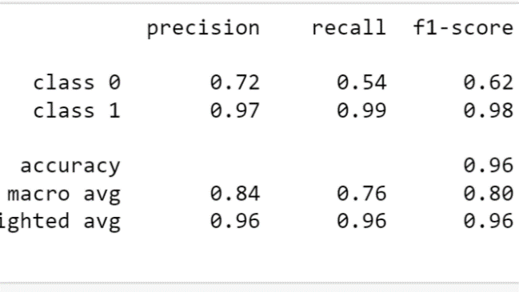

**2. Trained On raw tested on Balanced and Augmented.**

**Balanced Dataset**

Defective accuracy: 98%

Non Defective Accuracy: 98%

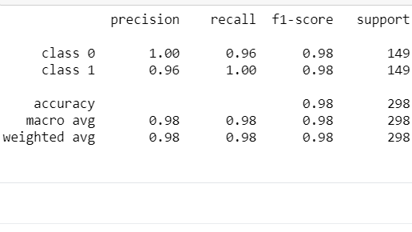

**Augmented Dataset**

Defective accuracy: 97%

Non Defective Accuracy: 97%

