

DEPARTMENT OF ARTIFICIAL INTELLIGENCE & MACHINE LEARNING
DIGITAL DESIGN & COMPUTER ORGANISATION CCA-1
TITLE : Ring Counter
BATCH NO:

SEM : 3rd SEM

SECTION : A

DATE OF SUBMISSION:13/12/2025

SUBJECT CODE: BCS302

FACULTY IN CHARGE: Prof. Salma Itagi

NAME | USN
Tharun Tej | 1BY24AI048
Koushik | 1TD24AI192
Anjali | 25UG1BYAI421-T
Narasimha | 1BY24AI092

ABSTRACT

A Ring Counter is a specialized digital sequential circuit designed to circulate a single active logic bit through a chain of flip-flops. Unlike a standard binary counter, it does not count in binary numbers but acts as a circular shift register.
This project implements a 4-bit Ring Counter using D Flip-Flops connected in a cascade arrangement, where the output of the last flip-flop is fed back to the input of the first. The system relies on a synchronous clock to shift the "High" state (logic 1) from one stage to the next in a continuous loop.
Tools such as Xilinx Viva do, Model Sim, and HDL (Verilog/VHDL) are suitable for the design, simulation, and verification of this logic. The resulting circuit demonstrates critical concepts of shift registers, feedback loops, and synchronous state transitions, making it highly useful for applications like signal scanning and frequency division.

Ring Counters operate using sequential logic, specifically utilizing the principle of Shift Registers. A shift register is a group of flip-flops used to store or move data bits.
Key concepts involved:
- Synchronous Operation: All flip-flops in the counter are triggered by a common clock pulse, ensuring all state changes happen simultaneously.
- Feedback Mechanism: The defining feature of a Ring Counter is that the output of the final stage ($Q_{last}$) is connected directly to the input of the first stage ($D_{first}$).
- Initialization: Unlike standard counters that often reset to 0, a Ring Counter must be preset with a specific value (usually 1000 or 0001) to function correctly. If reset to all zeros, no "1" will ever circulate.
In this project, a 4-bit design is implemented. This means there are 4 unique states, and the "ON" signal repeats every 4 clock cycles. This project applies these concepts to design a reliable timing circuit.

- Logic circuit

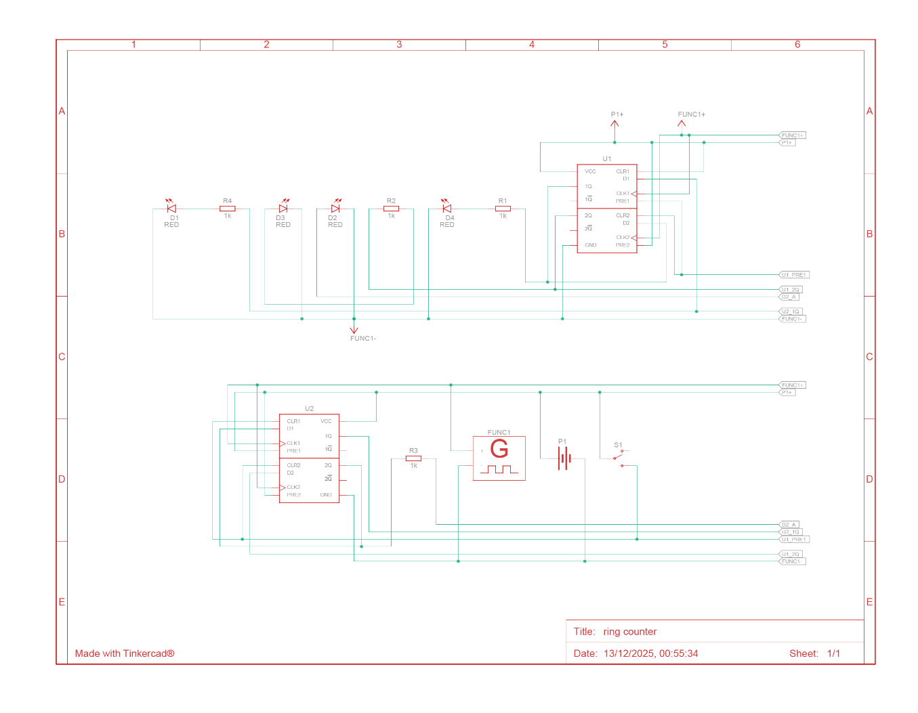

- Truth table

Clock Pulse | Q0​ | Q1​ | Q2​ | Q3​ | Meaning
Initial (Reset) | 1 | 0 | 0 | 0 | State 0
1 | 0 | 1 | 0 | 0 | State 1
2 | 0 | 0 | 1 | 0 | State 2
3 | 0 | 0 | 0 | 1 | State 3
4 | 1 | 0 | 0 | 0 | Repeat State 0

- K map simplification

Since the Ring Counter is a structural shift register, the Next State logic equations for the inputs ($D$) of the flip-flops are derived directly from the previous outputs ($Q$).
Let $Q(t)$ be the current state and $Q(t+1)$ be the next state.
- $D_0 = Q_3(t)$ (Feedback from last to first)
- $D_1 = Q_0(t)$
- $D_2 = Q_1(t)$
- $D_3 = Q_2(t)$
K-map Analysis (Optional for Structural)
Unlike the Traffic Light Controller which uses combinatorial logic to decode states, the Ring Counter's "One-Hot" encoding (only one bit is 1 at a time) simplifies the design. No complex decoding logic is required at the output because the state itself is the output.
- State 0 ($Q_0=1$) is unique.
- State 1 ($Q_1=1$) is unique.
- State 2 ($Q_2=1$) is unique.
- State 3 ($Q_3=1$) is unique.

----------------------------------------------------------------------------------
-- PART 1: THE DESIGN (Save as ring_counter.vhd)

library IEEE;
use IEEE.STD_LOGIC_1164.ALL;

entity ring_counter is
Port ( CLK : in STD_LOGIC;
RST : in STD_LOGIC;
Q : out STD_LOGIC_VECTOR (3 downto 0));
end ring_counter;

architecture Behavioral of ring_counter is
-- Initialize with "0001" so the ring has a '1' to circulate
signal temp_q : STD_LOGIC_VECTOR (3 downto 0) := "0001";
begin

process (CLK, RST)
begin
-- Asynchronous Reset
if (RST = '1') then
temp_q <= "0001"; -- Reset must restore the initial single '1'

-- Rising Edge of Clock
elsif rising_edge(CLK) then
-- Shift bits to the left and wrap the MSB back to the LSB
-- Example: 0001 -> 0010 -> 0100 -> 1000 -> 0001
temp_q <= temp_q(2 downto 0) & temp_q(3);
end if;
end process;

Q <= temp_q;

end Behavioral;

----------------------------------------------------------------------------------
-- PART 2: THE TESTBENCH (Save as ring_counter_tb.vhd)

library IEEE;
use IEEE.STD_LOGIC_1164.ALL;

entity ring_counter_tb is
-- Testbench has no ports
end ring_counter_tb;

architecture Behavioral of ring_counter_tb is

-- Component Declaration
COMPONENT ring_counter
PORT(
CLK : IN std_logic;
RST : IN std_logic;
Q : OUT std_logic_vector(3 downto 0)
);
END COMPONENT;

-- Inputs
signal CLK : std_logic := '0';
signal RST : std_logic := '0';

-- Outputs
signal Q : std_logic_vector(3 downto 0);

-- Clock period definition (100 MHz)
constant CLK_period : time := 10 ns;

BEGIN

-- Instantiate the Unit Under Test (UUT)
uut: ring_counter PORT MAP (
CLK => CLK,
RST => RST,
Q => Q
);

-- Clock Process (Generates the switching signal)
CLK_process :process
begin
CLK <= '0';
wait for CLK_period/2;
CLK <= '1';
wait for CLK_period/2;
end process;

-- Stimulus Process (Applies Reset and runs simulation)
stim_proc: process
begin
-- 1. Activate Reset to load the "0001" pattern
RST <= '1';
wait for 100 ns;

-- 2. Release Reset to let the counter spin
RST <= '0';

-- 3. Run for several clock cycles to observe the wave
wait for CLK_period * 20;

-- End simulation
assert false report "Simulation Finished" severity failure;
end process;

END Behavioral;

- Waveforms

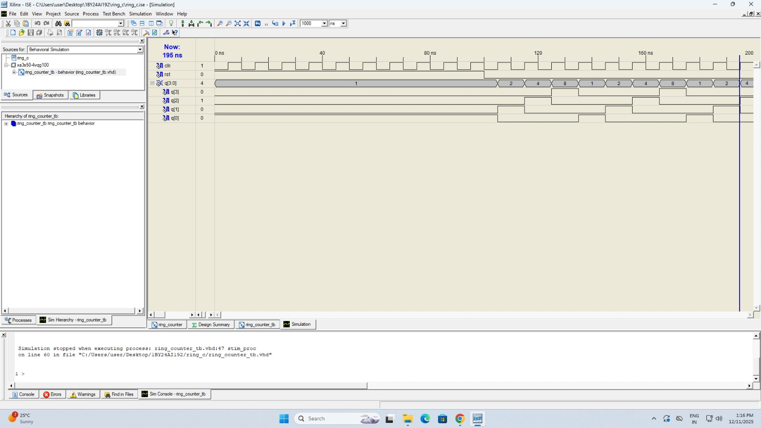

CASE 1: Initialization (Reset)
- Input: reset = '1'
- Action: Asynchronous reset overrides the clock.
- Result: Q becomes 1000 immediately. The first flip-flop is set, others are cleared.
Signal | Value
Clk | X (Don't Care)
reset | 1
Q (Output) | 1000
The following table:

CASE 2: Running Mode
- Input: reset = '0', clk = Rising Edge
- Action: The logic shifts the bit vector.

Trace Table:
Time (ns) | Clock Edge | Q (Current) | Q (Next)
0-100 | - | 1000 | 1000
110 | Rising | 1000 | 0100
130 | Rising | 0100 | 0010
150 | Rising | 0010 | 0001
170 | Rising | 0001 | 1000

(Note: The direction of shift depends on whether $Q_0$ is MSB or LSB in the vector definition. The logic above assumes the "1" moves from index 0 towards index 3 or vice-versa).

Ring counters are fundamental building blocks in digital electronics and are used in various real-world scenarios:
1. Step Motor Control:
- Ring counters are used to energize the coils of a stepper motor in a specific sequence. As the "1" shifts, it activates the next coil, causing the motor to rotate by a precise step.
2. Time Division Multiplexing (TDM):
- In communication systems, a ring counter can select different data channels sequentially. For example, a 4-bit ring counter can turn on Channel A, then Channel B, then C, then D, in a repeating loop.
3. Frequency Divider:
- If you tap the output of one specific flip-flop in the ring, the frequency of the pulse at that pin is $f_{clk} / N$, where N is the number of stages (4 in this case).
4. LED Chasers:
- A common educational project is "running lights" or "Christmas lights," where LEDs light up one by one in a sequence. This is a visual representation of a Ring Counter.

The design and simulation of a 4-bit Ring Counter successfully demonstrate the principles of synchronous sequential circuits. Unlike binary counters that require complex combinatorial logic to determine the next state, the Ring Counter utilizes the structural simplicity of shift registers with feedback.
Key takeaways from this project include:
1. Importance of Initialization:
- We observed that a Ring Counter requires a specific preset (Seed Value). If the system starts at 0000, it remains in a "dead" state. If it starts with multiple 1s (e.g., 1010), it becomes a different type of sequence generator.
2. Feedback Loops:
- The project highlights how connecting the output of the last stage to the input of the first creates a continuous loop, forming the basis of "Ring" topology.
3. Speed and Reliability:
- Ring counters are faster than standard ripple counters because there is no propagation delay accumulation across stages; the next state depends only on the immediate neighbour.
4. Educational Value:
- The simulator and VHDL implementation bridge the gap between the theoretical concept of data shifting and the practical application of timing control signals.

1. VHDL References:
- Perry, D. L., VHDL Programming by Example, 4th Edition, McGraw-Hill, 2002.
- Bhasker, J., A VHDL Primer, 3rd Edition, Pearson Education.
2. Digital Logic References:
- Mano, M. M., Digital Design, 5th Edition, Pearson, 2012.
- Floyd, T. L., Digital Fundamentals, 11th Edition, Pearson, 2015.
- Leach, D. P., & Malvino, A. P., Digital Principles and Applications, 7th Edition, Tata McGraw-Hill.

