INTERVIEW PREPARATION

Segment This Thing Interview Preparation Guide
  - Plain language notes for explaining the project clearly
This guide helps you explain the project in an interview. Read the short pitch first, then use the remaining pages to understand the method, results, limitations, and common follow-up questions.

Project in one sentence
I evaluated the official pretrained STT-B image segmentation model on the Oxford-IIIT Pet dataset to measure its accuracy, speed, robustness, and reliability, then compared it with SAM ViT-B.
Project fact | Details
Task | Point-prompted image segmentation
Model | STT-B from Segment This Thing CVPR 2025
Dataset | Oxford-IIIT Pet test split
Main evaluation | 499 successfully processed images with no retraining

Main conclusion
STT-B offered a useful speed and accuracy trade-off. It was about 5.7 times faster than SAM ViT-B on the paired subset, but SAM produced better average overlap. STT-B also had weak boundary quality and some high-confidence failures, so it is better suited to interactive work where a person can inspect or correct the mask.
Important interview rule Do not say that you trained STT-B. The project evaluated the official pretrained checkpoint without fine-tuning.

The problem this project studies

What image segmentation means
Image segmentation assigns a label to each pixel. In this project, the output is a binary mask: pixels belonging to the selected pet are foreground, and the remaining pixels are background. This is more detailed than object detection because detection gives a box, while segmentation tries to recover the object's exact shape.

What a point prompt means
The user clicks one point inside an object. The model uses that point to decide which object to segment. A point prompt is simple for the user, but the result can depend strongly on where the point is placed.

How STT B works
STT stands for Segment This Thing. Its key idea is foveated tokenization. The model keeps high spatial detail near the click and represents areas farther away more coarsely. This resembles human vision: we see the area we focus on in more detail than the edges of our visual field.
This reduces the number of image tokens that the model must process. The goal is to make interactive segmentation faster while preserving enough information around the selected object.

Why this question matters
A model can have a good average score and still be unsuitable in practice. For an interactive tool, response time matters. For automatic or high-risk use, failures, boundary accuracy, and confidence quality also matter. This project measured all of these, not only one accuracy number.
Term | Simple meaning
Ground truth | The correct mask supplied by the dataset
Predicted mask | The foreground pixels selected by the model
Checkpoint | Saved pretrained model weights
Inference | Running the trained model to make a prediction
Ablation | A controlled experiment that changes one condition

What I did in the project
I built a reproducible evaluation around the official STT-B predictor. The work focused on external evaluation rather than model training.
01 Loaded the data Used the 3,669-image Oxford-IIIT Pet test split and converted trimaps into binary foreground masks.
02 Fixed the sample Shuffled with seed 42, requested 500 main samples, and successfully processed 499.
03 Generated one prompt Used a distance transform to find the deepest interior foreground pixel.
04 Handled small images Upscaled the shorter side to at least 1,280 pixels and scaled the prompt coordinates with it.
05 Ran STT B Used the official pretrained checkpoint, selected the candidate with the highest predicted IoU, and reconstructed the mask.
06 Mapped results back Resized each binary prediction to the original image resolution before scoring.
07 Measured quality and speed Recorded overlap, boundary quality, geometry, model time, end-to-end time, and GPU memory.
08 Ran additional experiments Tested prompt placement, image degradation, confidence calibration, failures, and a paired SAM ViT-B baseline.

Tools and environment
Tool | How it was used
Python and PyTorch | Model inference and tensor operations
OpenCV and NumPy | Mask processing, point generation, and metrics
Pandas and Matplotlib | Result tables, analysis, and charts
Google Colab with Tesla T4 | GPU execution environment

How the evaluation metrics work
Metric | What it asks | Result | How to explain it
IoU | How much do prediction and truth overlap | 0.6070 | Useful overlap, but considerable room for improvement
Dice | Another overlap score that rewards agreement | 0.7149 | Supports the same broad conclusion as IoU
Precision | How much predicted foreground is actually correct | 0.8550 | The model usually avoids unrelated background
Recall | How much of the true object was recovered | 0.7226 | Lower than precision, so parts of the object are often missed
Boundary F1 | How closely the predicted contour matches the true contour | 0.0952 | The weakest result; edges are often inaccurate

How to interpret the main results
The mean IoU of 0.6070 shows that STT-B usually found the correct object region, but the masks were not highly precise. The 95 percent bootstrap confidence interval for IoU was 0.5844 to 0.6280, which gives a reasonable estimate of uncertainty around the mean.
Precision was higher than recall. In simple terms, the model more often left out part of the pet than added a large amount of unrelated background.
Boundary F1 was only 0.0952. This is an important limitation. A mask can overlap most of an object and still follow its outline poorly. The mean area error of 34.85 percent and perimeter error of 27.06 percent support the same conclusion.

Speed results
Measurement | Result | Meaning
Model-only time | 28.3 ms | Predictor execution only
End-to-end time | 93.0 ms | Includes resizing, reconstruction, and remapping
End-to-end throughput | About 11 FPS | More realistic practical speed
Peak allocated GPU memory | 0.397 GB | Memory allocated during the measured run

STT B and SAM ViT B comparison
The paired comparison used the same 100 images and the same deepest-interior point for both models. SAM timing included image embedding, so both latency measurements represent a complete single-image workflow.
Metric | STT B | SAM ViT B
Mean IoU | 0.6306 | 0.6717
Mean Dice | 0.7368 | 0.7686
Precision | 0.8472 | 0.7952
Recall | 0.7589 | 0.8685
Boundary F1 | 0.1007 | 0.0636
End-to-end latency | 76.8 ms | 440.0 ms
Throughput | 13.54 FPS | 2.28 FPS

What the comparison means
- SAM had better average overlap: its mean IoU was higher by about 0.041.
- STT-B was about 5.7 times faster on this subset.
- STT-B had higher precision, while SAM had higher recall and covered objects more completely.
- STT-B achieved higher IoU on 46 images, while SAM achieved higher IoU on 54 images.
The correct interview conclusion is a quality and speed trade-off. Do not say STT-B was better overall. Say that STT-B was substantially faster, while SAM was moderately more accurate on average.

When each model makes sense
Situation | Better fit | Reason
Fast interactive annotation | STT B | Low latency and a human can review the result
Completeness matters more than speed | SAM ViT B | Higher IoU and recall in the paired test
High-risk automatic decisions | Neither alone | The output needs validation and failure handling

Robustness and reliability findings

Prompt placement
Prompt type | Mean IoU | Meaning
Centroid | 0.6498 | Best average overlap in the ablation
Deepest interior | 0.6161 | Best precision and the fixed main protocol
Random interior | 0.5318 | Lower and less controlled
Near boundary | 0.5317 | A difficult prompt location
The centroid performed best in the later ablation, but the main 499-image result was not changed after seeing this. Keeping the predefined deepest-interior prompt avoids cherry-picking the primary protocol.

Image degradation
Condition | Mean IoU | Change from original
Original | 0.6161 | Reference
Blur | 0.6004 | -0.0157
Low resolution | 0.6079 | -0.0082
Dark | 0.6286 | +0.0125
Bright | 0.5744 | -0.0417
Brightening produced the largest decrease. Darkening slightly improved this subset, but that does not prove that dark images are generally easier. It is a dataset-specific, non-monotonic result.

Confidence and failures
The correlation between STT-B's predicted IoU and the actual IoU was 0.518. This is a moderate positive relationship, but it is not strong enough to treat confidence as a correctness guarantee.
- 66 of 499 images had actual IoU below 0.25, a catastrophic failure rate of 13.2 percent.
- 22 of those failures still had predicted IoU of at least 0.70.
This is one of the most important project findings: average performance can hide serious individual failures, and the model may be confident when it is wrong.

What successful and failed masks look like
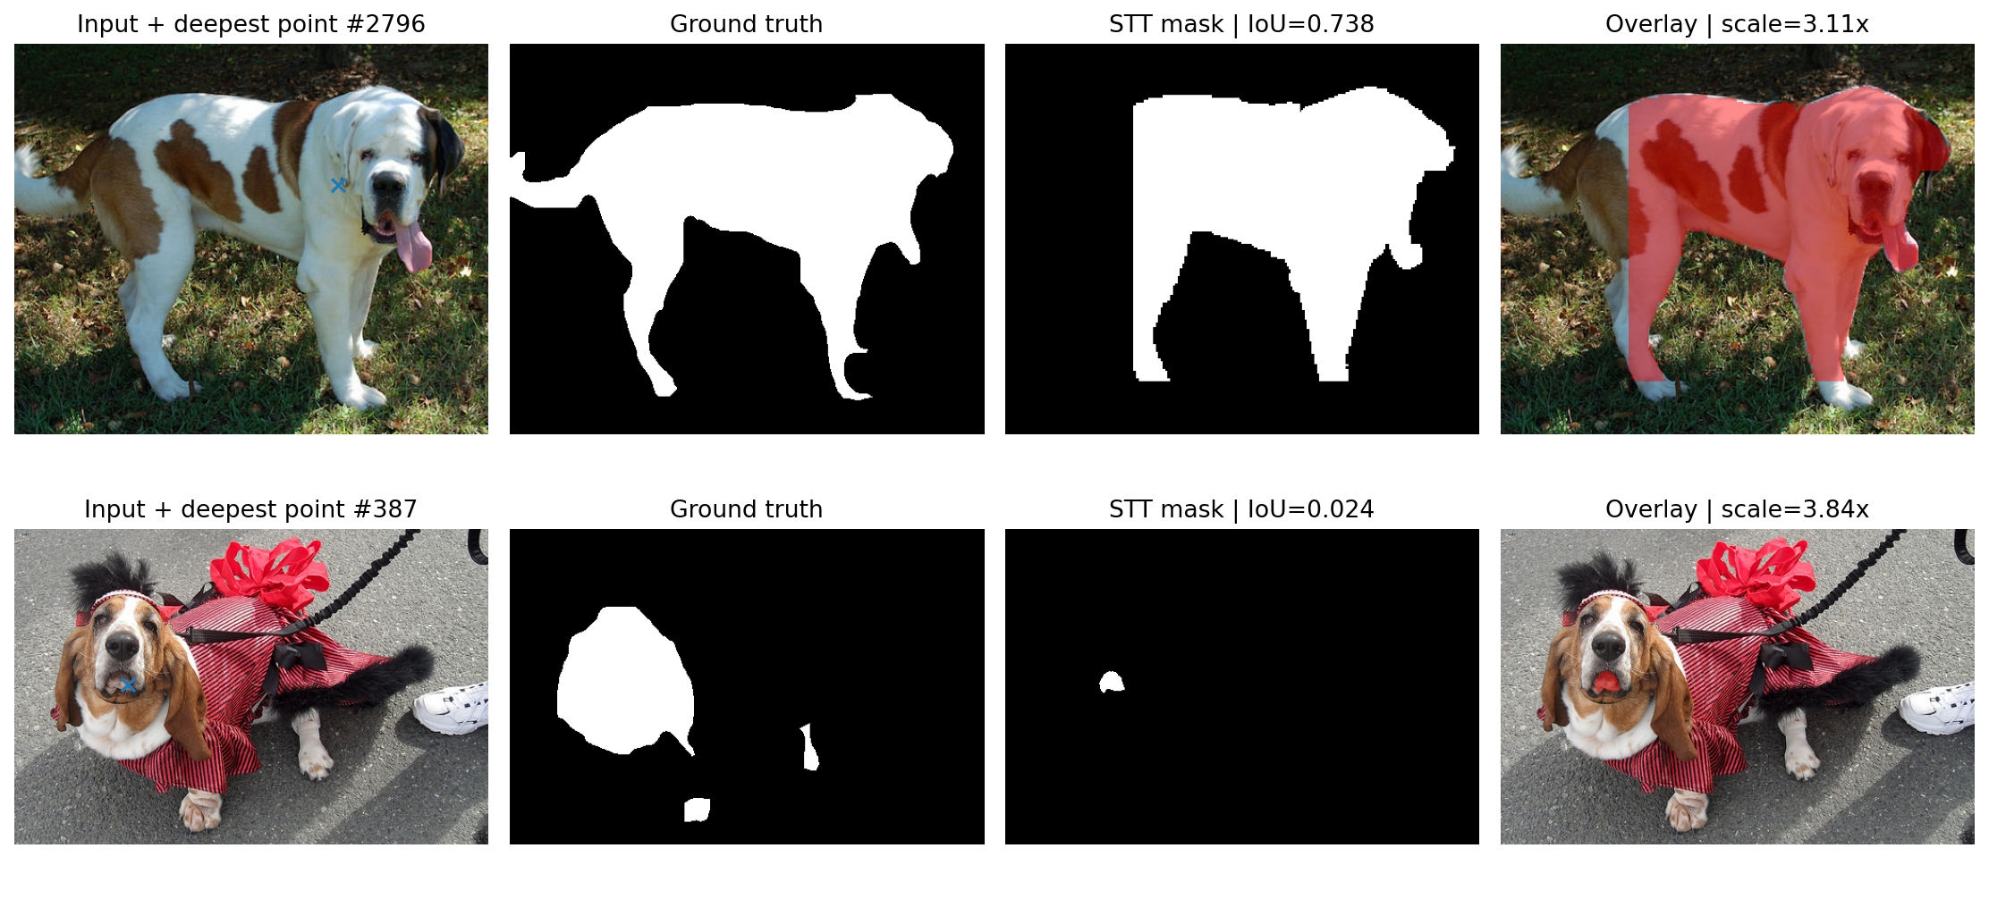
Top row shows a useful mask with IoU 0.738. Bottom row shows a catastrophic failure with IoU 0.024.

Project limitations
- This was an external evaluation on Oxford-IIIT Pet, not an exact reproduction of every benchmark in the STT paper.
- The model was not fine-tuned for this dataset.
- Oxford annotations are trimaps. The experiment treated label 1 as foreground and labels 2 and 3 as background, which can affect boundaries.
- Small inputs were heavily enlarged. The mean scale factor was 3.79, which may alter fine edges.
- The main experiment used only one positive click. Corrective clicks and negative prompts were not evaluated.
- The SAM comparison covered 100 images rather than all 499 main images.
- Boundary F1 used a fixed two-pixel tolerance, so its value depends on that convention.

What I would improve next
I would evaluate the full test split, add multiple positive and negative correction clicks, compare additional STT sizes and segmentation baselines, test more datasets, and calibrate the predicted IoU or train a lightweight failure detector.

Interview explanation you can rehearse

Short version
My project evaluated Segment This Thing, or STT-B, a CVPR 2025 model for point-prompted image segmentation. A user clicks inside an object, and the model creates a pixel-level mask. STT-B uses foveated tokenization, which keeps more detail near the click and less detail farther away, making inference efficient.
I used the official pretrained checkpoint without retraining and evaluated it on 499 Oxford-IIIT Pet images. I measured overlap, boundary quality, latency, memory, prompt sensitivity, degradation robustness, confidence, and failures. The model achieved 0.607 mean IoU and about 93 milliseconds end-to-end latency.
On the same 100-image subset, SAM ViT-B had better IoU, 0.672 versus 0.631, but STT-B was about 5.7 times faster. My main conclusion is that STT-B is attractive for interactive applications where speed matters and a user can check the result, but its weak boundaries and high-confidence failures make automatic high-risk use less suitable without validation.

A clear answer structure
01 Problem I studied fast point-prompted object segmentation.
02 Approach I reproduced the official STT-B inference path and evaluated it externally.
03 Evidence I used 499 main images, controlled robustness tests, and a paired SAM baseline.
04 Result STT-B was much faster, while SAM had better average overlap.
05 Judgment STT-B fits interactive work better than unmonitored high-risk automation.

Mistakes to avoid
- Do not say you trained or fine-tuned STT-B.
- Do not call this an exact reproduction of the paper's full benchmark suite.
- Do not say STT-B was more accurate than SAM overall.
- Do not present predicted IoU as a reliable guarantee.
- Do not hide the low Boundary F1 or the 66 catastrophic failures.

Common interview questions and answers
Why did you choose STT B
STT-B presents a useful engineering question. It aims to reduce latency through foveated tokenization, so I could study both model quality and practical speed instead of reporting only an accuracy score.
Why did you use Oxford IIIT Pet
It provides pixel-level annotations and varied breeds, poses, sizes, lighting, and backgrounds. It also acts as an external dataset, which helps test how the released checkpoint behaves outside the paper's original benchmark setup.
What is foveated tokenization
It preserves high spatial resolution near the user's click and uses coarser information farther away. By spending computation where the prompt says the important object is likely to be, the model can process fewer effective tokens and respond faster.
Why use the deepest interior point
It is a deterministic prompt that is safely inside the foreground and away from uncertain boundaries. Using a fixed rule makes results repeatable and avoids manually selecting favorable clicks.
Why did the centroid later perform better
Prompt location affects the information available to the model. On the 100-image ablation, the centroid gave better average overlap. I did not replace the primary prompt after seeing that result because the primary protocol had already been defined.
Why is precision higher than recall
The model usually labels predicted foreground correctly, but it does not always recover the entire pet. Its typical error is under-segmentation, meaning it misses object pixels, rather than including large areas of background.
Why is Boundary F1 so low when IoU is reasonable
IoU measures region overlap, while Boundary F1 checks contour alignment. A mask can cover most of the pet but still smooth, shift, or cut off its outline. Resizing and the trimap conversion may also affect fine boundaries.

More interview questions and final revision
Was the comparison with SAM fair
Both models used the same 100 images and the same deepest-interior point. SAM's image embedding was included in its timing, while STT-B timing included its complete preprocessing and reconstruction path. This makes the comparison relevant to a single-image interaction, though hardware and implementation still limit how broadly the exact numbers can be generalized.
What was the most important finding
The speed and accuracy trade-off was useful, but the reliability analysis was more revealing. Twenty-two masks were high-confidence catastrophic failures. That shows why average IoU and the model's own confidence score are not enough for deployment decisions.
What was technically challenging
A strong answer is the end-to-end evaluation path: keeping image and point coordinates consistent during resizing, reconstructing foveated outputs, mapping masks back to original resolution, and timing both models fairly. Adapt this answer to the parts you personally implemented.
Would you deploy this model
I would consider it for low-latency interactive annotation with visible masks and correction controls. I would not use a single unchecked prediction for high-risk automatic decisions because of weak contour quality and confident failures.
How would you improve the project
I would test the full dataset and additional domains, add multi-click correction, compare more baselines and STT model sizes, measure calibration more formally, and add a failure detector or abstention rule for uncertain outputs.

Five facts to remember
Fact | Number or phrase
Main sample | 499 images
Main quality | IoU 0.607 and Dice 0.715
Practical speed | 93 ms per image and about 11 FPS
SAM trade-off | SAM higher IoU and STT-B about 5.7 times faster
Reliability warning | 66 catastrophic failures and 22 confident failures
Final advice Explain the project as an evaluation and engineering study. Lead with the problem, describe the controlled protocol, give the trade-off, and volunteer the limitations. That sounds more credible than claiming one model is simply better.

