AIAC LAB 8.1
Name : G.Sreeja
Roll No : 2503A52692
Batch No : 24
Task Description #1 – Password Strength Validator
Question:
Apply AI to generate at least 3 assert test cases for is_strong_password(password) and implement the validator function.
Answer:
The Python program below implements the required function/class and verifies it using assert-based test cases.
#code
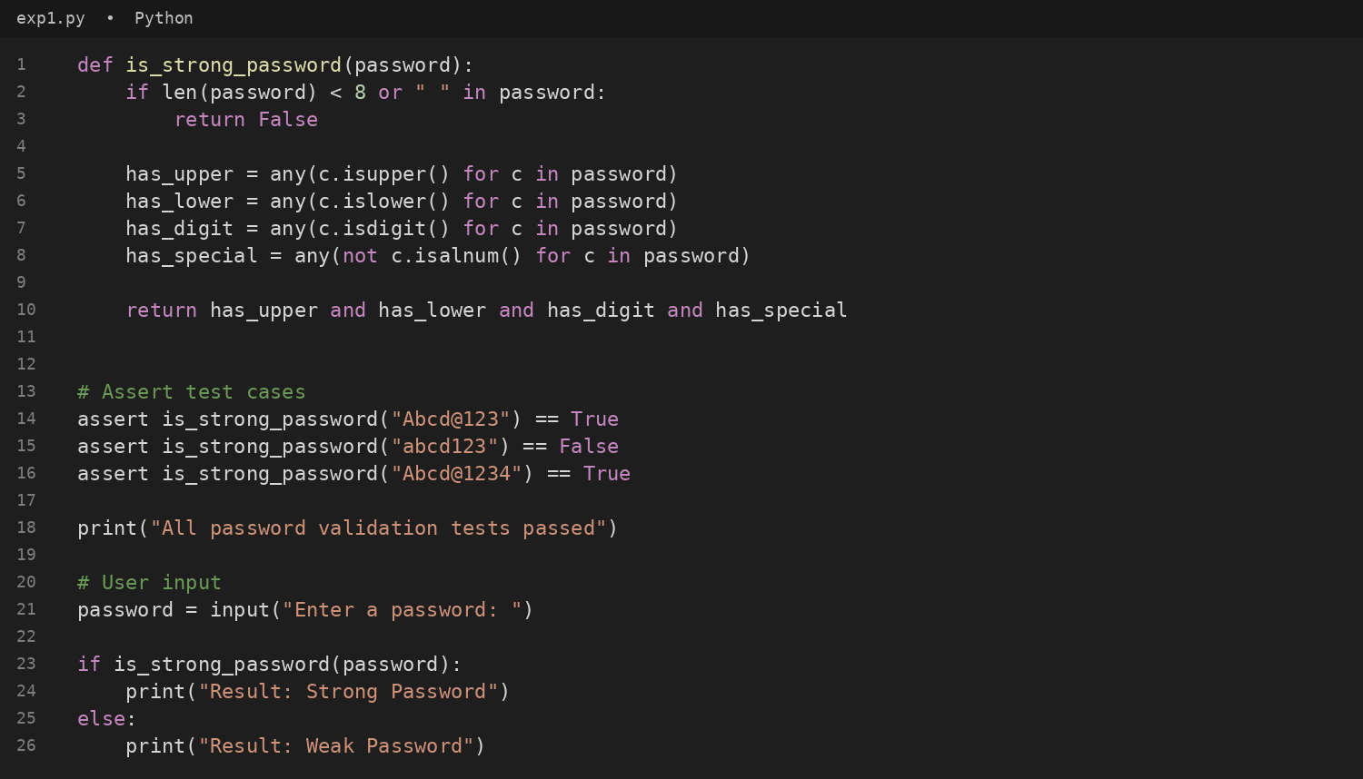
#output
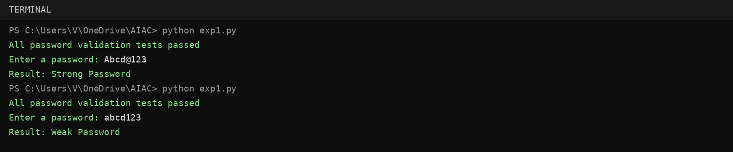
Task Description #2 – Number Classification with Loops
Question:
Use AI to generate at least 3 assert test cases for a classify_number(n) function and implement it using loops.
Answer:
The Python program below implements the required function/class and verifies it using assert-based test cases.
#code
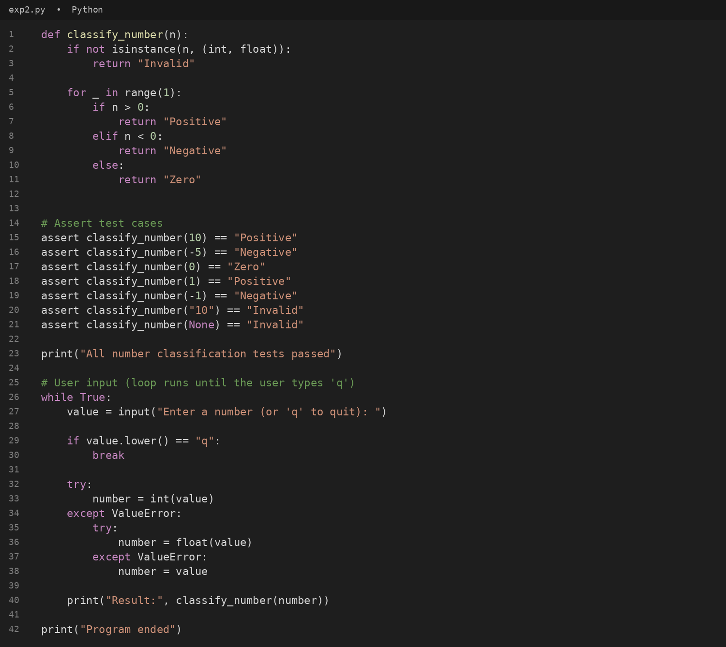
#output
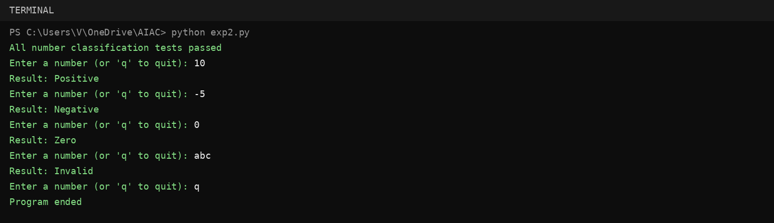
Task Description #3 – Anagram Checker
Question:
Use AI to generate at least 3 assert test cases for is_anagram(str1, str2) and implement the function.
Answer:
The Python program below implements the required function/class and verifies it using assert-based test cases.
#code
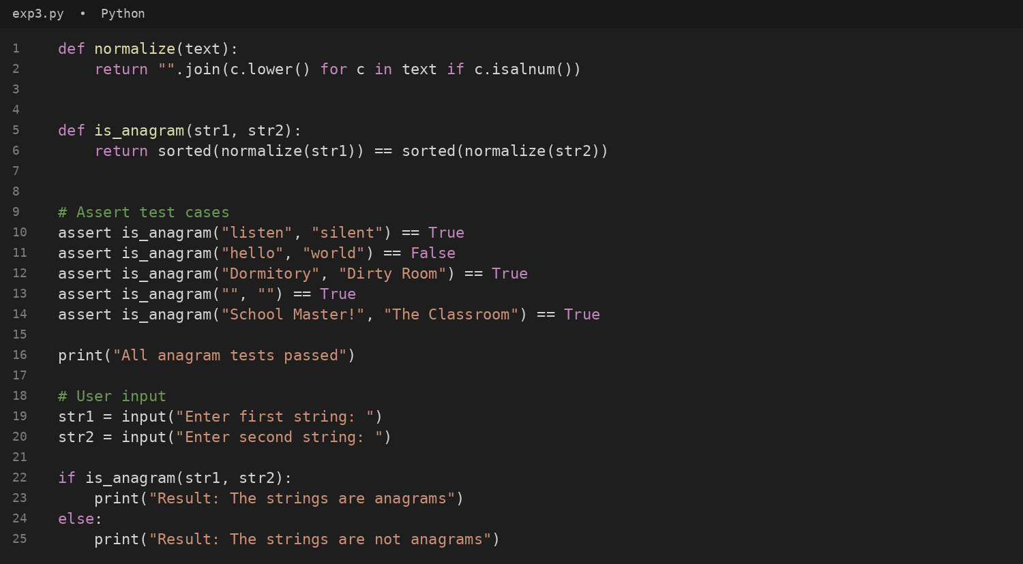
#output
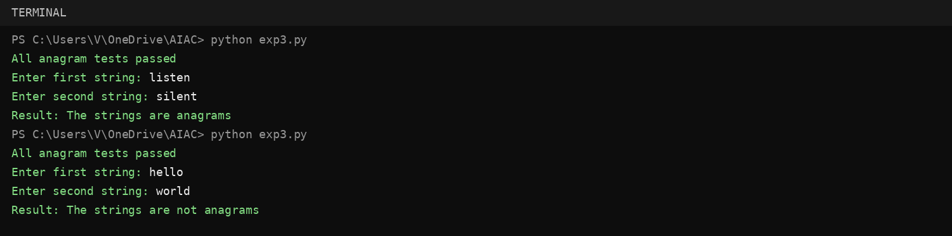
Task Description #4 – Inventory Class
Question:
Ask AI to generate at least 3 assert-based tests for an Inventory class with stock management.
Answer:
The Python program below implements the required function/class and verifies it using assert-based test cases.
#code
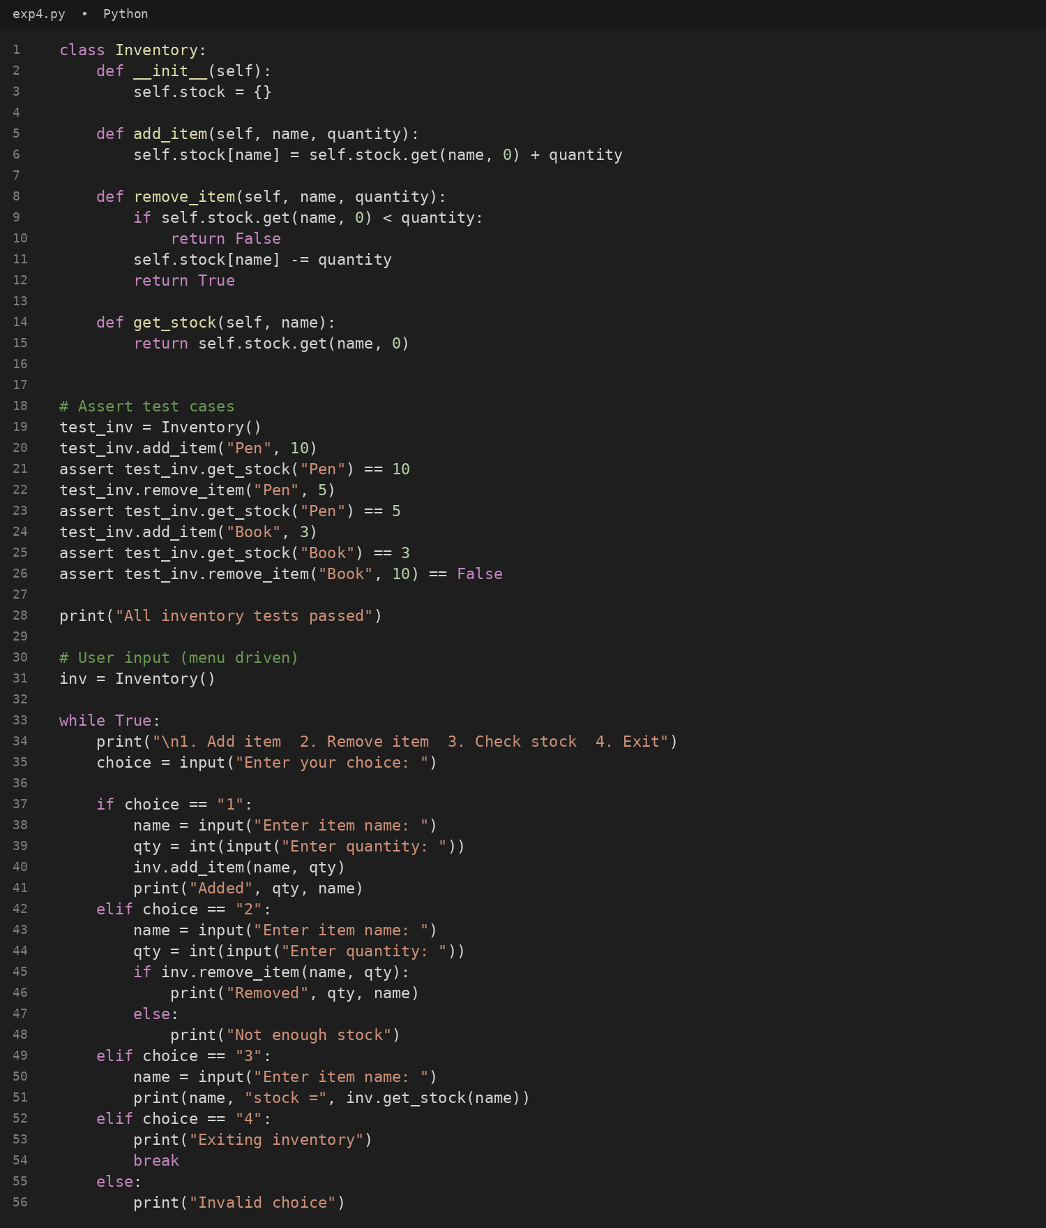
#output
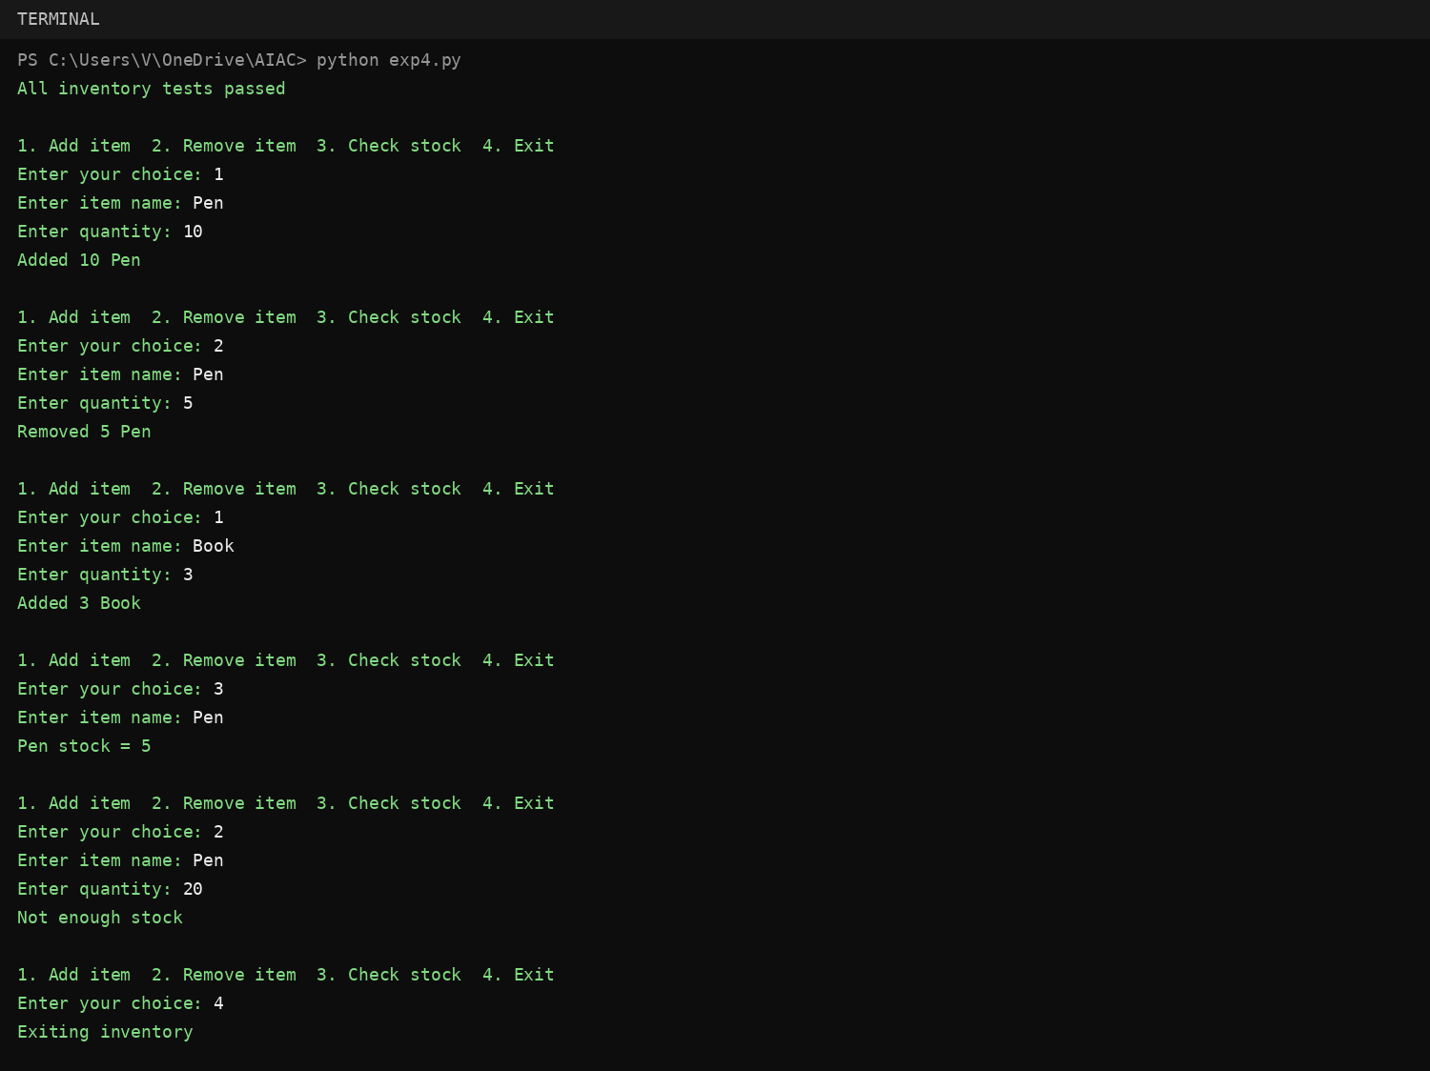
Task Description #5 – Date Validation & Formatting
Question:
Use AI to generate at least 3 assert test cases for validate_and_format_date(date_str) to check and convert dates.
Answer:
The Python program below implements the required function/class and verifies it using assert-based test cases.
#code
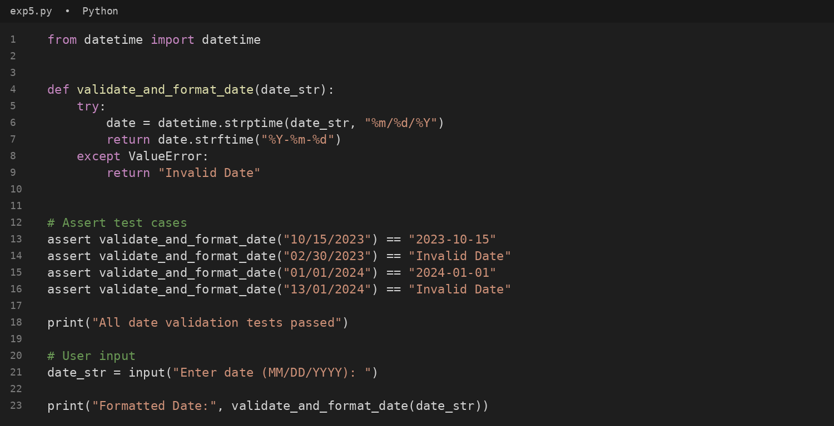
#output
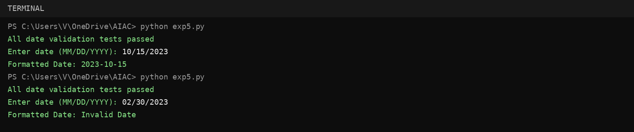
Conclusion
All five tasks were implemented and verified using assert-based test cases. The programs cover validation, edge cases, and expected outputs as required in Lab 8.

