AIAC LAB 9.1
Lab Experiment: Documentation Generation – Automatic documentation and code comments
Name : G.Sreeja
Roll No : 2503A52692
Batch No : 24
Problem 1 – Documenting find_max() in Three Styles
Question:
Consider the following Python function:
def find_max(numbers):
return max(numbers)
Task: Write documentation for the function in all three formats: (a) Docstring (b) Inline comments (c) Google-style documentation. Critically compare the three approaches. Discuss the advantages, disadvantages, and suitable use cases of each style. Recommend which documentation style is most effective for a mathematical utilities library and justify your answer.
Answer:
The Python program below documents find_max() in all three formats and takes the list of numbers from the user.
#code
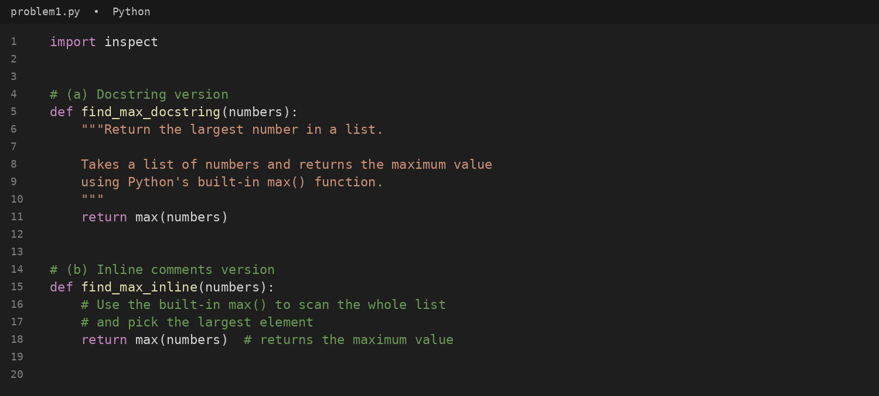
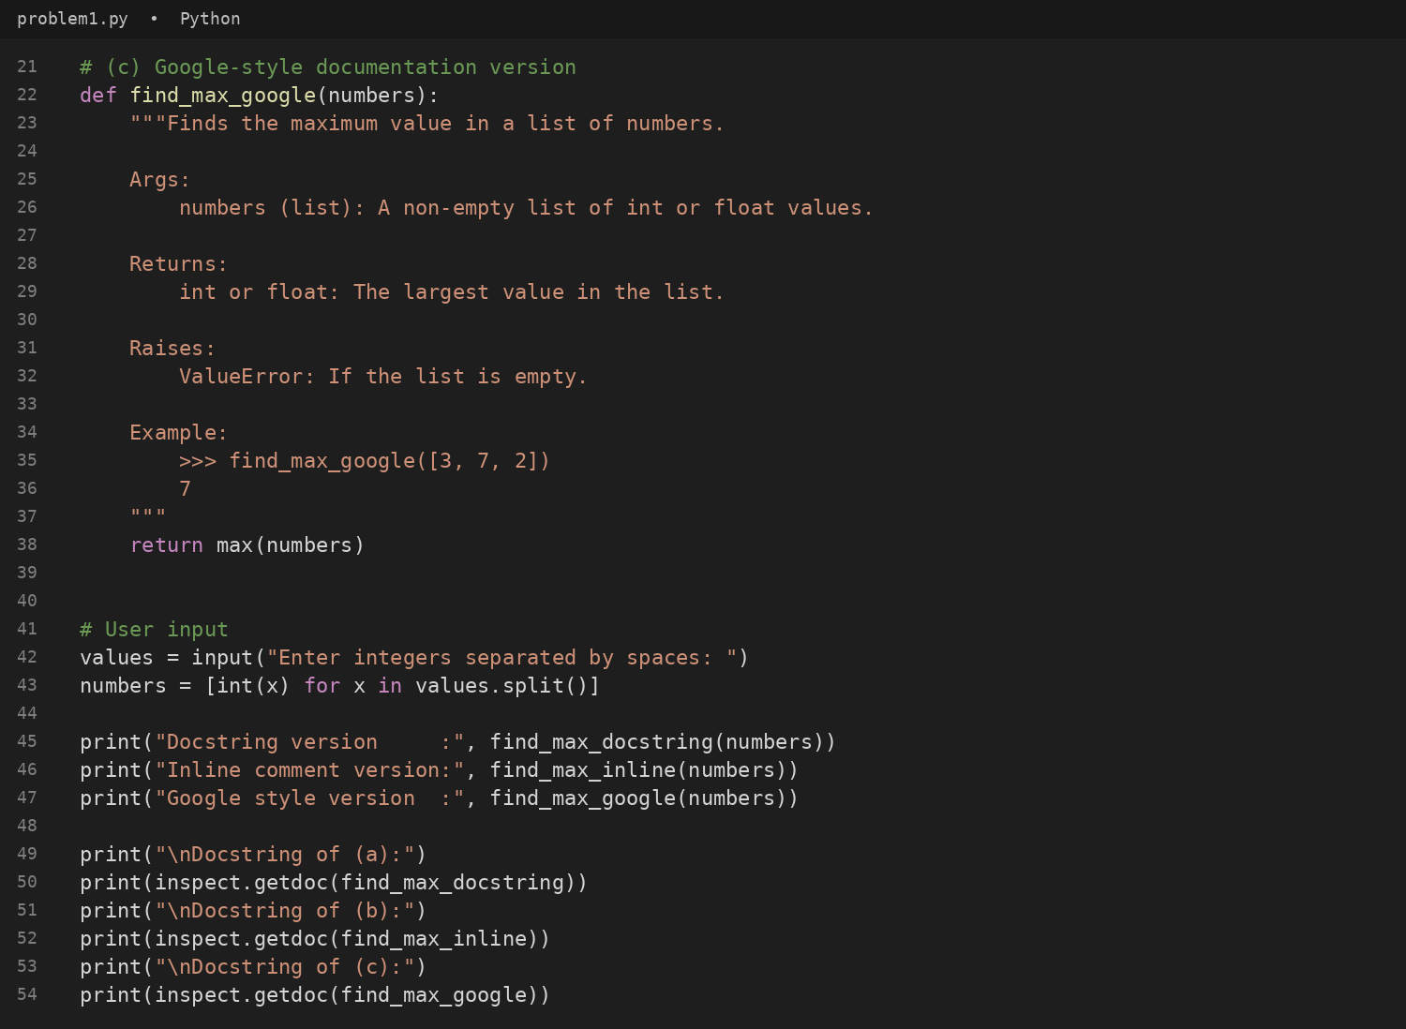
#output
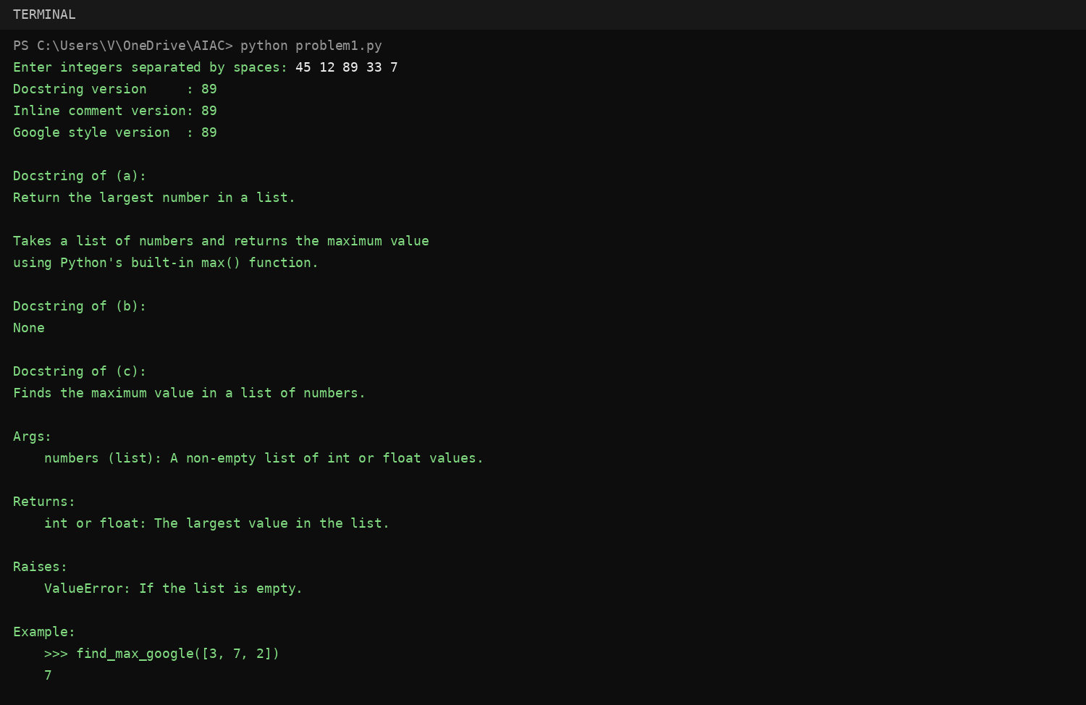
#comparison of the three styles
Style | Advantages | Disadvantages | Suitable use cases
(a) Docstring | Stored with the function, so help(), pydoc and IDE tooltips can show it at run time. Short and standard (PEP 257). | A plain summary has no fixed structure, so parameter, return and error details are easy to leave out. | Small, simple functions that only need a short description.
(b) Inline comments | Sit next to the exact line they explain; good for explaining why something is done. | Not available through help() or documentation tools; easily become outdated; a comment on a one-line max() call adds clutter. | Tricky or non-obvious logic inside a function body, mainly for maintainers reading the source.
(c) Google-style | Clear Args / Returns / Raises / Example sections; easy to read as plain text; Sphinx (napoleon) and IDEs can parse it; examples can run as doctests. | Longer than the code it describes for tiny functions; must be updated whenever behaviour changes. | Public APIs, libraries and team projects where other people call the function without reading its code.

Recommendation: Google-style docstrings are the most effective for a mathematical utilities library. Mathematical functions need precise contracts: the expected input types, what happens in edge cases (an empty list raises ValueError), the return type and a worked example. The Args / Returns / Raises / Example sections capture all of this in a fixed structure, the examples double as doctests, and tools such as help(), pydoc, IDE tooltips and Sphinx can turn them into reference pages for the library's users. Inline comments should only supplement them where a line of logic is not obvious.
Problem 2 – Documenting login()
Question:
Consider the following Python function:
def login(user, password, credentials):
return credentials.get(user) == password
Task: Write documentation in all three formats. Critically compare the approaches. Recommend which style would be most helpful for new developers onboarding a project, and justify your choice.
Answer:
The Python program below documents login() in all three formats and takes the username and password from the user.
#code
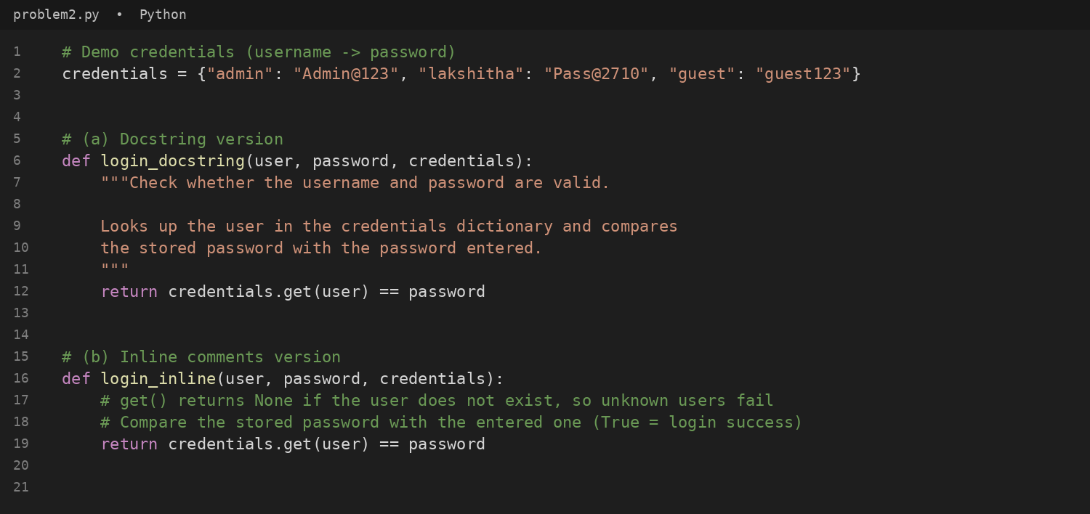
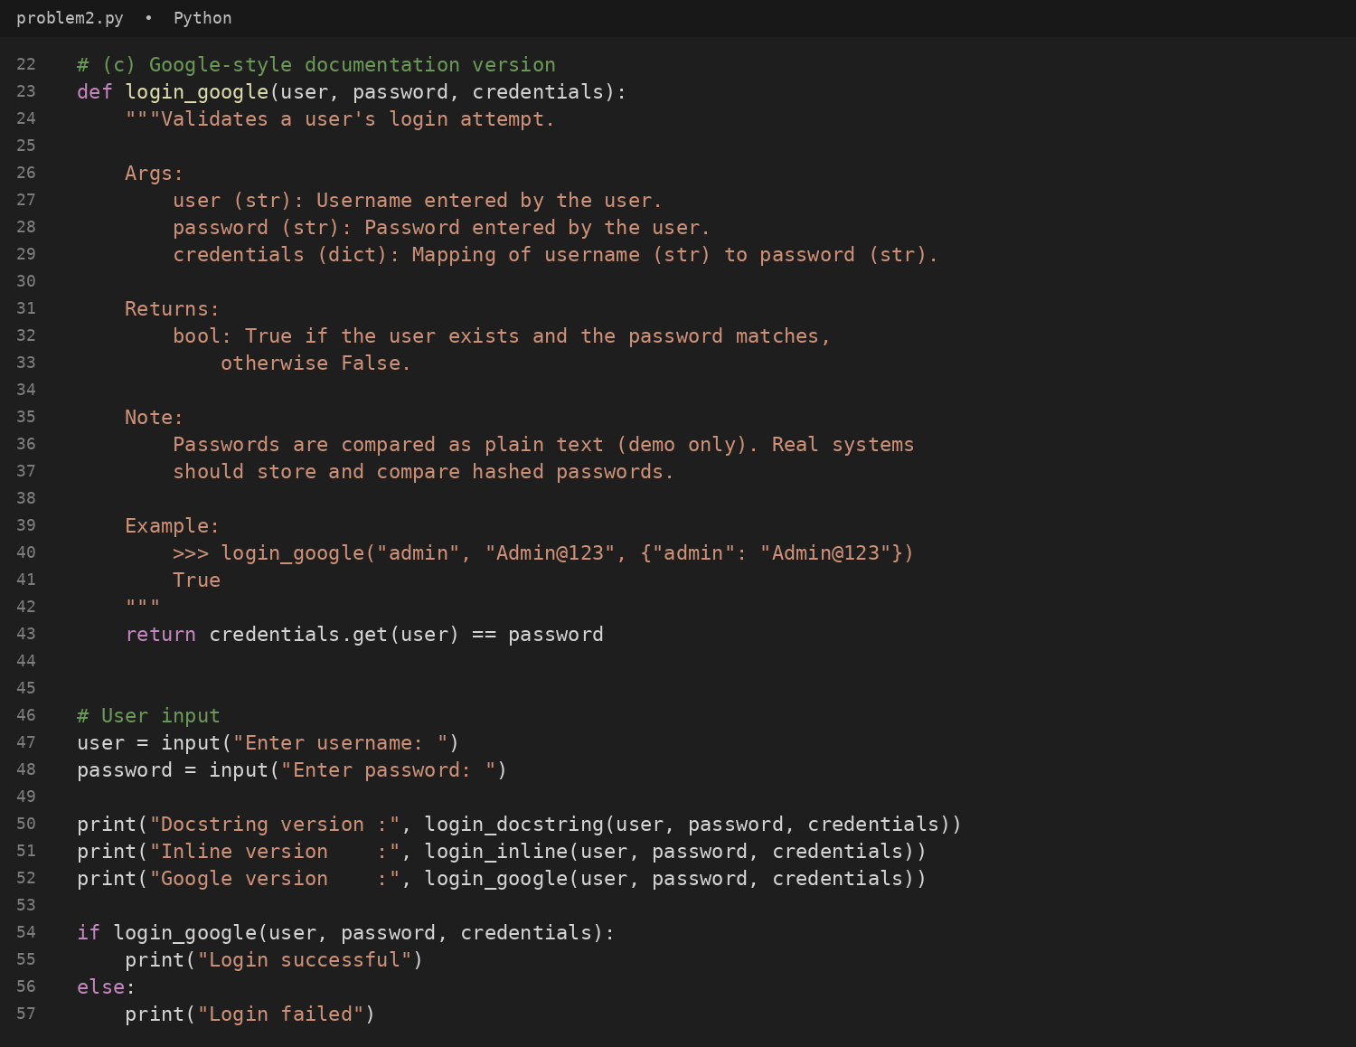
#output
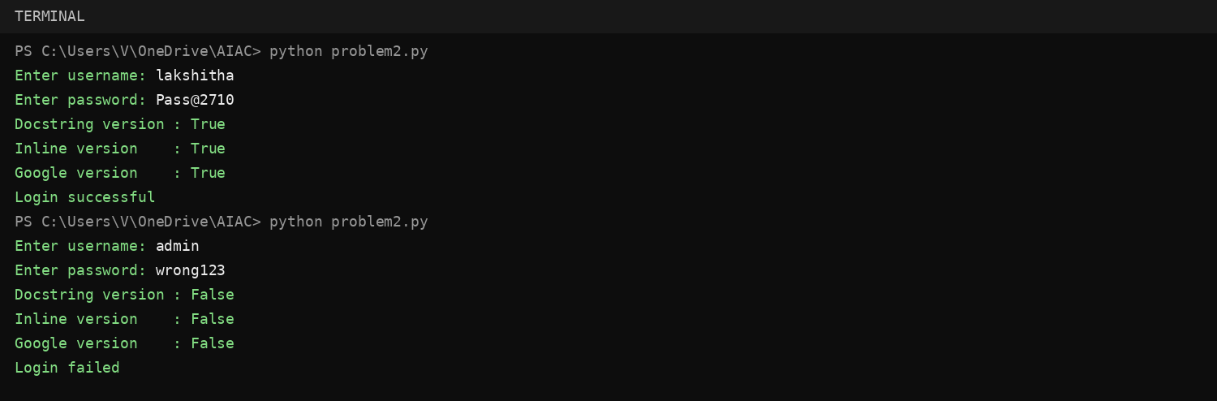
#comparison of the three styles
Style | Advantages | Disadvantages | Suitable use cases
(a) Docstring | Explains the purpose of login() in help(login) with very little effort. | A short summary does not say what shape credentials must have or what is returned for an unknown user unless the writer adds it. | Quick description of small helper functions.
(b) Inline comments | Explain details such as get() returning None for unknown users exactly where the logic sits. | A newcomer only sees them after opening the source file; not shown by help() or generated documentation. | Clarifying tricky lines for people already working inside the file.
(c) Google-style | Args, Returns, Note and Example tell a developer what to pass in (including the credentials dictionary format) and what to expect, without reading the body. Same layout across the project. | Takes longer to write and must be kept in sync with the code. | Shared or public functions in a team codebase, especially for onboarding.

Recommendation: Google-style docstrings are the most helpful for new developers onboarding a project. A newcomer can call login() correctly just by reading its docstring: it shows the type of every argument, the structure of the credentials dictionary, that the result is a bool (False for an unknown user), a runnable example and a security note about plain-text passwords. The same text appears in help(), IDE tooltips and generated HTML documentation, so nobody has to open the source. Inline comments are a good supplement for one specific line, but they are invisible to documentation tools.
Problem 3 – Calculator (Automatic Documentation Generation)
Question:
Task: Design a Python module named calculator.py and demonstrate automatic documentation generation.
Instructions: Create a Python module calculator.py that includes the following functions, each written with appropriate docstrings:
add(a, b) – returns the sum of two numbers
subtract(a, b) – returns the difference of two numbers
multiply(a, b) – returns the product of two numbers
divide(a, b) – returns the quotient of two numbers
Display the module documentation in the terminal using Python’s documentation tools. Generate and export the module documentation in HTML format using the pydoc utility, and open the generated HTML file in a web browser to verify the output.
Answer:
The module calculator.py below contains add(), subtract(), multiply() and divide(), each with a docstring. A main block takes the numbers and the operation from the user when the file is run directly.
#code
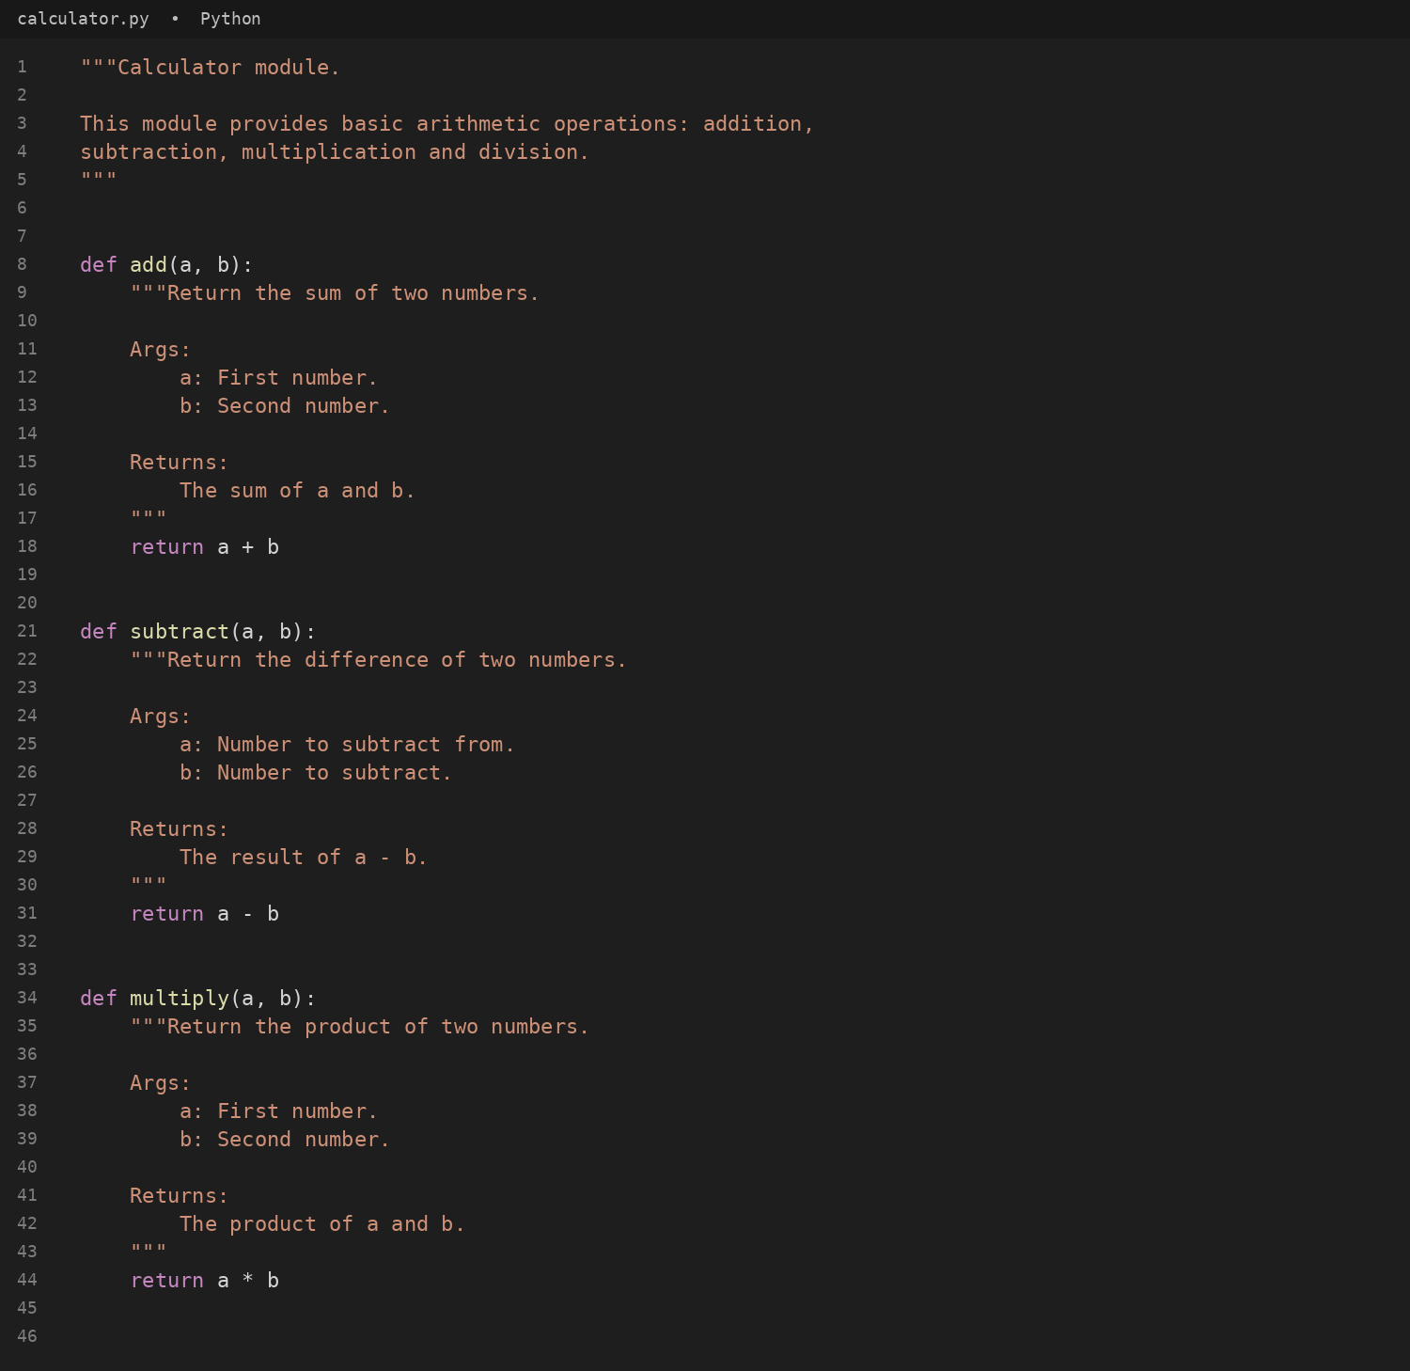
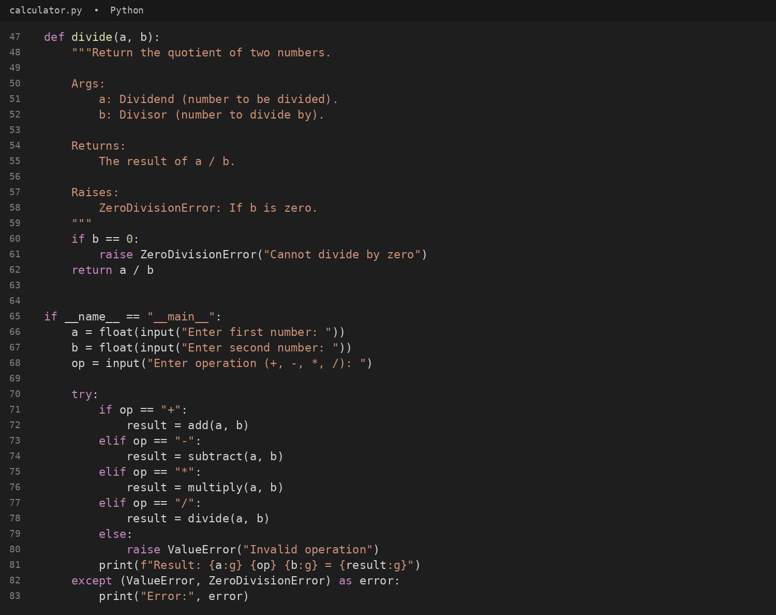
#output
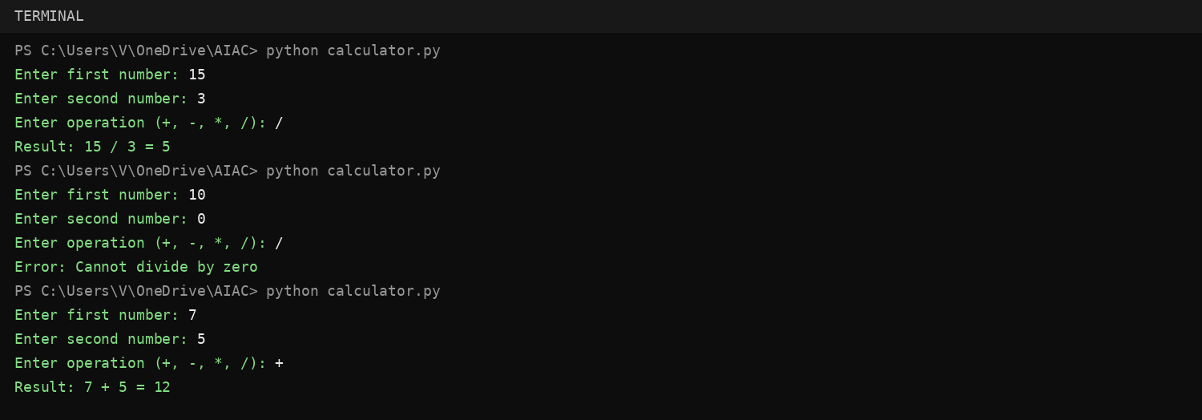
#documentation in the terminal (python -m pydoc calculator)
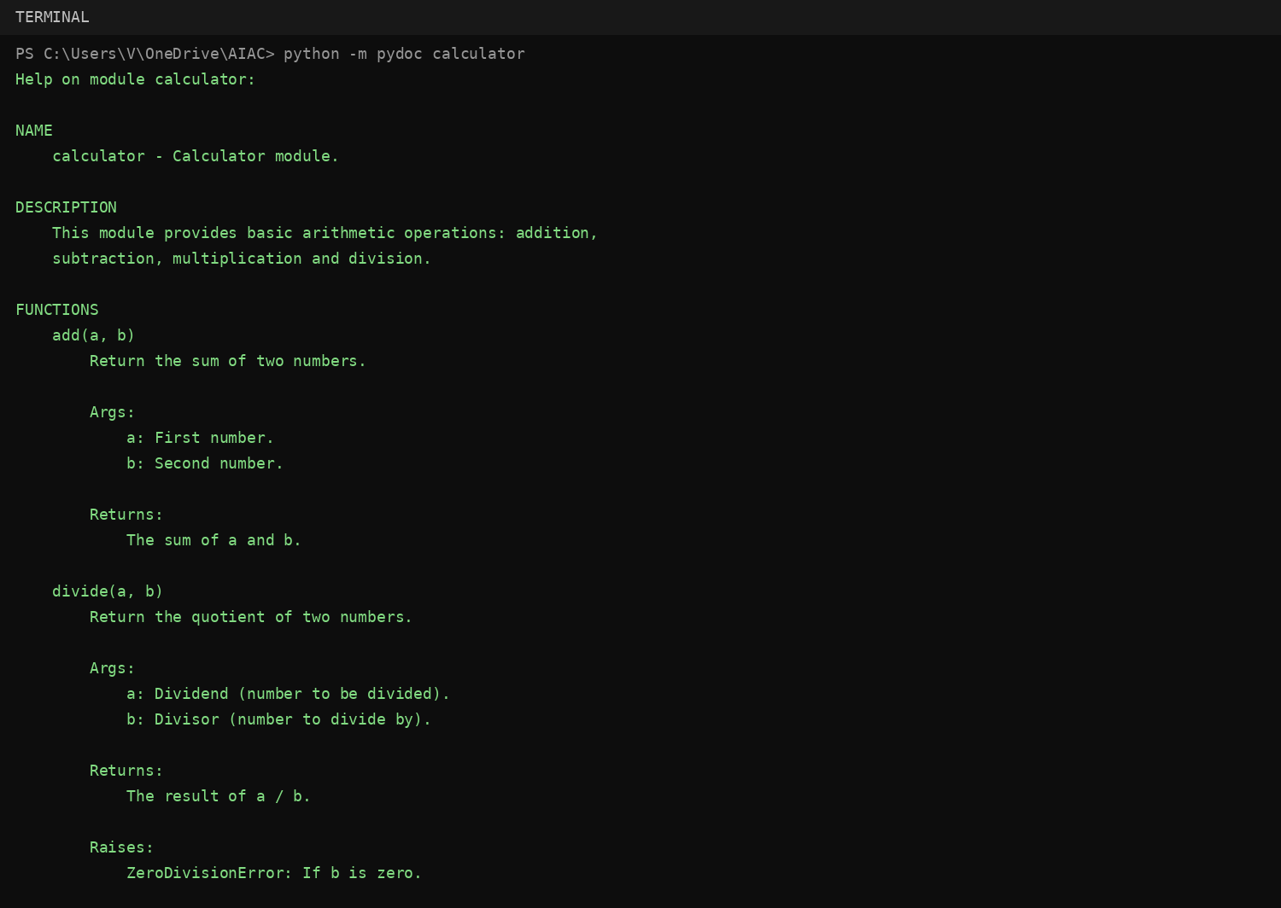
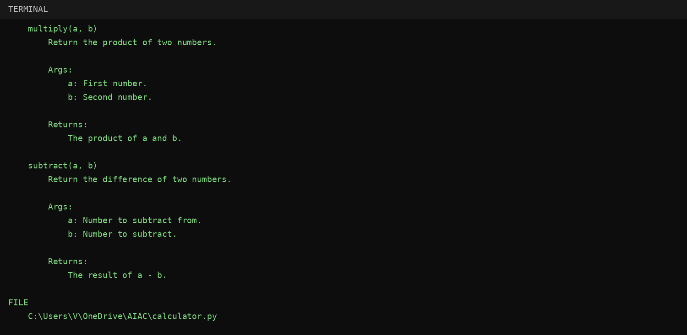
#export documentation as HTML (python -m pydoc -w calculator)
#calculator.html opened in a web browser
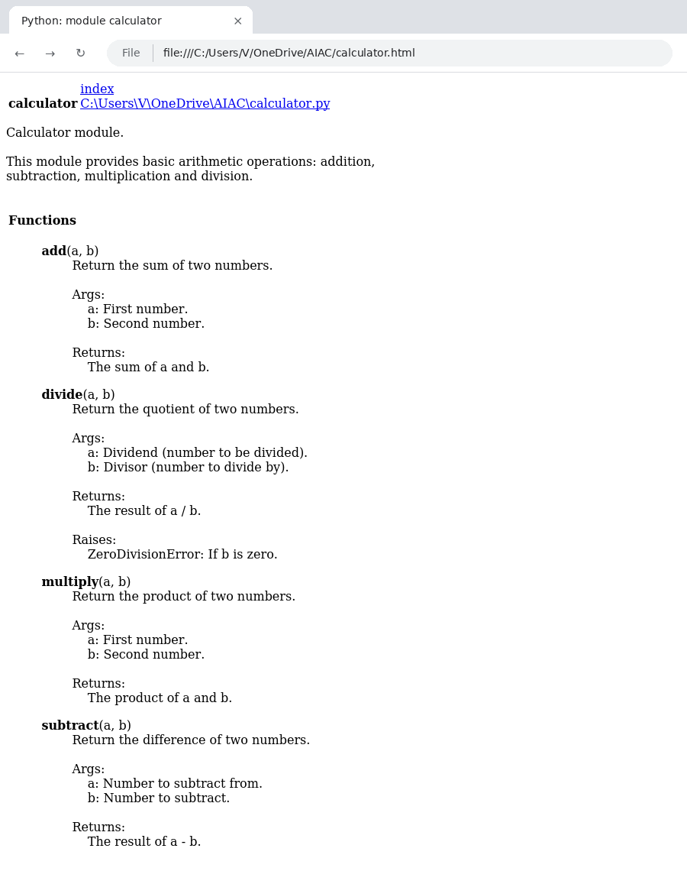
Problem 4 – Conversion Utilities Module
Question:
Task: Write a module named conversion.py with functions: decimal_to_binary(n), binary_to_decimal(b), decimal_to_hexadecimal(n).
Use Copilot for auto-generating docstrings. Generate documentation in the terminal. Export the documentation in HTML format and open it in a browser.
Answer:
The module conversion.py below contains the three conversion functions, each with a docstring. A main block asks the user which conversion to perform and reads the number to convert.
#code
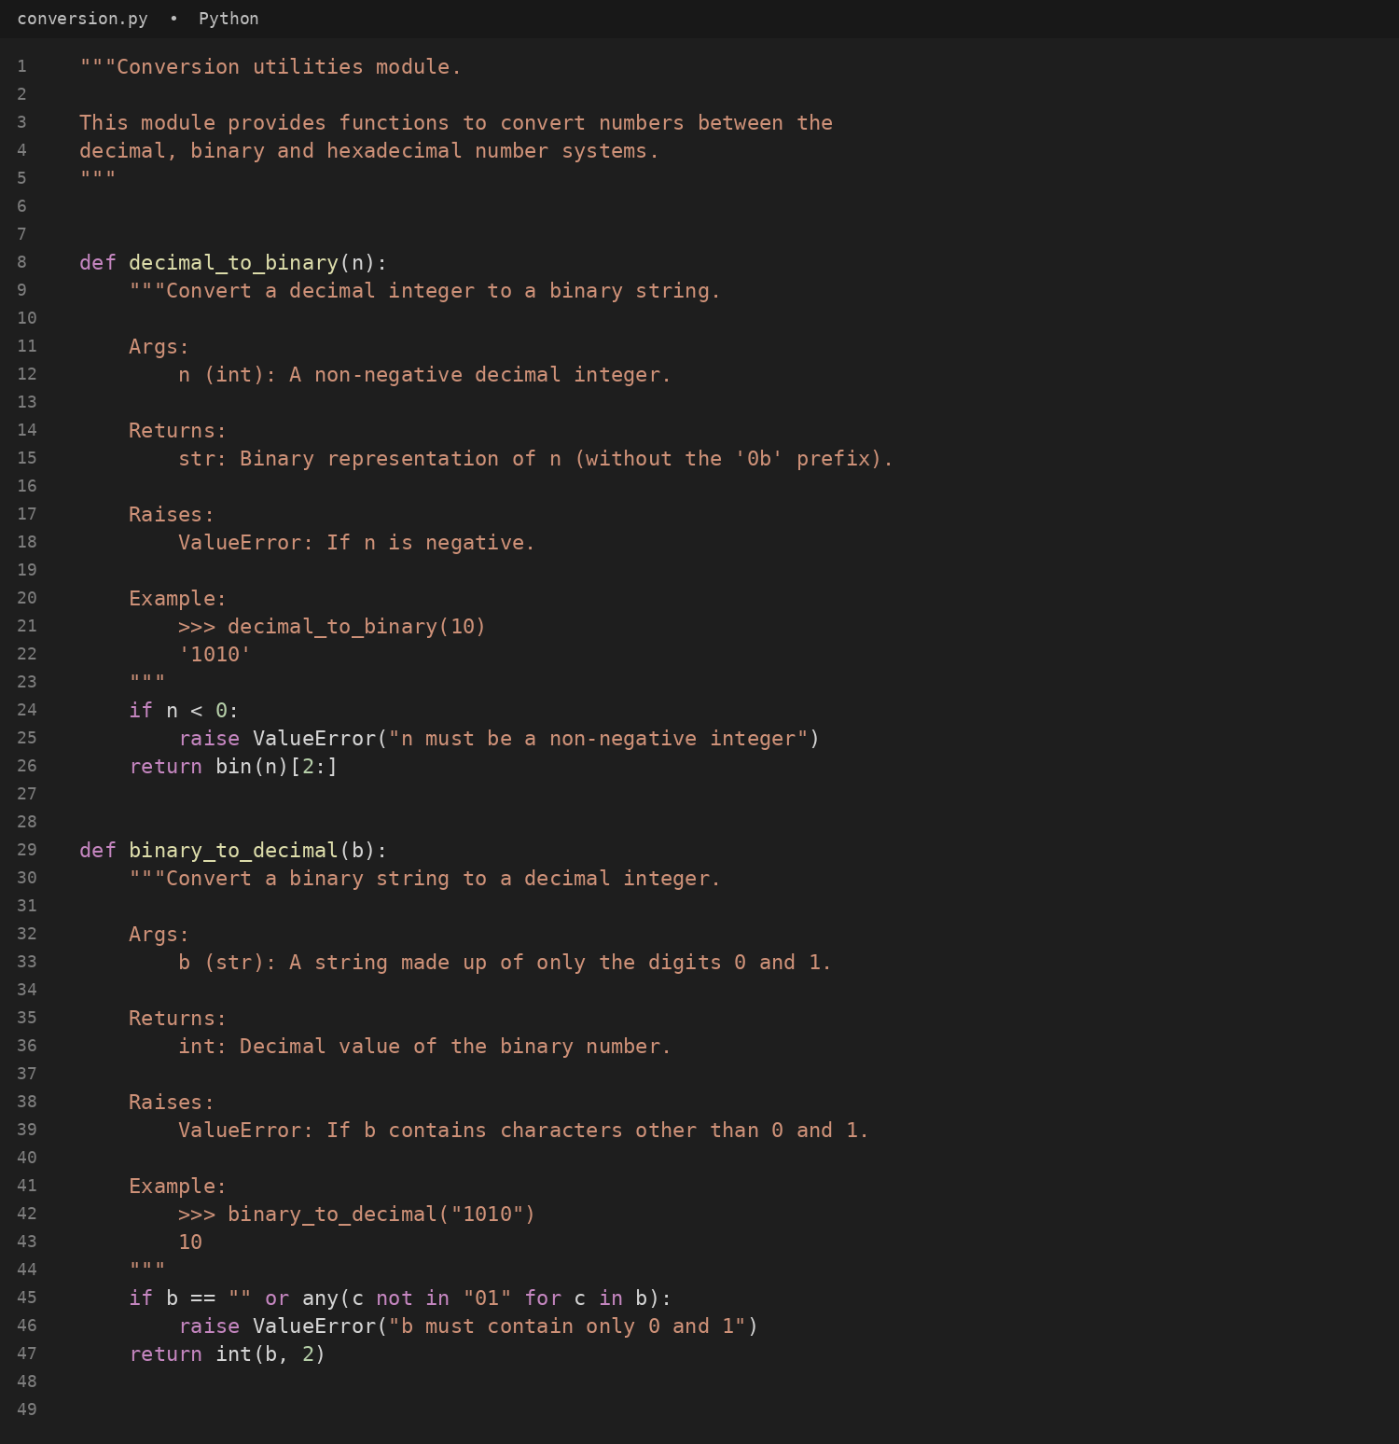
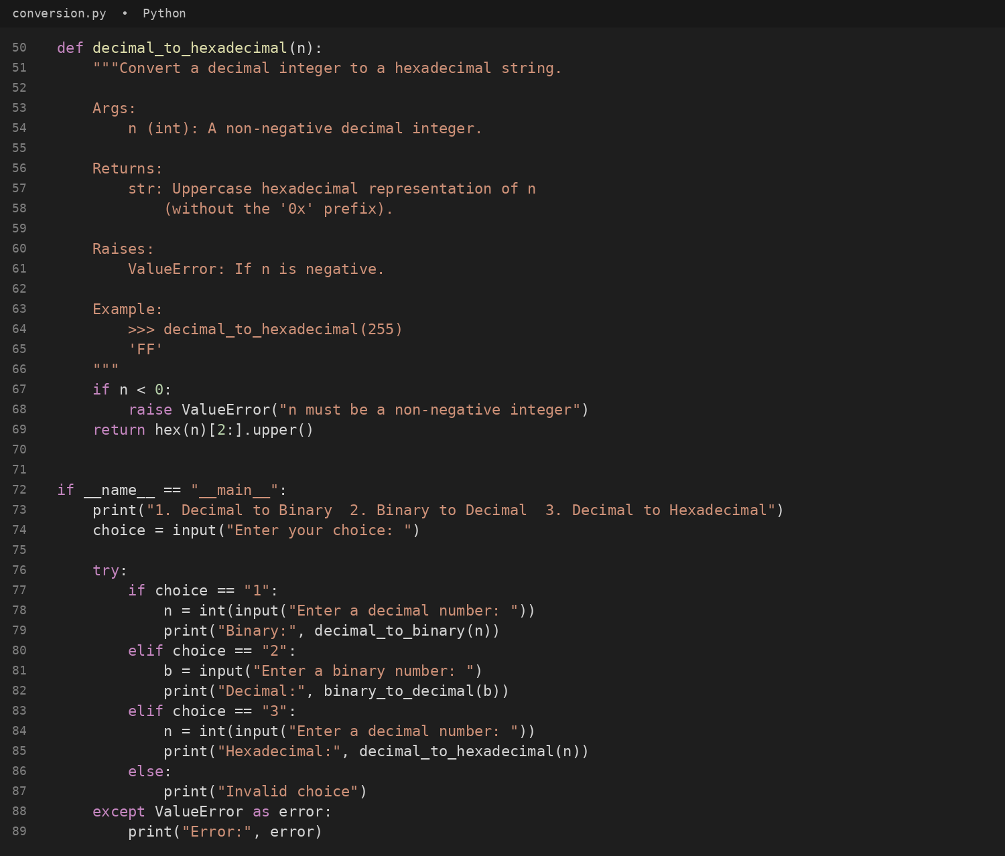
#output
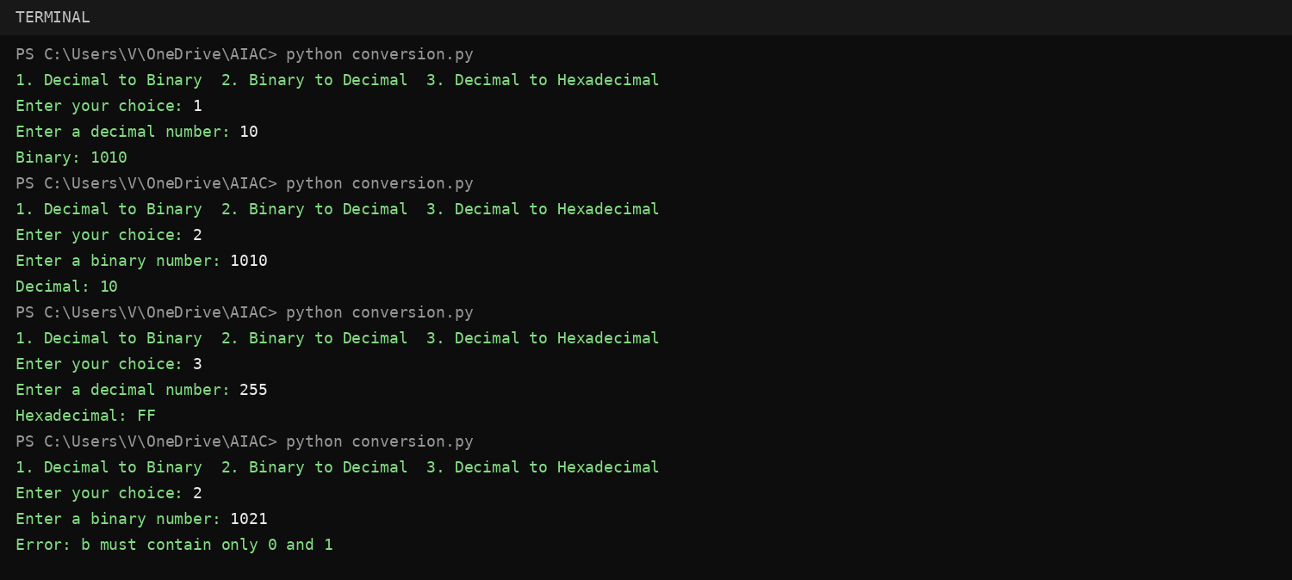
#documentation in the terminal (python -m pydoc conversion)
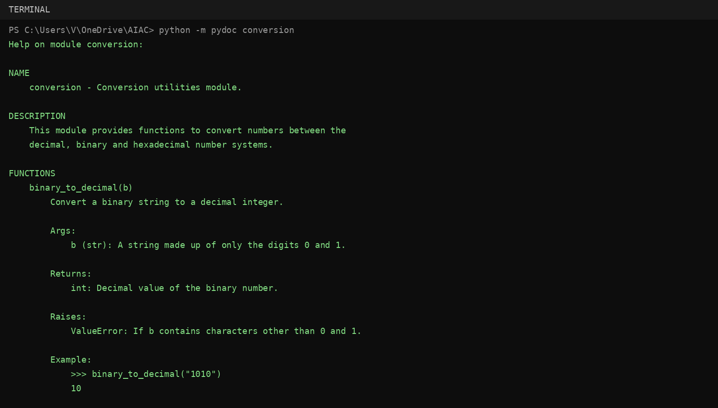
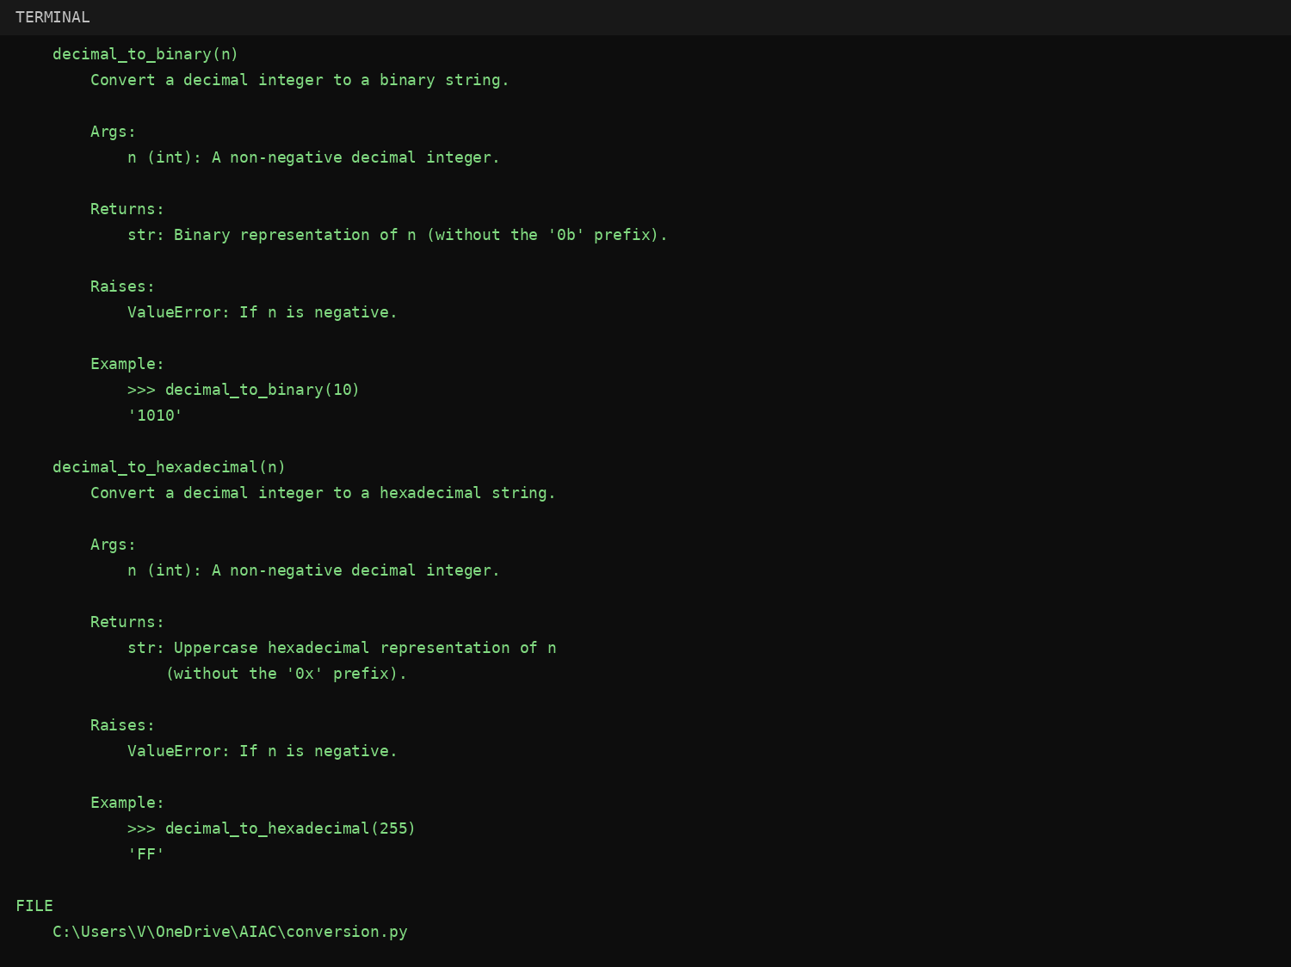
#export documentation as HTML (python -m pydoc -w conversion)
#conversion.html opened in a web browser
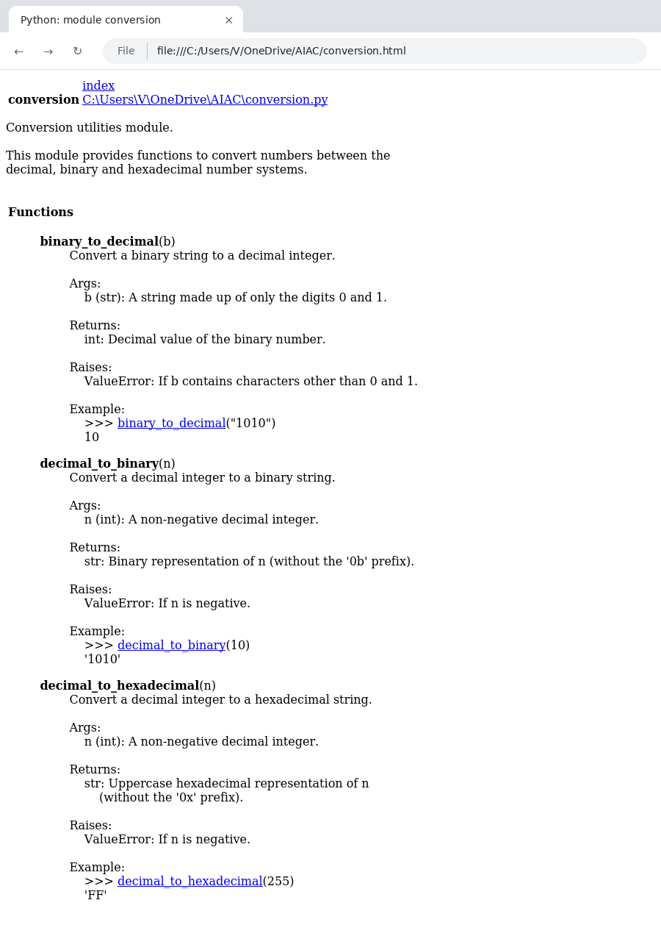
Problem 5 – Course Management Module
Question:
Task: Create a module course.py with functions: add_course(course_id, name, credits), remove_course(course_id), get_course(course_id).
Add docstrings with Copilot. Generate documentation in the terminal. Export the documentation in HTML format and open it in a browser.
Answer:
The module course.py below stores courses in memory and provides add_course(), remove_course() and get_course(), each with a docstring. A menu-driven main block takes the course details from the user.
#code
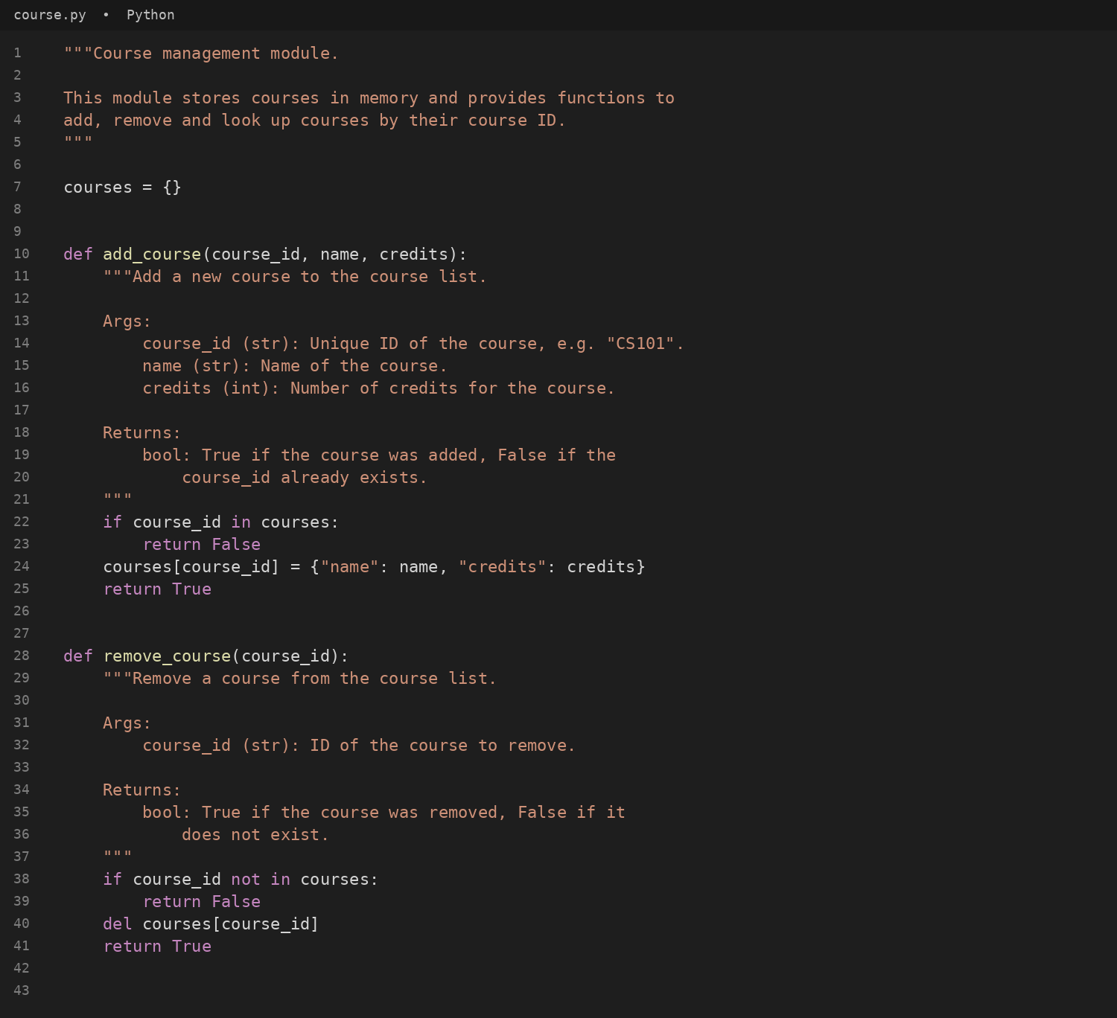
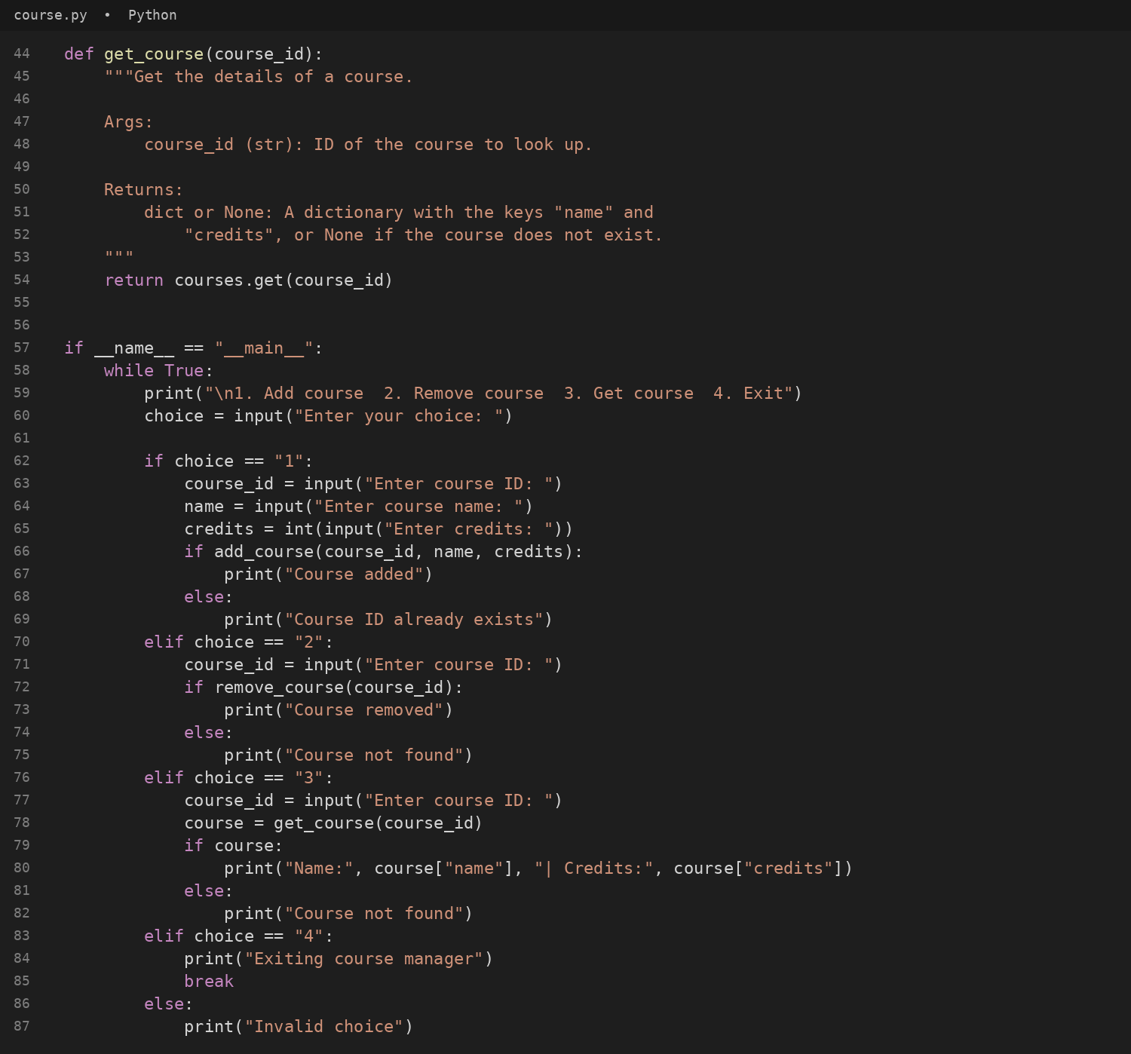
#output
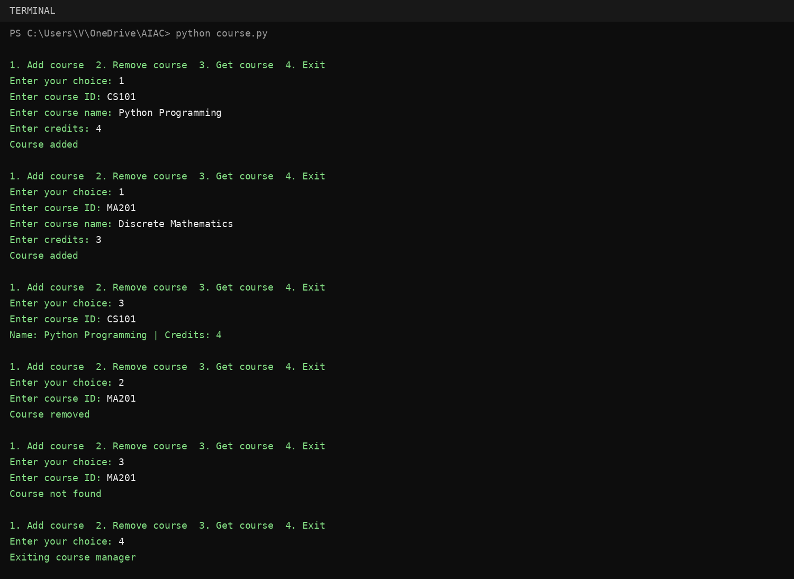
#documentation in the terminal (python -m pydoc course)
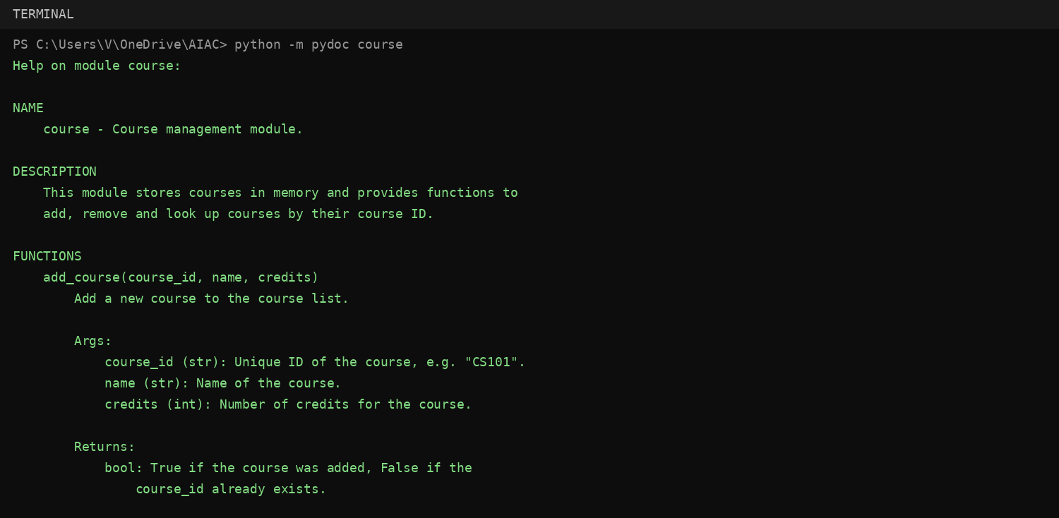
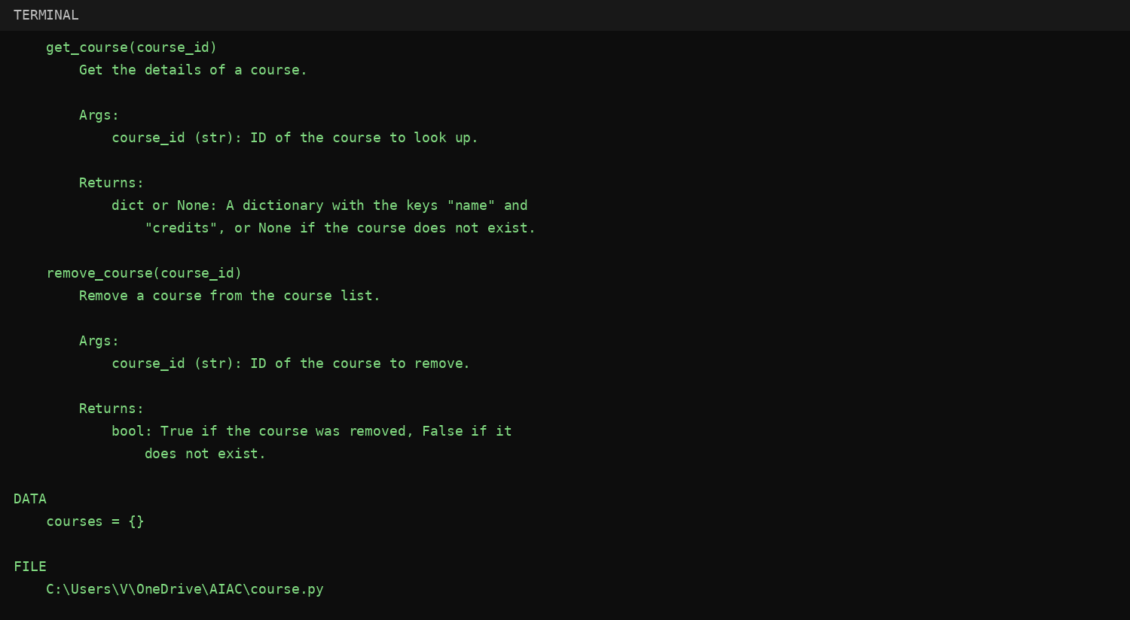
#export documentation as HTML (python -m pydoc -w course)
#course.html opened in a web browser
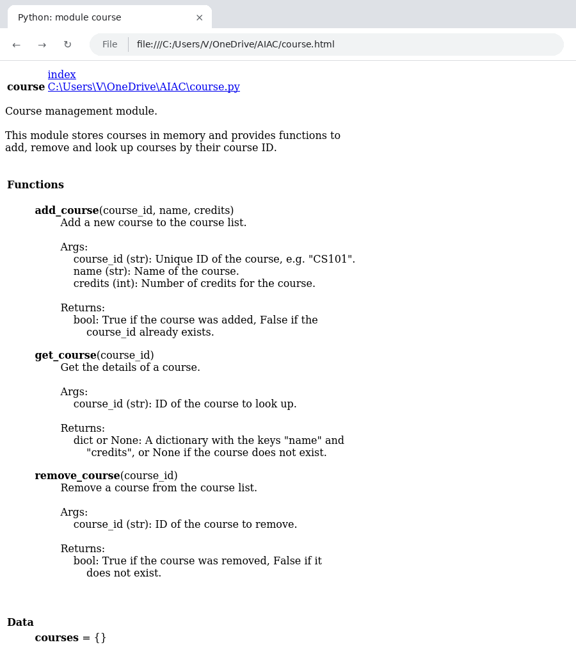
Conclusion
All five problems were completed. find_max() and login() were documented using docstrings, inline comments and Google-style documentation and the styles were compared. The modules calculator.py, conversion.py and course.py were documented with docstrings, viewed in the terminal with pydoc, exported as HTML pages with pydoc -w and verified in a web browser, as required in Lab 9.1.

