AS A CUSTOMER

* As a customer, I can login to my account. (* 1 point)
- This will need to be done before purchasing item
- Easier to maintain one session login session
- Access the user login credentials table

* As a customer, I can purchase items. (* 1 point)
- Item selected for purchase will first be added to a temp table (Check Out table) before being finalized for purchase
- This is accomplished by adding to Cart
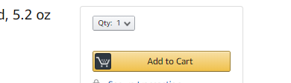
- A session for the items added to the shopping cart will be maintained and only become invalid upon completion of the orders. Example selecting Checkout
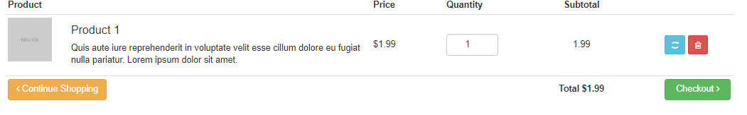
- The temp table will reflect the product table

* As a customer, I can view purchase history. (* 3 points)
- This is similar to our transaction table
- Only now we are viewing purchase for the selected users.

* As a customer, I can return purchase items. (* 2 points)
- From the purchase history table, you will have an option to return items
- Items return will need to be approve by an employee
- Return item will be credited to the store card only
- No item will have full refund price, only a percentage (this can be hard coded). Eg. 85% of the purchase price will be refunded.

* As a customer, I can apply for store card (* 2 points)
- Applying for store card will require the login session
- Below information is from the login session
UserLoginID (PK) | UserID (FK) | UserName | Password | Account Priv | Account Status
UID100 | ID100 | msmith | MikeSmith90 | CUSTOMER | ACTIVE
- Store card table
StoreCardID (PK) | UserID (FK) | UserLoginID | Balance
SID100 | ID100 | UID100 | 1000

* As a customer, I can purchase with my store card. (* 2 points)
- Easier to make this the default option for purchasing items
- We can take a look at how to implement other purchase options
* As a customer, I can request to have the parts assemble to build my workstation (* 2 points)
- Optional user story

