AS A USER

* As a user, I can view popular products available to purchase (* 2 points)
Dashboard populate purchase
- Every purchase adds a counter (count++) to the product table that increase its popularity
- Higher count display first
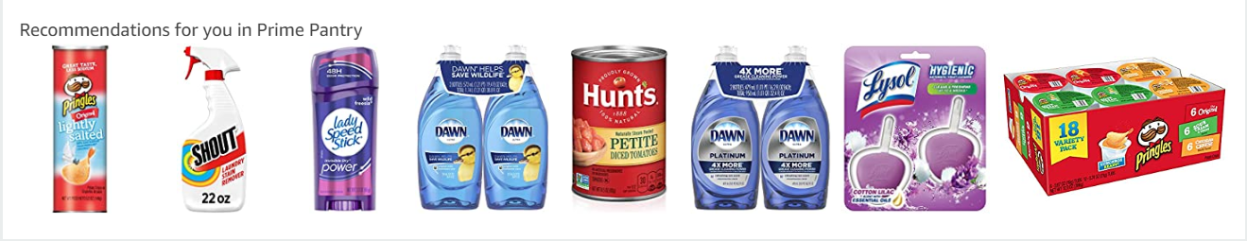

* As a user, I view additional information on each product that is available for purchase (* 3 points)
- Product detail is now available to the user
- User can view if an item is in stock (product table will have available number of item)
- Employee will refill the stock

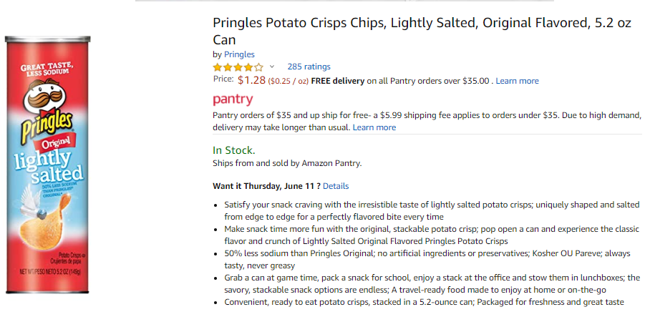

* As a user, I can register for a customer account. (* 3 points)
- This is the same as registering for a bank account in our P1
- Create a session, gather Personally Identifiable Information (PII)
- Select Next, continue the session, Gather Sensitive Information(SI) for User credentials

UserID (Auto) PK | First Name | Last Name | Address | Contact | email
ID100 | Mike | Smith | 141 Exam Street, NY 12341 | 1231231234 | mike@gmail.com

UserLoginID (PK) | UserID (FK) | UserName | Password | Account Priv | Account Status
UID100 | ID100 | msmith | MikeSmith90 | CUSTOMER | ACTIVE
 |  |  |  | EMPLOYEE
 |  |  |  | ADMIN

