Keegan Gunderson

Please include the following in your report.

* **Source code**
  + <https://github.com/gundie88/CS450/blob/master/Week_6/Neural_network.py>
* **Approach**
  + I chose the implementation option, this proved to be quite the challenge. I knew that in order to make a Neural Network that could be run on data I would need at least two classes, and a lot of methods. I started to make pseudo code for methods such as forward propagation, backwards propagation, activation, sigmoid, sigmoid prime, predict, and way to train (fit) the data. I stored the information I needed in lists.
* **Challenges**
  + The part of the assignment that gave me the most trouble was back propagation and the training of the data in the fit function. Coming to class and learning the math behind back propagation helped me fix that problem quite easily. To overcome the problem with the training I read a lot online and used my resources to help figure it out.
* **Results**

Iris dataset

Accuracy: 0.8666666666666667

Accuracy: 0.6666666666666666

Accuracy: 0.5333333333333333

Accuracy: 0.7333333333333333

Accuracy: 0.6666666666666666

Accuracy: 1.0

Accuracy: 0.6666666666666666

Accuracy: 0.9333333333333333

Accuracy: 0.6666666666666666

Accuracy: 0.9333333333333333

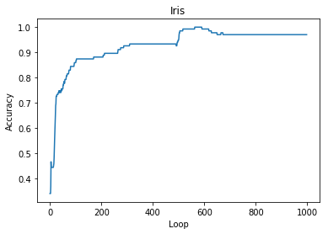My accuracy: 0.7666666666666668

Scikits accuracy: 0.9733333333333334

Wine dataset

Accuracy: 1.0

Accuracy: 1.0

Accuracy: 1.0

Accuracy: 1.0

Accuracy: 1.0

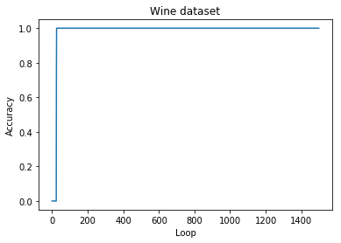

My classifier accuracy: 0.5

Scikit classifier accuracy: 0.5

* **Above and Beyond**
  + I didn’t make any efforts to go above and beyond.
* **Assessment**

Please state which category you feel best describes your assignment and give a 1-2 sentence justification for your choice:

* + A) Some attempt was made
  + B) Developing, but significantly deficient
  + C) Slightly deficient, but still mostly adequate
  + D) Meets requirements
  + E) Shows creativity and excels above and beyond requirements.
* I met the requirements because I showed that my algorithm has the ability to change how many layers, and it was able to learn on two different datasets. I was able to make a graph of the accuracy over the duration of the loop.