DMR Report

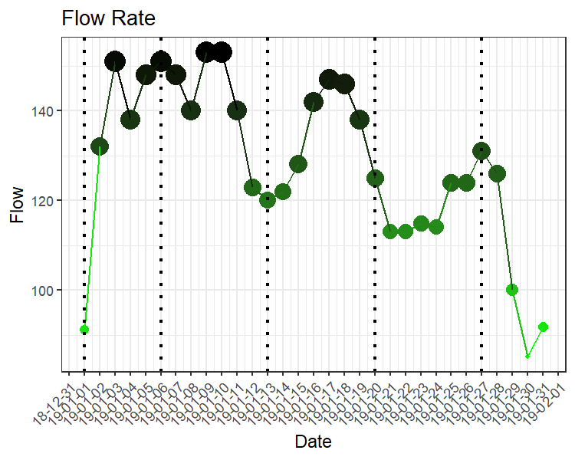

|  |  |  |  |  |
| --- | --- | --- | --- | --- |
| Week Number | mean | max | min | Count |
| 1 | 132.0 | 151 | 91.1 | 5 |
| 2 | 144.0 | 153 | 123.0 | 7 |
| 3 | 134.7 | 147 | 120.0 | 7 |
| 4 | 118.3 | 125 | 113.0 | 7 |
| 5 | 106.8 | 131 | 85.2 | 5 |
| JanuaryAverage | 128.2 | 153 | 85.2 | 31 |