Assignment: 5.4
Name: Lokesh Reddy
Hno: 2303a51676

Task Description #1:
- Prompt GitHub Copilot to generate a Python script that collects user data (e.g., name, age, email). Then, ask Copilot to add comments on how to anonymize or protect this data.

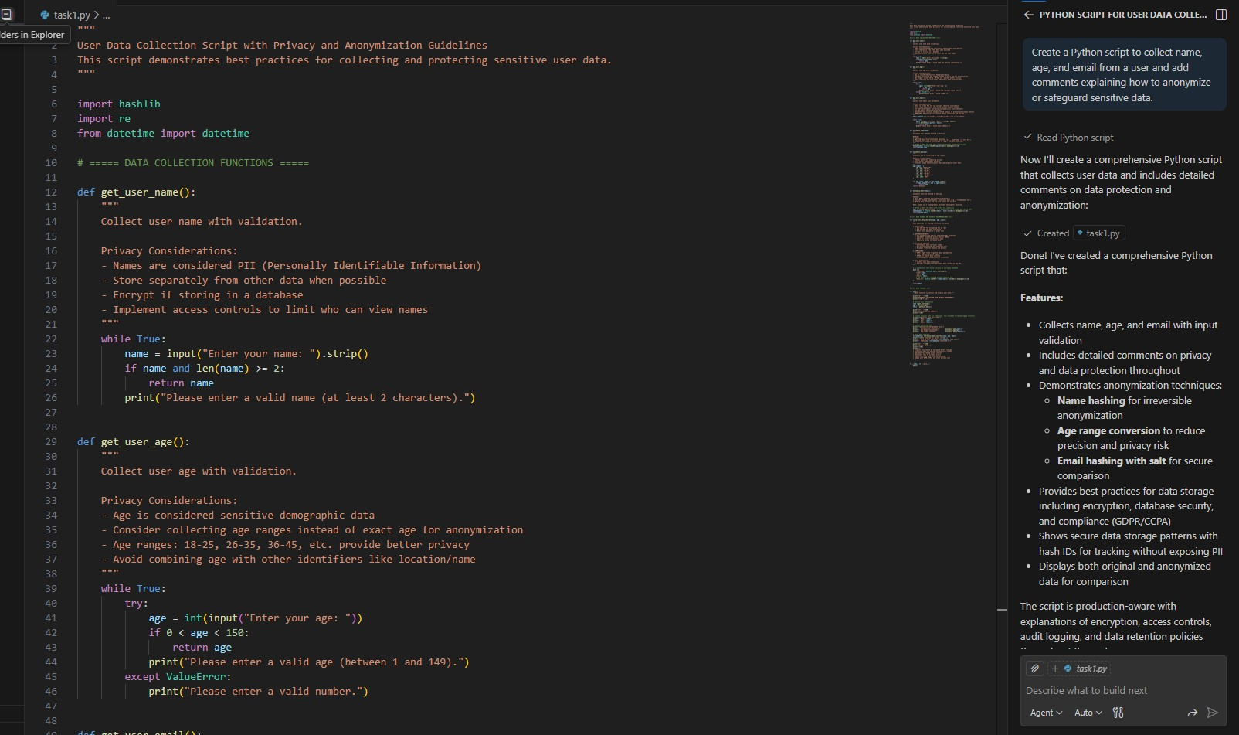
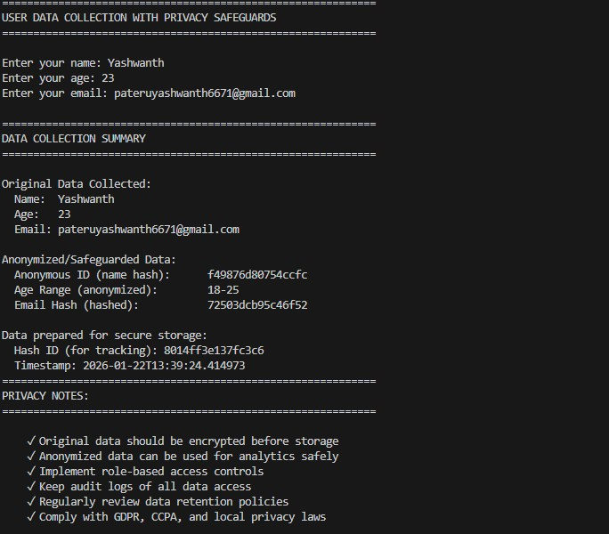
Task Description #2:
- Ask Copilot to generate a Python function for sentiment analysis. Then prompt Copilot to identify and handle potential biases in the data.
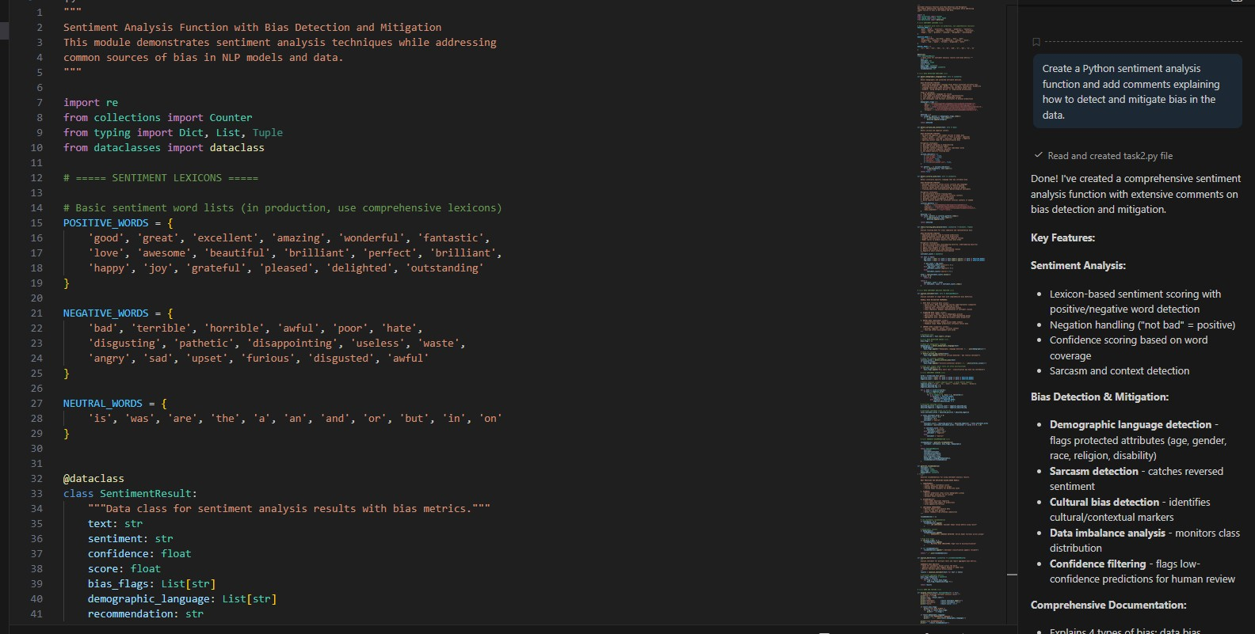
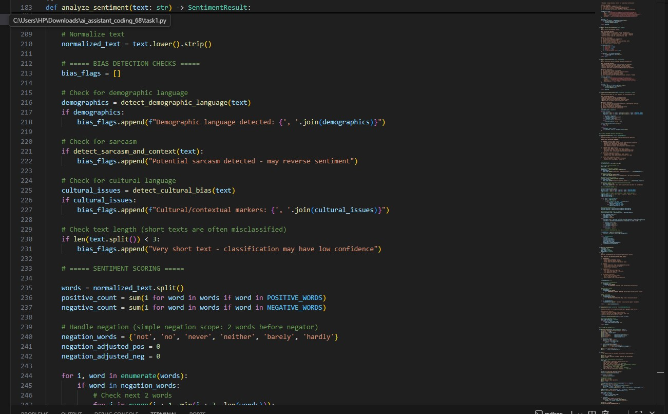
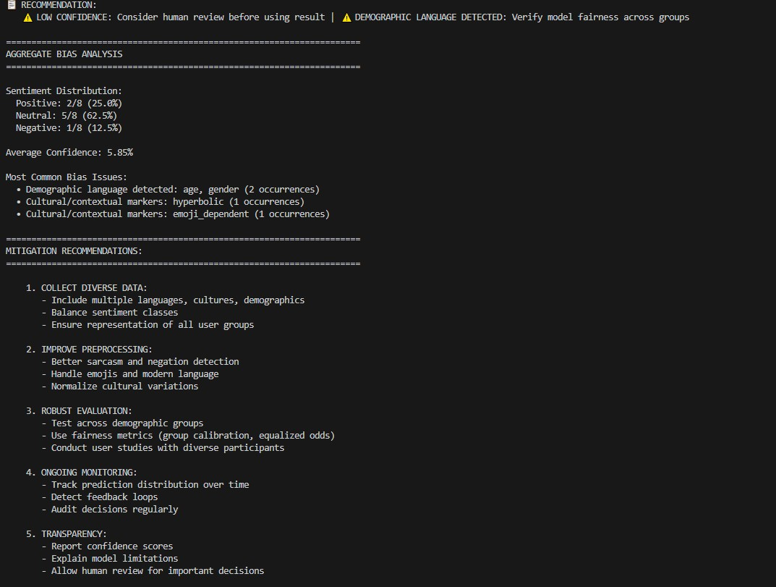
Task Description #3:
- Use Copilot to write a Python program that recommends products based on user history. Ask it to follow ethical guidelines like transparency and fairness.
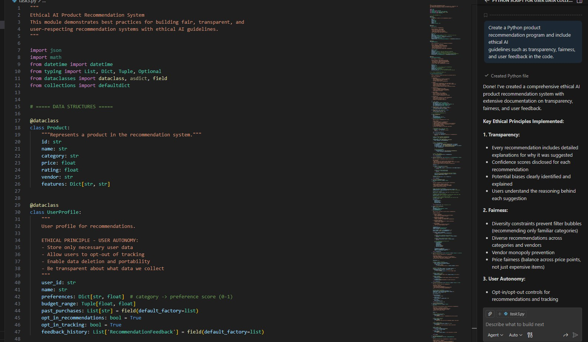
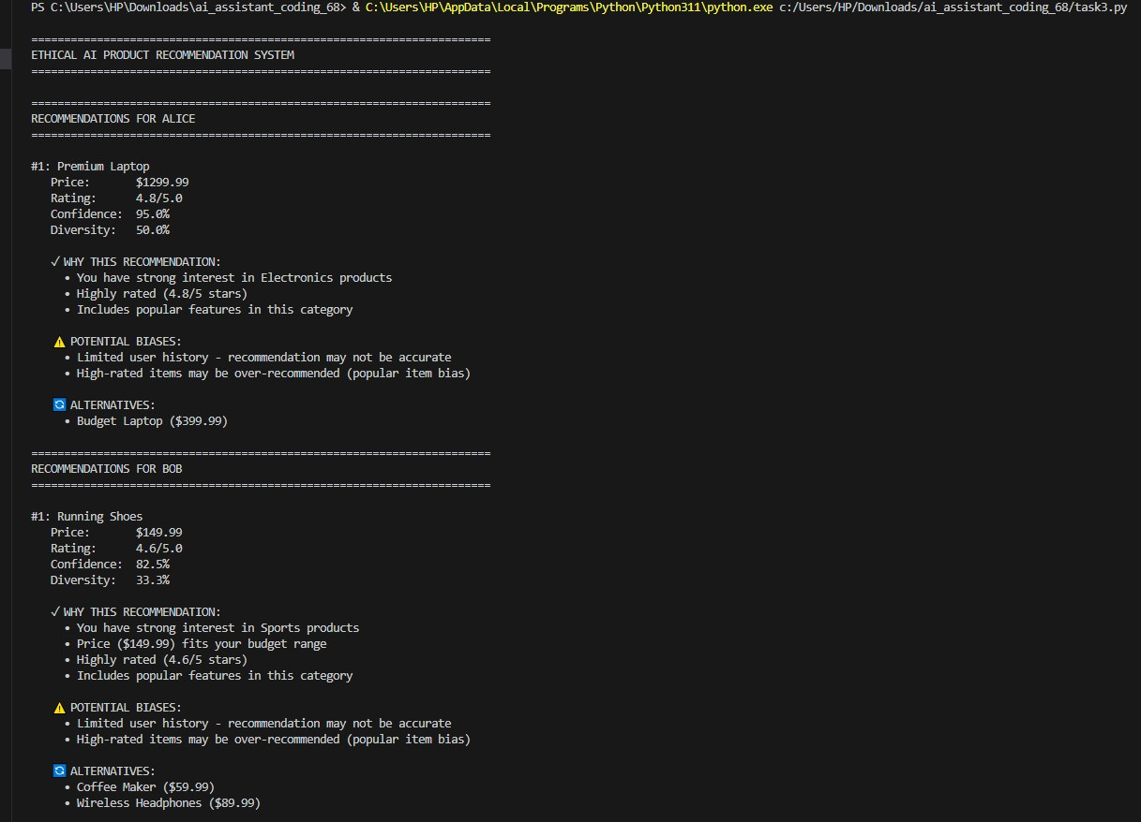
Task Description #4:
- Prompt Copilot to generate logging functionality in a Python web application. Then, ask it to ensure the logs do not record sensitive information.

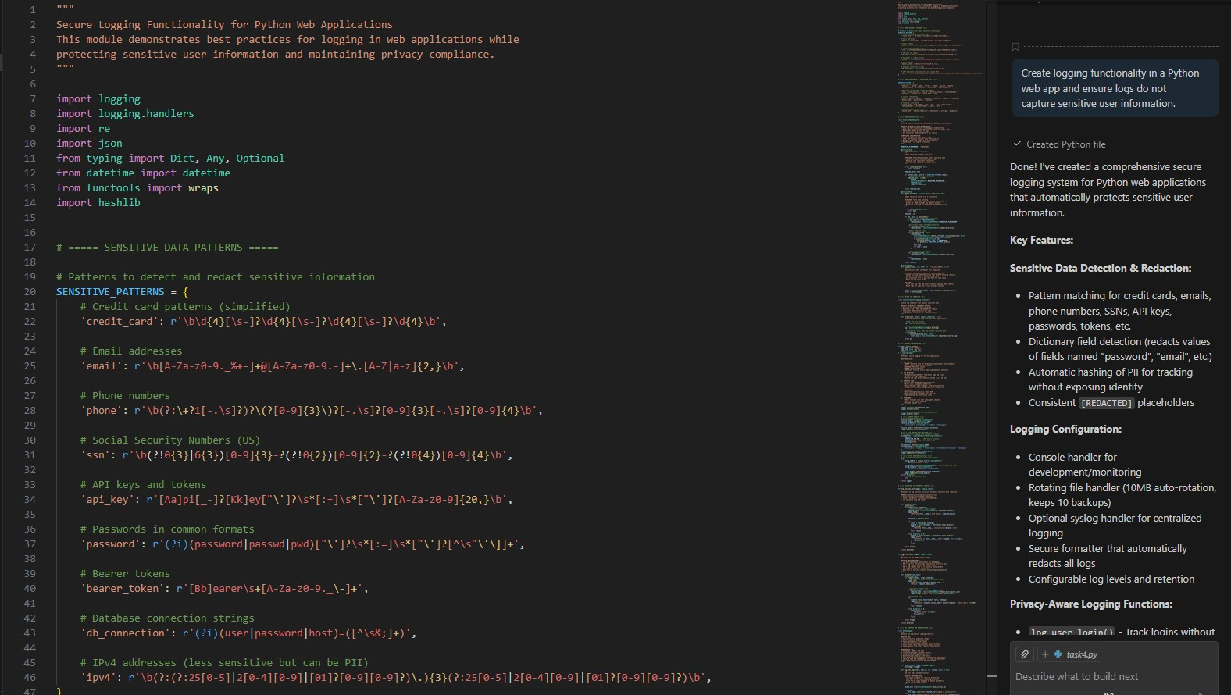
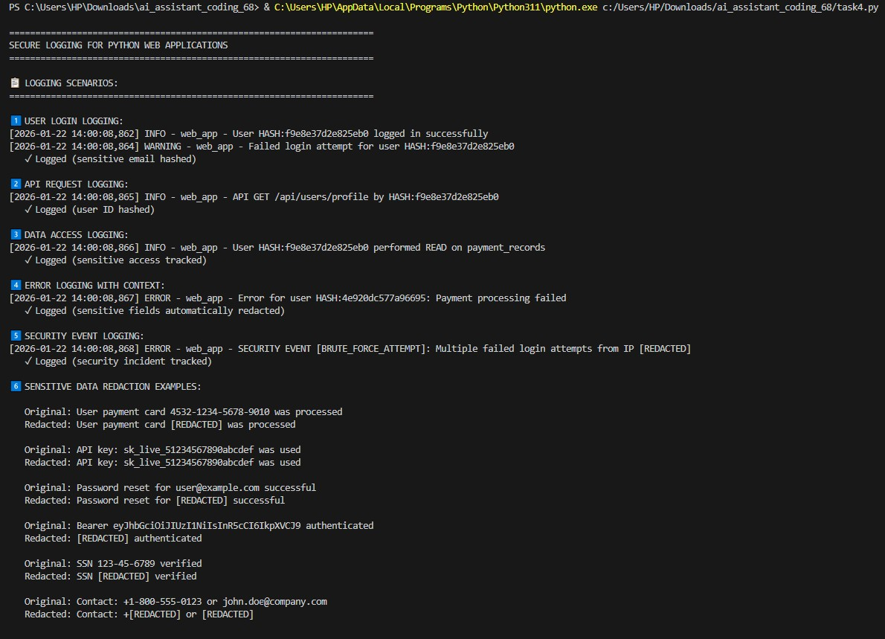
Task Description #5:
- Ask Copilot to generate a machine learning model. Then, prompt it to add documentation on how to use the model responsibly
(e.g., explainability, accuracy limits).
