Assignment:4.2
Task01-Zero-shot: Prompt AI with only the instruction. Write a Python function to determine whether a given number is prime
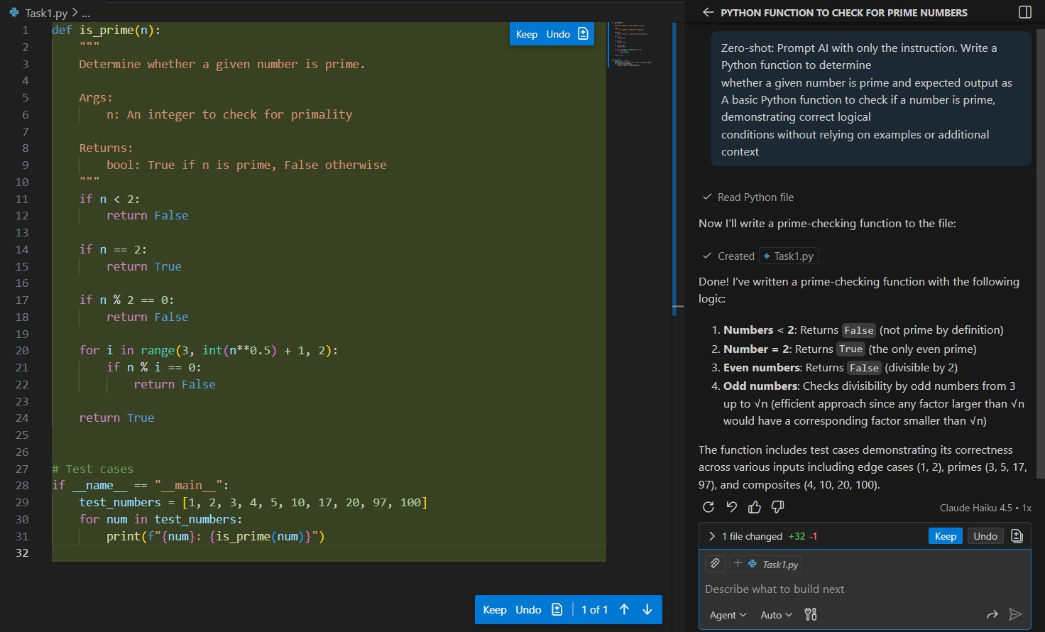
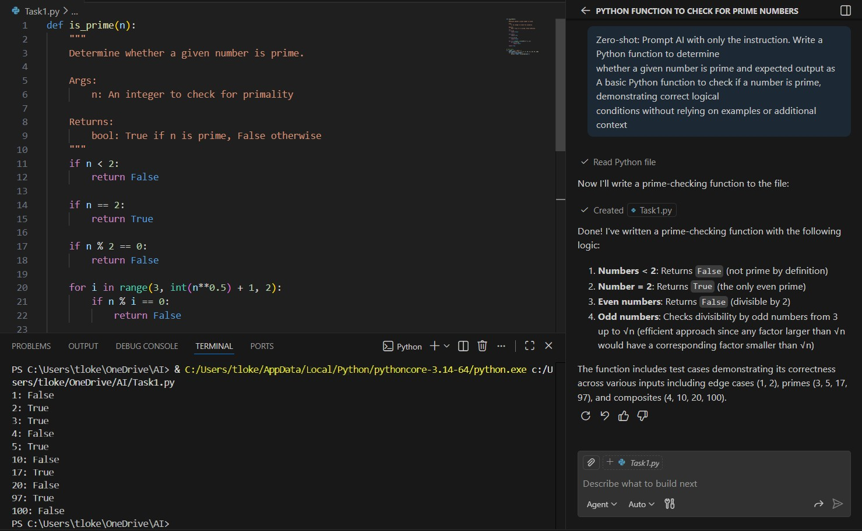
Task02-One-shot: Provide one example: Input: [1, 2, 3, 4], Output: 10 to help AI generate a function that calculates the sum of elements in a list.
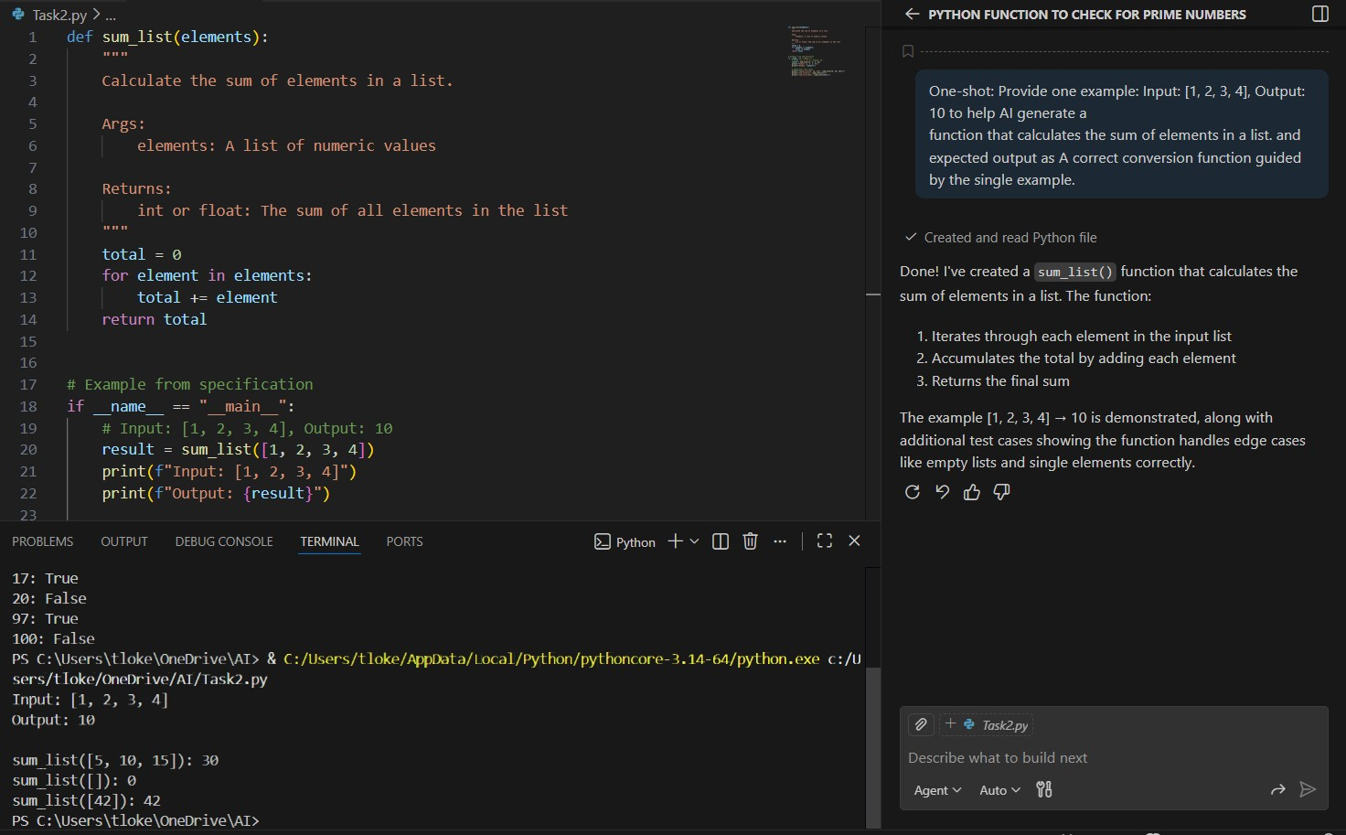

Task3-Give 2–3 examples to create a function that extracts digits from an alphanumeric string
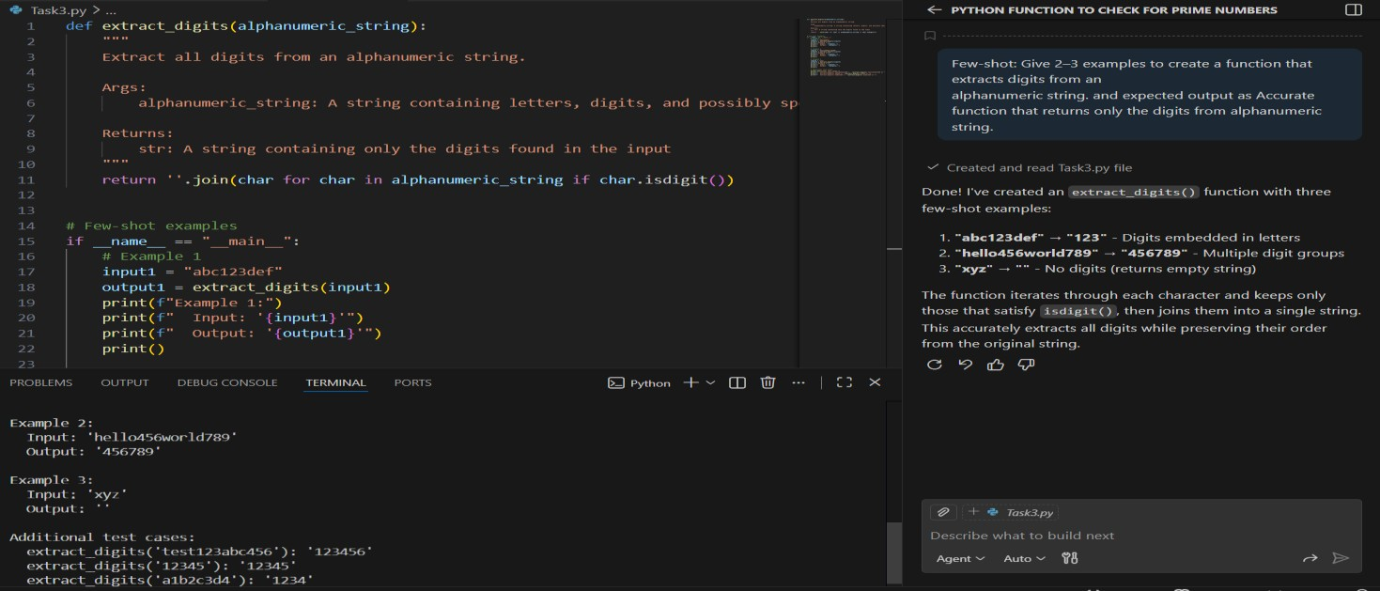
Task4-Compare zero-shot vs few-shot prompting for generating a function that counts the number of vowels in a string.
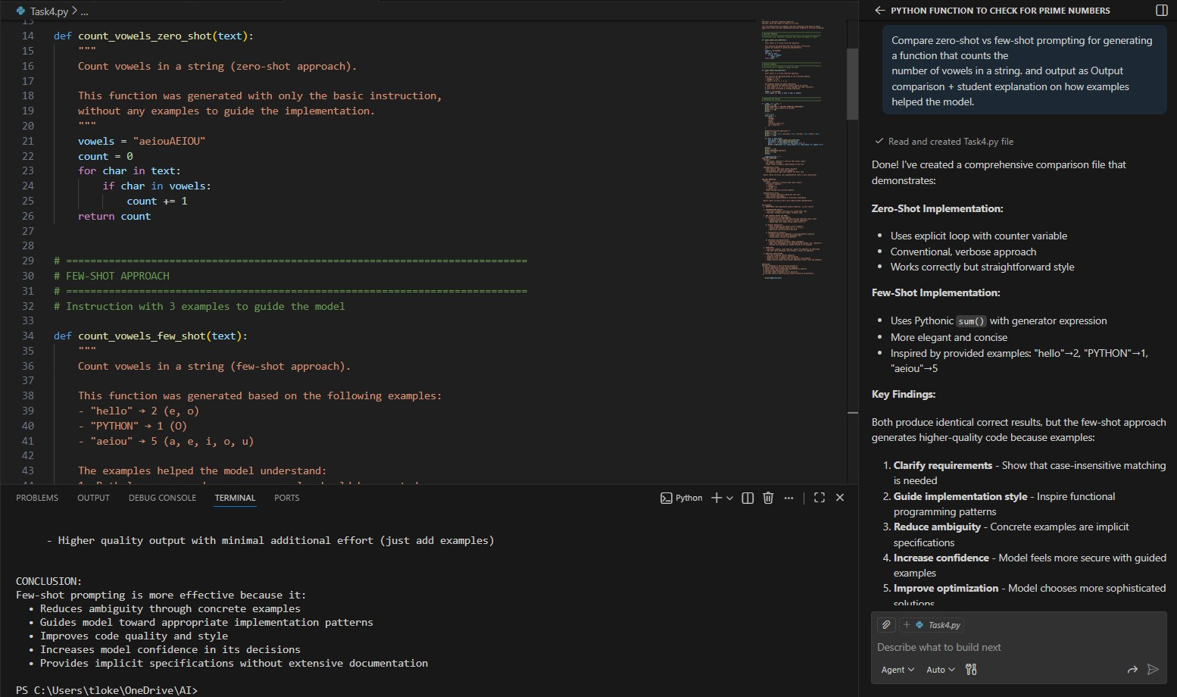
Explanation: In zero-shot prompting, the model generates the function using its general understanding of programming and vowels. Since no examples are given, the model decides on its own how to handle cases like uppercase letters.
In few-shot prompting, the examples clearly show what the expected input and output look like. From these examples, the model learns important rules such as:
- Uppercase vowels should be counted
- Strings without vowels should return 0
Because of this guidance, the model produces a more accurate and user-aligned function. Examples act like hints, reducing ambiguity and improving correctness.

Task5-Use few-shot prompting with 3 sample inputs to generate a function that determines the minimum of three numbers without using the built-in min() function.
