|  |  |  |  |  |  |  |  |
| --- | --- | --- | --- | --- | --- | --- | --- |
| **SCHOOL OF COMPUTER SCIENCE AND ARTIFICIAL INTELLIGENCE** | | | | **DEPARTMENT OF COMPUTER SCIENCE ENGINEERING** | | | |
| **Program Name:** B. Tech | | | **Assignment Type: Lab** | | | **AcademicYear:**2025-2026 | |
| **Course Coordinator Name** | | | Venkataramana Veeramsetty | | | | |
| **Instructor(s)Name** | | | 1. Dr. Mohammed Ali Shaik 2. Dr. T Sampath Kumar 3. Mr. S Naresh Kumar 4. Dr. V. Rajesh 5. Dr. Brij Kishore 6. Dr Pramoda Patro 7. Dr. Venkataramana 8. Dr. Ravi Chander 9. Dr. Jagjeeth Singh | | | | |
| **Course Code** | | 24CS002PC215 | **Course Title** | | AI Assisted Coding | | |
| **Year/Sem** | | II/I | **Regulation** | | R24 | | |
| **Date and Day of Assignment** | | 06-08-2025 | **Time(s)** | |  | | |
| **Duration** | | 2 Hours | **Applicable to Batches** | |  | | |
| **AssignmentNumber:4.5**(Present assignment number)/**24**(Total number of assignments) | | | | | | | |
| Name: Gundu Meghana  Roll NO: 2403A510C1  Batch: 04 | | | | | | | |
| **Q.**  **No.** | **Question** | | | | | | ***Expected Time to***  ***complete*** |
| 1 | **Lab 4: Advanced Prompt Engineering: Zero-shot, one-shot, and few-shot techniques**  **Objective:** To explore and compare Zero-shot, One-shot, and Few-shot prompting techniques for classifying emails into predefined categories using a large language model (LLM).  Suppose that you work for a company that receives hundreds of customer emails daily. Management wants to automatically classify emails into categories like "Billing", "Technical Support", "Feedback", and "Others" before assigning them to appropriate departments. Instead  of training a new model, your task is to use prompt engineering techniques with an existing LLM to handle the classification. | | | | | | 08.08.2025  EOD |

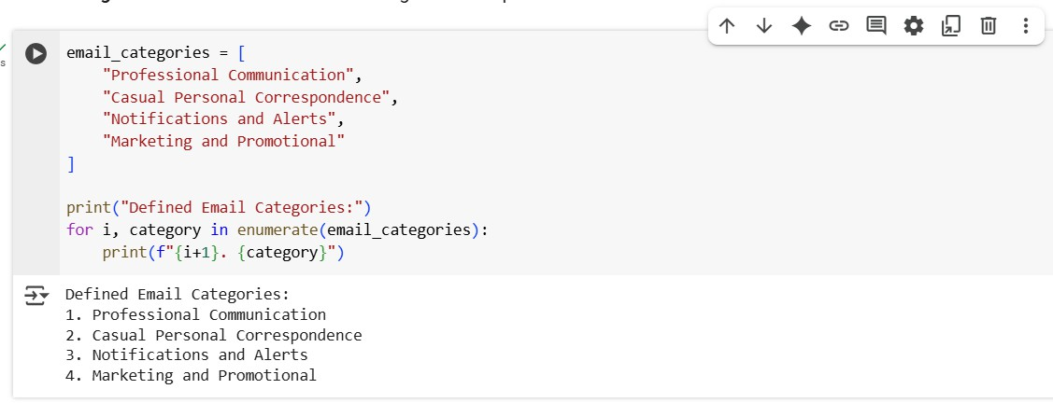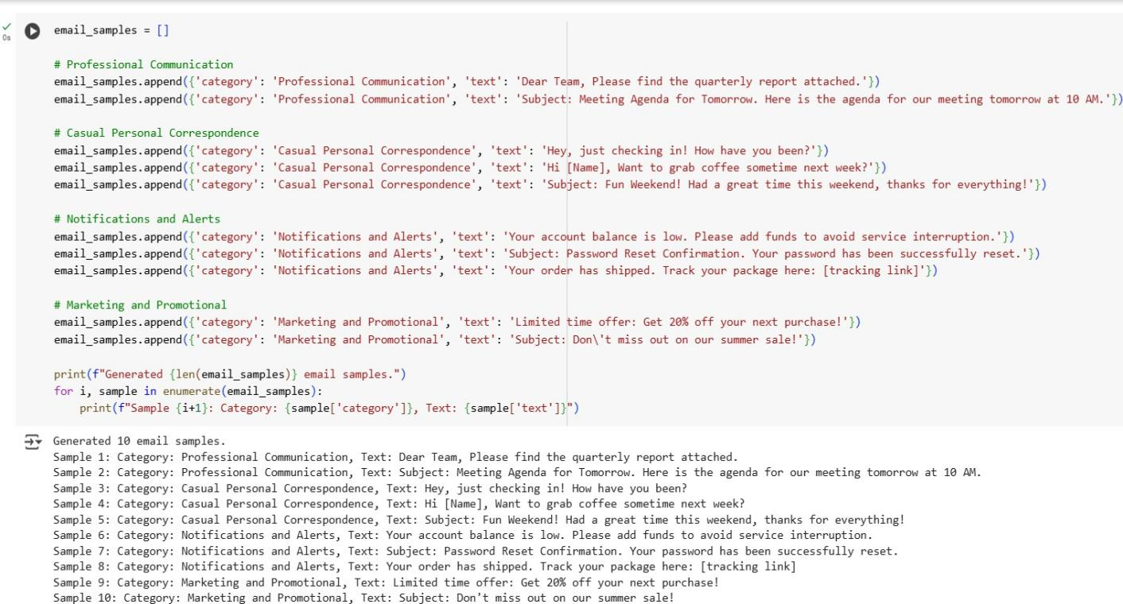

Tasks to be completed are as below

# Prepare Sample Data:

* + Create or collect 10 short email samples, each belonging to one of the 4 categories.

PROMPT: give a code Create or collect 10 short email samples, each belonging to one of the 4 categories

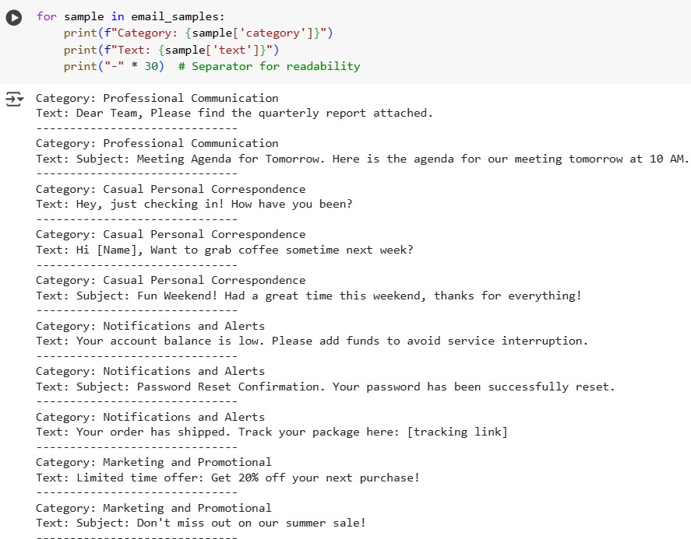

# Zero-shot Prompting:

* + Design a prompt that asks the LLM to classify a single email without providing any examples.
  + Example prompt:

*“Classify the following email into one of the following categories: Billing, Technical Support, Feedback, Others. Email: ‘I have not received my invoice for last month.’”*

*Prompt: GENERATE A CODE WHICH TAKES EMAILS FROM USER INPUT AND CODE*

*SHOULD GIVE OUTPUT AS FROM WHICH CATEGORY ( feedback, billing, technical support and others) THE EMAIL BELONGS TO.*

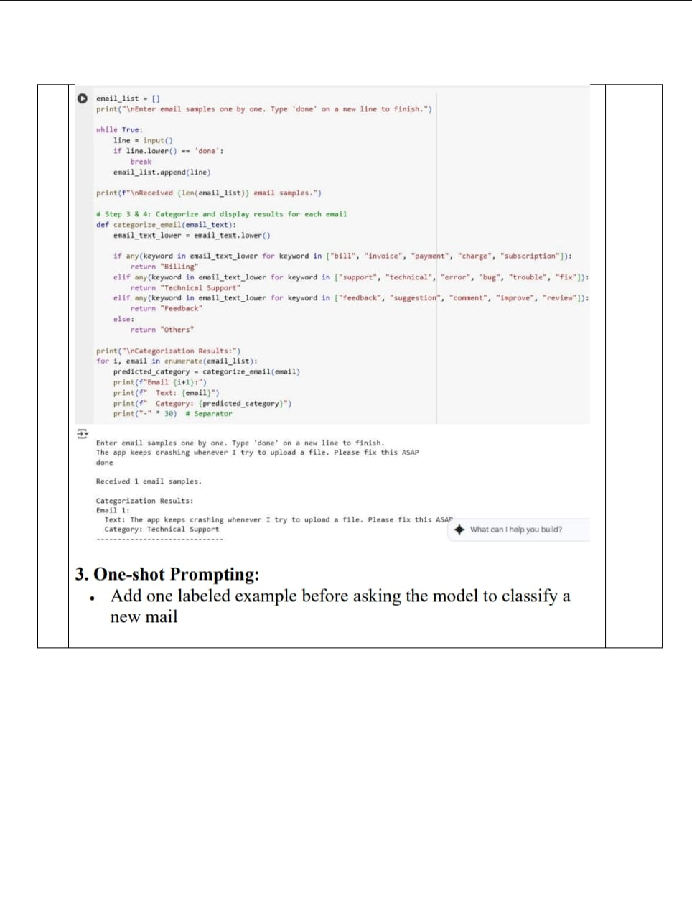

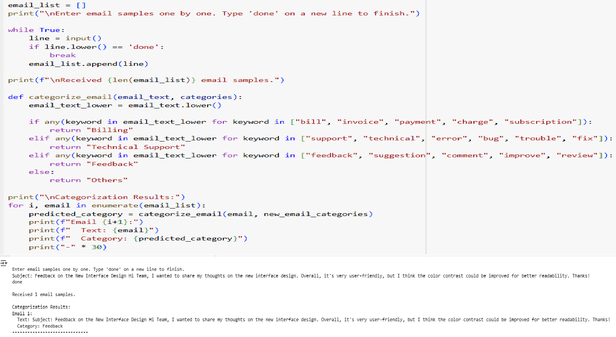

# 4.Few-shot Prompting:

* + Use 3–5 labeled examples in your prompt before asking the model to classify a new email.

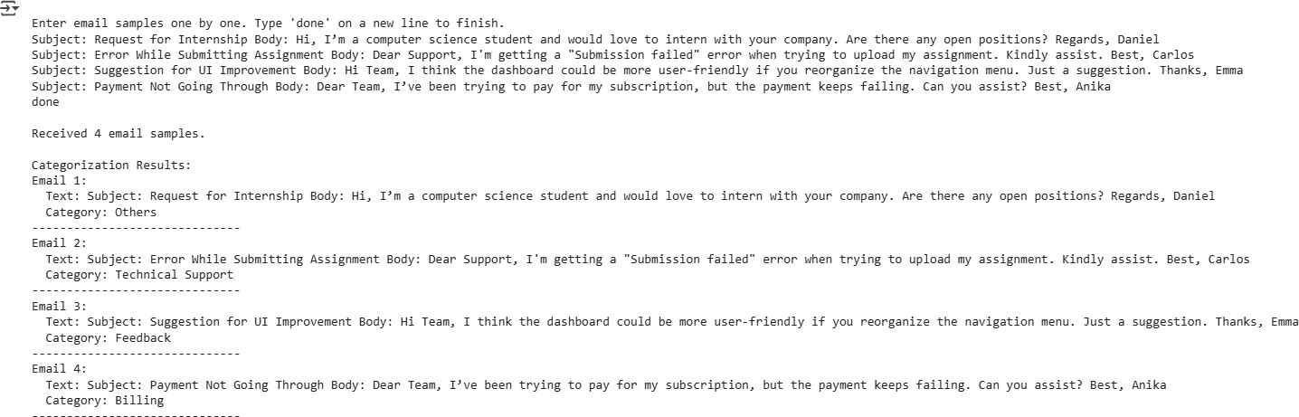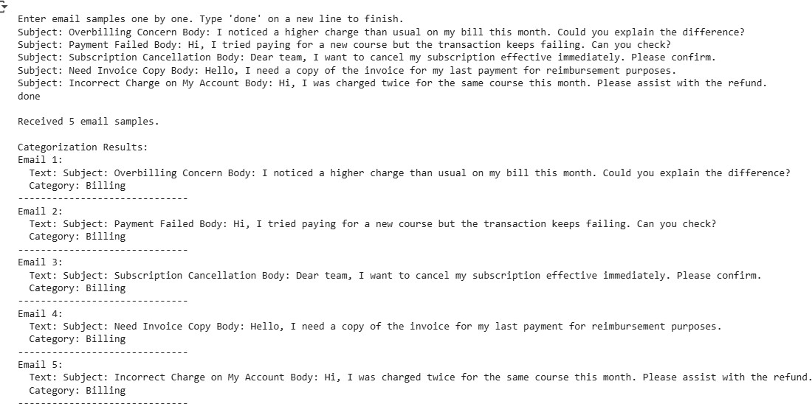

# 5.Evaluation:

* + Run all three techniques on the same set of 5 test emails.
  + Compare and document the accuracy and clarity of responses.

5 TEST EMAILS ON BILLING:

**5 TEST EMAILS ON FEEDBACK:**

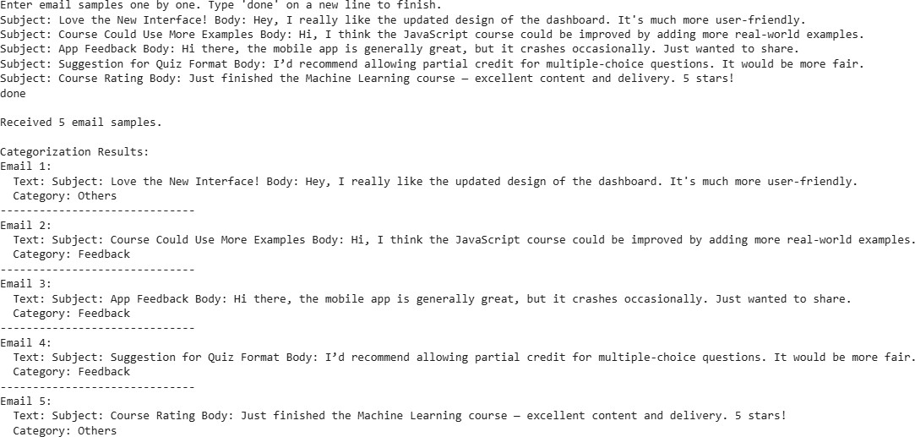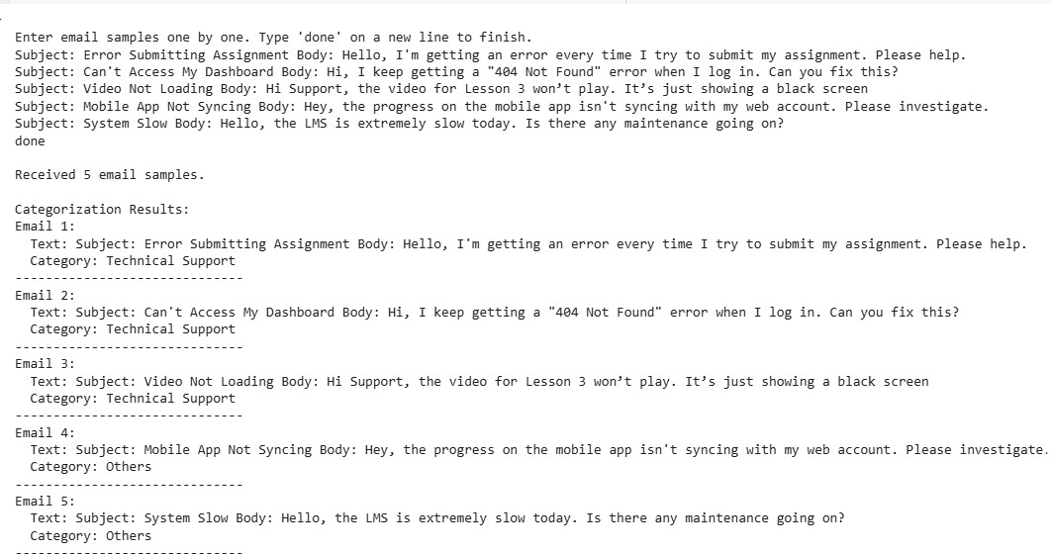

**5 TEST EMAILS ON TECHNICAL SUPPORT:**

**5 TEST EMAILS ON OTHERS:**

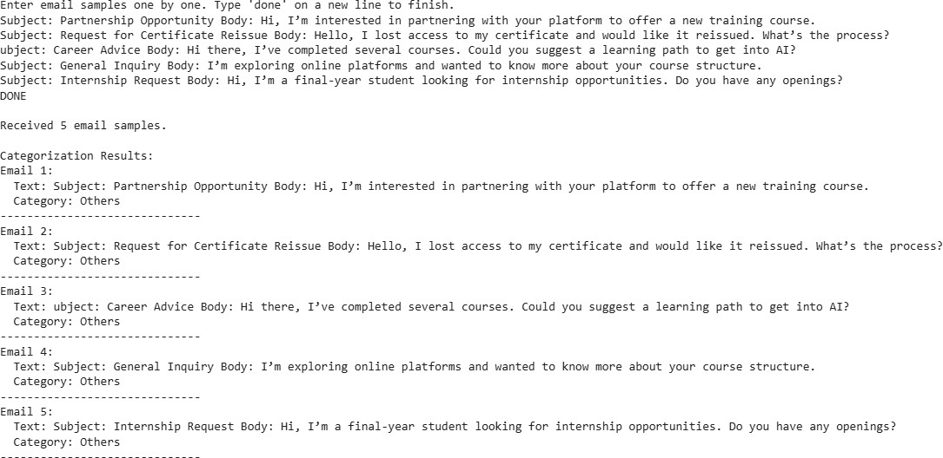

**Requirements:**

* VS Code with Github Copilot or Cursor IDE and/or Google Colab with Gemini

**Deliverables:**

* A .txt or .md file showing prompts and model responses.
* A comparison table showing classification accuracy for each technique.
* A short reflection on which method was most effective and why

.