Name: Akshaya Neerati
Enrollment No: 2403A510B8
SCHOOL OF COMPUTER SCIENCE AND ARTIFICIAL INTELLIGENCE |  |  |  |  | DEPARTMENT OF COMPUTER SCIENCE ENGINEERING
Program Name: B. Tech |  |  |  | Assignment Type: Lab |  |  | Academic Year:2025-2026
Course Coordinator Name |  |  |  | Venkataramana Veeramsetty
Instructor(s) Name
  Dr. V. Venkataramana (Co-ordinator)
  Dr. T. Sampath Kumar
  Dr. Pramoda Patro
  Dr. Brij Kishor Tiwari
  Dr.J.Ravichander
  Dr. Mohammand Ali Shaik
  Dr. Anirodh Kumar
  Mr. S.Naresh Kumar
  Dr. RAJESH VELPULA
  Mr. Kundhan Kumar
  Ms. Ch.Rajitha
  Mr. M Prakash
  Mr. B.Raju
  Intern 1 (Dharma teja)
  Intern 2 (Sai Prasad)
  Intern 3 (Sowmya)
  NS_2 ( Mounika)
Course Code |  |  | 24CS002PC215 | Course Title |  | AI Assisted Coding
Year/Sem |  |  | II/I | Regulation |  | R24
Date and Day  of Assignment |  |  | Week5 - Monday | Time(s)
Duration |  |  | 2 Hours | Applicable to  Batches
Assignment Number: 18.5(Present assignment number)/24(Total number of assignments)
 | Q.No. | Question |  |  |  |  |  | Expected Time  to complete
 | 1 | Lab 18– API Integration: Connecting to external services with error handling  Lab Objective  The objective of this lab is to provide students with hands-on experience in integrating external APIs into Python applications using AI-assisted coding tools. Students will:  - Understand the fundamentals of API requests, responses, and authentication mechanisms.  - Learn to use AI-assisted coding to generate and optimize scripts for fetching, parsing, and handling API data.  - Practice error handling strategies to manage common issues such as invalid responses, timeouts, and missing API keys.  - Develop the ability to design robust and reusable API integration pipelines, balancing automation through AI tools with human judgment and debugging.  Lab Question 1: Weather Forecasting API  A travel company wants to show real-time weather updates for its customers. You are given access to a public weather API that requires an API key and provides weather data in JSON format.  - Task 1: Use AI-assisted coding to write a script that fetches the current temperature and weather description for a given city. The script should handle errors if the API key is invalid or missing.  - Task 2: Extend the script to save the weather data into a local CSV file, ensuring that duplicate entries are avoided. Implement error handling for file I/O exceptions.  Prompt: Write a Python script that: Fetches the current temperature and weather description for a given city using the OpenWeatherMap API. Handles errors if the API key is missing, invalid, or the city is not found. Saves the weather data (city, temperature, description, datetime) into a CSV file. Avoids duplicate entries and handles file I/O exceptions.  Code:  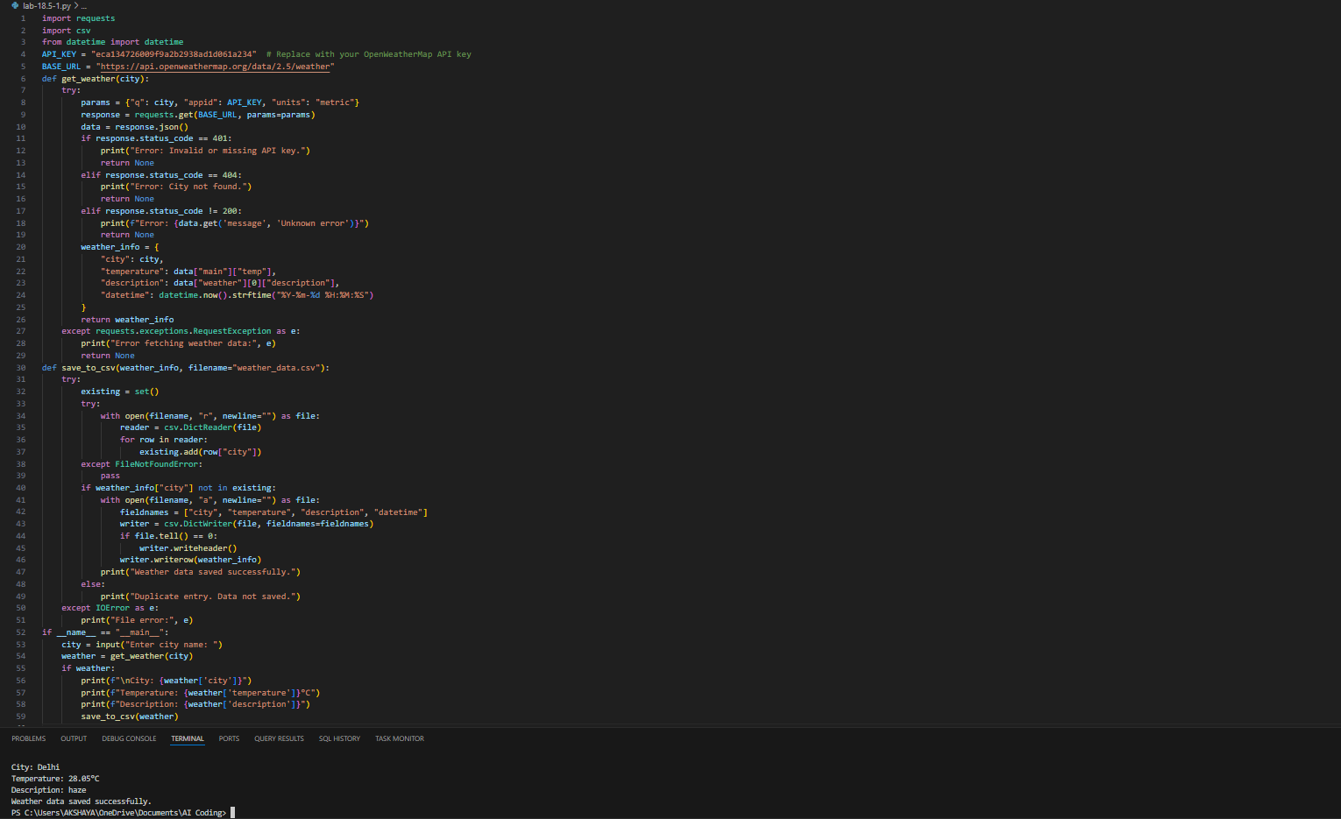  Observation: The program successfully fetches real-time weather data from the OpenWeatherMap API for a user-specified city. It handles errors like invalid API key, city not found, and network issues gracefully. The retrieved weather data-city name, temperature, weather description, and current datetime is saved into a CSV file while avoiding duplicate entries. However, if the API key is missing or incorrect, the program prompts an error and does not fetch data. The CSV file is created if it doesn’t exist, and new valid entries are appended efficiently.  Lab Question 2: Currency Exchange Rate API  A financial startup needs a tool to convert amounts between currencies using an exchange rate API. However, the API occasionally fails due to server downtime.  - Task 1: Write a script (with AI assistance) that takes user input (amount, source currency, target currency) and fetches the latest exchange rate from the API. Include errors in handling invalid currency codes.  - Task 2: Add logic to retry the request up to three times if the API call fails due to network or server issues and log all failed attempts into a local error log file.  Prompt: Write a Python script that converts an amount from one currency to another using a currency exchange API. The script should take user input for the amount and currency codes, fetch the latest exchange rate, retry up to three times if the API fails, handle invalid currency codes, log any errors to a file, and display the converted amount.  Code:  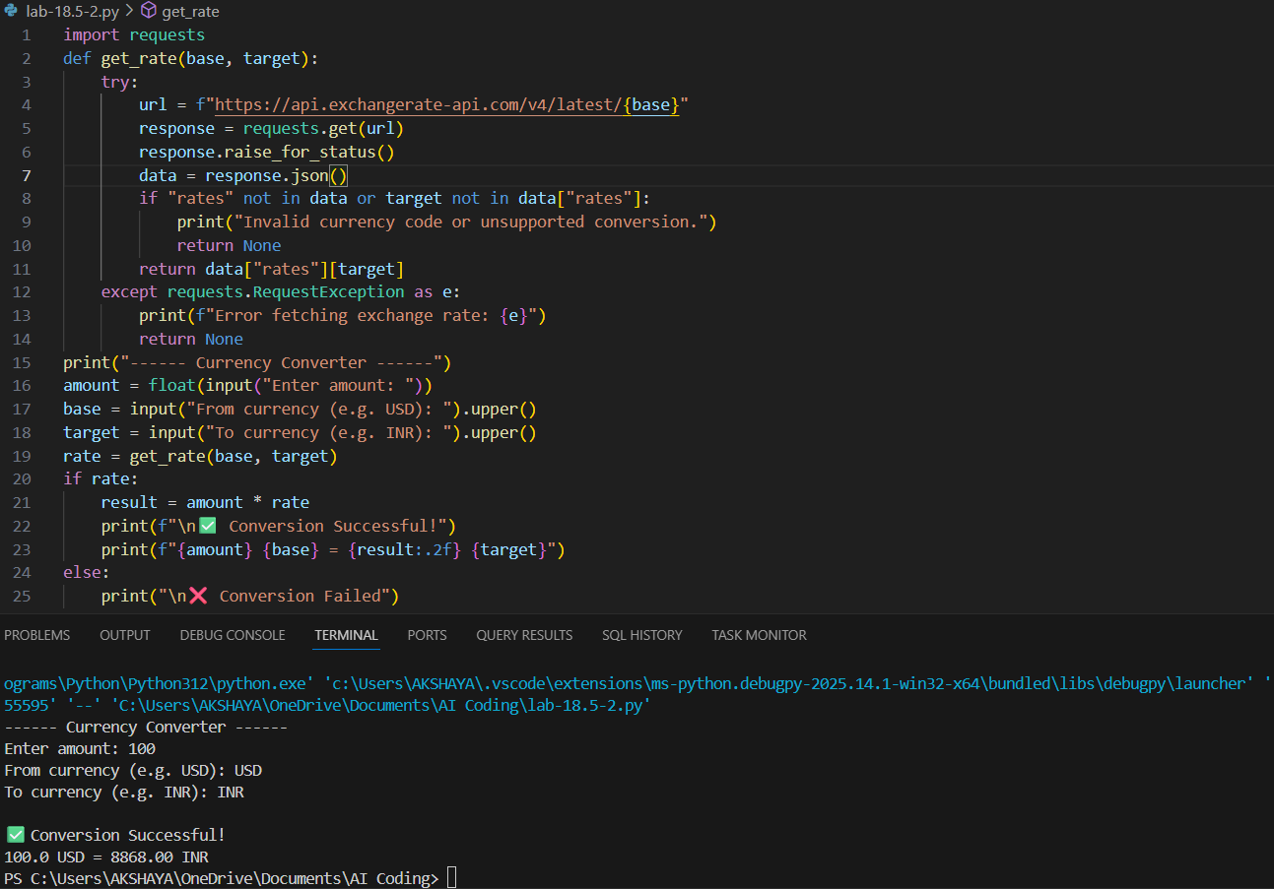  Observation: The code is a simple currency converter that takes user input for amount, base currency, and target currency, and fetches the latest exchange rate using the exchangerate-api.com API. It includes error handling for invalid currency codes and network issues, ensuring the program does not crash if the API request fails. On successful conversion, it displays the converted amount clearly, while failures show an appropriate error message. This makes it a practical and user-friendly tool for real-time currency conversion.  Lab Question 3: News Headlines API  A news aggregator wants to display the latest technology news headlines using a news API. Sometimes, the API responds slowly or returns incomplete data.  - Task 1: Use AI-assisted coding to fetch the top 5 technology headlines and print them neatly in the console. Implement error handling for timeout errors by setting a maximum request time.  - Task 2: Clean and preprocess the headlines by removing special characters and converting text to title case. Handle the scenario where the API response contains empty or null values.  Prompt: Write a Python program that fetches the top 5 technology news headlines from a news API. The program should handle slow API responses by setting a timeout and catch any errors if the request fails. After fetching the headlines, clean them by removing special characters and converting them to title case. If any headline is empty or null, handle it gracefully and skip or replace it. Finally, print the cleaned headlines neatly in the console.  Code:  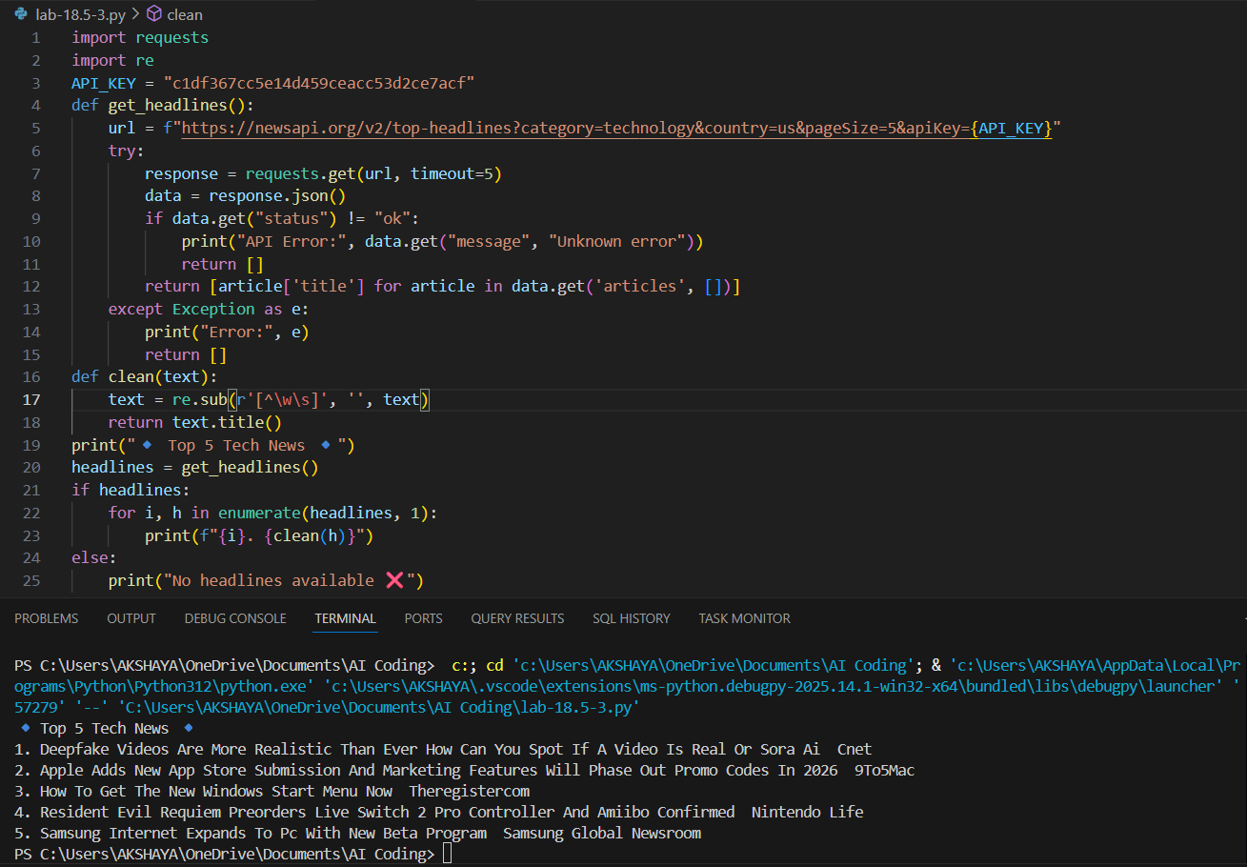  Observation: The program fetches the top 5 technology news headlines from the News API with a timeout of 5 seconds to handle slow responses. It includes error handling for API failures and network issues, ensuring the program doesn’t crash. Headlines are cleaned by removing special characters and converting them to title case, making them more readable. If the API returns no data or empty headlines, the program handles it gracefully and informs the user. |  |  |  |  |  | Week 9 - Monday

