2. Four Core Use Cases in a Software Requirements Specification Document

Use Case 1:
Title: Browse Ranked Feed
Main Actor: User
Goal: View a ranked list of posts (e.g., Top, New).
Preconditions:
- The system is running.
- Posts exist in the database.

Main Flow:
- The user accesses the main page.
- The user selects a feed type (if applicable).
- The system retrieves posts using the selected ranking strategy.
- The system displays the ranked feed.

Postconditions:
- The user can view and select posts from the feed.

Use Case 2:
Title: Submit Post
Main Actor: User
Goal: Submit a new post (link or text).
Preconditions:
- The user is authenticated (if authentication is implemented).
Main Flow:
- The user opens the submission form.
- The user enters post details (title and content/link).
- The system validates the input.
- The system saves the post to the database.
- The system confirms successful submission.
Postconditions:
- The new post appears in the appropriate feed.

Use Case 3:
Title: Add Comment
Main Actor: User
Goal: Add a comment to a post.
Preconditions:
- The selected post exists.

Main Flow:
- The user enters comment text.
- The system validates the input.
- The system stores the comment in the database.
- The system updates the comment thread.

Postconditions:
- The comment becomes visible under the post.

Use Case 4:
Title: Vote Content
Main Actor: User
Goal: Increase or decrease the score of a post or comment.
Preconditions:
- The content exists.
- The user has not already voted (if voting restrictions apply).

Main Flow:
- The user selects the upvote option.
- The system validates the voting action.
- The system records the vote.
- The system updates the score and ranking if necessary.

Postconditions:
- The content score increases and ranking may change accordingly.

3. Design Software Architecture

a) High-Level Architecture Design
SlashNews is designed using a layered (n-tier) architecture to keep responsibilities separated, improve maintainability, and support configurability. The system is composed of four main layers: Presentation, Application, Domain, and Infrastructure.

1) Presentation Layer (UI + Controllers)
- Provides web pages and handles user requests (e.g., browsing feeds, opening posts, submitting posts/comments, voting, moderation actions).
- Routes requests to application services and renders responses.
- Contains controller endpoints for: Feed, Post, Comment, Vote, Moderation, and Accessibility (Read Aloud).
2) Application Layer (Use Case / Service Layer)
- Implements the business workflows for each use case.
- Coordinates domain logic, repositories, and cross-cutting concerns.
- Main services (examples):
  - FeedService: Browse Ranked Feed
  - PostService: View Post & Comments, Submit Post
  - CommentService: Add Comment
  - VoteService: Upvote Content
  - ModerationService: Moderate Content
  - AccessibilityService / ReadAloudService: Voice Reading Support

3) Domain Layer (Core Business Logic)
- Contains core entities and rules independent of frameworks:
  - Entities: User, Role (User/Moderator), Post, Comment, Vote
- Pattern-focused components:
  - Strategy for ranking algorithms (e.g., Top/New ranking strategies).
  - Command for user actions (e.g., UpvoteCommand, AddCommentCommand, ModerateRemoveCommand).
  - State for content visibility/status (e.g., Normal/Hidden/Removed).
- Defines interfaces (ports) for data access and external dependencies:
  - PostRepository, CommentRepository, VoteRepository, UserRepository

4) Infrastructure Layer (Data + External Libraries)
- Implements repository interfaces using the chosen database technology.
- Handles persistence, migrations, and data mapping (DTO ↔ domain).
- Provides optional utility integrations used internally:
  - A Text-to-Speech (TTS) provider module for “Read Aloud” (can be a library or local service).

Mapping Architecture to Use Cases
- Browse Ranked Feed → Presentation (FeedController) → Application (FeedService) → Domain (RankStrategy) → Infrastructure (PostRepository)
- View Post & Comments → PostController → PostService → Repositories (Post/Comment)
- Submit Post → PostController → PostService → PostRepository
- Add Comment → CommentController → CommentService → CommentRepository
- Upvote Content → VoteController → VoteService → VoteRepository (and score update)
- Moderate Content → ModerationController → ModerationService → Authorization/Role Check → Repositories
- Voice Reading Support → AccessibilityController → ReadAloudService → TTS Provider

Key Architectural Notes
- Configurability: Ranking rules and moderation policies are configurable and replaceable without changing core flow (Strategy/Policy-based design).
- Separation of concerns: UI, workflows, business rules, and persistence are isolated to avoid tight coupling.
- Extensibility: New feed types, content types, or moderation rules can be added by extending strategies/commands and updating configuration.

b) Structured Description
SlashNews uses a client–server, layered architecture.
- Client (Web Browser): Users and moderators interact with the system through a web UI.
- Presentation Layer (Controllers + Views): Handles HTTP requests, input validation (basic), and page rendering.
- Application Layer (Use Case Services): Orchestrates workflows for each use case (feed browsing, post viewing, commenting, voting, moderation, voice reading).
- Domain Layer (Business Logic): Core entities and rules (Post, Comment, Vote, User/Role) and pattern-based components (Strategy/Command/State).
- Infrastructure Layer: Database access (repositories/ORM), persistence, and optional TTS provider module for voice reading support.
- Database (Relational DB): Stores posts, comments, votes, and user roles.
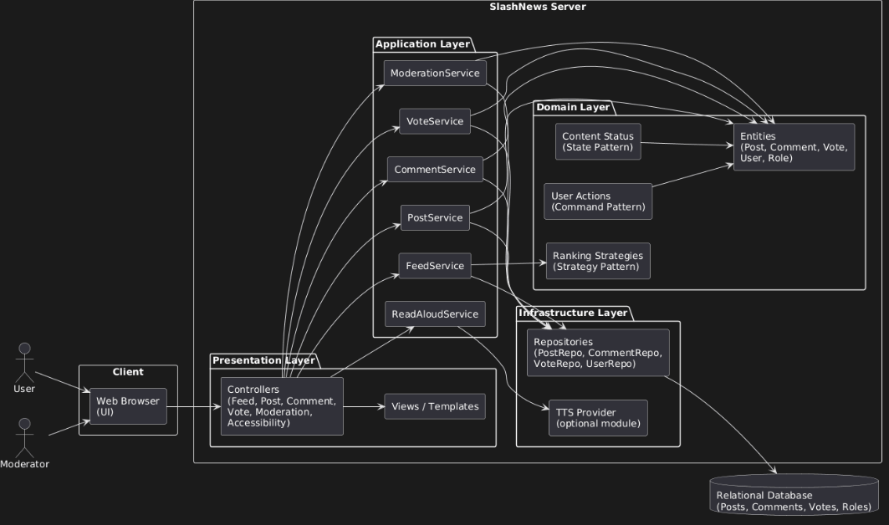

c) Explanation of Architectural Support for Use Cases
The layered client–server architecture of SlashNews directly supports the realization of the identified use cases by clearly separating responsibilities across system components. The Presentation Layer handles user interactions such as browsing feeds, viewing posts, submitting content, voting, moderating, and using voice reading support. These requests are forwarded to the Application Layer, where dedicated services coordinate the workflow for each use case.
The Domain Layer encapsulates the core business logic and rules, ensuring that operations such as ranking, voting, moderation, and content state management are handled consistently and independently of the user interface. The use of design patterns (e.g., Strategy for ranking, Command for user actions, State for content status) enables flexibility and configurability while maintaining clean separation of concerns. Finally, the Infrastructure Layer manages data persistence and optional voice support services, ensuring reliable storage and retrieval of system data.
This separation allows each use case to be implemented in a modular and maintainable manner, facilitating extensibility and future enhancements without impacting unrelated components.

4. Apply Design Patterns

Use Case 1: Browse Ranked Feed
Pattern: Strategy
Why it is appropriate:
The ranking logic (e.g., Top, New, or future ranking types) may change or expand over time. The Strategy pattern allows ranking algorithms to be interchangeable without modifying the core feed logic.
How it will be applied:
An interface such as IRankingStrategy will be defined in the domain layer. Concrete implementations (e.g., TopRankingStrategy, NewRankingStrategy) will implement this interface. The FeedService will use dependency injection or configuration to select the appropriate strategy at runtime, enabling extensibility without modifying existing logic.

Use Case 2: View Post and Comments
Pattern: Repository
Why it is appropriate:
Accessing posts and comments requires interaction with a data source. The Repository pattern abstracts data access, preventing business logic from depending directly on database implementation details.
How it will be applied:
Interfaces such as PostRepository and CommentRepository will be defined in the domain/application boundary. The infrastructure layer will implement these interfaces. The PostService will interact only with repository interfaces, allowing future changes in database technology without affecting the core logic.

Use Case 3: Submit Post
Pattern: Factory Method
Why it is appropriate:
Posts may have different types (e.g., link posts or text posts), each requiring specific initialization or validation rules. The Factory Method centralizes object creation logic and supports future extension.
How it will be applied:
A PostFactory will create the appropriate post object (e.g., LinkPost, TextPost) based on input parameters. The PostService will use the factory instead of directly instantiating objects, improving modularity and scalability.

Use Case 4: Add Comment
Pattern: Command
Why it is appropriate:
Adding a comment represents a user action that may require validation, authorization checks, logging, or future extensions. The Command pattern encapsulates this action into a single object.
How it will be applied:
An AddCommentCommand class will encapsulate the logic for adding a comment. The execute() method will handle validation and persistence. The CommentService will trigger the command, making user actions modular and easier to extend.

Use Case 5: Upvote Content
Pattern: Command
Why it is appropriate:
Upvoting is a user-triggered action with rules (e.g., preventing duplicate votes). Encapsulating this logic in a command object ensures separation of concerns and future flexibility.

How it will be applied:
An UpvoteCommand will be created containing vote validation and update logic. The VoteService will execute this command. This structure allows easy extension (e.g., undo vote, rate limiting, logging).

Use Case 6: Moderate Content

Pattern: State
Why it is appropriate:
Content may transition between states such as Normal, Hidden, or Removed. The State pattern helps manage behavior based on the content’s current status.
How it will be applied:
A ContentState model will define possible states. The ModerationService will change the state when moderation actions occur. The presentation layer will display or restrict content based on its state, ensuring consistent behavior across the system.

Use Case 7: Use Voice Reading Support
Pattern: Adapter
Why it is appropriate:
Voice reading relies on external text-to-speech (TTS) libraries or services. The Adapter pattern allows the system to integrate external services while maintaining independence from specific implementations.
How it will be applied:
An interface such as ITextToSpeech will be defined. A TextToSpeechAdapter will wrap the chosen TTS library. The ReadAloudService will depend only on the interface, allowing replacement of the TTS provider without modifying business logic.

