Project Plan
Project Scope
This project involves the design and implementation of a simplified, configurable social content aggregation platform inspired by Hacker News. The scope includes the development of core application functionality such as displaying ranked content feeds, viewing posts with threaded comments, and enabling user interactions including upvoting and commenting. In addition, the project includes a basic moderation capability, allowing designated moderator users to manage content through actions such as removing posts or comments and enforcing simple moderation rules. The project also covers the application of key software design patterns to structure the system architecture and support configurability, reusability, and maintainability. Preparing the codebase and documentation in a form suitable for open-source publication is also within the scope.
The project scope explicitly excludes advanced or non-essential features that are outside the educational goals of the course. These exclusions include real-time updates, complex moderation workflows (such as appeal systems or automated moderation), recommendation engines, mobile application development, large-scale performance optimization, and production-level security, deployment, or scalability concerns. The project is intended as an academic and architectural exercise rather than a production-ready system.
Project Organization
Joint Responsibilities
- Preparing project reports and documentation
- Designing the overall system architecture
- Selecting and defining the software design patterns to be used
- Reviewing code quality and architectural consistency
Cemil Gündüz
- Backend development
- Frontend implementation
- Integration of core application features
Ahmed Kaşık
- Backend development
- Frontend development
- Implementation of accessibility-related features and usability improvements
- Contribution to architectural decisions and pattern implementation

Yusuf Can Bahadırlıoğlu
• Software architecture design support
• Use case definition and documentation
• Design pattern selection and use case mapping
• Architectural diagram preparation
• Project documentation consistency and traceability
Objectives
The objective of project execution and management is to ensure that the project is completed in an organized, timely, and collaborative manner. The team aims to define clear responsibilities, follow a structured development plan, and maintain consistent communication throughout the project lifecycle.
Additionally, the project seeks to manage development tasks in a way that supports incremental progress, early identification of risks, and continuous integration of design decisions. Proper documentation, version control practices, and regular progress reviews will be used to ensure alignment with project goals and successful completion within the given timeframe.
Key Phases and Timeline
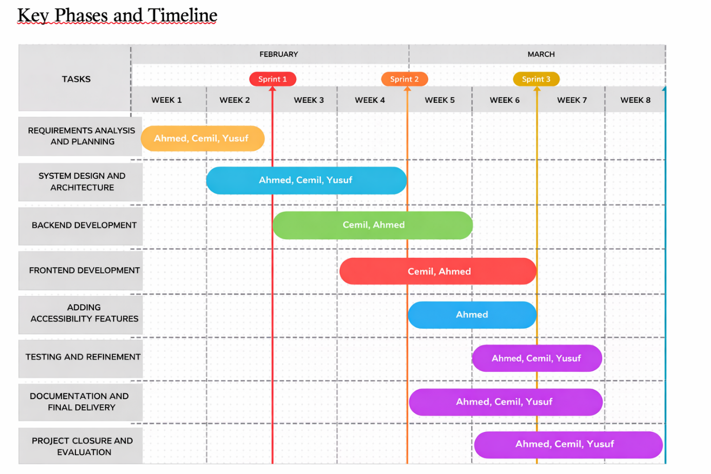

Resource Planning
The project will use standard and widely available software resources to support development and collaboration. Backend development will be carried out using a modern programming language and framework (e.g., Java with Spring or C# with ASP.NET), while the frontend will be implemented using server-rendered HTML and CSS. Version control will be managed using Git, with a shared remote repository for team collaboration.
A relational database system will be used to store application data such as posts, comments, votes, and user roles. Development and testing will be performed on personal computers, and all required tools, libraries, and dependencies will be accessed through publicly available package managers and open-source resources. No specialized hardware or paid software is required for the completion of the project.
Risk Management
Several potential risks may arise during the execution of the project. One risk is technical difficulty in correctly implementing and integrating the selected design patterns. This risk will be mitigated by clearly defining responsibilities, reviewing design decisions early, and validating implementations through regular team discussions.
Another risk is schedule delays due to workload or coordination issues among team members. To reduce this risk, the project will follow a phased timeline with intermediate milestones and regular progress checks. Additionally, there is a risk of uneven task distribution or temporary unavailability of a team member. This will be mitigated through shared documentation, use of version control, and maintaining overlapping knowledge of core system components to ensure continuity.
Communication Plan
Communication among team members will be ensured through regular face-to-face meetings and continuous communication via WhatsApp for quick updates and coordination. Weekly in-person meetings will be used to review progress, discuss design decisions, and plan upcoming tasks.
Communication with project stakeholders, including the course instructor, will be conducted through formal project submissions and in-person discussions when required. Feedback received during these interactions will be documented and incorporated into the project plan.

Change Management Plan
Any changes to project requirements or scope will be discussed and evaluated by all team members before implementation. Proposed changes will be reviewed in terms of their impact on project scope, timeline, and workload. If a change is approved, the project plan and documentation will be updated accordingly to ensure consistency and shared understanding among the team.

Budget Plan
This project does not require a financial budget, as it relies on free and open-source software tools and personal development environments. The only hardware resource involved is the use of team members’ local computers, including access to a local GPU for development and testing purposes where required. Since this hardware is already available to the team, it does not introduce any additional cost and is not considered a financial expense.

Acceptance Tests and Acceptance Criteria
The project will be considered acceptable if the following criteria are met through basic acceptance testing:
- Core Functionality Test
Acceptance Test: The system is tested by navigating content feeds, opening posts, and viewing threaded comments.
Acceptance Criterion: All core features function correctly without critical errors.
- User Interaction Test
Acceptance Test: Users perform actions such as submitting posts, commenting, and upvoting content.
Acceptance Criterion: User interactions are processed correctly and reflected in the system state.
- Moderation Feature Test
Acceptance Test: A moderator performs moderation actions such as removing posts or comments.
Acceptance Criterion: Only authorized moderator users can perform moderation actions, and the system behaves as expected.
- Design Pattern Validation Test
Acceptance Test: Code review is conducted to verify the implementation of selected design patterns.
Acceptance Criterion: Design patterns are correctly implemented, documented, and traceable to system functionality.
- Documentation Review Test
Acceptance Test: Project documentation is reviewed for completeness and clarity.
Acceptance Criterion: Documentation clearly explains system architecture, features, and design decisions.

