**#Microcontroller Project#**

**Student Name:** Hamza GÜNDÜZ **Student ID:** 31017066

**Student Name:** Ateş TAŞ **Student ID:**  31017068

1. **Proje Adı:** “Metro Station Lights”
2. **Projenin Amacı:** Making a digital routes like on metro cabinets
3. **Giriş (Teori):** Metro lines are a highly preferred public transportation vehicle today. Especially, with many metro lines; daily transportation take a very important place for the people in Istanbul. The rapid progress of the digitization process has also affected metro routes. Indeed, M2, M3, M4, M5 metro lines use digital routes. By considering the digital routes that started to replace the classic routes we thought of making digital metro routes. While we were doing this project, knowing the working style of the metro stations that we mentioned earlier helped us visually. The way that the digital route subway routes work, were an example that we take into consideration while making our project.
4. **Kullanan Malzemeler:**

elektronik eşyalar, devre içeren bir resim

Açıklama otomatik olarak oluşturuldu

**Microcontroller (PIC16f877a)**

We used the Microcontroller device to put the codes into practice

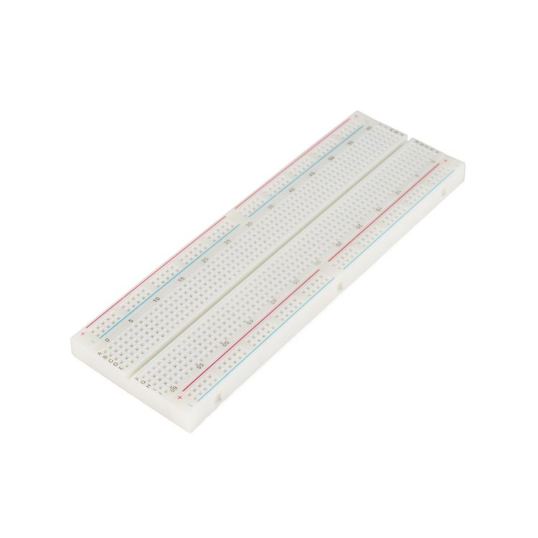

1. **Breadboard**

We made our project on breadboard

beyaz, oturma, dik, kedi içeren bir resim

Açıklama otomatik olarak oluşturuldu

**1 Buzzer**

We used buzzer for sounds

saat içeren bir resim

Açıklama otomatik olarak oluşturuldu

**1 LCD**

We viewed the texts by using the LCD screen

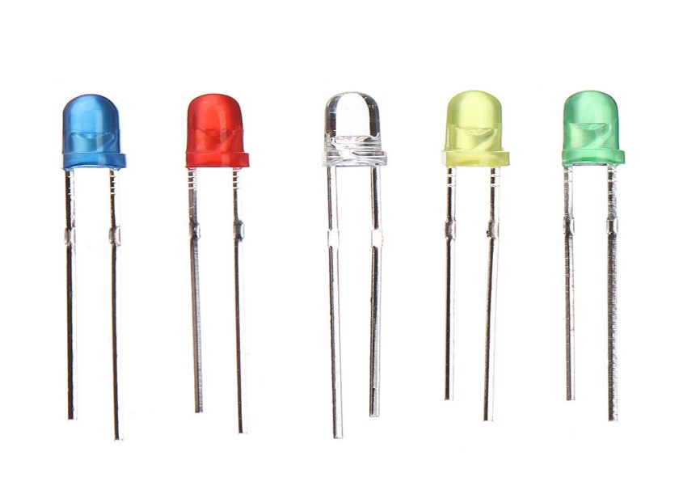

**7 Led**

We used LEDs to show us visually that they arrived at the stations

elektronik eşyalar, devre içeren bir resim

Açıklama otomatik olarak oluşturuldu

**Power Supply**

We used arduino for 5V source requirement.

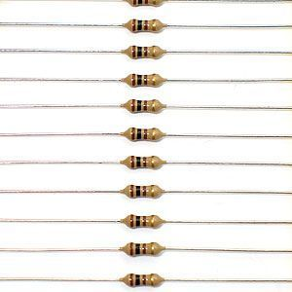

**7 Resistor (220R)**

Used to prevent the leds from burning

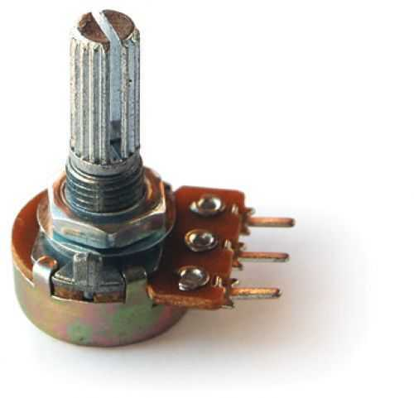

**1 Potansiyometre**

To adjust the appearance of the LCD

**kablo, devre içeren bir resim

Açıklama otomatik olarak oluşturuldu**

**Connection Wires**

Male / male connection cables are used to make the necessary connections.

1. **Verilerin Analizi**:

**#Proteus**

**metin içeren bir resim

Açıklama otomatik olarak oluşturuldu metin, harita içeren bir resim

Açıklama otomatik olarak oluşturuldu**

**metin içeren bir resim

Açıklama otomatik olarak oluşturuldu metin içeren bir resim

Açıklama otomatik olarak oluşturuldu**

**metin içeren bir resim

Açıklama otomatik olarak oluşturuldu**

**#MicroC**

**ekran görüntüsü içeren bir resim

Açıklama otomatik olarak oluşturuldu**

**metin içeren bir resim

Açıklama otomatik olarak oluşturuldu**

**metin, ekran görüntüsü içeren bir resim

Açıklama otomatik olarak oluşturuldu**

**Necessary\*\***

As the explanations we made for the first station are also valid for other station, we did not need to put all the stations. The necessary explanations are already given at the first stop.

**ekran görüntüsü içeren bir resim

Açıklama otomatik olarak oluşturuldu**

1. **Bulgular ve Yorum**:
2. **Sonuç, Tartışma ve Öneriler**: The first problem we encountered while doing our project was on the LCD screen. The texts started properly and then took a complex form. At first we couldn't understand what was the the error. So we decided to reduce the number of texts but when this did not give much results, we consulted with our classmates. We did not get much results from them either. Then, from our project team, Ateş Taş found the error and we corrected. It was because we wrote the text directly into the lcd_out function when coding the problem. We fix this problem with “char” by defining the expressions that we want to be written before writing the codes on the LCD. Codes and simulation was working perfectly. But when it comes to putting it into practice, we had a little hard time there. Because there was a shortage of materials for the students who returned to their homes hurriedly due to the Kovid-19. Even if we wanted to supply the missing materials, this was not possible. So we started to put our project into practice by using what we have. Solder, printed circuit board and LED deficiency prevented us to produce aesthetically beautiful results. Apart from that, we had a lot of trouble with connecting the pins of LCD. We didn't want to solder because the pins are so close. Because if we accidentally connect the pins together while soldering, we couldn't buy a new LCD. So we tried to keep the pins fixed by hand. As a result, the practical part was working properly but it wasnt look very aesthetic. So in short, we couldn't get what we wanted aesthetically but the working style was as we planned.
3. **Teşekkür:** No institution or organization has been supported in the realization of the project.
4. **Kaynak:**