Software Quality Engineering – Assignment 2
Manual Functional Testing and Test Reporting
Test Summary Report
Calori – calorie and macro tracker for Android
Version under test: 1.0.0 (build 1), source commit 35e2473 (2 Sep 2026)
Group member | Roll number | Role
Usman Ghani | 24f3000 | Test lead / test engineer
Faizan Ali | 24f3029 | Test engineer

Course | Instructors | Report date
Software Quality Engineering | Mr. Fraz Zaheer, Mr. Talha Dar | 11 October 2026

Document Control
Table 1: Document information
Item | Detail
Document | Test Summary Report (with test plan, RTM, test cases, defect log and evidence as appendices)
Application | Calori – Android calorie and macro tracker (open-source Flutter project)
Version under test | 1.0.0 (build 1), source commit 35e2473 (2 Sep 2026)
Build | Release APK built from source, SHA-1 f89461552d0e07e4fac8c4471b66fd10bbb60eca
Prepared by | Usman Ghani (24f3000), Faizan Ali (24f3029)
Prepared for | Mr. Fraz Zaheer, Mr. Talha Dar – Software Quality Engineering
Status | Final – for submission

Version history
Table 2: Version history
Version | Date | Author | Change
0.1 | 11-Oct-2026 | Usman Ghani | Test plan, scope and requirement list (FR-001 – FR-046)
0.2 | 11-Oct-2026 | Faizan Ali | Test case design (76 cases), RTM, expected values from the formula oracle
0.3 | 11-Oct-2026 | Both | Execution results for all cases; TC-077 added during execution; 34 defects logged
1.0 | 11-Oct-2026 | Both | Charts, analysis, recommendations and sign-off – final

Abbreviations
Table 3: Abbreviations
Term | Meaning
AUT | Application under test
FR | Functional requirement
TC | Test case
DEF | Defect
RTM | Requirement traceability matrix
EP / BVA / DT / ST / EG | Equivalence partitioning / boundary value analysis / decision table / state transition / error guessing
BMI | Body-mass index (kg ÷ m²)
TDEE | Total daily energy expenditure (maintenance calories)
kcal | Kilocalories
UC-xx | Use case from the project's 04-use-cases.md

Table of Contents
1. Executive Summary 5
2. Introduction 5
2.1 Purpose of the report 5
2.2 Application overview 5
2.3 Version and environment under test 6
2.4 Modules and features tested 6
3. Test Approach and Strategy 6
3.1 Overall approach 6
3.2 Test design techniques 7
3.3 How test cases were prioritised 7
3.4 Roles and responsibilities 8
3.5 Tools used 8
4. Test Execution Summary 8
4.1 Overall metrics 8
4.2 Module-wise breakdown 9
4.3 Requirement coverage 10
4.4 Notes on execution 10
5. Defect Summary 10
5.1 Top five most critical defects 11
6. Observations and Recommendations 12
6.1 Overall functional quality 12
6.2 Recommendations for fixes 12
6.3 Recommendations for future testing 12
7. Conclusion and Sign-off 12
7.1 Completion against exit criteria 12
7.2 Release recommendation 13
7.3 Sign-off 13
Appendix A – Test Plan 14
A.1 Objectives 14
A.2 Scope 14
A.3 Features and modules to be tested 14
A.4 Test environment 14
A.5 Entry criteria 14
A.6 Exit criteria 14
A.7 Suspension and resumption 15
A.8 Roles and responsibilities 15
A.9 Task allocation 15
A.10 Risks and mitigations 15
A.11 Test data 15
Appendix B – Requirements and Traceability Matrix 16
Appendix C – Test Cases 18
C.1 Test case summary 18
C.2 Detailed test cases 21
Appendix D – Defect Log and Defect Reports 52
D.1 Defect log 52
D.2 Defect reports 53
Appendix E – Exploratory Testing Notes 88
Appendix F – Evidence Index 89
F.1 Screen videos 89
F.2 Screenshot index 89
F.3 Key passed tests 91
Appendix G – Contribution Table 92
Appendix H – Reflection 92

1. Executive Summary
This report presents the results of manual functional testing of Calori, an Android calorie and macro tracker, at version 1.0.0 (build 1), the source state of commit 35e2473 dated 2 September 2026. A two-person QA team tested a release build on an Android 16 emulator on 11 October 2026, including the optional photo-estimate service.
We tested eight modules – onboarding, the goal and safety rules, manual food logging, the day view, the calendar, goal management, photo logging and navigation – against 46 functional requirements derived from the project's use cases. All 77 test cases were executed: 45 passed (58.4%) and 32 failed, none were blocked. We logged 34 defects: 1 Critical, 14 Major, 15 Minor and 4 Trivial.
What works well. Calorie and macro targets matched the published formula exactly in every scenario we calculated independently; the safety refusals and corrections appear inline with clear wording; food search is fast, works offline and tolerates unusual input; the photo path answers 'no food' and 'no connection' honestly and keeps the photo for a retry; a repeated meal gives identical numbers.
Key findings.
- Underweight users cannot finish setting up: both alternatives the app offers them lead to a loading screen that never ends (DEF-06, Critical).
- The under-18 stop – the app's only hard safety block – is bypassed by closing and reopening the app (DEF-02).
- Saved goals are unreliable: switching kg/lb erases the goal date and a hand-set target (DEF-23); the Goal screen sets a target up to 220 kcal away from the rate the user chose (DEF-24); changing the goal rewrites past days' results (DEF-22) and leaves Home's progress ring stale (DEF-21).
- After a food is added by hand, its card stays stuck on 'Saving…' and cannot be used again (DEF-11).
- In the photo flow, proposed items cannot be corrected before saving (DEF-27, DEF-28), typed details are ignored for gallery photos (DEF-30) and the camera's Close button cannot be tapped (DEF-26).
Quality statement and recommendation: Not ready for release. One Critical defect blocks an entire group of users, and the 9 High-priority defects undermine the two things Calori exists to do – set a safe target and record intake accurately. Release should be reconsidered once the High-priority defects are fixed and the failed test cases pass on re-test (Section 6).

2. Introduction

2.1 Purpose of the report
This report records what was tested in Calori, how it was tested, what was found, and whether the application is functionally fit to release. It is written so that a non-technical reader can follow the summary sections, while the appendices hold the full test plan, traceability, test cases, defect reports and evidence for review.

2.2 Application overview
Calori is an open-source Flutter application for Android that estimates a daily calorie and protein target and lets the user log what they eat. Its main parts are:
- Onboarding and goal engine – asks for sex, age, height, weight, target weight and activity, computes a target with the Mifflin-St Jeor equation, and applies safety rules (adults only, no target below BMI 18.5, at most 1 % of bodyweight per week, a calorie floor of 1,500 kcal for men and 1,200 kcal for women).
- Manual logging – an offline database of about 21,800 foods from eight national food tables, searchable in English and regional names, with household serving sizes.
- Day view, calendar and goal screen – progress against the target per day and per month, editing of logged meals, and changes to the goal with hand-set overrides.
- Photo logging (optional) – a meal photo is sent to the developer's own Cloudflare Worker, which asks a vision model for a list of foods; nothing is saved until the user confirms.

2.3 Version and environment under test
Table 4: Version and environment under test
Item | Value
Application / version | Calori 1.0.0 (build 1), source commit 35e2473 (2 Sep 2026)
Build | flutter build apk --release with photo estimates configured; APK SHA-1 f89461552d0e07e4fac8c4471b66fd10bbb60eca
Device | Android Emulator, AVD 'finall' (sdk_gphone64_x86_64), Android 16 / API 36, 1080 × 2424 px at 420 dpi
Photo service | Developer's Cloudflare Worker (health check OK), model google/gemini-2.5-flash via OpenRouter
Network | Online; airplane mode for the offline cases (TC-070, TC-071)
Test date and time | 11-Oct-2026, 20:00–21:23 (local time)

2.4 Modules and features tested
Table 5: Modules and features tested
ID | Module | Features covered | FRs | TCs | Owner
M1 | Onboarding – Profile Entry | Sex, age, height and weight entry; unit toggles; under-18 stop; back navigation | 6 | 13 | Usman Ghani
M2 | Goal Engine & Safety Rules | Target calculation, macro split, BMI refusals, rate and calorie-floor clamps, plan screen | 8 | 13 | Usman Ghani
M3 | Manual Food Logging | Food search, regional names, no-match handling, portion picker, add to log, recent foods | 6 | 10 | Faizan Ali
M4 | Day View & Entry Editing | Ring and totals, date strip, entry editor (meal type, portions, remove), delete and undo | 6 | 10 | Faizan Ali
M5 | Calendar | Month grid, month paging, day detail, month summary, history kept against old targets | 5 | 7 | Faizan Ali
M6 | Goal Management | Goal steppers, rate, refusals, hand-set calories and protein, unit preferences, Sources | 6 | 10 | Faizan Ali
M7 | Photo Logging | Viewfinder, gallery photos, details hint, review and correction, save, no-food, offline, repeat meals | 7 | 11 | Usman Ghani
M8 | Navigation | Nav bar tabs, '+' and calendar buttons, Android Back | 2 | 3 | Faizan Ali

Out of scope by definition: all non-functional testing (performance, security, usability, compatibility, accessibility), unit and automated testing, iOS, and the internals of the Worker and of the food-database build tools. The full scope statement is in Appendix A.

3. Test Approach and Strategy

3.1 Overall approach
Testing was requirements-based black-box testing. Requirements were derived from the project's twelve use cases, its README and statements the app makes on screen (Appendix B). Each test case was designed before execution with an expected result taken from the requirement. For calculations, expected values came from an independent re-implementation of the published formula (the 'oracle'), never from the app itself – for example, the reference profile (male, 30, 178 cm, 78 → 72 kg, moderately active) must give 2,160 kcal and 140 g protein.
Every test case was executed by hand, one step at a time, on the emulator. Android's adb tool was used to send taps and text, to read the text shown on screen, to capture screenshots and to record screen video. Scripted test sessions were complemented by six time-boxed exploratory sessions (Appendix E), which found 4 further defects and several usability observations.

3.2 Test design techniques
Table 6: Test design techniques used, with examples
Technique | Test cases using it | Example from this project
Equivalence Partitioning | 28 | Weight split into valid 25–400 kg and invalid partitions; decimal point and decimal comma treated as two valid input classes (TC-008). Regional versus English food names (TC-027).
Boundary Value Analysis | 17 | Age 17 / 18 and 119 / 120 (TC-003–TC-005); height 99 / 100 / 250 / 251 cm (TC-007); maintenance band at ±0.5 kg – 78.5 vs 78.6 kg (TC-022); calorie floor 1,499 / 1,500 kcal (TC-058); servings 0.5 / 20 (TC-031).
Decision Table | 10 | The UC-02 safety rules as an eight-rule table (Table 7), one or more test cases per rule (TC-004, TC-014–TC-021, TC-077).
State Transition | 25 | Onboarding steps and their transitions, including Back, restart and the refusal state (Table 8); entry life-cycle add → edit → delete → undo (TC-039–TC-044).
Error Guessing | 11 | Search operators such as NOT, rice* and quotes (TC-029); adding the same food twice (TC-034); restarting after the under-18 refusal (TC-013); switching units with a hand-set target (TC-061); protein larger than the calorie budget (TC-060).

Table 7: Decision table for the onboarding safety rules (UC-02)
Condition / action | R1 | R2 | R3 | R4 | R5 | R6 | R7 | R8
Age < 18 | Y | N | N | N | N | N | N | N
Current BMI < 18.5 and goal is to lose | – | Y | N | N | N | N | N | N
Target BMI < 18.5 | – | – | Y | Y | N | N | N | N
Direction of goal | – | lose | lose / keep | gain | lose / gain | lose | lose | any
Rate > 1 % of bodyweight per week | – | – | – | – | Y | – | – | N
Target would fall below calorie floor | – | – | – | – | – | Y | – | N
Maintenance (TDEE) ≤ floor | – | – | – | – | – | N | Y | N
ACTION | Block: refusal screen, no way on | Refuse; offer maintain | Refuse; offer maintain | Refuse; offer healthy-weight gain | Clamp rate; honest date | Clamp to floor; later date | Set to maintain | Accept plan
Test cases | TC-004, TC-013 | TC-017, TC-077 | TC-016 | TC-018 | TC-015, TC-019 | TC-020, TC-024 | TC-021 | TC-014, TC-022
Result | Pass / Fail | Pass / Fail | Pass | Fail | Pass / Fail | Pass / Fail | Pass | Pass

Table 8: State transition table for onboarding
From state | Event | Expected next state | Test case | Result
Sex | Choose Male / Female | Age | TC-002 | Pass
Age | Valid age ≥ 18, Continue | Height & weight | TC-003 | Pass
Age | Age < 18, Continue | Blocked (refusal) | TC-004 | Pass
Blocked | App restarted | Blocked | TC-013 | Fail
Height & weight | Back arrow | Age (answers kept) | TC-011 | Pass
Height & weight | Android Back | Age (answers kept) | TC-012 | Fail
Target | Refused; 'Maintain instead' | Activity → Plan (maintenance) | TC-016 | Pass
Target | Underweight; alternative chosen | Activity → Plan | TC-018, TC-077 | Fail
Plan | Start tracking | Home (profile saved) | TC-025 | Pass

3.3 How test cases were prioritised
Each test case carries a priority (how soon it must run and be fixed if it fails) and a severity (how much harm a failure would do). Priority was set by risk:
- High – safety rules, calorie calculations, saving and deleting data, and the core logging paths. A failure here either harms the user or makes the diary wrong.
- Medium – input validation, edge cases, secondary displays such as the calendar and Recent foods.
- Low – cosmetic or informational behaviour (e.g. the Sources screen).
Because many cases share set-up state (a saved profile, logged meals), execution followed module order. Priority was then used to rank defects and to decide what blocks release.

3.4 Roles and responsibilities
Table 9: Roles and responsibilities
Member | Roll no. | Role | Responsibilities
Usman Ghani | 24f3000 | Test lead | Test plan and scope; environment set-up (APK build, emulator, test images); design and execution of M1 Onboarding, M2 Goal engine and M7 Photo logging; exploratory sessions EXP-01 and EXP-05; compiling the report.
Faizan Ali | 24f3029 | Test engineer | Requirement analysis and RTM; design and execution of M3 Manual logging, M4 Day view, M5 Calendar, M6 Goal management and M8 Navigation; exploratory sessions EXP-02, EXP-03, EXP-04, EXP-06; defect-log consolidation and report review.

3.5 Tools used
Table 10: Tools used
Tool | Used for
Flutter SDK + Gradle | Building the release APK from the 35e2473 source
Android Emulator (Android 16) | Running the application under test
Android Debug Bridge (adb) | Taps and text input, reading on-screen text, screenshots (screencap), screen video (screenrecord), airplane mode, force-stop and data reset between scenarios
Python (Pillow, matplotlib, python-docx) | Results log, highlight boxes on screenshots, charts, this document
Formula oracle (oracle.py) | Independent expected values for every calculation test
Wikimedia Commons | Openly licensed meal photos used as photo test data (Appendix A.11)
Microsoft Word / LibreOffice | Report format (.docx) and page-layout checks

4. Test Execution Summary

4.1 Overall metrics
Table 11: Test execution metrics
Metric | Value
Total test cases designed | 77 (76 before execution + 1 added during execution: TC-077)
Test cases executed | 77
Passed | 45
Failed | 32
Blocked | 0
Not executed | 0
Pass percentage | 58.4% (45 of 77)
Execution effort (hours) | 1.4 h on 11-Oct-2026 (20:00–21:23), including 0.25 h build and set-up
Requirements covered | 46 of 46 (100%)
Defects logged | 34 (4 from exploratory sessions)
Paid photo-analysis calls used | 6 (limit agreed with the project owner: 20)

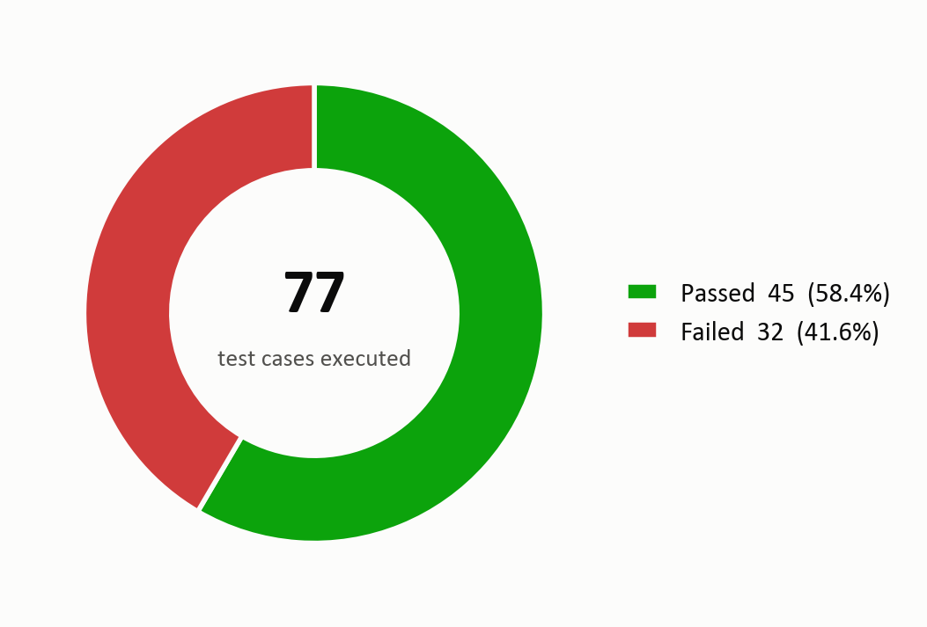
Figure 1: Overall pass/fail result of the 77 executed test cases

4.2 Module-wise breakdown
Table 12: Results by module
Module | Tester | TCs | Pass | Fail | Blocked | Pass % | Defects
M1 Onboarding – Profile Entry | Usman Ghani | 13 | 7 | 6 | 0 | 54% | 4
M2 Goal Engine & Safety Rules | Usman Ghani | 13 | 8 | 5 | 0 | 62% | 4
M3 Manual Food Logging | Faizan Ali | 10 | 8 | 2 | 0 | 80% | 6
M4 Day View & Entry Editing | Faizan Ali | 10 | 7 | 3 | 0 | 70% | 5
M5 Calendar | Faizan Ali | 7 | 4 | 3 | 0 | 57% | 3
M6 Goal Management | Faizan Ali | 10 | 6 | 4 | 0 | 60% | 4
M7 Photo Logging | Usman Ghani | 11 | 4 | 7 | 0 | 36% | 7
M8 Navigation | Faizan Ali | 3 | 1 | 2 | 0 | 33% | 1
Total |  | 77 | 45 | 32 | 0 | 58% | 34

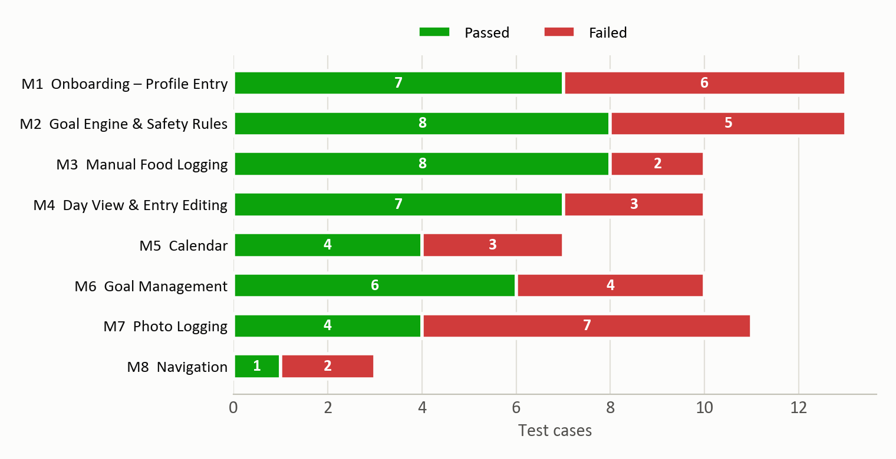
Figure 2: Passed and failed test cases per module

4.3 Requirement coverage
All 46 requirements are covered by at least one test case. 20 requirements are fully met (every linked case passed) and 26 have at least one failing case. The complete traceability matrix is in Appendix B.

4.4 Notes on execution
- TC-077 was added during execution, when exploring TC-017 showed that 'Maintain instead' leads to an endless spinner; it is designed, traced and reported like every other case.
- Two test cases had their test data adjusted to match the product: the quantity stepper moves in 0.5 steps, so TC-032 compares 1 with 1.5 servings; TC-066/TC-067 ran on the review screen of TC-064 so that no extra paid photo call was needed.
- Calculation cases were checked against the oracle; all matched exactly except where a defect is reported (TC-056 / DEF-24).
- Each onboarding scenario started from cleared app data so that earlier answers could not influence the result.

5. Defect Summary
34 defects were logged, each reproduced on the device with screenshot evidence (two also have screen video). All are Open: this cycle tested a fixed historical build, so no fixes were delivered during testing.
Table 13: Defects by severity
Severity | Count | Meaning
Critical | 1 | Blocks a core flow for a group of users with no workaround
Major | 14 | Wrong result, data loss or a broken feature; a workaround may exist
Minor | 15 | Incorrect behaviour in validation, wording or a secondary feature
Trivial | 4 | Cosmetic
Total | 34

Table 14: Defects by priority and by status
Priority | Count | Status | Count
High | 9 | Open | 34
Medium | 15 | Fixed | 0
Low | 10 | Closed / Rejected / Deferred | 0

Table 15: Defects by module and severity
Module | Critical | Major | Minor | Trivial | Total
M1 Onboarding – Profile Entry | 0 | 1 | 2 | 1 | 4
M2 Goal Engine & Safety Rules | 1 | 0 | 3 | 0 | 4
M3 Manual Food Logging | 0 | 2 | 3 | 1 | 6
M4 Day View & Entry Editing | 0 | 1 | 3 | 1 | 5
M5 Calendar | 0 | 1 | 1 | 1 | 3
M6 Goal Management | 0 | 2 | 2 | 0 | 4
M7 Photo Logging | 0 | 6 | 1 | 0 | 7
M8 Navigation | 0 | 1 | 0 | 0 | 1
Total | 1 | 14 | 15 | 4 | 34

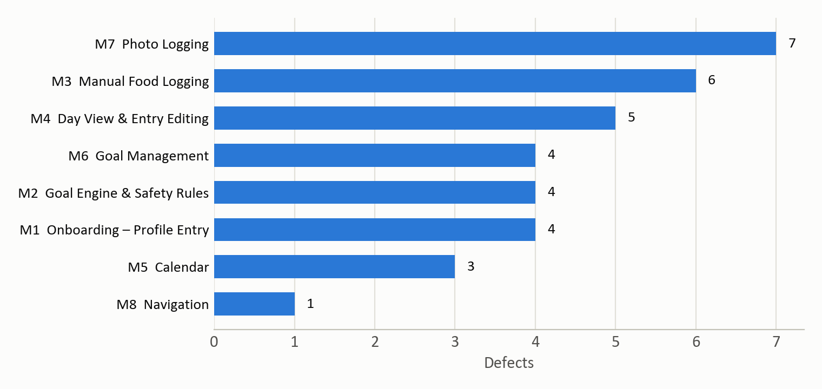
Figure 3: Defects by module
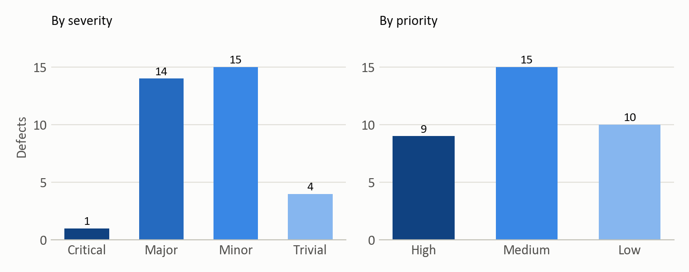
Figure 4: Defects by severity and by priority

5.1 Top five most critical defects
Table 16: Top five most critical defects
ID | Title | Severity / priority | Impact
DEF-06 | Underweight users' offered alternatives end on an endless loading spinner | Critical / High | Any user under BMI 18.5 cannot finish onboarding at all, using the very options the app recommends.
DEF-02 | Under-18 refusal is forgotten when the app is restarted | Major / High | The app's only hard safety stop can be bypassed in seconds by closing and reopening it.
DEF-23 | Switching the weight unit erases the goal date and hand-set calories | Major / High | A display preference silently rewrites the saved plan.
DEF-24 | Goal screen ignores the chosen rate (target up to 220 kcal off) | Major / High | The core calculation does not honour the user's input.
DEF-11 | 'Add to log' stays stuck on 'Saving…' after the first manual add | Major / High | Repeat foods - the most common manual log - cannot be added again without a new search.

Close behind these are DEF-22 (past days re-judged against a new goal), DEF-21 (stale progress ring), DEF-26 (camera cannot be closed) and DEF-27 (photo estimates cannot be corrected before saving). The full defect log and one report per defect are in Appendix D.

6. Observations and Recommendations

6.1 Overall functional quality
Calori's calculation core is sound: every target and macro split we checked against the formula matched to the kilocalorie, and the safety corrections say plainly what changed and why. Offline food search is a strength – fast, regional-name aware, and robust to odd input. The weaknesses cluster in three places:
- Edges of the safety flow – the underweight alternatives dead-end (DEF-06), the under-18 stop does not survive a restart (DEF-02), validation fails silently (DEF-01, DEF-04), and messages ignore the user's units or goal direction (DEF-07, DEF-08, DEF-09).
- Consistency of saved data – a unit preference rewrites the goal (DEF-23), the Goal screen miscalculates from the rate it shows (DEF-24), history is re-judged (DEF-22), displays go stale (DEF-21, DEF-18) and Undo is not a true undo (DEF-16).
- The photo review step – the UC-06 corrections are largely missing (DEF-27, DEF-28, DEF-31), details are dropped (DEF-30) and the camera screen's own controls are hard to use (DEF-25, DEF-26, DEF-29).

6.2 Recommendations for fixes
- Fix first (High priority): DEF-06, DEF-02, DEF-23, DEF-24, DEF-22, DEF-21, DEF-11, DEF-26, DEF-27. Each either harms a user, corrupts the diary or blocks a core action.
- Then: the Medium-priority defects, starting with the photo review (DEF-28, DEF-30, DEF-31), data quality of the INDB rows (DEF-13) and system Back handling (DEF-03).
- Add inline validation messages everywhere a button is disabled (DEF-01, DEF-04, DEF-19, DEF-20).
- Store each day's target with the day, so goal changes apply only from today forward (DEF-22) – this also removes the stale-ring class of problem (DEF-21).
- The project's next commit (36ead9d) states that it fixes DEF-11 and DEF-24; both should be re-tested on that build rather than assumed fixed.

6.3 Recommendations for future testing
- Regression: re-run all 32 failed cases after fixes, plus the whole M2 and M6 suites, since the goal engine is shared by onboarding and the Goal screen.
- Real devices: repeat M7 on physical phones with different status-bar and cut-out heights (DEF-26) and with the real camera rather than the emulator's virtual scene.
- Usability (out of scope here): the '+' button covering the last meal's calories and controls hidden behind the floating nav bar were noticed during exploration (Appendix E).
- Accessibility: TalkBack labels (several buttons have none), text scaling, contrast of grey text.
- Performance: search latency and memory on low-end devices with the 60 MB APK and the 21,800-food database; photo-analysis time on slow networks.
- Compatibility: Android 7 (the minimum supported) to 16, tablets and landscape.
- Security: the Worker shared secret is compiled into the APK; rate-limit and abuse testing of the Worker.
- Reliability: behaviour after process death mid-flow, low storage, and interrupted photo uploads.
- Automation: the formula oracle used here could become an automated regression suite for the goal engine.

7. Conclusion and Sign-off

7.1 Completion against exit criteria
Table 17: Exit criteria
Exit criterion (Appendix A.6) | Target | Actual | Met?
Planned test cases executed | 100% | 100% (77/77) | Yes
Every failure logged as a defect with evidence | 100% | 32 failures → 34 defects, all with screenshots | Yes
Requirements covered by at least one test | 100% | 46/46 | Yes
Pass rate | ≥ 90% | 58.4% | No
Open Critical defects | 0 | 1 | No
Open High-priority defects | 0 | 9 | No

The test cycle is complete: every planned case was run, every requirement was covered and every failure is documented. The quality criteria for release are not met.

7.2 Release recommendation
Not ready for release. Release should be reconsidered when the Critical defect and all High-priority defects are fixed and verified, and the failed test cases pass on a regression run.

7.3 Sign-off
Table 18: Sign-off
Name | Roll no. | Role | Signature | Date
Usman Ghani | 24f3000 | Test lead |  | 11 October 2026
Faizan Ali | 24f3029 | Test engineer |  | 11 October 2026

Appendix A – Test Plan

A.1 Objectives
- Verify that every Calori feature behaves as its requirement states.
- Exercise valid, invalid, empty and boundary inputs, error handling, business rules, data handling and navigation.
- Log every deviation as a reproducible defect with evidence, and judge fitness for release.

A.2 Scope
Table 19: Scope
In scope | Out of scope
Onboarding and all UC-02 safety rules  Goal calculation and macro split  Manual logging and food search  Day view, entry editing, delete and undo  Calendar  Goal management, overrides and units, Sources screen  Photo logging through the configured Worker, incl. offline and no-food cases  Navigation incl. Android Back | All non-functional testing: performance, security, usability, compatibility, accessibility  Unit tests and automated test scripts  iOS and other platforms  Worker / model internals and prompt quality (only the app's behaviour with the answers is tested)  Food-database build tools (tools/build_foods_db)  Accuracy of the bundled nutrition data as a whole (clearly implausible rows met during testing are still reported)

A.3 Features and modules to be tested
See Table 5 (Section 2.4) – eight modules, 46 requirements, 77 test cases.

A.4 Test environment
See Table 4 (Section 2.3). One emulator was used throughout; app data was cleared between onboarding scenarios.

A.5 Entry criteria
Table 20: Entry criteria
Criterion | Status on 11-Oct-2026
Release APK of commit 35e2473 builds and installs | Met – built 20:12, installed 20:13
Requirements baselined (FR-001 – FR-046) | Met
Test cases designed and reviewed, expected values computed | Met – 76 cases before execution
Test environment ready (emulator, density 420, photo Worker healthy) | Met – Worker /health returned ok
Test data ready (profiles, food images) | Met – seven images pushed to the emulator gallery

A.6 Exit criteria
- 100% of planned test cases executed.
- Every failure logged as a defect with evidence.
- Every requirement covered by at least one executed test case.
- For a release recommendation: pass rate of at least 90%, no open Critical defects and no open High-priority defects.

A.7 Suspension and resumption
Testing of a module is suspended if the build cannot be installed or a defect blocks every remaining case in it; the photo module would be suspended if the Worker were down or the agreed limit of 20 paid calls were reached. Blocked cases are marked 'Blocked' with the reason. None of these occurred.

A.8 Roles and responsibilities
See Table 9 (Section 3.4).

A.9 Task allocation
Table 21: Task allocation
# | Task | Owner | Start date | End date
1 | Test planning, scope, entry/exit criteria | Usman Ghani | 11-Oct-2026 | 11-Oct-2026
2 | Requirement analysis and RTM | Faizan Ali | 11-Oct-2026 | 11-Oct-2026
3 | Test design – M1, M2, M7 (37 cases) | Usman Ghani | 11-Oct-2026 | 11-Oct-2026
4 | Test design – M3, M4, M5, M6, M8 (40 cases) | Faizan Ali | 11-Oct-2026 | 11-Oct-2026
5 | Environment set-up: APK build, emulator, test images | Usman Ghani | 11-Oct-2026 | 11-Oct-2026
6 | Execution – M1, M2, M7 | Usman Ghani | 11-Oct-2026 | 11-Oct-2026
7 | Execution – M3, M4, M5, M6, M8 | Faizan Ali | 11-Oct-2026 | 11-Oct-2026
8 | Exploratory sessions EXP-01 – EXP-06 | Both | 11-Oct-2026 | 11-Oct-2026
9 | Defect logging, evidence and highlight boxes | Faizan Ali | 11-Oct-2026 | 11-Oct-2026
10 | Test summary report, metrics and charts | Usman Ghani | 11-Oct-2026 | 11-Oct-2026
11 | Report review and viva preparation | Both | 12-Oct-2026 | 12-Oct-2026

A.10 Risks and mitigations
Table 22: Risks and mitigations
Risk | Mitigation
Photo analysis costs money per call | Agreed limit of 20 calls; gallery images chosen to cover several cases each; 6 used
Emulator differs from a real phone (camera, status bar) | Camera cases use the gallery path; device-specific findings flagged for real-device re-test
Earlier answers leaking between scenarios | App data cleared before every onboarding scenario
Expected values copied from the app's own output | Expected values computed independently by the oracle before execution
Deadline 12-Oct-2026 | All execution completed on 11-Oct-2026

A.11 Test data
Profiles: the reference profile (male, 30, 178 cm, 78 kg) and the boundary/decision-table profiles listed in each test case. Photo test data: the following openly licensed images from Wikimedia Commons, pushed to the emulator's gallery.
Table 23: Photo test data and licences
File | Commons title | Licence | Author
biryani.jpg | Hyderabad biryani & naan.jpg | CC0 | Abithavelu
egg_breakfast.jpg | Liat Portal for Foodie Disorder - Israeli breakfast plate with fried egg and avocado.jpg | CC BY-SA 4.0 | HaJunkiyada
salad.jpg | Garden salad - San Francisco.jpg | CC0 | Daderot
dal_rice_chapati.jpg | Bhendi chapati and dal rice.jpg | CC BY-SA 4.0 | Wind Hashira
apple.jpg | Red Apple.jpg | CC BY 2.0 | Abhijit Tembhekar from Mumbai, India
chapati.jpg | Chapati-1.jpg | CC0 | safaritravelplus
cat_nonfood.jpg | Cute gray cat sitting in bed.jpg | CC0 | Aleenamustlive

Appendix B – Requirements and Traceability Matrix
Each requirement is traced to the test cases that verify it, their combined result and any defects found.
Table 24: Requirement traceability matrix
FR | Mod. | Requirement | Source | Pri. | Test cases | Result | Defects
FR-001 | M1 | On first launch with no saved profile the app opens onboarding; Home cannot be reached until a goal has been saved. | UC-01 pre/postcondition | High | TC-001, TC-025 | Pass | —
FR-002 | M1 | The user selects sex (Male / Female); selecting an option advances to the next step. | UC-01 step 1 | High | TC-002 | Pass | —
FR-003 | M1 | Age accepts whole numbers only. An age under 18 ends onboarding on a refusal screen with no path forward. | UC-02 (age < 18) | High | TC-003, TC-004, TC-005, TC-013 | Fail | DEF-01, DEF-02
FR-004 | M1 | Height must be 100–250 cm and weight 25–400 kg (or their imperial equivalents); out-of-range or malformed values are rejected with a clear message. | UC-01 step 1; error-handling guideline | High | TC-005, TC-006, TC-007, TC-008, TC-009 | Fail | DEF-01, DEF-04
FR-005 | M1 | Height (cm / ft'in) and weight (kg / lb) units are chosen independently; switching a unit converts any value already typed. | README 'Metric or imperial, separately' | Medium | TC-009, TC-010 | Fail | DEF-04
FR-006 | M1 | The user can step back to earlier onboarding questions with answers retained; a progress indicator shows position in the flow. | Onboarding UI | Medium | TC-002, TC-011 | Pass | —
FR-007 | M2 | The daily target is Mifflin-St Jeor BMR × activity factor, minus (loss) or plus (gain) rate × 7700 kcal/kg ÷ 7, rounded to 10 kcal; protein 1.8 g/kg (to 5 g), fat max(25 % of energy, 0.6 g/kg), carbs the remainder. | UC-01 step 4; README | High | TC-014, TC-056 | Fail | DEF-24
FR-008 | M2 | A target weight below BMI 18.5 is refused inline, stating the lowest healthy weight and offering an alternative: maintenance, or for a gain goal, gaining to a healthy weight. | UC-02 table; engine contract | High | TC-016, TC-018, TC-023 | Fail | DEF-06, DEF-08
FR-009 | M2 | A loss goal from a user already below BMI 18.5 is refused and maintenance is offered. | UC-02 table | High | TC-017, TC-077 | Fail | DEF-06
FR-010 | M2 | A rate faster than 1 % of bodyweight per week is clamped to 1 %, with an explanation and the honest achievable date. | UC-02 table | High | TC-015, TC-019 | Fail | DEF-07
FR-011 | M2 | A loss target below the calorie floor (1500 kcal male / 1200 kcal female) is clamped to the floor and the date extended; if maintenance is already at or below the floor, the plan is set to maintain. | UC-02 table | High | TC-020, TC-021 | Pass | —
FR-012 | M2 | A target within ±0.5 kg of current weight is treated as maintenance. | Engine contract | Medium | TC-022 | Pass | —
FR-013 | M2 | Refusal and correction messages use the units the user chose and the correct direction (loss vs gain). | UC-02 'plain language'; README units | Medium | TC-019, TC-023 | Fail | DEF-07, DEF-08
FR-014 | M2 | The plan screen shows the daily target, macro split, any correction and the projected date; 'Start tracking' saves the profile and opens Home. | UC-01 steps 6–7 | High | TC-014, TC-024, TC-025, TC-077 | Fail | DEF-06, DEF-09
FR-015 | M3 | Search queries the offline food database and shows ranked results, each with a source badge, default serving and kcal; the × button clears the query. | UC-05 steps 3–5 | High | TC-026, TC-028 | Pass | DEF-10
FR-016 | M3 | Search matches regional / local names (e.g. channa → chickpea, karela → bitter gourd). | README 'Search that speaks more than English' | Medium | TC-027 | Pass | —
FR-017 | M3 | A query with no matches shows a helpful 'No matches' message; special characters or search operators never cause an error. | UC-05; error handling | Medium | TC-028, TC-029 | Pass | —
FR-018 | M3 | Before anything is typed, search shows recent and frequent foods; tapping one searches for it. | UC-05 step 2 | Medium | TC-030, TC-073 | Fail | DEF-12, DEF-32
FR-019 | M3 | The portion picker offers serving units first, a quantity of 0.5–20 in 0.5 steps, and shows grams, kcal and macros scaled from per-100 g values. | UC-05 steps 7–8 | High | TC-031, TC-032 | Pass | —
FR-020 | M3 | 'Add to log' saves the food (source = database) to the day selected on Home with a meal type defaulted from the time of day, confirms it, returns to Home, and further foods can then be added. | UC-05 step 9 | High | TC-033, TC-034, TC-035 | Fail | DEF-11
FR-021 | M4 | Home shows the selected day's calories consumed against target (ring % and 'X / Y kcal'), protein against target, carbs and fat, and the day's entries. | UC-07 | High | TC-033, TC-036 | Pass | —
FR-022 | M4 | Being over target is shown neutrally ('over today'); no negative numbers. | UC-07 'Over target renders neutrally' | Medium | TC-037 | Pass | —
FR-023 | M4 | The date strip shows the last 12 days ending today (no future days) and switches the day shown. | Home UI; UC-05 retroactive logging | Medium | TC-035, TC-038 | Pass | —
FR-024 | M4 | Tapping an entry opens an editor to change its meal type, rescale item portions and remove items; totals update immediately. | UC-09 | High | TC-039, TC-040, TC-041, TC-042 | Fail | DEF-15
FR-025 | M4 | Swiping an entry deletes it with an Undo that restores it; 'Remove this meal' deletes it. | UC-09 | High | TC-043, TC-044 | Fail | DEF-16
FR-026 | M4 | Home figures update immediately when the goal changes. | UC-07 / UC-10 | High | TC-045 | Fail | DEF-21
FR-027 | M5 | The calendar shows the visible month: logged days as progress rings, unlogged past days as a neutral dot, future days dimmed and not selectable. | UC-08 steps 1–3 | High | TC-046, TC-047 | Pass | —
FR-028 | M5 | The user can page to previous months; forward paging stops at the current month. | UC-08 step 5 | Medium | TC-048 | Pass | —
FR-029 | M5 | Tapping a day shows its detail (consumed vs target, macros, entries); tapping it again closes the detail. | UC-08 step 4 | Medium | TC-049, TC-050 | Fail | DEF-17, DEF-18
FR-030 | M5 | The month summary shows average kcal per logged day and the number of logged days. | Calendar UI | Medium | TC-051 | Pass | —
FR-031 | M5 | Past days keep the target that was in force when they were logged; goal changes apply from today forward. | UC-10; Goal screen text | High | TC-052 | Fail | DEF-22
FR-032 | M6 | The Goal screen shows the saved target, macros and a caption, and lets the user change current weight, goal weight and rate (0.1–1.0 % per week) with live recalculation and automatic saving. | UC-10 | High | TC-053, TC-054, TC-055 | Pass | —
FR-033 | M6 | The recalculated target honours the rate chosen on the rate stepper. | UC-10 | High | TC-056 | Fail | DEF-24
FR-034 | M6 | Safety rules reapply on the Goal screen, including refusals; a refused goal is not saved. | UC-10 | High | TC-057 | Pass | —
FR-035 | M6 | Calories and protein can be set by hand; the engine's suggestion and a Reset stay visible; a value below the floor shows an advisory; unusable values are rejected with feedback; the macro split stays consistent with the calorie target. | README 'A daily target you can overrule' | Medium | TC-058, TC-059, TC-060 | Fail | DEF-19, DEF-20
FR-036 | M6 | Weight and height units can each be changed on the Goal screen without altering the goal itself. | Goal screen 'About' rows | Medium | TC-061 | Fail | DEF-23
FR-037 | M6 | 'Where the food data comes from' opens the Sources screen listing each data source with its attribution. | README data sources | Low | TC-062 | Pass | —
FR-038 | M7 | The camera button opens a viewfinder with a shutter, a Gallery button and an optional 'Add details' field that never takes focus automatically. | UC-03 / UC-04 constraint | High | TC-063 | Fail | DEF-25, DEF-26
FR-039 | M7 | A meal photo is analysed into proposed items (kcal, grams, macros); nothing is logged until Save; Save logs the meal (source = AI) with its photo. | UC-03 | High | TC-064 | Fail | DEF-29
FR-040 | M7 | Details typed before capture are sent with the photo and applied to the portions. | UC-04 | Medium | TC-065 | Fail | DEF-30
FR-041 | M7 | Before saving, the user can correct proposed items: adjust the portion, edit name or macros, remove an item, and add an item the photo missed. | UC-06 | High | TC-066, TC-067, TC-068 | Fail | DEF-27, DEF-28, DEF-31
FR-042 | M7 | A photo with no food returns 'No food in that photo' with Try again and manual options, never an invented entry. | README; UC-03 | Medium | TC-069 | Pass | —
FR-043 | M7 | Analysis failures (offline, server error, timeout) show a specific message, Try again (photo retained) and 'Add by hand instead'. | UC-11 | High | TC-070, TC-071 | Pass | DEF-32
FR-044 | M7 | A repeat meal reuses saved values so the same food gives the same numbers; accepted photo foods feed the Recent suggestions. | UC-12; UC-05 step 2 | Medium | TC-072, TC-073 | Fail | DEF-32
FR-045 | M8 | The nav bar switches between Home and Goal with the active tab highlighted; '+' opens Add food; the calendar button opens the calendar. | Shell UI | High | TC-046, TC-074, TC-075 | Fail | DEF-33
FR-046 | M8 | The Android system Back button navigates back within the app (previous onboarding step, or Home from a secondary screen) instead of leaving it. | Android navigation convention | Medium | TC-012, TC-076 | Fail | DEF-03

Appendix C – Test Cases

C.1 Test case summary
Table 25: Test case summary
ID | Module | Req. | Title | Technique | Type | Pri. | Sev. | Tester | Status | Defects
TC-001 | M1 | FR-001 | First launch opens onboarding, not Home | ST | Positive | High | Critical | Usman | Pass | —
TC-002 | M1 | FR-002, FR-006 | Selecting sex advances to the age step | EP | Positive | High | Major | Usman | Pass | —
TC-003 | M1 | FR-003 | Valid age boundaries 18 and 119 are accepted | BVA | Positive | High | Major | Usman | Pass | —
TC-004 | M1 | FR-003 | Age 17 ends onboarding on the refusal screen | BVA | Negative | High | Critical | Usman | Pass | —
TC-005 | M1 | FR-003, FR-004 | Invalid ages (0, 120, 999, blank) are rejected with a message | EP / BVA | Negative | Medium | Minor | Usman | Fail | DEF-01
TC-006 | M1 | FR-004 | Valid metric height and weight proceed | EP | Positive | High | Major | Usman | Pass | —
TC-007 | M1 | FR-004 | Height boundaries 99 / 100 / 250 / 251 cm | BVA | Negative | Medium | Minor | Usman | Fail | DEF-01
TC-008 | M1 | FR-004 | Weight boundaries 24.9 / 25 / 400 / 400.1 kg and decimal comma | BVA / EP | Negative | Medium | Minor | Usman | Fail | DEF-01
TC-009 | M1 | FR-004, FR-005 | Imperial height: valid ft/in accepted, inches of 12 or more rejected | EP / BVA | Negative | Medium | Minor | Usman | Fail | DEF-04
TC-010 | M1 | FR-005 | Unit toggles convert typed values, independently | EP | Positive | Medium | Minor | Usman | Pass | —
TC-011 | M1 | FR-006 | Back arrow returns to the previous step with answers kept | ST | Positive | Medium | Minor | Usman | Pass | —
TC-012 | M1 | FR-046 | System Back on an onboarding step goes to the previous step | EG | Negative | Medium | Minor | Usman | Fail | DEF-03
TC-013 | M1 | FR-003 | Under-18 refusal persists after the app is restarted | EG / ST | Negative | High | Major | Usman | Fail | DEF-02
TC-014 | M2 | FR-007, FR-014 | Reference profile produces the published target and macros | EP (business rule) | Positive | High | Major | Usman | Pass | —
TC-015 | M2 | FR-010 | Too-fast loss rate is clamped to 1 %/week | DT | Negative | High | Major | Usman | Pass | —
TC-016 | M2 | FR-008 | Target below BMI 18.5 is refused; 'Maintain instead' works | DT | Negative | High | Critical | Usman | Pass | —
TC-017 | M2 | FR-009 | Loss goal from an underweight user is refused | DT | Negative | High | Critical | Usman | Pass | —
TC-018 | M2 | FR-008 | Underweight user's gain to a still-underweight target is offered a healthy-weight gain | DT | Negative | High | Major | Usman | Fail | DEF-06
TC-019 | M2 | FR-010, FR-013 | Too-fast GAIN rate is clamped with gain wording | DT | Negative | Medium | Minor | Usman | Fail | DEF-07
TC-020 | M2 | FR-011 | Loss target below the female floor is clamped to 1,200 kcal | DT / BVA | Negative | High | Major | Usman | Pass | —
TC-021 | M2 | FR-011 | Maintenance already at or below the floor sets the plan to maintain | DT (edge) | Edge | Medium | Major | Usman | Pass | —
TC-022 | M2 | FR-012 | Maintenance band boundary ±0.5 kg | BVA | Edge | Medium | Minor | Usman | Pass | —
TC-023 | M2 | FR-013, FR-008 | Refusal message uses pounds when lb is selected | EP | Negative | Medium | Minor | Usman | Fail | DEF-08
TC-024 | M2 | FR-014 | Projected date more than a year away includes the year | EG / BVA | Edge | Medium | Minor | Usman | Fail | DEF-09
TC-025 | M2 | FR-014, FR-001 | 'Start tracking' saves the profile and opens Home (survives restart) | ST | Positive | High | Critical | Usman | Pass | —
TC-026 | M3 | FR-015 | Search 'rice' shows ranked results with source badges | EP | Positive | High | Major | Faizan | Pass | DEF-10
TC-027 | M3 | FR-016 | Regional names find English foods (channa, karela) | EP | Positive | Medium | Minor | Faizan | Pass | —
TC-028 | M3 | FR-017, FR-015 | Unknown query shows 'No matches'; × clears it | EP | Negative | Medium | Minor | Faizan | Pass | —
TC-029 | M3 | FR-017 | Search operators and special characters do not break search | EG | Negative | Medium | Major | Faizan | Pass | —
TC-030 | M3 | FR-018 | Recent foods are shown before typing after foods were logged by hand | ST | Positive | Medium | Minor | Faizan | Fail | DEF-12
TC-031 | M3 | FR-019 | Quantity stepper bounds 0.5 and 20 | BVA | Edge | Medium | Minor | Faizan | Pass | —
TC-032 | M3 | FR-019 | kcal, grams and macros scale with quantity and serving | EP (business rule) | Positive | High | Major | Faizan | Pass | —
TC-033 | M3 | FR-020, FR-021 | 'Add to log' saves to Home with a time-based meal type | ST | Positive | High | Critical | Faizan | Pass | —
TC-034 | M3 | FR-020 | A second food can be added after returning to Add food | ST / EG | Positive | High | Major | Faizan | Fail | DEF-11
TC-035 | M3 | FR-020, FR-023 | Food is logged against the day selected on Home | EP | Positive | High | Major | Faizan | Pass | —
TC-036 | M4 | FR-021 | Ring, calorie line and macros reflect logged food | EP (business rule) | Positive | High | Major | Faizan | Pass | —
TC-037 | M4 | FR-022 | Over target shown neutrally, never negative | BVA | Edge | Medium | Minor | Faizan | Pass | —
TC-038 | M4 | FR-023 | Date strip shows 12 days ending today, no future days | BVA | Positive | Medium | Minor | Faizan | Pass | —
TC-039 | M4 | FR-024 | Changing an entry's meal type in the editor | ST | Positive | High | Major | Faizan | Pass | —
TC-040 | M4 | FR-024 | Portion 2× then 0.5× returns to the original amount | EP (business rule) | Positive | High | Major | Faizan | Pass | —
TC-041 | M4 | FR-024 | Repeated 0.5× cannot shrink an item to nothing | BVA / EG | Edge | Low | Minor | Faizan | Fail | DEF-15
TC-042 | M4 | FR-024 | Removing items; removing the last item removes the meal | ST | Positive | Medium | Major | Faizan | Pass | —
TC-043 | M4 | FR-025 | Swipe to delete, then Undo restores the entry in place | ST | Positive | High | Major | Faizan | Fail | DEF-16
TC-044 | M4 | FR-025 | 'Remove this meal' deletes the entry and closes the editor | ST | Positive | Medium | Major | Faizan | Pass | —
TC-045 | M4 | FR-026 | Home updates when the calorie target is changed | ST | Positive | High | Major | Faizan | Fail | DEF-21
TC-046 | M5 | FR-027, FR-045 | Calendar opens with rings for logged days and dots for unlogged days | EP | Positive | High | Major | Faizan | Pass | —
TC-047 | M5 | FR-027 | Future days are not selectable | EP | Negative | Medium | Minor | Faizan | Pass | —
TC-048 | M5 | FR-028 | Paging months: back works, forward stops at the current month | BVA / ST | Positive | Medium | Minor | Faizan | Pass | —
TC-049 | M5 | FR-029 | Day detail shows consumed vs target, macros and entries | ST | Positive | Medium | Minor | Faizan | Fail | DEF-17
TC-050 | M5 | FR-029 | Day detail follows a change of month | ST | Negative | Medium | Minor | Faizan | Fail | DEF-18
TC-051 | M5 | FR-030 | Month summary averages over logged days only | EP (business rule) | Positive | Medium | Minor | Faizan | Pass | —
TC-052 | M5 | FR-031 | A past day keeps the target it was logged against | DT (business rule) | Negative | High | Major | Faizan | Fail | DEF-22
TC-053 | M6 | FR-032 | Goal screen shows the saved plan | EP | Positive | High | Major | Faizan | Pass | —
TC-054 | M6 | FR-032 | Goal weight stepper recalculates and the change persists | ST | Positive | High | Major | Faizan | Pass | —
TC-055 | M6 | FR-032 | Rate stepper bounds 0.1 and 1.0 %/week | BVA | Edge | Medium | Minor | Faizan | Pass | —
TC-056 | M6 | FR-033, FR-007 | Target honours the chosen rate (95 → 92 kg at 1.0 %/week) | EP / BVA (business rule) | Positive | High | Major | Faizan | Fail | DEF-24
TC-057 | M6 | FR-034 | Unsafe goal weight is refused on the Goal screen and not saved | DT | Negative | High | Major | Faizan | Pass | —
TC-058 | M6 | FR-035 | Hand-set calories: suggestion, floor advisory boundary and Reset | ST / BVA | Positive | Medium | Minor | Faizan | Pass | —
TC-059 | M6 | FR-035 | Unusable hand-set calories (0, blank) are rejected with feedback | EP | Negative | Medium | Minor | Faizan | Fail | DEF-19
TC-060 | M6 | FR-035 | Hand-set protein larger than the calorie target allows | EG | Negative | Medium | Minor | Faizan | Fail | DEF-20
TC-061 | M6 | FR-036 | Changing the weight unit keeps the goal and any hand-set values | EG / ST | Negative | High | Major | Faizan | Fail | DEF-23
TC-062 | M6 | FR-037 | Sources screen lists data sources and returns | EP | Positive | Low | Minor | Faizan | Pass | —
TC-063 | M7 | FR-038 | Viewfinder opens; details field not focused; close returns | EP | Positive | High | Major | Usman | Fail | DEF-26, DEF-25
TC-064 | M7 | FR-039 | Gallery meal photo → proposed items → Save logs an AI entry with photo | ST | Positive | High | Critical | Usman | Fail | DEF-29
TC-065 | M7 | FR-040 | Details typed before choosing a gallery photo are applied | EP | Positive | Medium | Minor | Usman | Fail | DEF-30
TC-066 | M7 | FR-041 | Portion of a proposed item can be adjusted before saving | EP | Positive | High | Major | Usman | Fail | DEF-27
TC-067 | M7 | FR-041 | Name and macros of a proposed item can be edited | EP | Positive | Medium | Major | Usman | Fail | DEF-28
TC-068 | M7 | FR-041 | Remove a proposed item; add an item the photo missed | ST | Positive | Medium | Major | Usman | Fail | DEF-31
TC-069 | M7 | FR-042 | A photo with no food is reported as such | EP | Negative | High | Major | Usman | Pass | —
TC-070 | M7 | FR-043 | Offline failure shows a specific message; retry keeps the photo | EG / ST | Negative | High | Major | Usman | Pass | —
TC-071 | M7 | FR-043 | 'Add by hand instead' opens manual search for the same day | ST | Positive | Medium | Minor | Usman | Pass | DEF-32
TC-072 | M7 | FR-044 | The same meal photographed again gives the same numbers | EP | Positive | Medium | Minor | Usman | Pass | —
TC-073 | M7 | FR-044, FR-018 | Accepted photo foods appear in Recent and a tap searches them | ST | Positive | Medium | Minor | Usman | Fail | DEF-32
TC-074 | M8 | FR-045 | Nav bar switches Home and Goal with the active tab highlighted | ST | Positive | High | Major | Faizan | Pass | —
TC-075 | M8 | FR-045 | '+' opens Add food; calendar button opens the calendar | ST | Positive | High | Major | Faizan | Fail | DEF-33
TC-076 | M8 | FR-046 | System Back from Calendar / Add food / Goal returns to Home | EG | Negative | Medium | Minor | Faizan | Fail | DEF-03
TC-077 | M2 | FR-009, FR-014 | 'Maintain instead' for an underweight user produces a maintenance plan | DT / EG | Negative | High | Critical | Usman | Fail | DEF-06

C.2 Detailed test cases
Every case lists the fields the assignment requires. All cases were executed on 11 October 2026.
Test Case ID | TC-001
Module / Feature | M1 Onboarding – Profile Entry
Linked requirement(s) | FR-001
Title / Description | First launch opens onboarding, not Home
Technique / Type | ST · Positive
Preconditions | App installed with no saved data (pm clear).
Test steps | 1. Launch Calori from the launcher.
Test data | —
Expected result | The first onboarding question 'First, a couple of basics' is shown with Male and Female options. No navigation bar or Home screen is reachable.
Actual result | Onboarding opened on 'First, a couple of basics' with Male and Female cards; no navigation bar or Home content was reachable.
Status | Pass
Priority / Severity | High / Critical
Tester / Execution date | Usman Ghani · 11-Oct-2026
Evidence | TC-001_first_launch
Defects | —

Test Case ID | TC-002
Module / Feature | M1 Onboarding – Profile Entry
Linked requirement(s) | FR-002, FR-006
Title / Description | Selecting sex advances to the age step
Technique / Type | EP · Positive
Preconditions | Onboarding open on the sex step.
Test steps | 1. Tap 'Male'.
Test data | Sex = Male
Expected result | The age question 'How old are you?' opens, the progress bar advances and a back arrow appears.
Actual result | Tapping Male opened 'How old are you?' with the numeric keyboard up; progress bar advanced from 20% to 40% and a back arrow appeared.
Status | Pass
Priority / Severity | High / Major
Tester / Execution date | Usman Ghani · 11-Oct-2026
Evidence | TC-002_age_step
Defects | —

Test Case ID | TC-003
Module / Feature | M1 Onboarding – Profile Entry
Linked requirement(s) | FR-003
Title / Description | Valid age boundaries 18 and 119 are accepted
Technique / Type | BVA · Positive
Preconditions | Onboarding on the age step.
Test steps | 1. Type 119 and observe Continue.  2. Clear the field (relaunch after pm clear), type 18 and tap Continue.
Test data | Age = 119; Age = 18
Expected result | For both values Continue is enabled; with 18, Continue opens 'Your height and weight'.
Actual result | 119 enabled Continue; 18 enabled Continue and tapping it opened 'Your height and weight'.
Status | Pass
Priority / Severity | High / Major
Tester / Execution date | Usman Ghani · 11-Oct-2026
Evidence | TC-003_age_119, TC-003_age18_body_step
Defects | —

Test Case ID | TC-004
Module / Feature | M1 Onboarding – Profile Entry
Linked requirement(s) | FR-003
Title / Description | Age 17 ends onboarding on the refusal screen
Technique / Type | BVA · Negative
Preconditions | Onboarding on the age step.
Test steps | 1. Type 17.  2. Tap Continue.
Test data | Age = 17
Expected result | 'Calori is built for adults' screen is shown with advice to speak to a doctor or guardian; no Continue button and no back arrow.
Actual result | Age 17 + Continue opened 'Calori is built for adults' with advice to talk to a doctor, school nurse, parent or guardian. No Continue button, no back arrow, progress bar hidden.
Status | Pass
Priority / Severity | High / Critical
Tester / Execution date | Usman Ghani · 11-Oct-2026
Evidence | TC-004_age17_blocked
Defects | —

Test Case ID | TC-005
Module / Feature | M1 Onboarding – Profile Entry
Linked requirement(s) | FR-003, FR-004
Title / Description | Invalid ages (0, 120, 999, blank) are rejected with a message
Technique / Type | EP / BVA · Negative
Preconditions | Onboarding on the age step.
Test steps | 1. Leave the field blank and observe.  2. Type 0 and observe.  3. Replace with 120 and observe.  4. Replace with 999 and observe.
Test data | Age = blank, 0, 120, 999
Expected result | Continue stays disabled for every value and a message explains why the value is not accepted (e.g. the valid age range).
Actual result | Continue stayed disabled for blank, 0, 120 and 999 (correct), but NO message was shown for any of them - the button simply greys out and the user is not told the accepted range.
Status | Fail
Priority / Severity | Medium / Minor
Tester / Execution date | Usman Ghani · 11-Oct-2026
Evidence | TC-005_age_0, TC-005_age_120
Defects | DEF-01

Test Case ID | TC-006
Module / Feature | M1 Onboarding – Profile Entry
Linked requirement(s) | FR-004
Title / Description | Valid metric height and weight proceed
Technique / Type | EP · Positive
Preconditions | Onboarding on 'Your height and weight' (cm and kg selected).
Test steps | 1. Type 178 in Height.  2. Type 78 in Current weight.  3. Tap Continue.
Test data | Height 178 cm, weight 78 kg
Expected result | Continue is enabled and opens 'What are you aiming for?' with the target pre-filled as 78 kg.
Actual result | 178 cm + 78 kg enabled Continue, which opened 'What are you aiming for?' with Target weight pre-filled as 78 kg (note: the target field did not take focus by itself - see exploratory note).
Status | Pass
Priority / Severity | High / Major
Tester / Execution date | Usman Ghani · 11-Oct-2026
Evidence | TC-006_target_prefilled
Defects | —

Test Case ID | TC-007
Module / Feature | M1 Onboarding – Profile Entry
Linked requirement(s) | FR-004
Title / Description | Height boundaries 99 / 100 / 250 / 251 cm
Technique / Type | BVA · Negative
Preconditions | On the height/weight step, weight = 78 kg.
Test steps | 1. Enter each height in turn (fresh field each time) and observe Continue and any message.
Test data | Height = 99, 100, 250, 251 cm
Expected result | 100 and 250 enable Continue; 99 and 251 keep it disabled and show a message giving the valid height range.
Actual result | Limits are enforced correctly - 100 and 250 cm enable Continue, 99 and 251 cm keep it disabled - but no message tells the user why Continue is disabled or what the valid range is.
Status | Fail
Priority / Severity | Medium / Minor
Tester / Execution date | Usman Ghani · 11-Oct-2026
Evidence | TC-007_height_99, TC-007_height_100, TC-007_height_251
Defects | DEF-01

Test Case ID | TC-008
Module / Feature | M1 Onboarding – Profile Entry
Linked requirement(s) | FR-004
Title / Description | Weight boundaries 24.9 / 25 / 400 / 400.1 kg and decimal comma
Technique / Type | BVA / EP · Negative
Preconditions | On the height/weight step, height = 178 cm.
Test steps | 1. Enter each weight in turn and observe Continue and any message.  2. Enter 78,5 (comma decimal) and tap Continue.
Test data | Weight = 24.9, 25, 400, 400.1 kg; 78,5
Expected result | 25 and 400 enable Continue; 24.9 and 400.1 keep it disabled with a message giving the valid range; 78,5 is accepted as 78.5 kg (target pre-filled 78.5).
Actual result | 25 and 400 kg enable Continue, 24.9 and 400.1 kg keep it disabled (correct), but again no message explains the rejection. '78,5' was accepted and the target step pre-filled 78.5 (correct).
Status | Fail
Priority / Severity | Medium / Minor
Tester / Execution date | Usman Ghani · 11-Oct-2026
Evidence | TC-008_weight_24_9, TC-008_weight_400_1, TC-008_comma_target_prefill
Defects | DEF-01

Test Case ID | TC-009
Module / Feature | M1 Onboarding – Profile Entry
Linked requirement(s) | FR-004, FR-005
Title / Description | Imperial height: valid ft/in accepted, inches of 12 or more rejected
Technique / Type | EP / BVA · Negative
Preconditions | On the height/weight step with ft'in selected, weight 78 kg.
Test steps | 1. Enter 5 ft 10 in and observe Continue.  2. Enter 5 ft 11 in, then 5 ft 12 in, then 5 ft 25 in and observe.
Test data | 5'10", 5'11", 5'12", 5'25"
Expected result | 5'10" and 5'11" are accepted. Inches of 12 or more are rejected with a message (inches must be 0–11).
Actual result | 5 ft 10 in and 5 ft 11 in accepted (correct). 5 ft 12 in and 5 ft 25 in were ALSO accepted: Continue enabled and led to the target step. The inches field takes any two digits (0-99) with no validation.
Status | Fail
Priority / Severity | Medium / Minor
Tester / Execution date | Usman Ghani · 11-Oct-2026
Evidence | TC-009_5ft10in, TC-009_5ft25in
Defects | DEF-04

Test Case ID | TC-010
Module / Feature | M1 Onboarding – Profile Entry
Linked requirement(s) | FR-005
Title / Description | Unit toggles convert typed values, independently
Technique / Type | EP · Positive
Preconditions | On the height/weight step, metric units.
Test steps | 1. Type 178 cm and 78 kg.  2. Tap ft'in.  3. Tap lb.  4. Tap cm again.
Test data | 178 cm, 78 kg
Expected result | ft'in shows 5 ft 10 in while weight stays in kg; lb shows 172 lb; switching height back shows 178 cm. Each toggle changes only its own measurement.
Actual result | 178 cm -> ft'in showed 5 ft 10 in with weight still 78 kg; lb converted 78 kg to 172 lb; cm restored 178 cm while weight stayed 172 lb. Each toggle changed only its own measurement.
Status | Pass
Priority / Severity | Medium / Minor
Tester / Execution date | Usman Ghani · 11-Oct-2026
Evidence | TC-010_ftin_converted, TC-010_lb_converted, TC-010_back_to_cm
Defects | —

Test Case ID | TC-011
Module / Feature | M1 Onboarding – Profile Entry
Linked requirement(s) | FR-006
Title / Description | Back arrow returns to the previous step with answers kept
Technique / Type | ST · Positive
Preconditions | Reached the height/weight step with age 30 entered.
Test steps | 1. Tap the back arrow.  2. Observe the age field.  3. Tap Continue.
Test data | Age 30
Expected result | The age step shows 30 still filled in; Continue returns to the height/weight step.
Actual result | Back arrow on the height/weight step returned to 'How old are you?' with 18 still filled in; Continue returned to the height/weight step.
Status | Pass
Priority / Severity | Medium / Minor
Tester / Execution date | Usman Ghani · 11-Oct-2026
Evidence | TC-011_back_arrow_age_kept
Defects | —

Test Case ID | TC-012
Module / Feature | M1 Onboarding – Profile Entry
Linked requirement(s) | FR-046
Title / Description | System Back on an onboarding step goes to the previous step
Technique / Type | EG · Negative
Preconditions | Onboarding on the height/weight step (age 30 entered).
Test steps | 1. Press the Android system Back button.  2. Reopen Calori if it closed.
Test data | —
Expected result | The previous onboarding step (age) is shown; the app does not close.
Actual result | With the keyboard closed, system Back on the height/weight step closed Calori (launcher came to the front). Reopening restarted onboarding at step 1 ('First, a couple of basics', progress 20%) - sex and age answers were lost.
Status | Fail
Priority / Severity | Medium / Minor
Tester / Execution date | Usman Ghani · 11-Oct-2026
Evidence | TC-012_before_back, TC-012_system_back_onboarding
Defects | DEF-03

Test Case ID | TC-013
Module / Feature | M1 Onboarding – Profile Entry
Linked requirement(s) | FR-003
Title / Description | Under-18 refusal persists after the app is restarted
Technique / Type | EG / ST · Negative
Preconditions | Age 17 was entered and the refusal screen is showing.
Test steps | 1. Force-stop Calori.  2. Relaunch it.
Test data | Age 17 previously entered
Expected result | The refusal remains in force (refusal screen shown again); the flow does not restart so that a different age can be typed.
Actual result | After force-stop and relaunch the app opened at step 1 of onboarding again, not the refusal screen. Entering age 25 enabled Continue and led to 'Your height and weight' - the under-18 stop is bypassed by restarting the app.
Status | Fail
Priority / Severity | High / Major
Tester / Execution date | Usman Ghani · 11-Oct-2026
Evidence | TC-013_after_restart, TC-013_reentered_age25
Defects | DEF-02

Test Case ID | TC-014
Module / Feature | M2 Goal Engine & Safety Rules
Linked requirement(s) | FR-007, FR-014
Title / Description | Reference profile produces the published target and macros
Technique / Type | EP (business rule) · Positive
Preconditions | Onboarding completed up to the target step for the reference profile.
Test steps | 1. Enter target 72 kg, keep 12 weeks; note the inline note.  2. Continue; choose 'Moderately active'.  3. Read the plan screen.
Test data | Male, age 30, 178 cm, 78 kg, target 72 kg, 12 weeks, moderately active. Oracle: BMR 1747.5, TDEE 2708.6, 0.5 kg/week
Expected result | Inline note 'about 0.6% of your bodyweight a week'. Plan: 2,160 kcal; Protein 140 g, Carbs 265 g, Fat 60 g; 'reach your target around 3 January' (2027).
Actual result | Inline note 'That works out at about 0.6% of your bodyweight a week.' Plan: DAILY TARGET 2,160; Protein 140 g, Carbs 265 g, Fat 60 g; 'At this pace you reach your target around 3 January.' All match the oracle.
Status | Pass
Priority / Severity | High / Major
Tester / Execution date | Usman Ghani · 11-Oct-2026
Evidence | TC-014_target_note, TC-014_activity_step, TC-014_plan
Defects | —

Test Case ID | TC-015
Module / Feature | M2 Goal Engine & Safety Rules
Linked requirement(s) | FR-010
Title / Description | Too-fast loss rate is clamped to 1 %/week
Technique / Type | DT · Negative
Preconditions | Male, age 30, 178 cm, 78 kg; on the target step.
Test steps | 1. Enter target 60 kg (12 weeks).  2. Read the inline message.  3. Continue, choose Moderately active and read the plan.
Test data | 78 → 60 kg in 12 weeks = 1.5 kg/week > 0.78 kg/week cap. Oracle: 1,850 kcal, 22 March 2027
Expected result | Correction explains that more than 1 % a week is too fast and gives the honest date '22 March'; plan shows 1,850 kcal and repeats the explanation; Continue is allowed.
Actual result | Inline correction: 'That timeframe would mean losing more than 1% of your bodyweight a week, which is faster than is safe to keep up. At a steady rate you'd reach 60 kg by 22 March.' Continue enabled. Plan: 1,850 kcal, Protein 140 g / Carbs 208 g / Fat 51 g, explanation repeated - matches oracle.
Status | Pass
Priority / Severity | High / Major
Tester / Execution date | Usman Ghani · 11-Oct-2026
Evidence | TC-015_rate_clamped, TC-015_plan
Defects | —

Test Case ID | TC-016
Module / Feature | M2 Goal Engine & Safety Rules
Linked requirement(s) | FR-008
Title / Description | Target below BMI 18.5 is refused; 'Maintain instead' works
Technique / Type | DT · Negative
Preconditions | Male, age 30, 178 cm, 78 kg; on the target step.
Test steps | 1. Enter target 55 kg.  2. Read the refusal and check Continue.  3. Tap 'Maintain instead', choose Moderately active.
Test data | 55 kg at 178 cm = BMI 17.4; lowest healthy weight ≈ 58.6 kg. Oracle maintenance: 2,710 kcal
Expected result | Refusal states the target is below a healthy weight and names about 59 kg; Continue is disabled. 'Maintain instead' leads to a plan of 2,710 kcal, 'Enough to hold your current weight.'
Actual result | Refusal: 'That target is below a healthy weight for your height. The lowest weight in the healthy range for you is about 59 kg.' Continue disabled. 'Maintain instead' -> activity -> plan 2,710 kcal, 'Enough to hold your current weight.'
Status | Pass
Priority / Severity | High / Critical
Tester / Execution date | Usman Ghani · 11-Oct-2026
Evidence | TC-016_refused_55, TC-016_maintain_plan
Defects | —

Test Case ID | TC-017
Module / Feature | M2 Goal Engine & Safety Rules
Linked requirement(s) | FR-009
Title / Description | Loss goal from an underweight user is refused
Technique / Type | DT · Negative
Preconditions | Male, 30, 178 cm, current weight 55 kg; on the target step.
Test steps | 1. Enter target 52 kg.  2. Read the message and check Continue.
Test data | BMI 17.4 now; target 52 kg
Expected result | Refusal: already below a healthy weight, Calori will not help you lose more; 'Maintain instead' offered; Continue disabled.
Actual result | Refusal: 'You are already below a healthy weight for your height, so Calori will not help you lose more...' with 'Maintain instead'; Continue disabled. (What happens after 'Maintain instead' is covered by TC-077.)
Status | Pass
Priority / Severity | High / Critical
Tester / Execution date | Usman Ghani · 11-Oct-2026
Evidence | TC-017_already_underweight
Defects | —

Test Case ID | TC-018
Module / Feature | M2 Goal Engine & Safety Rules
Linked requirement(s) | FR-008
Title / Description | Underweight user's gain to a still-underweight target is offered a healthy-weight gain
Technique / Type | DT · Negative
Preconditions | Male, 30, 178 cm, current weight 52 kg; on the target step.
Test steps | 1. Enter target 56 kg.  2. Read the message.  3. Tap 'Aim for a healthy weight instead', choose Moderately active, read the plan.
Test data | 52 kg (BMI 16.4) → 56 kg (BMI 17.7). Healthy minimum ≈ 58.6 kg; maintenance 2,310 kcal
Expected result | Refusal with button 'Aim for a healthy weight instead'. The resulting plan is a weight-GAIN plan toward about 59 kg (daily target above maintenance, about 2,880 kcal, with a target date).
Actual result | Refusal shown with 'Aim for a healthy weight instead' (correct). Tapping it and choosing 'Moderately active' opened the plan screen showing ONLY an endless loading spinner - no target, no 'Start tracking', no back arrow. Still spinning after 15 s; system Back closes the app. Onboarding cannot be completed this way.
Status | Fail
Priority / Severity | High / Major
Tester / Execution date | Usman Ghani · 11-Oct-2026
Evidence | TC-018_refused_gain, TC-018_plan_after_healthy_weight, TC-018_spinner_after_15s
Defects | DEF-06

Test Case ID | TC-019
Module / Feature | M2 Goal Engine & Safety Rules
Linked requirement(s) | FR-010, FR-013
Title / Description | Too-fast GAIN rate is clamped with gain wording
Technique / Type | DT · Negative
Preconditions | Male, 30, 178 cm, 70 kg; on the target step.
Test steps | 1. Enter target 85 kg (12 weeks).  2. Read the inline message.  3. Continue, Moderately active, read the plan.
Test data | 70 → 85 kg in 12 weeks = 1.25 kg/week > 0.70 cap. Oracle: 3,360 kcal, 10 March 2027
Expected result | Correction says gaining more than 1 % a week is too fast and gives '10 March'; plan 3,360 kcal. The message must talk about gaining, not losing.
Actual result | Figures correct (3,360 kcal; 10 March; Protein 125 / Carbs 506 / Fat 93 g) but the explanation on the target step and plan reads 'That timeframe would mean LOSING more than 1% of your bodyweight a week...' for a weight-GAIN goal (70 -> 85 kg).
Status | Fail
Priority / Severity | Medium / Minor
Tester / Execution date | Usman Ghani · 11-Oct-2026
Evidence | TC-019_gain_too_fast, TC-019_plan
Defects | DEF-07

Test Case ID | TC-020
Module / Feature | M2 Goal Engine & Safety Rules
Linked requirement(s) | FR-011
Title / Description | Loss target below the female floor is clamped to 1,200 kcal
Technique / Type | DT / BVA · Negative
Preconditions | Female, 40, 155 cm, 60 kg; on the target step.
Test steps | 1. Enter target 54 kg (12 weeks).  2. Continue, choose 'Not very active'.  3. Read the plan.
Test data | TDEE 1,449 − 550 = 899 < 1,200 floor. Oracle: 1,200 kcal, 15 April 2027
Expected result | Plan shows 1,200 kcal with the explanation that the date would put you under 1,200 kcal a day and that you would reach 54 kg by 15 April instead.
Actual result | Plan 1,200 kcal: 'Reaching that date would put you under 1200 kcal a day, which is lower than Calori will suggest. Holding at the floor, you'd reach 54 kg by 15 April instead.' Macros 110/109/36 g - matches oracle.
Status | Pass
Priority / Severity | High / Major
Tester / Execution date | Usman Ghani · 11-Oct-2026
Evidence | TC-020_floor_plan
Defects | —

Test Case ID | TC-021
Module / Feature | M2 Goal Engine & Safety Rules
Linked requirement(s) | FR-011
Title / Description | Maintenance already at or below the floor sets the plan to maintain
Technique / Type | DT (edge) · Edge
Preconditions | Female, 80, 150 cm, 45 kg; on the target step.
Test steps | 1. Enter target 42 kg.  2. Continue, choose 'Not very active'.  3. Read the plan.
Test data | TDEE 992 kcal ≤ 1,200 floor
Expected result | Plan says your body already uses about 992 kcal a day, at or below the 1,200 minimum, so it is set to maintain; target 990 kcal; 'Enough to hold your current weight.'
Actual result | Plan 990 kcal, 'Enough to hold your current weight.' with 'Your body already uses about 992 kcal a day, which is at or below the 1200 kcal minimum... so this is set to maintain for now.'
Status | Pass
Priority / Severity | Medium / Major
Tester / Execution date | Usman Ghani · 11-Oct-2026
Evidence | TC-021_tdee_below_floor_plan
Defects | —

Test Case ID | TC-022
Module / Feature | M2 Goal Engine & Safety Rules
Linked requirement(s) | FR-012
Title / Description | Maintenance band boundary ±0.5 kg
Technique / Type | BVA · Edge
Preconditions | Male, age 30, 178 cm, 78 kg; on the target step.
Test steps | 1. Enter target 78.5 and read the note.  2. Change to 78.6 and read the note.
Test data | 78.5 kg (= +0.5) and 78.6 kg (> +0.5)
Expected result | 78.5: 'Maintaining where you are. Calori will aim for about 2710 kcal a day.' 78.6: treated as a gain ('about 0.1% of your bodyweight a week').
Actual result | 78.5 kg: 'Maintaining where you are. Calori will aim for about 2710 kcal a day.' 78.6 kg: 'That works out at about 0.1% of your bodyweight a week.' (gain).
Status | Pass
Priority / Severity | Medium / Minor
Tester / Execution date | Usman Ghani · 11-Oct-2026
Evidence | TC-022_78_5_maintain, TC-022_78_6_gain
Defects | —

Test Case ID | TC-023
Module / Feature | M2 Goal Engine & Safety Rules
Linked requirement(s) | FR-013, FR-008
Title / Description | Refusal message uses pounds when lb is selected
Technique / Type | EP · Negative
Preconditions | Male, 30, 178 cm, weight entered as 172 lb (lb selected); on the target step.
Test steps | 1. Enter target 120 lb.  2. Read the refusal text.
Test data | 120 lb = 54.4 kg, BMI 17.2
Expected result | The refusal quotes the lowest healthy weight in pounds (about 129 lb), matching the unit the user chose.
Actual result | Weight entered in lb (172 lb), target field shows 'lb', target 120 lb refused - but the message says 'The lowest weight in the healthy range for you is about 59 kg.' The unit the user chose is ignored.
Status | Fail
Priority / Severity | Medium / Minor
Tester / Execution date | Usman Ghani · 11-Oct-2026
Evidence | TC-023_refusal_in_lb
Defects | DEF-08

Test Case ID | TC-024
Module / Feature | M2 Goal Engine & Safety Rules
Linked requirement(s) | FR-014
Title / Description | Projected date more than a year away includes the year
Technique / Type | EG / BVA · Edge
Preconditions | Female, 60, 150 cm, 75 kg; on the target step.
Test steps | 1. Enter target 45 kg (12 weeks).  2. Continue, 'Not very active', read the date on the plan and in the correction.
Test data | Rate clamp then floor clamp → 121 weeks; oracle date 7 February 2029
Expected result | The plan's date is unambiguous, e.g. '7 February 2029', not a day and month that could be read as the coming February.
Actual result | Plan: 'At this pace you reach your target around 7 February' and 'you'd reach 45 kg by 7 February instead'. The real projection is 7 February 2029 (121 weeks away); with no year shown it reads as February 2027.
Status | Fail
Priority / Severity | Medium / Minor
Tester / Execution date | Usman Ghani · 11-Oct-2026
Evidence | TC-024_long_goal_plan
Defects | DEF-09

Test Case ID | TC-025
Module / Feature | M2 Goal Engine & Safety Rules
Linked requirement(s) | FR-014, FR-001
Title / Description | 'Start tracking' saves the profile and opens Home (survives restart)
Technique / Type | ST · Positive
Preconditions | Plan screen for the reference profile (2,160 kcal).
Test steps | 1. Tap 'Start tracking'.  2. Force-stop and relaunch the app.
Test data | Reference plan
Expected result | Home opens showing '0 / 2,160 kcal' and 'nothing logged yet', protein 0 / 140 g. After relaunch Home is shown again, not onboarding.
Actual result | 'Start tracking' opened Home: ring 0%, '0 / 2,160 kcal', 'nothing logged yet', PROTEIN 0 / 140 g, Carbs 0 g, Fat 0 g, 'Nothing logged yet.' After force-stop and relaunch Home was shown again with the same figures.
Status | Pass
Priority / Severity | High / Critical
Tester / Execution date | Usman Ghani · 11-Oct-2026
Evidence | TC-025_home_after_start, TC-025_home_after_relaunch
Defects | —

Test Case ID | TC-026
Module / Feature | M3 Manual Food Logging
Linked requirement(s) | FR-015
Title / Description | Search 'rice' shows ranked results with source badges
Technique / Type | EP · Positive
Preconditions | Profile saved; Home showing.
Test steps | 1. Tap '+' (Add food).  2. Type rice.  3. Inspect the results.
Test data | Query: rice
Expected result | A list of rice foods appears within a second, each card showing the name, a source badge (e.g. USDA, CNF, INDB), a default serving and kcal.
Actual result | 'rice' returned ranked results within ~1 s, each card with name, source badge (CNF, COFID, USDA, INDB), default serving and kcal, e.g. 'Rice and split peas, brown rice - COFID - 100 g - 179 kcal'. Side finding: 'Rice cake' and 'Rice paper' (USDA) show their serving as '90000' (logged as DEF-10).
Status | Pass
Priority / Severity | High / Major
Tester / Execution date | Faizan Ali · 11-Oct-2026
Evidence | TC-026_search_rice, TC-026_rice_cake_expanded, TC-026_rice_cake_picker
Defects | DEF-10

Test Case ID | TC-027
Module / Feature | M3 Manual Food Logging
Linked requirement(s) | FR-016
Title / Description | Regional names find English foods (channa, karela)
Technique / Type | EP · Positive
Preconditions | Add food open.
Test steps | 1. Search channa.  2. Search karela.
Test data | Queries: channa, karela
Expected result | channa returns chickpea foods; karela returns bitter gourd foods.
Actual result | 'channa' returned chickpea foods: 'Chickpea Cooked (Channa) - FCT-PK', 'Chickpea Raw (Channa) - FCT-PK', 'Chickpeas curry (Safed channa curry) - INDB', plus channa dishes. 'karela' returned 'Gourd, karela - COFID', 'Bitter Gourd (Karela) - FCT-PK', karela curries.
Status | Pass
Priority / Severity | Medium / Minor
Tester / Execution date | Faizan Ali · 11-Oct-2026
Evidence | TC-027_channa, TC-027_karela
Defects | —

Test Case ID | TC-028
Module / Feature | M3 Manual Food Logging
Linked requirement(s) | FR-017, FR-015
Title / Description | Unknown query shows 'No matches'; × clears it
Technique / Type | EP · Negative
Preconditions | Add food open.
Test steps | 1. Search xqzvbn.  2. Tap the × in the search field.
Test data | Query: xqzvbn
Expected result | 'No matches' with advice to try a shorter word; × empties the field and the results.
Actual result | 'xqzvbn' showed 'No matches' with 'Try a shorter or more general word - "rice" finds more than "basmati rice, cooked".' The x button emptied the field and removed the message.
Status | Pass
Priority / Severity | Medium / Minor
Tester / Execution date | Faizan Ali · 11-Oct-2026
Evidence | TC-028_no_matches, TC-028_cleared
Defects | —

Test Case ID | TC-029
Module / Feature | M3 Manual Food Logging
Linked requirement(s) | FR-017
Title / Description | Search operators and special characters do not break search
Technique / Type | EG · Negative
Preconditions | Add food open.
Test steps | 1. Search each string in turn and observe.
Test data | Queries: rice" ; rice* ; NOT ; (egg ; egg-white ; AND OR
Expected result | Each query either returns sensible results or 'No matches'; no 'Search stopped working' error and no crash.
Actual result | rice\" , rice*, NOT, (egg, egg-white and 'AND OR' all returned ordinary results (e.g. 'Egg, white - USDA' for egg-white); no 'Search stopped working' error and no crash.
Status | Pass
Priority / Severity | Medium / Major
Tester / Execution date | Faizan Ali · 11-Oct-2026
Evidence | TC-029_quote, TC-029_NOT, TC-029_AND_OR
Defects | —

Test Case ID | TC-030
Module / Feature | M3 Manual Food Logging
Linked requirement(s) | FR-018
Title / Description | Recent foods are shown before typing after foods were logged by hand
Technique / Type | ST · Positive
Preconditions | At least two foods have been added through Add food today.
Test steps | 1. Open Add food with an empty search field.  2. Look for a 'Recent' section.
Test data | Previously logged by hand today: Rice cake (TC-033)
Expected result | A 'Recent' section lists the recently/frequently logged foods before anything is typed.
Actual result | After logging Rice cake by hand, clearing the search field showed an empty screen - no 'Recent' section at all. Manually logged foods never appear as recent/frequent suggestions.
Status | Fail
Priority / Severity | Medium / Minor
Tester / Execution date | Faizan Ali · 11-Oct-2026
Evidence | TC-030_no_recent_section
Defects | DEF-12

Test Case ID | TC-031
Module / Feature | M3 Manual Food Logging
Linked requirement(s) | FR-019
Title / Description | Quantity stepper bounds 0.5 and 20
Technique / Type | BVA · Edge
Preconditions | A search result is expanded (quantity 1).
Test steps | 1. Tap − once, then once more.  2. Tap + until it stops.
Test data | Step 0.5; min 0.5; max 20
Expected result | 1 → 0.5, then − is disabled at 0.5; + stops at 20 (cannot exceed it).
Actual result | From 1, '-' went to 0.5 and then the Decrease button became disabled (stayed 0.5). '+' stopped at 20 with the Increase button disabled after 42 presses.
Status | Pass
Priority / Severity | Medium / Minor
Tester / Execution date | Faizan Ali · 11-Oct-2026
Evidence | TC-031_min_0_5, TC-031_max_20
Defects | —

Test Case ID | TC-032
Module / Feature | M3 Manual Food Logging
Linked requirement(s) | FR-019
Title / Description | kcal, grams and macros scale with quantity and serving
Technique / Type | EP (business rule) · Positive
Preconditions | A result with household servings is expanded.
Test steps | 1. Note grams and kcal at quantity 1.  2. Press + once (the stepper moves in 0.5 steps) and note the values.  3. Choose a different serving chip.  4. Compare the values at 0.5 and at 20 (from TC-031).
Test data | Quantity 1 → 1.5; second serving size; 0.5 → 20
Expected result | Grams and kcal scale exactly with the quantity (1.5× at 1.5, 40× from 0.5 to 20, ±1 for rounding); another serving changes grams and kcal in proportion; macros follow.
Actual result | Rice cake: 1 serving = 18 g / 71 kcal; one step up (1.5) = 27 g / 106 kcal (x1.5); serving '1 cake' x1.5 = 5 g / 18 kcal; 0.5 -> 20 cakes went 2 g / 6 kcal -> 60 g / 235 kcal. Grams, kcal and macros scale linearly.
Status | Pass
Priority / Severity | High / Major
Tester / Execution date | Faizan Ali · 11-Oct-2026
Evidence | TC-032_qty2, TC-032_one_cake_qty2
Defects | —

Test Case ID | TC-033
Module / Feature | M3 Manual Food Logging
Linked requirement(s) | FR-020, FR-021
Title / Description | 'Add to log' saves to Home with a time-based meal type
Technique / Type | ST · Positive
Preconditions | Home on today; a result expanded; device time 18:00–22:00.
Test steps | 1. Tap 'Add to log'.  2. Observe the snackbar and Home.
Test data | Rice cake, 20 × '1 cake' (60 g, 235 kcal) as left in the picker by TC-031/TC-032; time 20:46
Expected result | Snackbar '<food> added'; Home shows a 'Dinner' card with the food's kcal; ring and totals increase by that amount.
Actual result | Snackbar 'Rice cake added'; returned to Home: DINNER card 'Rice cake 235 kcal' (logged at 20:46), ring 11%, '235 / 2,160 kcal left today', Protein 4 / 140 g, Carbs 49 g, Fat 3 g.
Status | Pass
Priority / Severity | High / Critical
Tester / Execution date | Faizan Ali · 11-Oct-2026
Evidence | TC-033_snackbar, TC-033_home_after_add
Defects | —

Test Case ID | TC-034
Module / Feature | M3 Manual Food Logging
Linked requirement(s) | FR-020
Title / Description | A second food can be added after returning to Add food
Technique / Type | ST / EG · Positive
Preconditions | One food was just added through Add food (TC-033).
Test steps | 1. Tap '+' again.  2. Observe the previously used result card.  3. Tap 'Add to log' on it (or expand and add).
Test data | Same session, same query
Expected result | The card is back in its resting state with 'Add to log' enabled; the second add saves a new entry and returns to Home.
Actual result | Returning to Add food showed the same Rice cake card still expanded with its button reading 'Saving...' and disabled. Tapping it did nothing; Home still had only the one entry. The card stays stuck for the rest of the session, so that food cannot be added again from it.
Status | Fail
Priority / Severity | High / Major
Tester / Execution date | Faizan Ali · 11-Oct-2026
Evidence | TC-034_stuck_saving, V1_stuck_saving_button.mp4
Defects | DEF-11

Test Case ID | TC-035
Module / Feature | M3 Manual Food Logging
Linked requirement(s) | FR-020, FR-023
Title / Description | Food is logged against the day selected on Home
Technique / Type | EP · Positive
Preconditions | Home showing; date strip visible.
Test steps | 1. Tap yesterday on the date strip.  2. Tap '+', search egg, add 1 serving.  3. Check yesterday and today on Home.
Test data | Yesterday's date; Egg
Expected result | The egg entry appears under yesterday's date and not under today.
Actual result | With 10 October selected, the egg logged from Add food appeared under 'Saturday, 10 October' (72 / 2,160 kcal, 3%). Switching to 11 October showed only the Rice cake (235 kcal) - today unchanged.
Status | Pass
Priority / Severity | High / Major
Tester / Execution date | Faizan Ali · 11-Oct-2026
Evidence | TC-035_logged_on_10oct, TC-035_today_unchanged
Defects | —

Test Case ID | TC-036
Module / Feature | M4 Day View & Entry Editing
Linked requirement(s) | FR-021
Title / Description | Ring, calorie line and macros reflect logged food
Technique / Type | EP (business rule) · Positive
Preconditions | Today has known entries; target 2,160 kcal.
Test steps | 1. Read the ring %, the 'X / Y kcal' line, the protein card and the meal cards.
Test data | Entries: Rice cake 235 kcal + Boiled egg (Ubla anda) 68 kcal
Expected result | Ring % = round(consumed ÷ 2,160 × 100); line '<consumed> / 2,160 kcal' 'left today'; protein/carbs/fat equal the sums of the entries.
Actual result | Entries 235 + 68 kcal: ring 14%, '304 / 2,160 kcal left today' (cards round individually; exact sum 303.8), Protein 11 / 140 g, Carbs 49 g, Fat 7 g - consistent with the entries.
Status | Pass
Priority / Severity | High / Major
Tester / Execution date | Faizan Ali · 11-Oct-2026
Evidence | TC-036_home_two_entries
Defects | —

Test Case ID | TC-037
Module / Feature | M4 Day View & Entry Editing
Linked requirement(s) | FR-022
Title / Description | Over target shown neutrally, never negative
Technique / Type | BVA · Edge
Preconditions | Today's total is below target.
Test steps | 1. Add a large portion so the day exceeds 2,160 kcal.  2. Read Home.
Test data | 10 cups of 'Biryani with chicken' (USDA) = 2,038 kcal
Expected result | Line reads '<consumed> / 2,160 kcal' with 'over today'; ring above 100 %; no negative number and no red.
Actual result | After adding 10 cups of Biryani with chicken (2,038 kcal): ring 105% with a dim second lap, '2,274 / 2,160 kcal' 'over today'; no negative number, no red. (Side note: the '+' button covers the last card's kcal - exploratory note.)
Status | Pass
Priority / Severity | Medium / Minor
Tester / Execution date | Faizan Ali · 11-Oct-2026
Evidence | TC-037_over_target
Defects | —

Test Case ID | TC-038
Module / Feature | M4 Day View & Entry Editing
Linked requirement(s) | FR-023
Title / Description | Date strip shows 12 days ending today, no future days
Technique / Type | BVA · Positive
Preconditions | Home on today.
Test steps | 1. Scroll the date strip to its oldest end.  2. Count the days and check the newest.
Test data | Today = 11 Oct 2026
Expected result | Exactly 12 chips from 30 Sep to 11 Oct; 11 Oct is the newest; no 12 Oct or later.
Actual result | Strip holds exactly 12 chips: Wed 30 Sep ... Sun 11 Oct; 11 Oct is newest and no future dates are offered.
Status | Pass
Priority / Severity | Medium / Minor
Tester / Execution date | Faizan Ali · 11-Oct-2026
Evidence | TC-038_strip_oldest, TC-038_strip_newest
Defects | —

Test Case ID | TC-039
Module / Feature | M4 Day View & Entry Editing
Linked requirement(s) | FR-024
Title / Description | Changing an entry's meal type in the editor
Technique / Type | ST · Positive
Preconditions | A Dinner entry exists today.
Test steps | 1. Tap the entry.  2. Tap 'Breakfast'.  3. Close the sheet.
Test data | Dinner → Breakfast
Expected result | The chip selection moves to Breakfast immediately and the Home card's label reads Breakfast.
Actual result | In the editor, tapping Breakfast moved the selection immediately; after closing, the Home card read 'BREAKFAST - Boiled egg (Ubla anda)'.
Status | Pass
Priority / Severity | High / Major
Tester / Execution date | Faizan Ali · 11-Oct-2026
Evidence | TC-039_editor_open, TC-039_breakfast_selected, TC-039_home_breakfast_label
Defects | —

Test Case ID | TC-040
Module / Feature | M4 Day View & Entry Editing
Linked requirement(s) | FR-024
Title / Description | Portion 2× then 0.5× returns to the original amount
Technique / Type | EP (business rule) · Positive
Preconditions | Entry editor open on an item of known grams/kcal.
Test steps | 1. Tap 2×; note grams/kcal.  2. Tap 0.5×; note grams/kcal.
Test data | Boiled egg (Ubla anda): 151 g / 68 kcal
Expected result | 2× doubles grams and kcal; 0.5× brings them back to the original; Home totals follow each change.
Actual result | Boiled egg 151 g / 68 kcal -> 2x = 302 g / 137 kcal (meal total 137 kcal) -> 0.5x = 151 g / 68 kcal, back to the original.
Status | Pass
Priority / Severity | High / Major
Tester / Execution date | Faizan Ali · 11-Oct-2026
Evidence | TC-040_after_2x, TC-040_after_half
Defects | —

Test Case ID | TC-041
Module / Feature | M4 Day View & Entry Editing
Linked requirement(s) | FR-024
Title / Description | Repeated 0.5× cannot shrink an item to nothing
Technique / Type | BVA / EG · Edge
Preconditions | Entry editor open on an item.
Test steps | 1. Tap 0.5× ten times.  2. Read the item's grams and kcal.
Test data | 10 × 0.5× = 1/1024 of the original
Expected result | A lower bound stops the item at a sensible minimum (or the user is asked to remove it); it never shows '0 g · 0 kcal' while still counted as a logged item.
Actual result | Ten presses of 0.5x took the item to '0 g - 0 kcal' with no lower limit or prompt; Home kept a 'BREAKFAST - Boiled egg (Ubla anda) - 0 kcal' meal in the day's list.
Status | Fail
Priority / Severity | Low / Minor
Tester / Execution date | Faizan Ali · 11-Oct-2026
Evidence | TC-041_zero_gram_item, TC-041_home_zero_kcal_meal
Defects | DEF-15

Test Case ID | TC-042
Module / Feature | M4 Day View & Entry Editing
Linked requirement(s) | FR-024
Title / Description | Removing items; removing the last item removes the meal
Technique / Type | ST · Positive
Preconditions | An entry with one item is open in the editor.
Test steps | 1. Tap × on the item.
Test data | —
Expected result | The item is removed, the sheet closes and the meal disappears from Home; totals drop accordingly.
Actual result | Tapping x on the only item closed the editor and the meal disappeared from Home; total went back to 235 kcal.
Status | Pass
Priority / Severity | Medium / Major
Tester / Execution date | Faizan Ali · 11-Oct-2026
Evidence | TC-042_editor_before_remove, TC-042_meal_removed
Defects | —

Test Case ID | TC-043
Module / Feature | M4 Day View & Entry Editing
Linked requirement(s) | FR-025
Title / Description | Swipe to delete, then Undo restores the entry in place
Technique / Type | ST · Positive
Preconditions | Today has at least two entries (A logged before B).
Test steps | 1. Swipe entry A to the left.  2. Tap Undo in the snackbar.  3. Compare the list with before.
Test data | Entries A (earlier), B (later)
Expected result | A disappears with a '… removed / Undo' snackbar; Undo restores A with the same items, values and position (before B).
Actual result | Swipe removed 'Rice cake' with snackbar 'Rice cake removed - Undo'. Undo brought it back, but BELOW the egg that had been logged after it: the restored entry is re-inserted with a new logged time instead of being restored in place.
Status | Fail
Priority / Severity | High / Major
Tester / Execution date | Faizan Ali · 11-Oct-2026
Evidence | TC-043_before_swipe, TC-043_snackbar_undo, TC-043_after_undo
Defects | DEF-16

Test Case ID | TC-044
Module / Feature | M4 Day View & Entry Editing
Linked requirement(s) | FR-025
Title / Description | 'Remove this meal' deletes the entry and closes the editor
Technique / Type | ST · Positive
Preconditions | Entry editor open.
Test steps | 1. Tap 'Remove this meal'.
Test data | —
Expected result | The sheet closes, the entry is gone and totals drop; the app keeps working (no blank screen).
Actual result | 'Remove this meal' closed the editor; 'Biryani with chicken' disappeared and Home returned to 235 / 2,160 kcal (11%). App kept working normally - no blank screen.
Status | Pass
Priority / Severity | Medium / Major
Tester / Execution date | Faizan Ali · 11-Oct-2026
Evidence | TC-044_editor, TC-044_after_remove
Defects | —

Test Case ID | TC-045
Module / Feature | M4 Day View & Entry Editing
Linked requirement(s) | FR-026
Title / Description | Home updates when the calorie target is changed
Technique / Type | ST · Positive
Preconditions | Today has entries; Home shows ring % against 2,160 kcal.
Test steps | 1. Note the ring % and calorie line.  2. On Goal, set daily calories by hand to half the previous target.  3. Return to Home.
Test data | Target 2,160 → 1,080 kcal
Expected result | Both the calorie line and the ring % reflect the new target immediately (ring % doubles).
Actual result | Before: ring 11%, '235 / 2,160 kcal'. After setting 1,080 kcal on Goal: line '235 / 1,080 kcal' but the ring still showed 11% (should be 22%). It corrected to 22% only after selecting another day and coming back. The calendar also kept the old target until the app was restarted.
Status | Fail
Priority / Severity | High / Major
Tester / Execution date | Faizan Ali · 11-Oct-2026
Evidence | TC-045_home_before, TC-045_home_after_goal_change, TC-045_today_after_day_switch
Defects | DEF-21

Test Case ID | TC-046
Module / Feature | M5 Calendar
Linked requirement(s) | FR-027, FR-045
Title / Description | Calendar opens with rings for logged days and dots for unlogged days
Technique / Type | EP · Positive
Preconditions | Entries exist today and yesterday.
Test steps | 1. On Home tap the calendar button.  2. Inspect October 2026.
Test data | October 2026
Expected result | 'October 2026' grid, Monday first; days with entries drawn as rings; unlogged past days with a neutral dot; today outlined; future days dimmed; legend shown.
Actual result | Calendar opened on 'October 2026', Monday-first; 10 and 11 Oct drawn as small rings (3% and 11% of target), unlogged past days with a neutral dot, today outlined, 12-31 Oct dimmed; legend 'on target / over / not logged'; forward arrow greyed.
Status | Pass
Priority / Severity | High / Major
Tester / Execution date | Faizan Ali · 11-Oct-2026
Evidence | TC-046_calendar_october
Defects | —

Test Case ID | TC-047
Module / Feature | M5 Calendar
Linked requirement(s) | FR-027
Title / Description | Future days are not selectable
Technique / Type | EP · Negative
Preconditions | Calendar on the current month.
Test steps | 1. Tap 20 October (future).
Test data | 20 Oct 2026
Expected result | Nothing happens: no day detail opens for a future day.
Actual result | Tapping 20 October (future) did nothing - the month summary stayed and no day detail opened.
Status | Pass
Priority / Severity | Medium / Minor
Tester / Execution date | Faizan Ali · 11-Oct-2026
Evidence | TC-047_future_tap
Defects | —

Test Case ID | TC-048
Module / Feature | M5 Calendar
Linked requirement(s) | FR-028
Title / Description | Paging months: back works, forward stops at the current month
Technique / Type | BVA / ST · Positive
Preconditions | Calendar on October 2026.
Test steps | 1. Tap the forward arrow.  2. Tap the back arrow.  3. Tap forward again.
Test data | Current month = October 2026
Expected result | Forward is disabled on October; back shows September 2026; forward then returns to October and is disabled again.
Actual result | Forward arrow did nothing on October 2026; back showed 'September 2026'; forward returned to October and was inert again.
Status | Pass
Priority / Severity | Medium / Minor
Tester / Execution date | Faizan Ali · 11-Oct-2026
Evidence | TC-048_september
Defects | —

Test Case ID | TC-049
Module / Feature | M5 Calendar
Linked requirement(s) | FR-029
Title / Description | Day detail shows consumed vs target, macros and entries
Technique / Type | ST · Positive
Preconditions | Calendar on October with today logged.
Test steps | 1. Tap today.  2. Read the detail card.  3. Tap today again.
Test data | Today
Expected result | Detail lists '<kcal> of 2,160 kcal', 'within/over target', protein, carbs and fat, and each entry; a second tap closes it.
Actual result | Tapping 11 Oct showed '11 OCTOBER - 235 of 2,160 kcal - within target - Protein 4 g - Carbs 49 g - Rice cake 235'; a second tap closed it (correct). Fat is missing from the day detail, although Home shows it.
Status | Fail
Priority / Severity | Medium / Minor
Tester / Execution date | Faizan Ali · 11-Oct-2026
Evidence | TC-049_day_detail, TC-049_closed
Defects | DEF-17

Test Case ID | TC-050
Module / Feature | M5 Calendar
Linked requirement(s) | FR-029
Title / Description | Day detail follows a change of month
Technique / Type | ST · Negative
Preconditions | Calendar on October with a logged day selected (detail open).
Test steps | 1. Tap the back arrow to September.  2. Read the detail area.
Test data | Selected 11 Oct, then page to September
Expected result | The October day's detail is closed (or replaced by September's summary); no detail that contradicts itself is shown.
Actual result | With 11 Oct selected, paging back to September kept the '11 OCTOBER' detail card under the September grid, now reading '0 kcal' while still listing 'Rice cake 235' - a card that contradicts itself and belongs to another month.
Status | Fail
Priority / Severity | Medium / Minor
Tester / Execution date | Faizan Ali · 11-Oct-2026
Evidence | TC-050_september_with_oct_detail
Defects | DEF-18

Test Case ID | TC-051
Module / Feature | M5 Calendar
Linked requirement(s) | FR-030
Title / Description | Month summary averages over logged days only
Technique / Type | EP (business rule) · Positive
Preconditions | Two days logged in October with known totals; no day selected.
Test steps | 1. Read the 'Average' and 'Logged' cards.
Test data | Day totals from Home
Expected result | Average = (sum of logged days' kcal) ÷ (number of logged days), rounded; Logged = number of days with entries.
Actual result | Logged days 10 Oct (72 kcal) and 11 Oct (235 kcal): 'AVERAGE 153 kcal per logged day' ((72+235)/2 = 153.5, exact values 153.x), 'LOGGED 2 days this month'.
Status | Pass
Priority / Severity | Medium / Minor
Tester / Execution date | Faizan Ali · 11-Oct-2026
Evidence | TC-046_calendar_october
Defects | —

Test Case ID | TC-052
Module / Feature | M5 Calendar
Linked requirement(s) | FR-031
Title / Description | A past day keeps the target it was logged against
Technique / Type | DT (business rule) · Negative
Preconditions | Yesterday logged against 2,160 kcal; note its ring % in Calendar and Home.
Test steps | 1. On Goal, set calories by hand to 1,080 (done in TC-045).  2. Reopen yesterday on Home, and in Calendar (also after a restart).
Test data | Target 2,160 → 1,080 kcal
Expected result | Yesterday still reads 'of 2,160 kcal' with the same ring %; only today onward uses 1,080 (the Goal screen promises this).
Actual result | Yesterday (10 Oct, 72 kcal) was logged against 2,160 kcal (3%). After changing the goal to 1,080 kcal, Home shows yesterday as '72 / 1,080 kcal' 7%, and after a restart the calendar shows '10 OCTOBER - 72 of 1,080 kcal', 7%. Past days are re-judged against the new target, contradicting the Goal screen's 'Days you have already logged keep the target they were measured against'.
Status | Fail
Priority / Severity | High / Major
Tester / Execution date | Faizan Ali · 11-Oct-2026
Evidence | TC-052_yesterday_home_after_change, TC-052_calendar_yesterday, TC-052_calendar_yesterday_after_restart
Defects | DEF-22

Test Case ID | TC-053
Module / Feature | M6 Goal Management
Linked requirement(s) | FR-032
Title / Description | Goal screen shows the saved plan
Technique / Type | EP · Positive
Preconditions | Reference profile saved (2,160 kcal).
Test steps | 1. Tap the Goal tab.  2. Read the card and steppers.
Test data | Reference profile
Expected result | 2,160 kcal; Protein 140 g, Carbs 265 g, Fat 60 g; caption 'On track to reach your target by 3 January'; current 78 kg, goal 72 kg, rate about 0.6 %.
Actual result | Goal screen: DAILY TARGET 2,160 (pencil), 'On track to reach your target by 3 January.', Protein 140 g / Carbs 265 g / Fat 60 g, Current weight 78 kg, Goal weight 72 kg, Rate of loss 0.6 %.
Status | Pass
Priority / Severity | High / Major
Tester / Execution date | Faizan Ali · 11-Oct-2026
Evidence | TC-053_goal_screen
Defects | —

Test Case ID | TC-054
Module / Feature | M6 Goal Management
Linked requirement(s) | FR-032
Title / Description | Goal weight stepper recalculates and the change persists
Technique / Type | ST · Positive
Preconditions | Goal screen, reference profile.
Test steps | 1. Tap − on Goal weight twice (72 → 70).  2. Wait 2 s; force-stop and relaunch; open Goal.
Test data | Goal weight 72 → 70 kg
Expected result | The target and caption change live; after relaunch Goal weight is 70 kg and the new target is shown.
Actual result | Goal weight 72 -> 70 kg: caption changed live to 'At 0.6 % per week you reach your target by 31 January.' (kcal stays 2,160 because the rate is unchanged - correct per formula). After force-stop and relaunch: Goal weight 70 kg, 'On track to reach your target by 31 January.'
Status | Pass
Priority / Severity | High / Major
Tester / Execution date | Faizan Ali · 11-Oct-2026
Evidence | TC-054_goal_70_live, TC-054_after_restart
Defects | —

Test Case ID | TC-055
Module / Feature | M6 Goal Management
Linked requirement(s) | FR-032
Title / Description | Rate stepper bounds 0.1 and 1.0 %/week
Technique / Type | BVA · Edge
Preconditions | Goal screen with a loss goal.
Test steps | 1. Tap − on the rate until it stops.  2. Tap + until it stops.
Test data | Step 0.1 %
Expected result | The rate cannot go below 0.1 % or above 1.0 %; the target updates at each step.
Actual result | Rate stopped at 0.1 % (Decrease disabled, target 2,620) and at 1.0 % (Increase disabled, target 1,910). Bounds correct. Two side observations: at 1.0 % the caption read 'At 0.9 % per week' (see TC-056 / DEF-24) and at 0.1 % 'by 2 October' with no year (DEF-09).
Status | Pass
Priority / Severity | Medium / Minor
Tester / Execution date | Faizan Ali · 11-Oct-2026
Evidence | TC-055_rate_min, TC-055_rate_max
Defects | —

Test Case ID | TC-056
Module / Feature | M6 Goal Management
Linked requirement(s) | FR-033, FR-007
Title / Description | Target honours the chosen rate (95 → 92 kg at 1.0 %/week)
Technique / Type | EP / BVA (business rule) · Positive
Preconditions | Profile: Male, 30, 178 cm, 95 kg, goal 92 kg, moderately active; Goal screen open.
Test steps | 1. Tap + on the rate until it reads 1.0 %.  2. Read the target and caption.
Test data | Oracle at 0.95 kg/week: 1,930 kcal, reached 3 November
Expected result | Target 1,930 kcal; caption 'At 1.0 % per week you reach your target by 3 November'.
Actual result | Rate stepper shows 1.0 % but the card says 'At 0.8 % per week you reach your target by 8 November' and 2,150 kcal. At the chosen 1.0 % (0.95 kg/week) the target should be 1,930 kcal by 3 November - the screen sets a target 220 kcal higher than the rate the user picked.
Status | Fail
Priority / Severity | High / Major
Tester / Execution date | Faizan Ali · 11-Oct-2026
Evidence | TC-056_rate_1_0_quantised
Defects | DEF-24

Test Case ID | TC-057
Module / Feature | M6 Goal Management
Linked requirement(s) | FR-034
Title / Description | Unsafe goal weight is refused on the Goal screen and not saved
Technique / Type | DT · Negative
Preconditions | Goal screen after TC-056 (current 95 kg, goal 92 kg).
Test steps | 1. Step Goal weight down to 58 kg.  2. Read the card.  3. Force-stop, relaunch, open Goal.
Test data | 58 kg at 178 cm = BMI 18.3
Expected result | The card shows the refusal (lowest healthy weight about 59 kg) and no target; after relaunch the last safe goal is still saved.
Actual result | At 58 kg the card showed '-' for the target and 'That target is below a healthy weight... about 59 kg.' After force-stop and relaunch, Goal weight was back to the last safe value (92 kg) and the refused goal was not saved.
Status | Pass
Priority / Severity | High / Major
Tester / Execution date | Faizan Ali · 11-Oct-2026
Evidence | TC-057_refused_58, TC-057_after_restart
Defects | —

Test Case ID | TC-058
Module / Feature | M6 Goal Management
Linked requirement(s) | FR-035
Title / Description | Hand-set calories: suggestion, floor advisory boundary and Reset
Technique / Type | ST / BVA · Positive
Preconditions | Goal screen, male profile (floor 1,500).
Test steps | 1. Tap the kcal figure, enter 1500, Save.  2. Repeat with 1499.  3. Tap 'Reset'.
Test data | 1500 (= floor), 1499 (floor − 1)
Expected result | 1500: target 1,500 with 'Calori suggests 2,160 · Reset', no advisory. 1499: advisory 'below the 1500 kcal a day…'. Reset returns to 2,160 and hides both lines.
Actual result | 1500 -> target 1,500 with 'Calori suggests 2,160 - Reset', no advisory. 1499 -> adds 'That is below the 1500 kcal a day Calori would suggest as a minimum. Your call...' (macros 140/129/47 g = 1,499 kcal). Reset -> back to 2,160, both lines gone.
Status | Pass
Priority / Severity | Medium / Minor
Tester / Execution date | Faizan Ali · 11-Oct-2026
Evidence | TC-058_kcal_sheet, TC-058_kcal_1500, TC-058_kcal_1499_advisory, TC-058_after_reset
Defects | —

Test Case ID | TC-059
Module / Feature | M6 Goal Management
Linked requirement(s) | FR-035
Title / Description | Unusable hand-set calories (0, blank) are rejected with feedback
Technique / Type | EP · Negative
Preconditions | Goal screen.
Test steps | 1. Open the kcal sheet, enter 0, Save.  2. Open it again, clear the field, Save.
Test data | 0; blank
Expected result | The value is refused with a message saying why (e.g. enter a number above 0); the previous target stays.
Actual result | Entering 0 and pressing Save closed the sheet and silently kept 2,160; same for an empty field. No message says the value was rejected or why - the user cannot tell whether it saved.
Status | Fail
Priority / Severity | Medium / Minor
Tester / Execution date | Faizan Ali · 11-Oct-2026
Evidence | TC-059_entered_0, TC-059_after_save_0, TC-059_after_save_blank
Defects | DEF-19

Test Case ID | TC-060
Module / Feature | M6 Goal Management
Linked requirement(s) | FR-035
Title / Description | Hand-set protein larger than the calorie target allows
Technique / Type | EG · Negative
Preconditions | Goal screen, target 2,160 kcal.
Test steps | 1. Tap the macro row, enter 600 g protein, Save.  2. Read the card.
Test data | 600 g protein = 2,400 kcal > 2,160 kcal
Expected result | The app refuses or warns that the protein exceeds the calorie target; the card never shows macros whose energy exceeds the calorie figure above them.
Actual result | 600 g protein accepted without any warning. Card shows 2,160 kcal with Protein 600 g, Carbs 0 g, Fat 47 g = 2,823 kcal of macros - 663 kcal more than the target printed directly above them.
Status | Fail
Priority / Severity | Medium / Minor
Tester / Execution date | Faizan Ali · 11-Oct-2026
Evidence | TC-060_protein_sheet, TC-060_protein_600
Defects | DEF-20

Test Case ID | TC-061
Module / Feature | M6 Goal Management
Linked requirement(s) | FR-036
Title / Description | Changing the weight unit keeps the goal and any hand-set values
Technique / Type | EG / ST · Negative
Preconditions | Goal screen with a loss goal and calories set by hand to 2,000 (suggestion line visible).
Test steps | 1. Note caption, rate and kcal.  2. Tap 'lb' in About → Weight.  3. Read the card and steppers.
Test data | kg → lb
Expected result | Steppers switch to pounds; the caption, rate, target and the hand-set 2,000 kcal with its 'Calori suggests' line are unchanged.
Actual result | Before: 'Calori suggests 2,160 - Reset', hand-set 2,000 kcal, 'On track to reach your target by 3 January.', rate 0.6 %. After tapping lb: caption became 'Enough to hold your current weight.' although the goal is still 172 -> 159 lb, rate jumped to 0.5 %, suggestion became 2,300. After a restart the 'Calori suggests... Reset' line was gone too: the toggle had erased the saved target date and the hand-set flag.
Status | Fail
Priority / Severity | High / Major
Tester / Execution date | Faizan Ali · 11-Oct-2026
Evidence | TC-061_before_units_toggle, TC-061_after_lb, TC-061_after_restart, V2_units_toggle_wipes_goal.mp4
Defects | DEF-23

Test Case ID | TC-062
Module / Feature | M6 Goal Management
Linked requirement(s) | FR-037
Title / Description | Sources screen lists data sources and returns
Technique / Type | EP · Positive
Preconditions | Goal screen.
Test steps | 1. Tap 'Where the food data comes from'.  2. Read the list.  3. Go back.
Test data | —
Expected result | Sources screen lists the food databases (USDA, CNF, CoFID, CIQUAL, INDB, Pakistan FCT) with attributions; back returns to Goal.
Actual result | Sources screen ('Food data') lists CIQUAL, Canadian Nutrient File, Food Composition Table for Pakistan, INDB, CoFID, USDA FNDDS, USDA Foundation and USDA SR Legacy, each with its attribution text; system Back returned to Goal.
Status | Pass
Priority / Severity | Low / Minor
Tester / Execution date | Faizan Ali · 11-Oct-2026
Evidence | TC-062_sources, TC-062_sources_2
Defects | —

Test Case ID | TC-063
Module / Feature | M7 Photo Logging
Linked requirement(s) | FR-038
Title / Description | Viewfinder opens; details field not focused; close returns
Technique / Type | EP · Positive
Preconditions | Home showing; build has photo estimates configured.
Test steps | 1. Tap the camera button.  2. Observe the keyboard and the 'Add details' control.  3. Tap Close.
Test data | —
Expected result | Viewfinder with shutter, Gallery and 'Add details'; no keyboard appears by itself; Close returns to Home with nothing logged.
Actual result | Viewfinder opened (after a one-time camera permission prompt) with 'Add details' and the shutter; no keyboard appeared (correct). But the Close (x) button sits under the status bar (button y 32-147 px, status bar 0-142 px): two taps on it did nothing; only a tap in the 5 px strip at y=145 closed it. Also, no 'Gallery' label is visible: the Gallery pill stretches across the whole bar and its label is hidden behind the shutter.
Status | Fail
Priority / Severity | High / Major
Tester / Execution date | Usman Ghani · 11-Oct-2026
Evidence | TC-063_viewfinder, TC-063_after_close, EXP_camera_permission_prompt
Defects | DEF-26, DEF-25

Test Case ID | TC-064
Module / Feature | M7 Photo Logging
Linked requirement(s) | FR-039
Title / Description | Gallery meal photo → proposed items → Save logs an AI entry with photo
Technique / Type | ST · Positive
Preconditions | Viewfinder open; test images in the gallery.
Test steps | 1. Tap Gallery, choose biryani.jpg.  2. Wait for the estimate; read the proposed items.  3. Tap 'Save to log'.  4. Open the new entry on Home.
Test data | biryani.jpg (CC0, Wikimedia Commons)
Expected result | Proposed items (e.g. biryani, naan) with kcal, grams and macros; nothing logged before Save; after Save 'Meal added', a new entry on Home whose editor shows the photo.
Actual result | Gallery -> biryani.jpg: 'WHAT WE FOUND 2,150 kcal' with paratha 850, mutton curry 600, biryani with egg 550, raita 80, sambar 70 kcal (grams, portion text, macros each). Nothing logged before Save. 'Save to log' -> 'Meal added' and a Dinner entry whose editor shows the photo (correct) - BUT the app returned to the live camera viewfinder instead of Home; the user had to press system Back to see the meal.
Status | Fail
Priority / Severity | High / Critical
Tester / Execution date | Usman Ghani · 11-Oct-2026
Evidence | TC-064_picker, TC-064_proposed, TC-064_proposed_2, TC-064_meal_added_snackbar, TC-064_home_after_save, TC-064_entry_with_photo
Defects | DEF-29

Test Case ID | TC-065
Module / Feature | M7 Photo Logging
Linked requirement(s) | FR-040
Title / Description | Details typed before choosing a gallery photo are applied
Technique / Type | EP · Positive
Preconditions | Viewfinder open.
Test steps | 1. Tap 'Add details', type 'three apples, about 540 g', Done.  2. Tap Gallery, choose apple.jpg.  3. Read the proposed portion.
Test data | apple.jpg shows ONE apple; hint says three apples ≈ 540 g
Expected result | The proposal follows the user's details (about 3 apples / ≈540 g), not the single apple visible.
Actual result | Details 'three apples, about 540 g' were accepted (chip 'Details: three apples, about 540 g'), then Gallery -> apple.jpg. The proposal was 'apple - 95 kcal - 182 g - 1 medium apple': the typed details were ignored for a gallery photo.
Status | Fail
Priority / Severity | Medium / Minor
Tester / Execution date | Usman Ghani · 11-Oct-2026
Evidence | TC-065_details_typed, TC-065_details_set, TC-065_apple_proposal
Defects | DEF-30

Test Case ID | TC-066
Module / Feature | M7 Photo Logging
Linked requirement(s) | FR-041
Title / Description | Portion of a proposed item can be adjusted before saving
Technique / Type | EP · Positive
Preconditions | Review screen showing proposed items for a meal photo.
Test steps | 1. Look for a portion control on each item.  2. Tap an item's portion text and try to change it.
Test data | Proposed items for biryani.jpg (review screen of TC-064, before saving)
Expected result | Every proposed item's portion can be changed (grams or serving multiplier) and its kcal and the total update live.
Actual result | On the biryani review none of the five items offered any portion control: tapping '250 g - 5 pieces' (and the other items) did nothing; there is no stepper, chip or grams field. Only the x (remove) is available, so a wrong portion cannot be corrected before saving.
Status | Fail
Priority / Severity | High / Major
Tester / Execution date | Usman Ghani · 11-Oct-2026
Evidence | TC-066_portion_tap_no_control
Defects | DEF-27

Test Case ID | TC-067
Module / Feature | M7 Photo Logging
Linked requirement(s) | FR-041
Title / Description | Name and macros of a proposed item can be edited
Technique / Type | EP · Positive
Preconditions | Review screen showing proposed items (biryani.jpg, TC-064, before saving).
Test steps | 1. Tap an item's name.  2. Tap one of its macro figures.
Test data | Item 'paratha'
Expected result | The name can be edited (or replaced from the database) and a macro value can be typed in directly.
Actual result | Tapping the item name 'paratha' and the macro '20 g Protein' did nothing - no edit field, no database replacement, no keyboard. Name and macros of a proposed item cannot be corrected.
Status | Fail
Priority / Severity | Medium / Major
Tester / Execution date | Usman Ghani · 11-Oct-2026
Evidence | TC-067_name_macro_tap_no_edit
Defects | DEF-28

Test Case ID | TC-068
Module / Feature | M7 Photo Logging
Linked requirement(s) | FR-041
Title / Description | Remove a proposed item; add an item the photo missed
Technique / Type | ST · Positive
Preconditions | Review screen with two or more proposed items.
Test steps | 1. Tap × on one item.  2. Tap '+ Add something it missed', add 'chapati'.  3. Return to the review screen and read the list.
Test data | Missed item: chapati
Expected result | The removed item leaves the list and the total drops; the missed item is appended to this meal's proposed list and is saved together with it.
Actual result | egg_breakfast.jpg -> 5 items, 335 kcal. x on 'fried egg' removed it and the total dropped to 245 kcal (correct). '+ Add something it missed' -> added 'Chapati/Roti' -> back on the review the list was unchanged (4 items, 245 kcal). After saving, Home showed TWO entries: 'Chapati/Roti 73 kcal' on its own (saved immediately) and the photo meal at 245 kcal.
Status | Fail
Priority / Severity | Medium / Major
Tester / Execution date | Usman Ghani · 11-Oct-2026
Evidence | TC-068_egg_proposal, TC-068_after_remove, TC-068_add_missed_search, TC-068_review_after_add, TC-068_home_two_entries
Defects | DEF-31

Test Case ID | TC-069
Module / Feature | M7 Photo Logging
Linked requirement(s) | FR-042
Title / Description | A photo with no food is reported as such
Technique / Type | EP · Negative
Preconditions | Viewfinder open.
Test steps | 1. Tap Gallery, choose cat_nonfood.jpg.  2. Read the result.
Test data | cat_nonfood.jpg (CC0)
Expected result | 'No food in that photo' with 'Try again' and 'Add by hand instead'; no items and nothing logged.
Actual result | cat_nonfood.jpg -> 'No food in that photo - Try again with the meal filling more of the frame, or add it by hand.' with 'Try again' and 'Add by hand instead'; no items, nothing logged.
Status | Pass
Priority / Severity | High / Major
Tester / Execution date | Usman Ghani · 11-Oct-2026
Evidence | TC-069_cat_no_food
Defects | —

Test Case ID | TC-070
Module / Feature | M7 Photo Logging
Linked requirement(s) | FR-043
Title / Description | Offline failure shows a specific message; retry keeps the photo
Technique / Type | EG / ST · Negative
Preconditions | Airplane mode on; viewfinder open.
Test steps | 1. Choose salad.jpg from Gallery.  2. Read the message.  3. Turn airplane mode off; tap 'Try again'.
Test data | salad.jpg; airplane mode on, then off
Expected result | Message 'No connection, so the photo can't be analysed right now…' with Try again and 'Add by hand instead'; after reconnecting, Try again analyses the same photo without choosing it again.
Actual result | Airplane mode on -> salad.jpg -> 'No connection, so the photo can't be analysed right now. You can still add this meal by hand.' with Try again and Add by hand instead. Airplane mode off -> 'Try again' analysed the same photo without re-picking: 'mixed salad - 250 kcal - 300 g - 1 bowl'.
Status | Pass
Priority / Severity | High / Major
Tester / Execution date | Usman Ghani · 11-Oct-2026
Evidence | TC-070_offline_message, TC-070_retry_result
Defects | —

Test Case ID | TC-071
Module / Feature | M7 Photo Logging
Linked requirement(s) | FR-043
Title / Description | 'Add by hand instead' opens manual search for the same day
Technique / Type | ST · Positive
Preconditions | Review screen showing a failure (airplane mode).
Test steps | 1. Tap 'Add by hand instead'.
Test data | —
Expected result | Add food opens (with a close button) for the day being logged; the keyboard is ready.
Actual result | From the offline failure, 'Add by hand instead' opened Add food with a close (x) button and the keyboard up. Observed alongside: the search box was empty while results for an earlier query ('chapati') were listed under it - logged as DEF-32.
Status | Pass
Priority / Severity | Medium / Minor
Tester / Execution date | Usman Ghani · 11-Oct-2026
Evidence | TC-071_add_by_hand
Defects | DEF-32

Test Case ID | TC-072
Module / Feature | M7 Photo Logging
Linked requirement(s) | FR-044
Title / Description | The same meal photographed again gives the same numbers
Technique / Type | EP · Positive
Preconditions | biryani.jpg was saved in TC-064.
Test steps | 1. Choose biryani.jpg again from Gallery.  2. Compare the proposed figures with the saved entry.
Test data | biryani.jpg, second time
Expected result | The items and kcal match the first saved values (items marked as your saved value where applicable).
Actual result | biryani.jpg a second time gave the same five items with identical kcal, grams and macros, each marked 'Using the numbers you accepted before'.
Status | Pass
Priority / Severity | Medium / Minor
Tester / Execution date | Usman Ghani · 11-Oct-2026
Evidence | TC-072_biryani_repeat
Defects | —

Test Case ID | TC-073
Module / Feature | M7 Photo Logging
Linked requirement(s) | FR-044, FR-018
Title / Description | Accepted photo foods appear in Recent and a tap searches them
Technique / Type | ST · Positive
Preconditions | A photo meal has been saved (TC-064).
Test steps | 1. Open Add food with an empty field.  2. Tap the first 'Recent' chip.  3. Observe the search field and results.
Test data | —
Expected result | Recent lists the saved foods; tapping a chip puts its name in the search field (with ×) and shows matching results.
Actual result | Recent now lists the accepted photo foods (sliced avocado, blue cheese, ... paratha, mutton curry, raita) - correct. Tapping 'paratha' showed paratha results, but the search box stayed EMPTY ('Search foods' placeholder) with no x to clear, so results and field disagree.
Status | Fail
Priority / Severity | Medium / Minor
Tester / Execution date | Usman Ghani · 11-Oct-2026
Evidence | TC-073_recent_chips, TC-073_after_chip_tap, EXP_stale_results_empty_field
Defects | DEF-32

Test Case ID | TC-074
Module / Feature | M8 Navigation
Linked requirement(s) | FR-045
Title / Description | Nav bar switches Home and Goal with the active tab highlighted
Technique / Type | ST · Positive
Preconditions | Home showing.
Test steps | 1. Tap Goal.  2. Tap Home.
Test data | —
Expected result | Goal opens and its tab shows a highlighted pill with its label; Home returns and becomes the highlighted tab.
Actual result | Tapping Goal opened the Goal screen and its tab became selected (selected=true, highlighted pill with label); tapping Home returned to Home and Home became the selected tab.
Status | Pass
Priority / Severity | High / Major
Tester / Execution date | Faizan Ali · 11-Oct-2026
Evidence | TC-074_goal_tab, TC-074_home_tab
Defects | —

Test Case ID | TC-075
Module / Feature | M8 Navigation
Linked requirement(s) | FR-045
Title / Description | '+' opens Add food; calendar button opens the calendar
Technique / Type | ST · Positive
Preconditions | Home showing.
Test steps | 1. Tap '+'.  2. Tap Home.  3. Tap the calendar button.  4. Tap Home.
Test data | —
Expected result | '+' opens Add food with the keyboard; Home returns; the calendar button opens the month view; Home returns. The nav bar stays visible throughout.
Actual result | '+' opened Add food, Home returned, the calendar button opened 'October 2026', Home returned; the nav bar stayed visible throughout (correct). But Add food opened with NO keyboard and the search field unfocused (also on the first visit in TC-026) - the user must tap the field first.
Status | Fail
Priority / Severity | High / Major
Tester / Execution date | Faizan Ali · 11-Oct-2026
Evidence | TC-075_plus_add_food, TC-075_calendar
Defects | DEF-33

Test Case ID | TC-076
Module / Feature | M8 Navigation
Linked requirement(s) | FR-046
Title / Description | System Back from Calendar / Add food / Goal returns to Home
Technique / Type | EG · Negative
Preconditions | Calendar showing (opened from Home).
Test steps | 1. Press the Android system Back button.  2. Repeat from Add food and from Goal.
Test data | —
Expected result | Each time the app returns to Home; it does not close or go to the background.
Actual result | System Back from Calendar, from Add food and from Goal each closed Calori (launcher came to the front) instead of returning to Home. Reopening showed Home.
Status | Fail
Priority / Severity | Medium / Minor
Tester / Execution date | Faizan Ali · 11-Oct-2026
Evidence | TC-076_back_from_calendar
Defects | DEF-03

Test Case ID | TC-077
Module / Feature | M2 Goal Engine & Safety Rules
Linked requirement(s) | FR-009, FR-014
Title / Description | 'Maintain instead' for an underweight user produces a maintenance plan
Technique / Type | DT / EG · Negative
Preconditions | Male, 30, 178 cm, 55 kg (BMI 17.4); target 52 kg refused (TC-017).
Test steps | 1. Tap 'Maintain instead'.  2. Choose 'Moderately active'.  3. Wait 10 s and read the plan screen.
Test data | Oracle maintenance for 55 kg: TDEE 2,352 → 2,350 kcal
Expected result | A maintenance plan of about 2,350 kcal with 'Start tracking', exactly as 'Maintain instead' promises.
Actual result | After 'Maintain instead' and 'Moderately active' the plan screen shows only an endless loading spinner (still spinning after 10 s) - no target, no 'Start tracking', no back arrow. The offered alternative is a dead end, so an underweight user cannot finish onboarding.
Status | Fail
Priority / Severity | High / Critical
Tester / Execution date | Usman Ghani · 11-Oct-2026
Evidence | TC-017_maintain_spinner
Defects | DEF-06

Appendix D – Defect Log and Defect Reports

D.1 Defect log
Table 26: Defect log
ID | Title | Module | Severity | Priority | Status | Found by | Reporter | Date
DEF-01 | Out-of-range onboarding values disable Continue without any message | M1 | Minor | Medium | Open | TC-005, TC-007, TC-008 | Usman Ghani | 11-Oct-2026
DEF-02 | Under-18 refusal is forgotten when the app is restarted | M1 | Major | High | Open | TC-013 | Usman Ghani | 11-Oct-2026
DEF-03 | System Back closes the app instead of going back (onboarding and secondary screens) | M8 | Major | Medium | Open | TC-012, TC-076 | Faizan Ali | 11-Oct-2026
DEF-04 | Inches field accepts 12–99 inches | M1 | Minor | Medium | Open | TC-009 | Usman Ghani | 11-Oct-2026
DEF-05 | Onboarding progress bar is full one step early | M1 | Trivial | Low | Open | EXP-01 | Usman Ghani | 11-Oct-2026
DEF-06 | Underweight users' offered alternatives end on an endless loading spinner | M2 | Critical | High | Open | TC-018, TC-077 | Usman Ghani | 11-Oct-2026
DEF-07 | 'Too fast' correction says 'losing' on a weight-gain goal | M2 | Minor | Medium | Open | TC-019 | Usman Ghani | 11-Oct-2026
DEF-08 | Refusal message quotes kilograms when pounds were chosen | M2 | Minor | Medium | Open | TC-023 | Usman Ghani | 11-Oct-2026
DEF-09 | Projected goal dates omit the year | M2 | Minor | Medium | Open | TC-024, TC-055 | Usman Ghani | 11-Oct-2026
DEF-10 | Raw portion code '90000' shown as a serving name | M3 | Minor | Low | Open | TC-026 | Faizan Ali | 11-Oct-2026
DEF-11 | 'Add to log' stays stuck on 'Saving…' after the first manual add | M3 | Major | High | Open | TC-034 | Faizan Ali | 11-Oct-2026
DEF-12 | Recent foods never appear for foods logged by hand | M3 | Minor | Medium | Open | TC-030 | Faizan Ali | 11-Oct-2026
DEF-13 | Implausible nutrition values for some INDB foods | M3 | Major | Medium | Open | EXP-02 | Faizan Ali | 11-Oct-2026
DEF-14 | Portion chip labelled '0.8×' applies 0.75× | M4 | Minor | Low | Open | EXP-03 | Faizan Ali | 11-Oct-2026
DEF-15 | Repeated 0.5× shrinks an item to 0 g / 0 kcal | M4 | Minor | Low | Open | TC-041 | Faizan Ali | 11-Oct-2026
DEF-16 | Undo after a swipe-delete restores the meal in the wrong position | M4 | Minor | Low | Open | TC-043 | Faizan Ali | 11-Oct-2026
DEF-17 | Calendar day detail omits fat | M5 | Trivial | Low | Open | TC-049 | Faizan Ali | 11-Oct-2026
DEF-18 | Day detail survives a month change and contradicts itself | M5 | Minor | Low | Open | TC-050 | Faizan Ali | 11-Oct-2026
DEF-19 | Hand-set calories of 0 or blank are silently discarded | M6 | Minor | Low | Open | TC-059 | Faizan Ali | 11-Oct-2026
DEF-20 | Hand-set protein can exceed the whole calorie target | M6 | Minor | Medium | Open | TC-060 | Faizan Ali | 11-Oct-2026
DEF-21 | Home ring % (and Calendar) keep the old target after a goal change | M4 | Major | High | Open | TC-045 | Faizan Ali | 11-Oct-2026
DEF-22 | Past days are re-judged against a new goal | M5 | Major | High | Open | TC-052 | Faizan Ali | 11-Oct-2026
DEF-23 | Switching the weight unit erases the goal date and hand-set calories | M6 | Major | High | Open | TC-061 | Faizan Ali | 11-Oct-2026
DEF-24 | Goal screen ignores the chosen rate (target up to 220 kcal off) | M6 | Major | High | Open | TC-056, TC-055 | Faizan Ali | 11-Oct-2026
DEF-25 | Viewfinder's Gallery button has no visible label | M7 | Major | Medium | Open | TC-063 | Usman Ghani | 11-Oct-2026
DEF-26 | Viewfinder's Close (×) sits under the status bar and cannot be tapped | M7 | Major | High | Open | TC-063 | Usman Ghani | 11-Oct-2026
DEF-27 | Proposed photo items' portions cannot be adjusted before saving | M7 | Major | High | Open | TC-066 | Usman Ghani | 11-Oct-2026
DEF-28 | Proposed item names and macros cannot be edited | M7 | Major | Medium | Open | TC-067 | Usman Ghani | 11-Oct-2026
DEF-29 | After saving a gallery photo the app returns to the camera, not Home | M7 | Minor | Medium | Open | TC-064 | Usman Ghani | 11-Oct-2026
DEF-30 | Details typed before choosing a gallery photo are ignored | M7 | Major | Medium | Open | TC-065 | Usman Ghani | 11-Oct-2026
DEF-31 | 'Add something it missed' logs a separate entry instead of adding to the meal | M7 | Major | Medium | Open | TC-068 | Usman Ghani | 11-Oct-2026
DEF-32 | Search box and results get out of sync | M3 | Minor | Medium | Open | TC-073, TC-071 | Faizan Ali | 11-Oct-2026
DEF-33 | Fields meant to take focus do not (Add food search, target weight) | M3 | Trivial | Low | Open | TC-075, EXP-01 | Faizan Ali | 11-Oct-2026
DEF-34 | Past days say 'left today' | M4 | Trivial | Low | Open | EXP-06 | Faizan Ali | 11-Oct-2026

D.2 Defect reports
One report per defect. The first image of each report is the device screenshot with a red highlight added to mark the fault; the unmarked originals are in the evidence folder (Appendix F).

DEF-01 – Out-of-range onboarding values disable Continue without any message
Defect ID | DEF-01
Title | Out-of-range onboarding values disable Continue without any message
Module / Feature | M1 Onboarding – Profile Entry
Found by | TC-005, TC-007, TC-008
Environment | Android 16 (API 36) emulator 'finall', 1080x2424 @ 420 dpi; release APK built from commit 35e2473
Severity | Minor
Priority | Medium
Status | Open
Steps to reproduce | 1. Clear app data and launch Calori.  2. Tap Male; on the age step type 0 (also try 120, 999).  3. Or reach 'Your height and weight' and enter height 99 cm (or 251) with weight 78 kg, or weight 24.9 / 400.1 kg.
Expected result | The value is rejected and a message states why, e.g. the accepted range (age 18+, height 100–250 cm, weight 25–400 kg).
Actual result | Continue simply turns grey. No message, hint or highlight explains why, so the user cannot tell what to fix.
Impact | Users with an unusual but valid entry, or a typo, are stuck at a dead button.
Evidence | TC-007_height_99, TC-005_age_0, TC-008_weight_24_9
Reporter / Date | Usman Ghani · 11-Oct-2026

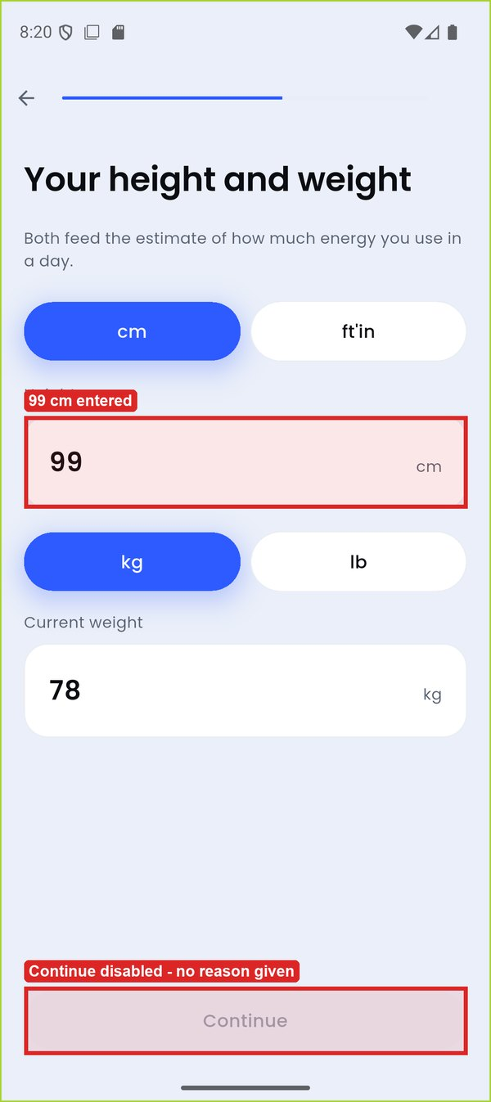 | 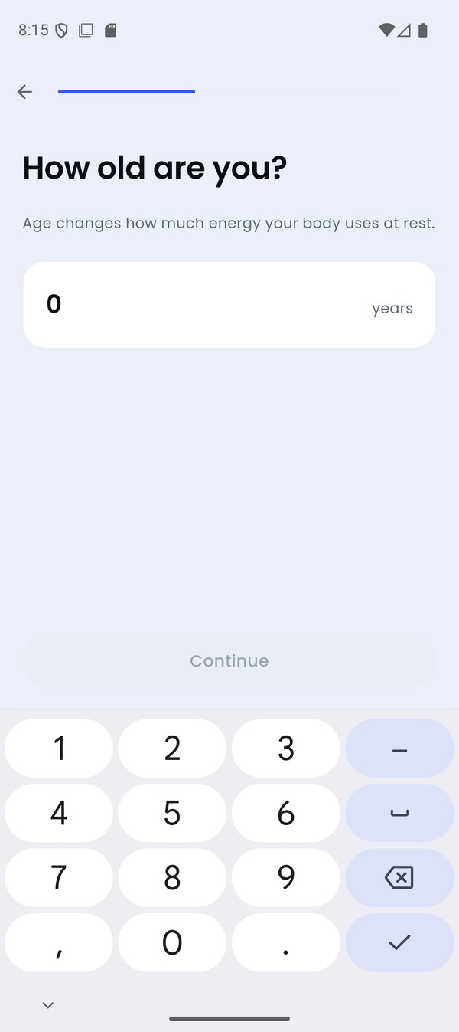
TC-007_height_99 (highlight added) | TC-005_age_0
Figure 5: DEF-01 evidence

DEF-02 – Under-18 refusal is forgotten when the app is restarted
Defect ID | DEF-02
Title | Under-18 refusal is forgotten when the app is restarted
Module / Feature | M1 Onboarding – Profile Entry
Found by | TC-013
Environment | Android 16 (API 36) emulator 'finall', 1080x2424 @ 420 dpi; release APK built from commit 35e2473
Severity | Major
Priority | High
Status | Open
Steps to reproduce | 1. Clear app data, launch, tap Male, enter age 17, tap Continue ('Calori is built for adults').  2. Force-stop Calori and relaunch it.  3. Tap Male, enter age 25, tap Continue.
Expected result | The refusal stays in force after a restart (UC-02: 'No path forward').
Actual result | The app restarts onboarding at step 1; any adult age is then accepted and the flow continues to 'Your height and weight'.
Impact | The app's only hard safety stop can be bypassed in seconds by closing and reopening it.
Evidence | TC-013_after_restart, TC-013_reentered_age25
Reporter / Date | Usman Ghani · 11-Oct-2026

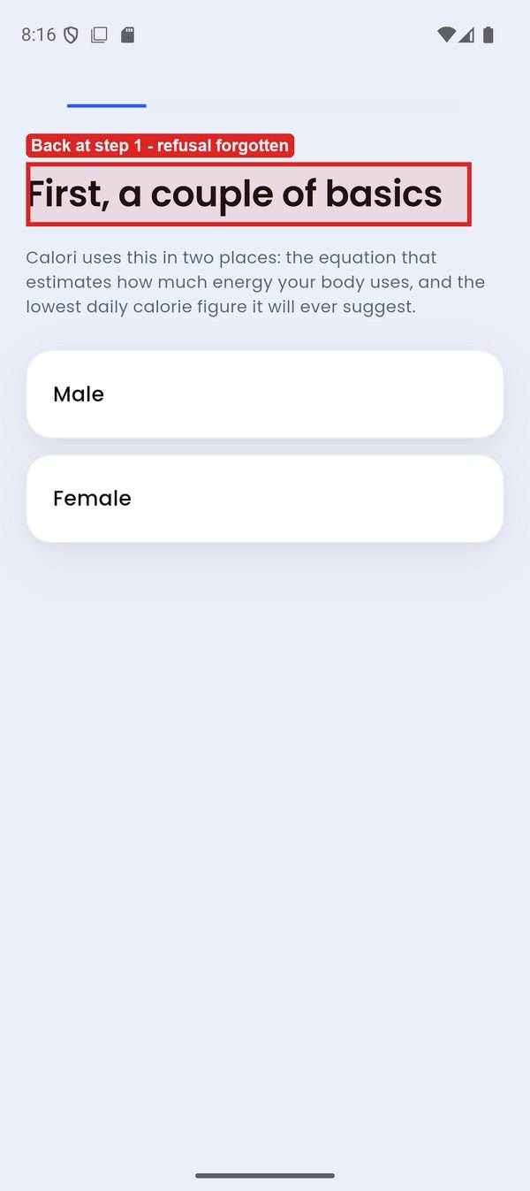 | 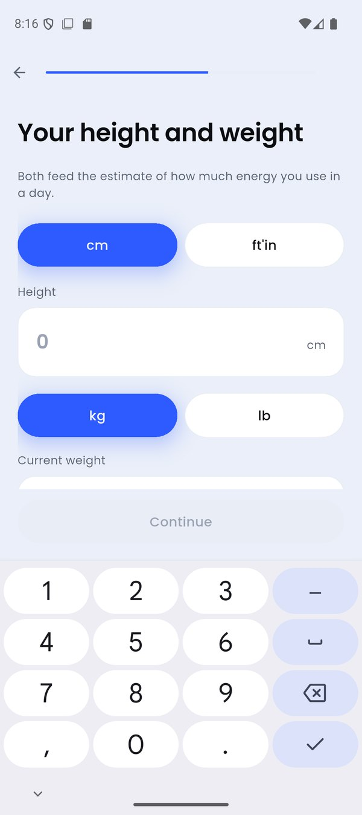
TC-013_after_restart (highlight added) | TC-013_reentered_age25
Figure 6: DEF-02 evidence

DEF-03 – System Back closes the app instead of going back (onboarding and secondary screens)
Defect ID | DEF-03
Title | System Back closes the app instead of going back (onboarding and secondary screens)
Module / Feature | M8 Navigation
Found by | TC-012, TC-076
Environment | Android 16 (API 36) emulator 'finall', 1080x2424 @ 420 dpi; release APK built from commit 35e2473
Severity | Major
Priority | Medium
Status | Open
Steps to reproduce | 1. During onboarding, on 'Your height and weight' with the keyboard closed, press the Android Back button.  2. Or, with a profile saved, open Calendar (or Add food, or Goal) and press Back.
Expected result | Back returns to the previous onboarding step, or to Home from a secondary screen.
Actual result | Calori closes and the launcher appears. In onboarding every answer is lost: reopening starts again at step 1.
Impact | The most-used Android gesture exits the app and discards onboarding progress.
Evidence | TC-012_system_back_onboarding, TC-012_before_back, TC-076_back_from_calendar
Reporter / Date | Faizan Ali · 11-Oct-2026

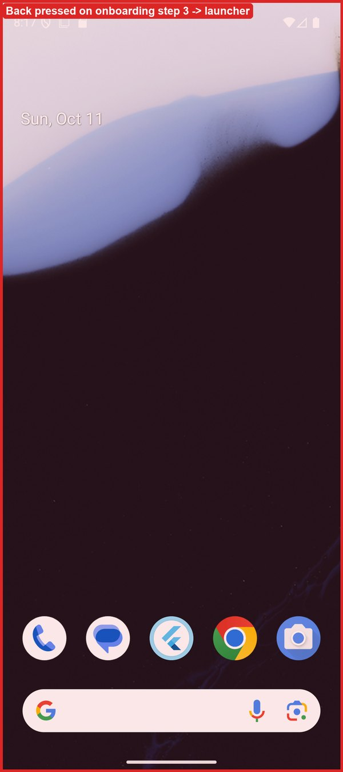 | 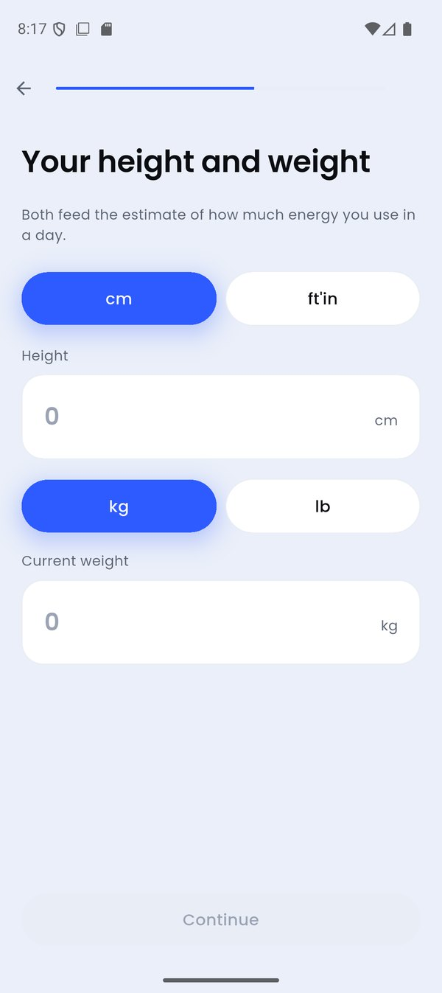
TC-012_system_back_onboarding (highlight added) | TC-012_before_back
Figure 7: DEF-03 evidence

DEF-04 – Inches field accepts 12–99 inches
Defect ID | DEF-04
Title | Inches field accepts 12–99 inches
Module / Feature | M1 Onboarding – Profile Entry
Found by | TC-009
Environment | Android 16 (API 36) emulator 'finall', 1080x2424 @ 420 dpi; release APK built from commit 35e2473
Severity | Minor
Priority | Medium
Status | Open
Steps to reproduce | 1. Reach 'Your height and weight', tap ft'in.  2. Enter 5 ft and 25 in; enter weight 78 kg.
Expected result | Inches above 11 are rejected with a message.
Actual result | 5 ft 25 in (and 5 ft 12 in) is accepted; Continue is enabled and the flow proceeds. The value is silently stored as 216 cm.
Impact | A slip of the finger produces a wrong height and therefore wrong targets with no warning.
Evidence | TC-009_5ft25in
Reporter / Date | Usman Ghani · 11-Oct-2026

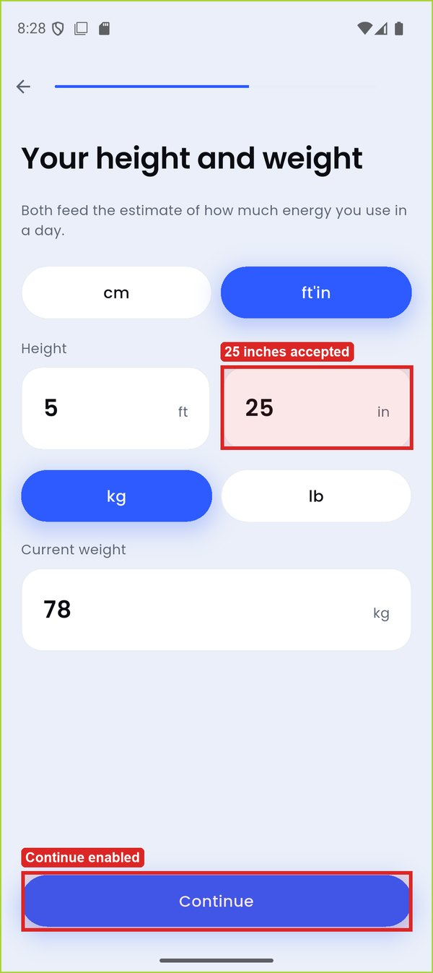
TC-009_5ft25in (highlight added)
Figure 8: DEF-04 evidence

DEF-05 – Onboarding progress bar is full one step early
Defect ID | DEF-05
Title | Onboarding progress bar is full one step early
Module / Feature | M1 Onboarding – Profile Entry
Found by | EXP-01
Environment | Android 16 (API 36) emulator 'finall', 1080x2424 @ 420 dpi; release APK built from commit 35e2473
Severity | Trivial
Priority | Low
Status | Open
Steps to reproduce | 1. Go through onboarding to 'How active are you?' (step 5 of 6).
Expected result | The bar shows about 83 % and reaches 100 % only on 'Here is your plan'.
Actual result | The bar is already 100 % on the activity step.
Impact | Cosmetic; the user is told they are finished one screen early.
Evidence | TC-014_activity_step
Reporter / Date | Usman Ghani · 11-Oct-2026

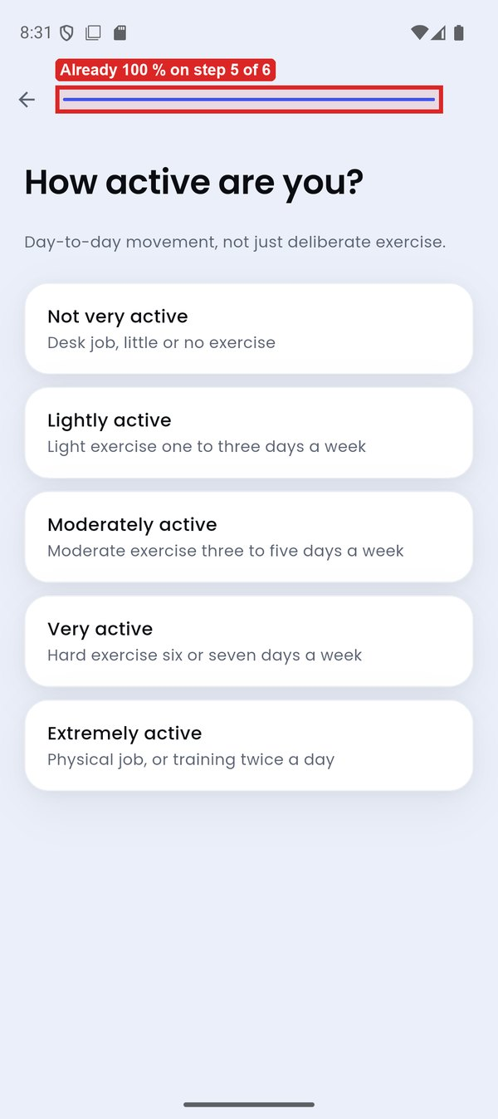
TC-014_activity_step (highlight added)
Figure 9: DEF-05 evidence

DEF-06 – Underweight users' offered alternatives end on an endless loading spinner
Defect ID | DEF-06
Title | Underweight users' offered alternatives end on an endless loading spinner
Module / Feature | M2 Goal Engine & Safety Rules
Found by | TC-018, TC-077
Environment | Android 16 (API 36) emulator 'finall', 1080x2424 @ 420 dpi; release APK built from commit 35e2473
Severity | Critical
Priority | High
Status | Open
Steps to reproduce | 1. Clear data; onboard as Male, 30, 178 cm, 52 kg.  2. On the target step enter 56 kg (refused).  3. Tap 'Aim for a healthy weight instead'; choose 'Moderately active'.  4. Repeat with 55 kg -> target 52 kg and 'Maintain instead'.
Expected result | A plan is shown: a gain toward about 59 kg, or a maintenance plan of about 2,350 kcal, with 'Start tracking'.
Actual result | The plan screen shows only a spinning loader - no target, no button, no back arrow. It never finishes (checked after 15 s); Back closes the app.
Impact | Any user under BMI 18.5 cannot finish onboarding at all, using the very options the app recommends.
Evidence | TC-018_spinner_after_15s, TC-018_refused_gain, TC-017_maintain_spinner
Reporter / Date | Usman Ghani · 11-Oct-2026

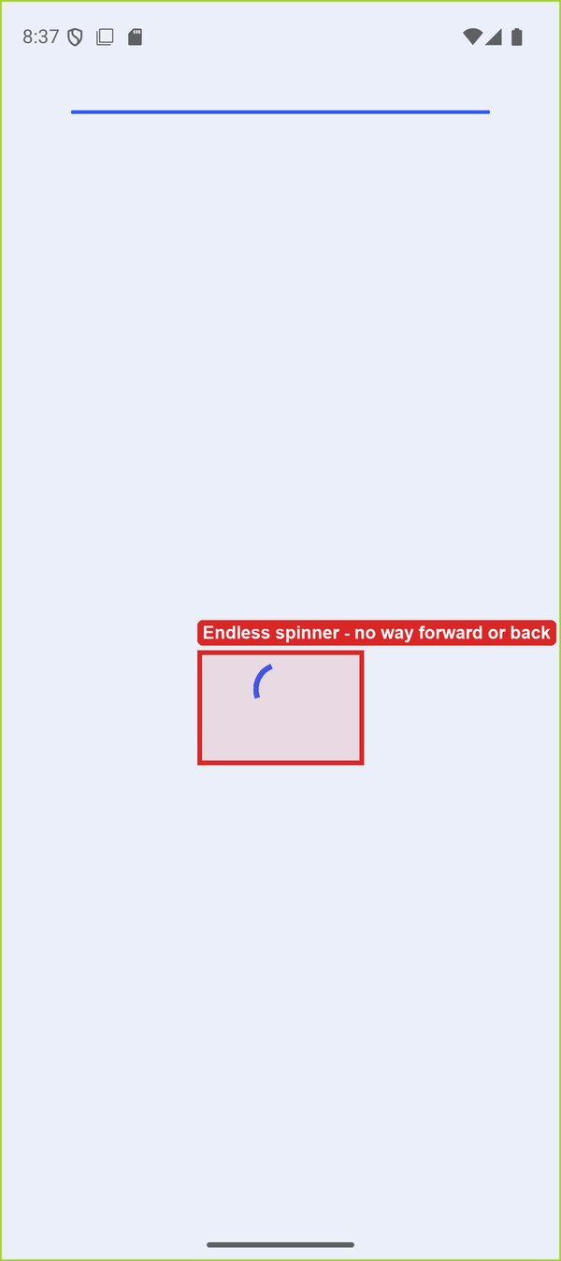 | 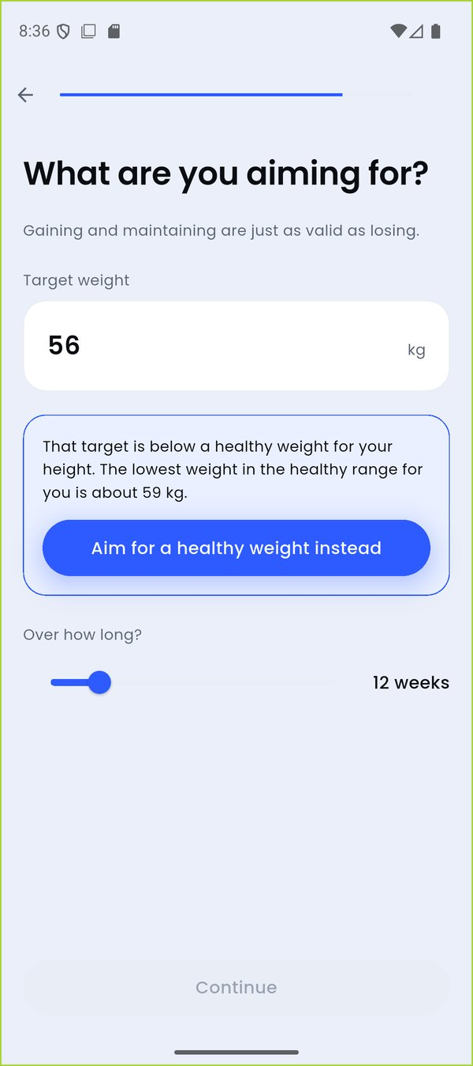
TC-018_spinner_after_15s (highlight added) | TC-018_refused_gain
Figure 10: DEF-06 evidence

DEF-07 – 'Too fast' correction says 'losing' on a weight-gain goal
Defect ID | DEF-07
Title | 'Too fast' correction says 'losing' on a weight-gain goal
Module / Feature | M2 Goal Engine & Safety Rules
Found by | TC-019
Environment | Android 16 (API 36) emulator 'finall', 1080x2424 @ 420 dpi; release APK built from commit 35e2473
Severity | Minor
Priority | Medium
Status | Open
Steps to reproduce | 1. Onboard Male, 30, 178 cm, 70 kg.  2. Enter target 85 kg with 12 weeks.
Expected result | The correction says gaining more than 1 % a week is too fast.
Actual result | 'That timeframe would mean losing more than 1% of your bodyweight a week...' - for a gain goal. Shown on the target step and the plan.
Impact | Contradictory advice on the screen whose purpose is to explain the plan.
Evidence | TC-019_gain_too_fast, TC-019_plan
Reporter / Date | Usman Ghani · 11-Oct-2026

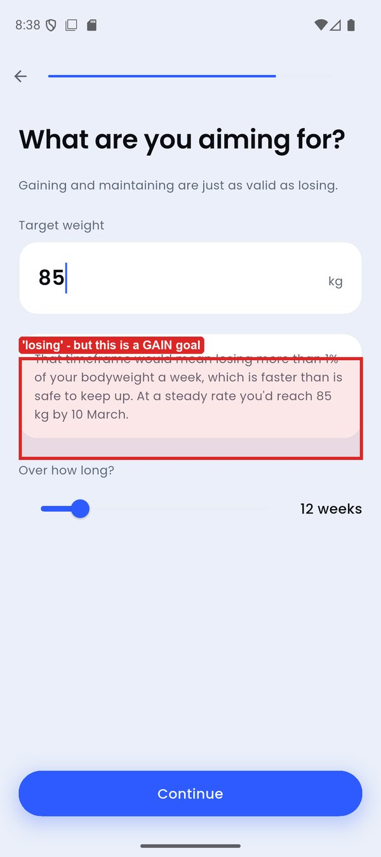 | 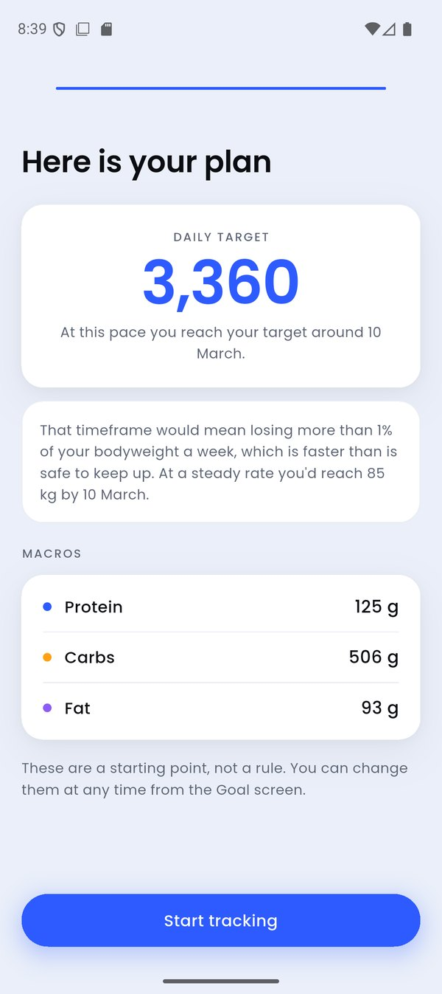
TC-019_gain_too_fast (highlight added) | TC-019_plan
Figure 11: DEF-07 evidence

DEF-08 – Refusal message quotes kilograms when pounds were chosen
Defect ID | DEF-08
Title | Refusal message quotes kilograms when pounds were chosen
Module / Feature | M2 Goal Engine & Safety Rules
Found by | TC-023
Environment | Android 16 (API 36) emulator 'finall', 1080x2424 @ 420 dpi; release APK built from commit 35e2473
Severity | Minor
Priority | Medium
Status | Open
Steps to reproduce | 1. Onboard Male, 30, 178 cm; choose lb and enter 172 lb.  2. On the target step enter 120 lb.
Expected result | The lowest healthy weight is given in pounds (about 129 lb).
Actual result | 'The lowest weight in the healthy range for you is about 59 kg.' while the field and the user's choice are in lb. The rate correction also quotes kg.
Impact | Users who think in pounds must convert the one number they need to act on.
Evidence | TC-023_refusal_in_lb
Reporter / Date | Usman Ghani · 11-Oct-2026

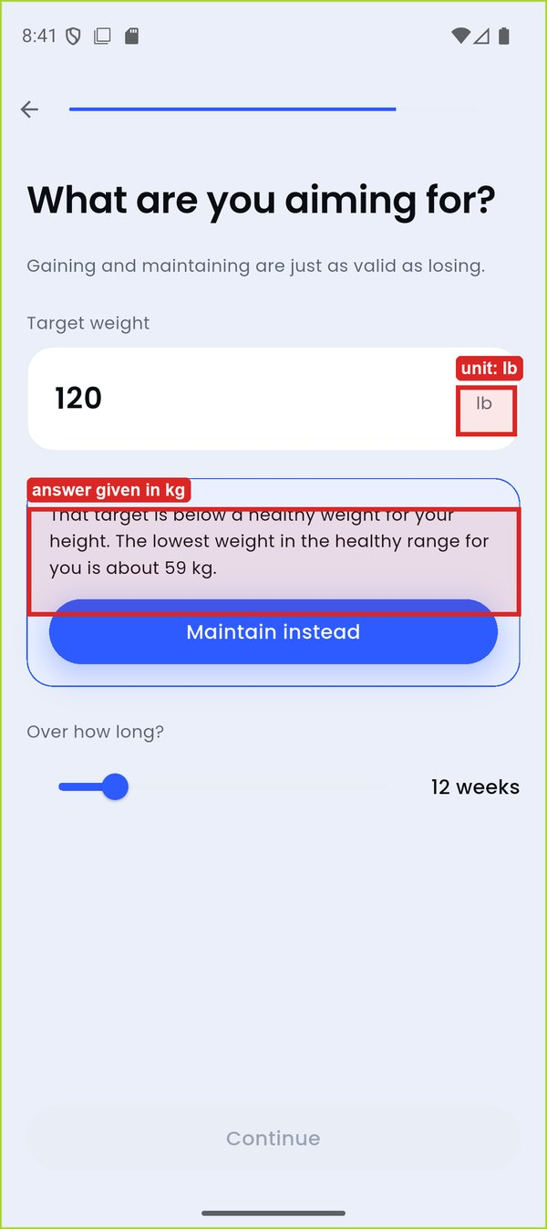
TC-023_refusal_in_lb (highlight added)
Figure 12: DEF-08 evidence

DEF-09 – Projected goal dates omit the year
Defect ID | DEF-09
Title | Projected goal dates omit the year
Module / Feature | M2 Goal Engine & Safety Rules
Found by | TC-024, TC-055
Environment | Android 16 (API 36) emulator 'finall', 1080x2424 @ 420 dpi; release APK built from commit 35e2473
Severity | Minor
Priority | Medium
Status | Open
Steps to reproduce | 1. Onboard Female, 60, 150 cm, 75 kg; target 45 kg; 'Not very active'.
Expected result | A date more than a year away shows its year, e.g. '7 February 2029'.
Actual result | '...reach your target around 7 February' - reads as February 2027. On the Goal screen at 0.1 %/week it reads 'by 2 October', which looks like a date nine days in the past.
Impact | Users misjudge their timeline by a year or more.
Evidence | TC-024_long_goal_plan, TC-055_rate_min
Reporter / Date | Usman Ghani · 11-Oct-2026

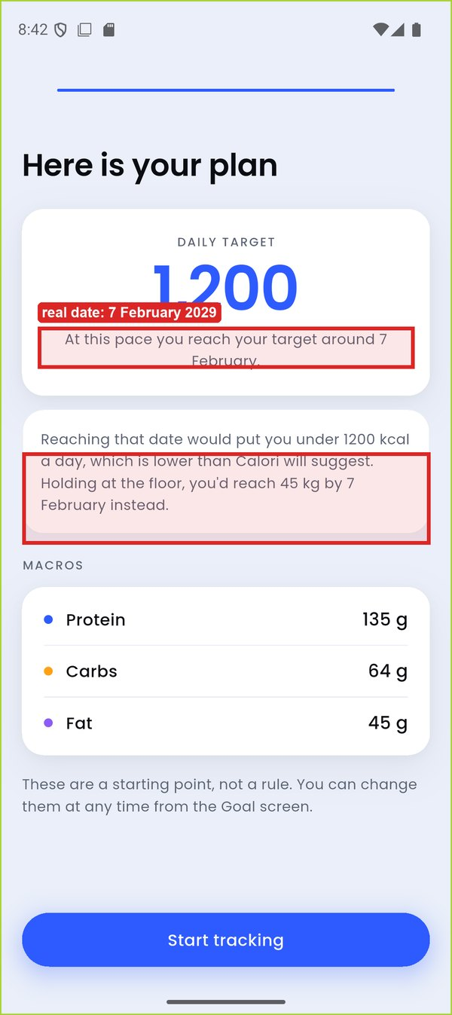 | 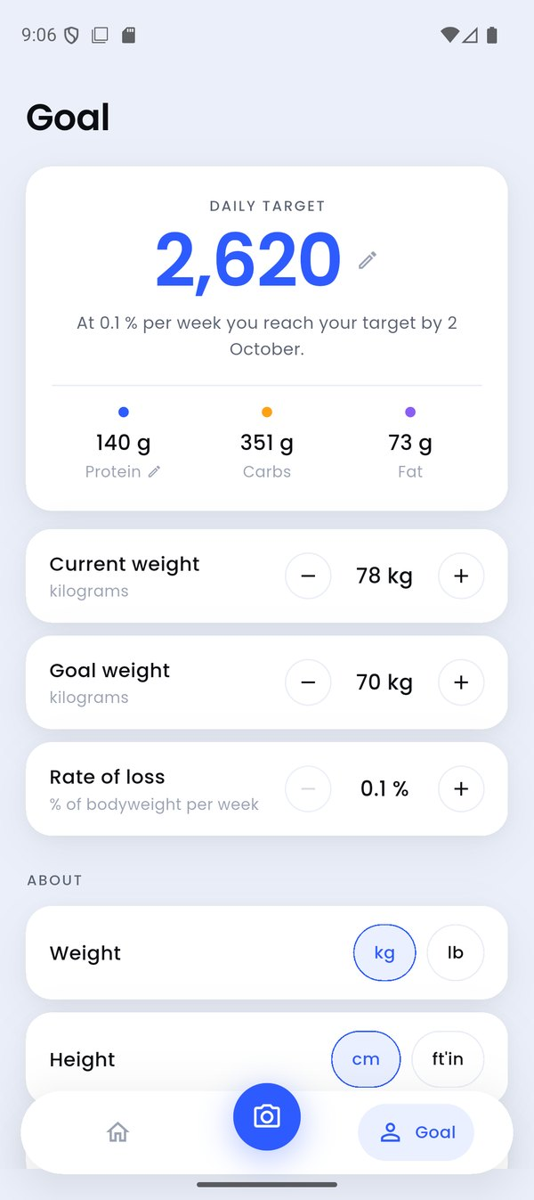
TC-024_long_goal_plan (highlight added) | TC-055_rate_min
Figure 13: DEF-09 evidence

DEF-10 – Raw portion code '90000' shown as a serving name
Defect ID | DEF-10
Title | Raw portion code '90000' shown as a serving name
Module / Feature | M3 Manual Food Logging
Found by | TC-026
Environment | Android 16 (API 36) emulator 'finall', 1080x2424 @ 420 dpi; release APK built from commit 35e2473
Severity | Minor
Priority | Low
Status | Open
Steps to reproduce | 1. Open Add food, search 'rice', expand 'Rice cake' (USDA).
Expected result | Servings have household names (e.g. '1 cake').
Actual result | The default serving chip, the stepper label and the result line read '90000' ('90000 servings'). Also seen on 'Rice paper' and 'Bread, paratha'.
Impact | The user cannot tell how big the default serving is.
Evidence | TC-026_rice_cake_picker, TC-026_search_rice
Reporter / Date | Faizan Ali · 11-Oct-2026

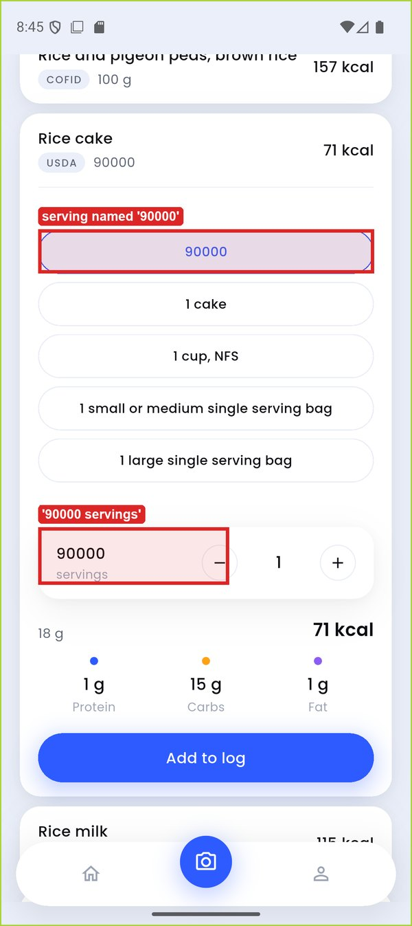 | 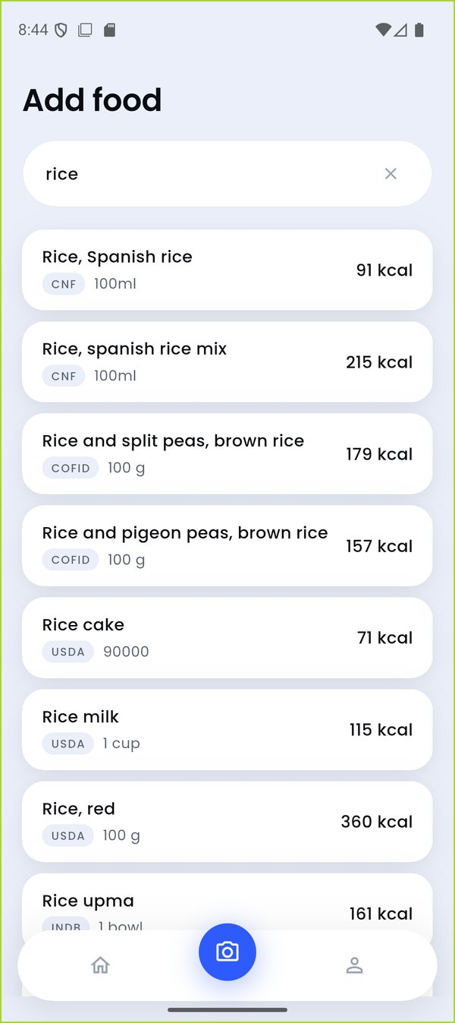
TC-026_rice_cake_picker (highlight added) | TC-026_search_rice
Figure 14: DEF-10 evidence

DEF-11 – 'Add to log' stays stuck on 'Saving…' after the first manual add
Defect ID | DEF-11
Title | 'Add to log' stays stuck on 'Saving…' after the first manual add
Module / Feature | M3 Manual Food Logging
Found by | TC-034
Environment | Android 16 (API 36) emulator 'finall', 1080x2424 @ 420 dpi; release APK built from commit 35e2473
Severity | Major
Priority | High
Status | Open
Steps to reproduce | 1. Tap '+', search 'rice', expand a result, tap 'Add to log' (returns to Home).  2. Tap '+' again and look at the same result card; tap its button.
Expected result | The card is back at rest and the food can be added again.
Actual result | The card is still expanded with a disabled 'Saving…' button. Tapping does nothing; it stays stuck for the session.
Impact | Repeat foods - the most common manual log - cannot be added again without a new search.
Evidence | TC-034_stuck_saving, V1_stuck_saving_button.mp4
Reporter / Date | Faizan Ali · 11-Oct-2026
Note | The project's next commit (36ead9d) says it fixes this; not re-tested in this cycle.

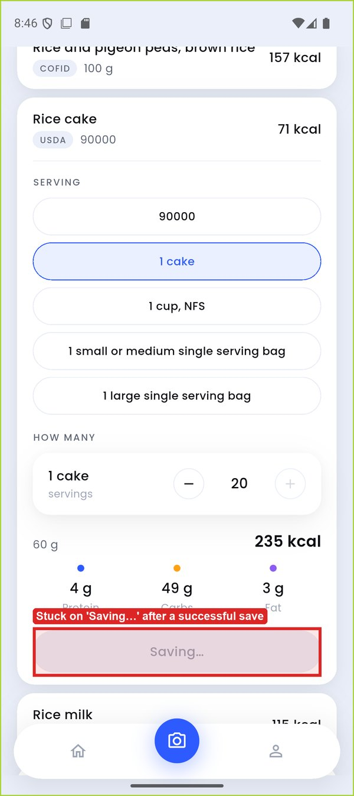
TC-034_stuck_saving (highlight added)
Figure 15: DEF-11 evidence

DEF-12 – Recent foods never appear for foods logged by hand
Defect ID | DEF-12
Title | Recent foods never appear for foods logged by hand
Module / Feature | M3 Manual Food Logging
Found by | TC-030
Environment | Android 16 (API 36) emulator 'finall', 1080x2424 @ 420 dpi; release APK built from commit 35e2473
Severity | Minor
Priority | Medium
Status | Open
Steps to reproduce | 1. Log a food through Add food.  2. Open Add food with an empty search field.
Expected result | A 'Recent' section lists recently/frequently logged foods (UC-05 step 2).
Actual result | Nothing is shown. Only foods saved from photo estimates ever appear as Recent (seen in TC-073).
Impact | Manual-only users - the default build - never get the shortcut UC-05 promises.
Evidence | TC-030_no_recent_section
Reporter / Date | Faizan Ali · 11-Oct-2026

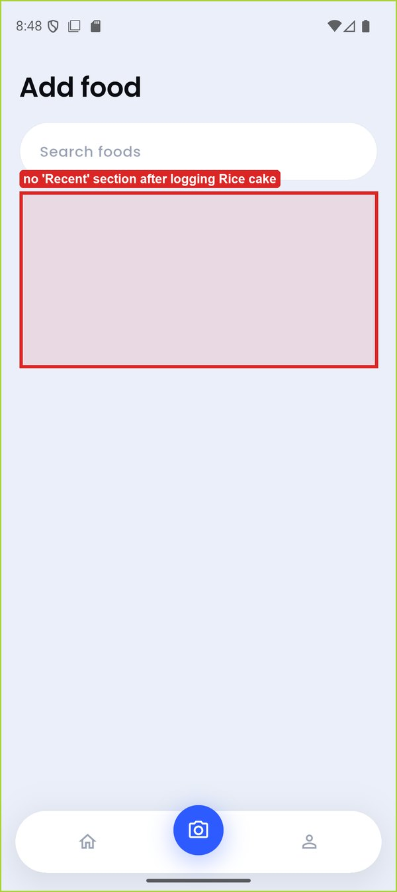
TC-030_no_recent_section (highlight added)
Figure 16: DEF-12 evidence

DEF-13 – Implausible nutrition values for some INDB foods
Defect ID | DEF-13
Title | Implausible nutrition values for some INDB foods
Module / Feature | M3 Manual Food Logging
Found by | EXP-02
Environment | Android 16 (API 36) emulator 'finall', 1080x2424 @ 420 dpi; release APK built from commit 35e2473
Severity | Major
Priority | Medium
Status | Open
Steps to reproduce | 1. Search 'palak channa cutlet', expand 'Spinach chickpeas cutlet (Palak channa dal cutlet)'.  2. Search 'egg boiled', look at 'Boiled egg (Ubla anda)'.
Expected result | One cutlet is roughly 60–100 g and 150–250 kcal; one boiled egg is about 50 g and 70–80 kcal.
Actual result | 1 cutlet = 328 g, 2,255 kcal, 241 g fat (73 % fat by weight). 'Boiled egg (Ubla anda)' 1 egg = 151 g but 68 kcal (45 kcal/100 g).
Impact | One log of the cutlet adds a whole day's calories; totals and targets become meaningless.
Evidence | TC-EXP_cutlet_2255kcal, TC-039_editor_open
Reporter / Date | Faizan Ali · 11-Oct-2026

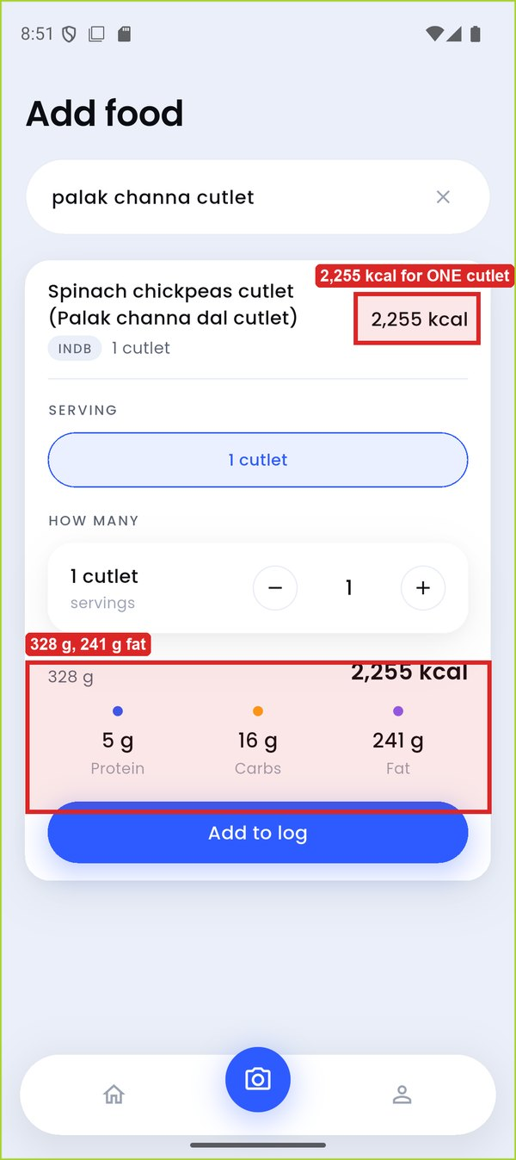 | 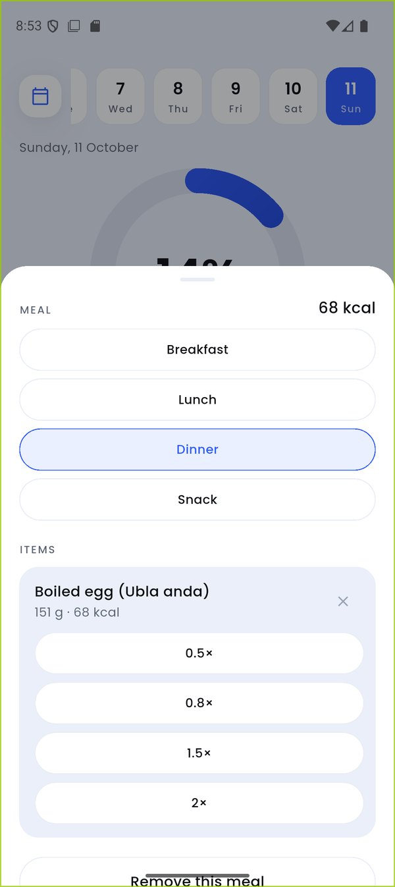
TC-EXP_cutlet_2255kcal (highlight added) | TC-039_editor_open
Figure 17: DEF-13 evidence

DEF-14 – Portion chip labelled '0.8×' applies 0.75×
Defect ID | DEF-14
Title | Portion chip labelled '0.8×' applies 0.75×
Module / Feature | M4 Day View & Entry Editing
Found by | EXP-03
Environment | Android 16 (API 36) emulator 'finall', 1080x2424 @ 420 dpi; release APK built from commit 35e2473
Severity | Minor
Priority | Low
Status | Open
Steps to reproduce | 1. Open an entry (e.g. 151 g boiled egg).  2. Tap '0.8×'.
Expected result | The item becomes 0.8 × 151 g = 121 g.
Actual result | It becomes 113 g / 51 kcal (0.75×). The label rounds 0.75 to '0.8'.
Impact | The amount logged differs from the amount chosen.
Evidence | EXP_chip_0_8x
Reporter / Date | Faizan Ali · 11-Oct-2026

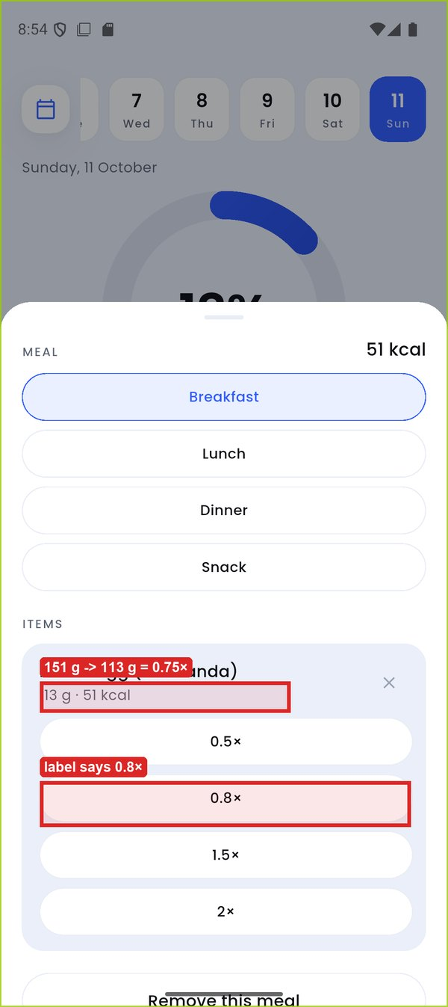
EXP_chip_0_8x (highlight added)
Figure 18: DEF-14 evidence

DEF-15 – Repeated 0.5× shrinks an item to 0 g / 0 kcal
Defect ID | DEF-15
Title | Repeated 0.5× shrinks an item to 0 g / 0 kcal
Module / Feature | M4 Day View & Entry Editing
Found by | TC-041
Environment | Android 16 (API 36) emulator 'finall', 1080x2424 @ 420 dpi; release APK built from commit 35e2473
Severity | Minor
Priority | Low
Status | Open
Steps to reproduce | 1. Open an entry editor.  2. Tap '0.5×' ten times.
Expected result | A sensible minimum, or an offer to remove the item.
Actual result | The item shows '0 g · 0 kcal' and the meal remains on Home as a 0 kcal entry.
Impact | Leaves meaningless zero entries in the diary.
Evidence | TC-041_zero_gram_item, TC-041_home_zero_kcal_meal
Reporter / Date | Faizan Ali · 11-Oct-2026

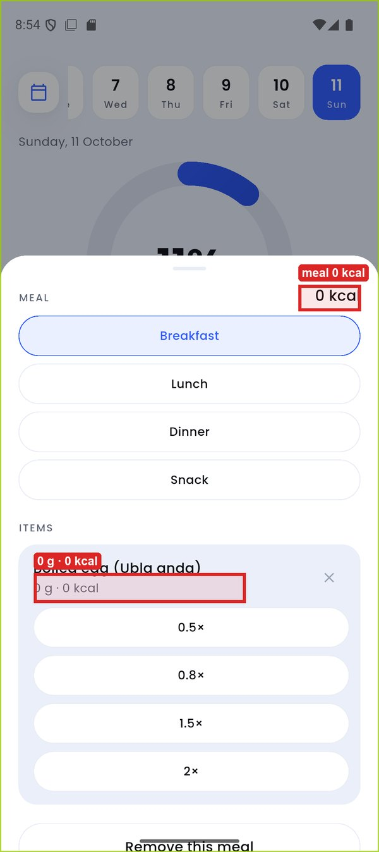 | 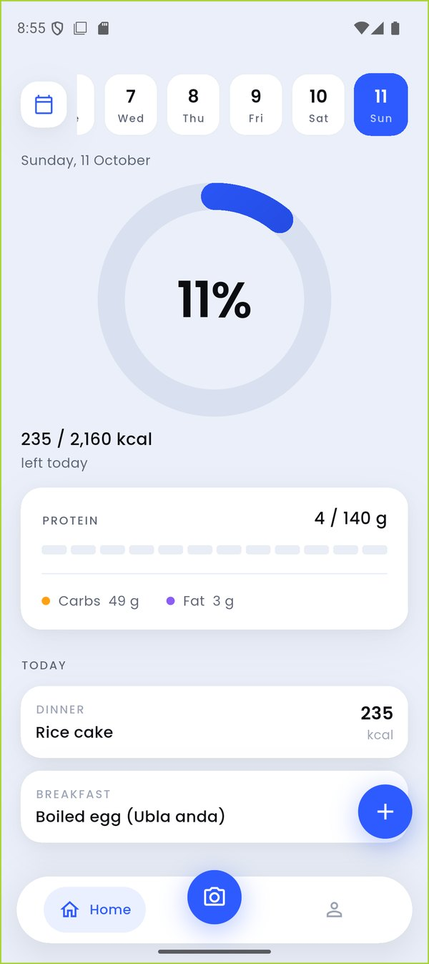
TC-041_zero_gram_item (highlight added) | TC-041_home_zero_kcal_meal
Figure 19: DEF-15 evidence

DEF-16 – Undo after a swipe-delete restores the meal in the wrong position
Defect ID | DEF-16
Title | Undo after a swipe-delete restores the meal in the wrong position
Module / Feature | M4 Day View & Entry Editing
Found by | TC-043
Environment | Android 16 (API 36) emulator 'finall', 1080x2424 @ 420 dpi; release APK built from commit 35e2473
Severity | Minor
Priority | Low
Status | Open
Steps to reproduce | 1. Log A (Rice cake) then B (egg) today.  2. Swipe A away; tap Undo.
Expected result | A is restored exactly as it was, before B.
Actual result | A returns below B: it is re-inserted as a new entry with a new logged time.
Impact | Undo does not truly undo; the diary's order and logged time change.
Evidence | TC-043_after_undo, TC-043_before_swipe
Reporter / Date | Faizan Ali · 11-Oct-2026

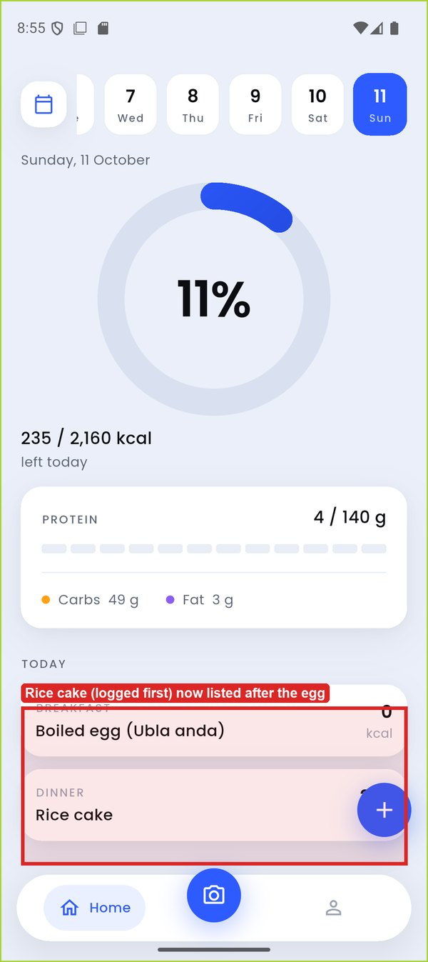 | 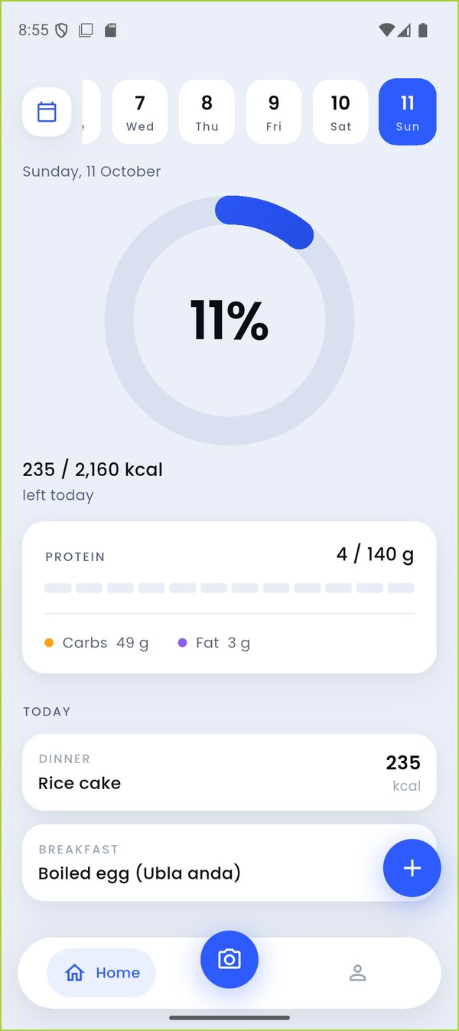
TC-043_after_undo (highlight added) | TC-043_before_swipe
Figure 20: DEF-16 evidence

DEF-17 – Calendar day detail omits fat
Defect ID | DEF-17
Title | Calendar day detail omits fat
Module / Feature | M5 Calendar
Found by | TC-049
Environment | Android 16 (API 36) emulator 'finall', 1080x2424 @ 420 dpi; release APK built from commit 35e2473
Severity | Trivial
Priority | Low
Status | Open
Steps to reproduce | 1. Open Calendar, tap a logged day.
Expected result | Protein, carbs and fat are listed.
Actual result | Only Protein and Carbs are shown.
Impact | Incomplete day summary.
Evidence | TC-049_day_detail
Reporter / Date | Faizan Ali · 11-Oct-2026

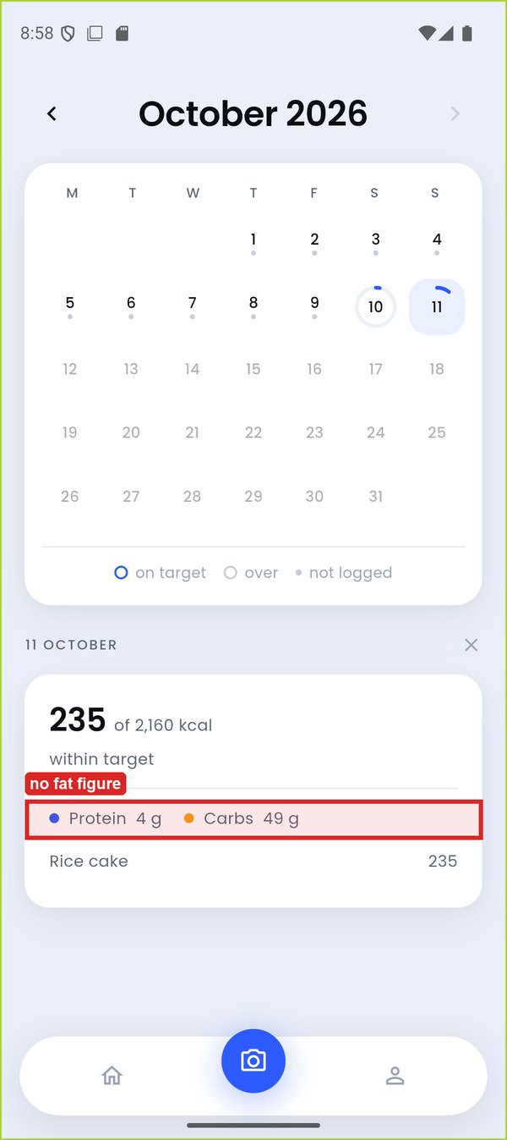
TC-049_day_detail (highlight added)
Figure 21: DEF-17 evidence

DEF-18 – Day detail survives a month change and contradicts itself
Defect ID | DEF-18
Title | Day detail survives a month change and contradicts itself
Module / Feature | M5 Calendar
Found by | TC-050
Environment | Android 16 (API 36) emulator 'finall', 1080x2424 @ 420 dpi; release APK built from commit 35e2473
Severity | Minor
Priority | Low
Status | Open
Steps to reproduce | 1. In Calendar tap 11 October (detail opens).  2. Tap the back arrow to September.
Expected result | The October detail closes, or is replaced by September's summary.
Actual result | Under the September grid a card '11 OCTOBER - 0 kcal' still lists 'Rice cake 235'.
Impact | Shows wrong totals for a day.
Evidence | TC-050_september_with_oct_detail
Reporter / Date | Faizan Ali · 11-Oct-2026

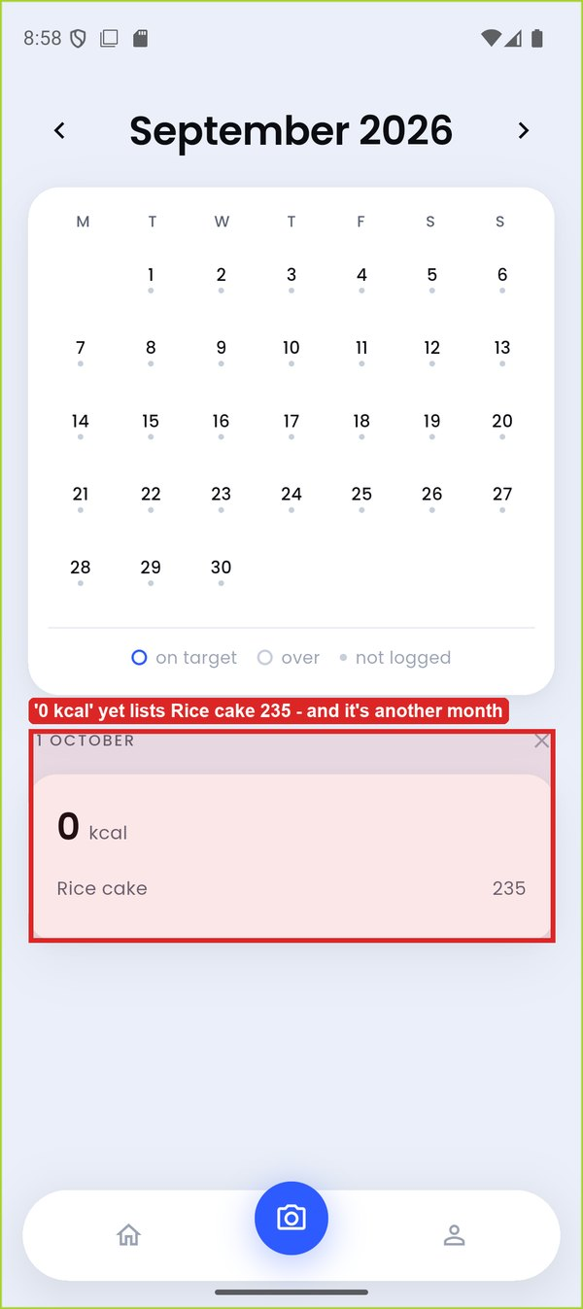
TC-050_september_with_oct_detail (highlight added)
Figure 22: DEF-18 evidence

DEF-19 – Hand-set calories of 0 or blank are silently discarded
Defect ID | DEF-19
Title | Hand-set calories of 0 or blank are silently discarded
Module / Feature | M6 Goal Management
Found by | TC-059
Environment | Android 16 (API 36) emulator 'finall', 1080x2424 @ 420 dpi; release APK built from commit 35e2473
Severity | Minor
Priority | Low
Status | Open
Steps to reproduce | 1. Goal: tap the calorie figure, enter 0, Save.  2. Repeat with an empty field.
Expected result | A message explains the value was not accepted.
Actual result | The sheet closes and the old target stays; nothing tells the user it did not save.
Impact | The user may believe a change was saved.
Evidence | TC-059_after_save_0, TC-059_entered_0
Reporter / Date | Faizan Ali · 11-Oct-2026

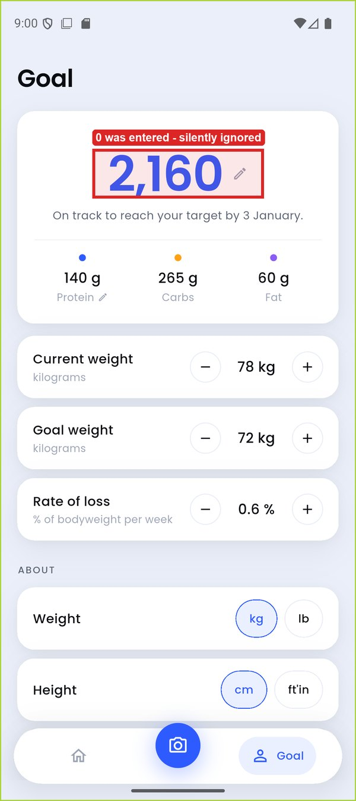 | 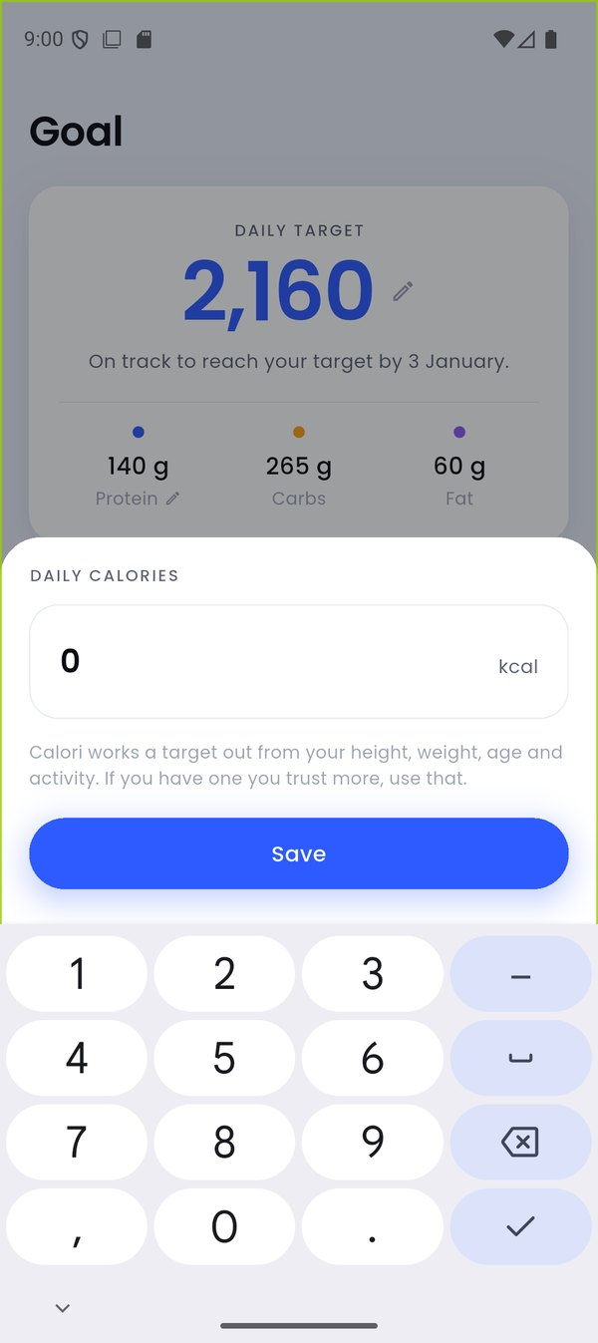
TC-059_after_save_0 (highlight added) | TC-059_entered_0
Figure 23: DEF-19 evidence

DEF-20 – Hand-set protein can exceed the whole calorie target
Defect ID | DEF-20
Title | Hand-set protein can exceed the whole calorie target
Module / Feature | M6 Goal Management
Found by | TC-060
Environment | Android 16 (API 36) emulator 'finall', 1080x2424 @ 420 dpi; release APK built from commit 35e2473
Severity | Minor
Priority | Medium
Status | Open
Steps to reproduce | 1. Goal (2,160 kcal): tap the macro row, enter 600, Save.
Expected result | A warning or refusal; the card never shows macros worth more than the calorie figure.
Actual result | Protein 600 g, Carbs 0 g, Fat 47 g = 2,823 kcal shown under a 2,160 kcal target, with no warning.
Impact | The plan contradicts itself.
Evidence | TC-060_protein_600
Reporter / Date | Faizan Ali · 11-Oct-2026

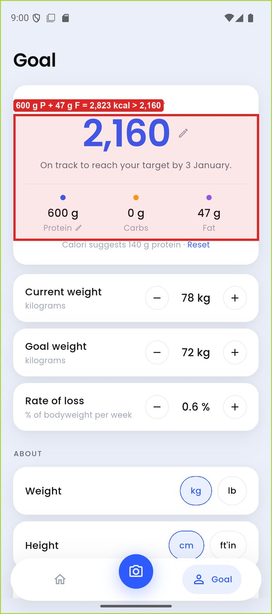
TC-060_protein_600 (highlight added)
Figure 24: DEF-20 evidence

DEF-21 – Home ring % (and Calendar) keep the old target after a goal change
Defect ID | DEF-21
Title | Home ring % (and Calendar) keep the old target after a goal change
Module / Feature | M4 Day View & Entry Editing
Found by | TC-045
Environment | Android 16 (API 36) emulator 'finall', 1080x2424 @ 420 dpi; release APK built from commit 35e2473
Severity | Major
Priority | High
Status | Open
Steps to reproduce | 1. Log 235 kcal today (ring 11 % of 2,160).  2. Goal: set calories by hand to 1,080.  3. Return to Home.
Expected result | Ring 22 % and line '235 / 1,080 kcal'.
Actual result | The line updates to '235 / 1,080 kcal' but the ring still says 11 %. It corrects only after switching day; the Calendar keeps the old target until restart.
Impact | Two figures on the same screen disagree about progress.
Evidence | TC-045_home_after_goal_change, TC-045_home_before, TC-045_today_after_day_switch
Reporter / Date | Faizan Ali · 11-Oct-2026

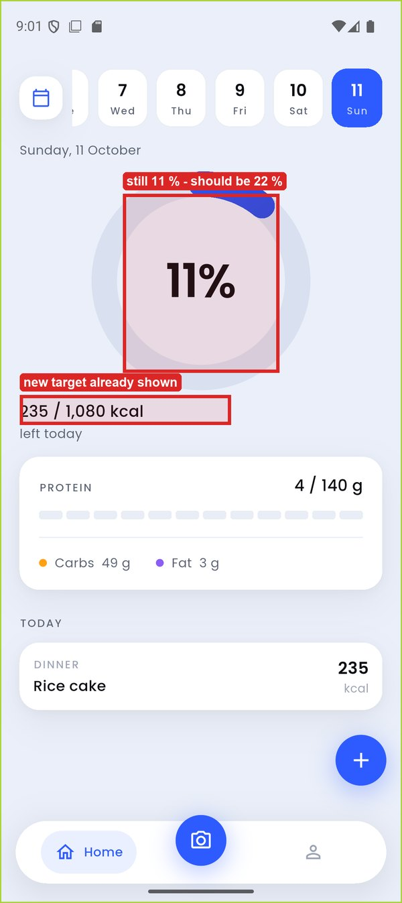 | 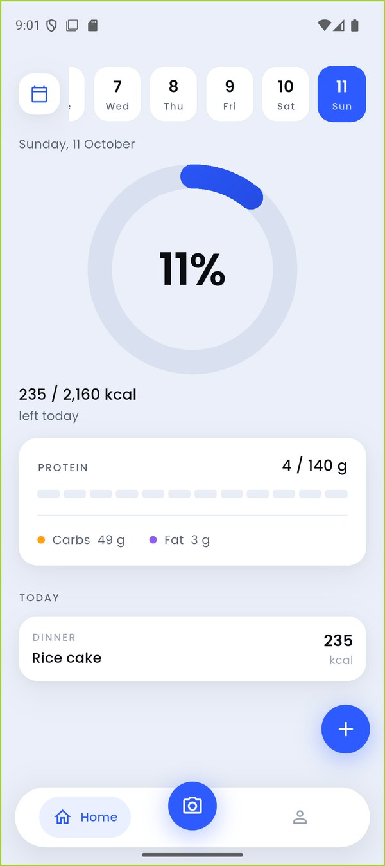
TC-045_home_after_goal_change (highlight added) | TC-045_home_before
Figure 25: DEF-21 evidence

DEF-22 – Past days are re-judged against a new goal
Defect ID | DEF-22
Title | Past days are re-judged against a new goal
Module / Feature | M5 Calendar
Found by | TC-052
Environment | Android 16 (API 36) emulator 'finall', 1080x2424 @ 420 dpi; release APK built from commit 35e2473
Severity | Major
Priority | High
Status | Open
Steps to reproduce | 1. Log 72 kcal on 10 Oct against 2,160 kcal (3 %).  2. Goal: set calories to 1,080.  3. View 10 Oct on Home, and in Calendar after a restart.
Expected result | Past days keep the target in force when logged (UC-10; Goal screen: 'Days you have already logged keep the target they were measured against').
Actual result | 10 Oct now reads '72 / 1,080 kcal' (7 %) on Home and '72 of 1,080 kcal' in Calendar.
Impact | History changes retroactively, breaking a stated promise and any record of adherence.
Evidence | TC-052_calendar_yesterday_after_restart, TC-052_yesterday_home_after_change, TC-052_calendar_yesterday
Reporter / Date | Faizan Ali · 11-Oct-2026

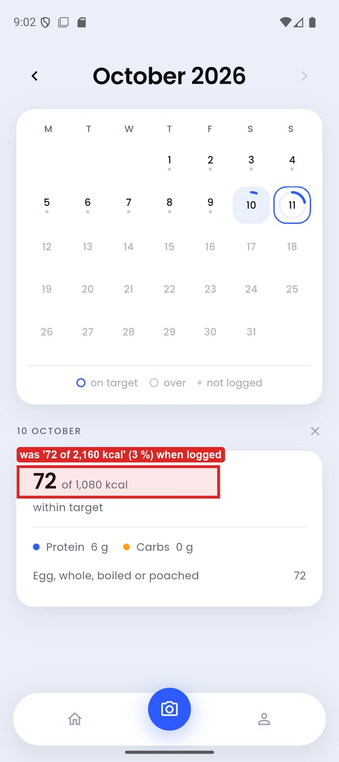 | 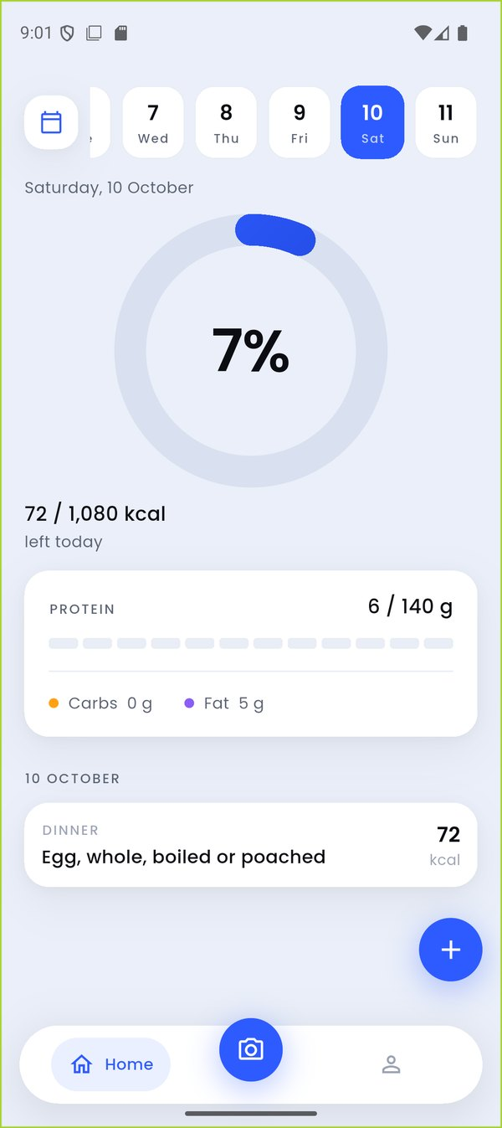
TC-052_calendar_yesterday_after_restart (highlight added) | TC-052_yesterday_home_after_change
Figure 26: DEF-22 evidence

DEF-23 – Switching the weight unit erases the goal date and hand-set calories
Defect ID | DEF-23
Title | Switching the weight unit erases the goal date and hand-set calories
Module / Feature | M6 Goal Management
Found by | TC-061
Environment | Android 16 (API 36) emulator 'finall', 1080x2424 @ 420 dpi; release APK built from commit 35e2473
Severity | Major
Priority | High
Status | Open
Steps to reproduce | 1. Goal: loss goal 'On track ... by 3 January', rate 0.6 %; set calories by hand to 2,000.  2. Under About -> Weight tap 'lb'.  3. Force-stop and relaunch; open Goal.
Expected result | Only the display unit changes; caption, rate, target and the hand-set value stay.
Actual result | Caption becomes 'Enough to hold your current weight.' (goal still 172 -> 159 lb), rate drops to 0.5 %, and after restart the 'Calori suggests… Reset' line is gone - the saved target date and hand-set flag were wiped.
Impact | A display preference silently rewrites the saved plan.
Evidence | TC-061_after_restart, TC-061_before_units_toggle, TC-061_after_lb, V2_units_toggle_wipes_goal.mp4
Reporter / Date | Faizan Ali · 11-Oct-2026

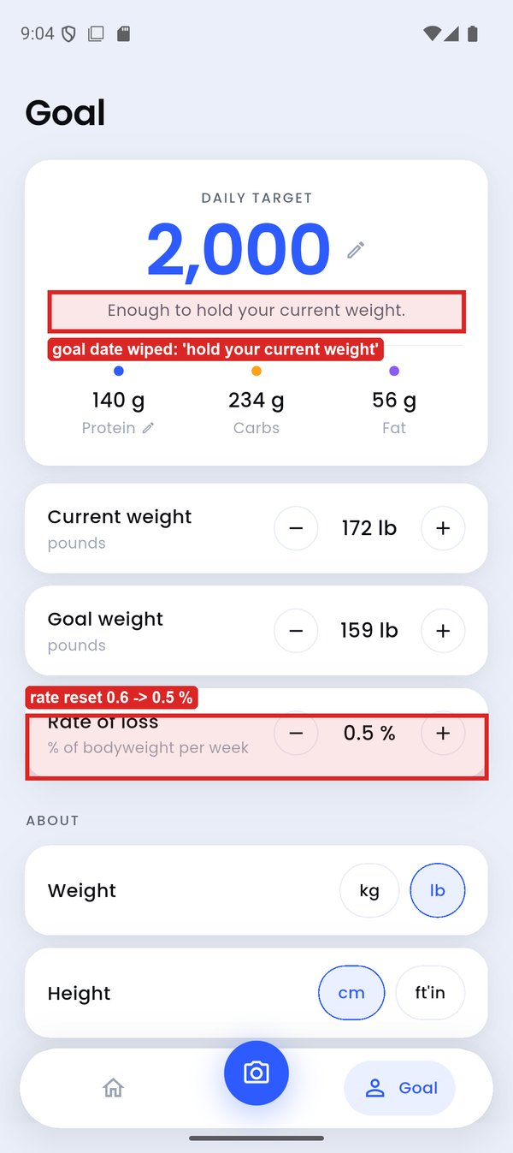 | 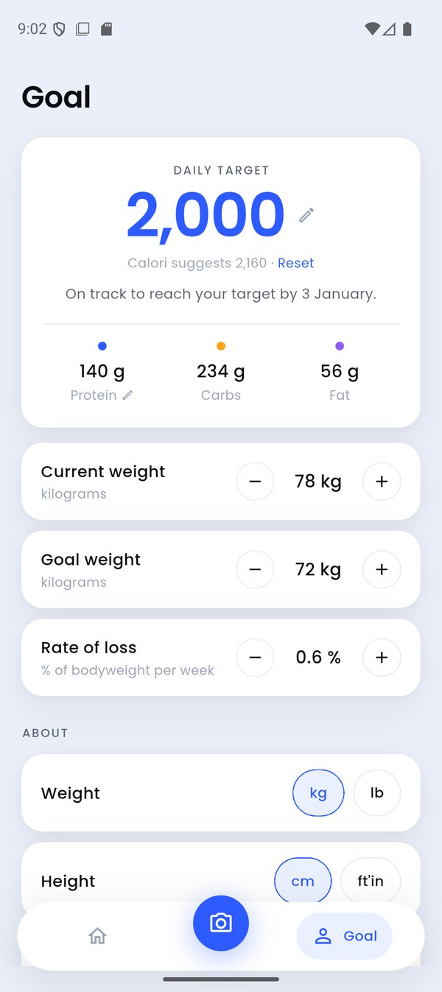
TC-061_after_restart (highlight added) | TC-061_before_units_toggle
Figure 27: DEF-23 evidence

DEF-24 – Goal screen ignores the chosen rate (target up to 220 kcal off)
Defect ID | DEF-24
Title | Goal screen ignores the chosen rate (target up to 220 kcal off)
Module / Feature | M6 Goal Management
Found by | TC-056, TC-055
Environment | Android 16 (API 36) emulator 'finall', 1080x2424 @ 420 dpi; release APK built from commit 35e2473
Severity | Major
Priority | High
Status | Open
Steps to reproduce | 1. Goal: current weight 95 kg, goal 92 kg (Male, 30, 178 cm, moderately active).  2. Set 'Rate of loss' to 1.0 %.
Expected result | Target 1,930 kcal; 'At 1.0 % per week you reach your target by 3 November'.
Actual result | 'At 0.8 % per week you reach your target by 8 November', 2,150 kcal - 220 kcal more than the chosen rate implies.
Impact | The core calculation does not honour the user's input.
Evidence | TC-056_rate_1_0_quantised, TC-055_rate_max
Reporter / Date | Faizan Ali · 11-Oct-2026
Note | The project's next commit (36ead9d) says it fixes this; not re-tested in this cycle.

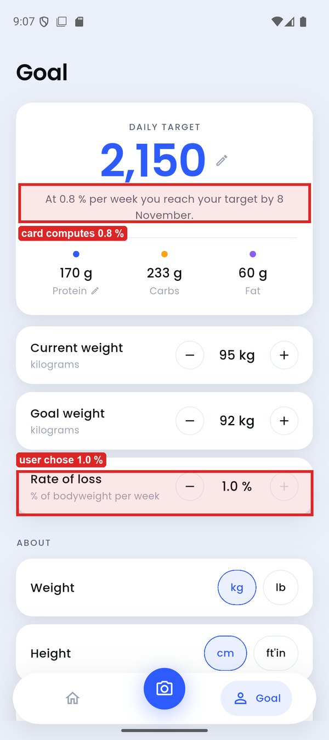 | 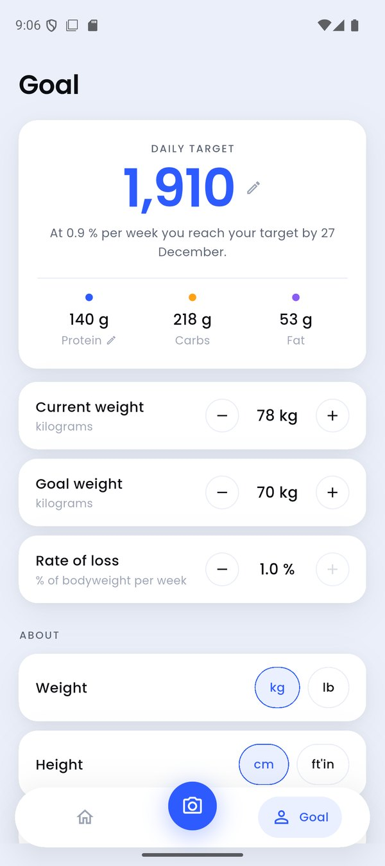
TC-056_rate_1_0_quantised (highlight added) | TC-055_rate_max
Figure 28: DEF-24 evidence

DEF-25 – Viewfinder's Gallery button has no visible label
Defect ID | DEF-25
Title | Viewfinder's Gallery button has no visible label
Module / Feature | M7 Photo Logging
Found by | TC-063
Environment | Android 16 (API 36) emulator 'finall', 1080x2424 @ 420 dpi; release APK built from commit 35e2473
Severity | Major
Priority | Medium
Status | Open
Steps to reproduce | 1. Tap the camera button to open the viewfinder.  2. Look for the Gallery button beside the shutter.
Expected result | A labelled 'Gallery' pill beside the shutter.
Actual result | The Gallery pill stretches across the whole bar and its 'Gallery' text is hidden behind the shutter; the bar looks empty.
Impact | Choosing an existing photo is effectively undiscoverable.
Evidence | TC-063_viewfinder
Reporter / Date | Usman Ghani · 11-Oct-2026

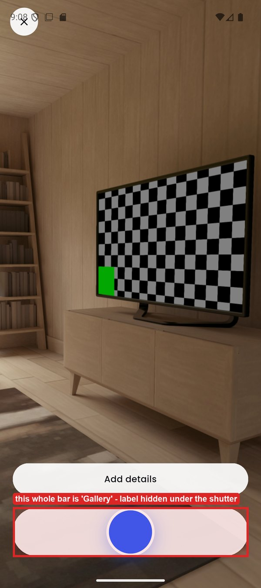
TC-063_viewfinder (highlight added)
Figure 29: DEF-25 evidence

DEF-26 – Viewfinder's Close (×) sits under the status bar and cannot be tapped
Defect ID | DEF-26
Title | Viewfinder's Close (×) sits under the status bar and cannot be tapped
Module / Feature | M7 Photo Logging
Found by | TC-063
Environment | Android 16 (API 36) emulator 'finall', 1080x2424 @ 420 dpi; release APK built from commit 35e2473
Severity | Major
Priority | High
Status | Open
Steps to reproduce | 1. Open the viewfinder.  2. Tap the × in the top-left corner.
Expected result | The viewfinder closes.
Actual result | Nothing happens: the button (y 32–147 px) lies under the status bar (y 0–142 px). Only a tap in the 5 px strip at y = 145 worked.
Impact | Users are trapped in the camera unless they know to use system Back.
Evidence | TC-063_viewfinder, TC-063_after_close
Reporter / Date | Usman Ghani · 11-Oct-2026

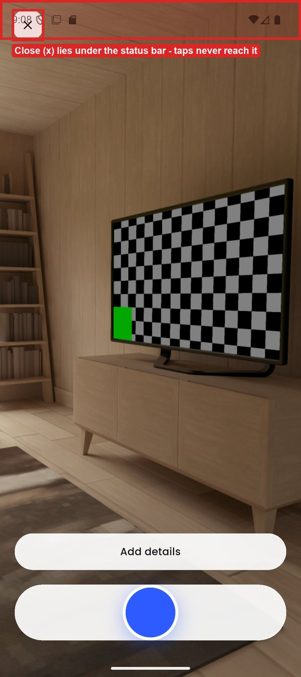 | 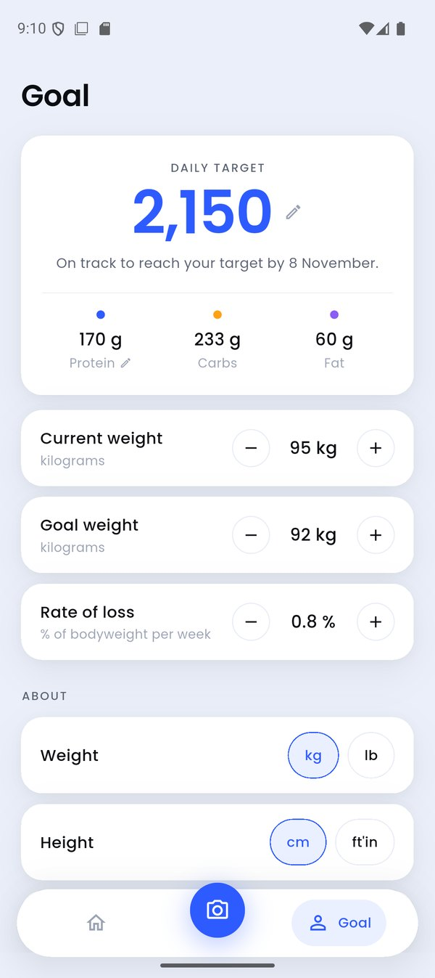
TC-063_viewfinder (highlight added) | TC-063_after_close
Figure 30: DEF-26 evidence

DEF-27 – Proposed photo items' portions cannot be adjusted before saving
Defect ID | DEF-27
Title | Proposed photo items' portions cannot be adjusted before saving
Module / Feature | M7 Photo Logging
Found by | TC-066
Environment | Android 16 (API 36) emulator 'finall', 1080x2424 @ 420 dpi; release APK built from commit 35e2473
Severity | Major
Priority | High
Status | Open
Steps to reproduce | 1. Analyse biryani.jpg from the Gallery.  2. Try to change any item's portion (tap '250 g · 5 pieces').
Expected result | Every proposed item's portion can be adjusted, with live totals (UC-06 main flow).
Actual result | No control exists; portion chips appear only for low-confidence items and none were offered here. Only × (remove) is available.
Impact | A wrong estimate must be saved first and fixed later, or discarded.
Evidence | TC-066_portion_tap_no_control
Reporter / Date | Usman Ghani · 11-Oct-2026

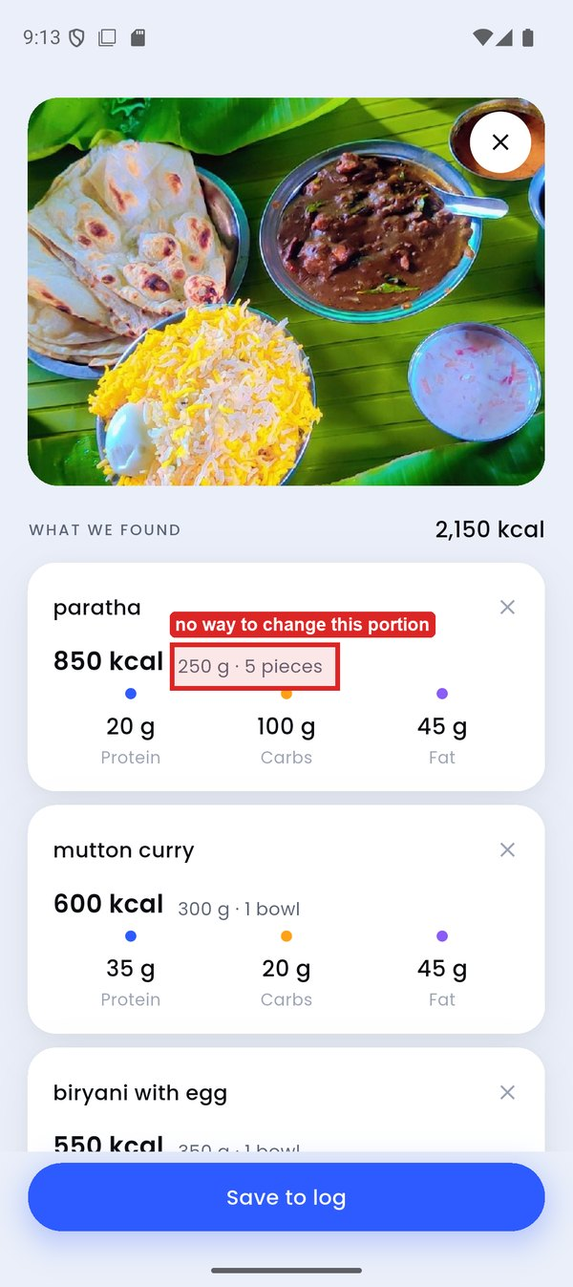
TC-066_portion_tap_no_control (highlight added)
Figure 31: DEF-27 evidence

DEF-28 – Proposed item names and macros cannot be edited
Defect ID | DEF-28
Title | Proposed item names and macros cannot be edited
Module / Feature | M7 Photo Logging
Found by | TC-067
Environment | Android 16 (API 36) emulator 'finall', 1080x2424 @ 420 dpi; release APK built from commit 35e2473
Severity | Major
Priority | Medium
Status | Open
Steps to reproduce | 1. On a photo review screen tap an item's name, then a macro figure.
Expected result | The name can be edited or replaced from the database; a macro can be typed (UC-06 variations).
Actual result | Nothing happens on either tap.
Impact | A misidentified food cannot be corrected.
Evidence | TC-067_name_macro_tap_no_edit
Reporter / Date | Usman Ghani · 11-Oct-2026

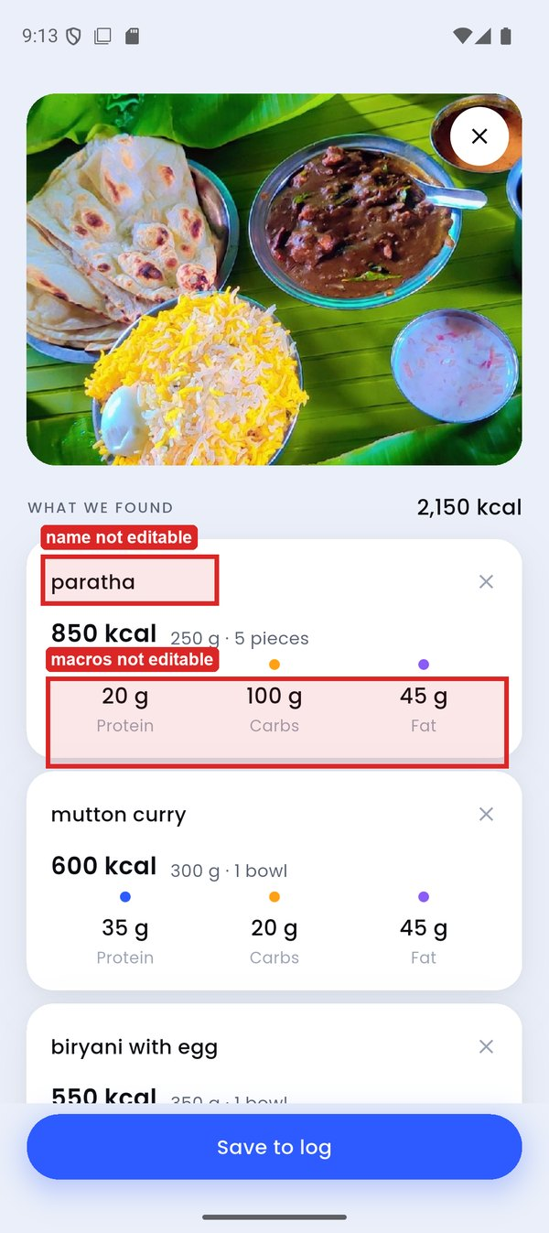
TC-067_name_macro_tap_no_edit (highlight added)
Figure 32: DEF-28 evidence

DEF-29 – After saving a gallery photo the app returns to the camera, not Home
Defect ID | DEF-29
Title | After saving a gallery photo the app returns to the camera, not Home
Module / Feature | M7 Photo Logging
Found by | TC-064
Environment | Android 16 (API 36) emulator 'finall', 1080x2424 @ 420 dpi; release APK built from commit 35e2473
Severity | Minor
Priority | Medium
Status | Open
Steps to reproduce | 1. Viewfinder -> Gallery -> choose a meal photo.  2. Tap 'Save to log'.
Expected result | 'Meal added' and Home, with the totals updated (UC-03).
Actual result | 'Meal added', then the live viewfinder again. Combined with DEF-26 the user must use system Back to leave.
Impact | Confusing flow; invites logging the meal twice.
Evidence | TC-064_meal_added_snackbar, TC-064_home_after_save
Reporter / Date | Usman Ghani · 11-Oct-2026

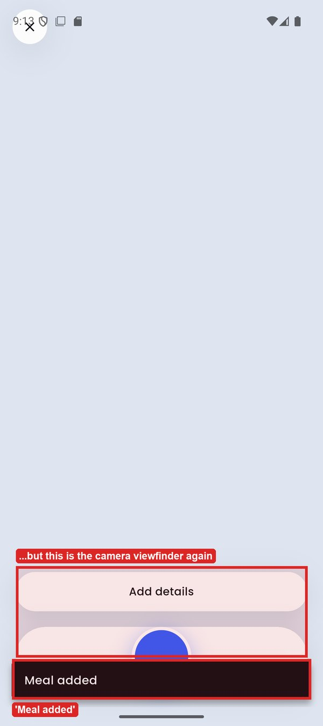 | 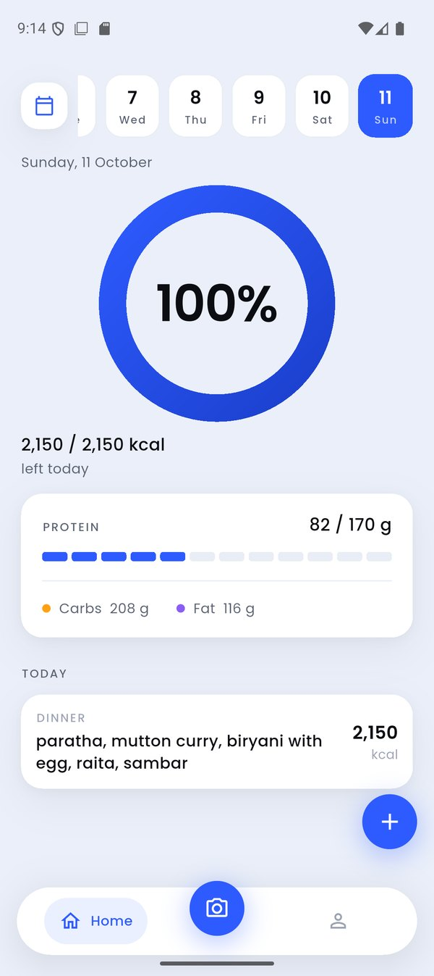
TC-064_meal_added_snackbar (highlight added) | TC-064_home_after_save
Figure 33: DEF-29 evidence

DEF-30 – Details typed before choosing a gallery photo are ignored
Defect ID | DEF-30
Title | Details typed before choosing a gallery photo are ignored
Module / Feature | M7 Photo Logging
Found by | TC-065
Environment | Android 16 (API 36) emulator 'finall', 1080x2424 @ 420 dpi; release APK built from commit 35e2473
Severity | Major
Priority | Medium
Status | Open
Steps to reproduce | 1. Viewfinder -> Add details 'three apples, about 540 g' -> Done.  2. Gallery -> apple.jpg (one apple).
Expected result | The estimate follows the user's details (about 3 apples / 540 g) (UC-04).
Actual result | 'apple · 95 kcal · 182 g · 1 medium apple' - the details were silently dropped.
Impact | The accuracy feature UC-04 exists for does nothing on the gallery path.
Evidence | TC-065_apple_proposal, TC-065_details_set
Reporter / Date | Usman Ghani · 11-Oct-2026

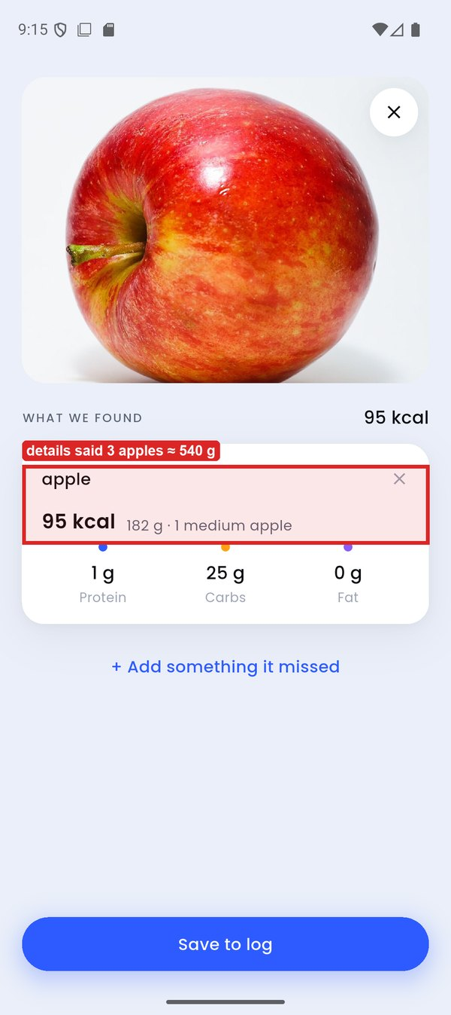 | 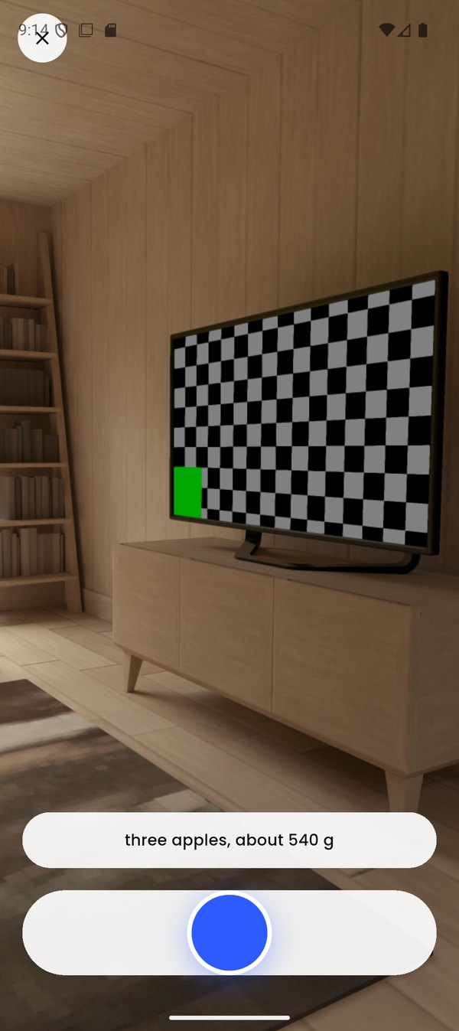
TC-065_apple_proposal (highlight added) | TC-065_details_set
Figure 34: DEF-30 evidence

DEF-31 – 'Add something it missed' logs a separate entry instead of adding to the meal
Defect ID | DEF-31
Title | 'Add something it missed' logs a separate entry instead of adding to the meal
Module / Feature | M7 Photo Logging
Found by | TC-068
Environment | Android 16 (API 36) emulator 'finall', 1080x2424 @ 420 dpi; release APK built from commit 35e2473
Severity | Major
Priority | Medium
Status | Open
Steps to reproduce | 1. Analyse egg_breakfast.jpg.  2. Tap '+ Add something it missed', add 'Chapati/Roti'.  3. Return to the review; Save.
Expected result | Chapati is appended to this meal's list and saved with it (UC-06).
Actual result | The review list is unchanged; Chapati was saved immediately as its own entry. Discarding the photo would leave it logged.
Impact | Meals split in two; abandoning a review leaves orphaned entries.
Evidence | TC-068_home_two_entries, TC-068_review_after_add
Reporter / Date | Usman Ghani · 11-Oct-2026

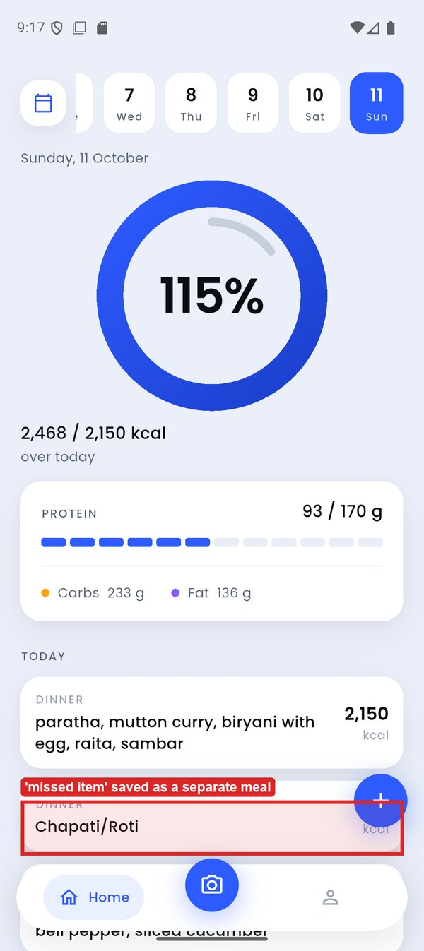 | 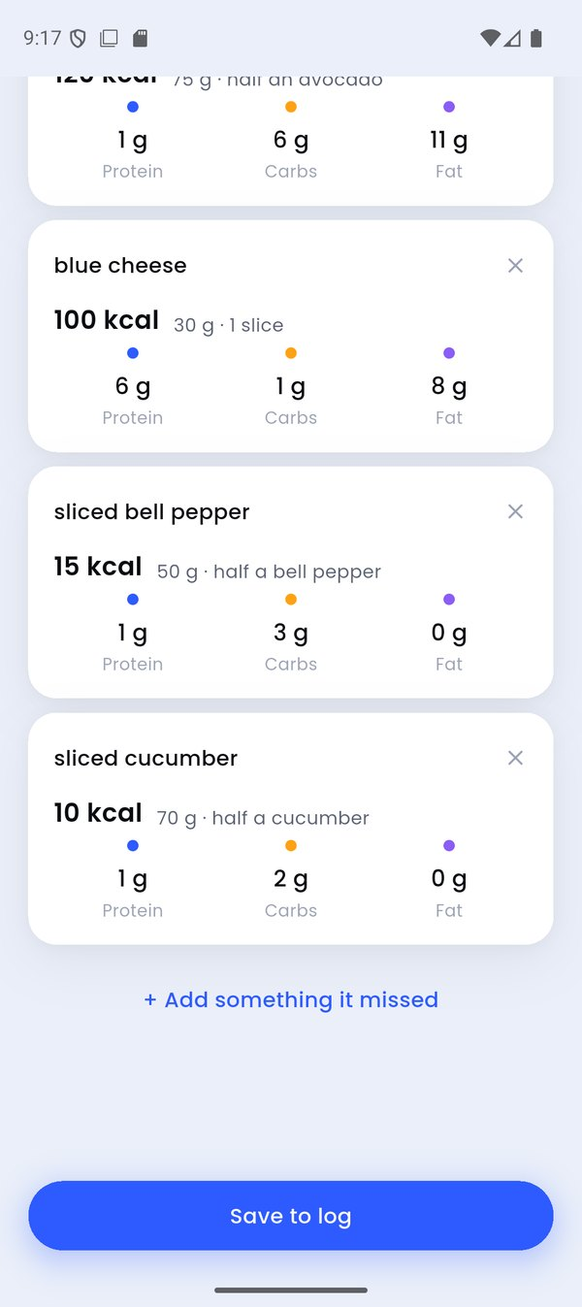
TC-068_home_two_entries (highlight added) | TC-068_review_after_add
Figure 35: DEF-31 evidence

DEF-32 – Search box and results get out of sync
Defect ID | DEF-32
Title | Search box and results get out of sync
Module / Feature | M3 Manual Food Logging
Found by | TC-073, TC-071
Environment | Android 16 (API 36) emulator 'finall', 1080x2424 @ 420 dpi; release APK built from commit 35e2473
Severity | Minor
Priority | Medium
Status | Open
Steps to reproduce | 1. Open Add food with an empty field; tap a Recent chip (e.g. 'paratha').  2. Or from a failed photo tap 'Add by hand instead'.
Expected result | The chip's text appears in the search box (with ×) above its results.
Actual result | Results show under an EMPTY search box with no × to clear them; the only way back is to type and delete.
Impact | The user cannot see or clear what is being searched.
Evidence | TC-073_after_chip_tap, EXP_stale_results_empty_field
Reporter / Date | Faizan Ali · 11-Oct-2026

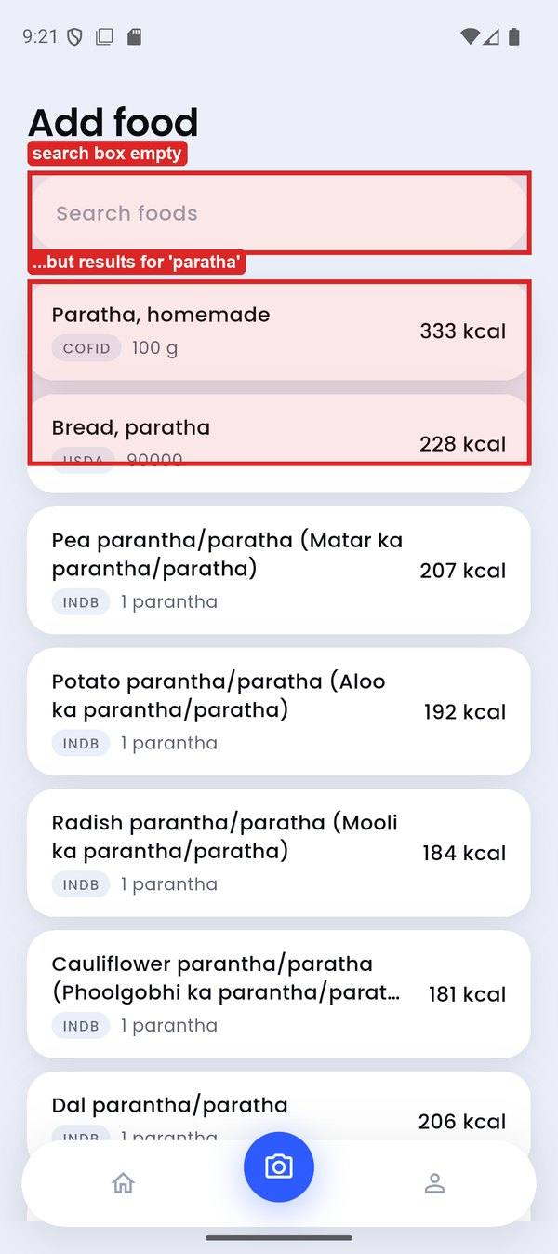 | 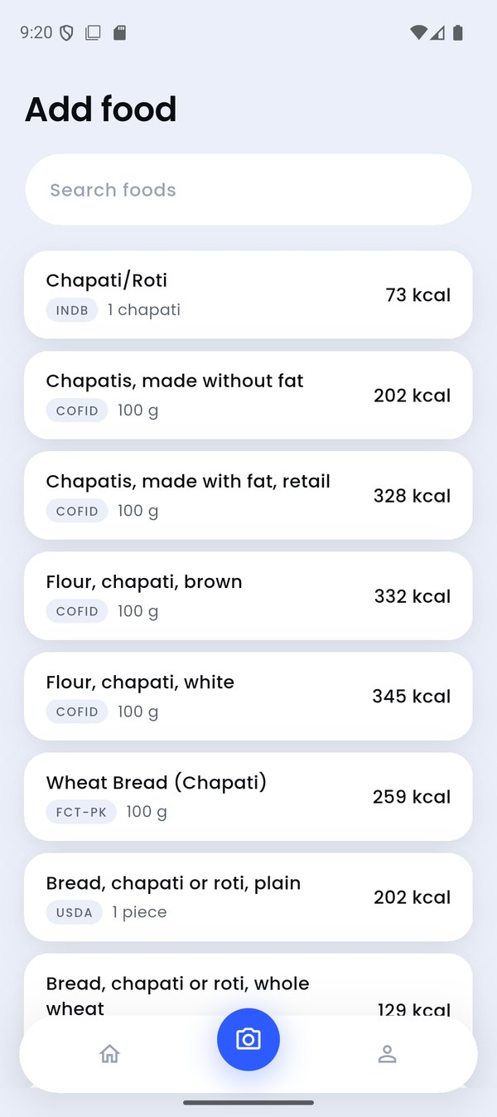
TC-073_after_chip_tap (highlight added) | EXP_stale_results_empty_field
Figure 36: DEF-32 evidence

DEF-33 – Fields meant to take focus do not (Add food search, target weight)
Defect ID | DEF-33
Title | Fields meant to take focus do not (Add food search, target weight)
Module / Feature | M3 Manual Food Logging
Found by | TC-075, EXP-01
Environment | Android 16 (API 36) emulator 'finall', 1080x2424 @ 420 dpi; release APK built from commit 35e2473
Severity | Trivial
Priority | Low
Status | Open
Steps to reproduce | 1. Tap '+' on Home.  2. Or reach 'What are you aiming for?' in onboarding.
Expected result | The field is focused with the keyboard up, ready to type.
Actual result | No focus and no keyboard; the user must tap the field first.
Impact | One extra tap on the most frequent action.
Evidence | TC-075_plus_add_food
Reporter / Date | Faizan Ali · 11-Oct-2026

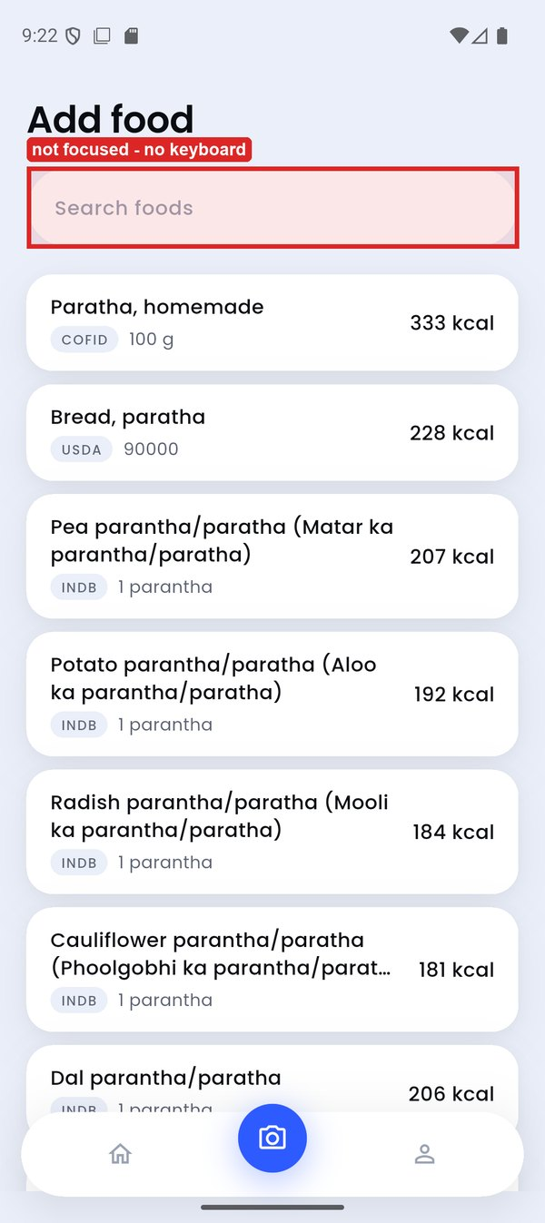
TC-075_plus_add_food (highlight added)
Figure 37: DEF-33 evidence

DEF-34 – Past days say 'left today'
Defect ID | DEF-34
Title | Past days say 'left today'
Module / Feature | M4 Day View & Entry Editing
Found by | EXP-06
Environment | Android 16 (API 36) emulator 'finall', 1080x2424 @ 420 dpi; release APK built from commit 35e2473
Severity | Trivial
Priority | Low
Status | Open
Steps to reproduce | 1. On Home select an earlier day that has entries (e.g. 10 Oct).
Expected result | Wording fits a past day (e.g. 'left' or 'under target').
Actual result | '72 / 2,160 kcal' followed by 'left today' on Saturday, 10 October.
Impact | Cosmetic wording error.
Evidence | TC-035_logged_on_10oct
Reporter / Date | Faizan Ali · 11-Oct-2026

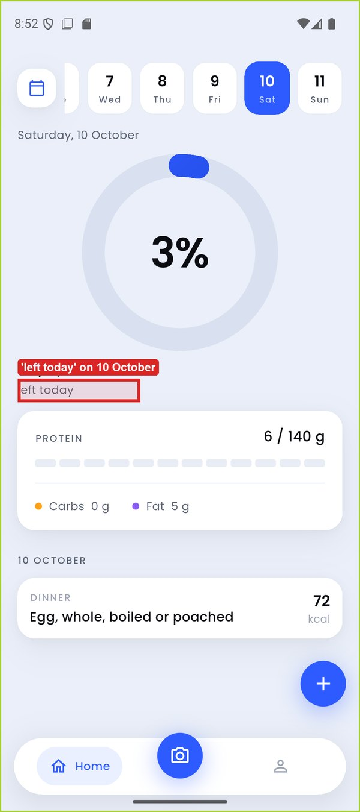
TC-035_logged_on_10oct (highlight added)
Figure 38: DEF-34 evidence

Appendix E – Exploratory Testing Notes
Six time-boxed sessions were run alongside the scripted cases, each with a charter. Findings that are functional defects are logged in Appendix D; usability observations are recorded here only.
Session | EXP-01
Charter | Onboarding: navigation, persistence and focus outside the scripted paths
Tester | Usman Ghani
Time (11-Oct-2026) | 20:14–20:45
Findings | System Back on any onboarding step closes the app and loses all answers (DEF-03).  Restarting after the under-18 refusal returns to step 1 (DEF-02).  Progress bar is full on the activity step, one step early (DEF-05).  Target-weight field does not take focus on arrival (DEF-33).  Observation (usability, out of scope): deleting digits passes through refused values, so the keyboard auto-closes 0.9 s after an intermediate refusal while editing.

Session | EXP-02
Charter | Food database: data quality while browsing search results
Tester | Faizan Ali
Time (11-Oct-2026) | 20:45–20:52
Findings | USDA servings named '90000' (Rice cake, Rice paper, Bread, paratha) (DEF-10).  INDB 'Spinach chickpeas cutlet' 1 cutlet = 328 g / 2,255 kcal / 241 g fat; 'Boiled egg (Ubla anda)' 151 g = 68 kcal (DEF-13).  Observation: some CNF rice dishes use a liquid serving ('100ml') for a solid food.

Session | EXP-03
Charter | Entry editor: every multiplier chip and repeated use
Tester | Faizan Ali
Time (11-Oct-2026) | 20:52–20:55
Findings | '0.8×' applies 0.75× (DEF-14).  Repeated 0.5× reaches 0 g / 0 kcal (DEF-15).

Session | EXP-04
Charter | Goal screen and shell: layout of controls near the floating nav bar
Tester | Faizan Ali
Time (11-Oct-2026) | 21:05–21:09
Findings | Before scrolling, 'Where the food data comes from' sits under the floating nav bar; tapping it hit the camera button and raised the camera permission prompt.  The round '+' button covers the kcal figure of the last meal card on Home.  (Both are layout/usability observations, recorded but not counted as functional defects.)

Session | EXP-05
Charter | Viewfinder and photo flow: controls, exits and return paths
Tester | Usman Ghani
Time (11-Oct-2026) | 21:08–21:21
Findings | Gallery label hidden under the shutter (DEF-25).  Close (×) untappable under the status bar (DEF-26).  After saving a gallery photo the app returns to the camera (DEF-29).  Pushed Add food shows a previous query's results under an empty box (DEF-32).

Session | EXP-06
Charter | Day view on past dates
Tester | Faizan Ali
Time (11-Oct-2026) | 20:52–20:53
Findings | Past days read 'left today' (DEF-34).

Appendix F – Evidence Index
All screenshots are full-resolution PNG files (1080 × 2424) in the 'evidence' folder submitted with this report; screen videos are in the 'videos' folder.

F.1 Screen videos
Table 27: Screen videos
File | Shows | Linked to | Length
V1_stuck_saving_button.mp4 | 'Saving…' button stays disabled; tapping it does nothing; Home has one entry | TC-034, DEF-11 | 20 s
V2_units_toggle_wipes_goal.mp4 | Tapping 'lb' changes the caption to 'hold your current weight' and the rate to 0.5 % | TC-061, DEF-23 | 9 s

F.2 Screenshot index
Table 28: Screenshot index
File | Linked to | Captured
EXP_camera_permission_prompt.png | TC-063 | 21:08
EXP_chip_0_8x.png | DEF-14 | 20:54
EXP_stale_results_empty_field.png | DEF-32, TC-073 | 21:20
TC-001_first_launch.png | TC-001 | 20:14
TC-002_age_step.png | TC-002 | 20:14
TC-003_age18_body_step.png | TC-003 | 20:17
TC-003_age_119.png | TC-003 | 20:15
TC-004_age17_blocked.png | TC-004 | 20:16
TC-005_age_0.png | DEF-01, TC-005 | 20:15
TC-005_age_120.png | TC-005 | 20:15
TC-006_target_prefilled.png | TC-006 | 20:30
TC-007_height_100.png | TC-007 | 20:21
TC-007_height_251.png | TC-007 | 20:21
TC-007_height_99.png | DEF-01, TC-007 | 20:20
TC-008_comma_target_prefill.png | TC-008 | 20:24
TC-008_weight_24_9.png | DEF-01, TC-008 | 20:22
TC-008_weight_400_1.png | TC-008 | 20:23
TC-009_5ft10in.png | TC-009 | 20:27
TC-009_5ft25in.png | DEF-04, TC-009 | 20:28
TC-010_back_to_cm.png | TC-010 | 20:29
TC-010_ftin_converted.png | TC-010 | 20:29
TC-010_lb_converted.png | TC-010 | 20:29
TC-011_back_arrow_age_kept.png | TC-011 | 20:17
TC-012_before_back.png | DEF-03, TC-012 | 20:17
TC-012_reopened.png | exploratory / working shot | 20:17
TC-012_system_back_onboarding.png | DEF-03, TC-012 | 20:17
TC-013_after_restart.png | DEF-02, TC-013 | 20:16
TC-013_reentered_age25.png | DEF-02, TC-013 | 20:16
TC-014_activity_step.png | DEF-05, TC-014 | 20:31
TC-014_plan.png | TC-014 | 20:31
TC-014_target_note.png | TC-014 | 20:31
TC-015_plan.png | TC-015 | 20:33
TC-015_rate_clamped.png | TC-015 | 20:32
TC-016_maintain_plan.png | TC-016 | 20:34
TC-016_refused_55.png | TC-016 | 20:34
TC-017_already_underweight.png | TC-017 | 20:35
TC-017_maintain_spinner.png | DEF-06, TC-077 | 20:38
TC-018_plan_after_healthy_weight.png | TC-018 | 20:36
TC-018_refused_gain.png | DEF-06, TC-018 | 20:36
TC-018_spinner_after_15s.png | DEF-06, TC-018 | 20:37
TC-019_gain_too_fast.png | DEF-07, TC-019 | 20:38
TC-019_plan.png | DEF-07, TC-019 | 20:39
TC-020_floor_plan.png | TC-020 | 20:39
TC-021_tdee_below_floor_plan.png | TC-021 | 20:40
TC-022_78_5_maintain.png | TC-022 | 20:41
TC-022_78_6_gain.png | TC-022 | 20:41
TC-023_refusal_in_lb.png | DEF-08, TC-023 | 20:41
TC-024_long_goal_plan.png | DEF-09, TC-024 | 20:42
TC-025_home_after_relaunch.png | TC-025 | 20:44
TC-025_home_after_start.png | TC-025 | 20:43
TC-026_rice_cake_expanded.png | TC-026 | 20:45
TC-026_rice_cake_picker.png | DEF-10, TC-026 | 20:45
TC-026_search_rice.png | DEF-10, TC-026 | 20:44
TC-027_channa.png | TC-027 | 20:49
TC-027_karela.png | TC-027 | 20:49
TC-028_cleared.png | TC-028 | 20:48
TC-028_no_matches.png | TC-028 | 20:48
TC-029_AND_OR.png | TC-029 | 20:50
TC-029_NOT.png | TC-029 | 20:49
TC-029_quote.png | TC-029 | 20:49
TC-030_no_recent_section.png | DEF-12, TC-030 | 20:48
TC-031_max_20.png | TC-031 | 20:46
TC-031_min_0_5.png | TC-031 | 20:45
TC-032_one_cake_qty2.png | TC-032 | 20:45
TC-032_qty2.png | TC-032 | 20:45
TC-033_home_after_add.png | TC-033 | 20:46
TC-033_snackbar.png | TC-033 | 20:46
TC-034_stuck_saving.png | DEF-11, TC-034 | 20:46
TC-035_logged_on_10oct.png | DEF-34, TC-035 | 20:52
TC-035_today_unchanged.png | TC-035 | 20:52
TC-036_home_two_entries.png | TC-036 | 20:53
TC-037_over_target.png | TC-037 | 20:56
TC-038_strip_newest.png | TC-038 | 20:53
TC-038_strip_oldest.png | TC-038 | 20:53
TC-039_breakfast_selected.png | TC-039 | 20:53
TC-039_editor_open.png | DEF-13, TC-039 | 20:53
TC-039_home_breakfast_label.png | TC-039 | 20:54
TC-040_after_2x.png | TC-040 | 20:54
TC-040_after_half.png | TC-040 | 20:54
TC-041_home_zero_kcal_meal.png | DEF-15, TC-041 | 20:55
TC-041_zero_gram_item.png | DEF-15, TC-041 | 20:54
TC-042_editor_before_remove.png | TC-042 | 20:55
TC-042_meal_removed.png | TC-042 | 20:55
TC-043_after_undo.png | DEF-16, TC-043 | 20:55
TC-043_before_swipe.png | DEF-16, TC-043 | 20:55
TC-043_snackbar_undo.png | TC-043 | 20:55
TC-044_after_remove.png | TC-044 | 20:57
TC-044_editor.png | TC-044 | 20:57
TC-045_home_after_goal_change.png | DEF-21, TC-045 | 21:01
TC-045_home_before.png | DEF-21, TC-045 | 21:01
TC-045_today_after_day_switch.png | DEF-21, TC-045 | 21:01
TC-046_calendar_october.png | TC-046, TC-051 | 20:57
TC-047_future_tap.png | TC-047 | 20:57
TC-048_september.png | TC-048 | 20:58
TC-049_closed.png | TC-049 | 20:58
TC-049_day_detail.png | DEF-17, TC-049 | 20:58
TC-050_september_with_oct_detail.png | DEF-18, TC-050 | 20:58
TC-052_calendar_yesterday.png | DEF-22, TC-052 | 21:01
TC-052_calendar_yesterday_after_restart.png | DEF-22, TC-052 | 21:02
TC-052_yesterday_home_after_change.png | DEF-22, TC-052 | 21:01
TC-053_goal_screen.png | TC-053 | 20:59
TC-054_after_restart.png | TC-054 | 21:05
TC-054_goal_70_live.png | TC-054 | 21:05
TC-055_rate_max.png | DEF-24, TC-055 | 21:06
TC-055_rate_min.png | DEF-09, TC-055 | 21:06
TC-056_rate_1_0_quantised.png | DEF-24, TC-056 | 21:07
TC-057_after_restart.png | TC-057 | 21:07
TC-057_refused_58.png | TC-057 | 21:07
TC-058_after_reset.png | TC-058 | 20:59
TC-058_kcal_1499_advisory.png | TC-058 | 20:59
TC-058_kcal_1500.png | TC-058 | 20:59
TC-058_kcal_sheet.png | TC-058 | 20:59
TC-059_after_save_0.png | DEF-19, TC-059 | 21:00
TC-059_after_save_blank.png | TC-059 | 21:00
TC-059_entered_0.png | DEF-19, TC-059 | 21:00
TC-060_protein_600.png | DEF-20, TC-060 | 21:00
TC-060_protein_sheet.png | TC-060 | 21:00
TC-061_after_lb.png | DEF-23, TC-061 | 21:03
TC-061_after_restart.png | DEF-23, TC-061 | 21:04
TC-061_before_units_toggle.png | DEF-23, TC-061 | 21:02
TC-062_sources.png | TC-062 | 21:10
TC-062_sources_2.png | TC-062 | 21:11
TC-063_after_close.png | DEF-26, TC-063 | 21:10
TC-063_viewfinder.png | DEF-25, DEF-26, TC-063 | 21:08
TC-064_analysing.png | exploratory / working shot | 21:12
TC-064_entry_with_photo.png | TC-064 | 21:14
TC-064_home_after_save.png | DEF-29, TC-064 | 21:14
TC-064_meal_added_snackbar.png | DEF-29, TC-064 | 21:13
TC-064_picker.png | TC-064 | 21:11
TC-064_proposed.png | TC-064 | 21:12
TC-064_proposed_2.png | TC-064 | 21:12
TC-065_apple_proposal.png | DEF-30, TC-065 | 21:15
TC-065_details_set.png | DEF-30, TC-065 | 21:14
TC-065_details_typed.png | TC-065 | 21:14
TC-066_portion_tap_no_control.png | DEF-27, TC-066 | 21:13
TC-067_name_macro_tap_no_edit.png | DEF-28, TC-067 | 21:13
TC-068_add_missed_search.png | TC-068 | 21:16
TC-068_added_snackbar.png | exploratory / working shot | 21:17
TC-068_after_remove.png | TC-068 | 21:16
TC-068_egg_proposal.png | TC-068 | 21:16
TC-068_home_two_entries.png | DEF-31, TC-068 | 21:17
TC-068_review_after_add.png | DEF-31, TC-068 | 21:17
TC-069_cat_no_food.png | TC-069 | 21:15
TC-070_offline_message.png | TC-070 | 21:18
TC-070_retry_result.png | TC-070 | 21:18
TC-071_add_by_hand.png | TC-071 | 21:19
TC-072_biryani_repeat.png | TC-072 | 21:20
TC-073_after_chip_tap.png | DEF-32, TC-073 | 21:21
TC-073_recent_chips.png | TC-073 | 21:20
TC-074_goal_tab.png | TC-074 | 21:22
TC-074_home_tab.png | TC-074 | 21:22
TC-075_calendar.png | TC-075 | 21:22
TC-075_plus_add_food.png | DEF-33, TC-075 | 21:22
TC-076_back_from_calendar.png | DEF-03, TC-076 | 21:22
TC-EXP_cutlet_2255kcal.png | DEF-13 | 20:51

F.3 Key passed tests
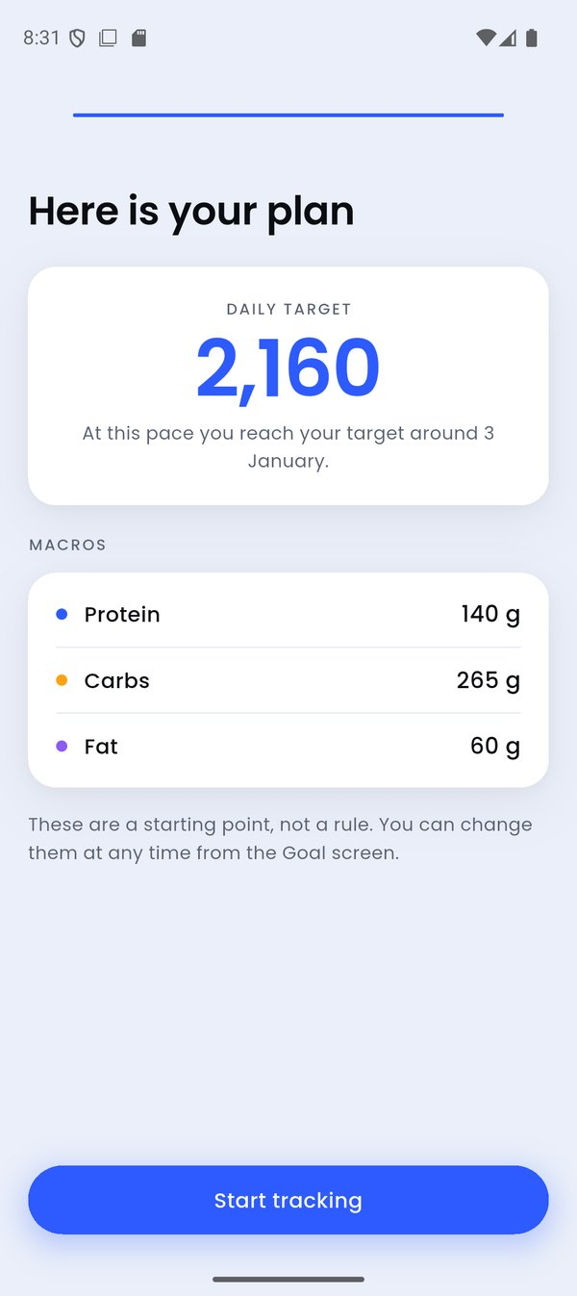 | 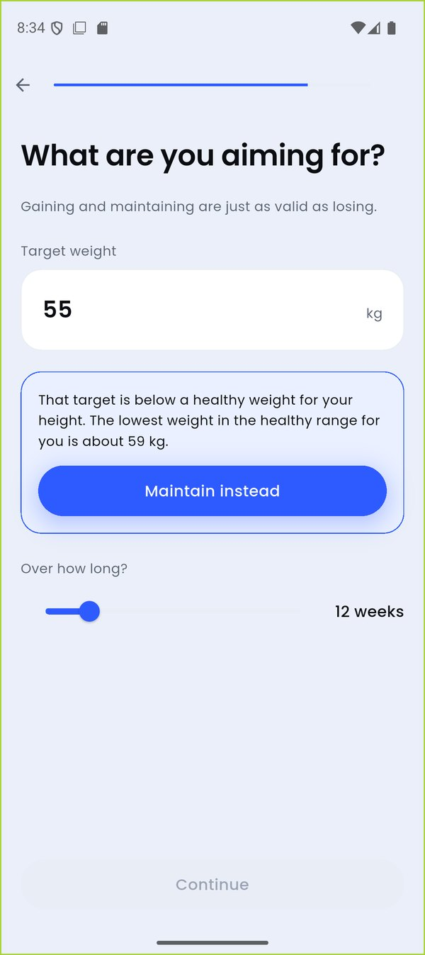 | 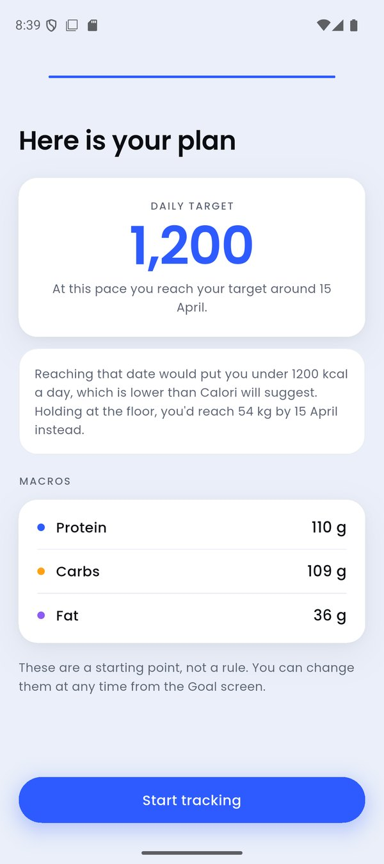 | 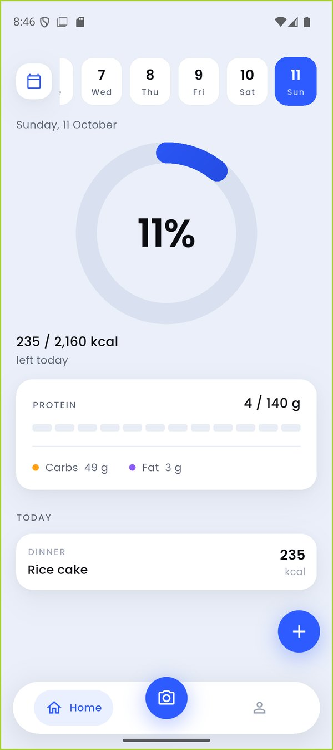
TC-014 reference plan | TC-016 BMI refusal | TC-020 calorie floor | TC-033 food added
Figure 39: Key passed tests – onboarding and logging
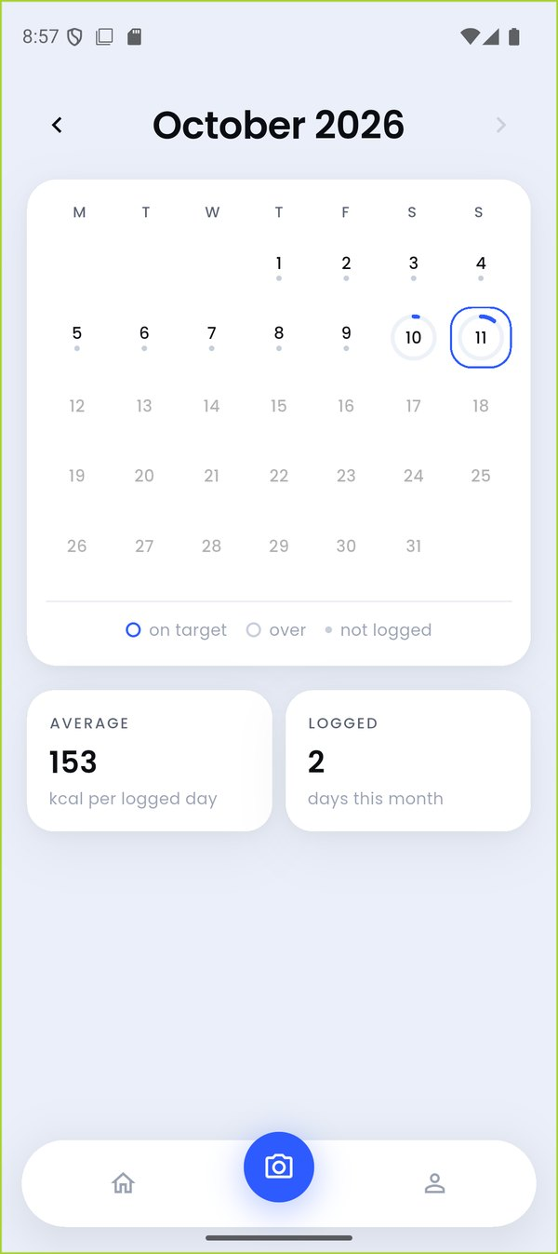 | 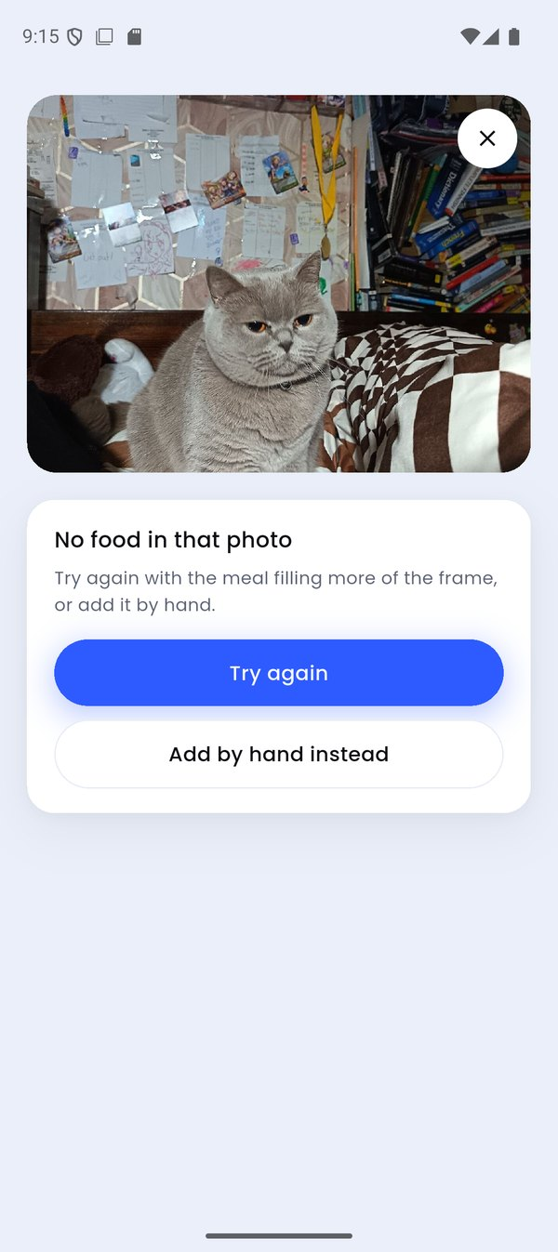 | 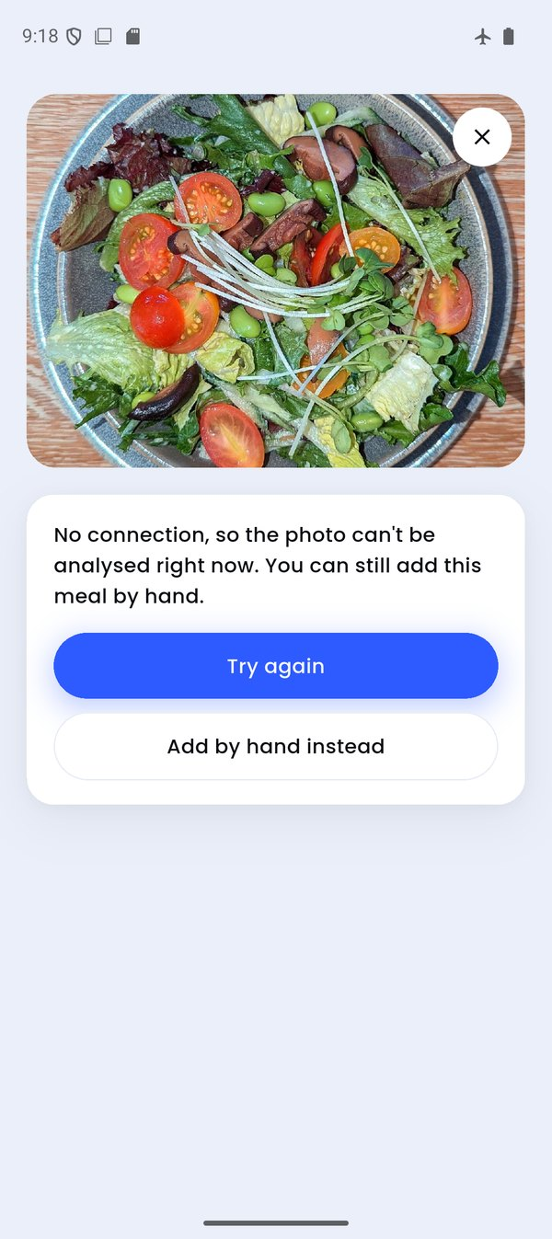 | 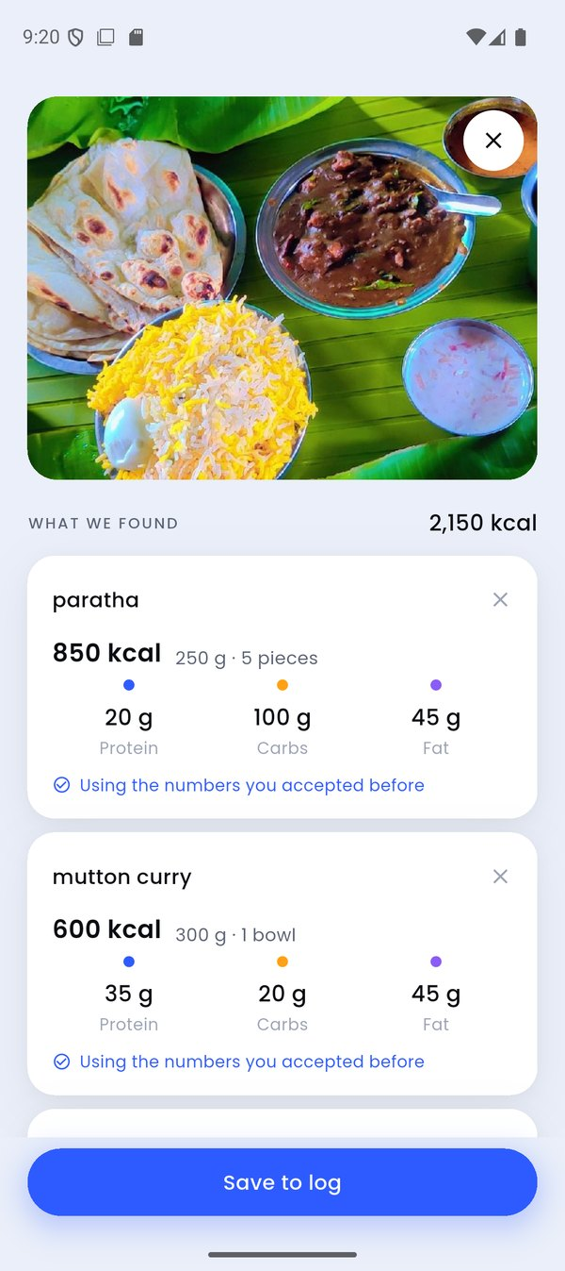
TC-046 calendar | TC-069 no food | TC-070 offline | TC-072 repeat meal
Figure 40: Key passed tests – calendar and photo path

Appendix G – Contribution Table
Table 29: Contribution by member
Member | Roll no. | Modules | TCs designed & executed | Defects reported | Exploratory sessions | Other work
Usman Ghani | 24f3000 | M1, M2, M7 | 37 | 15 | 2 | Plan, environment, report compilation
Faizan Ali | 24f3029 | M3, M4, M5, M6, M8 | 40 | 19 | 4 | RTM, defect log, report review

Appendix H – Reflection
Testing a real application against its own written use cases taught us more than testing a toy example could. Three lessons stand out.
Expected results must come from somewhere other than the app. Writing a small calculator from the published formula before running anything meant that a wrong target could not look right to us. That is how the Goal screen's rate problem (DEF-24) showed up as a clear 220 kcal gap rather than a number we accepted.
The edges are where the defects are. Most failures came from boundaries and transitions rather than the happy path: an underweight user taking the offered alternative, restarting after a refusal, pressing Android Back, adding the same food twice, or toggling a unit with a hand-set target. Decision tables and state transition tables made us list these paths deliberately.
Evidence has to be planned. A screenshot overwritten by the next step cost us a re-check; naming every capture after its test case, and highlighting the fault on the image, made the defect reports far easier to write and to read.
If we repeated the exercise we would test on a physical phone as well as the emulator, budget time for re-testing fixed builds, and automate the goal-engine checks so they could be re-run on every change.

