Zava Insurance: Hybrid AI Demo
On-Device AI + Microsoft WorkIQ — Best of Both Worlds on Windows 11

Duration | 2–3 minutes
Audience | Enterprise IT Decision Makers (ITDM) & Business Decision Makers (BDM)
Key Message | Windows 11 Copilot+ PCs deliver hybrid AI — fast private inference on the NPU + secure organizational intelligence from Microsoft 365 via WorkIQ
Hardware | Any Copilot+ PC (Snapdragon X, Intel Core Ultra, AMD Ryzen AI)
Prerequisites | Windows 11, phi-npu.exe (Phi Silica), Python 3.11+, Foundry Local

The Story
An insurance company deploys AI-powered claims processing to 10,000 field adjusters. The challenge: they need AI that works anywhere (in the field, offline) while still connecting securely to organizational knowledge when available. The answer is hybrid AI on Windows 11 — the NPU handles all sensitive inference locally (zero cloud cost, zero data exposure), and Microsoft WorkIQ enriches responses with CRM data, claims history, and internal communications when connected.
This is only possible on Windows. The dedicated NPU hardware means AI runs at hardware speed without touching the CPU or GPU. And the secure connection to Microsoft 365 means organizational intelligence flows in without sensitive customer data flowing out.

Demo Flow (2–3 minutes)

Step 1: Set the Stage (15 seconds)
TALK TRACK:
"Let me show you how a Windows 11 Copilot+ PC can run AI-powered insurance claims processing — entirely on the device, with zero cloud cost. This is Zava Insurance's hybrid AI prototype. Notice the NPU status indicator in the top right — green means the Neural Processing Unit is active and ready."
ACTION: Show the Home tab. Point out the NPU Online indicator and WorkIQ Off status.
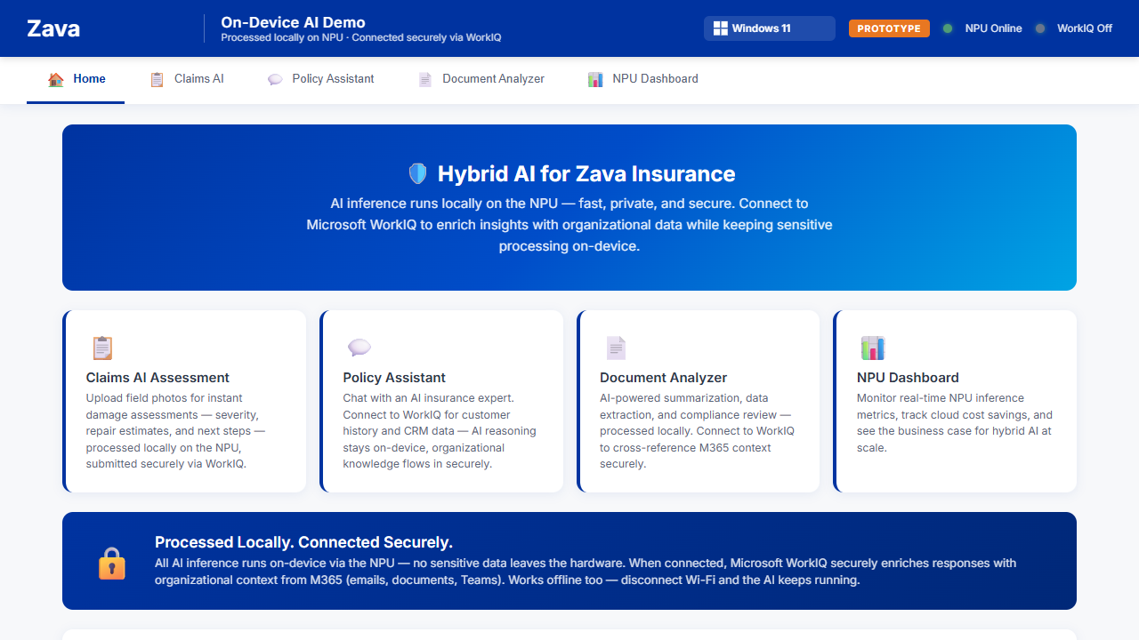

Step 2: Claims AI — Photo Assessment on NPU (45 seconds)
TALK TRACK:
"A field adjuster photographs water damage at a customer's home. Watch what happens — I upload the photo and the NPU analyzes it instantly. No internet needed, no data leaves the device. The AI identifies damage type, estimates severity, and recommends next steps."
ACTION:
1. Click 'Claims AI' tab
2. Drag a water damage photo from sample_data/claim_photos/ into the upload area
3. Select 'Water Damage' as damage type
4. Click 'Assess with On-Device AI'
5. Point out the response time (~8-12 seconds) and that it says 'Engine: NPU'
6. Open Task Manager (Ctrl+Shift+Esc) → Performance tab → show NPU utilization spike
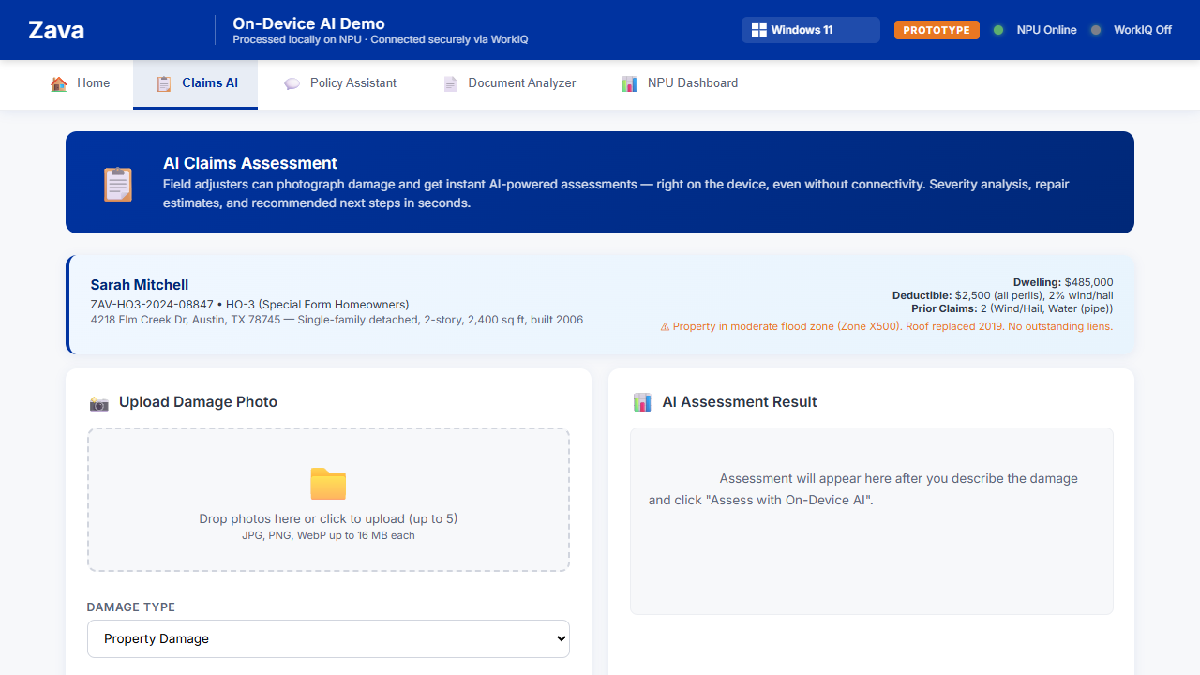

- 💡 KEY POINT: Open Task Manager (Ctrl+Shift+Esc) → Performance tab. You'll see the NPU utilization spike during inference. This is dedicated silicon — it's not touching the CPU or GPU, which remain free for other work.

Step 3: Policy Assistant — Hybrid AI in Action (45 seconds)
TALK TRACK:
"Now here's where it gets interesting. The Policy Assistant can answer questions using just the NPU — fast and private. But watch what happens when I connect to Microsoft WorkIQ..."
ACTION:
1. Click 'Policy Assistant' tab
2. First, ask WITHOUT WorkIQ: Type 'What does the HO-46 endorsement cover?' → Show fast NPU response
3. Now check the 'Connect securely to Microsoft WorkIQ' checkbox
4. Notice the WorkIQ indicator in the top bar turns green
5. Ask: 'What is the current claim status?' → Show enriched response with CRM data
6. Point out the 'Source: Microsoft 365 (WorkIQ)' badge on the response
TALK TRACK (continued):
"See the difference? Same NPU, same on-device processing — but now it's enriched with real organizational context. The AI pulled claim status, adjuster notes, and timeline from Microsoft 365. The sensitive reasoning still happened locally on the NPU — WorkIQ just provided the context securely. Best of both worlds."
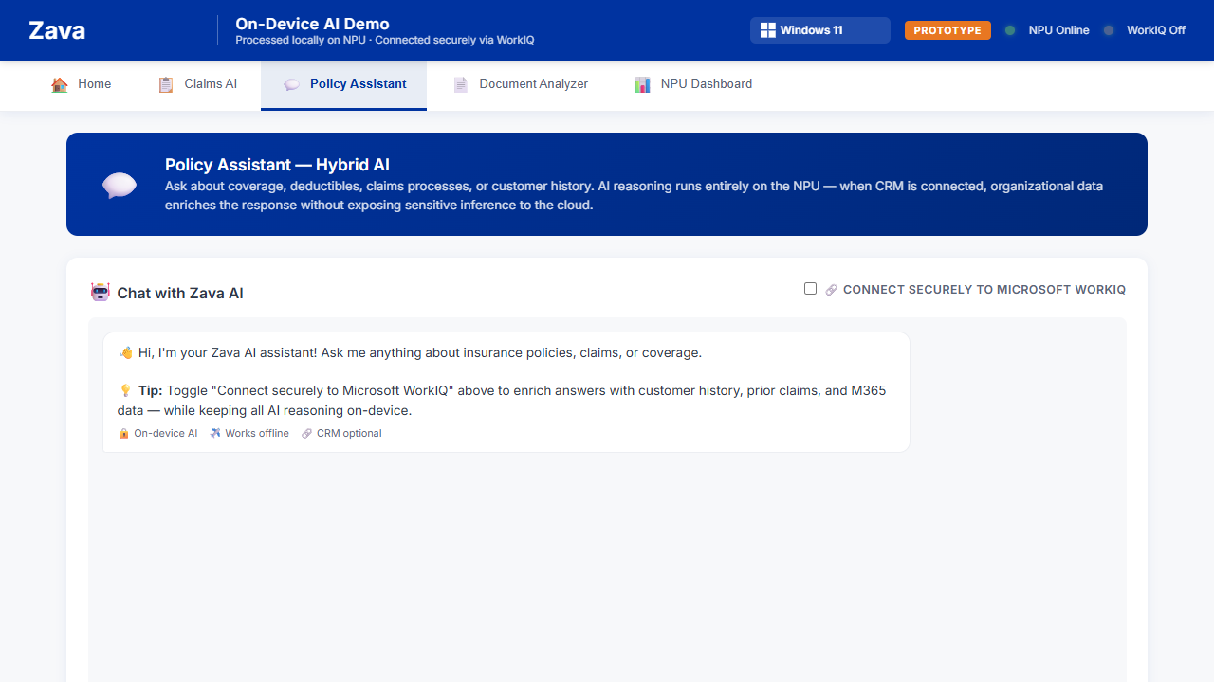

Step 4: NPU Dashboard — The Business Case (30 seconds)
TALK TRACK:
"Let me show you why this matters at scale. The NPU Dashboard tracks every inference — zero cloud cost, zero network latency, full data sovereignty. If you deploy this to 10,000 field adjusters doing 50 AI inferences per day, that's 130 million inferences per year at zero incremental cloud cost. That's $1.3 million saved annually — and that's just one application."
ACTION:
1. Click 'NPU Dashboard' tab
2. Point out: Cloud Cost Saved, Total Inferences, Avg Latency
3. Show the Fleet-Scale Projection calculator (already shows $1.3M)
4. Mention the Carbon Savings Calculator below
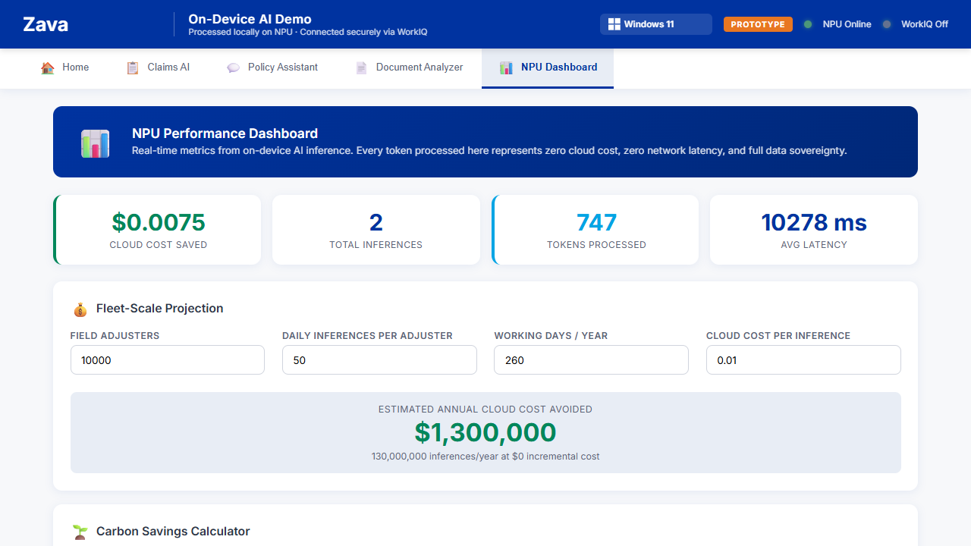

Step 5: Developer Experience — Customize with GitHub Copilot CLI (30 seconds)
TALK TRACK:
"One more thing. Because this is a Windows application built with standard web technologies, anyone in your organization can customize it using natural language. Let me show you — I'll use GitHub Copilot CLI to add a dark mode toggle to the app in seconds."
ACTION:
1. Open a terminal next to the app
2. Type: copilot "Add a light mode / dark mode toggle button to the top menu bar next to the NPU status indicator. When toggled, switch all backgrounds, text, and cards to a dark theme."
3. Show Copilot CLI making the code changes in real-time
4. Refresh the browser — show the new toggle in the top menu
5. Click it — show the app switch to dark mode
TALK TRACK (closing):
"That's the power of building on Windows. Dedicated AI hardware that runs offline, secure connection to organizational intelligence via Microsoft 365, and any developer in your company can extend it using natural language with GitHub Copilot. This is hybrid AI — only on Windows 11."

Key Messages for ITDM/BDM Audience
- Security & Compliance: All AI inference runs on-device. Sensitive customer data (PII, claims, photos) never leaves the hardware. Full data sovereignty.
- Cost at Scale: Zero incremental cloud cost per inference. At fleet scale (10K+ devices), this translates to millions in annual savings vs. cloud-only AI.
- Works Offline: Field adjusters can use AI in basements, rural areas, disaster zones — anywhere without connectivity. The NPU doesn't need internet.
- Best of Both Worlds: When connected, Microsoft WorkIQ securely enriches responses with organizational context (emails, Teams, documents) — without sending customer data to the cloud.
- Hardware Investment: Copilot+ PCs with dedicated NPUs are a platform for hundreds of AI applications — insurance is just one example.
- Developer Velocity: Standard web technologies + GitHub Copilot CLI means any developer can build, customize, and extend AI applications using natural language.

Technical Architecture
┌─────────────────────────────────────────────────────────────────┐
│ Windows 11 Copilot+ PC │
│ ┌─────────────────┐ ┌──────────────────┐ ┌──────────────┐ │
│ │ NPU (Primary) │ │ CPU (Fallback) │ │ GPU (Free) │ │
│ │ Phi Silica │ │ Foundry Local │ │ User apps │ │
│ │ ~8-12s/query │ │ Qwen 2.5 1.5B │ │ │ │
│ └────────┬─────────┘ └────────┬──────────┘ └──────────────┘ │
│ │ │ │
│ └──────────┬───────────┘ │
│ │ │
│ ┌───────┴────────┐ │
│ │ Flask App │◄── Microsoft WorkIQ (optional) │
│ │ localhost:5000│ (M365 CRM context) │
│ └────────────────┘ │
└─────────────────────────────────────────────────────────────────┘

Setup Instructions (Other Machines)
1. Clone the repository: git clone https://github.com/gusing_microsoft/zava-hybrid-ai-demo
2. Install Python dependencies: pip install -r requirements.txt
3. Ensure phi-npu.exe is available (ships with Windows AI APIs on Copilot+ PCs)
4. Install Foundry Local and pull the model: foundry model pull qwen2.5-1.5b
5. Copy sample_data/workiq/*.md files to your OneDrive for Business folder 'Zava Insurance Demo'
6. Run the app: python app.py
7. Open http://localhost:5000 in your browser

Task Manager Tip
During the demo, keep Task Manager open (Ctrl+Shift+Esc → Performance tab). When AI inference runs, you'll see the NPU utilization spike while CPU and GPU remain idle. This visually demonstrates that AI is running on dedicated silicon — not stealing resources from other applications. This is a powerful visual for technical audiences.

